## A STUDY ON CUSTOMS CLEARANCE PROCEDURE AND DOCUMENTATION AT PORTLINKS

**\*Shashank bharadwaj M** Dr.B.Veeramani\***

## Shashank bharadwaj M, MBA Shipping and logistics management, Vels Institute of Science and Technology and Advanced Studies (VISTAS), Pallavaram, Chennai, [Shashankbharadwajm@gmail.com](mailto:Shashankbharadwajm@gmail.com)

**\*Corresponding Author: Dr.B.Veeramani, Associate Professor, School Management studies, Vels Institute of Science and Technology and Advanced Studies (VISTAS), Pallavaram, Chennai,** [**veeramani.sms@velsuniv.ac.in**](mailto:veeramani.sms@velsuniv.ac.in)

## I ABSTRACT

This study examines customs clearance procedures and documentation in international trade, highlighting their importance in facilitating trade and economic development. It covers aspects such as classification, valuation, import and export processes, duty and tax assessment, risk assessment, and compliance measures. Accurate documentation is crucial, and challenges in compliance are highlighted. Key findings include the complexities of customs procedures, the need for technological advancements, and the need for capacity building and training initiatives. The study also presents case studies and best practices for successful customs clearance strategies. The study emphasizes the need for continuous improvement and collaboration among stakeholders to improve customs clearance procedures and documentation practices, promoting global trade facilitation and economic growth.

## II INTRODUCTION

A Customs House Agent (CHA) is a licensed individual responsible for a company's import and export of goods, often used in India. They aim to address the lack of resources for many businesses in India due to high bureaucracy and trade. Agents are legally treated as the company's own, but cannot be personally responsible for unpaid duties. Customs clearance is a complex process that involves submitting documentation, assessing duties and taxes, inspecting goods, and obtaining customs release. It involves a series of steps, including documentation submission, customs declaration, physical inspection, assessment of duties and taxes, and release of goods. Accurate documentation is crucial for customs officials to verify the nature, value, and origin of goods. Tariff classification is essential for compliance with trade agreements and calculating the cost of importing or exporting goods. Customs valuation

is crucial for taxation purposes. Importers must obtain necessary authorizations from government agencies before shipping goods across borders. Compliance with regulations is crucial to avoid fines, penalties, or seizure of goods. Customs brokers or freight forwarders can assist in navigating the clearance process.

## III INDUSTRY PROFILE

The customs clearance procedure and documentation industry is a vital part of international trade, facilitating the movement of goods and services across borders while adhering to regulatory requirements. This industry includes services provided by customs brokers, freight forwarders, logistics companies, and trade compliance specialists. The export and import industry is a significant contributor to the global economy, with leading countries like China, the United States, and Germany being major exporters and importers. The industry covers a wide range of products, including agricultural goods, manufactured products, raw materials, and services. Transportation is a critical aspect of international trade, with companies specializing in shipping, air freight, and logistics essential for smooth operations. Customs house agents (CHA) act as intermediaries between importers and exporters, facilitating clearance and ensuring compliance with customs laws, trade agreements, and international sanctions. The shipping industry in India is expected to grow at a compound annual growth rate of 12.0%, with 95% of trade volume and 70% value done through maritime transport.

# IV COMPANY PROFILE

Portlinks Inc, a Chennai-based freight forwarding company, was established in 1997 and has become one of the largest importers in Chennai. The company specializes in ocean/air cargo consolidation and customs clearance, ensuring timely delivery of goods from various industries. They offer air freight services and are acquiring IATA certification to make slot bookings with airlines. They have experience exporting agro-goods to countries in the Middle East and assure clients with safety and security. Ocean freight services are the most economical way to transport cargo, with leading liners like The Maersk providing vessels to remote locations. They also specialize in road transportation with a wide fleet of vehicles and well- trained drivers. They also specialize in custom clearance services, handling both export and import consignments. They have a dedicated team for marketing, operations, inspections, CFS incharge, and accounting.

# V OBJECTIVES OF THE STUDY

## PRIMARY OBJECTIVES:

To assess and analyze the efficiency and effectiveness of customs clearance procedures and drawbacks at Pot Link Pvt Limited, identifying areas for improvement and optimization.

## SECONDARY OBJECTIVES:

* + To Assess the accuracy and completeness of documentation submitted during customs clearance.
  + To Understand the communication and coordination between port link pvt limited Company and customs authorities.
  + To Analyze the impact of customs clearance procedure on overall supply chain effciency.
  + To understand the process of documentation for Import and Export cargos
  + To Examine the ways in digital platforms and automation of customs clearance efficiency.

## VI NEED OF THE STUDY

Studying customs clearance is crucial in the global economy for facilitating international trade and ensuring compliance with regulations. Mastery of customs clearance procedures helps avoid penalties and legal repercussions, enhances efficiency in cross-border trade, minimizes delays, reduces costs, and streamlines supply chain processes. This knowledge also improves logistics operations and customer satisfaction for businesses involved in international trade.

## VII. SCOPE OF THE STUDY

Customs clearance research is crucial for understanding international trade facilitation and regulatory compliance. It focuses on legal frameworks, procedural complexities, technology advancements, and global trade dynamics. Understanding international agreements, regional trade treaties, and national customs regulations helps determine cross-border trade rules. A thorough review of procedural variables, including documentation requirements, declaration procedures, and clearance processes, is essential for cost management and regulatory compliance. This research provides insights into the mechanisms driving international trade facilitation and regulatory compliance, identifying obstacles and opportunities for enhancing customs management.

# VIII STATEMENT OF PROBLEMS

Customs clearance is a complex process for businesses dealing with international trade, with inaccurate documentation leading to delays or rejections. Navigating regulations and requirements from different countries is challenging, as each jurisdiction has its own rules. Ensuring compliance while optimizing cost and efficiency is a significant challenge. The dynamic nature of international trade and evolving trade policies further complicates customs clearance. Addressing the problem requires meticulous attention to detail, a thorough understanding of regulations, and adaptability to changing trade dynamics.

# REVIEW OF LITERATURE

The research papers highlight the importance of efficient customs clearance procedures in promoting international trade, reducing costs, and enhancing economic growth. However, challenges such as bureaucratic complexities, delays, manual operations, and infrastructure limitations hinder trade efficiency and competitiveness. To improve trade facilitation, efforts should be made to streamline procedures, implement modern technologies like RFID, and

improve logistics performance. Standardization of policies and collaboration between public and private sectors are also crucial. Despite these challenges, there is optimism for improvement, as customs supports economic development goals and requires continuous reforms to adapt to changing global trade dynamics.

1. **RESEARCH METHODOLOGY**

The study on customs house agents uses a comprehensive research methodology, including literature reviews, interviews, surveys, and legal and regulatory document analysis. This approach provides a comprehensive understanding of the day-to-day practices, challenges, and experiences faced by these agents, providing valuable insights for policy decisions and enhancing trade facilitation efforts. Case studies and comparative analyses are also used to enrich the findings.

# DATA ANALYSIS AND INTERPRETATION

## TABLE NO 1: Are you confident that ,there is no problem faced by documentation process provided for import&export

|  |  |  |
| --- | --- | --- |
| **FACTORS** | **NO OF RESPONSE** | **PERCENTAGE** |
| STRONGLY AGREE | 5 | 13.9% |
| AGREE | 16 | 44.4% |
| NEUTRAL | 11 | 30.6% |
| DISAGREE | 3 | 8.3% |
| STRONGLY DISAGREE | 1 | 2.8% |
| TOTAL | 36 | 100% |

**CHART NO 1: Are you confident that,there is no problem faced by documentation process provided for import&export**

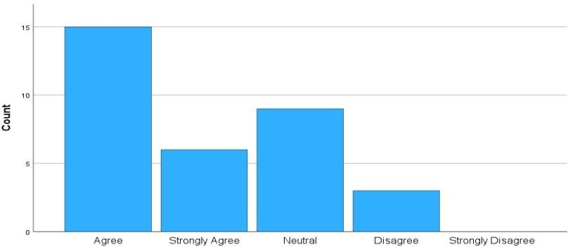

## INFERENCE:

From the above table chart inferred that 44.4% of the respondents Agree and 2.8% of the respondents Strongly disagree is no problem faced by documentation process provided for import&export.

## TABLE NO 2 :Do you agree that regular meetings between portlinks inc company &customs authorities improve coordination.

|  |  |  |
| --- | --- | --- |
| **FACTOR** | **NO OF RESPONSE** | **PERCENTAGE** |
| STRONGLY AGREE | 2 | 5.6% |
| AGREE | 25 | 69.4% |
| NEUTRAL | 7 | 19.4% |
| DISAGREE | 2 | 5.6% |
| STRONGLY DISAGREE | 0 | 0 |
| TOTAL | 36 | 100% |

**CHART NO 2:Do you agree that regular meetings between portlinks inc company &customs authorities improve coordination.**

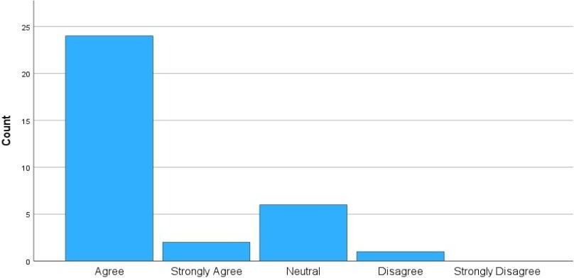

## INFERENCE:

From the above table chart inferred that 69.4% of the respondents Agree and 5.6 % of the respondents disagree customs authorities improve coordination.

## TABLE NO 3:Do you agree that investing in technology for customs clearance could enhance supply chain efficiency.

|  |  |  |
| --- | --- | --- |
| **FACTORS** | **NOOF RESPONSE** | **PERCENTAGES** |
| STRONGLY AGREE | 9 | 25% |
| AGREE | 17 | 47.2% |
| STRONGLY | 9 | 25% |
| NEUTRAL | 7 | 19.4% |
| DISAGREE | 2 | 5.6% |
| TRONGLY DISAGREE | 1 | 2.8% |
| TOTAL | 36 | 100 % |

**CHARTNO 3:Do you agree that investing in technology for customs clearance could enhance supply chain efficiency.**

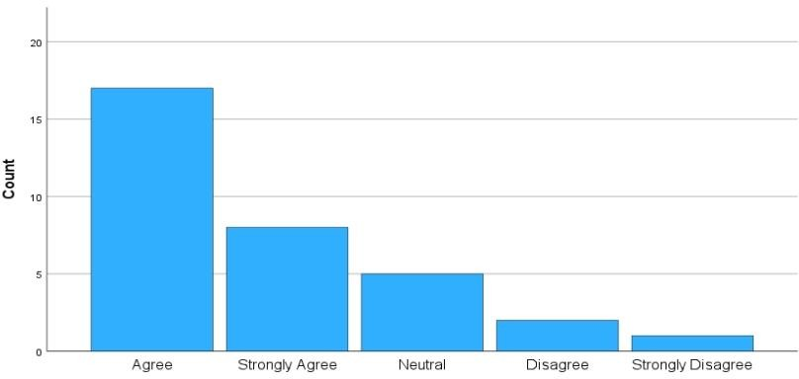

## INFERENCE:

From the above table chart inferred that47.2% of the respondents Agree and 2.8% of the respondents Strongly disagree customs clearance could enhance supply chain efficiency.

# FINDINGS OF THE STUDY

* The majority of respondents 46.2% agree there is no problem faced by documentation process provided for Import & Export.
* The majority of respondents 69.2% agree regular meetings between Portlinks INC company &customs authorities would improve coordination.
* The majority of respondents 48.7% agree that investing in technology for customs clearance could enhance supply chain efficiency

# WEIGHTED AVERAGE METHOD:

* Most members strongly agree on their direct relationships with shippers over partnerships, which helps with customs clearance, according to the weighted average for the statement.
* The majority of respondents strongly agree that they experienced delays due to communication breakdowns and customs authorities.

# CHI-SQUARE:

* The study found no significant correlation between effective communication between Port Link INC Limited company and regular meetings between portlinks INC company customs authorities, indicating no significant improvement in coordination.
* The study found no significant correlation between automation reducing human error in customs documentation and improving transparency in customs procedures.

# CORRELATION:

* The study found no significant correlation between automation reducing human error in customs documentation and improving transparency in customs procedures.

# SUGGESTIONS

1. Provide an overview of the customs clearance process, including its purpose, stakeholders involved, and the steps typically followed.
2. The documentation required for customs clearance, including but not limited to commercial invoices, packing lists, certificates of origin, bills of lading, and any special permits or licenses.
3. This study covers import/export duties, taxes, customs valuation, risk management EDI Automation ,trade facilation measures, challenges, bottlenecks, best practices, case studies, and future trends in customs clearance procedures. It also discusses the use of technology, trade facilitation measures, and emerging trends like blockchain and e- commerce.
4. The pricing policy and marketing strategies must be reviewed.

# CONCLUSION

The study emphasizes the importance of efficient customs clearance procedures in international trade, highlighting the need for meticulous documentation to ensure smooth goods flow and protect national security. It advocates for investments in electronic systems to reduce errors and administrative burdens. Technological advancements like automated systems and advanced tracking can further streamline clearance processes and enhance supply chain visibility. The study underscores the need for businesses to understand regulations and embrace technological innovations.