**Impact on Pattern of Educational Teaching Skills and Personality Traits after Globalization**

**Balram Singh**

**Assistant Professor (B.Ed.) Maharana Pratap Govt. P.G. College, Hardoi, U.P. India -241001 (balramsingh088@gmail.com)**

**Abstract:**

The study of interwoven global discourses, processes, and institutions that influence regional educational practices and policies is central to research on globalization and education. World culture, world systems, postcolonial, and culturalist are the four main theoretical stances on globalization and education. The knowledge economy and technology, lifelong learning, global migration or brain circulation, and neoliberalism are the main topics of discussion in the field of global education. The World Bank, the Organization for Economic Cooperation and Development, the World Trade Organization, the United Nations, and UNESCO are the main organizations that influence global educational discourses and initiatives. Opponents of the present global tendencies are in favour of alternative educational approaches that uphold regional languages and customs, guarantee innovative teaching methods that shield the underprivileged from the wealthy, and safeguard the environment and human rights. This study argues that most research and views on teaching as a profession in the northern hemisphere, especially in industrialized nations, are founded on these experiences. With an emphasis on the settings in industrialized nations, the study agenda aims to reassess preconceived conceptions about teachers' job and question their usefulness in light of the radically different realities in developing nations. Additionally, it aims to cast doubt on widely held beliefs about globalization and local development by claiming that, in light of actual evidence on educators and education in developing nations, these beliefs should also be updated.

**Keywords:** Globalization, Education, Teacher skills, Research, Global.

1. **INTRODUCTION:**

The study of interwoven global discourses, processes, and institutions that influence regional educational practices and policies is central to research on globalization and education. Scholars hailing from diverse fields of study frequently adopt an interdisciplinary perspective while tackling their subjects. In particular, the discipline is creating its own conceptual frameworks and vocabulary when it comes to "flows" and "networks." Groups of individuals that share traits and regard themselves as related beyond national borders are sometimes referred to as societies or civilizations. Furthermore, there are now four overlapping theoretical views in research on globalization and education on its origins and processes. Additionally, I will go over research on the intergovernmental and nongovernmental organizations, like the United Nations, UNESCO, the World Bank, the Organization for Economic Cooperation and Development (OECD), the World Trade Organization (WTO), and nongovernmental organizations that support women's, environmental, and human rights education, that are promoting globalization in education. India had democratic elections for the first time in its history in 1994. The African National Congress became the ruling party and a Black majority government was established. Similar to other developing nations, the post-apartheid administration has considered education to be essential to development in its policy documents and laws. According to these texts, progress is the imitation of the most successful capitalist democracies in the West as well as the quest of modernity and economic expansion. An examination of the connections between national and international growth and the transformation of education in the new India opens this essay. The particular reforms affecting teachers are related to school governance, curricula and pedagogies, education budget cuts, new norms and standards for educators (NSE), and the implementation of quality assurance procedures for working in public schools. These are set against this global (Bauman, 1998) backdrop (i.e., the dialectic of the local and the global; Amove and Torres, 2003).

1. **Globalization and Education:**

The word "globalization" was reportedly first used in 1985 by economist Theodore Levitt to refer to shifts in the world economy that had an impact on investment, consumption, and production (Stromquist, 2002). The phrase was rapidly used to describe cultural and political shifts that have an impact on sizable portions of the global population. Education is one of these widespread worldwide phenomena. Formal education is the most widely located institution and most widely shared experience of all in the modern world, according to the opening editorial of the newly founded journal Globalization, Societies and Education (Dale & Robertson, 2003). The very founding of this journal indicates the growing importance of globalization and education as a field of study. Relationship between the globalisation and education shown below in figure 1. Studies comparing local and global education, however, show that globalization of education does not imply uniformity among educational institutions (Anderson-Levitt, 2003).

Globalization-related terminology has swiftly permeated discussions concerning education. Groups in government and industry discuss how important it is for schools to prepare students for the demands of the global economy. More significant than the sharp increase in trade volume and scope is the integration of the global economy through affordable information and communications technologies. The world's countries are becoming increasingly similar via trade and technology.

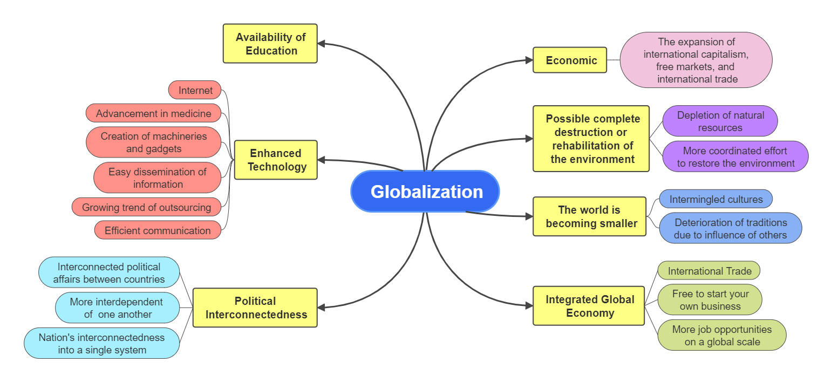

**Fig.1.** Globalisation and Education

The editors of the magazine Globalization, Societies and Education had to specify their area of expertise when it was first launched. Globalization and education will be seen as a unified collection of global processes that have an influence on education, according to the editors of the inaugural issue. According to Dale and Robertson (2003), these processes include international discourses on human capital, economic development, and multiculturalism as well as multinational enterprises, nonprofit organizations, information and communication technologies, and intergovernmental organizations. Papers such as “Globalization, Knowledge Economy and Comparative Education” that have appeared in the Comparative Education journal make sense as to why researchers studying comparative education would concentrate on the subject of globalization (Dale, 2005). Marginson and Sawir (2005) have critiqued these three approaches to globalization for failing to take into account the role that human choice and agency play in the process of globalization, despite the fact that they have given conceptual frameworks and vocabulary to the study of globalization.

* 1. **Global Discourses: The Knowledge Economy and Technology**

Common educational practices and policies are largely shaped by global educational discourses. Undoubtedly, a prominent worldwide discourse revolves on the knowledge economy. Conversations regarding the knowledge economy often touch on topics like technology, human capital, lifelong learning, and labor migration worldwide. According to Brown and Lauder (2006), the idea of the knowledge economy evolved conceptually original work on human capital economics, which maintained that while economies today rely on the knowledge and skills of all people, industrial development in the 20th century depended on the knowledge and skills of an elite few. In conclusion, these theorists claimed that post industrialism and shifts in human capital led to the creation of a knowledge economy in which wealth was correlated with knowledge workers and, eventually, with educational institutions. Discussions about the knowledge economy centre on the need to provide students with competencies relevant to the global labour market. Regarding this, technology serves two purposes. First and foremost, education must prepare students for a workforce in which new technical advancements are made on an almost daily basis (Monahan, 2005). In the words of the World Bank (2003), A knowledge-based economy relies primarily on the application of technology and the use of ideas rather than physical abilities.

* 1. **Global Uniformity: Instruction, Testing, and Education**

A worldwide standardization of educational procedures is facilitated by the current global commerce in education services. Furthermore, assistance organizations like the World Bank and OECD have promoted specific teaching strategies and studies pertaining to such strategies (Carney, 2003). World culture theorists claim that this is fostering the development of a global school culture (Baker & LeTendre, 2005). This dynamic is seen by postcolonial and world system theorists as a component of the core's dominance over the periphery (Spring, 2006). Culturalists, on the other hand, believe that this process might fail or negatively impact the loss of regional cultural values. International test score comparisons on a worldwide scale are crucial for establishing uniformity in educational methods. Leaders in charge of national education policies may decide to structure their curricula to conform to the criteria established by these international examinations as a result of these global comparison test results. Furthermore, the Trends in Mathematics and Science Study (TIMSS) and the Progress in International Reading Literacy Studies (PIRLS) assessments are conducted by the International Association for the Evaluation of Education Achievement (IEA), which also offers the TIMSS, R Video Study of Classroom Practices. Researchers can get useful information on assessment and worldwide patterns in learning from all three of these international testing initiatives (OECD, ETS, and IEA).

**2.3. Globalization, National Development, and Educational Change**

They show the long historical ancestry of the connection among national growth, globalization, and educational reforms. I'll talk about the main conceptual changes and how academic writing has been affected by them. The structural-functionalism of Robert Merton and Talcott Parsons during the 1950s and 1970s cleared the path for modernization theory and the importance of economics in developmental studies. All societies were said to follow five stages in order to achieve self-sustaining growth and prosperity: the traditional society, the conditions for take-off, the drive to maturity, and the age of high mass consumption. This progressive, linear development was equated with processes of capital formation.

1. **Teacher Voice in Education Reform**

Similar to individuals, governments frequently act differently from what they say, and policies are infamous for having unforeseen consequences. However, it hasn't helped that the educators who are meant to bring about the changes have been alienated and marginalized in many ways. Teachers are often encouraged to attend OBE seminars in silence, listening to department representatives and/or subject matter experts explain what they will now need to do; they are not asked to participate in the discussions, offer counterarguments, or alter the new curriculum changes. At least two potential outcomes result from this: policy makers (and academics) fail to comprehend the settings and situations in which change is meant to occur, and teachers' substantive knowledge about the job they perform on a daily basis is neglected and counts for little to nothing. In turn, teachers' beliefs, attitudes, behaviors, and ideas affect how national and international forces operate in classrooms and at schools. In the context of national and global change, teachers might utilize the idea of education as labor to problematize the local realities they deal with on a daily basis.

* 1. **Teachers' Work: Strengths in the Literature**

The notion of education as labour has the advantage of being able to depict the worsening circumstances in which teachers are employed today. Changes in industrial relations have put pressure on unions; salaries have decreased; the demands of social and organizational demands have increased, making teachers' work more intense; they feel less valued in the community; their work has become more routine and accountable; and due to funding cuts for education, they are working in increasingly underfunded workplaces. The 1988 Education Reform Act was being introduced at the time this research was conducted. The law established new school governance structures, national standards, and testing and assessment procedures. Compared to instructors in other nations, British educators did not oppose the reforms, and older educators were more impacted than younger educators. Lawn (1990) claimed that the interaction between the curriculum business, education markets, and teachers' labour was at the centre of these extensive curricular changes.

Meiser (2000) conducted a synthesis of the literature about teachers and educational change, taking into account the challenges and roadblocks faced by new reform projects. She talked about conflict, not having enough time during the day, and the cultural settings of schools. She looked at instructors' varying views of change, their individual and group experiences with ambivalence and uncertainty, and the need for resources and training in relation to the implementation of education policy. Five emotional geographies of Japanese teachers' relationships with students, coworkers, and parents were examined by Hargreaves (2001). He also looked at the intensification thesis, which contends that educators are too busy to relax, socialize with coworkers, or stay current on advancements in their areas of specialization. They are unable to provide high-quality services because of their ongoing job overload and excessive reliance on other specialists. Writing on teacher stress, job satisfaction and unhappiness, burnout, and alienation is important, but sometimes these conversations miss the bigger picture of how teachers' experiences relate to national and international policies as well as the social contexts in which they operate. Nonetheless, there are a few significant outliers. According to studies conducted in the US, between one-third and one-half of the teachers polled said they felt burned out, alienated from their employment, coworkers, and pupils, and that it was a mistake to become teachers. These studies are valuable because they highlight the opinions and practical experiences of educators. "In the process of perceiving and interpreting, the teachers are guided by their immediate experiences in the workplace culture of the school". Along with the "rising teacher dissatisfaction in many countries," this research discusses teacher growth in terms of self-reflection, biographies, careers, identities, and classroom practices. Empirically, it informs us about the social reality of regular classroom instruction.

* 1. **Teacher’s knowledge of the subject matter**

People who work in a vocational sector must have certain knowledge and abilities in order for it to be considered a professional career field. Instructors that possess extensive expertise in their subjects allow their pupils to actively engage in the learning process. These instructors are prepared to answer any inquiries from the students and are aware of the difficulties they may have while studying. They also give clear, concise solutions to any queries that may come up. A structured training program is necessary for someone to become an expert in a field.

For all types of competence, this duration is four years in Turkey, and it is the same in almost every other nation. Knowledge is created and consumed quite quickly these days. The knowledge that an educator imparts to his pupils need to be current and aligned with the most recent scientific discoveries in the discipline. After graduation, the person's professional progress often comes to a halt. This is not the right strategy. Information must be updated due to the speed at which it is created.

* 1. **Teaching skills and Personality traits of the teacher**

No matter how skilled he is in the topic, a teacher cannot succeed if he is unable to communicate his knowledge to his students. As a result, the instructor must possess instructional abilities (Erden, 2007). By organizing and executing lessons, grading students, keeping the classroom in order, and making sure that their students engage in activities that will help them meet the lesson's objectives, teachers manage the learning and teaching process. Through practical experiences and courses included in teacher education programs, teachers gain this talent.

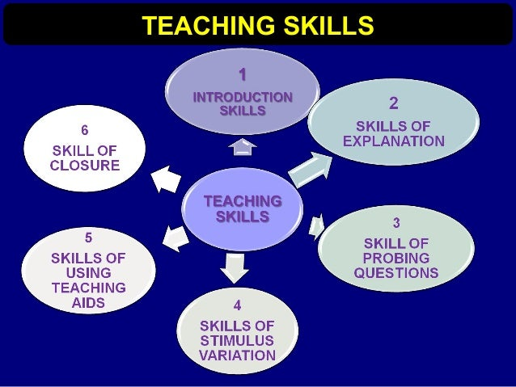

**Fig. 2.** Various Teaching Skills of Teacher

Various teaching skill of a teacher, which he used for his overall development shown in figure 2. Basic characteristics of an effective teacher include "knowledge of the subject matter, motivation for learning, awareness of student differences, planning the teaching process, knowing and using teaching-learning strategies, designing learning environment, effective communication, and objective evaluation." In this paper, teachers' teaching skills are discussed, including "planning the teaching process, offering variety, using the instruction time effectively, creating a participatory learning environment, monitoring the development of the students and ensuring the student’s self-control."

1. **Strategies of the teaching process:**

Planning includes selecting instructional strategies, practices, and evaluation tasks, as well as developing learning experiences to meet predetermined objectives. Annual plans are important for instructors, according to Burden and Byrd (1994), and creating semester, unit, weekly, and daily plans serve as a roadmap for figuring out what to teach when. Given that every student has a distinct style of thinking and a variety of interests, it is the duty of educators to plan and arrange educational activities. Morrison, Ross, and Kemp (2004) state that planning include figuring out how long it will take the student to master the essential material, where the instruction will take place, and how the students' progress in learning will be assessed. Planning is the instructors' primary duty since it plays a major role in the instructional process. Most of the disciplinary issues arise when teachers are unable to start their class as anticipated. Therefore, having well-designed lesson plans is crucial to the teaching process's success.

**(b) Options in teaching:**

One of the key elements that makes teaching monotonous and contributes to classroom disciplinary issues is monotony. When a teacher delivers the same lesson every day, uses the same gestures, facial expressions, or tone of voice, or asks comparable questions, there is a risk of monotony developing in the classroom. Verbal communication is "a method of carrying out the exchange of emotions and opinions" in the classroom. Additionally, "body language (nonverbal communication), which is effective in initiating, resuming, and ending a communication process and which complements verbal communication" should be used by a successful teacher to engage the students and diversify teaching approaches, class formation, and types of assignments (Hotaman, 2005). In addition to effectively communicating with the kids, a teacher needs also be a good listener. Students who get instruction in this way are able to feel more emotionally secure.

**(c) Effective instruction time:**

Making the most use of the instructional time allotted is one of the main goals of classroom management. The quantity of learning will always rise if more time is spent receiving direct instruction. For the purpose of making the most of the time allotted, behavior modification programs for these unanticipated student behaviors have to be provided to all teachers. Within the allotted class time, the pupils must to be able to grasp the lesson's objectives. Additionally, the time allotted for the stated objectives must to be enough. Effective use of instructional time is essential for other skills to function well, and teachers may avoid a lot of difficulties by maintaining order and strong classroom management (Jones, 2000).

**(d) Development of teaching-learning environment:**

To learn, that is, for a lasting change in behaviour brought about by experience, students must actively engage in the teaching-learning process. A good educator actively engages his pupils in the process of teaching and learning. The democratic classroom management system is mandated by both societal ideology and educational framework, since education fosters the development of a sound personality that aligns with democratic values. While involving the kids in the lecture, teachers in a democratic classroom do not incite disobedience. The instructor includes the students in choosing what will be studied in the classroom, just as they do when creating the rules.

**(e) Development and monitoring of the students:**

A good teacher keeps a close eye on how well their pupils comprehend and react to new material. When a teacher finds gaps in the students' knowledge, he fills in the gaps and fixes the errors. Receiving feedback on the students' progress is made possible through the evaluation of the teaching-learning process. Feedback has the following effects: it directs, inspires, and reinforces (Sönmez, 2007). Even kids in the same age range don't always have the same requirements, interests, or rates of development. It is therefore unrealistic to anticipate that every kid would perform at the same level across the board in every activity. A youngster with developmental disabilities may feel compelled to act differently from his peers. If this circumstance is made fun of, it makes the kids lose confidence, which has a detrimental effect on their ability to study.

**(f) Confirmation of the student’s self-control:**

Three different sources are necessary for children to develop self-control: good feelings toward themselves and others, the ability to distinguish between right and wrong, and different approaches to problem-solving. While some techniques focus on prevention, some on remediation, and still others on developing plans for change, all of them give parents a constructive and successful approach to child discipline. Nowadays, it's crucial to learn how to study. A person with self-control may prepare for his future or job, as well as lead and supervise oneself.

**3.4 The personality traits of the teacher for transforming the education:**

According to some opinions, the teacher's personality is the most significant factor in the classroom (Sönmez, 2007). Numerous research on instructors have demonstrated that students respond positively to professors who possess a sufficient personality, whereas pupils who lack a sufficient personality get alienated from their education or even from learning itself. A teacher's educational qualities are assessed based more on his true nature than his actions. Teachers' personalities have a lot of effects on their pupils. All of the components of a teacher's personality have an impact on students and a positive classroom environment. Once a great classroom environment is established, the effects of the teacher's personality continue to affect students even outside of the classroom.

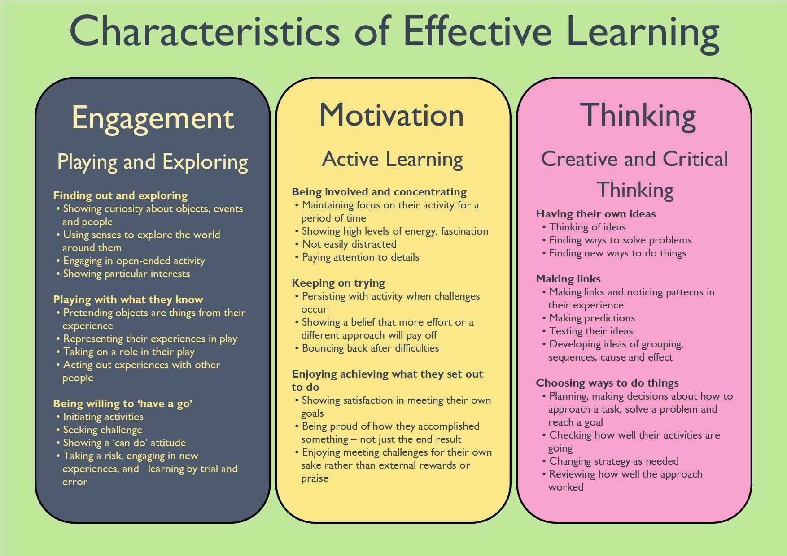

**Fig. 3.** Characteristics of effective teaching and learning process

There are various characteristics of effective teaching and learning process shown in figure 3 used by teacher. Studies reveal that attentive, kind, understanding, and amusing teachers who pay attention to their pupils have a greater favourable impact on their learning and attitudes than do teachers who lack these attributes. While nervous and insecure instructors worry about their students' feelings toward them, direct, self-assured teachers who are at peace with themselves welcome other viewpoints, are tolerant, and promote student engagement and interaction. Friendly instructors have been proven to have more creative and scientifically oriented students. Instructors with these kinds of personalities assist their pupils emotionally. Personality qualities including tolerance and patience, open-mindedness, flexibility and adaptability, affection, understanding, and humour, success expectations, and encouragement and support are discussed in this work.

1. **Being kind, understanding, and Humorous:**

Students' personality development and their maturation into self-assured, sociable people are greatly influenced by affection. Pupils who adore their instructors thrive because they have favourable attitudes toward learning and the school. Relationships that are constructive and encouraging are built between pupils and loving teachers. A light-hearted instructor makes the classroom a welcoming and pleasurable place to be. Humour breaks down barriers and shortens the gap between educators and learners. Teachers and students have a strong relationship. Lessons start to become more comfortable and fun. pupils will think positively if their instructor is patient, understanding, and honest; on the other hand, if the teacher acts in an inconsistent manner, the pupils will react negatively.

**(b)Tolerance and patience:**

School-age children sometimes exhibit a great deal of bad behaviour in the classroom because they struggle to understand right from wrong and want to show themselves. In this instance, the instructor ought to be understanding and patient with some of the pupils' inappropriate behaviour. Teachers that are kind and gentle with their pupils might influence their behaviour. It is crucial that educators accept divergent, uncommon, and conflicting viewpoints from their students in addition to unexpected behaviour.

**(c) Being open-minded, flexible, and adaptable:**

Teachers must possess these qualities in order to better themselves and their pupils in today's cultures, when social change is accelerating and science and technology are making significant strides. Teachers who exhibit these qualities are aware that their thoughts, feelings, and perceptions may differ from those of other individuals. They are able to view circumstances from many angles. Using unforeseen circumstances in addition to the scheduled activities is associated with the adaptable personality attributes of the instructor.

**(d) High expectations for success:**

There is a strong correlation between teachers' expectations for their pupils' achievement and those of the students themselves. It may be argued that instructors become more aware of the teaching process when they hold high expectations for their students' achievement. They make time for them, support their learning, and have faith in their ability to learn. Additionally, a student who perceives that his teacher has high expectations for him will succeed and form a favourable academic self-concept. To put it another way, pupils learn the amount that their lecturers anticipate them to. Actually, research indicates that a teacher's expectation of their pupils has a big impact on how well those students do. Students that urge their teachers to review their notes, knowledge and methods should choose teaching profession.

**(e) A democratic personality:**

Individuals needed by today's cultures are trained in settings that emphasize freedom, democracy, self-assurance, and accountability. Since teachers are the central component of the educational system, they bear this obligation in the classroom. The teacher should, above all, be a believer in human rights, the virtue of democracy, and the inevitable existence of diversity. Participation in the democratic classroom environment's planning, practice, monitoring, and evaluation procedures should serve as the foundation for everything. It is simpler for students to understand, follow, and share responsibility for the rules when they establish the rules for the classroom together. It is simpler for students to understand, follow, and share responsibility for the rules when they establish the rules for the classroom together. According to Dewey, schools are institutions built on balance, transparency, and simplicity. Because of these qualities, students are able to transform their surroundings and form connections with one another in a democratic and true (open) manner.

**(f) Being upbeat and encouraging:**

A helpful instructor makes sure that the pupils are independent learners, confident in their abilities, and have a positive academic self-concept (Erden, 2007). Studies have shown that providing pupils with encouragement and support not only improves their academic performance but also lessens disruptive behaviour and disciplinary issues.

1. **Conclusion:**

The global patterns covered in this article may be the cause of the uniformity of curriculum, instruction, and testing around the globe. National policy makers are being influenced by global educational discourses on human capital education, lifelong learning, and the information economy. According to research, the majority of IGOs and NGOs, particularly the World Bank and OECD, also fund educational initiatives related to the development of human capital and the knowledge economy. The majority of international organizations prioritize gender equality in education. International comparisons of TIMSS and PISA results attest to the uniformity of curriculum throughout the world. The creative and scientific characteristics of the teaching profession are defined by subject-matter knowledge, instructional techniques, and personality attributes that are necessary for education to achieve its objectives. In addition to adopting the position of a scientist and behaving like an artist, educators should also include the qualities of an artist into their design of the learning environment, incorporating elements such as elegance, beauty, understanding, tolerance, and affection. Teachers have a heavy burden of decision-making over what to do and how to accomplish it, as well as for maintaining and expanding their professional knowledge and abilities. Therefore, the field of teacher training ought to be one where critical knowledge and effective teaching techniques may be directly applied, where inquiries are constantly made, analyses and experiments are conducted, and so on.

**REFERENCES:**

1. Z. Bauman, On glocalization: or globalization for some and localization for some others, Thesis Eleven, Volume 54, 1998, P. 37-49.
2. R. F. Amove and C. A. Torres (Eds.), Comparative education: The dialectic of the global and the local (2nd ed.). Lanham, MD: Rowman & Littlefield, 2003.
3. N. Stromquist, Education in a globalized world: The connectivity of economic power, technology, and knowledge. Lanham, MD: Rowman & Littlefield, 2002.
4. R. Dale and S. Robertson, Editorial. Introduction. Globalisation, Societies and Education, Volune1, Issue1, 2003, P. 3–11.
5. K. Anderson-Levitt, A world culture of schooling? In K. Anderson-Levitt (Ed.), Local meanings, global schooling: Anthropology and world culture theory (P. 1–26). New York: Palgrave Macmillan, 2003.
6. R. Dale, Globalisation, knowledge economy and comparative education. Comparative Education, Volume 41, Issue 2, 2005, P.117–149.
7. S, Marginson, and E. Sawir, Interrogating global flows in higher education, Globalisation, Societies and Education, Volume 3, Issue 3, 2005, P. 281–309.
8. P. Brown, and H. Lauder, Globalization, knowledge and the myth of the magnet economy, Globalisation, Societies and Education, Volume 4, Issue1, 2006, P. 25–57.
9. T. Monahan, Globalization, technological change, and public education. New York: Routledge, 2005.
10. S. Carney, Globalisation, neo-liberalism and the limitations of school effectiveness research in developing countries: The case of Nepal. Globalisation, Societies and Education, Volume 1, Issue1, 2003, P. 87–101.
11. D. Baker, and G. LeTendre, National differences, global similarities: World culture and the future of schooling. Palo Alto, CA: Stanford University Press, 2005.
12. J. Spring, Pedagogies of globalization: The rise of the educational security state. Mahwah, NJ: Lawrence Erlbaum, 2006.
13. M. Lawn, From responsibility to competency: A new context for curriculum studies in England and Wales. Journal of Curriculum Studies, Volume 22, 1990, P. 388-392.
14. D. G. Meiser, Teachers and change: Examining the literature. Paper presented at the annual meeting of the American Educational Research Association, New Orleans, LA, 2002.
15. A. Hargreaves, Classrooms, colleagues, and change: The sociology of teaching at the turn of the century. Asia-Pacific Journal of Education and Development, Volume 4, 2001, P.101-129.
16. M. Erden, (Introduction to teaching profession), 2007.
17. P. R Burden, and D. M. Byrd, Methods for effective teaching. Massachusetts, 1994.
18. G. R. Morrison, S. M. Ross, and J. E. Kemp, Designing effective instruction. New York: John Willey & Sons Inc, 2004.
19. D. Hotaman, (The Degree of Body Language Use in Primary School Teachers), XIV. 28-30 Eylül, Denizli, 2005.
20. S.C. Jones, Classroom management strategies. New York: John Wiley& Sons, Inc. 2000.
21. V. Sönmez, (Teaching principles and methods), 2007.