A TRANSFER LEARNING APPROACH FOR FAKE NEWS IDENTIFICATION BASED ON MULTI MODEL NEURAL NETWORKS

**AMRIT SINGH1, Dr. PRAMOD KUMAR2**

**1** M.Tech Scholar,Ganga Institute Of Technology & Management Kablana Jhajjar,India

*Amri.javaexpert@gmail.com*

2 Assistant Professor, Ganga Institute Of Technology & Management Kablana Jhajjar,India

[pramod.gill1@gmail.com](mailto:pramod.gill1@gmail.com)

## **ABSTRACT**

Effective fake news detection systems are becoming critical as a result of inaccurate data spreading on the internet. This research presents a unique method that combines a multi-model neural network architecture with a transfer learning framework to detect bogus news. The paper's first section gives a overall summary of the false news recognition issue, highlighting the social implications of the issue and the difficulties in identifying real information from phoney. The limits of traditional methods for detecting false news are explored, along with how well they handle emerging forms of disinformation.

The suggested approach makes use of transfer learning, a strategy that makes use of information learned from a basis domain to enhance performance in a target domain with a dearth of labelled data. Here, a neural network model that has already been qualified on a large corpus of generic text data is refined using a smaller, labelled dataset that is tailored to the identification of false news. The research also presents an architecture of multi-model neural networks intended to extract various aspects from textual, visual, and metadata sources related to news stories. This design combines many neural network submodels, each of which is an expert in extracting distinct information modalities pertinent to the identification of bogus news.

Through fine-tuning on the labelled dataset, the pre-trained multi-model neural network is adjusted to the target false news detection task as part of the transfer learning process. By doing this, the model may take use of the information included in the pre-trained parameters and learn domain-specific patterns that are suggestive of false news. Results from experiments on benchmark datasets show how well the suggested method works to detect bogus news items. Superior presentation is shown in terms of precision recall, and total classification accuracy in comparison with current approaches.

The study also addresses possible real-world applications and pragmatic issues of the suggested transfer learning paradigm. It emphasises the method's versatility and scalability across several languages and disciplines, highlighting its potential for use in social media networks and online platforms to counter false information.

**Key Words:** Transfer Learning, Fake News Identification, Multi-Model Neural Networks, Deep Learning, Natural Language Processing (NLP), Machine Learning

# INTRODUCTION

The speedy advancement and widespread accessibility of Fake news technology have created significant concerns and challenges in various domains. Detecting and mitigating the threats posed by Fake news is essential for safeguarding truth, privacy, and cybersecurity. The motivations for developing effective Fake news detection techniques are manifold and urgent, as outlined below:

**a) Safeguarding truth and authenticity**

The proliferation of Fake news [1] poses a fundamental challenge to the integrity of visual information, making it increasingly difficult to distinguish genuine content from manipulated or fabricated material. Fake news detection methods play a crucial role in restoring trust in digital media and preserving the authenticity of visual evidence. By developing robust and reliable algorithms, we can accurately identify manipulated content and prevent the dissemination of deceptive narratives.

**b) Preventing misinformation and disinformation**

Fake news have the potential to propagate false narratives, manipulate public opinion, and fuel campaigns of misinformation. The development of effective Fake news detection techniques is essential for countering the spread of fabricated content. By accurately detecting and exposing Fake news, we can prevent the manipulation of information and protect the public from being misled by malicious actors.

**c) Protecting individuals' privacy and reputation**

With the increasing accessibility of Fake news technology, individuals are at a higher hazard of dropping victim to identity theft, revenge porn, or character assassination through the creation and distribution of highly realistic fake videos or images. Robust Fake news detection algorithms are critical for empowering individuals to protect their privacy and reputation. By enabling the identification and mitigation of Fake news attacks, we can provide individuals with effective tools to safeguard their digital identities.

**d) Enhancing Cybersecurity and online safety**

Fake news not only pose risks in terms of misinformation but also have the potential to be utilized for more nefarious purposes, including phishing attacks, social engineering, and fraud. Developing sophisticated Fake news detection methods can strengthen cybersecurity systems and enhance online safety. By efficiently identifying deep fake-based threats, we can proactively defend against malicious activities and prevent potential harm to individuals, organizations, and critical infrastructures.

Our study emphasises the application of transferable ideas in fake news identification in order to overcome these incentives. To extract high-level features from images, transfer learning [2] makes use of pre-trained models that have been developed on massive datasets like ImageNet [3]. We can improve the efficiency of fraud identification, quicken the training process, and boost accuracy by utilising the knowledge gained from these pre-trained models.

We can adapt the pre-trained models to the task of false news identification by fine-tuning them using deep fake-specific datasets. Through this knowledge transfer, we may specialise in the model to identify the distinctive traits and artefacts connected to fake news, while also taking advantage of the learnt representations. The amount of time and computing power needed to train a fake news detection model from scratch can be decreased by using transfer learning.

Furthermore, transfer learning helps us to solve the issues given by limited labeled data efficiently. Fake news datasets are frequently limited and unbalanced, making correct model training challenging. We may reduce the data scarcity problem by using the information gained by pre-trained models and fine-tuning them on smaller Fake news datasets using transfer learning. Even with less labeled data, we can attain greater accuracy and generalization performance with this strategy.

We hope to illustrate the usefulness of transfer learning in Fake news detection through our study, demonstrating its capacity to boost accuracy, reduce training time, and improve overall efficiency. We can construct robust and reliable Fake news detection models using transfer learning, which will help us meet the goals described above, thereby limiting the hazards presented by Fake news technology and safeguarding the integrity of digital media.

**1.2 OVERVIEW OF FAKE NEWS AND THEIR POTENTIAL IMPACT**

Fake news are a fast-growing technology with a wide range of applications. The entertainment sector is one of the major uses of Fake news. Fake news allow actors who have died to be reproduced in films and television programs, bringing up news avenues for narrative. Fake news may also be used to produce realistic special effects and visualizations in films and video games. Fake news are a sort of AI-generated material that employs machine learning algorithms to create realistic-looking but fake photos, videos, and audio recordings. These algorithms employ a process known as "deep learning," in which enormous volumes of data are fed into neural networks, which afterwards acquire the ability to replicate the original data in news reports.

Fake news are created by training neural networks using a vast collection of pictures, videos, and audio recordings of the target person or item. After being taught, the neural network may create news information that is similar to the original data. For example, in the instance of Fake news films, the neural network may be trained to replace the face of one person in a video with the face of another. The resulting video is a Fake news in which the target individual looks to be doing or saying something they never actually did.

Fake news can be used in marketing and advertising to produce personalized content that looks to include the target customer. This can increase ad interaction and boost the efficacy of marketing initiatives.

Fake news are also employed in academic and scientific contexts to recreate real-world events that would be too expensive, hazardous, or time-consuming to carry out in real life. Fake news, for example, may be used to model city traffic patterns or natural disasters in order to better understand how people and systems react in these scenarios. However, the possibility of Fake news being utilized for nefarious reasons is a major worry. Fake news may be used to disseminate misinformation, sway public opinion, and even perpetrate fraud or blackmail. As a result, there is an urgent need for Fake news recognition algorithms to mitigate the undesirable influences of Fake news.

Fake news have the potential to have a tremendous influence on our civilization. Fake news may be used to propagate misleading information and affect public opinion since they are difficult to differentiate from genuine material. Fake news, for example, may be used in politics to produce fake recordings of political figures making contentious comments or indulging in unethical behavior. These films have the potential to sway public perception and impact electoral outcomes. Fake news may be utilized in the entertainment industry to build accurate digital reproductions of deceased performers for use in films or television shows. Fake news may be used to harass, libel, or humiliate someone on social media. Fake news are difficult to detect owing to their superior technology and ability to trick human perception. Fake news may be made to appear and sound extraordinarily lifelike, making them impossible to tell apart from genuine footage. Fake news may also be made rapidly and cheaply, making them available to everyone with a computer and an internet connection.

The absence of large-scale, high-quality datasets for training Fake news finding models is one of the key obstacles in Fake news detection. This is because Fake news are a very news technology, and obtaining huge volumes of high-quality Fake news data for training purposes might be challenging. Another problem is the requirement for fast and effective Fake news detection algorithms capable of keeping up with the continuously growing technologies used to construct Fake news. Fake news detection algorithms must be updated as news approaches are discovered to stay up with the newsest trends in Fake news development.

To summarise, Fake news are a strong developing technology with numerous uses, but they also offer substantial societal hazards. Fake news detection is a significant issue that necessitates the development of improved detection systems capable of keeping up with the ever-changing technologies used to make Fake news. Overcoming the obstacles involved with Fake news identification is critical for preventing the detrimental impacts of Fake news and protecting our society's integrity. To overcome these issues, scholars and developers are working on a variety of Fake news detection algorithms. One method is to train machine learning models on massive datasets of actual and Fake news videos and images in order to uncover patterns that differentiate between real and fake material. Another way is to look for anomalies in Fake news movies, such as odd facial expressions or movements, which betray the video's artificial character.

However, as Fake news technology evolves, so must detection systems. Adversarial machine learning can be applied to enhance Fake news detection as well as Fake news generation. This entails teaching machine learning models to detect and defend against adversarial assaults, which are strategies designed to fool the models into misclassifying the material. Fake news detection systems must be developed in order to safeguard people and society from the detrimental impacts of Fake news. Governments and technology corporations must invest in and develop these technologies, as well as raise public awareness of the hazards of Fake news. We can prevent the undesirable effects of False news and guarantee that this emergent technology is handled ethically and responsibly with the correct tools and education.

# OBJECTIVES

* To present a novel strategy to Fake news detection that integrates InceptionResNetV2[7], Vision Transformer [8], and the Nyström Attention mechanism [9] to obtain cutting-edge results on hard datasets such as Celeb DF v1[5], Celeb DF v2[5], and DFDC[9].
* To estimate the proposed approach against existing state-of-the-art methods such as MesoNet[10], XceptionNet[11], and EfficientNet[12], and demonstrate its superiority.
* To analyze the effectiveness of feature extraction and classification methods in Fake news detection.

# LITERATURE REVIEW

Table.1 An overview of nearly every of the data sets, methods, and information that are accessible to anyone.

|  |  |  |  |
| --- | --- | --- | --- |
| **Data set Name** | **Year** | **Method Used** | **Content** |
| HOHA-based [13] | 2018 | Films are gathered from websites that broadcast videos. | It includes 300 movies that were selected at accidental from the HOHA dataset in addition to 300 fakes from websites that stream videos online. |
| FaceSwap-GAN [14] | 2019 | “Using Face Swap GAN” | It has 200 frames per video, with 320 LQ (64x64 pixels) and 320 HQ (128x128 pixels) available. |
| UADFV [15] | 2018 | Making use of the FakeApp mobile app | It has 49 fictitious and 49 authentic videos, with Nicolas Cage's visage in place of the real. |
| Face Forensics [16] | 2018 | The Face2Face reenactment technique and the Self-reenactment method are used to split the dataset into two halves. | 1004 movies using a ground truth mask and at least 300 frames per second in an 854x480 resolution |
| Face Forensics++ [17] | 2018 | Face manipulation Methods include Face2Face, FaceSwap, Neural Textures, and Fake News. | It includes a thousand carefully chosen FullHD, HD, and VGA YouTube videos in addition to a thousand FaceSwap and a thousand Fake News films. |
| Fake Face in the Wild (FFW) [18] | 2018 | GANs, CGI, manual and automatic manipulation, and various combinations were used as techniques.  to produce this. | It includes 150 YouTube videos, ranging in duration from 2 to 74 seconds and with a resolution of 854 x 480 pixels. The films are converted into 53000 photos. |
| DFDC preview [6] | 2019 | produced using a diversity of non-learned, GAN-based, and fake news methods  . | It includes over 5000 videos with 66 actors' altered face likenesses (1131 genuine and 4119 false). |
| Real and Fake Face Detection (Kaggle)1 | 2019 | Expert generated imaged | It has 960 fake and 1081 genuine 600x600 pixel news photos. |
| Celeb-DF[5] | 2020 | developed using an enhanced Fake News Synthesis Algorithm | Eighty-nine genuine YouTube videos with a period of around 13 seconds and 400 borders per second are mixed in with 5639 high definition false videos featuring 59 celebrities. |

# METHODOLOGY

**BACKGROUND OF TECHNIQUES USED IN THE PROPOSED METHODOLOGY**

**MTCNN (Multi-task Cascaded Convolutional Networks)**

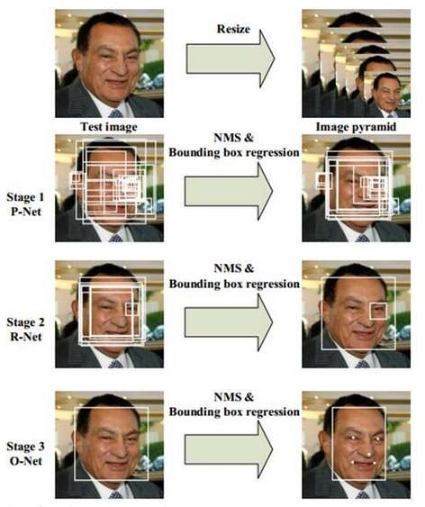

Fig.4.1 Visualization of working of each stage of MTCNN used in the study conducted by Xiang et al.

2017

MTCNN (Multi-task Cascaded Convolutional Networks)[36] is a deep learning model for face detection and alignment. It was introduced in a research paper in 2016 by Zhang et al. and has since become a widely used model in the computer vision community. Three phases make up the MTCNN face detection model: the suggestion network (P-Net), the improvement networks  and the output network. Convolutional neural networks  are used in each step of the face identification process to carry out certain tasks. (As seen in Fig.4. 2)

First, the P-Net applies a multi-scale pyramid to the input picture and uses a sliding window technique to scan the image for coarse face detection. A collection of potential bounding boxes for faces and the associated probability scores are produced by the P-Net. Using more accurate bounding box regression and deleting false positive detections, the R-Net improves the bounding boxes produced by the P-Net in the second stage. To categorise the faces in the bounding boxes as either faces or non-faces, the R-Net further employs a CNN.

In the last step, the O-Net refines the bounding boxes and generates facial landmarks (e.g., the location of the mouth, nose, and eyes) for each recognised face. In addition, the O-Net forecasts the age range of the identified faces and labels them as male or female. The MTCNN model is trained on an enormous dataset of annotated faces and non-faces. The training process involves minimising a loss function that evaluates the discrepancy between each input image's ground truth annotations and the network's predicted output.

Cutting-edge results on a range of face detection benchmarks, such as the FDDB and WIDER FACE datasets, have been shown with MTCNN. It is frequently used in many different applications, such as facial expression analysis, tracking, and face recognition. Its ability to identify tiny and partly veiled faces makes it an invaluable tool for real-time video analysis and surveillance systems.

**InceptionResNetV2**

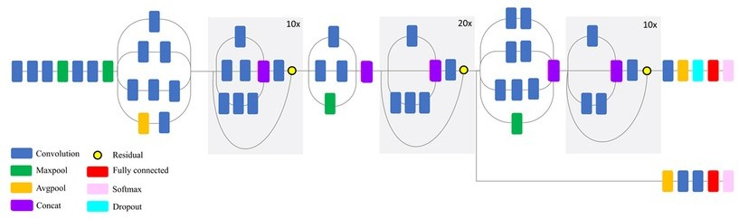

Fig.4.2 Compressed Visualization of InceptionResNetV2 used in the study by Mahdianpari et al.

InceptionResNetV2[7] is a deep learning model that has shown strong performance on a variety of image arrangement responsibilities. It combines the Inception architecture, which uses multiple convolutions with different filter sizes, with residual connections that allow for better information flow between layers. In Fake news detection, InceptionResNetV2 is commonly used for feature extraction due to its ability to capture important visual patterns in images. By leveraging the pre-trained InceptionResNetV2 model and retraining it, the proposed approach for Fake news detection aims to reduce training time and recover accuracy.

The main components of InceptionResNetV2 are:

1. Stem: The first network module that analyses the input picture and extracts the first features. It is made up of three layers: convolutional, pooling, and normalization.
2. Inception ResNet blocks: These are repeated numerous times across the network, and each block comprises multiple parallel routes that process the input characteristics in various ways. The routes inside each block are meant to collaborate in order to extract characteristics at various sizes and degrees of complexity.
3. Reduction blocks: These blocks are used to minimize the feature maps' spatial dimensions while increasing the amount of stations. This is completed to minimize the network's computing cost and enable deeper network designs.
4. Final layers: The network's final layers comprise pooling, dropout, fully linked, and SoftMax layers. These layers are in charge of creating the network's ultimate output, which is the projected class probabilities.

InceptionResNetV2 is well-known for its ability to extract features at many sizes and degrees of complexity, making it a popular choice for many computer vision applications such as Fake news detection.

**Vision Transformer**

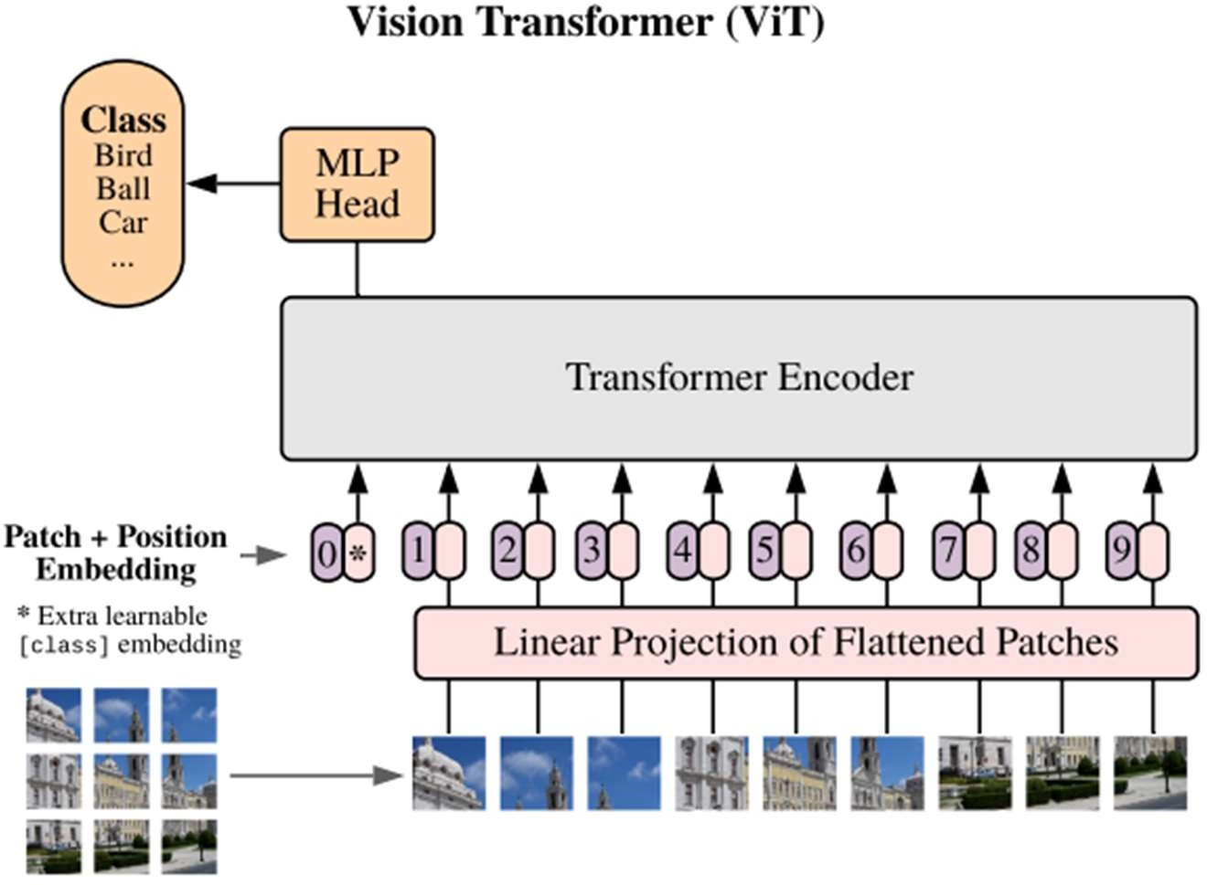

Fig.4.3 Visualization of Structure of the Vision Transformer used in the study by Alexey Dosovitskiy et al.

Vision Transformers, abbreviated ViT[8] is a sort of neural network architecture introduced in 2020 for image categorization applications. It is built on the Transformers idea, which was first presented for natural language processing jobs.

The fundamental idea behind ViT is to interpret an image as a series of patches and then apply the Transformer architecture to these patches to extract features for classification. This is in contrast to typical Convolutional Neural Networks (CNNs), which extract characteristics from the full picture using convolutional layers.

The input image is separated into fixed-size patches in the ViT architecture before being flattened and sent into the Transformer encoder. The Transformer encoder is made up of numerous layers of self attention and feedforward neural networks that process and extract characteristics from patches.

One advantage of the ViT design is that it enables greater scalability and transferability. ViT may employ pre-trained Transformer models for transfer learning since it is built on the Transformer architecture, which is very effective for natural language processing applications. ViT also has the advantage of being able to be trained using only image-level labels rather than pixel-level annotations. This makes training on huge datasets easier and more efficient.

VIT's ability to identify long-term relationships and spatial interactions between patches helps it detect Fake news detection. Small distortions or inconsistencies in the spatial relationships between distinct parts of the picture or video can occur when constructing Fake news, making traditional Fake news detection methods difficult to recognize. By analyzing these correlations with the transformer encoder, VIT can reveal patterns indicative of Fake news development, resulting in more accurate Fake news detection.

The main components of VIT are:

1. Patch Embeddings: Divides input into smaller patches and converts each patch into a vector representation using an embedding layer.
2. Transformer Encoder: employs an array of transformers decoder layers each with a feed-back level and a multi head self-awareness layer to handle patching incorporation.
3. Positional Encoding: Adds a positional encoding to each patch embedding to explicitly encode the positions of the patches in the image or video.
4. Classification Head: Predicts the probability of the input being a Fake news or genuine image/video using a simple feed advancing neural system that earnings the output of the transformer encoder and produces a binary classification output.

**Nyström Attention Mechanism**

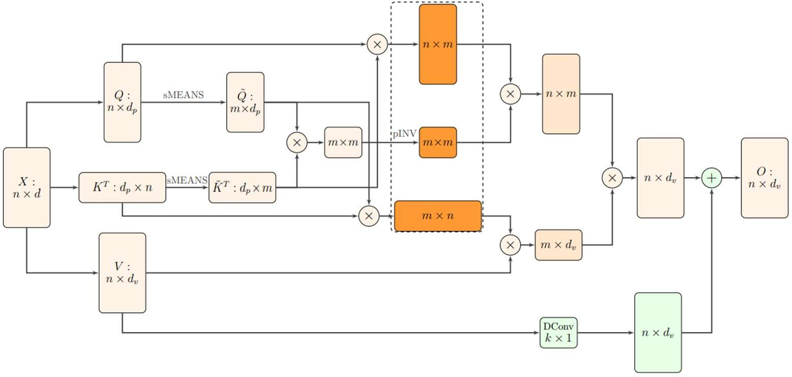

Fig.4.4. Visualization of Efficient self-attention with the Nyström method7: The image displays three orange matrices which correspond to the matrices generated from the key and query landmarks. In addition, there is a DConv block that represents a skip connection, which uses a 1D depth-wise convolution to add the values.

“Nyström Attention Mechanism[38] is a variant of the self consideration mechanism used in the transformer architecture, which uses the Nyström method to approximate the self- attention matrix. The self-attention mechanism in transformers is computationally expensive due to the need to calculate the dot product of all pairs of tokens in a sequence, which leads to a quadratic complexity in the number of tokens. The Nyström method is a technique for approximating a large matrix by a smaller one, which can decrease the computational complication of the self care mechanism.”

The self attention matrix is approximated in the Nyström Attention Mechanism by a low rank matrix generated using the Nyström method. The number of pairwise dot products that must be computed is reduced, resulting in lower computational complexity. The Nyström Attention Mechanism can be employed in vision transformers to detect Fake news by boosting the transformer architecture's performance on huge image datasets. The Nyström Attention Mechanism can also help to limit the danger of overfitting on training data and improve the model's simplification performance.

The basic self-attention technique employed in transformer models has a computational cost that climbs quadratically with sequence length, making large-scale transformer models computationally expensive and memory-intensive. To overcome this issue, the Nyström Attention mechanism approximates self-attention more quickly by sampling a selection of patches from the input sequence and computing attention exclusively between these sampled patches. This technique minimizes self-attention's computational complexity and memory needs, making it more practical for large-scale transformer models like ViT.

In ViT, the Nyström Attention mechanism is integrated into the self-attention layers of the transformer encoder. Rather than computing attention over all patches in the input sequence, the Nyström Attention mechanism randomly selects a subset of patches to attend to, resulting in efficient processing of large images while maintaining high performance on image classification tasks.

**DESCRIPTION OF THE PROPOSED FAKE NEWS DETECTION APPROACH**

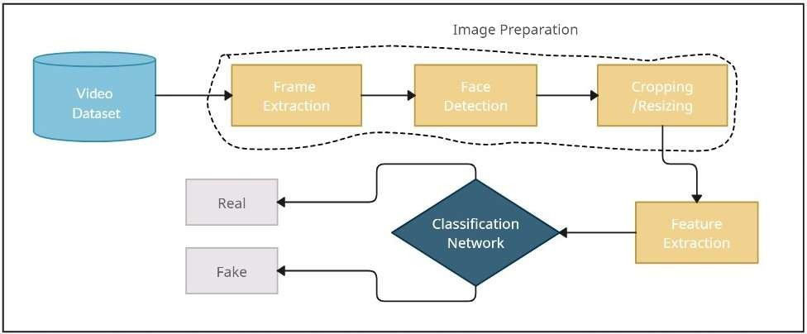

Fig.4.5 The General Flow Diagram of Fake news Detection

As we can see in Fig4.5 ., the main component of Fake news Detection:

1. **RESULT**

**DATASET DESCRIPTION**

Three dissimilar datasets were used to train and assess the Fake news detection model in this study. CelebDFv1, CelebDFv2, and DFDC datasets were used.

The CelebDFv1 dataset contains a total of 5,639 movies, 1,100 of which are Fake news and 4,539 of which are real. The videos range in resolution and are divided into categories such as chatting, singing, interviewing, and so on.

CelebDFv2 is an expansion of CelebDFv1 and comprises a total of 5,639 videos, 2,000 of which are Fake news videos and 3,639 of which are real footage. The videos range in definition and are divided into categories such as chatting, singing, and others.

The DFDC dataset comprises many Fake news films created using various deep- learning algorithms. A subset of DFDC, DFDC_train_18, with a total of 2,883 videos, was used for this project. There are 458 real films and 2,425 Fake news, accounting for 84.16% of the dataset. The videos have a resolution of 1080x1920 and are divided into categories such as chatting, singing, interviewing, and so on.

We plotted various graphs to gain a better understanding of the datasets before starting our work. The graphs included:

* + 1. Class Distribution: To understand the balance of the datasets and to guarantee that we had a sufficient amount of both actual and Fake news movies, we plotted the number of real and Fake news videos in each dataset.
    2. Count Plot of Resolution: To understand the resolution distribution of the datasets, we created a count plot of the resolutions of the movies in each dataset. This allowed us to determine whether the videos had similar resolutions or if there were any outliers.
    3. Count plot of length: To understand the length distribution of the datasets, we drew a count plot of the duration of the films in each dataset. This allowed us to determine whether the films were of comparable length or whether there were any outliers.

**CelebDFv1**

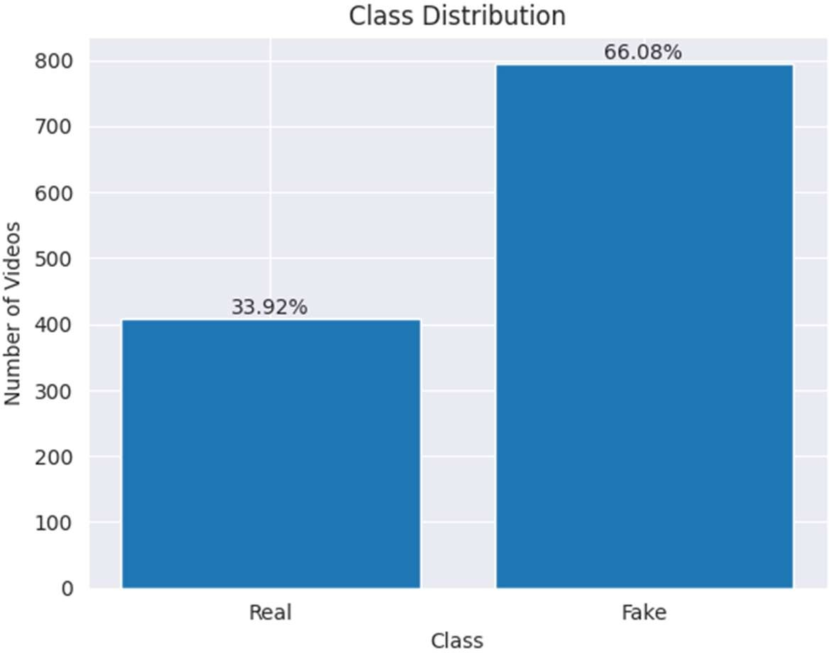

Fig.4.6. Class Distribution Plot of CelebDF-v2

***Observation:*** The class distribution plot (in Fig. 8.) for CelebDFv1 showed that approximately 33.92% of the videos were real while 66.08% were fake. This indicates that the dataset is heavily skewed toward fake videos. This could potentially impact the presentation of any model competent on this dataset as it may not generalize well to real-world scenarios where the proportion of real to fake videos is likely to be more balanced. Therefore, appropriate measures need to be taken to address this class imbalance issue, such as data augmentation techniques or adjusting the loss function during training.

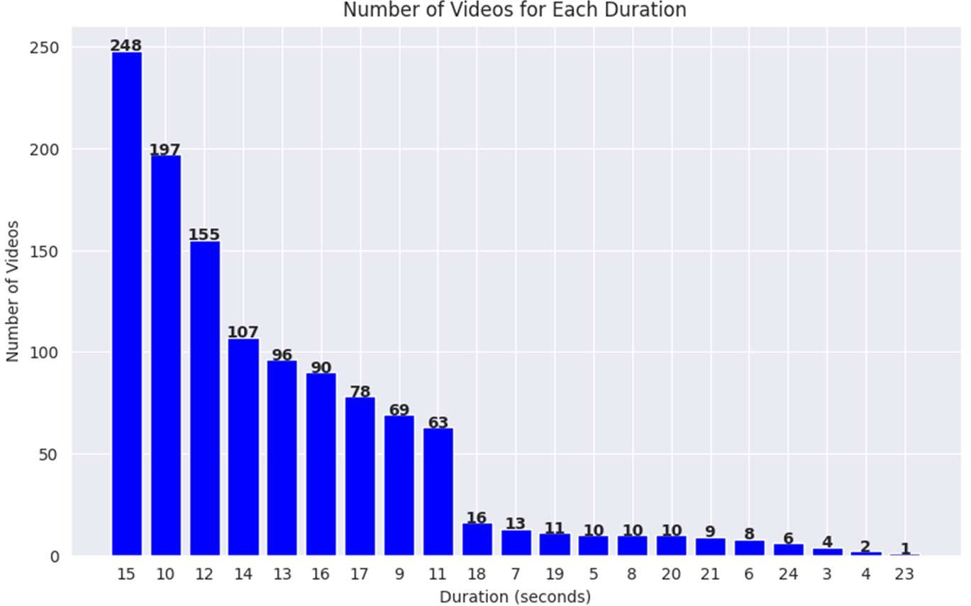

Fig.4.7. Count plot of durations of all the videos

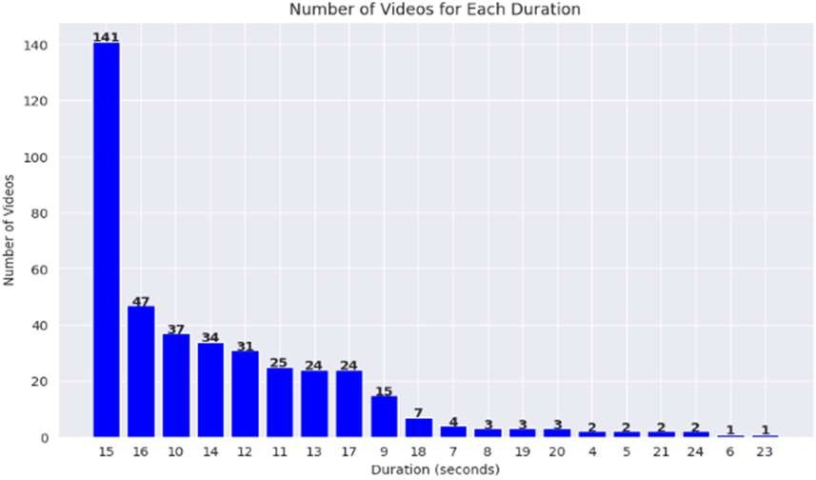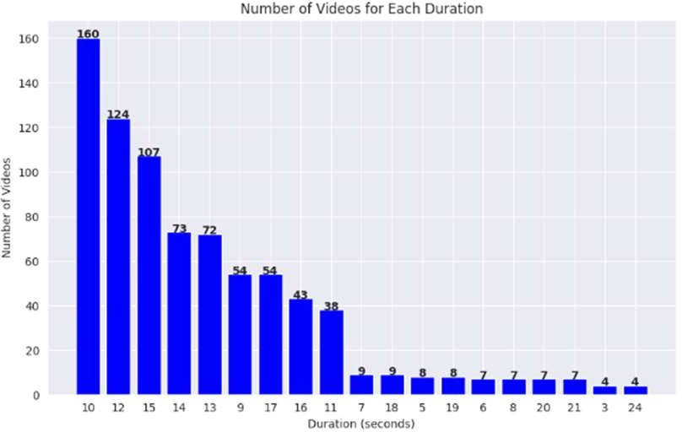

* + - 1. (ii)

Fig.4.8 Count plot of durations of real videos (i) and fake videos (ii)

Observation: The analysis of the duration count plot for together actual and false videos revealed that there is a important alteration in the circulation of duration among real and fake videos. Real videos had a maximum duration of 15 seconds, whereas fake videos had a maximum duration of 10 seconds. The max. of videos in the dataset had a period of 15 seconds, followed by 10 and 12 seconds.

The information about the distribution of duration in the dataset could be helpful in determining the optimal duration for Fake news detection models. It could also aid in identifying potential outliers in the dataset that might need to be removed during preprocessing. Additionally, the observation highlights the need for differentiating real and fake videos based on factors other than duration alone.

We have a diverse range of resolutions in the CelebDFv1 dataset, so we binned them into different categories for better analysis. The binning was done as follows:

* Poor Quality: resolution less than or equal to 480 pixels in width or height
* Medium Quality: resolution greater than 480 pixels but less than or equal to 720 pixels in width or height
* High Quality: resolution greater than 720 pixels but less than or equal to 1080 pixels in width or height
* Ultra-High Quality: resolution greater than 1080 pixels in width or height

This allowed us to plot a count plot of the distribution of videos across different resolution categories.

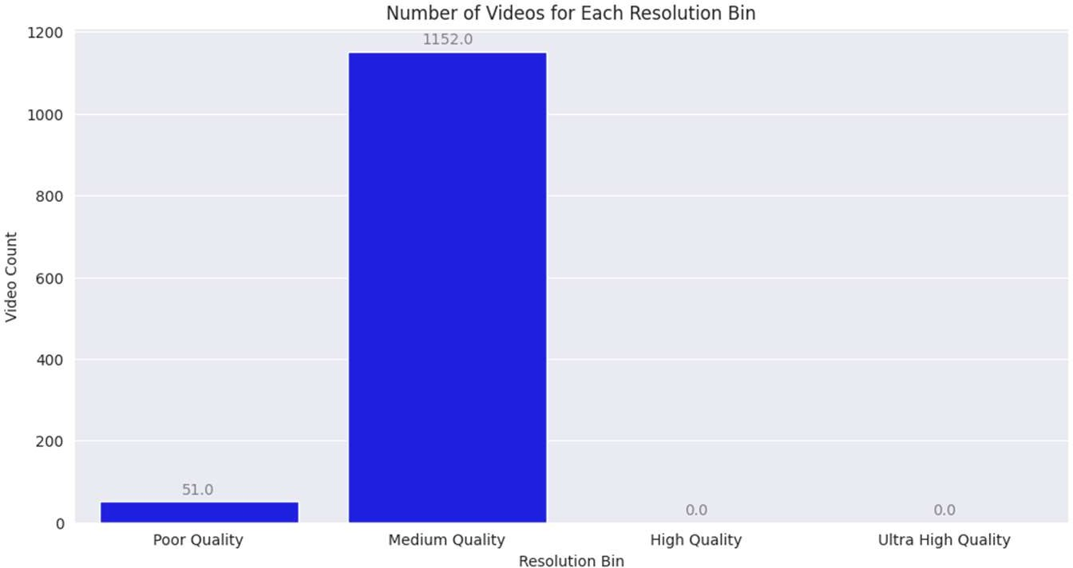

Fig.4.9. Count plot of resolution of all the videos

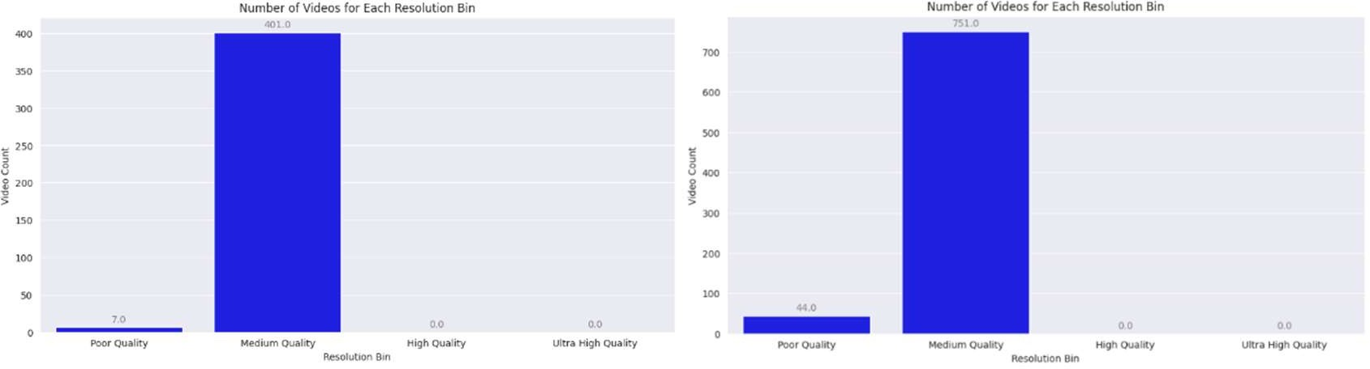

(i) (ii)

Fig.4.10 Count plot of resolution of real videos(i) and fake videos(ii)

1. **CONCLUSION**

The accuracy and robustness of fake news detection systems may be improved by combining InceptionResNetV2 with vision transformers and the Nyström attention mechanism. Sophisticated deep learning model InceptionResNetV2 is resistant to picture noise, distortions, and occlusions that are common in fake news photographs since it gathers features of various sizes and orientations. Because it has been pre trained on large datasets like ImageNet, transfer learning is possible, and less training data is needed to achieve high accuracy on news tasks like fake news detection. Because InceptionResNetV2 has few parameters, it is computationally efficient and suitable for real-time applications including the identification of fake news. In contrast, vision transformers can detention long range dependances and interactions among dissimilar areas of an image by using the self-attention process to extract highly discriminative characteristics from raw picture data.

Large transformer model training computational costs are reduced using the Nyström approximation, which calculates the self-attention process quickly. In our tests, we were able to identify deep fakes with an accuracy of 97.10%, an AUC of 0.9868, a precision of 97.53%, and a recall of 99.21% using the suggested technique on the DFDC dataset. The suggested approach's superior performance and efficiency make it a viable option for real-world implementation.

In conclusion, the proposed approach using a combination of InceptionResNetV2 and Vision Transformer with Nystrom Attention mechanism has demonstrated state-of- the-art performance on three different datasets, namely DFDC, CelebDFv1, and CelebDFv2. The approach has achieved high accuracy exactness, recall, and F1 score, and also outperformed other state-of-the-art techniques such as EfficientNetB4, EfficientNetB7, XceptionNet, NASNetLarge, and ResNet50.

This study's significance lies in the development of a highly accurate and reliable Fake news detection approach, which is crucial for identifying and mitigating the harmful effects of Fake news videos on society. The proposed approach's potential impact is immense, as it can be used by various organizations, including social media platforms, news agencies, and governments, to detect Fake news videos and take appropriate measures to avoid the spread of misinformation and propaganda. Additionally, the approach's architecture and methodology can also be applied to other related fields, such as image and speech recognition, and could lead to the expansion of even extra correct and strong deep learning models.

1. **REFERENCES**
2. T. T. Nguyen *et al.*, “Deep learning for Fake news creation and detection: A survey,” *Computer Vision and Image Understanding*, vol. 223, p. 103525, Oct. 2022, doi: 10.1016/j.cviu.2022.103525.
3. A. Hosna, E. Merry, J. Gyalmo, Z. Alom, Z. Aung, and M. A. Azim, “Transfer learning: a friendly introduction,” *J Big Data*, vol. 9, no. 1, Dec. 2022, doi: 10.1186/s40537-022- 00652-w.
4. J. Deng, W. Dong, R. Socher, L.-J. Li, Kai Li, and Li Fei-Fei, “ImageNet: A large-scale hierarchical image database,” in *2009 IEEE Conference on Computer Vision and Pattern Recognition*, IEEE, Jun. 2009, pp. 248–255. doi: 10.1109/CVPR.2009.5206848.
5. R. S. Siva Kumar *et al.*, “Adversarial Machine Learning-Industry Perspectives,” in *2020 IEEE Security and Privacy Workshops (SPW)*, IEEE, May 2020, pp. 69–75. doi: 10.1109/SPW50608.2020.00028.
6. Y. Li, X. Yang, P. Sun, H. Qi, and S. Lyu, “Celeb-DF: A Large-Scale Challenging Dataset for Fake news Forensics,” in *2020 IEEE/CVF Conference on Computer Vision and Pattern Recognition (CVPR)*, IEEE, Jun. 2020, pp. 3204–3213. doi: 10.1109/CVPR42600.2020.00327.
7. B. Dolhansky, R. Howes, B. Pflaum, N. Baram, and C. C. Ferrer, “The Fake news Detection Challenge (DFDC) Preview Dataset,” *ArXiv*, Oct. 2019, [Online]. Available: <http://arxiv.org/abs/1910.08854>
8. C. Szegedy, S. Ioffe, V. Vanhoucke, and A. Alemi, “Inception-v4, Inception-ResNet and the Impact of Residual Connections on Learning,” *Proceedings of the AAAI Conference on Artificial Intelligence*, vol. 31, no. 1, Feb. 2017, doi: 10.1609/aaai.v31i1.11231.
9. A. Dosovitskiy *et al.*, “An Image is Worth 16x16 Words: Transformers for Image Recognition at Scale,” *ArXiv*, Oct. 2020, [Online]. Available: <http://arxiv.org/abs/2010.11929>
10. B. Dolhansky *et al.*, “The Fake news Detection Challenge (DFDC) Dataset,” *ArXiv*, Jun. 2020, [Online]. Available: <http://arxiv.org/abs/2006.07397>
11. D. Afchar, V. Nozick, J. Yamagishi, and I. Echizen, “MesoNet: a Compact Facial Video Forgery Detection Network,” in *2018 IEEE International Workshop on Information Forensics and Security (WIFS)*, IEEE, Dec. 2018, pp. 1–7. doi: 10.1109/WIFS.2018.8630761.
12. F. Chollet, “Xception: Deep Learning with Depthwise Separable Convolutions,” in *2017 IEEE Conference on Computer Vision and Pattern Recognition (CVPR)*, IEEE, Jul. 2017, pp. 1800–1807. doi: 10.1109/CVPR.2017.195.
13. F. Chollet, “Xception: Deep Learning with Depthwise Separable Convolutions,” in *2017 IEEE Conference on Computer Vision and Pattern Recognition (CVPR)*, IEEE, Jul. 2017, pp. 1800–1807. doi: 10.1109/CVPR.2017.195.
14. D. Guera and E. J. Delp, “Fake news Video Detection Using Recurrent Neural Networks,” in *2018 15th IEEE International Conference on Advanced Video and Signal Based Surveillance (AVSS)*, IEEE, Nov. 2018, pp. 1–6. doi: 10.1109/AVSS.2018.8639163.
15. I. Laptev, M. Marszalek, C. Schmid, and B. Rozenfeld, “Learning realistic human actions from movies,” in *2008 IEEE Conference on Computer Vision and Pattern Recognition*, IEEE, Jun. 2008, pp. 1–8. doi: 10.1109/CVPR.2008.4587756.
16. Y. Li, M.-C. Chang, and S. Lyu, “In Ictu Oculi: Exposing AI Created Fake Videos by Detecting Eye Blinking,” in *2018 IEEE International Workshop on Information Forensics and Security (WIFS)*, IEEE, Dec. 2018, pp. 1–7. doi: 10.1109/WIFS.2018.8630787.