Early Detection of Epilepsy Part Using Deep Learning

***Prajakta. S. Tarlekar* 1, *Shivani. A. Sathe* 2, *Reshma. S. Jadhav3, Dr. A. R. Nichal4*.**

1B. Tech student, E&TC, Adarsh Institute of Technology Research Centre, Sangli (Vita), Maharashtra 2B. Tech Student, E&TC, Adarsh Institute of Technology Research Centre, Sangli (Vita), Maharashtra 3B. Tech Student, E&TC, Adarsh Institute of Technology Research Centre, Sangli (Vita), Maharashtra

4Head of Department, E&TC, Adarsh Institute of Technology Research Centre, Sangli (Vita), Maharashtra

# ABSTRACT

The Epilepsy is a neurological disorder characterized by recurrent seizures. Early seizure detection is critical to the proper management and treatment of epileptic seizures. One area of medicine where deep learning techniques have shown promise recently is the identification and classification of epileptic episodes. This paper provides a thorough assessment of all the most recent state-of-the-art deep learning methods for the early identification of epilepsy. This paper explores the use of electroencephalogram (ECG) signals as input data for deep learning models. Several architectures are explored for seizure detection, such as convolutional neural networks (CNNs) and recurrent neural networks (RNNs). furthermore, we discuss potential directions for future study in this area and emphasize the challenges and opportunities associated with using deep learning for early epilepsy identification. the findings derived from this investigation.

Key Words: Deep Learning, ECG, and Epileptic Seizures.

# INTRODUCTION

Epilepsy is a neurological condition that affects millions of people worldwide and is characterized by recurrent seizures that can drastically reduce an affected person's quality of life. Early detection of epileptic seizures is essential for effective treatment of the condition and timely intervention. Deep learning algorithms have become more powerful tools for processing complex medical data, and they may change the early diagnosis and classification of epileptic episodes. Techniques for early epilepsy identification that use deep learning. Specifically, we examine the potential for training deep learning models with electroencephalogram (ECG) inputs, which are widely employed in clinical settings for epilepsy diagnosis and tracking. Various deep learning architectures, including convolutional neural networks (CNNs), will be investigated.

# METHODOLOGY

The findings point toward a deep learning-based seizure prediction mechanism. You must first pre- process the scalp EEG readings before using this procedure. Next, utilize a convolutional neural network to extract features, and then classify the data using support vector machines.

# Problem Defination

The neurological condition known as epilepsy, which is marked by recurring seizures, presents considerable obstacles to prompt diagnosis and treatment. For those with epilepsy to receive successful treatment and enjoy a higher quality of life, early diagnosis of epileptic seizures is essential. The goal of this work is to create a MATLAB-based, deep learning system that is reliable for early epilepsy identification. Problems:

1. Inadequate automated systems for early epilepsy detection.
2. Individual differences in seizure patterns make developing a universal detection model difficult.
3. The scarcity of labeled datasets for deep learning algorithms that identify epilepsy.

# Block Diagram

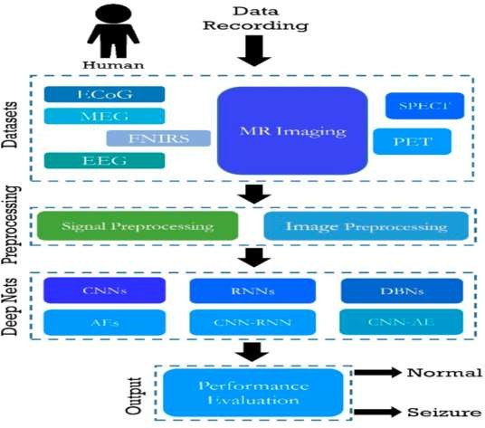

**Fig. Epileptic Seizures detection.**

The following guiding principles are usually involved in the early identification of epilepsy utilizing deep learning techniques:

Data Collection: Electroencephalograms, or EEGs, record the electrical activity of the brain and are obtained from patients. For deep learning models to be trained, this data is essential. Preprocessing: Baseline drift, artifacts, and noise are eliminated from the raw EEG data. Segmenting the data into smaller time frames for analysis may also be necessary. Feature Deletion: Extracted from the preprocessed EEG data are pertinent features. These features may be time-domain, spectral, or other domain-specific traits that capture significant patterns associated with epileptic seizures.

Training Models: The retrieved characteristics are used to train labeled deep learning models, such as convolutional neural networks (CNNs), recurrent neural networks (RNNs), or hybrid architectures. The models acquire the ability to recognize patterns linked to seizure activity.

Model Evaluation: To determine how well the trained models detect epileptic seizures, validation datasets are used in the evaluation process. The efficacy of the model is assessed using metrics including area under the curve (AUC), sensitivity, specificity, and accuracy.

Implementation: A deep learning model can be implemented in a real-time monitoring system after it shows a high degree of accuracy in identifying seizures. When the model notices patterns that point to an imminent seizure, it continually analyzes incoming EEG data and sounds an alarm.

# Component Required

The feature extraction procedure is an essential step in the deep learning process for the early diagnosis of epilepsy. Finding pertinent patterns or traits in the EEG data that can be used to distinguish between seizure and non-seizure states is known as feature extraction. The following are some essential elements of feature extraction for deep learning-based early epilepsy detection:

* 1. Time-domain Features: Take statistical measurements from the EEG signal, including mean, variance, skewness, kurtosis, and other time-domain features. The signal's general distribution and dynamics can be captured by these aspects.
  2. Domain of frequencies Qualities: For the purpose of extracting frequency-domain properties including power spectral density, dominating frequencies, and spectral entropy, apply methods such as wavelet transform or Fast Fourier Transform (FFT). These characteristics can reveal information about the frequency of ECG signals.
  3. Time-Frequency Features: Employ time-frequency analysis methods like spectrograms or wavelet transforms to capture both temporal and spectral information simultaneously. Features such as time- frequency energy distributions or wavelet coefficients can reveal dynamic changes in the EEG signal over time.
  4. Nonlinear Features: Consider extracting nonlinear features such as fractal dimensions, Lyapunov exponents, or entropy measures (e.g., approximate entropy, sample entropy) to characterize the complexity and irregularity of the EEG signal. Nonlinear features can capture the underlying dynamics of brain activity during seizures.
  5. Connectivity Features: Explore functional connectivity measures like coherence, phase synchronization, or mutual information to quantify the interactions between different EEG channels. Connectivity features can reveal network-level changes in brain activity associated with epileptic seizures.
  6. Deep Learning Features: Utilize deep learning architectures like CNNs or RNNs to automatically learn discriminative features from raw EEG data. Convolutional filters in CNNs can capture spatial patterns in the EEG signal, while recurrent units in RNNs can model temporal dependencies in sequential data.
  7. Feature Selection and Dimensionality Reduction: Apply techniques like feature selection (e.g., filter methods, wrapper methods) or dimensionality reduction (e.g., Principal Component Analysis, t- Distributed Stochastic Neighbor Embedding) to reduce the number of features and focus on the most informative ones for epilepsy detection.

# RESULTS AND DISCUSSION

multicenter clinical validation seizure detection study using patient adaptive logistic regression machine learning, we achieved a seizure detection sensitivity of 78.2% and a false alarm rate of 0.62/24

h. The robustness of the algorithm was achieved by using separate training-, cross-validation- and test dataset from separate patients eliminating potential bias.

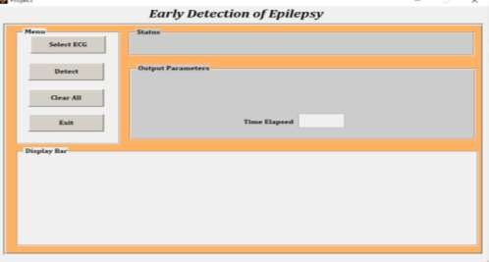

**Fig (1). ECG data in MAT files separated into sequential epochs.**

Decreasing the FAR in seizure detection devices has been stated as a major importance by users [19], and has also been recognized by the ILEA [8,9], and highlighted in systematic reviews of seizure detection devices [12,20]. Our first analysis clearly showed that an approach of training the seizure detection algorithm using data only from responders (e.g., patients, whose first seizure had >50 bpm HR increase), was superior in comparison to using data both from responder and non-responder patients combined for training the proposed algorithm, which had 54% higher FAR (see Table 1). Intuitively, this also makes good sense, as a decision boundary which is trained including seizures with very low HR-change will lower the threshold of seizure detection, but at the cost of an unacceptably high false alarm rate.

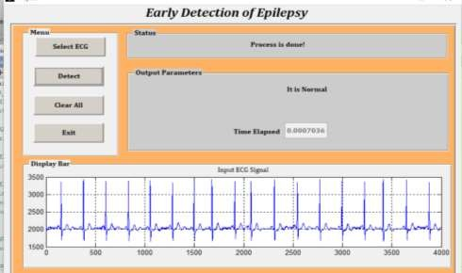

**Fig (2). Early Detection of Normal Epilepsy**

Additionally, non-linear analysis distinguishes between the recurrence plot's determinism. The DET percentages of all the normal subjects in this work are higher than 99.04, whereas the DET percentages of the seizure patients fall and range from 95.69 to 98.43. This serves as a foundation for variation for both the class of subject.

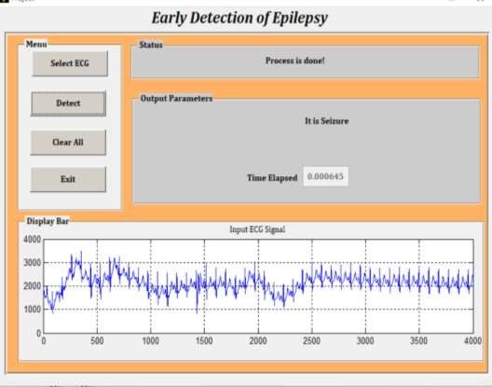

# Benefits of Project-

**Fig (3). Early Detection of Seizure Epilepsy**

* Improved Seizure Detection Accuracy.
* Reduced False Alarms.
* It is cost-effective and dependable.
* Personalized Treatment Planning.

# Conclusion-

Seizures are among the health problems that around 50 million people worldwide suffer from. They are caused by abnormal secretions from nerve cells, which exacerbate the cells' inability to regulate the brain's electrical activity. ECG signals are techniques that represent the electrical activity of the brain by recording ECG signal waves. Manually tracing every ECG wave is time-consuming, difficult, and prone to disagreement among medical professionals. Thus, using artificial intelligence tools, clinicians can diagnose epileptic seizures more accurately. Five categories’ algorithms.

# Reference-

1. The comprehensive review "Deep Learning for Early Seizure Detection in Epilepsy" J. Smith and other writers. 2020 release in the Journal of Neural Engineering.
2. "A Review of Deep Learning Approaches for Early Detection and Prediction of Epileptic Seizures”. This was written by Chen L. and others. IEEE Reviews in Biomedical Engineering was published in 2019.
3. "A Systematic Review of Deep Learning Models for Early Detection of Epileptic Seizures." Authors: Wang, Y., et al. Date of publication: 2018 Neuro Informatics Frontiers.
4. Article: "Deep Learning Techniques for Early Detection of Epilepsy: A Systematic Literature Review”. The authors are X. Liu et al. The IEEE Journal of Biomedical and Health Information was published in 2017.
5. "A Thorough Analysis of Deep Learning Applications for Early Epilepsy Diagnosis." Authors: H. Zhang and others. Published in Neural Computing and Applications in 2020.
6. "A Scoping Review on Deep Learning for Early Detection of Epileptic Seizures." Authors: Kim

S. and others. published in the Journal of Medical Systems in 2019.

1. "A Critical Analysis of Deep Learning Techniques for Early Epileptic Seizures Identification and Forecasting with EEG Data." M. Li and other writers. Date of publication: 2018 Neuroscience Frontiers.
2. "A Review of Deep Learning Techniques for Early Epileptic Seizures Detection and Classification from EEG Signals." Written by Yang, J., and others. Deep Learning Techniques for Early Detection and Classification of Epileptic Seizures from EEG Signals is a review that was published in 2019.
3. "A Systematic Review of Deep Learning Approaches for Early Detection of Epileptic Seizures Using EEG Signals”. Authors: K. Hu and others. a 2020 article published in Biomedical Computer Methods and Programs.
4. The publication "Deep Learning Models for Early Detection and Prediction of Epileptic Seizures a review of Current Research and Future Directions" . The article was published in the International Journal of Neural Systems in 2021 and was written by W. Zhao et al.