**EXPORT DOCUMENTATION AND CUSTOMS CLEARANCE PROCEDURE AT PORTLINK INC, CHENNAI**

**AZLANSHAH N, MBA (SLM)**

**Ms.P.C.Saranya, Assistant Professor SCHOOL OF MANAGEMENT STUDIES**

**Vels Institute of Science, Technology & Advanced Studies (VISTAS), CHENNAI – 600 117.**

**I. ABSTRACT**

Important components of global trade, export paperwork and customs clearance are essential to the efficient movement of commodities across borders. The goal of this study is to present a thorough overview of the complexities associated with export documentation and customs clearance processes. The study explores the basic components of export documentation, including licenses, certifications, and forms needed for various export kinds. In order to ensure compliance with regulatory standards and reduce the possibility of delays or penalties during the export process, it examines the importance of precise paperwork. Additionally, the study looks into the intricate processes of tariff classification, value, and customs declarations that are involved in customs clearance. It looks at the function of customs.

## II.INTRODUCTION

Learning about export documentation and customs clearance processes is essential to understanding the intricacies of global trade. In order to comply with export laws and customs procedures, it includes the creation and filing of a variety of documentation, including business invoices, packing lists, and certificates of origin. The purpose of this study is to shed light on these processes by outlining the crucial actions and factors that must be taken into account to enable seamless cross-border transactions. Comprehending export paperwork and customs clearance is essential for successfully navigating global commerce. Along with complex customs procedures like tariff classification and valuation, it involves a variety of documents like commercial invoices, packing lists, and certificates of origin. This study intends to investigate

these processes, taking into account the effects of modifications to trade agreements, customs laws, or technological advancements.

## INDUSTRY PROFILE

The global economy depends heavily on the export and import sectors, which enable the flow of commodities and services over international borders through a variety of operations including sales, transportation, and regulatory procedures. The World Trade Organisation estimates that worldwide merchandise exports will reach $18.89 trillion in 2020, while imports will reach

$19.03 trillion. These are impressive numbers for this industry. China, the United States, and Germany are the leading exporters, and the United States, China, and Japan are the top importers. Transportation firms are vital to the trading of goods, which include technology, cars, and agricultural products. The industry must comply with complex regulations, such as trade agreements and customs rules, in order to conduct worldwide business. It is expected that the significance of this industry will increase as the world becomes increasingly interconnected.

## COMPANY PROFILE

Located in Mannady, Chennai, Portlinks Inc. was founded in 1997 and specialises in freight forwarding, warehouse outsourcing, customs brokerage, and customs clearance services. Under the direction of its founder and managing director, Shri M.D. Sivakumar, the business was able to secure a Custom House Agent licence in 2001 and, after arduous testing, a Custom House licence in 2003. Since then, it has developed into one of Chennai's most reputable CHAs, with prestigious clientele that includes the PHA group and others. A whole range of supply chain services, such as warehouse inventory management, storage, fulfilment, shipping, and return logistics, are provided by third-party logistics provider (3PL) SKLS WAREHOUSE. SKLS WAREHOUSE, with its multi-industry experience, guarantees client pleasure through effective inventory control and customized fulfilment solutions. Graded surfaces, temperature-controlled warehouses.

## OBJECTIVES OF THE STUDY PRIMARY OBJECTIVES

To analyse export documentation and customs clearance procedures.

## SECONDARY OBJECTIVES

* Streamlining documentation processes to expedite customs clearance and reduce transit times.
* Ensuring all export documents is complete and error-free to avoid delays and penalties.
* Adhering to relevant regulations and requirements to prevent legal issues and ensure smooth clearance.
* Maintaining clear communication channels with stakeholders to address any issues promptly.
* Keeping comprehensive records of all documentation and clearance procedures for auditing and future reference.

# NEED OF THE STUDY

The need for your study on export customs clearance and procedures could arise from the increasing globalization of trade, highlighting the importance of understanding and improving the efficiency of customs processes. By investigating current practices, potential bottlenecks, and regulatory challenges, your study can contribute valuable insights to businesses, policymakers, and stakeholders involved in international trade. The increasing complexity of international trade, the evolving regulatory landscape, and the critical role of efficient customs processes in facilitating smooth cross-border transactions. This study aims to provide insights into the challenges faced by businesses, potential bottlenecks in customs clearance, and opportunities for improvement in order to enhance overall trade efficiency.

# STATEMENT OF PROBLEM

In the context of international trade, the process of export documentation and customs clearance plays a pivotal role in facilitating the smooth flow of goods across borders. However, this process is often characterized by complexity, inefficiencies, and regulatory hurdles, which can impede trade operations, increase costs, and hinder economic growth. Despite its critical importance, there is a lack of comprehensive understanding regarding the challenges, bottlenecks, and best practices associated with export documentation and customs clearance procedures. This study aims to address this gap by examining the key issues and obstacles faced by exporters, customs authorities, and other stakeholders in the export-import process. By identifying the root causes of these challenges and exploring potential solutions, this research seeks to inform policymakers, trade practitioners, and industry stakeholders about strategies to streamline export documentation and customs clearance procedures, enhance trade facilitation, and promote global competitiveness.

# SCOPE OF THE STUDY

* Definition and importance of export documentation.
* Detailed process flow of export documentation from initiation to completion.
* Common challenges and solutions in export documentation.
* The purpose of study is understanding the satisfaction of clients at portlinks Inc that covers the different work schedules.

## REVIEW OF LITERATURE

The overview of literature includes a range of research that concentrate on trade facilitation, logistics management, and customs procedures in various nations and areas. These studies cover a wide range of subjects, including the effects of bureaucratic procedures on the import and export of goods, the possibilities for robotic process automation (RPA) to speed up pre-customs paperwork, and the difficulties associated with putting the single window idea for trade facilitation into practice. Additionally, studies look into the effectiveness of DMAIC

methodologies for performance enhancement, the efficiency of customs clearance procedures, and the role national single window systems play in simplifying customs services. Research also emphasizes how crucial it is to modernize customs, manage risk, and use technology to improve trade facilitation and lower transaction costs. Additionally, the review emphasizes how important it is to comprehend the complexity of traditions.

## RESEARCH METHODOLOGY

Research technique, which is crucial for information collection, is the methodical strategy utilised to solve research problems in a scientific manner. The pursuit of information through rigorous inquiry and scientific investigation is known as research. It progresses from the discovery of the known to the unknown. According to Clifford Woody, research entails defining the problem, formulating hypotheses, gathering and analysing evidence, and testing conclusions. The term "methodology" describes particular techniques for gathering and analysing data.

An exploratory research design was selected for this study, with an emphasis on characterising the traits of individuals or groups. In order to describe current circumstances or features, descriptive research was used. With a sample size of 30, convenience sampling—that is, pulling samples from Port Links PVT.LTD.—was used. Surveys were used to collect data, both first- hand (primary data) and second-hand (secondary data) from company magazines.

1. **DATA ANALYSIS AND INTERPRETATION**

**TABLE:** DO YOU AGREE WITH THAT INVESTING IN INFRASTRUCTURE UPGRADES AT CUSTOMS CHECKPOINTS CAN SUPPORT FASTER PROCESSING OF DOCUMENTATION AND GOODS.

|  |  |  |
| --- | --- | --- |
| **FACTOR** | **NO OF RESPONSE** | **PERCENTAGE** |
| YES | 26 | 86.7% |
| NO | 1 | 3.3% |
| MAYBE | 3 | 10% |
| TOTAL | 30 | 100% |

**CHART**: DO YOU AGREE WITH THAT INVESTING IN INFRASTRUCTURE UPGRADES AT CUSTOMS CHECKPOINTS CAN SUPPORT FASTER PROCESSING OF DOCUMENTATION AND GOODS.

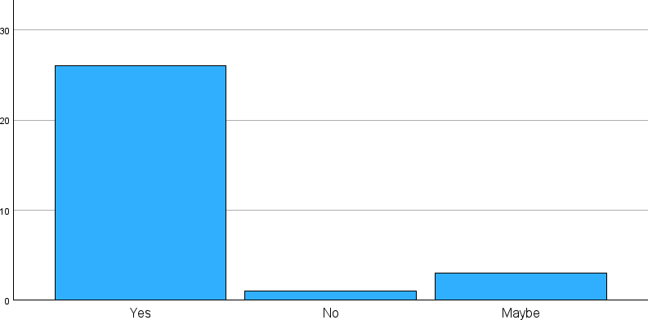

**INTERPRETATION:** From the above table, it was inferred that 86.7% of the respondents yes, 10% of the respondents maybe, and 3.3% of the respondents No is the investing in infrastructure upgrades at customs checkpoints can support faster processing of documentation and goods. . Do you agree with that Investing in infrastructure upgrades at customs checkpoints can support faster processing of documentation and goods.

**TABLE:** IMPLEMENTING ADVANCED TECHNOLOGIES LIKE AI AND MACHINE LEARNING CAN FURTHER OPTIMIZE CUSTOMS DOCUMENTATION PROCESSES.

|  |  |  |
| --- | --- | --- |
| **FACTORS** | **NO OF RESPONSE** | **PERCENTAGES** |
| STRONGLY AGREE | 11 | 36.7% |
| AGREE | 9 | 30% |
| NEUTRAL | 9 | 30% |
| DISAGREE | 1 | 3.3% |
| STRONGLY DISAGREE | 0 | 0% |
| **TOTAL** | 30 | 100% |

**CHART:** IMPLEMENTING ADVANCED TECHNOLOGIES LIKE AI AND MACHINE LEARNING CAN FURTHER OPTIMIZE CUSTOMS DOCUMENTATION PROCESSES**.**

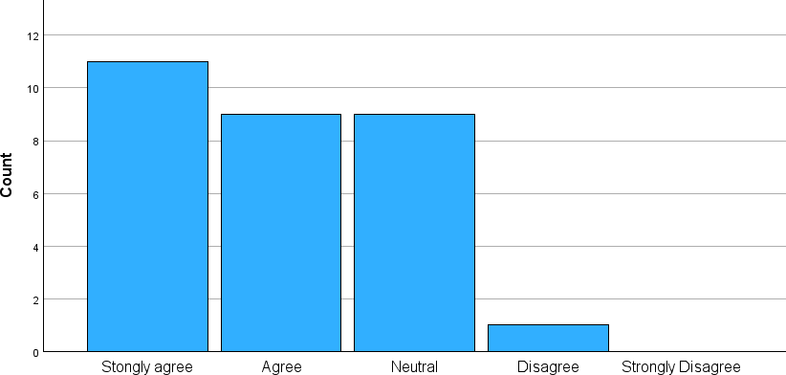

**INTERPRETATION**: From the above table, it was inferred that 36.7% of the respondents strongly agree, 30% of the respondents agree and neutral, 3.3% of the respondents disagree implementing advanced technologies like AI and machine learning can further optimize customs documentation processes.

**TABLE**: DO YOU BELIEVE THAT THE STREAMLINING DOCUMENTATION PROCESSES CAN SIGNIFICANTLY REDUCE CUSTOMS CLEARANCE DELAYS**.**

|  |  |  |
| --- | --- | --- |
| **FACTOR** | **NO OF RESPONSE** | **PERCENTAGE** |
| YES | 20 | 66.7% |
| NO | 4 | 13.3% |
| MAYBE | 6 | 20% |
| TOTAL | 30 | 100% |

**CHART**: DO YOU BELIEVE THAT THE STREAMLINING DOCUMENTATION PROCESSES CAN SIGNIFICANTLY REDUCE CUSTOMS CLEARANCE DELAYS.

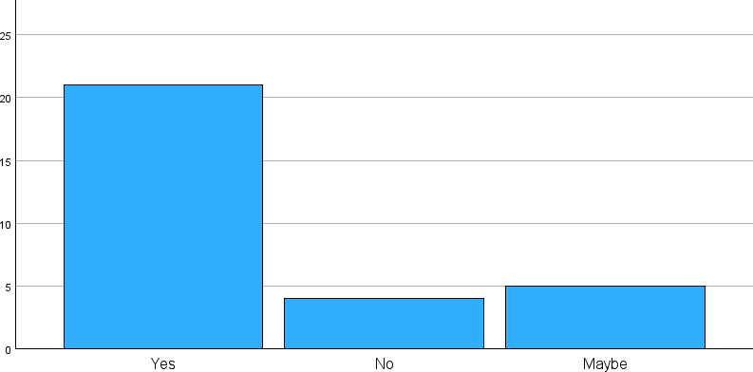

**INTERPRETATION**: From the above table, it was inferred that 66.7% of the respondents yes, 20% of the respondents Maybe, and 3.3% of the respondents No. Do you believe that the Streamlining documentation processes can significantly reduce customs clearance delays.

## FINDING OF THE STUDY

* The majority of respondents 86.7% yes Do you agree with that Investing in infrastructure upgrades at customs checkpoints can support faster processing of documentation and good
* The majority of respondents 36.7% strongly agree Implementing advanced technologies like AI and machine learning can further optimize customs documentation processes.
* The majority of respondents 66.7% yes do you belive that the Streamlining documentation processes can significantly reduce customs clearance delays.

## CHI SQUARE

* + Test statistics values surpass 0.5; null hypothesis remains unchallenged. Hence, insufficient evidence to suggest a notable correlation for documentation process reduce customs clearance delay Strongly agree Agree Neutral Disagree Strongly Disagree
  + Values surpassing 0.5; null hypothesis remains unaltered. Insufficient evidence to deduce a significant association documentation process reduce customs clearance delay
  + Test statistics values exceed 0.5; null hypothesis persists. Thus, inadequate evidence to infer a significant correlation documentation process reduce customs clearance delay.

## WEIGHTED AVERAGE METHOD

* + It is inferred that the majority of the respondents agree that establishing clear communication protocols is the responsibility of the project team.
  + It is inferred that majority of the respondents strongly agree that the do you believe that the important to regularly update our company's policies to comply with new regulations.

## CORRELATIONS

* + There is no significant relationship between Do you agree with that Investing in infrastructure upgrades at customs checkpoints can support faster processing of documentation and goods and Implementing advanced technologies like AI and machine learning can further optimize customs documentation processes.
  + There is no significant relationship between Errors in export documentation can lead to significant delays in shipments and Exporters are usually well-informed about the importance of accurate documentation.

# FINDING OF STUDY

* The majority of respondents 83.3% yes Do you agree with that properly completing export documents is crucial for smooth international trade
* The majority of respondents 76.7% yes Errors in export documentation can lead to significant delays in shipments.
* The majority of respondents 43.3% strongly agree do you believe that the incomplete export documents can result in financial penalties for exporters.

# SUGGESTION

* Adhere to pertinent rules and regulations to prevent legal concerns and implement a thorough plan to expedite customs clearance, decrease transit times, and assure proper export documentation
* In order to ensure prompt resolution and efficient problem detection during the clearing phase, it is imperative to maintain open contact and provide frequent updates. It is also crucial to keep detailed records of all documentation and clearance procedures for auditing purposes and future reference.
* Systems for digital documentation can increase productivity and accessibility by simplifying the process of obtaining information when needed. Frequent evaluations of documentation processes can identify areas for improvement and simplification

# CONCLUSION

The significance of effective procedures for global trade, highlighting the necessity of timely, accurate, and compliant documentation. It could also point up areas that need improvement, such implementing digital solutions to simplify processes and cut down on paperwork.

The conclusion may also emphasise how important it is to keep up with changing laws and trade agreements in order to enable seamless cross-border transactions. The results highlight how crucial it is to pay close attention to details, follow rules and regulations, and implement effective technology.

Businesses can more successfully manage the difficulties of international trade by cutting down on delays, lowering risks, and optimising growth prospects through streamlined processes and proactive compliance measures. Furthermore, to remain flexible and competitive, stakeholders must continue to collaborate and closely monitor any changes to the law.