PCC, RCC and Pre-Stressed Beam in Construction
First Author: - Piyush Sinha
Student, B. Tech Civil Engineering, Galgotias University, Greater Noida, Uttar- Pradesh, India

ABSTRACT
This study investigates the structural efficiency of three distinct beam models: Reinforced Concrete (RCC), Prestressed Concrete (PCC), and Prestressed Beam (PB) models. The research aims to provide a comprehensive comparison of the three models in terms of their load-carrying capacity, deflection, and stress distribution. Finite Element Analysis (FEA) is employed to simulate the behaviour of each beam model under various loading conditions. The results indicate that the Prestressed Beam model exhibits superior structural efficiency, with a significant increase in load-carrying capacity and reduced deflection compared to RCC and PCC models. The study's findings have important implications for the design and construction of concrete structures, highlighting the potential of Prestressed Beam technology to enhance structural performance and reduce material usage.

Keywords: RCC, PCC, Prestressed Beam, Structural Efficiency, Finite Element Analysis, Load-Carrying Capacity, Deflection, Stress Distribution.

INTRODUCTION

Beam-In building construction, a beam is a horizontal member spanning an opening and carrying a load that may be a brick or stone wall above the opening, in which case the beam is often called a lintel (see post-and-lintel system).
Our project is on the topic PCC,RCC, and Pre-Stressed beam, In this project we have shown that what is the difference between these beam and what are the advantage & disadvantages of these beams, and where are this beams are used in constructions.
We have use Is code 456 for a concrete -
IS 456-2000 Plain and Reinforced Concrete - Code of Practice is an Indian Standard code of practice for general structural use of plain and reinforced concrete. The latest revision of this standard was done in year 2000, and reaffirmed 2021.

At the present scenario, in India there is the rapid growth of urbanization and the vehicular traffic is increasing day by day. Due to this the load on the road pavement is increasing which causes a need of increasing the depth of pavement to resist the load. In such cases for the increase of depth of pavement it increases the concentration of cement and concrete which thereafter increases the emission of carbon dioxide which is further harmful for the environment and human life. On Contrary to such cases, if any new advance material basically known as "smart materials" is entertained in road pavement which has more strength, economical and increases the lifespan of the road pavement can eliminate the cost of material and reduces the emission of harmful gases. There are many smart materials ex bamboo, steel fibre, geogrid and geotextile which can increase the strength and durability but out of them geogrid has more ability to sustain the load and proved to be economical. A geogrid is geosynthetic material used to reinforce soils and similar materials. The main objective of this paper to study the flexural behaviour of beam reinforced with geogrid over plan cement concrete beam (PCC). A comparative study between a PCC beam and a Geogrid beam will be analysed based on the test result observation can be drawn out about how much a geogrid beam is effective to PCC beams. To achieve the objective of this paper according to the IS 516 the two point testing apparatus properly known as “flexural testing machine” is used which gives the test result of flexural behaviour of PCC as well as beam reinforced with reinforced.

METHODOLOGY

To examine the results the experiment is conducted by casting 3type of beams, out off which one is PCC beam and other 2 beam are reinforced with biaxial geogrid with 150KN grade of geogrid and 200KN grade of geogrid in beam 2 and beam 3 respectively. Geogrid use in both beam are of different grade. Beams are casted for 7 days and for 28 days respectively and there is 3 specimens for each type of beam that means total 18 beams are required to cast for perform this experiment. Geogrid use in both beam are of different grade. The size of all beams is 700x150x150mm as per IS 516.The concrete mix used in the beams should be same for all 3 beams and it should gain the characteristic strength of 40 MPa.

Theory
Purpose of beam-
Beams support the weight of a building's floors, ceilings and roofs and to move the load to the framework of a vertical load bearing element. In order to withstand the combined weight of stacked walls and transfer the support load, often larger and heavier beams called transfer beams are used.

The principle of beam-
A beam balance works on the principle of moments according to which in equilibrium, the anti-clockwise moment due to the weight of an object on left pan of the beam is equal to the clockwise moment due to the standard weights on the right pan of the beam.

PCC Beam

PCC meaning in construction-

PCC is a mixture of cement, fine aggregate (sand) and coarse aggregate. Before doing any construction work on the solid, PCC is done to level up the surface to create a strong base for the building.
It is also called Cement Concrete (CC) or Binding Concrete. This is a construction material which consists of Cement, Sand, Aggregate (Coarse and Fine) , Water and Admixtures. · It is used for providing a rigid, level space and impervious bed to RCC in foundation.

PCC stand for in construction-
Plain concrete, also known as plain cement concrete or PCC, is most commonly used for paving and flooring. Made from a mix of cement, aggregate, and water the different types of aggregate and ratio of materials used will give different types of cement with slightly different properties.

PCC load bearing-
PCC is a mixture of cement, fine aggregate or coarse aggregate, and water without steel reinforcement. It is generally used for flooring, roads, and retaining walls but not for columns, slabs, and beams, etc because it can't carry load or tensile force.

PCC is required below footing-
The main reason of providing PCC is to provide a rigid impervious bed to RCC in the foundation before starting any RCC or masonry work directly on the excavated soil, PCC is done to form a leveled surface and to avoid laying concrete on soil directly so as to avoid mixing with soil and also to prevent soil extracting.

The maximum height for PCC-
Explanation: As per clause 13.2 of IS 456: 2000, the maximum permissible free fall of concrete to avoid segregation may be taken as 1.5 m or 150 cm.

The minimum height of PCC-
PCC stand for Plain Cement Concrete. It is called plain because there is no reinforcement involved in it. The height of the PCC in foundation ranges from 10-15 cm and it is done of exact size (L*B) of footing.

The cost of PCC per square foot-

Local PCC Flooring Service, Rs 45/square feet

Formwork required for PCC-
It should not be permitted to perform PCC without formwork. The concrete surface needs to be levelled and compressed before pouring. Concrete should not be poured into the hole from a height of more than 1.5 metres. Avoid adding additional cement mortar on top of PCC, for smooth finishing.

M25 ratio-
In M25 , M stands for mix ratio (which is the ratio of cement, sand, and aggregates) Mix ratio of M25 grade of concrete is 1:1:2 (Cement : sand: aggregates) 25 stands for compressive strength of a 150mm cube after 28 days of curing, express.

Advantages of Precast Concrete
There are many precast concrete advantages. They are discussed below.
- Saves Construction Time: Precast Concrete construction saves time, and the risk of project delay is also less. The precast concrete casting can be carried on simultaneously with other works on site such as earthwork, survey, etc., and thus saves time. It is a major advantage of precast concrete.
- Quality Assurance: The key factors which regulate the quality of construction such as curing, temperature, mix design, formwork, etc. can be monitored for pre cast concrete. So, improved quality construction can be performed.
- Usage of Prestressed Concrete: By using pre-stressed precast, structural materials of high strength and load-bearing capacity can be achieved, which can result in greater clear span, reduced size of the cross-section of structural members, etc.
- Cost-effective: The simplified construction process reduces time, increases productivity, quality and safety and thus the cost is reduced.
- Durability: Precast Concrete structure has a longer service time period and minimal maintenance. The high-density Precast Concrete is more durable against acid attack, corrosion, and impact, reduces surface voids, and resists the accumulation of dust.
- Aesthetics: As the structures are made of prefabricated concrete in a controlled factory environment, several combinations of colors and textures can be used. A wide range of shapes and sizes are available to choose from with smooth finishing and thus the aesthetical value of products is increased.
- Safe Construction Platform: No raw materials have to be stocked on the site for precast concrete construction. It reduces the requirement of traditional formworks and props, wastage, workers, etc., and thus provides a safe working platform.

Disadvantages of Precast Concrete
There are some disadvantages to precast concrete. They are discussed below.
- High Initial Investment: For installing a precast concrete plant, heavy and sophisticated machines are necessary which requires a high initial investment. A large scale of precast construction projects must be available to ensure sufficient profit.
- Transportation Issue: The construction site can be at a distant location from the precast concrete plant. in that case, the precast members must be carried to the site using trailers. in many cases, the reduced costs of pre cast concrete are compensated by the transportation cost.
- Handling Difficulties: Proper care and precaution have to be taken for handling precast concrete. Usually, precast members are heavy and large which makes them difficult to handle without damage. Generally, portable or tower cranes are used to handle precast members.
- Modification: Limitation in the case of precast structures, it is difficult to modify the structure. For example, if structural precast concrete walls are to be dismantled for modification it will impact the overall stability of the structure.
- Sensitive Connection Works: Assembling the precast members is one of the key points for ensuring strong structural behavior. Connections between several structural members must be supervised and done properly to ensure the intended behavior of the connection such as simple, semi-rigid, or rigid connections. Besides this, faulty connections in precast concrete may lead to water leakage and failed sound insulation.

*Details of PCC casted beam-
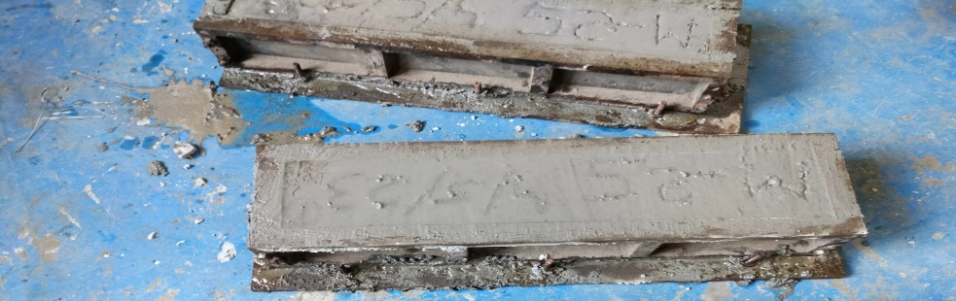

MATERIAL SPECIFICATION –

For the testing of the beam using two point apparatus the beam is casted using - The plain cement concrete mix was prepared using Portland cement of 53 grade, natural sand as fine aggregate and crushed blue granite as coarse aggregate. The maximum size of coarse aggregate is limited to 20mm.Super plasticizer was used to improve the workability of concrete and water cement ratio maintain as 0.45.
We have use M25 grade of concrete for casting the beam and done the curing of concrete for proper 28 days.

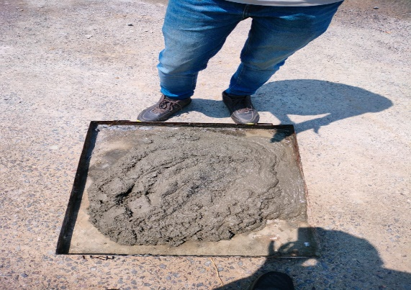
Size of fine aggregates – 4mm
Size of coarse aggregates- 20mm
Company of cement- Ultratech
Grade of a cement- 53
Size of beam- 50”*10” cm
We have used vibrateor machine for tamping



We have also marked the grade and date on the beam-
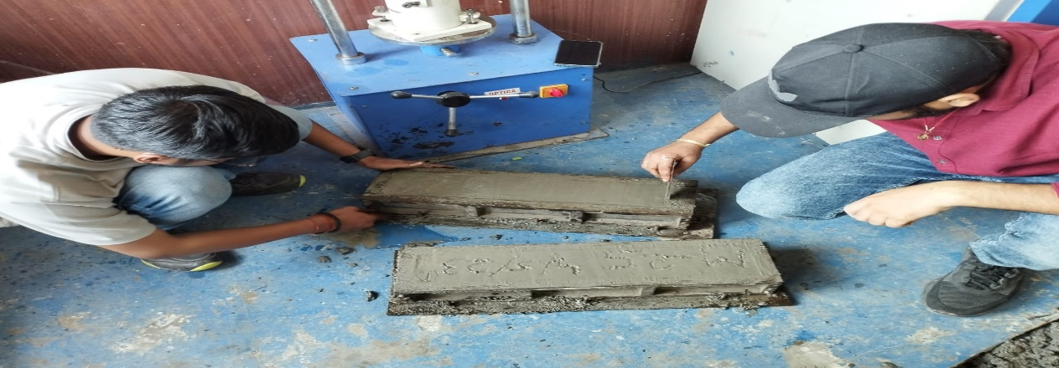

Result of casted beam-

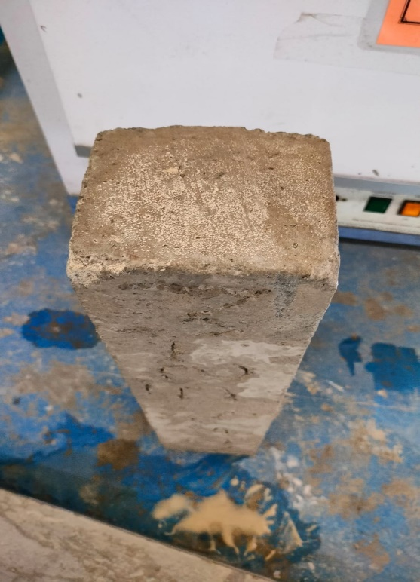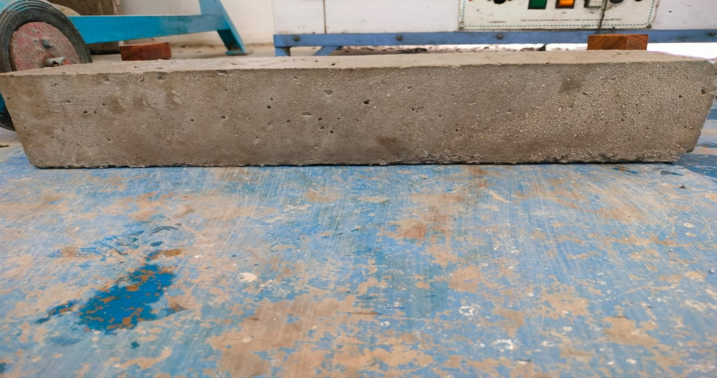

PLAIN Cement Concrete (PCC): – It is also called Cement Concrete (CC) or Binding Concrete. This is a construction material which consists of Cement, Sand, Aggregate (Coarse and Fine) , Water and Admixtures. It is used for providing a rigid, level space and impervious bed to RCC in foundation.
PCC stand for in construction- plain cement concrete
Plain concrete, also known as plain cement concrete or PCC, is most commonly used for paving and flooring. Made from a mix of cement, aggregate, and water the different types of aggregate and ratio of materials used will give different types of cement with slightly different properties.

PCC used-

The objective of plain cement concrete alias PCC is to arrange a firm impermeable bed to RCC in the foundation where the soil is soft and flexible. It is mostly applied over brick flat soling or devoid of brick flat soling. It is also known as Cement Concrete (CC) or Blinding Concrete

DESIGN of the model

The beams which are reinforced with geogrid in that beam geogrids are laid in two layers in tension zone with a spacing of 20mm as shown in fig.5 and 6 and each layer should be vibrated using table vibrator. Beam 1 is of plain cement concrete beam and in beam 2 150KN grade of geogrid is introduce where in beam 3 200KN of geogrid is introduce. There are 3 specimens for each type of beam. Take cover of 10 mm from all 4 sides in both layers as shown in fig. 4 and 5. While lying of the geogrids the Machine direction (MD) ribs should be laid parallel to the longitudinal direction of the beam. The geogrids used in beam 2 and beam 3 is of different grades. For every beam type two beam specimens is casted one for 7 days and 28 days respectively.
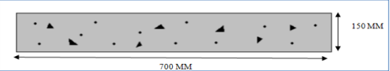
Conventional PCC Beam (Beam 1)
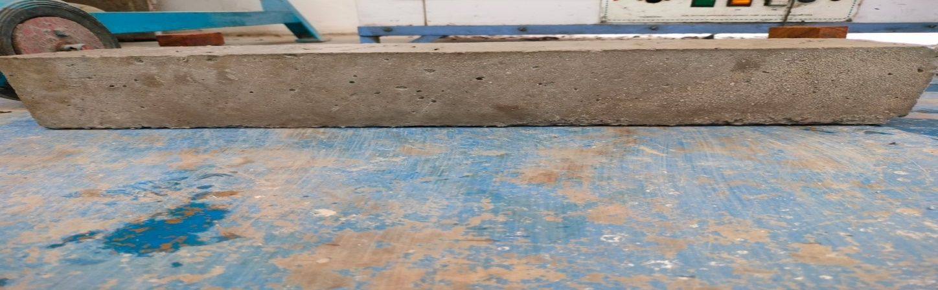
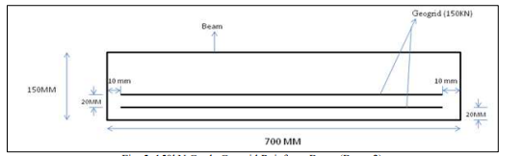

Reinforce Beam (Beam 2)

RCC Beam

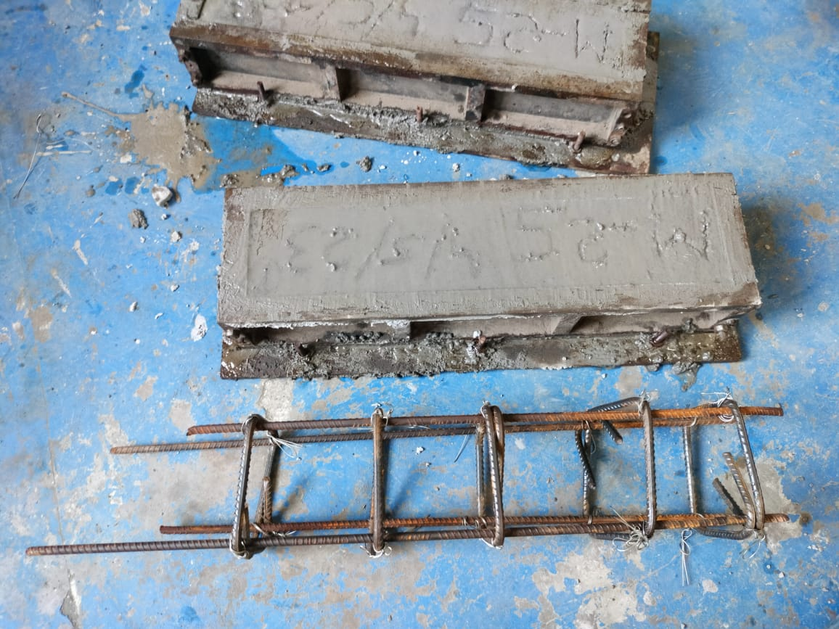

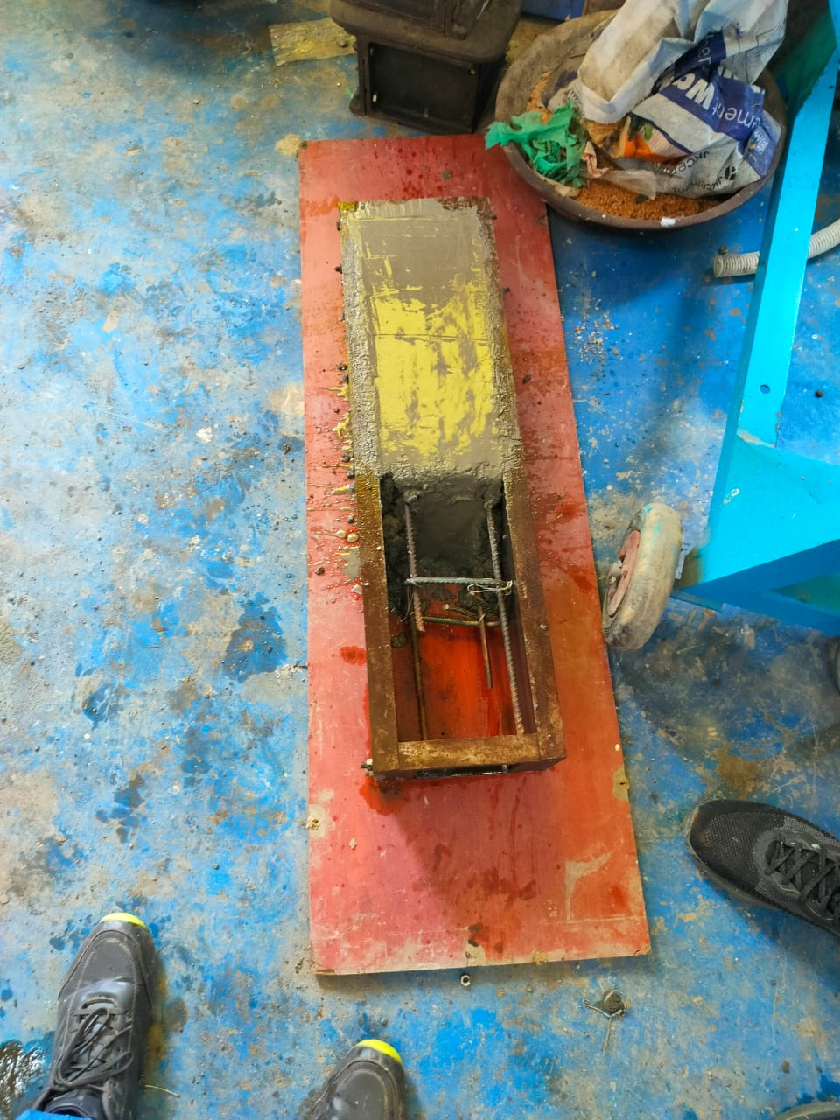

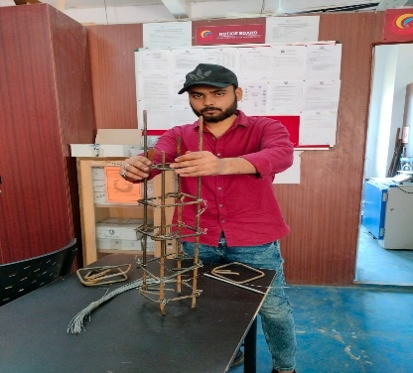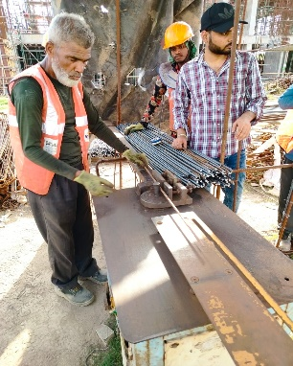
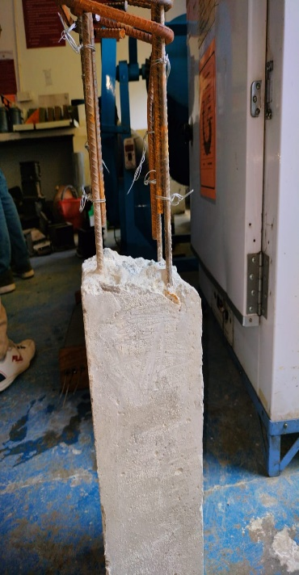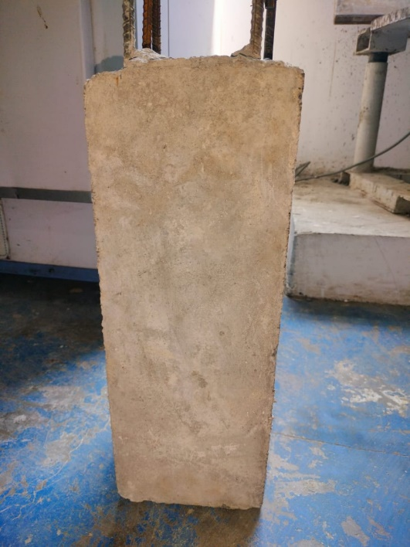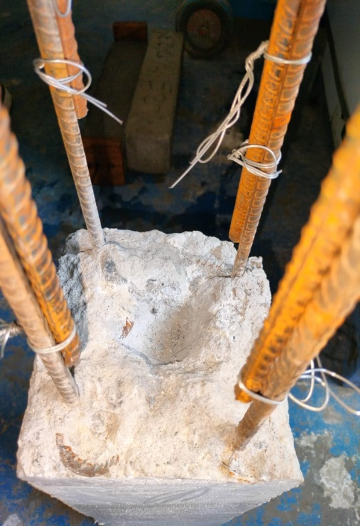

RCC Beam
Reinforced concrete beams are structural elements that designed to carry transverse external loads. The loads cause bending moment, shear forces and in some cases torsion across their length. Moreover, concrete is strong in compression and very weak in tension.

RCC ratio of M25 -
Generally 1:2:4 and 1:1.5: 3 ratios of RCC are used in construction work. Here RCC 1:1:2. Where cement concrete 1:1:2 is used; it means 1 part of cement 1 parts of fine aggregate/coarse sand and 2 parts of coarse aggregate.

Beam in RCC structure-
Beam can be defined as a structural member which carries all vertical loads and resists it from bending. There are various types of materials used for beam such as steel, wood, aluminum etc. But the most common material is reinforced cement concrete (RCC).
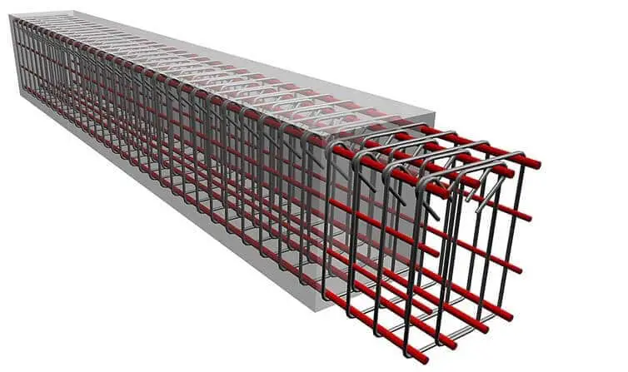

Reinforced concrete beams are structural elements that designed to carry transverse external loads. The loads cause bending moment, shear forces and in some cases torsion across their length. Moreover, concrete is strong in compression and very weak in tension

RCC beam used in construction-
Reinforced concrete beams are structural members that support the transverse load which usually rest on supports at its end. Girder is a type of beam that supports one or more smaller beam. Contents: Types of Concrete Beams.

RCC beam made up of-
An RCC beam can be considered as a composite beam since it is made up of concrete and steel. Similarly, wooden beam reinforced with steel strips or flitter form composite beams.

Purpose of RCC beam-
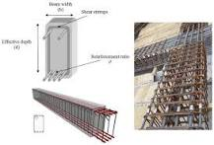
Reinforced concrete beams are structural elements that designed to carry transverse external loads. The loads cause bending moment, shear forces and in some cases torsion across their length. Moreover, concrete is strong in compression and very weak in tension.

The maximum depth of RCC Beam-
Alternatively, designers can estimate the depth of a beam at 60 mm to 65 mm per meter of the beam's span. Requirements related to the width-depth ratio of reinforced concrete beams are not provided by codes.
What is the maximum length of RCC beam-
There is no limitation for the length of a beam unless some factors are presumed. We can have any span for the beam. When the span increases, there will be problems with excessive deflections which leads to large bending moments and shear forces.

The minimum RCC beam-
Size should not be less than 9 ʺ × 9 ʺ or 225mm × 225mm with the addition of a 125mm slabthickness. 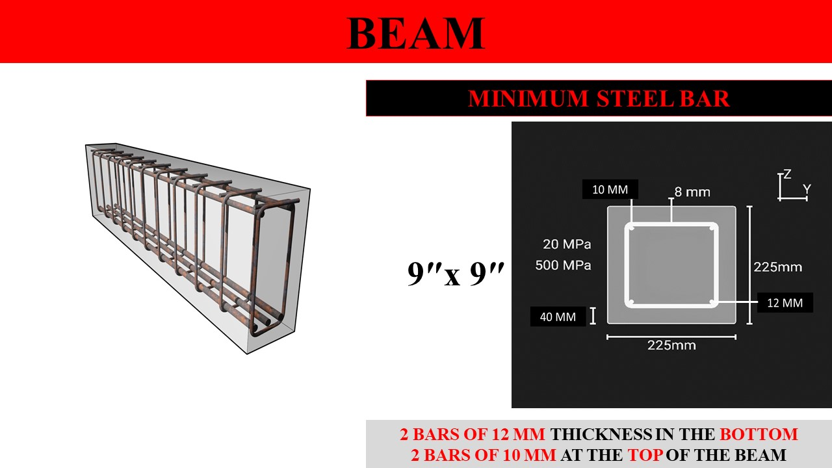

The minimum steel in RCC beam-
Minimum percentage of steel (for Fe415) is 0.205 % of effective area of beam.

The grade of RCC for beam-
Standard grade: The standard grade of concrete includes M25 The most common concrete grades used to build RCC constructions, including footings, columns, slabs, beams, etc., are M25

The highest grade of RCC?
In India maximum grade of concrete used is M60 mostly, and the concrete used above this grade will be designed as self-compacting concrete to ensure compaction.

Is code 456 a concrete-
IS 456-2000 Plain and Reinforced Concrete - Code of Practice is an Indian Standard code of practice for general structural use of plain and reinforced concrete. The latest revision of this standard was done in year 2000, and reaffirmed 2021.

Plinth Beam-

A plinth beam is a rectangular stone block that supports a building's pillars and subcolumns. A reinforced concrete plinth beam is built between the wall and its foundation during construction. A plinth beam is a rectangular stone block that supports the pillars and sub-columns of a building.

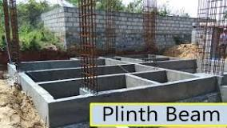

The purpose of the plinth Beam-
The plinth distributes that weight outwards, dispersing it more evenly through the ground or floor. That's the most important function of a plinth; however, it can also be used to physically separate structures like houses from the ground. This is especially important if the ground is not solid, stable, or dry.

Lapping in beam-
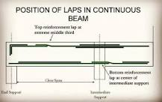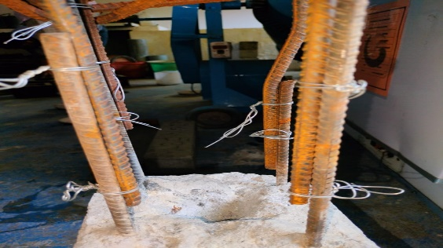
length or overlapping length is the length at which two bars of a beam are spliced or overlapped in order to maintain the continuity of the bars throughout the length of the column. This method of overlapping two reinforcement bars is called lap splicing.
The term "lapping" is used to describe a number of various surface finishing operations where loose abrasive powders are used as the grinding agent at normally low speeds. It is a process reserved for products that demand very tight tolerances of flatness, parallelism, thickness or finish.

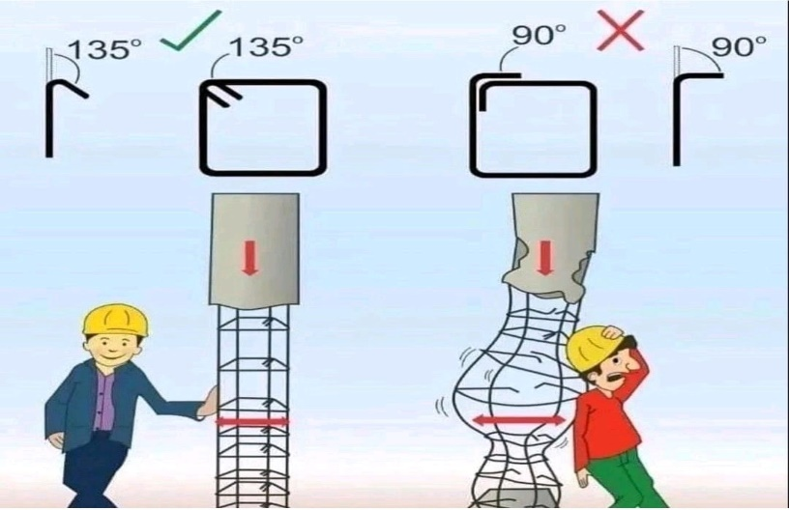
Lapping length-
As per IS Code 456-2000 overlapping length should not be less than 75mm. Lapping should be avoided in the tensile zone of construction members. In case of column generally, we take 24d – 40d where 'd' is dia of the bar.
During placing the steel in RC structure if the required length of a bar is not sufficiently available to make a design length then lapping is done. Lapping means overlapping two bars side by side to achieve the required design length.

Steel lapping size?
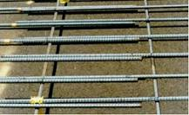
Normally, steel bars have a 6m length. If length of a bar is not enough to keep the reinforcement, we have to lap two steel bars. Normally, lapping position is at where near the minimum shear force is acting. Normally lap length is 50D meaning 50 times the bar diameter if both bars are of same diameter.

LAPPING ZONE-
If the length of the column is L, then the length L / 4 from the top and bottom of the column is classified as tension A-zone and the central length L / 2 of the column (B-Zone) is considered a safe area for the purpose of lapping.

The formula for lap length-
Lap length For flexural tension = L x d or 30 x d (The greater value among the two values calculated is taken.) 2. Lap length For direct tension = 2 x L x d or 30 x d (The greater value among the two values calculated is taken.)

Pre-Stressed beam

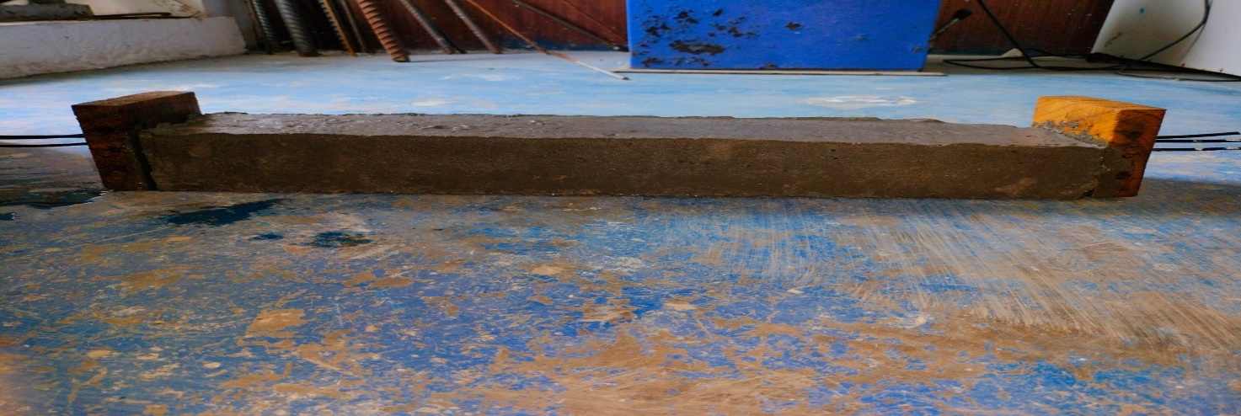
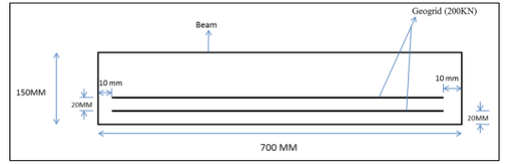
Pre -Stressed Reinforced beam ( Beam 3)

What is prestressed beam-
A concrete beam is “prestressed' because stress is created before, or “pre,” the actual use of the beam when the working stress is applied.
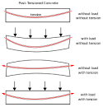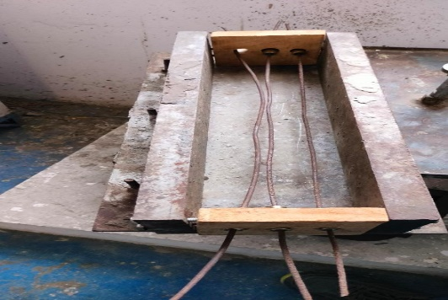

How do prestressed beams work-
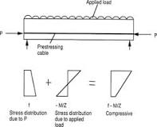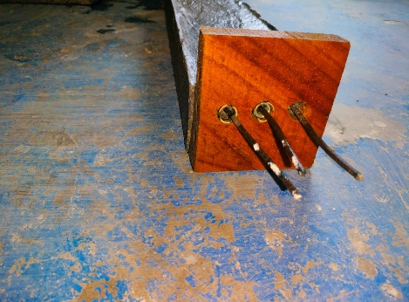
In prestressed concrete beams, the tensile weakness is remedied by applying a longitudinal compressive force creating internal compressive stresses which balances to a desired degree the tensile internal stresses. By so doing, the resulting internal stresses are mainly in compression.

Why is prestressed used?
Prestressing can reduce the volume of concrete required in construction, lowering the use and transportation of materials, as well as boosting durability and service life. Concrete is intrinsically resistant to compressive stresses, but its resistance to tension is much lower.

What is the concept of prestressing?
Prestressing is the creation of permanent internal stresses in a structure or system to improve its performance by counteract the stresses induced by external loading. Pre-tensioning is the process where the tendons are tensioned prior to the concrete being cast.

Where is prestressing mostly used?
Prestressed concrete is commonly used for floor beams, piles and railways sleepers, as well as structures such as bridges, water tanks, roofs and runways.

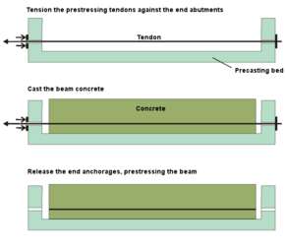
Pre-tensioned concrete is a variant of prestressed concrete where the tendons are tensioned prior to the concrete being cast. The concrete bonds to the tendons as it cures, following which the end-anchoring of the tendons is released, and the tendon tension forces are transferred to the concrete as compression by static friction.

Pre-tensioned bridge girder in precasting bed, with single-strand tendons exiting through the formwork
Pre-tensioning is a common prefabrication technique, where the resulting concrete element is manufactured off-site from the final structure location and transported to site once cured. It requires strong, stable end-anchorage points between which the tendons are stretched. These anchorages form the ends of a "casting bed" which may be many times the length of the concrete element being fabricated. This allows multiple elements to be constructed end-to-end in the one pre-tensioning operation, allowing significant productivity benefits and economies of scale to be realized.
The amount of bond (or adhesion) achievable between the freshly set concrete and the surface of the tendons is critical to the pre-tensioning process, as it determines when the tendon anchorages can be safely released. Higher bond strength in early-age concrete will speed production and allow more economical fabrication. To promote this, pre-tensioned tendons are usually composed of isolated single wires or strands, which provides a greater surface area for bonding than bundled-strand tendons.

Building structures
Building structures are typically required to satisfy a broad range of structural, aesthetic and economic requirements. Significant among these include: a minimum number of (intrusive) supporting walls or columns; low structural thickness (depth), allowing space for services, or for additional floors in high-rise construction; fast construction cycles, especially for multi-storey buildings; and a low cost-per-unit-area, to maximise the building owner's return on investment.
The prestressing of concrete allows "load-balancing" forces to be introduced into the structure to counter in-service loadings. This provides many benefits to building structures:
- Longer spans for the same structural depth
Load balancing results in lower in-service deflections, which allows spans to be increased (and the number of supports reduced) without adding to structural depth.
- Reduced structural thickness
For a given span, lower in-service deflections allow thinner structural sections to be used, in turn resulting in lower floor-to-floor heights, or more room for building services.
- Faster stripping time
Typically, prestressed concrete building elements are fully stressed and self-supporting within five days. At this point they can have their formwork stripped and re-deployed to the next section of the building, accelerating construction "cycle-times".
- Reduced material costs
The combination of reduced structural thickness, reduced conventional reinforcement quantities, and fast construction often results in prestressed concrete showing significant cost benefits in building structures compared to alternative structural materials.

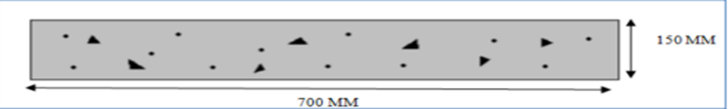 Conventional PCC Beam (Beam 1)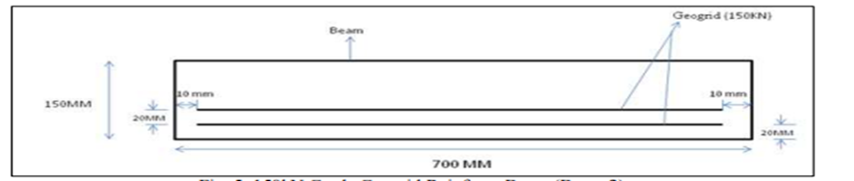 RCC(Beam 2)
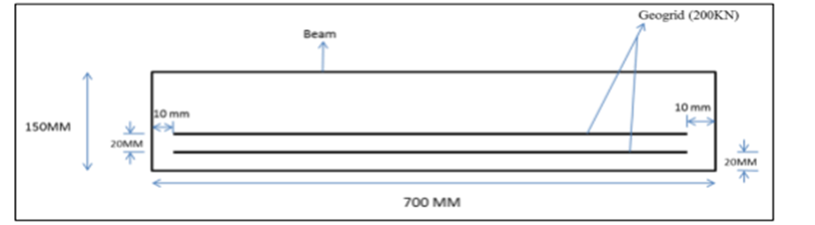
Pre-stressed (beam 3)
For calculating the flexural strength the following formula is used
𝑓𝑏 = 𝑃𝑙 𝑏𝑑 2
Where, f b= flexural strength in MPa
P = load at which beam fail in KN
l = total length of beam in mm
b = width of beam member in mm
d = depth of beam member in mm
Note: - while placing geogrid beam in flexural testing machine one thing should check that the beam should place properly as geogrid place in tension zone it should be place in bottom only while placing the beam

CRACK PATTERN
For determining load carrying capacity of beam, 3 beams of 7 days and 28 days were casted and tested in the flexural testing machine as per specification of IS standard 516. After completion of curing periods of 7 days and 28 days, beams were taken out to determine its flexural strength. While testing the beam in flexural testing machine load is gradually increases on beam which causes failure of beam and cracks over beam. That cracks have particular pattern which shows that beam was properly casted or not. The beam is divided in 3 regions of 200mm each. During the testing of beam if flexural cracks are developed in middle region as shown in fig. 8 and beam gets broken from the middle region then it is shown that the beam is strong enough to carry ultimate load. But if beam is not broken from middle region then it is shown that the beam is not able to carry enough load for which it design.
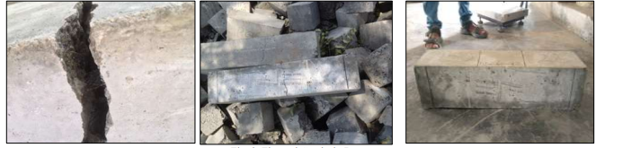
Flexural Cracks in Beam

RESULT

After testing of all 18 beams in which 3 specimen for each type of beams are of 7 days and 28 day. In every beam one common thing is notice in all beams that are cracks occurs in all beam are occurs in middle portion. It shows that all beams are able to carry enough ultimate loads. Following results are come under observation.
Table-1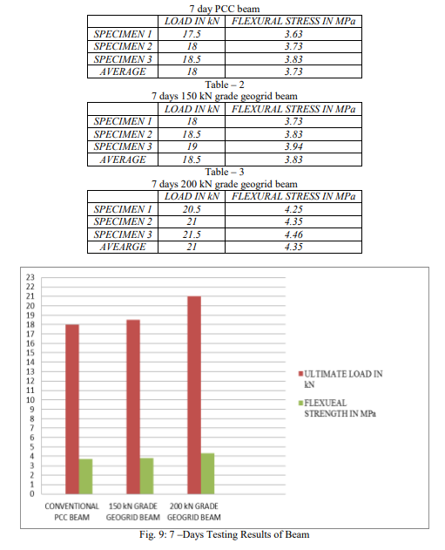

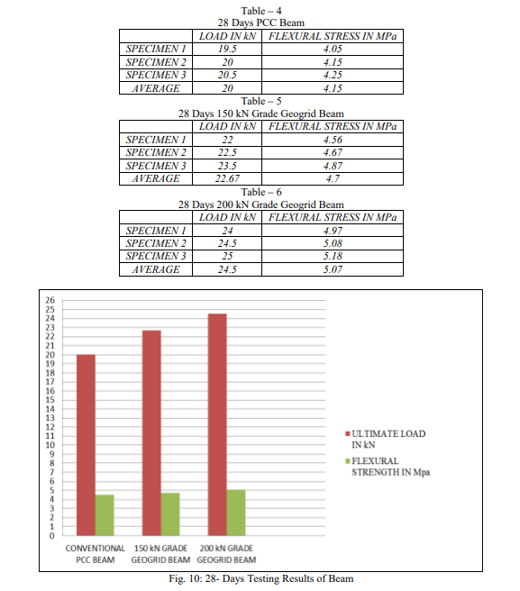

ANALYSIS
For analysis of deflection in beams finite element model (FEM) software ANSYS is used. FEM supports all types of advanced analysis such as dynamic, static, linear and non-linear supported by ANSYS. ANSYS suited for Civil engineering project such high-rise buildings, bridges, seismic calculations, offshore structures, power plants, soil mechanics, dams and tunnels.
While preparing model Geogrid is moulded in line body and concrete is moulded in solid body .Meshing is done in mechanical environment. The size of meshing element is 25 mm. loading taken while analyzing is average loading value of each type of beam. Steps for analyzing the beam by ANSYS
1) Preparing model
2) Applying boundary condition and loading
3) Result Results of Deformation of 7 Day and 28 Days Curing Beam
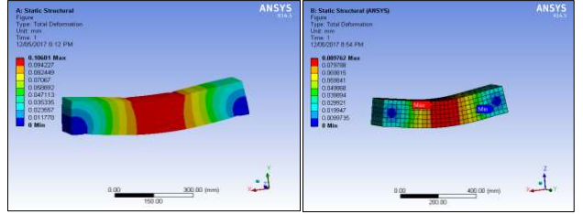Deflection of 7 Days Conventional PCC Beam Deflection of 7 Days 150 kN RCC Beam
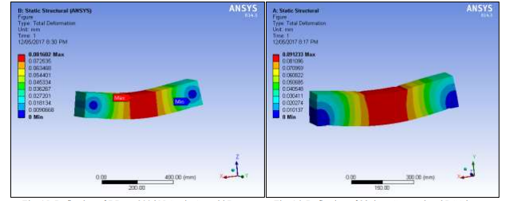
Deflection of 7 Days 200 kN Pre-stressed beam Deflection of 28 days Conventional PCC beam

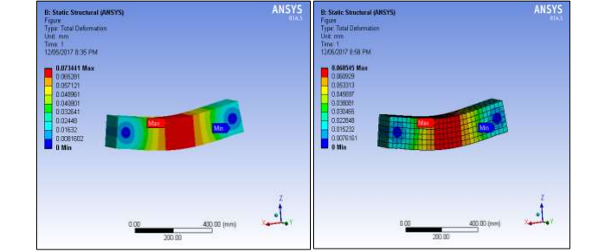
Deflection of 28 Days 150 kN RCC Beam Deflection of 28 Days 200 kN Pre-Stressed Beam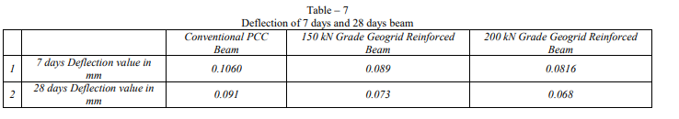

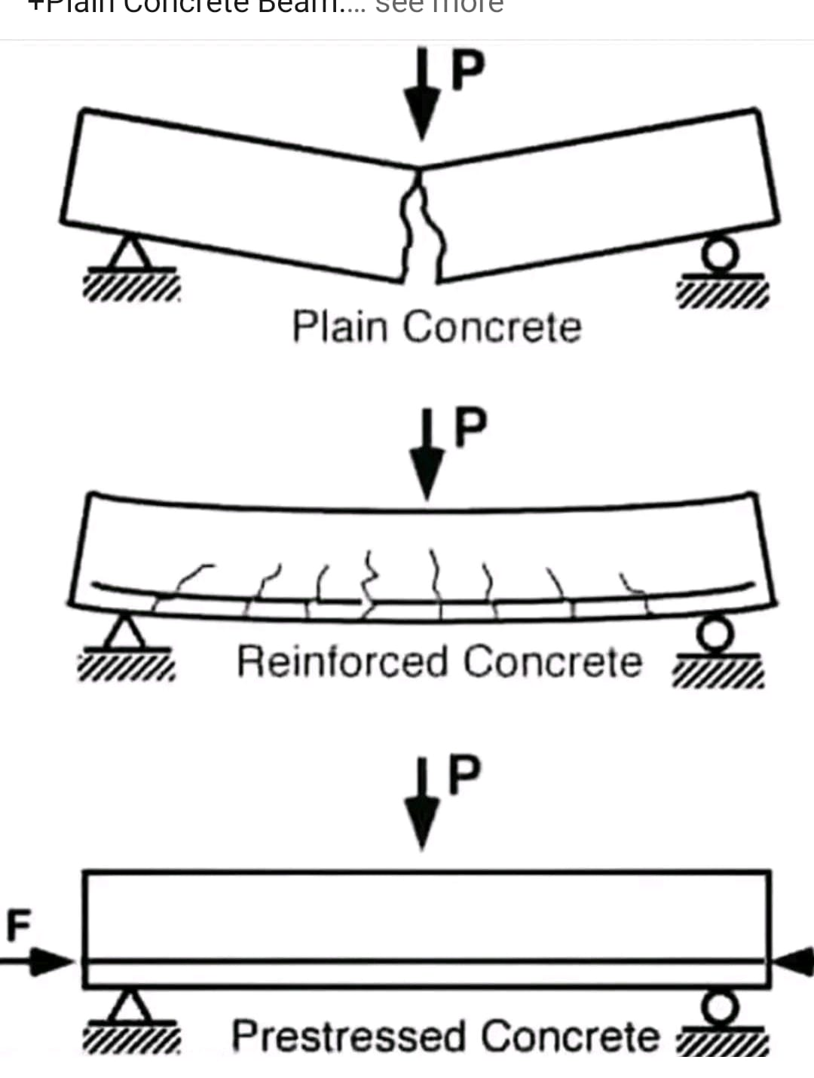

CONCLUSION
An experimental comparison has been carried out to study the behaviour of plain cement concrete beams reinforced with various loads of RCC & Pre-Stressed beam over plain cement concrete beam. After performing flexure test it has been found out that the load carrying capacity of geogrid reinforced beam is more as compared to conventional PCC beam. Following points summarized the experimental study: -
1) After failure of the conventional plain cement concrete beam it is separated in two parts while the beam which is reinforced with geogrid bind the concrete even after the failure of the beam as geogrid have more strength, durability and more elasticity.
2) As the number of layers of geogrids is increased, the strength of beam will also increase.
3) According to the graphical representation fig 9 and 10 as the grade of geogrid is increased, the strength of beam increases accordingly to the grade of geogrid.
4) With the use of geogrid in the plain cement concrete beam the Flexural strength of beam will show the remarkable improvement.
5) The formation of crack width is reduced as the grade of geogrid is increased.
6) In analysis deflection in 200 KN Load on Pre-stressed beam and 150 KN on RCC beam is less than c PCC beam in both 7 day and 28 days curing of beam as shown in table no.7.
7) Which shows Pre- stressed also help to reduce the deflection and strengthen the beam.

REFERENCES
[1] IOSR-JMCE e-ISSN: 2278-1684, p-ISSN: 2320- 334X by Satyajeet B. Mopari, Ajinkya D. Raut (NCIEST2015) - “Experimental Study of Steel Fiber Prestressed Concrete Beam for Shear, Bending and Torsion
[2] ACI Structural journal paper by S. K. Padmarajaiah and Ananth Ramaswamy Title no.98-S73(SeptemberOctober 2001) - “Behavior of Fiber-Reinforced Prestressed and Reinforced High-Strength Concrete Beams Subjected to Shear”
[3] IJRCMCE Vol. 2, Issue 1 (2015) ISSN 2349-1442 EISSN 2349-1450 by Iqbal Khaleel Khan, M.S. Jafri - “Behaviour of SFRC with Varying Mixes and Percentages of Fibres”
[4] ISSN 2319-183X, 2319-1821 Volume 1, Issue 1 (September 2012), PP. 043-048 by A.M. Shende, A.M. Pande, M. Gulfam Pathan - 1450Experimental Study on Steel Fiber Reinforced Concrete.
[5] ACI Structural journal paper Title no.103-S74 by Carlo Pellegrino and Claudio Modena - Fiber-Reinforced Polymer Shear Strengthening of Reinforced Concrete Beams.
[6] ACI Manual of Concrete Practice, Part 1: Materials and General Properties of Concrete, (ACI 211.1- 91), (2000).
[7] ACI Material Journal July August 1991. Triana, Mansour, “Biaxial Strength and Deformational Behavior of Plain and Steel Fiber Concrete”,
[8] An et al. (1991) to study of stresses and forces of a reinforcedconcrete beam with externally appliewed Steel fiber reinforced concrete (SFRC). Vol 39, No 4, pp.339-354

