**Patient Classification in Emergency Department for Priority based Treatment**

# Pradyumna G Naik,

# *JSS Science And Technology*

*University,*

Mysuru, Karnataka , India

pradyumnanaik041@gmail.com

# Harshitha S,

# *JSS Science And Technology*

*University,*

Mysuru, Karnataka , India

achuharshitha5@gmail.com

# Divya M,

# *JSS Science And Technology*

*University,*

Mysuru, Karnataka , India

divyam25802@gmail.com

# Ajaykumar B,

# *JSS Science And Technology*

*University,*

Mysuru, Karnataka , India

ajaykumarajayb182@gmail.com

*Abstract*— **This work contains the classification of patients in an Emergency Department in a hospital according to their critical conditions. Machine learning can be applied based on the patient’s condition to quickly determine if the patient requires urgent medical intervention from the clinicians or not. Basic vital signs like Systolic Blood Pressure (SBP), Diastolic Blood Pressure (DBP), and Respiratory Rate (RR), Oxygen saturation (SPO2), Random Blood Sugar (RBS), Temperature, and Pulse Rate (PR) are used as the input for the patients’ risk level identification. High-risk or non-risk categories are considered as the output for patient classification. Machine learning techniques such as Gaussian NB, KNN or DT are used for the classification. We'll use a variety of supervised machine learning methods before deciding which one is best for the model. Existing systems rely on classical learning models, which are inefficient and imprecise. They aren't as accurate as the proposed model and take a little longer to process. There are many research works on this topic where they have built models and shown results generated using R language, Python language and data science tools. But all these works are just models, cannot be used as application useful in real time. In our project work we build an application with model that can predict high risk patients and low risk patients in an emergency department and provides doctors with the information of how to handle patients and treat better. Proposed system is a real time medical system useful for hospitals and doctors and built using Microsoft tools such as Visual Studio tool and SQL Server tool.**

***Keywords— Prediction model, machine learning, artificial intelligence, supervised learning, mortality.***

1. INTRODUCTION

The Intensive Care Unit is a critical area within hospitals, providing essential care and life support to severely ill or injured patients. Equipped with specialized monitoring equipment, ICUs are staffed by expert medical professionals trained to provide clinical assistance to critical patients. Due to the high cost of monitoring equipment, ICU allocations are limited in medical facilities, necessitating a referral from a medical expert for admission. Patients admitted to the ICU include those with planned surgeries as well as those experiencing severe accidents or unexpected health deteriorations.

Information and communication technology advancements redefined almost all sectors, including health care through different intensive care unit technologies. Digitization and digitized monitoring tools have revolutionized ICUs, resulting in personal behavior-emerged monitoring, accurate diagnosis, on-time detection, preventive medicine, and first treatment. Integration of various monitoring devices creates a considerable volume of data termed as big data in ICUs . Big data can be stored in cloud storage and processed using artificial intelligence and data mining technology to obtain information. This information enables accurate disease diagnosis, conducting effective clinical procedures, and proper prescription of medicine, which ultimately improves the quality of medical care and reduces its price.

Another important application of AI and data mining in ICUs

is predicting the level of risk that the patient possesses. Forecasting high-risk and low-risk patients ensures that healthcare professionals can use resources more expeditiously. High-risk patients can be provided with more resources. This increases the quality of care and decreases mortality rates.

1. RELATED WORK
2. **IEEE PAPER TITLE: “Mortality Prediction in ICU Patients Using Machine Learning Models”**

DESCRIPTION: Effective utilization of limited intensive care unit (ICU) allocations is a challenging task for medical experts to save precious human lives. The prolonged ICU stay of relatively secure patients and patients with low chances of recovery can cause life-threatening effects on patients waiting for ICU accommodation. Machine learning based techniques for early prediction of mortality can help in this regard. This paper presents two mortality prediction models using the support vector machine (SVM) and linear discriminant analysis. The proposed models use clinical data of the ICU patients for early prediction of mortality.

METHODOLOGY: SVM and linear discriminant analysis methods used.

**Limitations:**

* In this topic patient mortality prediction is done.
* Takes more time for processing data.
* ICU patients’ classification is not done.
* No real time implementations just ML model built.

1. **IEEE PAPER TITLE: Artificial Intelligence based Comparative Study of Mortality Prediction.**

DESCRIPTION: The mortality prediction of the patient becomes an important and critical prediction problem in the area of artificial intelligence. The aim of machine learning algorithms is to help doctors to make critical decisions here. Mortality prediction can be very helpful for taking critical decisions which can help in optimizing the resources available in the hospital and also an extra opinion for doctors and family members in cases of euthanasia i.e. ending life of patient to relieve pain and suffering.

METHODOLOGY: logistic regression, random forest, and support vector machine used.

**Limitations:**

* Here patients’ mortality prediction is done. Not high risk patients’ classification is done.
* No real time implementations done.
* Huge datasets required.

1. **IEEE PAPER TITLE: Machine Learning Based Emergency Patient Classification System**

DESCRIPTION: Public Health Office and the risk map created from the patient information. Many provincial hospitals currently have to admit a large number of patients to their emergency room. Each year, the number outgrow limited medical resources, causing tremendous operational delay, and thus undermining quality of medical services. In addition, existing ER flows remain lacking means of communicating with patients’ relatives and notifying them with treatment status of patients under their care. To addresses these concerns, registered nurses with experiences are required not only to make initial patient screening and prioritization, but also to serve as liaison between physicians and patients’ relatives. These double tasks impose great burden to already overloaded medical staffs. An emergency patient classification system, based on support vector machine was developed. It was implemented as a web application, written in PHP, and running on MySQL database.

METHODOLOGY: SVM used.

**Limitations:**

* Graphical outputs generated.
* Less datasets used.
* Not suitable in real time.
* No real time implementations done.

1. **IEEE PAPER TITLE: Identification of high-risk COVID-19 patients using machine learning.**

DESCRIPTION: The current COVID-19 public health crisis, caused by SARS-CoV-2 (severe acute respiratory syndrome coronavirus 2), has produced a devastating toll both in terms of human life loss and economic disruption. In this paper we present a machine-learning algorithm capable of identifying whether a given patient (actually infected or suspected to be infected) is more likely to survive than to die, or vice-versa. We train this algorithm with historical data, including medical history, demographic data, as well as COVID-19-related information. This is extracted from a database of confirmed and suspected COVID-19 infections in Mexico, constituting the official COVID-19 data compiled and made publicly available by the Mexican Federal Government. We demonstrate that the proposed method can detect high-risk patients with high accuracy, in each of four identified clinical stages, thus improving hospital capacity planning and timely treatment.

METHODOLOGY: supervised learning algorithms used.

**Limitations:**

* Specific disease oriented.
* Require huge datasets.
* Only ML model built.
* No real time implementations.

**SURVEY SUMMARY**

In the current system doctors will decide the priority of patient treatments in ICU departments. All cases are emergency but doctors based on their experiences and patient conditions will decide which patient to handle at first and so on. This process sometimes may go worst which leads to patient’s death. Many existing research works on this topic build machine learning models using ready libraries such as R language, Python and other data science tools but these works can be applied in real time.

**Drawbacks of Existing System**

* Manual Process
* Requires more experiences
* Models for static datasets
* Cannot be applied in real time
* More time and more expensive
* Less Reliable and Less Efficient
* No real time implementations done.

1. DATASETS USED

The dataset is taken from Kaggle website

The data set we have had a separate file with the result of corresponding 8483 patients in the binary form, where binary 1 means High Priority and binary 0 means Low Priority.

The results of the patients are shown in the form of a chart in the Fig.1. Here in this figure, we have presented that out of 8483 patients 610 are of high priority and 7873 are of low priority.

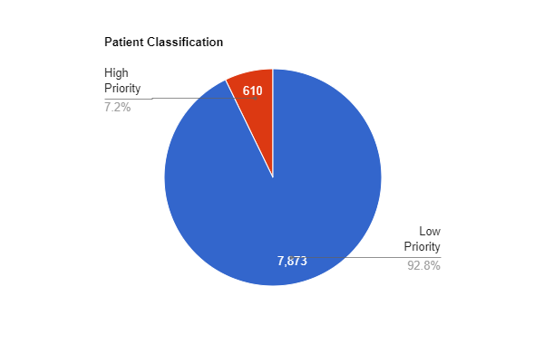

Fig 1: Patient Classification

1. DATA PREPROCESSING

There were a few problems with datasets. We started our data preprocessing work by changing the format of few columns of dataset for easy training machine learning algorithms and neural network, this was done using one-hot encoding. Then, there were many missing values in multiple columns, we filled them either using mean value or the most repeated value in the same column also, we removed few columns that were irrelevant and not contributing anything in the prediction.

V. TOOLS AND TECHNOLOGIES

**1. .NET Framework:**

Functionality- Deployment of applications across the enterprise, scalability.

Description- Collection of technologies including C# and VB .NET, ASP.NET for web pages and services, ADO.NET for database interaction, and a class library for various tools.

**2. C#:**

Functionality- Modern, object-oriented language; leverages .NET Framework.

Description- Derived from C++, C# is a type-safe language created by Microsoft for developing applications on the .NET platform. It enforces object-oriented principles and incorporates time-tested features with innovations.

**3. ASP.NET:**

Functionality- Server-side technology for dynamic web pages; part of the .NET Framework.

Description- Powerful and flexible technology for creating dynamic web pages. Combines developer productivity with performance reliability and development.

Features include easy programming, flexible language options, rich class framework, improved performance, scalability, and enhanced reliability.

**4. Advantages of Using ASP.NET:**

Functionality- .NET compatibility, powerful database-driven functionality, faster web applications, multiple language support.

Description- Highlights the advantages of ASP.NET, including compatibility with .NET features, object-oriented programming for databases, faster web applications through compiled code and caching, and support for multiple languages.

**5. Internet Information Server (IIS):**

Functionality- Web server management with features like ASP, ASP.NET.

Description- IIS is a web server with administrative features for managing websites. It supports technologies like ASP and ASP.NET for scalable and flexible web applications.

**6. ADO.NET:**

Functionality- Data access model for interacting with databases; part of the .NET Framework.

Description- Microsoft's data access model allowing ASP.NET applications to communicate with databases. It includes namespaces and classes optimized for various data providers like SQL Server, OLE DB, ODBC, and Oracle.

**7. Microsoft SQL Server 2005 (SQL Server Express):**

Functionality- Database management for small businesses, web applications, and training.

Description- SQL Server 2005, specifically the Express version, is a free, easy to-use database. It is suitable for small businesses, web applications, and serves as a training tool for learning database basics. It is also ideal for building web applications when combined with Visual Web Developer Express and Visual Basic Express

1. METHODOLOGY

Supervised Learning Algorithms Applied:

**Step 1: Raw data Collected**

This is the first step in the prediction process where we collect medical data.

**Step 2: Extract and Segment Data (Data Preprocessing)**

Here medical data analyzed and only relevant data extracted. The data required for processing extracted and segmented according to the requirement.

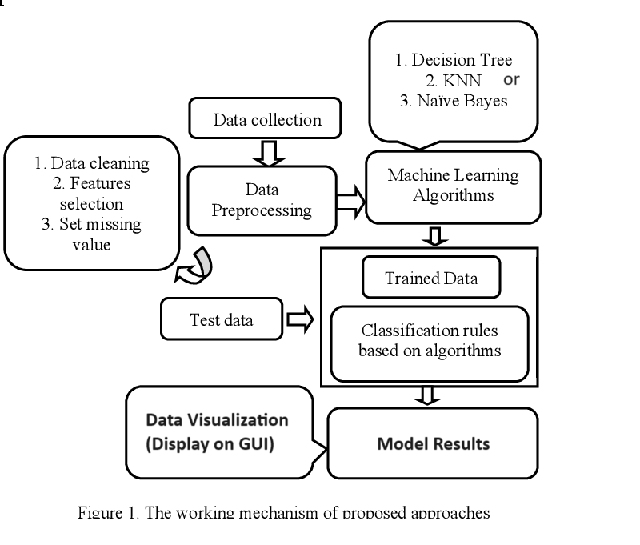

**Step 3: Train Data**

Once required data extracted and segmented, we need to train the data, train means converting the data into the required format such as numerical values or binary or string etc.

**Step 4: ML Technique for Prediction**

In this project for prediction, we make use to “*Bayesian Classifier or KNN algorithm*” which is an efficient and works fine for all different sets of parameters. It also generates accurate results.

**Step 5: Model Built**

Model developed using efficient machine learning algorithms and test for all different ratios and best model is used.

**Step 6: Results**

Results generated by the algorithm is checked with the accuracy using confusion matrix method. Here we validate the results generated by the algorithm “*Bayesian classifier*” and “*KNN algorithm*”.

**Step 7: Visual Representation**

Final outputs represented on GUI. When user’s gets login to the application system predicts the outputs and displays on a GUI.

**Naïve bayes algorithm**

**Input:**

Training dataset T,

F=( f_{1}, f_{2}, f_{3} ,...,f n ) // value of the predictor variable in testing dataset.

**Output:**

A class of testing dataset.

**Steps:**

1. Read the training dataset T;

2. Calculate the mean and standard deviation of the predictor variables in each class;

3. Repeat

Calculate the probability of fi using the gauss   
density equation in each class;

Until the probability of all predictor variables ( f_{1}, f_{2} , f_{3} ,...,f n ) has been calculated.

4. Calculate the likelihood for each class;

1. Get the greatest likelihood;

**Random Forest**

The working of random forest algorithm is as follows.

1. A random seed is chosen which pulls out at random a collection of samples from the training dataset while maintaining the class distribution.

2. With this selected data set, a random set of attributes from the original data set is chosen based on user defined values. All the input variables are not considered because of enormous computation and high chances of over fitting.

3. In a dataset where M is the total number of input attributes in the dataset, only R attributes are chosen at random for each tree where R < M

4. The attributes from this set creates the best possible split using the Gini index to develop a decision tree model. The process repeats for each of the branches until the termination condition stating that leaves are the nodes that are too small to split.

VI. EXPERIMENTATION RESULTS

**NB Algorithm Results**

Here we build a real time application useful for the society. This project build using Microsoft technologies. Medical datasets trained using Naive Bayes algorithm and we got very good results. Naive Bayes algorithm is programmed in such a way that, it works for dynamic datasets. Naive Bayes algorithm logic is written and it’s our own library. We are getting around 85.7% of accurate results and it takes around 1500 milli seconds for prediction.

|  |  |
| --- | --- |
| **Constraint** | **Naïve Bayes Algorithm** |
| **Accuracy** | **85.78** % |
| **Time (milli secs)** | **1606** |
| **Correctly Classified (precision)** | **85.78** % |
| **Incorrectly Classified (Recall)** | **14.22 %** |

VII. CONCLUSION

Now a days patients mortality increasing in the hospitals. To many emergency patients admitting to the hospitals due to heart problems, kidney problem, lung cancer, liver disease and many other chronic diseases. It is very important to identify such kind of diseases at early stages. Identifying low risk and high risk patients at emergency department play a vital role in the hospital or medical sector. Proposed system uses ML models to predict high risk patients so as to provide proper treatments in time. Real time application built which helps ICU departments in knowing high risk patients.

REFERENCES

[1] Tiwari, S. P., Upadhyay, A., & Karthikeyan, S. (2020). Artificial Intelligence based Comparative Study of Mortality Prediction. In Proceedings of the Fourth International Conference on Computing Methodologies and Communication (ICCMC 2020) (pp. 1-6). IEEE. https://doi.org/10.1109/ICCMC48092.2020.9138554

[2] Ahmad, F., Ayub, H., Liaqat, R., Khan, A. A., Nawaz, A., & Younis, B. (2021). Mortality Prediction in ICU Patients Using Machine Learning Models. In 2021 International Bhurban Conference on Applied Sciences and Technologies (IBCAST), Islamabad, Pakistan (pp. 372-376). doi: 10.1109/IBCAST51254.2021.9393012.

[3] Puttinaovarat, S., Pruitikanee, S., Kongcharoen, J., & Horkaew, P. (2021). Machine learning based emergency patient classification system. International Journal of Online Engineering, 17(5), 1-12. doi:10.3991/ijoe.v17i05.22341

[4] M. G. and B. G. Jayram (2017). Feature based Encryption for Data Privacy and Access Control for Medical application. In 2017 International Conference on Current Trends in Computer, Electrical, Electronics and Communication (CTCEEC), Mysore, India (pp. 175-179). doi: 10.1109/CTCEEC.2017.8455164.

[5] Ahmad, F., Ayub, H., Liaqat, R., Khan, A. A., Nawaz, A., & Younis, B. (2021). Mortality Prediction in ICU Patients Using Machine Learning Models. In 2021 International Bhurban Conference on Applied Sciences and Technologies (IBCAST) (pp. 372-376). doi: 10.1109/IBCAST51254.2021.9393012.

[6] Quiroz-Juárez, M. A., Torres-Gómez, A., Hoyo-Ulloa, I., León-Montiel, R. de J., & U’Ren, A. B. (2021). Identification of high-risk COVID-19 patients using machine learning. PLOS ONE, 16(9), e0257234. doi:10.1371/journal.pone.0257234.

[7] Joshi, H., Varma, H., & Surapaneni, R. T. (2014). Enhanced Test Case Design mechanism for regression & impact testing. In International Conference on Computing and Communication Technologies, Hyderabad, India (pp. 1-3). doi: 10.1109/ICCCT2.2014.7066739.

[8] Johnson, A. E., Ghassemi, M. M., Nemati, S., Niehaus, K. E., Clifton, D., & Clifford, G. D. (2016). Machine learning and decision support in critical care. Proceedings of the IEEE, 104(2), 444–466.

[9] Silva, I., Moody, G., Scott, D. J., Celi, L. A., & Mark, R.G. (2012). Predicting in-hospital mortality of ICU patients: The Physionet/Computing in Cardiology challenge 2012. In Computers in Cardiology, 2012. IEEE.

[10] Johnson, A. E., Ghassemi, M. M., Nemati, S., Niehaus, K. E., Clifton, D., & Clifford, G. D. (2016). Machine learning and decision support in critical care. Proceedings of the IEEE, 104(2), 444–466.

[11] Wei, Q., & Dunbrack, R. L. Jr. (2013). The role of balanced training and testing data sets for binary classifiers in bioinformatics. PloS one, 8(7), e67863.

[12] Citi, L., & Barbieri, R. (2012). PhysioNet 2012 Challenge: Predicting mortality of ICU patients using a cascaded SVM GLM paradigm. 2012 Computing in Cardiology. IEEE.

[13] Vairavan, S., et al. (2012). Prediction of mortality in an intensive care unit using logistic regression and a hidden Markov model. 2012 Computing in Cardiology. IEEE.

[14] Gannon, W. D., Lederer, D. J., Biscotti, M., Javaid, A., Patel, N. M., Brodie, D., Bacchetta, M., & Baldwin, M.R. (2018). Outcomes and mortality prediction model of critically ill adul