**ENHANCING WELLBEING: INTEGRATING GERIATRIC DESIGN PRINCIPLES IN SENIOR CARE CENTERS FOR REABLEMENT**

**1Ekemezie, Peter Chiemelie; 2Barnaby, Jude; 3Ezennia, Stephen Ikenna; 4Onuorah, Ikenna M; 5Aniakor, Ugochi C; 6Agu, Arinze; 7Ibekwe, Daniel; 8Onwurah, Chrysantus Chinyere**

12345&6Department of Architecture,

Faculty of Environmental Sciences,

7Department of Health Promotion and Public Health Education

Faculty of Education

Nnamdi Azikiwe University, Awka, Anambra State, Nigeria.

Email: b.jude@unizik.edu.ng

**ABSTRACT**

As societies worldwide confront the challenges posed by aging populations, there is a growing recognition of the need to shift from traditional models of eldercare towards holistic approaches that prioritize independence, functionality, and quality of life. This article explores the transformative potential of integrating geriatric design principles into senior care centers to facilitate reablement and enhance the wellbeing of older adults. Through a synthesis of existing research, case studies, and expert perspectives, this article investigates how the application of geriatric design principles can contribute to the success of reablement programs in senior care settings. It examines the fundamental principles of geriatric design, including accessibility, safety, comfort, and social engagement, emphasizing their role in creating environments that support reablement goals. Additionally, the article addresses implementation challenges and opportunities, including financial constraints, regulatory considerations, staff training, and resident-centered care approaches. By showcasing successful reablement initiatives and design interventions from around the globe, this article offers valuable insights and practical recommendations for architects, healthcare professionals, policymakers, and caregivers committed to enhancing the wellbeing and autonomy of older adults in senior care centers. Ultimately, the integration of geriatric design principles holds promise for revolutionizing eldercare practices and fostering positive outcomes for aging populations in an increasingly age-friendly world.

**INTRODUCTION**

"Ageing is not lost youth but a new stage of opportunity and strength," states the World Health Organization (WHO), encapsulating the evolving narrative around ageing and elder care (WHO, 2015). This profound sentiment urges a reexamination of how societies perceive and treat their ageing populations. As demographic shifts result in a growing number of older adults globally, there is an increasing imperative to develop innovative and compassionate care approaches that enhance the quality of life for this demographic. According to the United Nations, the number of people aged 60 years or over is expected to more than double by 2050, reaching 2.1 billion (UN, 2019). This significant increase underscores the necessity for effective strategies that promote healthy ageing and improve the well-being of older adults.

One such approach that has gained considerable attention is reablement, a person-centered model of care focused on rehabilitation and recovery. Reablement emphasizes the restoration of functional abilities and independence among older adults following illness or injury, thereby enabling them to maintain or regain their autonomy (Tuntland et al., 2015). Unlike traditional care models that may foster dependency, reablement aims to empower individuals by encouraging active participation in their own care and promoting the development of skills necessary for daily living. Studies have shown that reablement can lead to significant improvements in physical function, mental health, and overall quality of life for older adults (Metzelthin et al., 2013; Lewin et al., 2014). Furthermore, the approach aligns with the principles outlined in the WHO Global Strategy and Action Plan on Ageing and Health, which advocates for comprehensive health and social care systems that support functional ability and well-being in older age (WHO, 2017).

Reablement’s focus on rehabilitation and functional recovery also contributes to reducing the long-term demand on healthcare resources. By promoting independence and reducing the need for continuous care, reablement can lead to more sustainable healthcare systems. The National Institute for Health and Care Excellence (NICE) in the UK highlights that reablement services can help delay or avoid the need for more intensive and costly health and social care interventions (NICE, 2018). Access to green spaces, both indoor and outdoor, can provide opportunities for relaxation, social interaction, and physical activity, promoting a sense of connection with nature and reducing stress levels (Barnaby et al, 2023). This economic benefit, coupled with the personal and societal advantages of enhanced quality of life and increased independence, makes reablement an attractive and necessary approach in contemporary elder care.

In light of these considerations, integrating reablement into the broader framework of elder care represents a progressive step towards addressing the complex needs of ageing populations. This integration acknowledges the multifaceted challenges faced by older adults, including physical decline, social isolation, and the loss of independence. By focusing on reablement, elder care strategies can shift from merely managing ageing to fostering environments where older adults can regain and maintain their functional abilities. Reablement programs are designed to help individuals relearn essential daily activities, thereby promoting autonomy and reducing dependency on long-term care services (Tuntland et al., 2015). This approach aligns with the goals of the WHO's Active Ageing framework, which emphasizes the importance of optimizing opportunities for health, participation, and security to enhance quality of life as people age (WHO, 2002).

The shift towards reablement reflects a broader movement within geriatric care to promote resilience and strength among older adults. This paradigm shift is rooted in the understanding that ageing should not be viewed solely as a period of inevitable decline, but rather as a stage of life that can be enriched through targeted interventions and supportive environments. Research indicates that reablement can lead to significant improvements in physical functioning, mental health, and social engagement (Lewin et al., 2014). For instance, studies have shown that reablement services can reduce the need for hospital admissions and delay the onset of disability, thereby enhancing the overall well-being of older adults (Metzelthin et al., 2013). Such outcomes are crucial in an era where the ageing population is rapidly expanding, placing increasing demands on healthcare systems worldwide.

This paradigm shift towards reablement is supported by robust evidence and international endorsements, underscoring the importance of viewing ageing as a period of continued growth and potential. The success of reablement programs in various countries highlights the potential for widespread adoption of this approach. For example, the Danish model of reablement, which has been implemented nationwide, has demonstrated substantial benefits in terms of cost-effectiveness and improved quality of life for older adults (Meldgaard Hansen, 2017). Furthermore, the National Institute for Health and Care Excellence (NICE) in the UK has recommended reablement as a key strategy for promoting independence and reducing the need for long-term care (NICE, 2018). These endorsements reflect a growing consensus on the value of reablement as a transformative approach to elder care.

By integrating reablement into the fabric of elder care, societies can transform how they support their older members, fostering an environment where ageing is seen as a time of opportunity and growth. This approach not only benefits older adults by enhancing their quality of life but also alleviates the burden on healthcare systems by reducing the demand for intensive care services. As societies continue to grapple with the implications of an ageing population, the adoption of reablement and similar strategies will be crucial in ensuring that older adults can live fulfilling, independent lives. This transformation requires a commitment to rethinking and redesigning elder care, guided by the principles of resilience, autonomy, and holistic well-being (Lazarus & Folkman, 1984; Vellas et al., 1998).

This article aims to explore the transformative potential of integrating geriatric design principles in senior care centers for reablement. By examining how thoughtful design can enhance the physical, emotional, and social well-being of older adults, this study seeks to illuminate the critical role that the built environment plays in supporting reablement efforts. This exploration will contribute to a deeper understanding of how geriatric design principles can be effectively implemented to foster resilience and empower older adults in their journey towards recovery and sustained well-being.

**RESEARCH METHOD**

This study employed a qualitative research methodology, incorporating an extensive literature review and detailed case studies to explore the integration of geriatric design principles in senior care centers for reablement. The literature review encompassed a wide range of sources, including books, journal articles, reports, and guidelines from international organizations such as the World Health Organization (WHO) and the American Society on Aging (ASA), to establish a theoretical framework and identify best practices. Concurrently, case studies of senior care centers that have successfully implemented reablement programs with geriatric design elements were analyzed to uncover practical insights and real-world applications. This mixed approach ensured a comprehensive understanding of how geriatric design principles can be effectively integrated into reablement-focused senior care settings.

**THE CONCEPT OF REABLEMENT**

Reablement is a transformative approach in elder care that emphasizes the restoration and enhancement of functional abilities in older adults following illness or injury. This concept is rooted in a person-centered philosophy, focusing on enabling individuals to regain independence and improve their quality of life through targeted rehabilitation interventions. According to Tuntland et al. (2015), reablement aims to empower older adults by emphasizing their strengths and capacities rather than their limitations. This approach is designed to be holistic, addressing not only physical rehabilitation but also cognitive, emotional, and social aspects of well-being. The World Health Organization (WHO) underscores the importance of reablement as a means to promote active ageing and reduce the burden of chronic diseases and disabilities in older populations (WHO, 2015).

Central to the reablement philosophy is the idea of active participation, where older adults are encouraged to take an active role in their recovery process. This involves tailored support plans that focus on achieving specific, meaningful goals that are important to the individual, such as walking to a local store, gardening, or cooking a meal independently. As pointed out by Lewin and Vandermeulen (2010), the reablement approach contrasts with traditional care models that may focus more on providing care rather than enabling self-care. By fostering a sense of autonomy and self-efficacy, reablement not only improves physical health outcomes but also enhances psychological well-being and social engagement.

The evidence supporting reablement is robust and growing. Studies have demonstrated that reablement can lead to significant improvements in daily functioning and a reduction in the need for long-term care services. For instance, a study by Glendinning et al. (2010) found that older adults who participated in reablement programs showed marked improvements in mobility and daily living activities compared to those receiving conventional home care. Furthermore, reablement has been shown to be cost-effective, reducing the overall expenditure on health and social care by decreasing hospital admissions and delaying the need for more intensive care services (King et al., 2012).

In practice, reablement programs often involve multidisciplinary teams comprising physiotherapists, occupational therapists, nurses, and social workers who collaborate to provide comprehensive support tailored to the individual's needs. This integrated approach ensures that all aspects of an older adult's health and well-being are addressed. According to Delloite and Traynor (2012), successful reablement interventions require not only professional expertise but also a supportive environment that encourages and facilitates active engagement in rehabilitation activities.

**Components of Reablement**

Reablement is a multifaceted approach that enhances the well-being and independence of older adults. By addressing the comprehensive needs of ageing populations, reablement offers a promising framework for promoting resilience and quality of life in elder care. Below are some components of reablement.

1. Person-Centered Approach

At the heart of reablement is a person-centered approach, which involves individualized assessment and goal setting tailored to each older adult's unique needs and aspirations. This approach recognizes the importance of personal autonomy and empowers individuals to take an active role in their recovery. Tuntland et al. (2015) emphasize that reablement programs focus on what individuals can do rather than what they cannot, fostering a sense of independence and self-efficacy. Empowerment and active participation are crucial as they ensure that the rehabilitation process is meaningful and aligned with the individual's personal goals and values.

1. Multidisciplinary Team Involvement

Reablement relies heavily on the involvement of a multidisciplinary team, including physiotherapists, occupational therapists, nurses, and social workers. Collaborative care planning among these professionals ensures a comprehensive approach to addressing the various aspects of an older adult's health and well-being. The integration of different expertise facilitates holistic care that covers physical, emotional, and social dimensions. Lewin and Vandermeulen (2010) highlight the importance of such collaboration in creating effective and sustainable reablement programs.

1. Holistic Rehabilitation

Holistic rehabilitation is another cornerstone of reablement, addressing not only physical capabilities but also cognitive and emotional well-being. Physical rehabilitation focuses on improving mobility, strength, and daily functioning, while cognitive and emotional support aims to enhance mental health and coping strategies. According to Chaudhury et al. (2013), a holistic approach ensures that all facets of an individual’s life are considered, promoting overall well-being and a higher quality of life.

1. Environmental Adaptations

Environmental adaptations play a significant role in supporting reablement by creating safer and more accessible living environments. Home modifications, such as installing grab bars or ramps, and the use of assistive technology, like mobility aids and communication devices, help individuals perform daily activities more independently. The World Health Organization (WHO) underscores the importance of adapting environments to meet the needs of ageing populations, thereby reducing the risk of accidents and promoting autonomy (WHO, 2007).

1. Community Engagement and Social Inclusion

Reablement also focuses on fostering community engagement and social inclusion, which are essential for preventing social isolation and promoting mental well-being. Building social support networks and encouraging participation in community-based activities help older adults stay connected and engaged. Vellas et al. (1998) note that social inclusion is vital for maintaining a sense of belonging and purpose, which significantly contributes to overall well-being.

1. Monitoring and Evaluation

Monitoring and evaluation are critical components of reablement, ensuring that the interventions are effective and meet the desired outcomes. Progress tracking involves regular assessments to gauge improvements and identify areas needing adjustment. Outcome measurement helps in understanding the impact of reablement programs on individuals' functional abilities and quality of life. King et al. (2012) highlight the importance of continuous evaluation in refining reablement strategies and achieving long-term success.

**Types of Reablement**

Various types of reablement programs exist, each tailored to meet the unique needs and preferences of older adults in different care settings. these programs aim to promote independence, enhance well-being, and facilitate successful ageing among older populations.

1. Home-Based Reablement

Home-based reablement programs focus on providing rehabilitation and support services to older adults within their own homes. This type of reablement allows individuals to remain in familiar surroundings, promoting independence and autonomy (Lewin & Vandermeulen, 2010). Trained professionals, including physiotherapists, occupational therapists, and home care aides, deliver personalized care and support tailored to the individual's needs and goals (Tuntland et al., 2015). Research suggests that home-based reablement programs lead to improvements in activities of daily living, mobility, and overall quality of life among older adults (Lewin & Vandermeulen, 2010).

**2.** Hospital-Based Reablement

Hospital-based reablement programs provide intensive rehabilitation services to older adults recovering from acute illness or injury in hospital settings. This type of reablement aims to facilitate recovery and functional independence before transitioning individuals back to their homes or community settings (King et al., 2012). Interdisciplinary teams, including physicians, nurses, therapists, and social workers, collaborate to design and implement individualized care plans focused on rehabilitation and discharge planning (Tuntland et al., 2015). Hospital-based reablement has been shown to reduce hospital readmissions and improve post-discharge outcomes, such as functional status and caregiver burden (King et al., 2012).

**3.** Community-Based Reablement

Community-based reablement programs offer rehabilitation and support services to older adults living in community settings, such as assisted living facilities or retirement communities. This type of reablement aims to promote independence and social inclusion among older adults while enabling them to age in place within their chosen community (Lewin & Vandermeulen, 2010). Community-based reablement services may include group exercise classes, social activities, and home visits by healthcare professionals to address individuals' physical, social, and emotional needs (Tuntland et al., 2015). Studies indicate that community-based reablement programs contribute to improved well-being, reduced social isolation, and enhanced community engagement among older adults (Lewin & Vandermeulen, 2010).

**4.** Residential Reablement

Residential reablement programs offer rehabilitation and support services to older adults residing in long-term care facilities or nursing homes. This type of reablement aims to maximize functional independence and quality of life among older adults with complex care needs who may require ongoing support (Tuntland et al., 2015). Trained staff members, including nurses, therapists, and personal care aides, work collaboratively to provide individualized care plans focused on rehabilitation, self-care skills, and social engagement (Lewin & Vandermeulen, 2010). Residential reablement programs have been associated with improvements in mobility, independence in activities of daily living, and resident satisfaction with care services (Tuntland et al., 2015).

**5.** Virtual Reablement

Virtual reablement programs leverage technology to deliver rehabilitation and support services to older adults remotely, often through telehealth platforms or digital health applications. This type of reablement offers flexibility and convenience, allowing older adults to access care and support services from the comfort of their homes while promoting social distancing and reducing healthcare-related costs (Tuntland et al., 2015). Virtual reablement services may include virtual consultations with healthcare professionals, remote monitoring of vital signs and progress, and access to educational resources and exercise programs through online platforms (King et al., 2012). Research suggests that virtual reablement programs can lead to improvements in physical function, adherence to treatment plans, and overall satisfaction with care among older adults (King et al., 2012).

**GERIATRIC DESIGN PRINCIPLES FOR REABLEMENT**

**Accessibility and Mobility**

Accessibility and mobility are fundamental aspects of geriatric design principles aimed at optimizing the living environment for older adults within senior care centers. According to Steinfeld and Danford (1999), ensuring ease of access to facilities and amenities is crucial in accommodating individuals with mobility impairments. This involves the installation of features such as ramps, handrails, and wide doorways, which facilitate movement and navigation for residents with mobility challenges. Moreover, implementing universal design principles, as proposed by Mace (1985), is essential for creating environments that are usable by people of all ages and abilities. By integrating elements such as step-free entrances, lever door handles, and adjustable-height countertops, senior care centers can promote inclusivity and independence among residents. These design strategies not only enhance accessibility for older adults with mobility limitations but also contribute to a more welcoming and inclusive environment for all residents, regardless of their physical abilities or age.

**Safety and Fall Prevention**

Safety and fall prevention are paramount considerations in geriatric design, aimed at minimizing the risk of accidents and injuries among older adults. Incorporating features such as non-slip flooring, grab bars, and adequate lighting is essential to create environments that prioritize safety (WHO, 2007). According to the World Health Organization (WHO), these design elements contribute significantly to reducing the incidence of falls, which pose a significant health risk for older individuals. Additionally, designing layouts that minimize obstacles and hazards while maintaining clear sightlines and wayfinding cues enhances safety and navigation within the facility (Chaudhury et al., 2013). This approach aligns with the principles of universal design, ensuring that environments are accessible and user-friendly for individuals of all ages and abilities, thereby promoting inclusivity and independence (Mace, 1985). By integrating these safety features into the built environment, geriatric design principles prioritize the well-being and physical integrity of older adults, fostering environments that support their continued mobility and independence.

**Comfort and Ergonomics**

Comfort and ergonomics play a crucial role in enhancing the well-being of older adults within senior care centers. It involves carefully selecting furnishings and equipment that prioritize comfort, support, and ease of use, considering the physical limitations and preferences of older individuals (Chaudhury et al., 2013). This approach ensures that the living environment is tailored to meet the unique needs of seniors, promoting independence and minimizing discomfort. Additionally, optimizing factors such as lighting, acoustics, and thermal comfort is essential in creating pleasant and stimulating environments that contribute to overall well-being and engagement (Ulrich, 1984). Adequate lighting helps seniors navigate their surroundings safely, while appropriate acoustics reduce noise levels and promote relaxation. Moreover, maintaining thermal comfort ensures that older adults feel at ease within their living spaces, fostering a sense of contentment and satisfaction. By prioritizing comfort and ergonomics, senior care centers can create environments that support the physical and emotional needs of older adults, enhancing their quality of life and promoting well-being.

**Socialization and Community Engagement**

The aspect of Socialization and Community Engagement within geriatric design principles for reablement encompasses creating environments that promote meaningful interactions and a sense of belonging among older adults. Designing communal spaces tailored for social interaction, recreation, and group activities is essential for fostering a supportive community within senior care centers (Day, Carreon, & Stump, 2000). These spaces serve as hubs for residents to engage in shared interests, build relationships, and alleviate feelings of loneliness or isolation commonly experienced in older age. Moreover, incorporating outdoor spaces and gardens within senior care facilities has been shown to have profound benefits for residents' mental and emotional well-being (Marx et al., 2014). Access to green spaces encourages outdoor activities, relaxation, and contact with nature, providing opportunities for physical exercise, contemplation, and connection with the natural environment, which are all vital aspects of promoting holistic well-being among older adults.

**Flexibility and Adaptability**

Flexibility and adaptability in geriatric design principles are essential to address the evolving needs of older adults within senior care centers. This approach involves creating spaces that can easily adjust to changing circumstances, preferences, and care requirements over time. As highlighted by Chaudhury et al. (2013), flexibility allows for customization and personalization according to individual needs, promoting a sense of autonomy and empowerment among residents. Additionally, incorporating modular design elements and adjustable features, as advocated by Steinfeld and Danford (1999), enables senior care facilities to cater to varying levels of mobility, independence, and care needs among residents. By designing spaces that can be easily modified or reconfigured, senior care centers can better accommodate the diverse and changing needs of their residents, ultimately enhancing their quality of life and well-being.

**Dignity and Privacy**

The concept of dignity and privacy is integral to the well-being and quality of life of older adults in senior care centers. According to the World Health Organization (WHO, 2007), it is essential to respect the dignity of older individuals by providing them with private living spaces and personal storage areas where they can maintain a sense of autonomy and self-expression. This approach aligns with the principles of person-centered care, emphasizing the importance of preserving individual identity and agency even in a care setting (Chaudhury et al., 2013). Furthermore, Chaudhury and colleagues (2013) emphasize the significance of designing layouts that strike a balance between privacy and social interaction, allowing residents to engage with others while still having the option for solitude and personal space. By creating environments that prioritize dignity and privacy, senior care centers can empower older adults to maintain a sense of control over their lives while fostering a supportive and respectful community atmosphere.

**CHALLENGES OF INCORPORATING GERIATRIC DESIGN PRINCIPLES FOR REABLEMENT**

Incorporating geriatric design principles for reablement in senior care centers presents several challenges that must be addressed to optimize the effectiveness of such initiatives. One primary challenge is the need to balance safety with autonomy. While ensuring safety is paramount, overly restrictive design features can inadvertently diminish residents' sense of independence and agency. Finding the right balance between safety measures and opportunities for self-determination requires careful planning and consideration (Chaudhury et al., 2013). Additionally, financial constraints often pose a significant challenge, as implementing geriatric design principles may require investments in infrastructure, technology, and staff training. Limited resources can hinder the ability of senior care centers to fully integrate these principles into their facilities, highlighting the importance of creative solutions and collaboration with stakeholders to overcome budgetary constraints (Kane et al., 2017).

Resistance to change within existing care systems and organizational structures can impede the adoption of geriatric design principles for reablement. Traditional models of care may prioritize efficiency and institutional routines over person-centered approaches, making it challenging to implement innovative design strategies that prioritize individual needs and preferences (Chaudhury et al., 2013). Overcoming resistance to change requires strong leadership, staff buy-in, and ongoing education and training to foster a culture that values and embraces new approaches to elder care. Additionally, addressing the diverse and evolving needs of older adults presents another significant challenge. Seniors entering care facilities have varying levels of physical, cognitive, and emotional functioning, necessitating flexible and adaptable design solutions that can accommodate a wide range of abilities and preferences (Cutchin et al., 2008). Providing personalized care and support requires a nuanced understanding of individual needs and circumstances, highlighting the importance of comprehensive assessments and interdisciplinary collaboration in the design and implementation of geriatric care environments for reablement.

**SENIOR CARE CENTERS WHERE GERIATRIC DESIGN PRINCIPLES ARE INTEGRATED FOR REABLEMENT.**

There are several senior care centers worldwide that have successfully integrated geriatric design principles for reablement, creating environments that support the rehabilitation, independence, and well-being of older adults. Here are a three notable examples:

**Hogeweyk Dementia Village**

Hogeweyk Dementia Village in the Netherlands stands as a pioneering example of how geriatric design principles can be effectively integrated into senior care to support reablement. Opened in 2009, Hogeweyk reimagines dementia care by creating an environment that mimics a typical Dutch village, providing residents with a sense of normalcy, autonomy, and community.

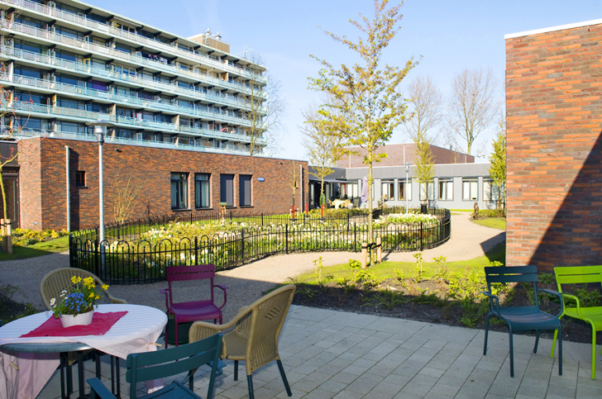

Figure 1: Exterior of the Hogeweyk Dementia Village

Source: https://inhabitat.com/self-contained-dementia-village-protects-people-suffering-from-dementia-and-alzheimers-from-themselves/

The design of Hogeweyk reflects key geriatric principles such as accessibility, safety, and social engagement. Each of the 23 houses within the village accommodates 6-7 residents, providing private rooms and shared communal spaces designed to foster social interaction and a homely atmosphere (van Steenwinkel, Baumers, & Heylighen, 2017). This layout not only respects the privacy and dignity of each resident but also encourages daily activities that promote physical and cognitive function, aligning with the goals of reablement by maintaining and enhancing residents' abilities in a familiar and supportive environment (WHO, 2007).

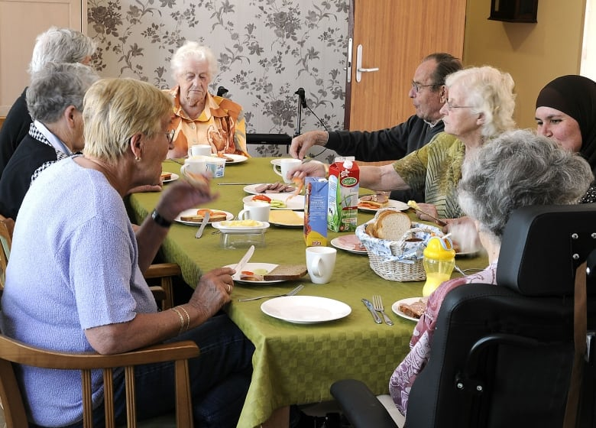

Figure 2: Common meal at Hogeweyk Dementia Village

Source: https://www.cbc.ca/news/canada/calgary/dementia-village-alzheimers-alberta-calgary-gerontology-1.4024693

The entire village is enclosed, ensuring safety without the feel of confinement, which is crucial for residents with dementia. Hogeweyk’s design includes accessible outdoor spaces, such as gardens, streets, and squares, which are vital for physical activity and mental well-being (Calkins, 2018). Additionally, the presence of various amenities, like a supermarket, cafe, and theater, allows residents to engage in everyday activities, fostering a sense of normalcy and purpose (Verbeek et al., 2010). This innovative approach not only improves the quality of life for residents but also aligns with contemporary geriatric care models that emphasize the importance of a therapeutic environment in promoting reablement and holistic well-being (Chaudhury et al., 2013). By integrating these design principles, Hogeweyk demonstrates that it is possible to create a supportive and enriching environment for seniors, which promotes independence and enhances their overall quality of life.

**The Green House Project, USA**

The Green House Project in the USA exemplifies a transformative approach to senior care by integrating geriatric design principles that support reablement. This innovative model seeks to create environments that are radically different from traditional nursing homes, focusing on providing a more home-like, personalized setting for older adults. Each Green House home is designed to house a small number of residents, typically 10-12, which fosters a sense of community and personal connection.

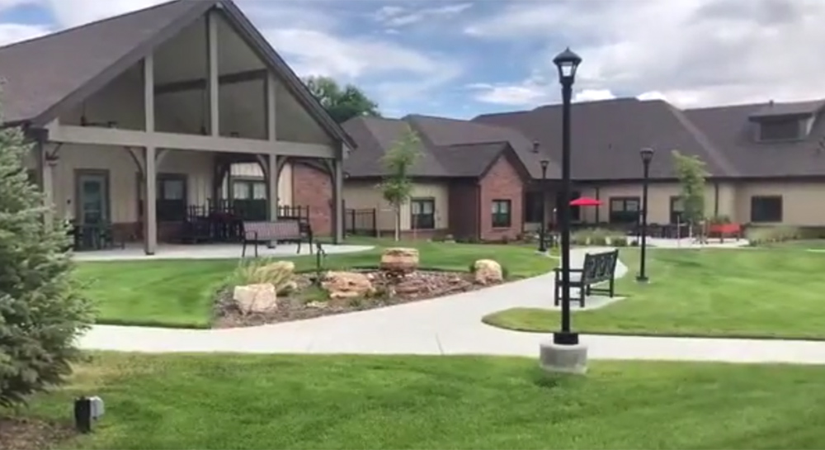

Figure 3: Exterior of the Green House Project

Source: <https://thegreenhouseproject.org/education-events/workshops/>

The design emphasizes private rooms with private baths to ensure privacy and dignity, while communal spaces such as open kitchens and living rooms encourage social interaction and engagement. This layout promotes autonomy and a sense of normalcy, allowing residents to live more independently and participate in daily activities at their own pace (Kane et al., 2007).

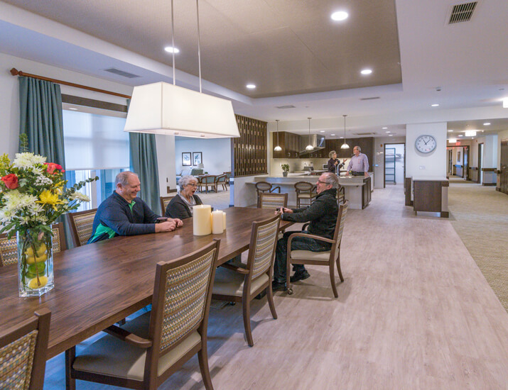

Figure 4: An interior space in the Green House Project

Source: https://www.clarklindsey.com/care-services/green-house-homes/

In addition to architectural design, The Green House Project incorporates principles that align with the goals of reablement, which focuses on restoring functional abilities and enhancing quality of life. The care model emphasizes resident-centered care, where staff, known as Shahbazim, are cross-trained to provide both care and support in household tasks, thereby fostering a closer relationship with residents and understanding their individual needs and preferences. This holistic approach not only addresses the physical health needs of the residents but also supports their emotional and social well-being. Studies have shown that residents in Green House homes experience better health outcomes and higher satisfaction levels compared to traditional nursing home settings (Rabig et al., 2006). By integrating geriatric design principles that promote dignity, privacy, and community engagement, The Green House Project serves as a benchmark for reablement-focused senior care that prioritizes the holistic well-being of older adults.

**Saint Bede's Home, Australia**

Saint Bede's Home in Australia stands out as a prominent example of a senior care center where geriatric design principles are meticulously integrated to support reablement. The facility emphasizes a holistic approach to elder care, blending architectural design with therapeutic practices to create an environment conducive to both physical and psychological well-being.

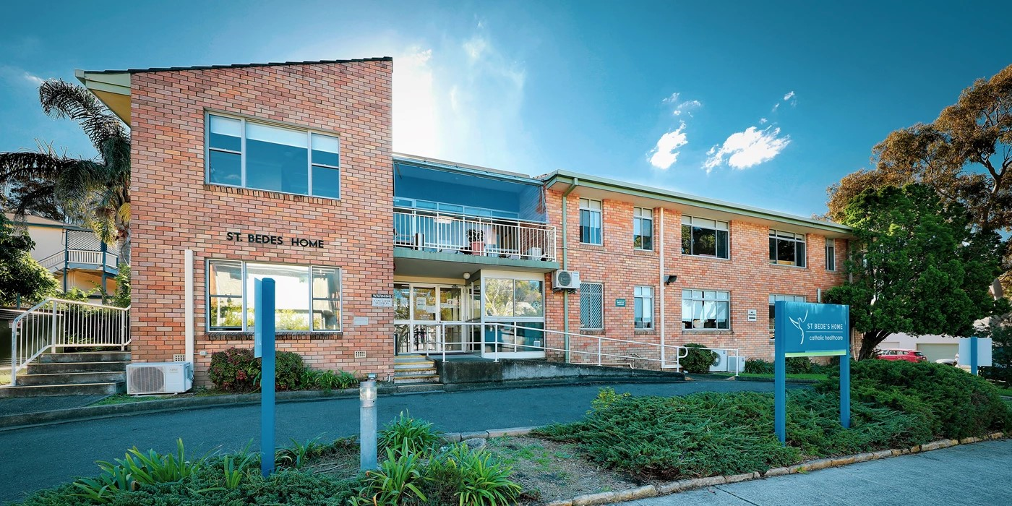

Figure 5: Exterior view of Saint Bede's Home

Source: https://www.catholichealthcare.com.au/residence/st-bedes-home-south-hurstville/

Key features of Saint Bede's Home include private living quarters that provide residents with a sense of dignity and personal space, while common areas are designed to encourage social interaction and community engagement. The facility's layout includes wide corridors, non-slip flooring, and handrails to ensure safety and mobility, thereby reducing the risk of falls and facilitating independence among residents (Aged Care Quality and Safety Commission, 2020).

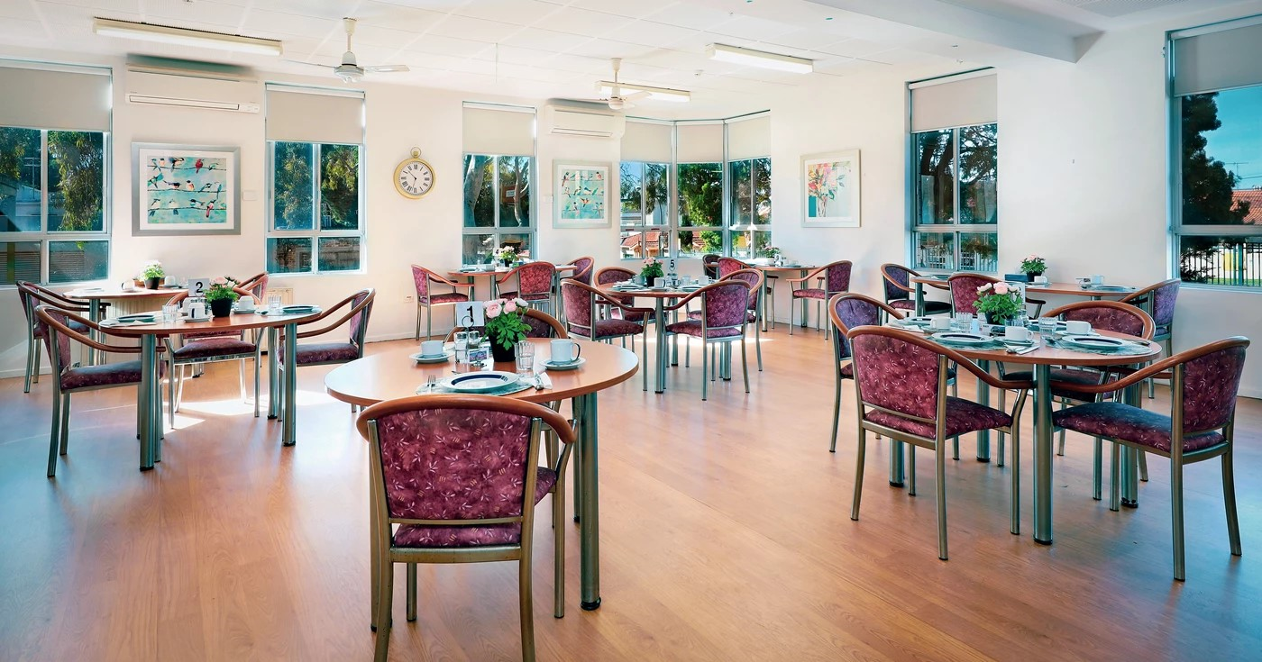

Figure 6: A communal space in Saint Bede's Home

Source: <https://www.catholichealthcare.com.au/residence/st-bedes-home-south-hurstville/#3793>

The integration of accessible outdoor spaces such as gardens and walking paths encourages physical activity and interaction with nature, which are essential components of reablement. These spaces are not only therapeutic but also promote a sense of tranquility and well-being. The center's commitment to reablement is reflected in its structured programs that focus on restoring functional abilities through physical therapy, occupational therapy, and social activities. By incorporating these design elements and therapeutic interventions, Saint Bede's Home effectively supports the principles of reablement, enhancing the overall quality of life for its residents and aligning with the recommendations of international organizations such as the World Health Organization (WHO, 2007; Chaudhury et al., 2013). This comprehensive approach underscores the potential of geriatric design principles to transform senior care environments into spaces that promote resilience, autonomy, and dignity for older adults.

**CONCLUSION**

Integrating geriatric design principles in senior care centers for reablement is essential to enhancing the well-being of older adults. By prioritizing accessibility, safety, comfort, and social engagement, these design principles create environments that support the physical, cognitive, and emotional health of residents. Successful examples such as Hogeweyk Dementia Village, Green House project and Saint Bede's Home demonstrate the transformative impact of thoughtfully designed spaces on the quality of life for seniors. These centers illustrate that it is possible to foster autonomy, dignity, and community through strategic design.

Implementing such principles requires a balance between safety and autonomy, careful planning, and collaboration among stakeholders. The benefits, however, are profound, offering not only a better quality of life for residents but also aligning with contemporary models of elder care that emphasize person-centered approaches and therapeutic environments. The commitment to integrating geriatric design principles in senior care centers is an investment in the health and happiness of older adults, paving the way for more resilient, independent, and engaged senior communities. As the population ages, it is imperative that more care facilities adopt these principles to ensure that all seniors can live their later years with dignity, comfort, and purpose.

**RECOMMENDATIONS**

1. Prioritize Person-Centered Design: Emphasize the importance of prioritizing individual needs and preferences in the design of senior care centers. Incorporate feedback from residents, caregivers, and healthcare professionals to create environments that promote autonomy, dignity, and comfort.

2. Invest in Staff Training and Education: Recognize the pivotal role of staff members in implementing and sustaining geriatric design principles. Invest in ongoing training and education programs to empower staff with the knowledge and skills needed to support reablement-focused care and create positive, supportive environments for residents.

3. Foster Collaboration and Partnerships: Encourage collaboration between architects, designers, healthcare providers, and community stakeholders to leverage collective expertise and resources in designing senior care centers. Foster partnerships with local organizations, universities, and research institutions to stay informed about innovative design practices and emerging trends in elder care.

4. Promote Research and Evaluation: Advocate for the integration of research and evaluation processes into design initiatives to assess the impact of geriatric design principles on resident wellbeing and quality of life. Support interdisciplinary research efforts that explore the effectiveness of specific design interventions and their implications for reablement outcomes.

5. Advocate for Policy and Regulatory Support: Advocate for policy and regulatory frameworks that prioritize reablement-focused design in senior care settings. Collaborate with policymakers, advocacy groups, and regulatory agencies to develop guidelines and standards that promote the adoption of geriatric design principles and ensure their implementation across diverse care environments.

**REFERENCES**

Aged Care Quality and Safety Commission. (2020). Design principles for aged care homes. Retrieved from <https://www.agedcarequality.gov.au>

Barnaby, J., Ezezue, A., Dominic, Anthony., David, C., Anaebo, C. (2023). Applying The Health Benefits of Biophilic Design to Priests’ Retirement Facilities in South Eastern Nigeria. African Journal Of Educational Management, Teaching And Entrepreneurship Studies 9 (1), 110 – 131.

Calkins, M. P. (2018). From research to application: Supportive and therapeutic environments for people living with dementia. The Gerontologist, 58(S1), S114-S128.

Chaudhury, H., Cooke, H. A., Cowie, H., & Razaghi, L. (2013). The influence of the physical environment on residents with dementia in long-term care settings: A review of the empirical literature. The Gerontologist, 53(5), 704-717.

Chaudhury, H., Mahmood, A., & Valente, M. (2013). The effect of environmental design on reducing nursing errors and increasing efficiency in acute care settings: A review and analysis of the literature. Environment and Behavior, 45(5), 627-672.

Cutchin, M. P., Dickie, V. A., & Dew, A. (2008). Building bridges: Community architecture, community work, and the reworking of dementia care. Health & Place, 14(4), 817-828.

Day, K., Carreon, D., & Stump, C. (2000). The therapeutic design of environments for people with dementia: A review of the empirical research. The Gerontologist, 40(4), 397-416.

Deloitte, S., & Traynor, J. (2012). Reablement: A cost-effective route to better outcomes. Journal of Integrated Care, 20(6), 327-343.

Glendinning, C., Jones, K., Baxter, K., Rabiee, P., Curtis, L., Wilde, A., & Arksey, H. (2010). Home care re-ablement services: Investigating the longer-term impacts (prospective longitudinal study). Research Works, 2010-03, Social Policy Research Unit, University of York.

Kane, R. A., Cutler, L. J., & Kane, R. L. (2017). Resident outcomes in small-house nursing homes: A longitudinal evaluation of the initial Green House program. Journal of the American Geriatrics Society, 65(11), 2426-2431.

King, A. I., Parsons, M., Robinson, E., & Jörgensen, D. (2012). Assessing the impact of a restorative home care service in New Zealand: A cluster randomised controlled trial. Health & Social Care in the Community, 20(4), 365-374.

Lazarus, R. S., & Folkman, S. (1984). Stress, appraisal, and coping. Springer Publishing Company.

Lewin, G., & Vandermeulen, S. (2010). A non-randomised controlled trial of the Home Independence Program (HIP): An Australian restorative programme for older home-care clients. Health & Social Care in the Community, 18(1), 91-99.

Lewin, G., Allan, J., Patterson, C., Knuiman, M., Boldy, D., & Hendrie, D. (2014). A comparison of the home-care and healthcare service use and costs of older Australians randomised to receive a restorative or a conventional home-care service. Health & Social Care in the Community, 22(3), 328-336.

Mace, R. L. (1985). Universal design: Barrier-free environments for everyone. Designers West, 33(2), 147-152.

Marx, M. S., Cohen-Mansfield, J., Regier, N. G., Dakheel-Ali, M., Srihari, A., & Thein, K. (2014). The impact of different therapies on the psychophysiological well-being of institutionalized dementia patients. Journal of Aging and Health, 26(4), 616-630.

Meldgaard Hansen, A. (2017). Reablement in Denmark: The use of everyday life as a treatment tool. Journal of Aging Research, 2017, Article ID 2081235.

Metzelthin, S. F., Rostgaard, T., Parsons, M., & Burton, E. (2013). Development and evaluation of reablement services. Ageing & Society, 33(4), 665-684.

National Institute for Health and Care Excellence (NICE). (2018). Intermediate care including reablement. NICE guideline [NG74]. <https://www.nice.org.uk/guidance/ng74>

Rabig, J., Thomas, W., Kane, R. A., Cutler, L. J., & McAlilly, S. (2006). Radical Redesign of Nursing Homes: Applying the Green House Concept in Tupelo, Mississippi. The Gerontologist, 46(4), 533-539.

Steinfeld, E., & Danford, G. S. (1999). Enabling environments: Measuring the impact of environment on disability and rehabilitation. Kluwer Academic/Plenum Publishers.

Tuntland, H., Aaslund, M. K., Espehaug, B., Førland, O., & Kjeken, I. (2015). Reablement in community-dwelling older adults: A randomised controlled trial. BMC Geriatrics, 15, 145.

Ulrich, R. S. (1984). View through a window may influence recovery from surgery. Science, 224(4647), 420-421.

United Nations (UN). (2019). World Population Ageing 2019: Highlights. Department of Economic and Social Affairs, Population Division. <https://www.un.org/development/desa/pd/news/world-population-ageing-2019>

Van Steenwinkel, I., Baumers, S., & Heylighen, A. (2017). How architectural design affords experiences of home: A phenomenological ethnography of the experience of home for people with dementia. Journal of Aging Studies, 41, 84-92.

Vellas, B. J., Rubenstein, L. Z., Ousset, P. J., & Andrieu, S. (1998). One-year fluoxetine therapy associated with sustained improvement of depressive symptoms and decline of depressive signs in patients with Alzheimer’s disease. International Journal of Geriatric Psychiatry, 13(7), 491-499.

Verbeek, H., van Rossum, E., Zwakhalen, S. M. G., Kempen, G. I. J. M., & Hamers, J. P. H. (2010). Small, homelike care environments for older people with dementia: A literature review. International Psychogeriatrics, 22(2), 252-264.

World Health Organization (WHO). (2002). Active Ageing: A Policy Framework. WHO.

World Health Organization (WHO). (2007). Global Age-Friendly Cities: A Guide. WHO.

World Health Organization (WHO). (2015). World report on ageing and health. WHO.

World Health Organization (WHO). (2017). Global Strategy and Action Plan on Ageing and Health. WHO.