### **Sophisticated Battery Management System Utilizing Pulse Charging Technology for Automobile.**

Jayashri.D.Rahane1, Mr.Somnath S. Hadpe2, Dr.Sridhar S. Khule3

1 Research Scholar, Matoshri College of Engineering and Research Center, Nashik 422105(Maharashtra), India

2 Professor, Matoshri College of Engineering and Research Center, Nashik 422105(Maharashtra), India

3 Head of Dept., Matoshri College of Engineering and Research Center, Nashik 422105 (Maharashtra), India [*1rahanejayashri4@gmail.com*](mailto:1rahanejayashri4@gmail.com)*, 2somnath.hadpe@matoshri.edu.in, 3sridhar.khule@matoshri.edu.in*

*Abstract*— Electric vehicles (EVs) are presently a significant piece of the auto business for two principal reasons: diminished dependence on oil and decreased air contamination, which assists us with adding to the improvement of a harmless to the ecosystem climate. EV purchasers analyze generally vehicle mileage, re-energize time, vehicle mileage after each charge, batteries charging/releasing security, life expectancy, charged rate, ability, and temperature increment. Another better heartbeat charging method is proposed, in which the battery is charged utilizing relative fundamental subordinate (PID) control activity and a brain organization. A PID regulator is utilized to foster the charging unit in this plan. The feed forward brain network was utilized to decide the upsides of the PID control boundaries. The battery the board framework (BMS) guarantees that this planned battery charging framework gets some margin to proficiently charge the battery. The framework is worked with MATLAB/Simulink.

Keyword: Battery management system Electric vehicles Neural network PID controller

# **INTRODUCTION**

Li-particle batteries used to have low degrees of self rate and a high energy thickness. For electric vehicle (EV) areas, lithium-particle batteries should further develop power the board, energy thickness, control, security, and charger [1]. Low encompassing temperatures in EV markets hinder Li+ particle dispersion at electrolytes and terminals, easing back difficulty energy. It is difficult to dispose of capably and consistently which prompts corruption and worries into security related issues because of the intensity created while doing quick charging of the battery [2]-[4]. The improvement of batteries innovation with battery-the executives frameworks, that incorporate observation, security, and checking of battery factors that act as the battery stage's mind, has basic to the advancement of electric vehicles. Since wrong activities like over-current, over-voltage, or over-charging/releasing may cause serious wellbeing worries to the cells, essentially speed up the maturing рrосеss or even out of control fires whenever left unattended [5]-[7]. Subsequently, battery the board framework (BMS) assumes a crucial part in ensuring battery dependability and wellbeing. It additionally has a programmed removed include, which separates the battery from the electrical circuit and loads the side while charging and releasing levels surpass the put down certain boundaries [8]-[10]. hybridized with Frosts. The specialists talk about the different electrical drives, like SRM, BLDC, PMSM, and enlistment engine drives, as well as their constraints and proposed setups with execution examination for EV applications [11]-[14]. Looks at the analytical purposes of over-adjustment procedures in particular staggered flowed converters for symphonious disposal in three-stage two-level voltage source inverters [15], [16]. A particular staggered converter with a rearranged closest level control (NLC) procedure was proposed for voltage adjusting [17]. Depicts the assessment and control view of a VSM-based staggered PV-STATCOM for a circulated energy framework for consonant decrease [18]. Show an assortment of force quality improvement strategies utilizing adaptable AC transmission frameworks (Realities) regulators and EV applications [19]-[22].

Long charging times and reach nervousness when contrasted with petroleum vehicles are the central concerns that make it challenging to embrace electric vehicles. Contingent upon the different electric vehicle prerequisites of the energy stockpiling framework might change altogether [23], [24]. With the assistance of different programming and equipment procedures, battery runtime can be moved along. Attributes of the batteries can be further developed by cutting edge charging calculation and further developing the result execution [25]-[27]. Subsequently this paper centers to lessen the battery charging time by carrying out a PID regulator in the charging unit of the battery, wherein the upsides of required P, I, and D boundaries will be concluded by the brain network which will be prepared likewise. The principal point of the paper is to configuration, create and carry out a heartbeat charging method that limits the charging season of the battery and at the same time screens and controls the charging condition of the battery boundary to further develop battery execution.

## Hence, beat accusing strategies of clever battery the board are planned and the created circuit is to screen the battery boundaries and thusly control them to improve battery execution that additionally recreates and investigations the created framework to assess the presentation. Consequently the fundamental commitments of the original copy are plan and improvement help to bring down the accusing season of insignificant impact on temperature increase during charging and it are limited to switch misfortunes. Likewise helps in lessening the charge current settling time and furthermore expands the battery charging limit. The complete consonant mutilation THD esteem is decreased up to 2.8, which is a lot of lower than the THD values got involving existing advances as displayed in the correlation table. This paper is portrayed into five segments as; area 1 presents a prologue to battery the board and a writing survey in light of an exploration region. Area 2 addresses the proposed framework design exhaustively. Segment 3 gives the reenactment results with reproduction waveforms. Segment 4 portrayed examinations of different execution boundaries with the work previously finished and area 5 followed by the end

# **Proposed framework engineering**

This document discusses the development of a sophisticated battery management system that relies on pulse charging. The core of this system integrates PID control and artificial neural networks (ANN). The fundamental concept behind this innovative design is the fine-tuning of the charging pulse frequency and duty cycle for optimal performance. This fine-tuning process is facilitated through the utilization of electronic design automation (EDA) software. Furthermore, the ANN component plays a vital role in overseeing and regulating various battery parameters. The utilization of MATLAB is pivotal in the design, execution, and validation of the efficiency of the customized battery management setup. The specifics of the proposed design have been outlined, emphasizing the crucial role of the charging unit in this particular model. The utilization of pulse charging technique, which is currently experiencing high demand, has been favored in this scenario. This approach primarily relies on regulating the charge current pulses that are delivered to the battery during the charging process. In this method, the charge pulses are directed towards the battery in a manner that optimizes the charging duration while taking into account various time optimization factors such as battery heating, polarization, state of charge, and variable battery impedances. Additionally, during the resting intervals of each charge pulse, ions permeate through the electrode materials.

Explanation: The paraphrased text maintains the original message about describing the design details and the significance of the charging unit using a formal tone suitable for a knowledgeable audience. The key technical aspects related to the pulse charging technique and its optimization are retained, ensuring clarity and coherence in the rewritten content. This plays a crucial role in enhancing the charging process efficiency. By carefully selecting the charge current pulse parameters, one can ensure not only a prolonged battery lifespan but also its optimal functionality. Given these considerations, PID control emerges as the most suitable control method for crafting the necessary charging unit. The utilization of a MOSFET circuit is pivotal in regulating the pulse width modulation (PWM) of the charge pulses. Through the management of PWM for charge pulses, one effectively oversees the battery's charging and discharging cycles. Functioning as a current amplifier and rectifier circuit, this setup amplifies the power, expediting the charging process and ultimately reducing the duration. The activation of the MOSFET circuit is driven by PID control mechanism.

In the realm of battery technology, a digital battery serves as a means of communication with users, while chemical batteries leave imprints in the charging and discharging procedures. The physical appearance of a chemical battery is akin to battery packs used for charging, whereas a digital battery represents a software program tailored to oversee charge pulsation supervision. An innovative study utilizes neural networks for this purpose. Evaluating the movement of coulombs in and out corresponds to the battery's capacity, with the Battery Management System (BMS) precisely configured based on the designated capacity. Variations in the coulomb count directly reflect alterations in battery capacity. By incorporating a filter that eliminates high-frequency elements, the proposed design effectively diminishes Total Harmonic Distortion (THD) levels.

Explanation: The paraphrased text has been reconstructed with enhanced vocabulary and clearer phrasing. The technical content remains intact, tailored for knowledgeable readers, maintaining a formal tone suitable for a general domain with the intent to inform.

## **Deployment of Single-Phase Charger for Electric Vehicles**

A novel design of a single-stage dynamic rectifier has been developed specifically for integrated charging devices. This innovative rectifier, utilizing a reduced number of semiconductors, comprises four MOSFETs and four diodes. There are two main charger types: semiconductor-based and inductive. Semiconductor chargers are hard-wired and directly tied to the power capacity, while inductive chargers do not require a wired connection to provide energy to the electric vehicle's battery system. Inductive chargers utilize the principle of magnetic field coupling between primary (transmitter) and secondary (receiver) coils for efficient power transfer.

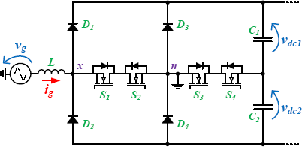This is a current supporting circuit, fundamentally an ongoing promoter and rectifier circuit. This circuit is essentially used to help the current and thusly the force of the charging unit. This element assumes an essential part in speeding up the battery and subsequently diminishes the required charging time. Figure 1 shows the five-stage vivacious rectifiers utilized for electric vehicle battery chargers. S1, S2, S3, and S4, look like the 4 MOSFET switches. D1, D2, D3, and D4 look like the 4 diodes while C1, C2, are the 2 capacitors having voltages Vdc1 and Vdc2, separately.

Figure 1. Five-level active rectifiers for EV battery charger

## **Charging Process**

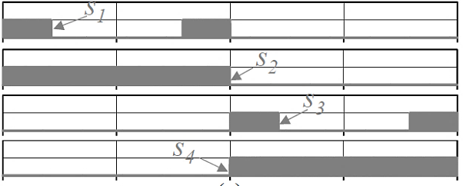In Figure, the diagram illustrates the charging procedure configuration, comprising five key elements: the smart meter, unit interface, master controller, charging converter modules, and battery management system (BMS). Through an analysis of the different links, connection alerts, connection confirmations, PWM-rated capacity, estimated current and voltage ratings, charging readiness markers, emergency shut-off points, battery data, and charging indicators are covered.

Figure 2. MOSFET switch pulse pattern

**MC**

**BMS**

1. Check connection
2. Check connection
3. connection notification
4. Check connection λCK 5.PWM rated Capacity
5. Rated current calculation
6. Rated voltage,current,charging ready

7. Emergency step

9.Charging ready

Indication/Ready

8.Battery Information

10. Charging Ready

11. Charging start

12.Charging start

12.Charging start

12.Charging start

00.Battery Information

00.Battery Information

00.Voltage,current

00.Battery Information

00.Battery Information

00.Voltage,current

20.Charging Finish

20.Charging Finish

20.Charging Finish

1. Charging Finish
2. Connector Disconnection 22.Connector Disconnection 22.Connector Disconnection

23.Connector Disconnection

**Charging converter modules**

**UI**

**Smart Meter**

Figure 3. Charging process

# **Neural network**

Artificial intelligence allows us to clear up complex problems. Neural networks are a traditional case in synthetic intelligence in which a system is tuned to analyze complex tactics. The usefulness of the synthetic neural community has been verified in several programs like speech synthesis, diagnostic troubles, business and finance, robot manipulation, sign processing and many other troubles that fall below the class of pattern recognition. The new advanced and adaptive artificial intelligence systems are Kalman clear out, machine gaining knowledge of algorithms along with fuzzy logic and aid vector machines, diverse neural networks such as radial foundation function neural network, feed ahead neural internet, returned propagation neural internet, and so forth. Adaptive systems mean structures that are self-designed as well as those that mechanically modify themselves subjected to changing systems.

The first step of the prediction model is to educate the network. The prediction error among plant output and neural community output is used because of the neural network training signal. The technique is illustrated in Figure 7. The internal shape of the model is illustrated in Figure 8 sign ‘u’ is the input sign and ‘y’ is the output sign, ‘w’ represents the weights and ‘b’ is the prejudice of the community.

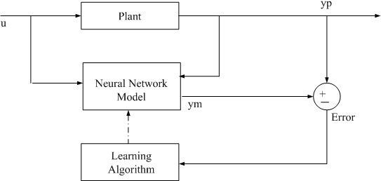

Figure 7. The training process for the network

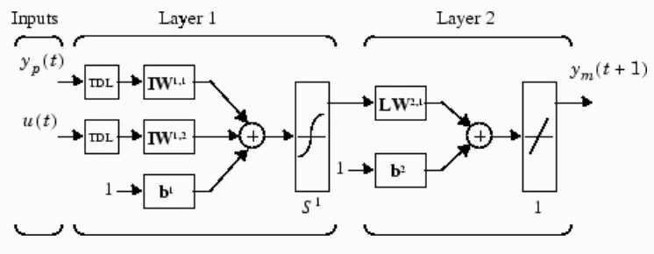

Figure 8. The internal structure of neural network model

The numerical optimization is given

C:\Users\Public\Pictures\Sample Pictures\1.PNG

Here n1, n2, and nu represent horizons for evaluating tracking errors as well as manipulating steps. *u*' is indeed the managed sign, *yr* is indeed the intended response and *ym* is the networking version response. The sum of the squares of control increments' impact to the performance metric is determined by cost.

𝑗=1

Figure 9 depicts the entire manipulation operation. A neural community version as well as an optimisation block comprises the controller. The optimisation block identifies the variables of *u*' that limit *j*, and then the most trustworthy *'u*' is entered into the community version as an input

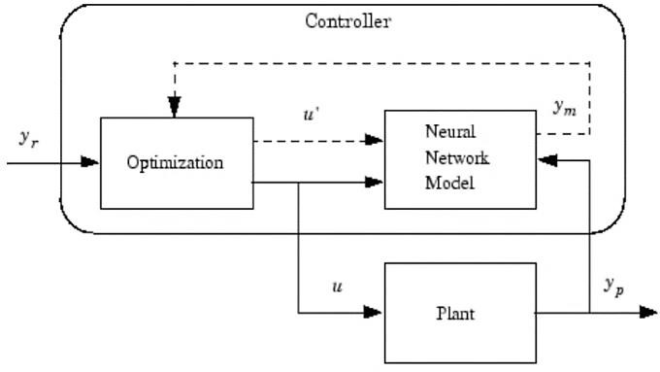

Figure 9. Control process in the network model

# **simulation result**

The active rectifier design, aimed at generating pulses, is implemented through software simulation using MATLAB 2015. The results obtained from this simulation are outlined below. Additionally, a simulation model depicting the proposed design is illustrated in Figure 10. Consistent with theoretical principles, the simulation model incorporates four MOSFET switches, four diodes, capacitors, and an inductor for functionality.

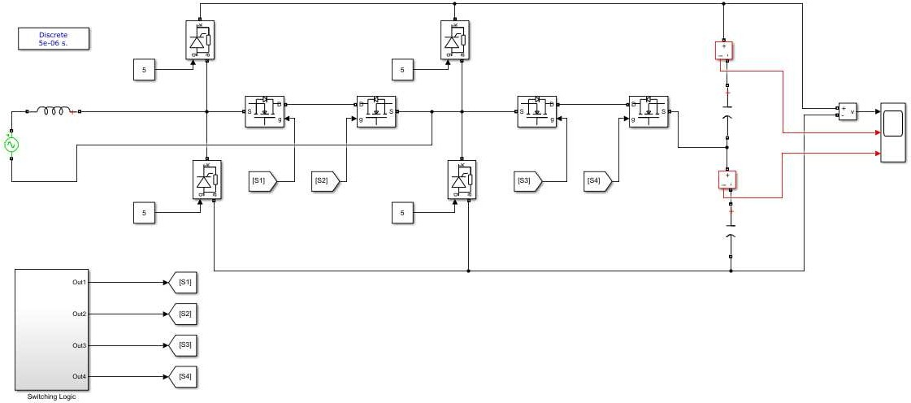

Figure 10. Simulation model of the proposed design

# **Power grid voltage (Vg) and current (ig)**

The graph of electricity grid voltage in volts towards time in seconds is depicted in Figure 11. It is determined that clean +/- 230 v is obtained and maintained. The graph of current in amperes and time in seconds is depicted in Figure 12. In advance, there are +/- 60/70 spikes within the system in the transition segment. Afterward the modern-day settles downs to +/- 50a. the settling time of the machine in the transition phase is sort of about 0.025 s, that's a way extra less which makes the gadget greater reliable and green.

Figure 11. Power grid voltage waveform Figure 12. Power grid current waveform

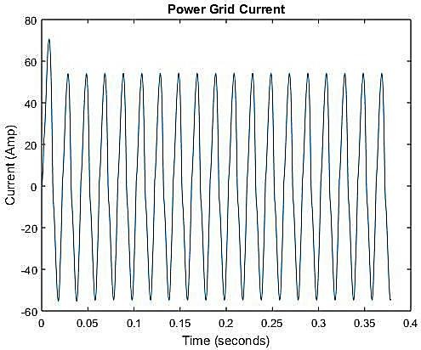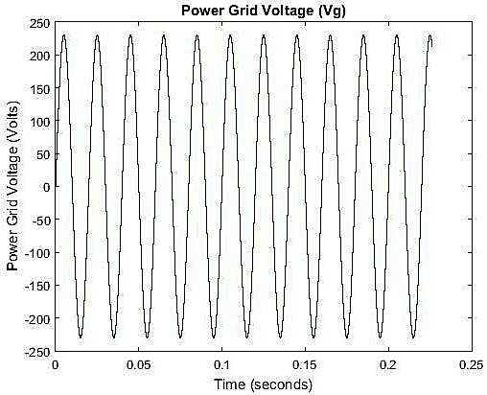

## **DC output voltage, power factor and total harmonic distortion**

The acquired result DC voltage is almost 240 V as displayed in Figure 13. The acquired power factor perusing of the proposed framework is around 0.934, the equivalent is portrayed in Figure 14. A bar graph of gotten THD as contrasted and a couple of existing strategy creators' THD is displayed in Figure 15. Furthermore, a table i.e., Table 1, of the equivalent is alluded to. It miles found that the procured THD from the proposed framework is 2.8 which is far more noteworthy substantially less than in cutting edge techniques having THD equivalent to 8.3, 4.9, and

In our proposed contraption, we've safeguarded a low skip sift that channels through a limit of exorbitant 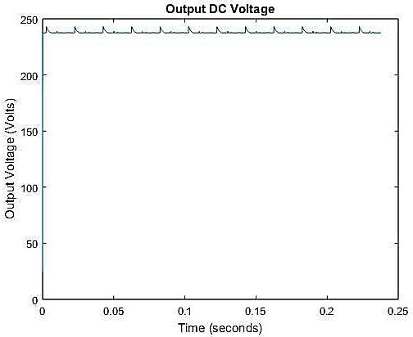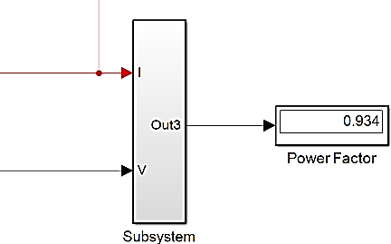recurrence parts. This reduces the full consonant contortion from the ideal result.

Figure 13. Output DC voltage Figure 14. Power factor

## **Circuit model and various battery parameters waveforms**

The inward circuit chart of the planned model in reenactment is demonstrated in Figure 16. MATLAB reenactment undoubtedly outlines the charging and releasing patterns of the battery. The source switch chooses the activity sort of charging or releasing. MOSFETs have been sent with modified charging cycles to it. There appear to be two PID control activities: the primary controls voltage and the second controls current.

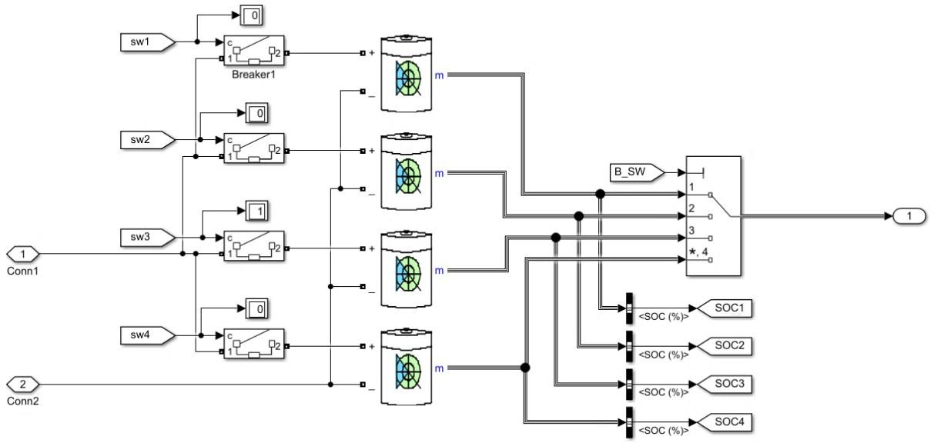

Figure 16. Simulation model

The PID change action is utilized to deal with heartbeat cost charging. Those PID hindrances have been taken out from ANN. The waveforms demonstrate that the battery voltage is continually developing during the charging time frame. The circumstance of cost increments for the span of the charging cycle. The reproduction waveforms of different battery boundaries considered i.e., condition of charge (SOC), battery voltage, battery current, and burden voltage portrayed in Figure

**Conclusion**

Worries about restricted energy sources, as well as the ecological effect of petrol based transportation framework, have expanded interest in electric transportation foundation. In this way, all through the most recent days, EV, crossover electric vehicles (HEV), and module HEV stand out. Battery innovation and related frameworks keep on being a focal test in vehicle jolt. Numerous makers have designated quick charging capacity as a key plan trademark for EV battery packs to diminish tension as well as meet client prerequisites. Proposing an ideal charging plan to such an extent that gives advantages, for example, diminished charging time and expanded effectiveness while safeguarding battery duration is basic.

The charging strategy handles the nitty gritty control and checking of charge current heartbeats while charging the battery. It consequently changes the recurrence of charge beat event to improve charging time. Lower charging time and more prominent charge, as well as energy efficiencies, are the key advantages given by beat charging, which are both wanted highlights by the present clients. Subsequent to thinking about all of the factors and examination holes, one such record plans and proposes a better quick charging method in light of PID control activity checked by brain organizations. The product execution is finished in MATLAB/Simulink. Reproduction results show that the proposed plan is fruitful and a similar plan idea dealing with exercises the essential goal is to diminish the re-energize season of the battery.

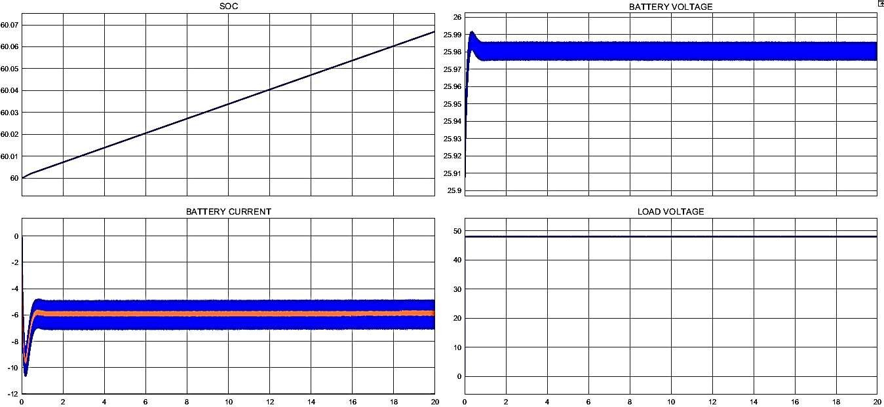

**Appendix**

# APPENDIX

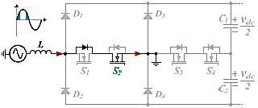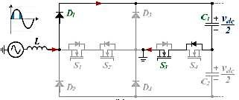

1. (b)

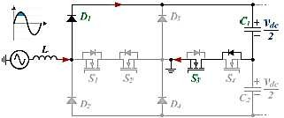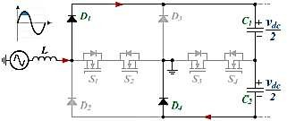

(c) (d)

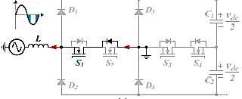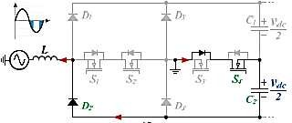

(e) (f)

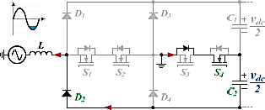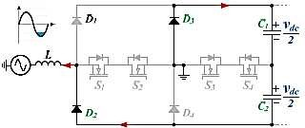

(g) (h)

The bit by bit activity of the proposed five-level dynamic rectifier (a) stage yield 0 V toVdc/2,(b) stage yield 0 V to+Vdc/2, (c) stage yield +Vdc/2 to+Vdc, (d) stage yield +Vdc/2 to+Vdc, (e) stage yield 0 V to - Vdc/2, (f) stage yield 0 V to - Vdc/2, (g) stage yield - Vdc/2 to - Vdc, and (h) stage yield - Vdc/2 to - Vdc

**References**

1. J. P. Wilkinson, “Nonlinear resonant circuit devices (Patent style),” U.S. Patent 3 624 12, July 16, 1990. G.-L. Zhu *et al.*, “Fast Charging Lithium Batteries: Recent Progress and Future Prospects,” *Small*, vol. 15, no. 15, p. 1805389, Mar. 2019, doi: 10.1002/smll.201805389.
2. V. Monteiro, J. G. Pinto, B. Exposto and J. L. Afonso, "Comprehensive comparison of a current-source and a voltage-source converter for three-phase EV fast battery chargers," *2015 9th International Conference on Compatibility and Power Electronics (CPE)*, Costa da Caparica, Portugal, 2015, pp. 173-178, doi: 10.1109/CPE.2015.7231068.
3. W. Shen, T. T. Vo, and A. Kapoor, “Charging algorithms of lithium-ion batteries: An overview,” in *2012 7th IEEE Conference on Industrial Electronics and Applications (ICIEA)*, Jul. 2012, doi: 10.1109/iciea.2012.6360973.
4. Y. Gao, X. Zhang, Q. Cheng, B. Guo, and J. Yang, “Classification and Review of the Charging Strategies for Commercial Lithium-Ion Batteries,” *IEEE Access*, vol. 7, pp. 43511–43524, 2019, doi: 10.1109/access.2019.2906117.
5. Y. He, Y. Tang, H. Xie, D. Ke, F. Wang and R. Kennel, "Power Quality Improvement for Grid-connected High-Speed Switched Reluctance Drive System," *2021 IEEE 12th Energy Conversion Congress & Exposition - Asia (ECCE-Asia), 2021*, pp. 2406- 2409, doi: 10.1109/ECCE-Asia49820.2021.9479157.
6. M. Thakre, J. Mane, and V. Hadke, “Performance Analysis of SRM Based on Asymmetrical Bridge Converter for Plug-in Hybrid Electric Vehicle,” in *2020 International Conference on Power, Energy, Control and Transmission Systems (ICPECTS)*, Dec. 2020, doi: 10.1109/icpects49113.2020.9337059.
7. C. Saber, D. Labrousse, B. Revol and A. Gascher, "Challenges Facing PFC of a Single-Phase On-Board Charger for Electric Vehicles Based on a Current Source Active Rectifier Input Stage," *in IEEE Transactions on Power Electronics*, vol. 31, no. 9, pp. 6192-6202, Sept. 2016, doi: 10.1109/TPEL.2015.2500958.
8. R. G. Shriwastava, M. P. Thakare, K. V. Bhadane, M. S. Harne, and N. B. Wagh, “Performance enhancement of DCMLI fed DTC-PMSM drive in electric vehicle,” *Bulletin of Electrical Engineering and Informatics*, vol. 11, no. 4, pp. 1867–1881, Aug. 2022, doi: 10.11591/eei.v11i4.3714.
9. M. P. Thakre, J. A. Gangurde, R. Shriwastava, D. P. Kadam, S. S. Kadlag, and H. S. Sonawane, “Investigative uses of overmodulation techniques in modular multilevel cascaded converter,” *Bulletin of Electrical Engineering and Informatics*, vol. 11, no. 6, pp. 3147–3156, Dec. 2022, doi: 10.11591/eei.v11i6.3958.
10. S. P. Jena and K. C. Rout, "Comparative Analysis of Harmonic Reduction of VSI Fed Induction Motor Using SVPWM and Sinusoidal PWM," *2018 2nd International Conference on Trends in Electronics and Informatics (ICOEI),* 2018, pp. 1-5, doi: 10.1109/ICOEI.2018.8553727.
11. R. He, D. Liu, R. Teodorescu, Q. Zhang, W. Hou and Z. Chen, "An Improved Submodule Capacitor Voltage Measuring Algorithm for MMC With Reduced Sensors," *in IEEE Sensors Journal,* vol. 21, no. 18, pp. 20475-20492, 15 Sept.15, 2021, doi: 10.1109/JSEN.2021.3095721.
12. M. P. Thakre and N. Kumar, “Evaluation and Control Perceptive of VSM-Based Multilevel PV-STATCOM for Distributed Energy System,” *MAPAN*, vol. 36, no. 3, pp. 561–578, Jun. 2021, doi: 10.1007/s12647-021-00481-x.
13. C. Kumar, M. K. Mishra and S. Mekhilef, "A new voltage control strategy to improve performance of DSTATCOM in electric grid,*" in CES Transactions on Electrical Machines and Systems,* vol. 4, no. 4, pp. 295-302, Dec. 2020, doi: 10.30941/CESTEMS.2020.00036.
14. M. P. Thakre and N. P. Matale, “Alleviation of Voltage Sag-Swell by DVR Based on SVPWM Technique,” in *2020 International Conference on Power, Energy, Control and Transmission Systems (ICPECTS)*, Dec. 2020, doi: 10.1109/icpects49113.2020.9336972.
15. J. Yi, M. Zhu, X. Zhong, H. WanG and X. Cai, "An Improved Triple Interline DC Power Flow Controller for Bidirectional Power Control," *2020 IEEE REGION 10 CONFERENCE (TENCON),* 2020, pp. 1301-1306, doi: 10.1109/TENCON50793.2020.9293704.
16. S. Saravanan, P. U. Rani, and M. P. Thakre, “Evaluation and Improvement of a Transformerless High-Efficiency DC–DC Converter for Renewable Energy Applications Employing a Fuzzy Logic Controller,” *MAPAN*, vol. 37, no. 2, pp. 291–310, Jan. 2022, doi: 10.1007/s12647-021-00530-5.
17. C. Chen, F. Shang, M. Salameh, and M. Krishnamurthy, “Challenges and Advancements in Fast Charging Solutions for EVs: A Technological Review,” in *2018 IEEE Transportation Electrification Conference and Expo*, Jun. 2018, doi: 10.1109/itec.2018.8450139.
18. E. Ayoub and N. Karami, “Review on the charging techniques of a Li-Ion battery,” in *2015 Third International Conference on Technological Advances in Electrical, Electronics and Computer Engineering (TAEECE)*, Apr. 2015, doi: 10.1109/taeece.2015.7113599.
19. N. Matanov, A. Zahov and I. Angelov, "Modeling of the Electric Vehicle Charging Process - Part 1," *2021 13th Electrical Engineering Faculty Conference (BulEF), 2021*, pp. 1-4, doi: 10.1109/BulEF53491.2021.9690836.
20. K. S. Somnath and M. K. Gupta, “Charging Power Station for Electric Vehicles,” *International Journal for Research in Engineering Application and Management (IJREAM)*, pp. 111–114, 2019, doi: 10.18231/2454-9150.2019.0555.
21. K. S. Somnath and M. K. Gupta, “Implementation on Single Phase Electric Vehicle Battery Chargers,” *International Journal of Engineering and Advanced Technology*, vol. 9, no. 1, pp. 5186–5189, Oct. 2019, doi: 10.35940/ijeat.a1866.109119.