**A ROBUST EMERGENCY COMMUNICATION IN HILLS AND FORESTS**

**Dr.B.BABYPRIYA1, Dr.S.GOMATHI2,M.PRADEEP3, R.CHANDRU4, K.LOGAPRIYAN5, S.VIGNESH6**

1Associate Professor , Department of EEE, Government College of Engineering-Erode,Tamil Nadu, India.

2 Assistant Professor , Department of EEE Government College of Engineering-Erode,Tamil Nadu, India.

3 Student , Department of EEE Government College of Engineering-Erode,Tamil Nadu, India.

4 Student , Department of EEE Government College of Engineering-Erode,Tamil Nadu, India.

5 Student , Department of EEE Government College of Engineering-Erode,Tamil Nadu, India.

6 Student , Department of EEE Government College of Engineering-Erode,Tamil Nadu, India.

**ABSTRACT**

This project aims to create a system using Arduino and LoRa (Long Range) communication technology to send SMS messages over long distances without relying on a GSM network. The proposed system utilizes LoRa for long- range wireless communication between two or more Arduino devices equipped with LoRa modules. Additionally, Bluetooth communication is employed for local communication between the Arduino device and a smartphone or computer for sending SMS messages. The system architecture consists of Arduino boards equipped with LoRa modules, such as the Arduino Uno or Arduino Mega, along with LoRa transceivers. These devices communicate wirelessly over long distances using the LoRa protocol. For local communication with a smartphone or computer, Bluetooth modules are integrated into the Arduino boards. The user interacts with the system through a dedicated mobile application or computer software.

***Keywords—*** *Arduino, LoRa, Communication Technology, GSM Network, Bluetooth Communication, Smartphone or Computer, LoRa Transceiver, Mobile Application.*

1. **INTRODUCTION**

In remote areas or during emergencies, access to traditional GSM networks for sending SMS messages may be limited or unavailable. In such scenarios, alternative communication methods are essential. This project proposes a solution using Arduino, LoRa (Long Range) communication, and Bluetooth technology to enable the transmission of SMS messages over long distances without relying on GSM networks. The primary objective of this project is to design a system that allows Arduino devices equipped with LoRa modules to exchange SMS messages over considerable distances. By leveraging LoRa's long-range capabilities and Bluetooth's local connectivity, the system enables communication even in areas where cellular coverage is absent. The system's architecture involves Arduino boards equipped with LoRa transceivers for long-range communication and Bluetooth modules for local connectivity. Users can interact with the system through a dedicated mobile application or computer software, allowing them to compose and send SMS messages using their smartphones or computers. This project offers several advantages over traditional GSM-based SMS systems: i) Independence from GSM Networks: The system operates independently of traditional cellular networks, making it suitable for remote areas, disaster zones, or situations where GSM coverage is unavailable. ii)Long-Range Communication: LoRa technology enables communication over several kilometers, surpassing the range of standard Bluetooth or Wi-Fi connections. iii) Cost-Effective: Utilizing LoRa and Bluetooth technology minimizes the need for expensive GSM network infrastructure, making the system cost-effective, particularly for low-budget or resource-constrained environments. iv) Flexibility: The system's modular design allows for easy integration with various Arduino boards and peripherals, providing flexibility for different use cases and applications. In the subsequent sections, we will delve into the detailed implementation of the system, including hardware components, firmware development, and user interface design. Additionally, practical considerations such as power consumption, data encryption, and message routing will be addressed to ensure the system's reliability and security. Overall, this project aims to demonstrate how Arduino, LoRa, and Bluetooth technologies can be combined to create a robust and versatile solution for sending SMS messages over long distances without relying on traditional GSM networks.

1. **LoRa TECHNOLOGY**

The LoRa Alliance defines two different layers of this technology:

* + LoRa physical layer
  + LoRa WAN (Long Range Wide Area Network) protocol.

From the physical layer point of view, LoRa is a radio modulation patented technique by Semtech. In this case, the technology is going to work with frequencies under the order of GHz in the unlicensed ISM (Industrial, Scientific and Medical) band. It operates in unlicensed spectrum bands and offers low power consumption, making it suitable for battery-operated devices. The Low-Power Wide-Area network ensures the connectivity of low power devices distributed on large geographical areas. These networks represent a new model of communication, successfully competing the already existent wireless communication technology such as: Bluetooth, ZigBee, LTE, GSM and Wi-Fi.

**Key features of LoRa Technology:**

* Long range:A single base station using LoRa Technology enables deep penetration capability for dense urban environments and indoor coverage, while also providing the ability to connect to sensors more than 3 to 5 miles away in rural areas.
* Low power: The LoRaWAN protocol was developed specifically for low power and enables unprecedented battery lifetime of up to 20 years depending on the application.
* Geolocation: Enables tracking applications without GPS or additional power consumption.
* Low cost: LoRa Technology reduces up front infrastructure investments and operating costs, as well as end-node sensor costs.
* Open standard: The LoRaWAN protocol ensures interoperability among applications, IoT solution providers and telecom operators to speed adoption and deployment.
  1. **COMPARASION BETWEEN LoRa AND OTHER WIRELESS TECHNOLOGY**

A comparison of Lora and other wireless technologies is shown in Fig 1 and 2

Fig no:1 LoRa other other wireless technology

Fig no:2 Data rate & power consumption and Range

1. **METHODOLOGY**

The methodology for implementing the Arduino LoRa Free SMS system over long distances without a GSM network involves several steps, including hardware setup, software development, and system integration. Here's a detailed overview of the implementation methodology.

**3.1 Hardware setup:**

* Gather the necessary hardware components, including Arduino boards (e.g., Arduino Uno or Arduino Mega), LoRa modules (e.g., SX1278 or SX1276), Bluetooth modules (e.g., HC-05 or HC-06), and power supplies (e.g., batteries or adapters).
* Connect the LoRa and Bluetooth modules to the Arduino boards according to their specifications and pin configurations.
* Ensure proper wiring and connections, including power supply connections, serial communication interfaces (e.g., SPI or UART), and external antenna connections (if applicable).
  1. **Software Development:**
* Develop firmware for the Arduino boards to handle LoRa communication, Bluetooth connectivity, and SMS messaging.
* Use Arduino IDE or other compatible development environments to write and upload the firmware code to the Arduino boards.
* Implement communication protocols for both LoRa and Bluetooth, including message routing, error handling, and data packet formatting.
* Create functions for SMS message composition, formatting, and transmission, including recipient selection and message validation.
  1. **User Interface Development:**
* Develop a user-friendly interface for composing and sending SMS messages, either as a mobile application or computer software.
* Choose a suitable platform and programming language/framework for the user interface development (e.g., Java for Android, Swift for iOS, Python for desktop).
* Design the interface layout, including text input fields, recipient selection options, send buttons, and status indicators.
* Implement functionalities for interacting with the Arduino devices via Bluetooth, such as pairing, data exchange, and error handling.
  1. **Integration and Testing:**
* Integrate the hardware components, firmware, and user interface modules to create a functional system.
* Conduct thorough testing to ensure proper functionality, reliability, and compatibility.
* Test the system under various conditions, including different communication ranges, environmental factors, and user scenarios.
* Identify and address any bugs, errors, or performance issues encountered during testing, and iteratively refine the implementation as needed.

1. **BLOCK DIAGRAM**

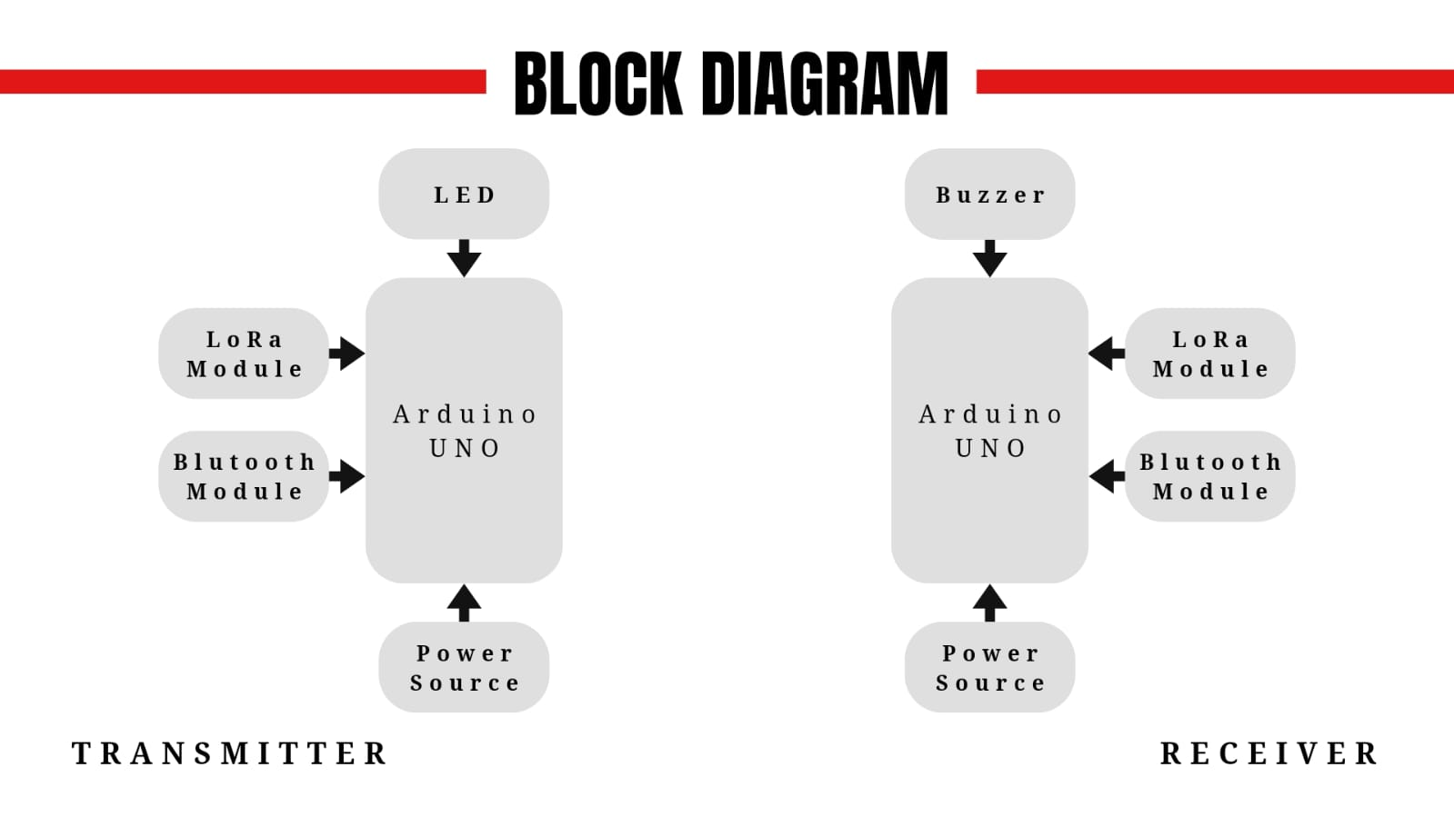

Fig.no:3 Block Diagram

First, a message is transmitted to Bluetooth from a smartphone and then Bluetooth forwards it to Arduino. Then, using LoRa module and Arduino this message is sent wirelessly to the remote side or receiver side. On the other side, Arduino receives a message from LoRa module and then forwards it to the smartphone application through Bluetooth. A 5V buzzer connect to the receiver side and an LED to the transmitter side. The SMS is transmitted to the receiving end but the application is not opened .when that time the buzzer will be turned on it is indicates the SMS from the transmitter side and also the LED on the transmitter side will be turned on, which is indicating that the SMS was received.

1. **RESULT AND DISCUSSION**

The prototype of the proposed system was developed using Arduino Uno, SX1278 Lora module and HC-05 Blue tooth module. The kit was tested in a hilly area with poor network coverage. The messages sent from the transmitter end were received at the receiver. The buzzer and LED are also found to do their functions in the case of the mobile application not being opened.

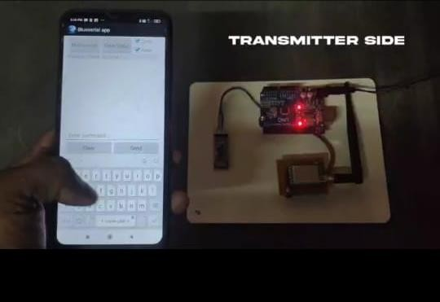.

Fig.no:4 Transmitter side

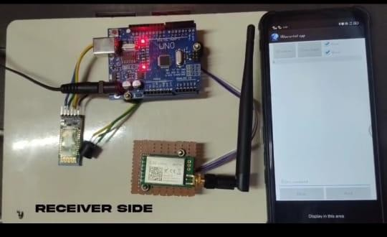

Fig.no:5 Receiver side

1. **CONCLUSION**

The Arduino LoRa Free SMS system presents a versatile and cost-effective solution for wireless communication over long distances without relying on a GSM network. By leveraging Arduino boards, LoRa modules, and Bluetooth technology, this project enables users to send SMS messages over extended ranges, making it suitable for remote or off-grid environments where traditional cellular networks may be unavailable or unreliable. Throughout the implementation of this project, several key aspects were addressed, including hardware setup, software development, integration, testing, and optimization. The system offers a user-friendly interface for composing and sending SMS messages, as well as features for LoRa communication and Bluetooth connectivity. Additionally, considerations were made for power management, security, and scalability to ensure robustness and reliability in practical applications. Looking ahead, there are numerous opportunities for future development and enhancement of the Arduino LoRa Free SMS system. These include improvements to the user interface, integration with external services, implementation of advanced features such as geolocation and encryption, optimization of power consumption, and expansion of network capabilities. In summary, the Arduino LoRa Free SMS system represents a valuable tool for wireless communication in remote or challenging environments, offering flexibility, reliability, and scalability for a wide range of applications. Through continued innovation and collaboration, this project has the potential to further evolve and address the evolving needs of users in various industries and scenarios. In future development of the Arduino LoRa Free SMS system and its associated functionalities, several potential avenues can be explored to enhance its capabilities, expand its features, and improve its performance. Here are some ideas for future development.

* **Enhance User Interface**:

Develop a more intuitive and user-friendly interface for composing and sending SMS messages, incorporating features such as message templates, contact management, and message history. Implement support for multimedia messaging (MMS), allowing users to send images, videos, or other multimedia content via SMS.

* **Integration with External Services**:

Integrate the system with external services or APIs to enhance its functionality, such as integrating with weather APIs to send weather alerts or with mapping services to send location-based information. Implement integration with social media platforms or messaging apps to enable cross-platform communication and message forwarding.

* **Geo-location and Tracking**:

Incorporate GPS modules or geolocation services to enable location tracking and reporting functionality, allowing users to send SMS messages with their current location coordinates. Develop features for geo-fencing and location-based alerts, where users receive SMS notifications when entering or leaving predefined geographic areas.

* **Advanced Security and Encryption**:

Enhance the security of the system by implementing encryption algorithms and secure communication protocols to protect sensitive data transmitted over LoRa and Bluetooth connections. Integrate authentication mechanisms to verify the identity of users and devices, preventing unauthorized access or tampering with the system.

* **Power Management and Efficiency:**

Develop power-saving algorithms and optimizations to further reduce power consumption and extend battery life, especially for battery-powered deployments in remote or off-grid locations. Implement dynamic power management techniques that adjust transmission parameters based on signal strength, environmental conditions, and power availability. Scalability and Network Expansion: Explore options for creating mesh networks or extending the range of LoRa communication by deploying additional gateway nodes or relay stations to cover larger geographic areas. Develop protocols and mechanisms for automatic network configuration, self- healing, and load balancing to ensure scalability and reliability of the communication network.

1. **REFERENCES**
2. Zhao, M.; Ye, R.-J.; Chen,S.-T.; Chen, Y.-C.; Chen, Z.-Y.Realization of Forest Internet of Things Using Wireless Network Communication Technology of Low- Power Wide-Area Network Sensors 2023, 23, 4809. https://doi.org/10.3390/s23104809
3. Banzi, M., & Shiloh, M. (2014). "Arduino: A Quick-Start Guide." O'Reilly Media.
4. Scherz, P., & Monk, S. (2013). "Practical Electronics for Inventors." McGraw- Hill Education.
5. Azim Zulfiqar "Hands-On ESP32 with Arduino IDE " Packt Publishing.
6. Robin Heydon "Bluetooth Low Energy: A Developer's Handbook." Leanpub.
7. Albert S. Huang and Larry Rudolph. "Bluetooth Essentials for Programmers." Cambridge University Press.
8. Zhan, Y. (2017). "LoRaWAN Specification v1.1." LoRa Alliance.
9. Garg, V. K. (2010). "Mobile Communication." Tata McGraw-Hill Education.
10. ETSI GSM 03.40 specification: "Technical Realization of Short Message Service (SMS)." European Telecommunications Standards Institute (ETSI).
11. Kortuem, Gerd & Kawsar, Fahim & Fitton, Daniel & Sundramoorthy, Vasughi. (2010). Smart Objects as Building Blocks for the Internet of Things. Internet Computing, IEEE. 14. 44 - 51. 10.1109/MIC.2009.143.
12. Al-Fuqaha, Ala & Guizani, Mohsen & Mohammadi, Mehdi & Aledhari, Mohammed & Ayyash, Moussa. (2015). Internet of Things: A Survey on Enabling Technologies, Protocols and Applications. IEEE Communications Surveys &amp Tutorials. 17. Fourthquarter 2015. 10.1109/COMST.2015.2444095.