Assessment of Water Quality Index of Pariyat River at panagar Region in jabalpur City (M.P.)

**Abstract-** *River water isuse for various purpose drinking, bathing, irrigation etc. In the recent times the ecology of River Pariyat is seriously affected by the disposal of sewage, industrial waste and various human activities. The objective of this work is to study the physical, chemical and biological parameters of water sample in Pariyat River. Pariyat River is situated near Sihora region district Panagar .The water samples collected were analyzed, as per standard methods parameters such as Temperature, pH, Turbidity, Alkalinity, Total Hardness, BOD, Chloride, DO were measured. Raised values of physicochemical parameters indicate the pollution of river in water due to domestic wastes ,municipal sewage, industrial effluent and agricultural run-off that influence the water quality directly or indirectly.*

*KeyWords: BOD, pH ,Chloride ,DO ,Temperature.*

## *INTRODUCTION*

*Water is the basic and primary need of all vital life processes. Even today it is the major consideration for all socio- economic cultural, industrial and technological developments. We need consumption of water for our good health. Today water resources have been the most exploited natural systems. Pollution of water bodies is increasing steadily due to rapid population growth, industrial proliferation, urbanization, increasing living standard and wide share of human activities. So it’s become very important to do continuous monitoring of certain water quality indicator so parametes in order to keep the health of water bodies at good condition.*

*Hence keeping the above scenario in mind the present study has been undertaken to assess the impact of surrounding area of Sihora region on water quality of river Pariyat.*

## *MATERIALSANDMETHODS*

*Water samples were collected from the five different sampling locations in the stretch of Sihora region of Panagar City. The sampling locations were selected as follows:*

* 1. *deori,*
  2. *tagar,*
  3. *muhas*
  4. *Sarai,*
  5. *imaliya.*

*Sampling locations were selected according to the intake point of raw water used by water supply department.Sample collection was usually completed during mornings between 9.00AM to 12.00 PM every for further analysis.*

*Water samples from the River were directly collected from the above five stations in one liter plastic cans. The water samples were collected from a depth of 30 cm using Ruttner Water Sampler. Sampling and Analytical procedures were followed as per the Standard Methods (APHA, 2005).*

## *RESULTSANDDISCUSSION*

*The present study was conducted at selected sampling station of Pariyat River at Sihora town, Panagar. Physico- chemical parameters were carried out in the samples collected from the study area to study the drinking water quality and pollution level. The average value of all five sample points was located in the Table -2. According to Water Quality Index the values of all the parameter were found to be within the limits.*

*Table1:Water Quality Parameter Standards Given By WHO and ISO*

|  |  |  |
| --- | --- | --- |
| *Parameters* | *WHO*  *Standard* | *ISO*  *Standard* |
| *Temperature* | *-* | *4-12* |
| *Turbidity* | *5* | *5* |
| *pH* | *7.0–8.0* | *6.5-8.5* |
| *TotalHardness(mg/L)* | *100* | *200-600* |
| *Alkalinity(mg/L)* | *120* | *200-600* |
| *Chloride(mg/L)* | *250* | *200-1000* |
| *D.O.(mg/L)* | *4* | *5* |
| *B.O.D(mg/L)* | *2* | *5* |

*Table2:Water quality parameter of Priyat River Sample from Study area*

|  |  |  |  |  |  |
| --- | --- | --- | --- | --- | --- |
| *Parameters* | *S1* | *S2* | *S3* | *S4* | *S5* |
| *Ph* | *7.24* | *7.2* | *7.4* | *7.25* | *7.3* |
| *Temperature* | *18* | *17.9* | *18.7* | *18.5* | *19* |
| *Turbidity* | *3.5* | *4* | *2.5* | *3* | *2.1* |
| *Alkalinity* | *72* | *80* | *75* | *70* | *74* |
| *Total hardness* | *253* | *332* | *245* | *291* | *230* |
| *Chloride* | *205* | *135* | *270* | *231* | *235* |
| *Dissolve Oxygen* | *8* | *7.6* | *8* | *7.8* | *8.3* |
| *B.O.D.* | *1.1* | *1.3* | *1.5* | *1.2* | *1.4* |

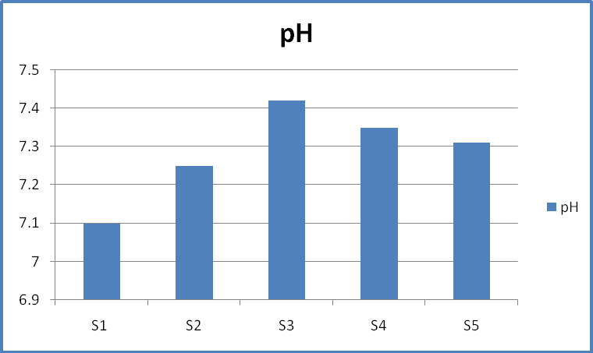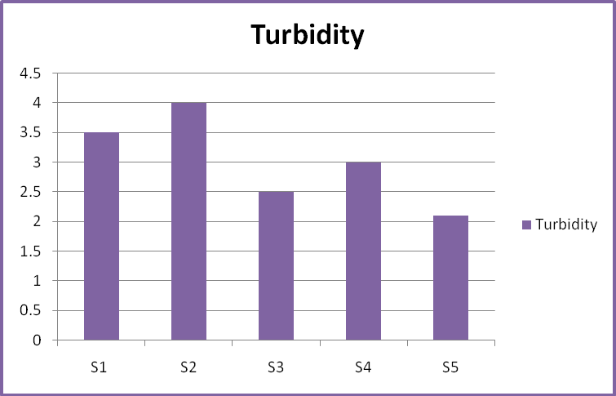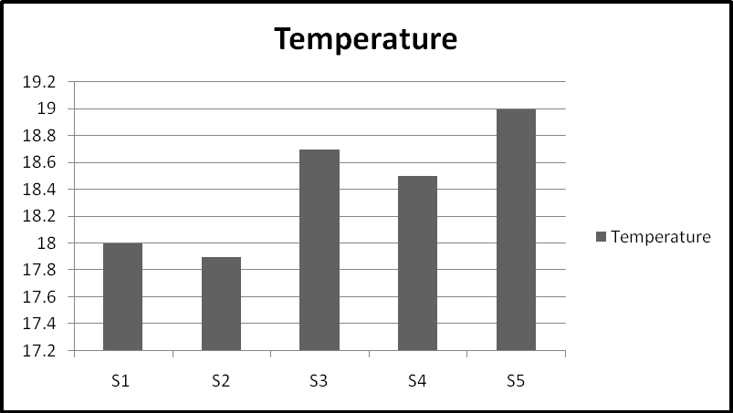

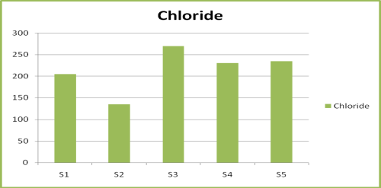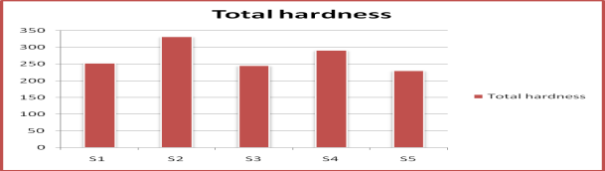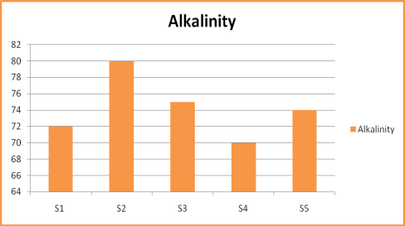

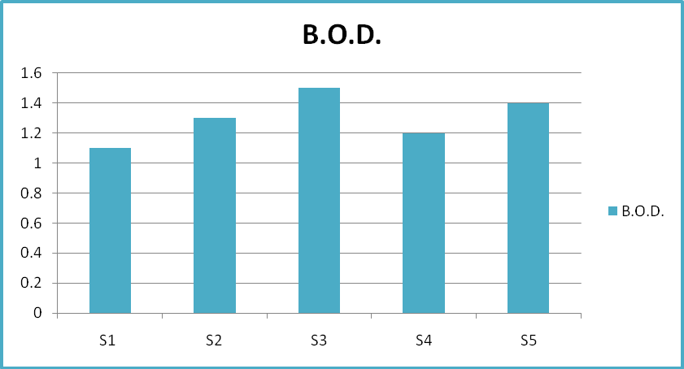

## 

## 4*.CONCLUSION*

*The data revealed that there were consider able variations in physic-chemical parameters at different stations of Pariyat River. Significant spatial lchanges were observed inpH and chloride. The major sources of chloride in river water include agricultural run-off, discharge of industrial and municipal waste water and chlorination of public water supplies. The quality parameters determined for sources of the area show that the water of Pariyat River at all the locations was quite with in the acceptable range and shows that the overall quality of water is suitable and safe for domestic and irrigation purposes.*

## *REFERENCES*

1. *Tirkey Poonam., Bhattacharya Tanushree and Chakraborty Sukalyan., “Water Quality Indices - Important Tools for Water Quality Assessment: A Review”,International Journal ofAdvances inChemistry, vol. 1, 2013.*