**ABSTRACT**

Earthquake strike suddenly, violently and without warning at any time day or night. In populated areas it may cause deaths and destruction to the property. Hence it is necessary to do seismic analysis and design to safeguard the structure against collapse. It is impossible to prevent an earthquake from occurring but the damage to the building can be controlled through proper designing and detailing.

Ironically, the people at large are still ignorant or worried about extra cost involved in making the structure earthquake resistant. For that reason they are putting their precious life at risk. This project aims not only to analyze and design a building to make it earthquake resistant but also to find out percentage extra cost involved in the same.

In this project a real life G+6 multi-storied RC moment resisting framed structure building with shear wall in Bhopal city (Indian seismic zone 2) is considered for analysis and design. The building is designed with and without seismic provisions and cost is compared. For working out the extra cost implications of constructing the same building in other seismic zones, three more cities are chosen namely Mumbai (zone 3), Delhi (zone 4) and Guwahati (zone 5). Extra cost is involved due to increase in member sizes (leading to change in volume of concrete) and increase in reinforcement steel bars. Hence, quantities of concrete and steel are worked out in each analysis/ design and compared.

The analysis and design are carried out using ‘STAAD Pro’ and ‘STAAD Foundation’ software which are industry standard software the world over. The earthquake resistant design is carried out as per IS 1893: (Part 1) 2002. Design of RCC slabs are carried out manually for which an excel sheet is developed for working out moment coefficients for different edge conditions as per IS code. Wind load analysis is also carried out in all cases but not found governing.

The project gives an insight into the actual process of analysis and design of earthquake resistant multistory building using STAAD Pro. The cost comparison gives an approximate estimation of extra cost involved in making the multistory building earthquake resistant in different seismic zones of India. This may make people realize that it is not a great amount which need to be invested to make their life safe against earthquake.

**INTRODUCTION**

An earthquake is a natural phenomenon that leads to the vast devastation of engineered systems and facilities. In the present scenario earthquake engineering attracts major attention of scientist because this is the event which cannot be accurately predicted it is the sadden event which happens due to various reasons such as;

1. Movement of tectonic plates.
2. Sudden slips at the faults.
3. Building of dams.
4. Volcanic earthquakes.
5. Due to explosive.
6. Due to mining etc.

Fig 1. Details of earth crust

Many reaches have been conducted on this topic and still it is continuing, because more we try to learn more we can minimize the damages and save the lives. According to studies that have been made on the seismology about 90% earthquake happens due to tectonics. If we come to civil engineering an engineer’s job is to provide maximum safety in the structures designed and maintain the economy. Whenever a structure is designed for natural incident such as earthquake we design it to behave limit states of serviceability, damageability and collapse.

Due to these reasons earthquake engineering gaining popularity. For designing a safe structure we should consider detailing of structure, choosing without inherent ductility that is concrete, masonry etc. if we introduce the reinforcement in the structure we can increase the ductility of the structure. In earthquake engineering ductility is the major fact that responds to motion of the ground. But incorporation of reinforcement in the structure mainly affects the economy of the structure.

In this project we have taken G+6 multi-storied RC moment resisting framed structure building with shear wall. We have analysed the structure for gravity load, wind load and seismic loads for different cities. In selecting the cities, we have select four different cities on the basis of seismic zones and also considering that the basic wind speed should be different. We have select Bhopal for seismic zone II, Mumbai for seismic zone III, Delhi for seismic zone IV and Guwahati for Zone V.

The analysis and design for all the cities are carried out using ‘STAAD Pro’ and ‘STAAD Foundation’ software which are industry standard software the world over. The wind resistant design is carried out as per IS 875: (Part 3) 1987 and the earthquake resistant design is carried out as per IS 1893: (Part 1) 2002. Analysis and design of beams, columns and shear wall have been done in STAAD Pro and the foundation is done in STAAD Foundation. We have also checked the design of some beams, columns and footings manually and find correct. Design of RCC slabs are carried out manually for which an excel sheet is developed for working out moment coefficients for different edge conditions as per IS code.

After the analysis and design we found that wind load is governing as compared to gravity load but it is not governing as compared to earthquake load. We have compared the volume of concrete and weight of reinforcement for all the loads in all cities and found the percentage variation in them with respect to gravity load.

We have then calculated the cost of RCC of the whole structure and compared to the gravity load in all seismic zones. Since the cost of the RCC is not the cost of whole building so we have assumed that it is 50% of total cost of the building. The main reason behind the cost comparisons is the removing of the myth that earthquake resistant building costs too much. For cost comparisons we have taken the rate of each item from D.S.R. published by CPWD New Delhi.

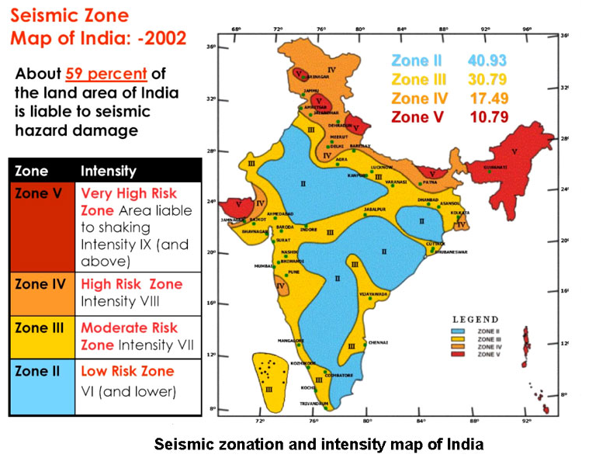

Fig 2. Seismic zone and intensity map of India

**LITRATURE REVIEW**

* G Papa Rao and Kiran Kumar (2013), the author’s researches on the changes in the percentage of steel and volume of concrete for the RCC framed structure for various seismic zones of India.
* Purnachandra Saha, P.Prabhu Teja &,P Vijay Kumar (2012), this research is mainly focuses on variation in percentage of steel when building is designed for different seismic zones. As per their research work they concluded that percentage variation of steel in beams are not varying much as compared to columns. Variation is around 0.07% in columns and overall variation is around 0.91% from Zone II to Zone V.
* Md Zubair Ahmed, Arshad, & Abdul Khadeer, (2015) the study was conducted to compare percentage of steel quantities for buildings subjected to gravity loads, seismic forces along with wind load. After analysis and design they got to the conclusion that percentage of reinforcement in column with maximum load is 1.985% to 45.438%, in case of beams it was 35.112% to 95.867% for basement floors.
* Perla Karunakar (2014) the author put his efforts to find out the performance and variation in steel percentage and concrete quantities in various seismic zones and impact on overall cost of construction. According to his research the concrete quantities are increased in exterior and edge columns due to increase in support reactions however variation is very small in interior column footings. Reinforcement variation for whole structure between gravity and seismic loads are 12.96, 18.35, 41.39, 89.05%.the cost variation for ductile vs. non ductile detailing are 4.06%.
* J. C. Wason, V. Thiruvegadam, K. I. Prakash (2014) the study shows the cost modeling and quantity of a building foundation for RC multistoried structure designed for earthquake forces for various seismic zones of India.

**PROBLEM DESCRIPTION**

We have adopted G+6 multi-storied RC moment resisting framed structure building plan. This building is considered with shear wall in different seismic zones of India for analysis and design. This is a real life structure which is future upcoming project of Essarjee Constructions Pvt. Ltd, Bhopal. It is a residential cum commercial building. In this stilt level is kept for parking purpose. First and second floor are commercial purpose whereas third to sixth floor are for residential purpose.

We get the plan from the Essarjee Constructions, in which the column position is given then we have decided the sizes of beams and columns.

In this project grade of concrete M20 is used in beams columns and slabs and M25 is used in foundation.

**3.1 Statement of project**

Utility of building : commercial cum residential building

No of stories : G+6

Shape of the building : rectangular

No of staircases : 1

No. of flats : 16

No of shops : 60

Type of construction : R.C.C framed structure

Types of walls : brick wall

**3.2 Geometric details**

First floor height : 2.5m.

Floor height for commercial building : 3.5m

Floor height for residential building : 3m

Height of plinth level : 0.6m

Depth of foundation : 2.4 m

Area of each residential flat : 73.4 sq m

**3.3 Materials**

Concrete grade : M20, M25

All steel grades : Fe415 grade

Type of steel bars : HYSD

Bearing capacity of soil : 131 kN/m2

Poisson's ratio : 0.17

Young's modulus of concrete : 5000



**3.4 Density**

Plain concrete : 24.0kN /m3

Reinforced concrete : 25.0kN /m3

Flooring material : 20.0kN/m3

Brick masonry :19.0kN/m3

**3.5 Plans**

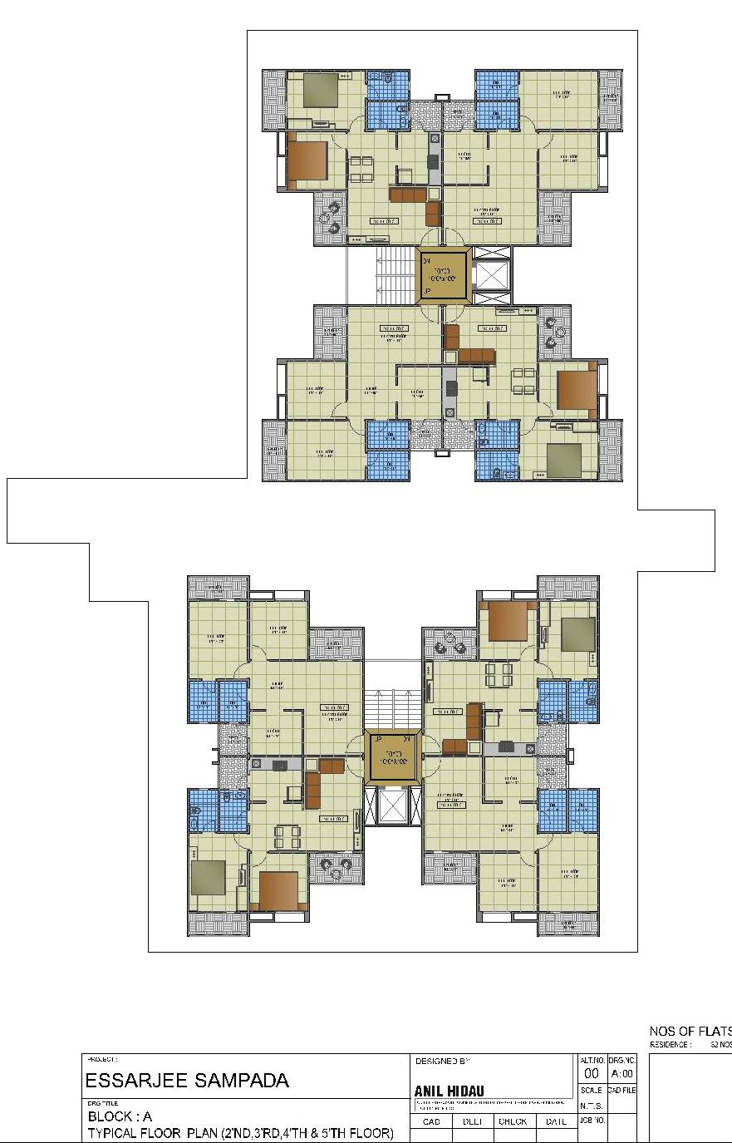

Fig 3. Plan of residential apartment

Stilt level

Stilt level

Stilt level

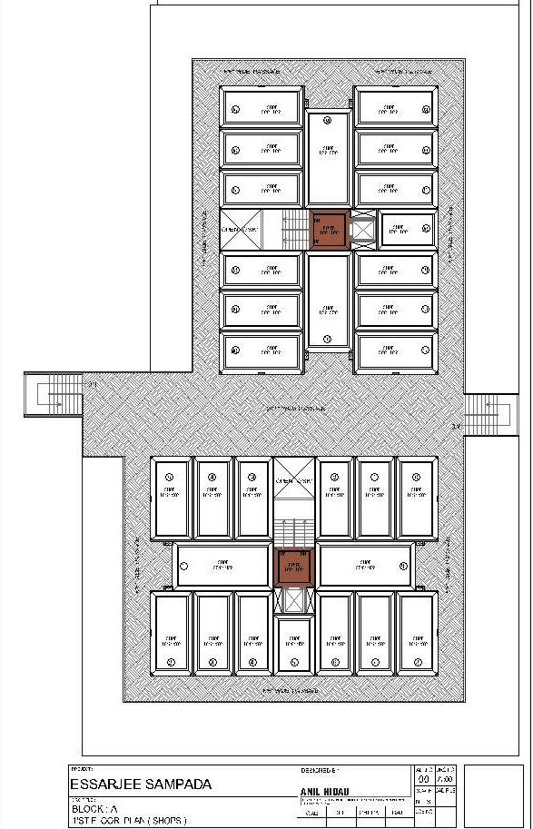Fig 4. Plan of commercial building

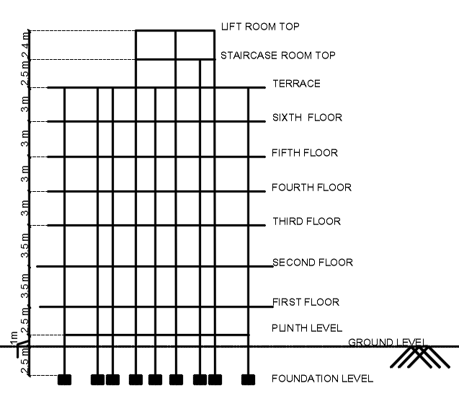Fig 5. Section of the structure

**OBJECTIVE**

Following are the objectives of this project

* Modeling of a framed structure from the given plan
* Analyzing and designing of beams columns and shear wall through STAAD Pro and foundation through STAAD Foundation for gravity load, wind load and seismic load.
* Analysis is to be carrying out for cities of different seismic zones. These cities are Bhopal (seismic zone 2), Mumbai (seismic zone 3), Delhi (seismic zone 4) and Guwahati (seismic zone 5).
* Design of RCC slabs is to be carried out manually with an excel sheet is to developed for working out moment coefficients for different edge conditions as per IS code.
* Comparing the quantities of concrete and steel worked out in each analysis/ design for different cities.
* To make a comparison of the cost of building in each analysis/ design for different city for different load combinations.

**METHODOLOGY**

Problem Description

Modeling

Design of the RCC member

Analysis of the structure

Literature review on previous researches

weight

Cost comparison

Comparing volume of concrete and reinforcement weight

Design of the slabs

Design of the foundation

Adding of load combination

reinforcement weight

Assigning seismic load as per IS1893 Part 1

Assigning wind load as per IS 875 Part 3

Assigning live load as per IS875 Part 2

Assigning dead loads as per IS 875 Part 1

3D rendering view

Creation of nodal points

Assigning supports and properties

Representation of beams and columns

Analysis of the foundation

**RESULT AND DISCUSSION**

The analysis and design was done according to standard specifications to the possible extend. For analyzing the beams and the columns, we had assuming the width of the beam on the architectural considerations and some theoretical knowledge. The depth of the beams was decided according to the Clause 23.2.1 of IS 456:2000.Leaving some section, all the sections were passed and the failed section had been reconsidered.

After the analysis and designing various results like maximum bending moment, maximum shear force, maximum axial force, maximum joint displacement and maximum section displacement are evaluated and effective and critical floor is determine among the structure considering combined factored dead and live load.

After analysis STAAD shows the quantity of concrete and steel for the beams and columns. For slabs staircases and foundation we have calculated the volume of concrete and reinforcement is calculated on thumb rule i.e. one cum of slab and isolated footing contains 70kg of reinforcement whereas in staircases and raft one cum contains 100 kg of reinforcement.

For comparing the costs we have taken the rates from the D.S.R published by the C.P.W.D. Delhi. Following are the rates

* M-20 grade concrete – Rs 7390.80 per cum
* M-25 grade concrete (up to plinth level) – Rs 6446.45 per cum
* M-25 grade concrete (above plinth level) – Rs 7250.05 per cum
* Fe-415 steel – Rs 56.60 per kg

Finally we would consider that R.C.C works is 50% of the total cost of building

**Table 7:** Quantity of concrete and reinforcement in different loading conditions

|  |  |  |  |  |  |  |  |
| --- | --- | --- | --- | --- | --- | --- | --- |
| CITY | COMPONENT | GRAVITY LOAD | | WIND LOAD | | EARTHQUAKE LOAD | |
| CONC. | STEEL | CONC. | STEEL | CONC. | STEEL |
| (m3) | (kg) | (m3) | (kg) | (m3) | (kg) |
| BHOPAL | SLAB | 322.1 | 22550.5 | 322.1 | 22550.5 | 322.1 | 22550.5 |
| STAIRCASE | 12.3 | 1225.1 | 12.3 | 1225.1 | 12.3 | 1225.1 |
| BEAMS + COLUMNS+ SHEARWALL | 366.4 | 31639.7 | 366.4 | 31753.2 | 366.4 | 33509.7 |
| FOUNDATION | 103.5 | 7642.9 | 103.5 | 7645.4 | 114.7 | 8582.9 |
| **TOTAL** | **804.3** | **63058.1** | **804.3** | **63174.2** | **815.5** | **65868.1** |
| MUMBAI | SLAB | 322.1 | 22550.5 | 322.1 | 22550.5 | 322.1 | 22550.5 |
| STAIRCASE | 12.3 | 1225.1 | 12.3 | 1225.1 | 12.3 | 1225.1 |
| BEAMS + COLUMNS+ SHEARWALL | 366.4 | 31639.7 | 366.4 | 31889.2 | 366.4 | 37123.3 |
| FOUNDATION | 103.5 | 7642.9 | 104.3 | 7721.7 | 118.9 | 9087.3 |
| **TOTAL** | **804.3** | **63058.1** | **805.1** | **63386.4** | **819.7** | **69986.1** |
| DELHI | SLAB | 322.1 | 22550.5 | 322.1 | 22550.5 | 322.1 | 22550.5 |
| STAIRCASE | 12.3 | 1225.1 | 12.3 | 1225.1 | 12.3 | 1225.1 |
| BEAMS + COLUMNS+ SHEARWALL | 366.4 | 31639.7 | 366.4 | 32069.3 | 375.8 | 44293.9 |
| FOUNDATION | 103.5 | 7642.9 | 106.3 | 7897.0 | 136.6 | 10594.7 |
| **TOTAL** | **804.3** | **63058.1** | **807.1** | **63741.8** | **846.8** | **78664.2** |
| GUWAHATI | SLAB | 322.1 | 22550.5 | 322.1 | 22550.5 | 322.1 | 22550.5 |
| STAIRCASE | 12.3 | 1225.1 | 12.3 | 1225.1 | 12.3 | 1225.1 |
| BEAMS + COLUMNS+ SHEARWALL | 366.4 | 31639.7 | 366.4 | 32087.2 | 399.7 | 55085.1 |
| FOUNDATION | 103.5 | 7642.9 | 105.1 | 7865.6 | 166.3 | 13093.4 |
| **TOTAL** | **804.3** | **63058.1** | **805.9** | **63728.4** | **900.4** | **91953.9** |

**Table 8:** Cost comparision of concrete and reinforcement in different loading conditions

|  |  |  |  |  |  |  |  |
| --- | --- | --- | --- | --- | --- | --- | --- |
| CITY | COMPONENT | GRAVITY LOAD | | WIND LOAD | | EQ LOAD | |
| CONC. | STEEL | CONC. | STEEL | CONC. | STEEL |
| Rs. | Rs. | Rs. | Rs. | Rs. | Rs. |
| BHOPAL | SLAB | 23,80,942 | 12,76,356 | 23,80,942 | 12,76,356 | 23,80,942 | 12,76,356 |
| STAIRCASE | 90,541 | 69,338 | 90,541 | 69,338 | 90,541 | 69,338 |
| BEAMS + COLUMNS+ SHEARWALL | 27,07,989 | 17,90,804 | 27,07,989 | 17,97,234 | 27,07,989 | 18,96,650 |
| FOUNDATIO  N | 6,67,383 | 4,32,589 | 6,67,064 | 4,32,732 | 7,39,633 | 4,85,789 |
| **TOTAL** | 58,46,856 | 35,69,087 | 58,46,537 | 35,75,660 | 59,19,106 | 37,28,133 |
| MUMBAI | SLAB | 23,80,942 | 12,76,356 | 23,80,942 | 12,76,356 | 23,80,942 | 12,76,356 |
| STAIRCASE | 90,541 | 69,338 | 90,541 | 69,338 | 90,541 | 69,338 |
| BEAMS + COLUMNS+ SHEARWALL | 27,07,989 | 17,90,804 | 27,07,989 | 18,04,927 | 27,07,989 | 21,01,178 |
| FOUNDATIO  N | 6,67,383 | 4,32,589 | 6,72,516 | 4,37,051 | 7,66,665 | 5,14,340 |
| **TOTAL** | 58,46,856 | 35,69,087 | 58,51,989 | 35,87,672 | 59,46,138 | 39,61,212 |
| DELHI | SLAB | 23,80,942 | 12,76,356 | 23,80,942 | 12,76,356 | 23,80,942 | 12,76,356 |
| STAIRCASE | 90,541 | 69,338 | 90,541 | 69,338 | 90,541 | 69,338 |
| BEAMS + COLUMNS+ SHEARWALL | 27,07,989 | 17,90,804 | 27,07,989 | 18,15,120 | 27,77,463 | 25,07,036 |
| FOUNDATIO  N | 6,67,383 | 4,32,589 | 6,84,984 | 4,46,972 | 8,80,348 | 5,99,662 |
| **TOTAL** | 58,46,856 | 35,69,087 | 58,64,456 | 36,07,786 | 61,29,294 | 44,52,392 |
| GUWAH  ATI | SLAB | 23,80,942 | 12,76,356 | 23,80,942 | 12,76,356 | 23,80,942 | 12,76,356 |
| STAIRCASE | 90,541 | 69,338 | 90,541 | 69,338 | 90,541 | 69,338 |
| BEAMS + COLUMNS+ SHEARWALL | 27,07,989 | 17,90,804 | 27,07,989 | 18,16,136 | 29,54,103 | 31,17,815 |
| FOUNDATIO  N | 6,67,383 | 4,32,589 | 6,77,810 | 4,45,195 | 10,72,133 | 7,41,084 |
| **TOTAL** | **58,46,856** | **35,69,087** | **58,57,283** | **36,07,025** | **64,97,720** | **52,04,594** |

**7.1 Comparison of different results**

Table 9: Comparison of volume of concrete and percentage variation with respect to gravity load

|  |  |  |
| --- | --- | --- |
| Type of loading | volume of concrete | % variation |
| Gravity loads | 804.3 | ----------- |
| SEISMIC LOAD (Zone II ) | 815.5 | 1.39 |
| SEISMIC LOAD (Zone III ) | 819.7 | 1.91 |
| SEISMIC LOAD (Zone IV ) | 846.8 | 5.28 |
| SEISMIC LOAD (Zone V ) | 900.4 | 11.95 |

Fig 43. Graph showing variation of volume of concrete

Fig 44. Graph showing percentage variation of volume of concrete

Table 10: Comparison of volume of steel and percentage variation with respect to gravity load

|  |  |  |
| --- | --- | --- |
| Type of loading | weight of steel | % variation |
| Gravity loads | 63058 | -------------------------- |
| SEISMIC LOAD (Zone II ) | 65868 | 4.46 |
| SEISMIC LOAD (Zone III ) | 69986 | 10.99 |
| SEISMIC LOAD (Zone IV ) | 78664 | 24.75 |
| SEISMIC LOAD (Zone V ) | 91954 | 45.82 |

Fig 45. Graph showing variation of weight of steel

Fig 46. Graph showing percentage variation of weight of steel

Table 11: Comparison of volume of R.C.C

|  |  |
| --- | --- |
| Type of loading | Cost of R.C.C. (in Rs.) |
| Gravity loads | 9415943 |
| Seismic Load (Zone II ) | 9647239 |
| Seismic Load (Zone III ) | 9907350 |
| Seismic Load (Zone IV ) | 10581686 |
| Seismic Load (Zone V ) | 11702313 |
|  |  |
| Table 12: Comparison of percentage variation of cost of R.C.C | |
| Type of loading | % variation |
| GL vs Seismic Load (Zone II ) | 2.462 % |
| GL vs Seismic Load (Zone III ) | 5.22 % |
| GL vs Seismic Load (Zone IV ) | 12.38 % |
| GL vs Seismic Load (Zone V ) | 24.28 % |

Fig 47. Graph showing comparison of cost of R.C.C.

Fig 48. Graph showing percentage variation of cost of R.C.C

Table 13: Comparison of percentage variation of cost of earthquake resistant building vs. non- earthquake building

|  |  |
| --- | --- |
| Type of loading | % variation of overall cost |
| GL vs Seismic Load (Zone II ) | 1.23 |
| GL vs Seismic Load (Zone III ) | 2.61 |
| GL vs Seismic Load (Zone IV ) | 6.19 |
| GL vs Seismic Load (Zone V ) | 12.14 |

Fig 49. Graph showing Comparison of percentage variation of cost of earthquake resistant building vs. non- earthquake building

**CONCLUSIONS**

Following important conclusions are drawn from this project:-

1. Earthquake resistant analysis design of real life multistory buildings can be carried out using powerful tools like STAAD Pro. However, extreme care is needed to understand and feed data in accurate manner else there may be blunders. The various difficulties encountered in the design process and the various constraints faced by the structural engineer in designing up to the architectural drawing also need to be properly understood and sorted to arrive at proper design.
2. STADD is very powerful tool; still some designs like design of slabs can be more conveniently carried out manually. The excel sheet developed as a part of this project successfully carried out slab design as per the provisions of IS 456: 2000.
3. It is found that the volume of concrete in footing near the shear walls increases in seismic zones IV and V due to increase of support reactions with the effect of lateral forces.
4. It is found that the percentage of bottom middle reinforcement is almost same for both earthquake resistant and non-earthquake resistant designs in the external and internal beams.
5. Percentage variation of total concrete quantity for the whole structure (including foundation) , between gravity load design and seismic load design for seismic zones II, III, IV and V is found to vary as 1.39 %, 1.91 %, 5.28% and 11.95 % respectively.
6. Percentage variation of total reinforcement quantity for the whole(including foundation between gravity load design and seismic load design for seismic zones II, III, IV and V is found to vary as 4.46 %. 10.99 %, 24.75 % and 45.82 % respectively.
7. It is found that the percentage variation of cost for the whole structure (including foundation), between gravity load design and seismic load design for seismic zones II, III, IV and V varies as 1.23%, 2.61%, 6.19% and 12.14% respectively.
8. Thus it is found in this study that for making a typical multistory building earthquake resistant under seismic zone II and III, hardly an additional cost of less than 3% is required. The additional cost required may be of the order of around 6% under seismic zone III of the order of around 12%under seismic zone IV. With this slight amount of additional cost we can safeguard our life to a great extent.

**LIMITATIONS**

Following are the limitations of this project:-

1. The results are for a particular type of building may not be applicable to each type of structure. However, it provides general idea about the variation of materials and cost.
2. Due to time constraints we have not done the seismic detailing of the members. The seismic detailing of the members may increase the quantity of the reinforcement to some extent.
3. We have decided the cost of RCC members on the thumb rule as 50 % of the whole structure, it may ~~be~~ change in actual depending upon the type and configuration of the structure.

**PRACTICAL UTILITY OF THE WORK**

This project compare the cost of constructing the earthquake resistant multi story building in different zones with that of non earthquake resistant building it shows that only with a marginal increase in cost the building can be made earthquake resistant thus protecting the precious life and property to a great extent which cant be measured in monitory terms. This awareness will be of great practical importance to encourage people to adopt earthquake resistant design for their buildings.

**SCOPE FOR FUTURE WORK**

Following are the scope for the project of this project:-

1. Variation of quantity and cost can be determined for different type of the structures.
2. Average percentage in increase of cost can be determined by taking different categories of the buildings.
3. This is based on static analysis on the earthquake; dynamic analysis of earthquake can be done and results can be compared.
4. Exact cost estimating can be done on the basis of the design report of the STAAD Pro to get more refined results.

**REFERENCES:**

1. Kiran Kumar, G. Papa Rao, Comparison of percentage steel and concrete quantities of a RCC building in different seismic zones.
2. P. VIJAY KUMAR & P. PRABHU TEJA, PURNACHANDRA SAHA, Variation in percentage of steel for a building designed in various seismic zones.
3. Abdul Khadeer Quraishi, Arshad, Syed Masood Ahmed , Md. Zubair Ahmed, Variation of Steel Percentage in Different Sesmic Zone Including Wind Effect VS Gravity Load.
4. Karunakar Perla, Earthquake Resistant Design- Impact on Cost of Reinforced Concrete Buildings.
5. Salahuddin Shakeeb S M, Prof Brij Bhushan S2, Prof Maneeth P D, Prof Shaik Abdulla, Comparative Study on Percentage Variation of Steel In Different Seismic Zones Of India
6. T. Anusha, S. V. Narsi Reddy, T. Sandeep, Earthquake Resistance Design-Impact On Cost Of Reinforced Concrete Builidings.
7. Sunayana Varma, A. Malar, S. Thenmozhi, T. Suriya, Comparative Study of Seismic Base Shear of Reinforced Concrete Framed Structures in Different Seismic Zone.
8. V.Thiruvengadam, J.C.Wason , Lakshmi Gayathri, cost modeling of reinforced concrete buildings designed for seismic effects.
9. B. Suresh, P.M.B Raj kiran Nanduri, earthquake analysis and design vs non earthquake analysis and design using staad pro.
10. Andreas J. Kappos, Alireza Manafpour, Seismic design of R/C buildings with the aid of advanced analytical techniques.
11. Pankaj Agrawal and Manish Shrikhande (2006), “Earthquake Resistance Design Of Structures”, ISBN 978- 81-203-3892-1, PHI Learning PrivateLimited.
12. IIT Kanpur, Learning Earthquake Resistant Design and Construction, Earthquake Tips.
13. Dr SK Duggal , “Earthquake Resistance Design Of Structure”.
14. IS: 875(Part-1)- 1987 ‘Code of Practice for Design Loads (Other than Earthquake) buildings and frames’, Part-1 Dead load, Unit weight of building materials and stored materials, Bureau of Indian Standards, New Delhi.