**Examining import and export documentation procedures and challenges in sea freight**

**JASMINE.H, MBA shipping and logistics management, Vels Institute of Science and Technology and Advanced Studies (VISTAS), Pallavaram, Chennai,** [**jasminesamuel2310@gmail.com**](mailto:jasminesamuel2310@gmail.com)

**Corresponding Author: Anitha Kumari D, Professor, School Management studies, Vels Institute of Science and Technology and Advanced Studies (VISTAS), Pallavaram, Chennai,** [**anitha.sma@velsuniv.ac.in**](mailto:anitha.sma@velsuniv.ac.in)

**ABSTRACT:**  
The purpose of this study is to examine the documentation requirements and difficulties that come with shipping products by sea. In addition to examining the difficulties importers and exporters encounter in meeting these standards, the research looks at the documentation requirements, which include bills of lading, commercial invoices, packing lists, and certificates of origin. Through an analysis of existing practices and identification of obstacles, the purpose of this study is to offer ideas for enhancing the efficacy and efficiency of sea freight documentation procedures.

**INTRODUCTION:**

The project “ import and export documentation procedures and challenges in sea freight” studies the various procedures and challenges of sea freight Efficient import and export documentation procedures are critical for effective operations in the maritime freight industry. Navigating the complicated marine commerce landscape requires an understanding of the specifics, difficulties, and solutions related to documentation. In this analysis, we explore the complicated procedures and difficulties associated with import and export documentation that are exclusive to maritime cargo. We strive to offer thorough insights and useful solutions, from understanding the necessary documentation to overcoming language difficulties and regulatory concerns. The study aims to support professionals and business organizations in streamlining international trade operations, guaranteeing compliance, and streamlining documentation processes by delving into the subtleties of documentation procedures and resolving typical sea freight difficulties.

throughout the import and export documentation process. Recognizing the difficulties with documentation helps in reducing the possibility of mistakes, delays, and non-compliance. Finding inefficiencies in documentation processes can result in process automation and optimization, which reduces costs. Regulations connected to import and export must be followed. Compliance to legal standards can be ensured by being aware of the documentation requirements.

**Objectives:**

* To analyse the procedures in import and export documentation.
* To identify the documentation error in import and export for forwarding.
* To understand about the customs clearance process of goods.
* To implement new strategies for improving the service level.

**Need for the study:**

Examining the documentation process may assist identify areas for improvement, streamline procedures, and reduce processing times. It is essential to understand the common problems and challenges that arise throughout the import and export documentation process in order to address them appropriately. Acknowledging the challenges associated with documentation contributes to lowering the likelihood of errors, hold-ups, and non-compliance. Determining inefficiencies in documentation procedures can lead to cost-saving process automation and improvement. It is necessary to abide by import and export regulations. It is possible to guarantee adherence to legal standards by being aware of the documentation requirements.

**SCOPE OF THE STUDY:**

The aim of the research "Examining Import and Export Documentation Procedures and Challenges in Sea Freight" is to look at the difficulties that come with import and export documentation in the maritime freight sector. and give a summary of the documentation processes already in place as well as list typical problems encountered by the maritime freight sector. The research will examine the methods for import and export paperwork, emphasizing the particular papers needed and the related procedures. It will list and evaluate the difficulties that these techniques provide. The study will end with proposals for future research as well as recommendations for enhancing documentation processes and resolving issues with maritime freight operations.

**REVIEW OF LITERATURE**

The study of (**Medda, F., & Trujillo, L. (2010)).** They analyze the Recent manufacturing changes, such as global sourcing and just-in-time delivery, have increased demand for freight transportation. However, traffic congestion threatens to overtake overland carriage and restrict economic growth. The transport sector must create an efficient supplement to the current road network, such as shortsea shipping (SSS). SSS is considered environmentally friendly and economically viable due to its fuel efficiency and reduced emissions of hazardous pollutants. This article reviews literature on SSS and its potential to maintain efficient freight movement.

**Rintamäki, S. (2013).**The study aimed to identify the export process used by Olvi plc and identify common issues encountered during it. It covered the export process and internationalisation in a theoretical framework, discussing justifications, global market actions, and logistics. A qualitative research approach was used, using the balancing scorecard and its objectives as the basis for interviews. The findings indicated that the primary difficulties were managing exports and integrating the process into domestic production. The study also highlighted the importance of skilled labour in exporting, as it is a reality and a positive aspect of the process.

**Moini, A. H.(1997).**This study uses a step-wise discriminant analysis to address two related topics: identifying significant and challenging obstacles in starting an export program, and responding to the critique that existing export research doesn't differentiate between the degree of significance and difficulty a company can face in overseas markets. A study of 248 Wisconsin-based small and medium-sized manufacturing enterprises found three significant obstacles, but disagreed with the critique of separating difficulty and importance.

**Escap,U.N.(2011**)This book presents the results of product-specific import and export process studies in Asian nations, providing detailed data on trade procedures, duration, and costs. It aims to improve understanding of procedural obstacles in intra-regional trade and complements existing macro-level and cross-country trade facilitation indicators. The book is expected to be useful for those assessing or enhancing trade transaction effectiveness in developing nations.

**1 Taha, O. (2022)** Exporting technology and dual-use goods poses a threat to national security and human rights, leading to breaches of international humanitarian law. The European Union has implemented laws to regulate the export, transfer, brokering, and transit of such items. This study provides definitions of dual-use commodities, their regulated activities, and authorization requirements. The research will analyze a company's export process, policies, and practices, identifying weaknesses and areas for improvement. A risk assessment will be offered to help reduce risks. The internal compliance program (ICP) will be described, and a case study will be presented and assessed. The main topics of investigation include the company's export procedure, categorization of dual-use items, end users, customs classification, and authorization requirements.

**Peuraniemi, M. (2007**This study focuses on the export procedure from the European Union to the United States, specifically focusing on men's suits. The study investigates the procedures, laws, and limits of textile imports into the US, customs declaration methods, and documentation requirements. The comparative advantage theory and competitive advantage theory were used as theoretical foundations. A desk study was conducted, utilizing customs publications from Finland and the US, as well as international trade organizations and customs departments. The findings indicate that the export process is complex, requiring consideration of both national laws and international trade standards. Customs brokers are often used to ensure understanding of laws. The study also identifies tariff classifications for men's suits and the import tariffs and fees. EU-made clothes struggle to compete in US markets due to high tariffs and labour costs. The North American Free Trade Agreement guarantees duty-free entry for Mexican textile items.

**PERCENTAGE ANALYSIS**

Sea Freight cargo typically take to correct documentation error within.

Table no:1

|  |  |  |  |  |  |
| --- | --- | --- | --- | --- | --- |
| **Principal difficulties for importing documents for marine.** | | | | | |
|  | | Frequency | Percent | Valid Percent | Cumulative Percent |
|  | |  |  |  |  |
| Valid | Document processing delays | 24 | 45.3 | 45.3 | 45.3 |
| Documentation errors | 14 | 26.4 | 26.4 | 71.7 |
| Problems with rules compliance | 12 | 22.6 | 22.6 | 94.3 |
| Information discrepancies | 3 | 5.7 | 5.7 | 100.0 |
| Total | 53 | 100.0 | 100.0 |  |

Chart:1

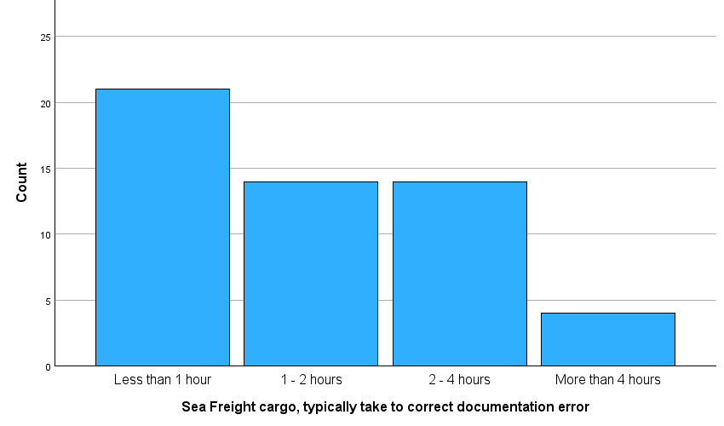

**INTERPRETATION:**

From the above table and chart inferred that 39.6% of the respondents are less than 1 year, 26.4% of the respondents are 1- 2 hours and 2- 4 hours and 7.5 respondents are more than 4 hours in sea Freight cargo, how much time does it typically take to correct

documentation error.

|  |  |  |  |  |  |
| --- | --- | --- | --- | --- | --- |
| Table:2  **Sea Freight cargo typically take to correct documentation error** | | | | | |
|  | | Frequency | Percent | Valid Percent | Cumulative Percent |
| Valid | Less than 1 hour | 21 | 39.6 | 39.6 | 39.6 |
| 1 - 2 hours | 14 | 26.4 | 26.4 | 66.0 |
| 2 - 4 hours | 14 | 26.4 | 26.4 | 92.5 |
| More than 4 hours | 4 | 7.5 | 7.5 | 100.0 |
| Total | 53 | 100.0 | 100.0 |  |

Chart 2:

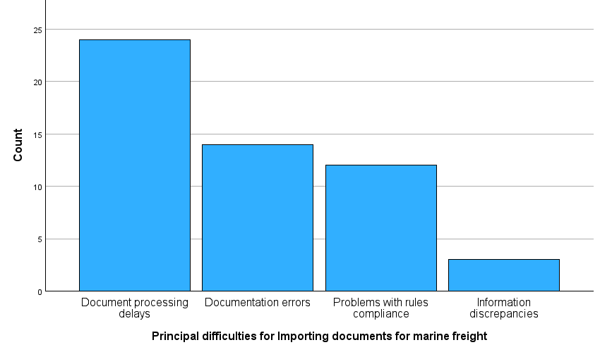

**INTERPRETATION:** From the above table and chart inferred that 45.3% of the respondents are document processing delays, 26.4%of the respondents are document processing delays, 22.6% of the respondents are document processing delays and 5.7% respondents are

Information discrepancies in the principal difficulties for importing documents for marine freight. documents for marine

**Chi- Square Test**

1.comparing two variables between Did the procedures for importing documents for marine freight present any difficulties for you? And If so, what are the principal difficulties you have

Table no:3

|  |  |  |  |
| --- | --- | --- | --- |
| **Chi-Square Tests** | | | |
|  | Value | df | Asymptotic Significance (2-sided) |
| Pearson Chi-Square | 2.918a | 6 | .819 |
| Likelihood Ratio | 3.491 | 6 | .745 |
| N of Valid Cases | 53 |  |  |
| 1. 8 cells (66.7%) have expected count less than 5. The minimum expected count is .62. | | | |

**Inference:**

The test was conducted to determine if there is a association between did the procedures for importing documents and principal difficulties you have encountered. the pearson chi-square test statistics is 2.918 and 6 degrees of freedom. The like hood ratio test statistics is 3.491 and 6 degrees of freedom.

If the calculated value is 0.5< accepted null (NO).

Result:

Here, there is no association between the procedures for importing documents and principal difficulties you have encountered.

Accepted the null hypothesis and rejected the alternative hypothesis.

2. Comparing two different variables What proportion of shipping delays by sea are caused by mistakes in documentation? And What proportion of companies now use electronic documentation for shipments of marine freight?

|  |  |  |  |
| --- | --- | --- | --- |
| **Chi-Square Tests** | | | |
|  | | | |
|  | Value | df | Asymptotic Significance (2-sided) |
| Pearson Chi-Square | 13.332a | 9 | .148 |
| Likelihood Ratio | 14.611 | 9 | .102 |
| N of Valid Cases | 53 |  |  |
| a. 12 cells (75.0%) have expected count less than 5. The minimum expected count is .34. | | | |

The test was conducted to determine if there is a significant association between What proportion of shipping delays by sea are caused by mistakes in documentation? And What proportion of companies now use electronic documentation for shipments of marine freight?

**Inference:**

The test was conducted to determine if there is a association between what proportion of shipping delays by sea are caused by mistake in documentation and what proportion of companies now use electronic documentation for shipments. The pearson di – square test statistics is 13.332 and 9 degree of freedom. The like hood 14.611and 9 degree of freedom.

If the calculated value is 0.5> rejected null (NO).

Result:

Here, there is an association between what proportion of shipping delays by sea are caused by mistake in documentation and what proportion of companies now use electronic documentation for shipments. rejected the null hypothesis and accepted the alternative hypothesis.

Research gap:

The study limited resources and time available, it may be difficult to address every relevant procedure, issues, and challenges in-depth due to the extensive and intricate nature of import and export documentation processes in marine freight. Period of study was restricted to two months. The results of the study might vary depending on factors like age, job title, experience, and so on. It is challenging to get the necessary samples since the logistics and shipping company employs a smaller number of employees. Since the information is sensitive, the organization didn't provide the proper data.

**Research methodology:**

A methodical approach to addressing a research issue is known as a research technique. One way to conceptualize it is as an industry that examines the procedures employed in scientific research. This essay examines the several steps a researcher frequently takes to look into his research topic and the justifications for each step. The intended research will mostly be descriptive in character. Since research design ensures that the different research methodologies function properly, it is essential to doing research as efficiently as possible.

**Conclusion:**

Consequently, the study emphasizes the complex nature of import/export paperwork pertaining to marine cargo, including several stages, challenges, and opportunities for advancement. By adopting new technologies, supporting employee training, and promoting collaboration, stakeholders may lessen present problems and adapt to how international trade is evolving. Proactive measures and continual monitoring are essential to achieving efficiency, compliance, and competitiveness in the global economy.

reference:

Medda, F., & Trujillo, L. (2010). Short-sea shipping: an analysis of its determinants. *Maritime Policy & Management*, *37*(3), 285-303.

Moini, A. H. (1997). Barriers inhibiting export performance of small and medium-sized manufacturing firms. *Journal of global marketing*, *10*(4), 67-93.

Escap, U. N. (2011). *Trade facilitation in Asia and the Pacific: an analysis of import and and export processes*. United Nations.

Rintamäki, S. (2013). Challenges of the export process: Case Olvi Plc.

ESCAP, U., & ECE, U. (2009). Business process analysis guide to simplify trade procedures

Taha, O. (2022). *Compliance as a response to export control* (Doctoral dissertation, Politecnico di Torino).

Peuraniemi, M. (2007). Export process to the United States of America