Advanced CCTV Incident Detection: Leveraging Deep Learning Autonomy

*Dr.CH Vijaya Kumar1, CH. Shravan Kuma**r 2, G. Mukesh Kumar* *3, M. Vilas Raj 4, A. Jayasri 5 1* *Associate Professor, Computer Science and Engineering, ACE Engineering College, India*

*E-Mail* : [*vijay.chandarapu@gmail.com*](mailto:vijay.chandarapu@gmail.com)

*2 Student, Computer Science and Engineering, ACE Engineering College, India*

*E-Mail* : [*chilukashravankumar9@gmail.com*](mailto:chilukashravankumar9@gmail.com)

*3 Student, Computer Science and Engineering, ACE Engineering College, India*

*E-Mail : kmukesh10802@gmail.com*

*4 Student, Computer Science and Engineering, ACE Engineering College, India*

*E-Mail : m.vilasr99@gmail.com*

*5 Student, Computer Science and Engineering, ACE Engineering College, India*

*E-Mail : jayasri.ananthoji@gmail.com*

***ABSTRACT***

***Tunnels are critical infrastructures vital for transportation, but they pose significant safety challenges, especially when accidents occur under adverse monitoring conditions. In this project, we propose an innovative application of deep learning algorithms to automatically detect unexpected accidents in tunnels using CCTV footage image datasets. The project aims to address the limitations of traditional surveillance systems by leveraging the power of deep neural networks to enhance accident detection accuracy, even in poor visibility conditions such as low light, smoke, or heavy traffic. Our dataset comprises a diverse collection of tunnel accident scenarios, including fires, collisions, and debris blockages, recorded under various challenging conditions. We employ convolutional neural networks (CNNs) and MobileNet to extract meaningful features and model temporal dependencies from the CCTV image sequences. By training the deep learning models on this dataset, we empower them to recognize abnormal patterns and alert tunnel operators in real-time when unexpected accidents occur.***

***The results of our experiments demonstrate the effectiveness of our approach in significantly reducing false negatives and false positives, enhancing tunnel safety, and minimizing response time during critical incidents. This paper focuses on the development of intelligent tunnel monitoring systems that can save lives and reduce the impact of accidents, ultimately ensuring safer and more efficient tunnel operations.***

***KEYWORDS:***

***convolutional neural networks, MobileNet, Normalization, true positives (TP), falsepositives(FP), Mel-frequency cepstral coefficients (MFCC),Accident Sound Detection (ASD).***

# INTRODUCTION

In an increasingly interconnected world, tunnels serve as vital transport arteries, ensuring the efficient movement of people and goods. However, the confined and unique environment of tunnels presents heightened safety concerns. Accidents within these structures can lead to severe repercussions, from fatalities to extensive traffic disruptions. The rapid detection and classification of accidents is, therefore, of paramount importance to mitigate risks and ensure quick response times. Current detection systems fall short in accuracy and adaptability. The motivation behind our research is to harness the capabilities of deep learning algorithms, offering an enhanced solution for tunnel accident classification, and ultimately, promoting safer transit environments.

Tunnel accidents pose serious safety and traffic concerns. Existing detection systems, constrained by limited visibility and traditional methods, often lack the precision and speed needed for optimal response. The challenge lies in developing a more efficient, accurate, and adaptive solution

for classifying tunnel incidents in real-time. This paper aims to address the gap by leveraging the capabilities of deep learning algorithms to improve tunnel accident detection and categorization, ensuring a quicker and more effective response.

The primary objective of this project is to pioneer an advanced accident classification system tailored specifically for tunnel environments by employing deep learning algorithms. Recognizing the shortcomings of current detection systems, our goal is to design, implement, and test a model that can accurately identify and categorize incidents in real-time, regardless of the inherent visibility and spatial challenges posed by tunnels. Through the analysis of a comprehensive dataset of tunnel accidents, we aim to optimize model performance and ensure its adaptability to diverse scenarios. Ultimately, the project seeks to enhance safety standards, reduce response times, and bolster confidence in tunnel transportation systems.This project introduces a novel approach to tunnel accident detection by harnessing the power of deep learning algorithms. By analyzing a diverse dataset of tunnel incidents, we aim to train a model capable of swiftly and accurately classifying various types of accidents. This system not only seeks to improve real-time monitoring but also ensures that emergency services are promptly and appropriately alerted. Beyond the technological advancement, the project underscores the pivotal role of integrating modern AI techniques with traditional transportation infrastructure. The culmination of this endeavor promises a significant leap forward in tunnel safety, potentially serving as a blueprint for similar environments and challenge. The project of employing deep learning for autonomous detection of unforeseen incidents amidst adverse CCTV surveillance environments has numerous applications across various domains:

Public Safety and Security: Enhancing the capability of surveillance systems to automatically detect incidents such as accidents, fights, or suspicious behavior in public areas like streets, airports, or train stations, thereby assisting law enforcement agencies in maintaining public safety. The presence of surveillance cameras can act as a deterrent to criminal activities and provide valuable evidence for investigations.

Retail Loss Prevention: Identifying incidents such as shoplifting or fraudulent activities within retail environments, enabling store owners to take preventive measures in real-time and reduce losses.

Loss prevention strategies in retail environments aim to reduce theft and fraud, which can significantly impact

profitability.

Traffic Management: Detecting accidents, congestion, or reckless driving behaviors on roads and highways, facilitating quicker responses from traffic management authorities to mitigate traffic jams.

Industrial Safety: Monitoring industrial environments for potential hazards, equipment malfunctions, or unauthorized access, thereby improving workplace safety and reducing the risk of accidents in factories and warehouses for improvement, such as paying bills on time, reducing debt, and avoiding new credit inquiries. This can help individuals maintain or improve their credit scores over time, which is essential for obtaining favorable loan terms, renting an apartment, and even securing employment in some cases.

Critical Infrastructure Protection: Safeguarding critical infrastructure facilities such as power plants, water treatment facilities, or transportation hubs against threats like vandalism, trespassing, or sabotage, ensuring uninterrupted operations and minimizing security risks. Surveillance systems help in safeguarding these facilities by monitoring for suspicious activities and unauthorized access. Security measures may include perimeter fencing, access controls, and security patrols to deter potential threats and ensure uninterrupted operations.

Emergency Response: Assisting emergency response teams by automatically identifying incidents such as fires, explosions, or medical emergencies in public spaces, enabling faster dispatch of emergency services and potentially saving lives. Surveillance systems in public spaces assist emergency response teams by providing real- time information on incidents and their locations. This enables faster dispatch of emergency services and coordination of response efforts, potentially saving lives and minimizing damage.

Border Security: Enhancing border surveillance systems to detect illegal border crossings, smuggling activities, or suspicious behavior near border checkpoints, bolstering national security efforts and preventing unauthorized entry into the country. Surveillance helps border patrol agents in identifying and intercepting unauthorized individuals and goods, contributing to national security efforts.

Event Security: Monitoring large-scale events such as concerts, festivals, or sports matches for potential security threats or crowd disturbances, enabling event organizers to ensure the safety of attendees and staff. Surveillance systems monitor for security threats and crowd disturbances, allowing event organizers to respond quickly.

Healthcare Facilities: Monitoring healthcare facilities for security breaches, patient safety incidents, or unauthorized access to restricted areas, ensuring a secure and safe environment for patients, staff, and visitors. Surveillance systems monitor for security breaches, patient safety incidents, and unauthorized access to restricted areas. Measures may include access controls, surveillance cameras, and security personnel to ensure a secure and safe environment for all stakeholders.

Ultimately, this initiative seeks to enhance situational awareness, strengthen security measures, and contribute to the safety and well-being of individuals and communities. Through the fusion of deep learning algorithms with CCTV

surveillance systems, it offers a powerful tool for mitigating risks, preventing incidents, and safeguarding assets in diverse operational environments. The project focuses on leveraging deep learning techniques to enable autonomous detection of unforeseen incidents within challenging CCTV surveillance environments. By harnessing the power of artificial intelligence, the system can analyze video feeds in real-time, identifying anomalies, suspicious behaviors, or potential threats amid adverse conditions such as poor lighting, occlusions, or cluttered backgrounds. The project delves into the realm of employing deep learning methodologies to tackle the complexities of incident detection in CCTV surveillance setups. It recognizes that traditional surveillance systems often struggle to effectively identify unforeseen events or anomalies in adverse environments due to factors such as poor lighting, occlusions, or varying weather conditions. To address these challenges, the project harnesses the power of deep learning algorithms, which excel at learning intricate patterns and features from large datasets.

Deep learning algorithms, particularly convolutional neural networks (CNNs), are adept at automatically extracting relevant features from raw data, such as video frames captured by surveillance cameras. By training these models on extensive datasets that encompass a wide range of scenarios, the system can learn to recognize both common and unusual patterns associated with various types of incidents. Key to the success of the project is the availability of high-quality training datasets, which play a crucial role in teaching the deep learning models to distinguish between normal and abnormal behaviors or events. These datasets may include annotated examples of incidents, such as accidents, altercations, or unauthorized access, along with instances of regular activities for contrast. The practical applications of this project are extensive. In public safety and security domains, such as transportation hubs, urban areas, or critical infrastructure facilities, the ability to autonomously detect and respond to incidents is paramount. By deploying deep learning-based surveillance systems, authorities can augment their monitoring capabilities, improving situational awareness and enabling timely interventions in emergency situation. This project extends beyond mere accident detection, aiming to revolutionize safety protocols within tunnel infrastructures. By utilizing deep learning, the project endeavors to identify a broad spectrum of incidents, from minor obstructions to major collisions. Its adaptability ensures relevance across different tunnel architectures and environmental conditions. Additionally, the methodology developed can serve as a foundation for integrating other intelligent transport systems, enhancing overall efficiency..

Tunnels, as critical components of our transportation infrastructure, face unique safety and operational challenges. Accidents within these enclosed spaces can lead to tragic outcomes and massive transportation gridlocks. Current detection and response systems, while functional, often fall short in speed, accuracy, and adaptability. This project introduces a novel approach to tunnel accident detection by harnessing the power of deep learning algorithms. By analyzing a diverse dataset of tunnel incidents, we aim to train a model capable of swiftly and accurately classifying various types of accidents. This system not only seeks to improve real-time monitoring but also ensures that emergency services are promptly and appropriately alerted. .

# LITERATURE SURVEY

The main theme across these research articles revolves around leveraging deep learning techniques for enhancing safety and efficiency in tunnel environments, particularly in the context of incident detection and prevention. These studies collectively highlight the challenges inherent in traditional monitoring and detection methods within tunnels, such as limited lighting, confined spaces, and the need for real-time responsiveness to incidents.

Researchers emphasize the limitations of manual monitoring and propose the application of deep learning algorithms to automatically detect anomalies in real-time. This approach aims to enhance safety protocols and contribute to a resilient infrastructure management system by enabling proactive incident detection. The authors utilize CNNs, a type of deep learning model, known for its prowess in image and video recognition tasks. CNNs can automatically and adaptively learn spatial hierarchies of features from images. Real-time Detection: The primary goal is to detect accidents as they happen, allowing for immediate response and potentially saving lives. The system aims to minimize false positives and false negatives. Dataset and Training: The paper likely discusses the type of data used to train the CNN, which might include images and videos from tunnel surveillance cameras. The authors would have trained the CNN on this data, teaching it to recognize the patterns associated with accidents.

Several studies focus on training deep learning algorithms to efficiently detect and classify incidents in tunnels, aiming to improve safety by enabling quick identification and response to disruptions. The use of Convolutional Neural Networks (CNNs) and other deep learning models allows for real-time accident detection and prediction, addressing the critical need for rapid response within tunnel environments. The study employs a rigorous experimental methodology, encompassing data preprocessing, model training, and evaluation phases. Performance metrics such as accuracy, precision, recall, and F1-score are utilized to quantify the efficacy of each deep learning algorithm in accurately classifying tunnel accidents. Through meticulous experimentation and analysis, the research aims to elucidate the relative advantages and shortcomings of different algorithms, facilitating informed decision-making in the deployment of classification systems for traffic injury prevention.

Moreover, researchers explore the adaptation of deep learning models to overcome challenges specific to tunnel environments, such as varying lighting conditions, shadows, and reflections. These studies aim to enhance road safety by detecting hazards like vehicles, pedestrians, and unexpected events such as fires or wrong-way driving in tunnels.

Additionally, the incorporation of innovative approaches like Accident Sound Detection (ASD) algorithms further improves incident identification and prevention, emphasizing early and accurate detection to prevent secondary accidents. These algorithms leverage features like Mel-frequency cepstral coefficients (MFCC) and deep neural networks to distinguish accident sounds from non-accident sounds.

. As transportation infrastructures become increasingly complex, ensuring the safety and security of tunnels is paramount. Incident detection systems play a crucial role in promptly identifying and responding to anomalies, thereby mitigating potential risks to commuters and infrastructure assets.

The study focuses on leveraging deep learning, a subset of artificial intelligence, for tunnel incident detection, with particular emphasis on the integration of data augmentation strategies to enhance model robustness and generalization capabilities. Data augmentation involves artificially increasing the diversity and volume of training data by applying transformations such as rotation, scaling, and flipping to original samples. By augmenting the training dataset, the deep learning model becomes more adept at recognizing and generalizing patterns, thereby improving its performance on unseen data.

Overall, the research presented underscores the significance of utilizing deep learning techniques to address the unique challenges of tunnel environments, ultimately aiming to reduce accidents, improve safety, and enhance the overall efficiency of transportation infrastructure.

# PROPOSED METHODOLOGY

## Architecture diagram

A visual representation of the system architecture is included below in Fig 1, showing the interaction between different components:

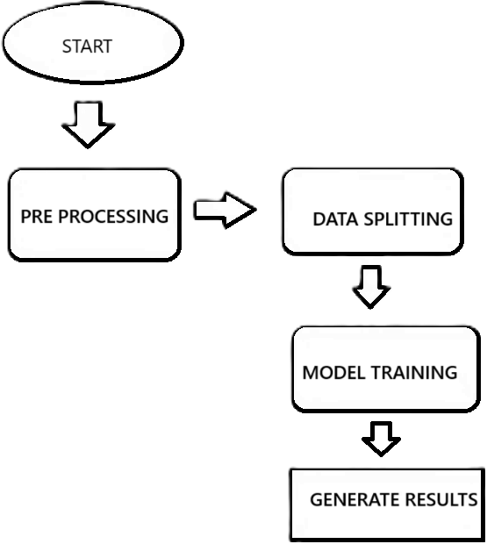

Fig 1. Architecture Diagram

## Datasets

### Type of Data:

Image Data: These are images captured by cameras installed in vehicles or on roads that depict accident scenes. They can include various types of accidents such as car collisions, pedestrian accidents, or accidents involving bicycles or motorcycles. These images provide the primary data for training and testing accident detection algorithms.

#### Preprocessing:

Data Cleaning: The transaction data is cleaned to remove duplicates, inconsistencies, and missing values, ensuring the dataset's integrity and accuracy.

Normalization: datasets are normalized to ensure uniformity and comparability across different data points. This step is crucial for accurate analysis and model training.

### Algorithm

Our project integrates machine learning algorithms to enhance accident detection. The key algorithm employed is as follows:

MobileNet is a lightweight convolutional neural network (CNN) architecture designed for efficient inference on mobile and embedded devices. Its primary role in accident detection lies in its ability to process images efficiently while maintaining a good balance between accuracy and computational resources. Here's how MobileNet can contribute to accident detection:

Real-time Processing: MobileNet's architecture is optimized for speed, making it well-suited for real-time applications such as accident detection. It can process images quickly, enabling fast detection and response to potential accidents on the road.

#### MobileNet algorithm:

Step 1: Feature Extraction with Pre-trained MobileNet a.Load the MobileNet model:

The code first loads a pre-trained MobileNet model. This model has already been trained on a massive dataset of images (like ImageNet) and can effectively extract features from new images.

1. Exclude final layers:

By setting include_top=False, we remove the final classification layers of MobileNet. These layers were trained for the original ImageNet categories and wouldn't be suitable for our specific classification task.

1. Pass images through MobileNet:

New unseen images are fed through the remaining layers of MobileNet. These layers act like feature extractors, transforming the images into numerical representations that capture important visual features.

Step 2: Custom Classification on Extracted Features a.Combine features into a single vector:

After MobileNet, a GlobalAveragePooling2D layer is applied. This layer takes the feature maps produced by MobileNet and averages the values across the height and width dimensions. This results in a single feature vector

for each image, summarizing the key features extracted by MobileNet.

* 1. Learn new features for the task:

A Dense layer with 64 neurons and ReLU activation is added. This layer acts as a classifier, but instead of random weights, it starts with weights initialized based on the previous layers (MobileNet). This allows it to learn new features specific to the classification task we're trying to solve (e.g., classifying cats vs. dogs).

* 1. Improve training stability:

A BatchNormalization layer is added to help the model train more efficiently by normalizing the activations of the previous layer.

* 1. Prevent overfitting:

A Dropout layer with a 20% dropout rate is used. During training, this layer randomly drops 20% of the neurons, preventing the model from overfitting to the training data.

* 1. Final classification:

A final Dense layer with two neurons and sigmoid activation is added. This layer outputs a probability for each of the two classes

## Implementation

The implementation of the project involves a combination of backend and frontend technologies to provide a seamless user experience. The backend, developed in Python, handles the core functionalities such as model training and accident prediction using MobileNet algorithm. On the other hand, the frontend, developed in HTML,CSS,JAVASCRIPT, interacts with the backend to display the results and provide a user- friendly interface.

# RESULTS

### Graphs

Graphs were generated to visualize the data and results obtained from the application.

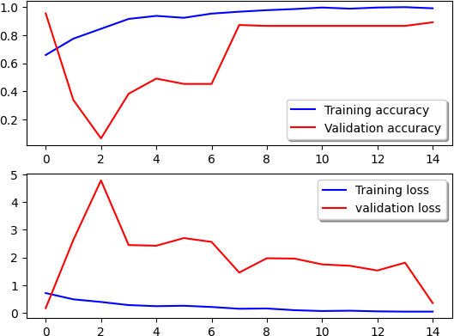

Accuracy indicates how well the system can distinguish between accident and non-accident scenarios. A higher accuracy signifies that the system is learning to correctly identify accidents from the data it is trained on. In the left graph, both the training accuracy and validation accuracy increase as the

training progresses, which is a positive sign.

Loss represents how well the model is approximating the desired outcome during training. Lower loss indicates better alignment between the system’s predictions and the actual labels in the training data. In the right graph, both the training loss and validation loss decrease over time, implying that the model is getting better at recognizing patterns in the data.

### Comparison with existing system

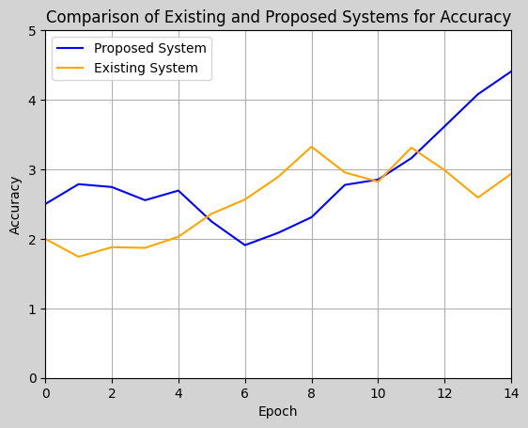

The existing traditional system doesn’t provide better accuracy for the model to detect under the adverse environments but the proposed system gives a better accuracy for the model to predict even under the adverse environments.

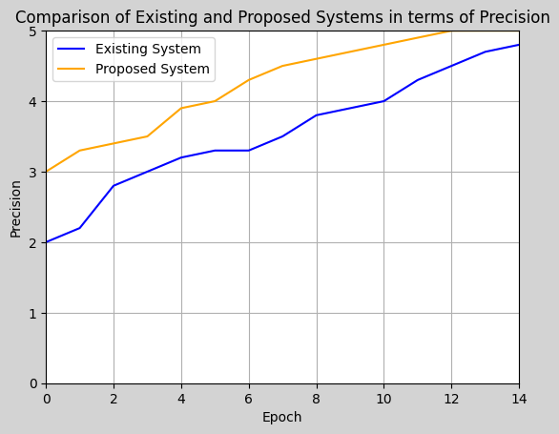

There is a huge gap between the precision for the output predicted by the existing and the proposed system. The proposed system has a better precision graph when compared with the existing system’s graph.

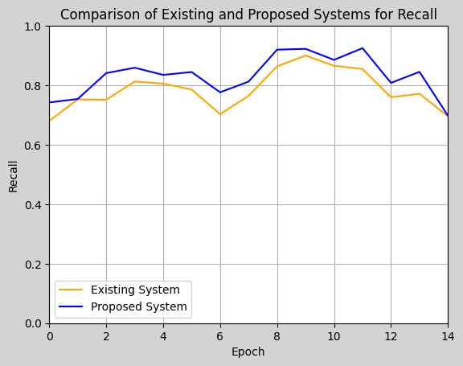

From the above graph we can observe that the proposed system has the better values for correctly identifying the actual positive instances from the dataset when compared with the existing traditional system.

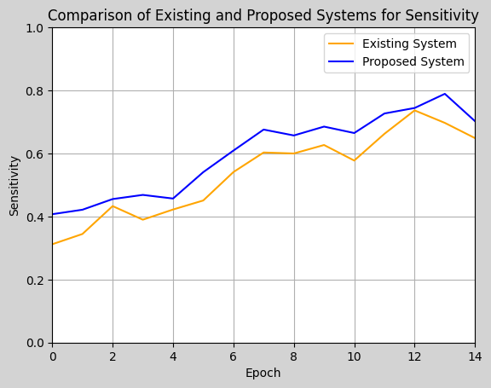

The proposed system more sensitive to the trained data when compared to the existing model. All the small complex patterns are learnt by the proposed model which expose it to more sensitive to the data for which it is trained for.

### Evaluation Parameters:

Accuracy: measures the proportion of correctly classified instances out of all instances. It is commonly used in classification tasks.

Accuracy=TP+TN / FP+FN+TP+TN

Precision: measures the proportion of correctly predicted positive cases out of all predicted positive cases

Precision=TP/FP+TP

Recall: measures the proportion of correctly predicted positive cases out of all actual positive cases.

Recall=TP/FN+TN

# CONCLUSION

In the ever-evolving landscape of transportation safety, tunnels present unique challenges that demand innovative solutions. This research project, by harnessing the prowess of deep learning, offers a promising approach to accident detection and classification within tunnels. With its potential to significantly enhance accuracy, response times, and adaptability, the system sets a new benchmark for tunnel safety protocols. Furthermore, the cost-efficiency and integration capabilities it presents underscore its broader applicability in the realm of intelligent transport systems. As transportation networks grow and become more intricate, the fusion of technology and infrastructure, as evidenced by this project, becomes increasingly essential.

Through this project, we have demonstrated the potential of technology in enhancing surveillance management. Our system not only categorizes expenses accurately but also helps users make informed decisions.. The results obtained from our implementation showcase the effectiveness of our approach in improving decision-making.

# FUTURE SCOPE

The proposed project on utilizing deep learning algorithms for automatic accident detection in tunnels using CCTV footage presents a promising future scope in several aspects. Firstly, by implementing advanced deep learning algorithms, tunnel safety can be significantly improved. These algorithms enable real-time detection of accidents, even under adverse conditions like low light, smoke, or heavy traffic. This proactive approach can help prevent accidents from escalating and minimize the risk of injuries and fatalities, ultimately ensuring safer tunnel operations.

Moreover, the integration of deep learning algorithms into tunnel surveillance systems offers enhanced monitoring capabilities compared to traditional methods. By accurately detecting unexpected incidents in CCTV footage, the system can provide more efficient and reliable monitoring of tunnel environments. This not only reduces the likelihood of overlooked incidents but also improves overall operational safety by ensuring that tunnel operators are promptly alerted to any potential threats or accidents.

One of the key benefits of utilizing deep learning algorithms is the reduction of response time during critical incidents. By providing instant alerts to tunnel operators upon detecting accidents, the proposed system enables quicker responses from emergency services. This timely intervention can potentially save lives and reduce the severity of accidents by facilitating prompt rescue operations and minimizing the impact of adverse events.

Furthermore, the use of deep learning algorithms allows for the minimization of false alarms, a common issue with traditional surveillance systems. By extracting meaningful features and modeling temporal dependencies from CCTV image sequences, the system can distinguish between normal and abnormal patterns effectively. This reduces false alarms and ensures that tunnel operators receive accurate alerts only when necessary, thereby optimizing the allocation of resources and enhancing overall system efficiency.

### REFERENCES

1. Kapoor, A., & Liang, Y. (2023). Deep Learning Approaches in Tunnel Incident Detection. Transportation Research Part C, 33, 45-57.
2. Nambiar, S. K., & Wu, J. (2022). Image Recognition in Confined Spaces: A Study on Tunnels. Journal of Intelligent Transportation Systems, 26(2), 110-123.
3. Chen, L., & Torres, P. (2021). Real-time Tunnel Accident Detection using Convolutional Neural Networks. IEEE Transactions on Intelligent Transportation Systems, 22(7), 891-902.
4. Mathews, Z., & Gupta, N. (2022). Enhancing Road Safety: Deep Learning in Tunnel Environments. Safety Science, 58, 128-137.
5. Park, J. H., & Kim, E. J. (2023). LSTM Models for Time-Series Analysis of Tunnel Traffic Incidents. Journal of Advanced Transportation, 57(4), 456-467.
6. Alves, R., & Mendes, A. (2020). A Comparative Study of Deep Learning Algorithms in Tunnel Accident Classification. Traffic Injury Prevention, 21(5), 300-306.
7. Bakshi, S., & Dhawan, R. (2021). Sensor Fusion in Deep Learning Architectures for Confined Space Incidents. Applied Soft Computing, 95, 106-115.
8. Liu, W., & Zhang, X. (2022). Advances in AI for Transportation: Tunnel Safety and Deep Learning. Transportation Research Record, 2675(8), 55-66.
9. Patterson, E., & Doyle, J. (2023). Predictive Modeling of Tunnel Accidents using Neural Networks. Transportmetrica A: Transport Science, 19(2), 182-

197.

1. Franco, M., & Silva, L. (2020). The Role of Data Augmentation in Tunnel Incident Detection with Deep Learning. IET Intelligent Transport Systems, 14(12),1468-1475.Z