## AN OVERVIEW OF FREIGHT FORWARDING OPERATION

## MAGESHWAR.M, Vels Institute of Science, Technology and Advanced Studies (VISTAS) Pallavaram, Chennai. [mageshmurugan333@gmail.com](mailto:mageshmurugan333@gmail.com)

## Corresponding Author, Veeramani. , Professor Vels Institute of Science, Technology and Advanced Studies (VISTAS) Pallavaram, Chennai. [Veeramanig10@gmail.com](mailto:Veeramanig10@gmail.com)

# ABSTRACT

Global trade depends on freight forwarding to make sure that items are transported across borders without incident. This document provides a thorough overview of freight forwarding operations, including the important procedures and factors to take into account. Freight forwarders handle the intricacies of transportation planning, paperwork, customs clearance, and risk management by first understanding the demands of their clients. To give customers fast updates, they arrange for many routes of delivery, bargain with carriers, and keep an eye on shipments in real time. Furthermore, freight forwarders provide end-to-end logistics solutions and are essential in the aggregation, storage, and distribution of cargo. The need of ongoing process improvement in freight forwarding is emphasized in the article as a means of adjusting to changing market conditions and legal requirements. Businesses involved in international trade must comprehend the complexities of freight forwarding operations.

## INTRODUCTION

Freight forwarding businesses are middlemen who, on behalf of their

clients, negotiate the best prices and routes using their "black book" of reliable contacts. They are in charge of paperwork, freight transportation, and customs processing. They make plans with logistics companies for storage, shipping, and other related services to prepare for the delivery of a company's products. Through the use of businesses they have agreements with, they offer a reliable and affordable way to deliver and receive goods both domestically and globally.

Provision of precise freight quotes, export and port charges, insurance expenses, paperwork costs, and other associated fees are some of the primary responsibilities of freight forwarding firms. A meticulous planning and execution process ensures that the cargo is transported in the safest and most efficient manner possible, taking into account the group's specific needs (e.g., perishable, poisonous, or dangerous commodities).

Airway bills and Bills of Landing are among the many documents that freight forwarding businesses create for import

and export. They employ cutting edge software and modern technology to provide consumers with detailed information about the cargo's present position in real time. They also monitor and stay current on international trade standards and rules, political developments, and potential hazards such as labor strikes, inaccurate weather predictions, etc. that might impede the efficient transportation of the commodities.

# OBJECTIVES

* + To analyze the effectiveness of the present freight forwarding procedures to find bottlenecks and inefficiencies.
  + To assess the level of service quality offered to clients in freight forwarding.
  + To examine risk factors such delays, damages, and problems with regulatorycompliance that are related to freight forwarding operations.
  + To examine how international trade laws affect freight forwarding businesses.
  + To understand the preferences and behavior of customers in freight forwardingservices.

# NEED FOR THE STUDY

Globalization has led to an increase in international trade, necessitating a deeper understanding of freight forwarding processes. These actions optimize the movement of goods across borders by

adhering to international trade regulations, paperwork requirements, and customs protocols. By examining these processes, businesses may identify opportunities for cost cutting, negotiate cheaper costs, and streamline processes. It also helps with customer experience improvement,service quality improvement, and pain point detection. Productivity may be increased by utilizing technological advancements like blockchain and IoT-enabled tracking systems. Risks like as delays, damages, theft, and geopolitical issues can be recognized and minimized. Ultimately, sustainable supply chain management and logistics may be studied using eco- friendly methods. Understanding these procedures encourages further improvement and gives one a competitive advantage.

# SCOPE OF THE STUDY

* + The project focuses on freight forwarding operations, examining key areas such as logistics management, customs clearance, risk management, supply chain optimization, regulatory compliance, technological integration, sustainability practices, and customer relationship management.
  + It aims to provide insights into the challenges, opportunities, and best practices within the industry, ensuring efficient and effective

management of the logistics chain for transporting goods across borders.

* + - The holistic approach provides valuable insights into the industry's future

# LITERATURE REVIEW

**Rabiya Hanif, Edward Kaluwa. African Journal of Business Management 10 (24), 607- 614, 2016.** Due to poor road and rail infrastructure, inefficient port and transit border procedures, and high transportation costs, Malawi, a landlocked country in sub-Saharan Africa, confronts significant challenges in managing its transportation infrastructure. The purpose of this study is to investigate these concerns through a systematic survey to offer transportation logistics that are predictable, dependable, and economical.

**Stephen Cahoon, Hong-Oanh Nguyen, and Peter Dzakah Fanam 2018; 10(5)–6; International Journal of Shipping and Transport Logistics, 567–586** From the standpoint of freight forwarders, the study looks at the variables influencing the choice of ocean

container carriers and their competitiveness. Structural equation modeling was utilized to examine data from 105 organizations. The findings showed that the competitiveness of maritime carriers is greatly influenced by environmental conditions, door-to-door service, freight pricing, timetable reliability, document accuracy, and service quality. The report also emphasizes how these elements directly affect how well freight forwarder's function.

## Mauno Mäkilä Satakunnan ammattikorkeakoulu, 2016

Using systems theory, scientific literature analysis, induction and deduction methodologies, this study investigates the interactions between parties in the freight forwarding industry. For state transport policy, it consults worldwide and local scientists as well as legislative and regulatory texts from Ukraine. The article discusses basic communications, categorized freight forwarding service components, the idea and goal of the freight forwarding system, ways of collaboration, and

existing components.

**Vasco Reis Transportation research part A: Policy and practice 61, 100-120, 2014** Customsclearance and long- distance multimodal transportation are only two of the intricate administrative and bureaucratic responsibilities that freight forwarding companies manage. Because shipments are becoming more and more dependent on third parties, shipper businessesconcentrate on their core business activity. Addressing a problem that hasn't been fully addressed in the literature before, this study focuses on freight forwarding, where air travel serves as the main form of transportation.

**Milorad Kilibarda, Svetlana Nikolicic, Milan Andrejic the International Journal of Logistics Management 27 (3), 770-794, 2016** Transportation is impacted by supply and demand, two fundamental problems in human history. Using men or horses and wagons for farm-to-village trade made transportation simple. Traveling across borders and

continents, however, increased as people looked into other trading options. International sea trade began as a result of exploration, underscoring the significance of

transportation in achieving our goals.

## Percentage Analysis:

**Table NO 1: Technology used in freight forwarding (software, tracking tools) enhances overall efficiency**

|  |  |  |
| --- | --- | --- |
| **Statement** | **No Of Responses** | **Frequency** |
| Agree | 34 | 63 |
| Disagree | 5 | 9.3 |
| Neutral | 12 | 22.2 |
| Strongly Disagree | 3 | 5.6 |
| Total | 50 | 100 |

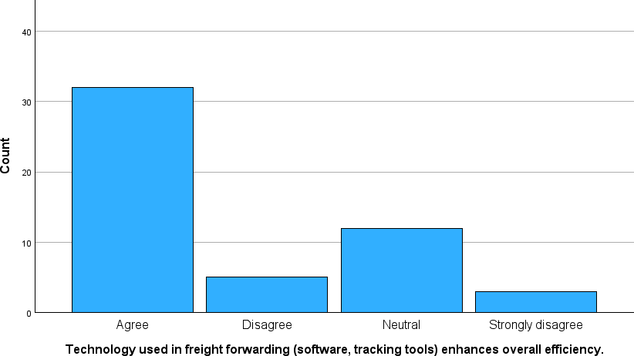**CHART NO 1: Technology used in freight forwarding (software, tracking tools) enhances overall efficiency**

**INFERENCE**:

From the above table chart inferred that 63% of the respondents agree and 5.6% of the respondents Strongly Disagree for technology used in freight forwarding.

## Table 2: How are shipments located and observed during the shipping process?

|  |  |  |
| --- | --- | --- |
| **Statement** | **No Of Responses** | **Frequency** |
| GPS | 23 | 43.4 |
| Carrier  updates | 12 | 22.6 |
| Automated  notifications | 7 | 13.2 |
| Combination  of the above | 11 | 20.8 |
| Total | 50 | 100 |

**CHART NO 2: How are shipments located and observed during the shipping process?**

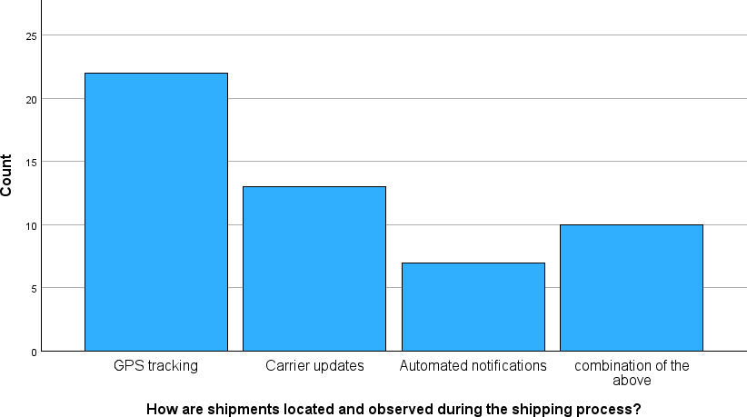

**INFERENCE**:

From the above table chart inferred that 43.4% of the respondents GPS and 13.2% of the respondents Automated notifications for shipments located and observed.

## Research Gap:

Opinion of employees may be biased at time Respondents would have hidden some facts due to the fear of management. The study is based on the data collected from respondents and a journal hence the reliability of the data is not probed into. Utmost care has to be taken while extending the results to the other areas**.** Since logistics and shipping company has less no.of employee it is difficult to collect the required sample

1. **RESEARCH METHODOLOGY:** The methodical approach used by researchers to carry out investigations, collect data, examine sources, and make inferences is known as research methodology.

It includes planning the investigation, sampling, gathering data, analyzing and interpreting it, taking ethical issues into account, and guaranteeing validity and dependability

By guaranteeing the rigor and validity of research findings and offering a methodical approach to research inquiry, this organized framework directs the creation of knowledge across a range of domains.

## CONCLUSION:

In summary, freight forwarding businesses are critical to the world economy because they facilitate the smooth movement of goods across international boundaries. Despite its significance, this business has a number of challenges, including challenging logistics, regulatory barriers, and emerging technologies. However, these challenges may be overcome with careful planning, effective communication, and an open mind to novel ideas. Freight forwarders must prioritize cost- effectiveness and efficiency in their operations while still ensuring cargo security and safety. This necessitates leveraging cutting-edge technology such digital tracking systems, automation, and data analytics in order to streamline processes and lower risks.

## XI Reference:

* Jain Khushpat .S - Export Import Procedure and Documentations, Mumbai, Himalaya Publishing House, Third Editions 2006.
* Pramod Rao – Logistics Management Concept and Cases, Hyderabad, The Icfai University, First Edition 2007.
* Raghuram And N. Rangaraj – Logistics And Supply Chain Management, Mac Millan India Limited, 2001 Delhi.
* Martin christo-pher – Logistics and Supply Chain Management, New Delhi.