**GSM/GPS based Vehicle Accident Alert System using NodeMCU**

**Harshada Dattatray Hajare1, Gauri Maruti Bansode2, Anuja Devanand Khandekar3, Rahul Krishna Patole 4**

1,2,3 BE Student, Dept. of E&TC, Fabtech Technical Campus College of Engineering & Research, Sangola, India

4Asst. Prof., Dept. of E&TC, Fabtech Technical Campus College of Engineering & Research, Sangola, India

**ABSTRACT**

Vehicle accidents pose a significant threat to road safety, often resulting in loss of lives and property. Timely intervention by emergency services can mitigate the severity of accidents and save lives. This research paper presents a GSM/GPS based vehicle accident alert system utilizing NodeMCU, aimed at enhancing emergency response times. The system automatically detects accidents and transmits real-time accident location information to emergency services via GSM communication. Through integration with GPS technology, precise accident coordinates are obtained, enabling quick and accurate dispatch of rescue teams. The proposed system offers a promising solution to improve road safety and minimize the impact of vehicle accidents.

**Keywords:** Accident detection, Emergency services, IoT technology, Real-time monitoring.

1. **INTRODUCTION**

The advancement of transportation systems has propelled human civilization, with automobiles playing a pivotal role in daily life. While vehicles facilitate mobility and connectivity, they also pose risks, particularly in terms of accidents. Speed, a fundamental factor in driving, not only influences the severity of accidents but also increases the likelihood of crashes.

Speed is a significant contributor to vehicle accidents, often resulting in loss of lives. The timely arrival of emergency services could potentially save lives if accident information is relayed promptly. This project focuses on developing an accident detection system that triggers alerts to rescue teams when accidents occur. The system aims to automatically detect accidents and notify emergency services with the precise accident location, thereby improving response times and saving lives.

Despite concerted efforts by governmental and non-governmental organizations to promote safe driving, accidents continue to occur, often resulting in fatalities. Studies have shown that timely emergency response could prevent a significant percentage of these fatalities. Hence, there is a critical need for an efficient automatic accident detection system capable of alerting emergency services promptly.

1. **LITERATURE REVIEW**

In recent years, there has been a significant surge in research efforts towards the development of advanced accident detection and alert systems aimed at enhancing road safety and reducing fatalities. This literature review presents a synthesis of relevant studies conducted in this domain, spanning various methodologies and technological approaches.

1. T Kalyani et al. (2019) introduced an Accident Detection and Alert System, emphasizing the importance of real-time accident detection for timely intervention. Their system leverages modern technologies to detect accidents and promptly notify emergency services, thereby potentially reducing response times and saving lives [1].

2. Parag Parmar and Ashok M. Sapkal (2017) explored real-time detection and reporting of vehicle collisions. Their research focused on the utilization of sophisticated sensors and algorithms to accurately detect collisions as they occur, enabling swift reporting to relevant authorities and emergency services [2].

3. Md. Syedul Amin et al. (2012) proposed an Accident Detection and Reporting System using GPS, GPRS, and GSM technology. Their study highlighted the integration of GPS for location tracking and GSM/GPRS for real-time communication, facilitating rapid response to accidents and efficient coordination of rescue efforts [3].

4. Gowshika B et al. (2019) presented a Vehicle Accident Detection System using GPS and GSM modem. Their system aimed to detect accidents using GPS coordinates and transmit alerts via GSM communication, demonstrating a practical approach to enhancing road safety through technology [4].

5. Sayanee Nanda et al. (2018) developed an IoT-Based Smart System for Accident Prevention and Detection. Their research focused on leveraging IoT technology to prevent accidents through real-time monitoring of road conditions and vehicle behavior, highlighting the potential of IoT in proactive accident prevention strategies [5].

6. Norsuzila Yaacob et al. (2017) proposed a Real-Time Wireless Accident Tracker using Mobile Phone. Their study emphasized the utilization of mobile phones as tracking devices to monitor vehicles and detect accidents in real-time, showcasing the feasibility of mobile-based accident detection solutions [6].

7. S. Sonika et al. (2014) introduced an Intelligent Accident Identification System using GPS and GSM modem. Their system aimed to intelligently detect accidents based on sensor data and communicate relevant information to emergency services, demonstrating an automated approach to accident detection and reporting [7].

8. Dhruvesh H. Patel et al. (2019) presented an IoT-Based System for Obligatory Usage of Safety Equipment for Alcohol and Accident Detection. Their research focused on integrating IoT technology with safety equipment to prevent accidents caused by alcohol consumption, highlighting the potential of IoT in promoting safer driving practices [8].

9. Ajith Kumar et al. (2018) proposed an Accident Detection and Alert System using GPS and GSM. Their study emphasized the integration of GPS and GSM technologies for accurate accident detection and timely alerting of emergency services, showcasing a practical approach to improving road safety [9].

Overall, the literature review highlights the diverse approaches and technological innovations in the field of accident detection and alert systems, underscoring the importance of continuous research and development efforts to address road safety challenges and mitigate the impact of accidents on society.

1. **METHODOLOGY**

The accident detection and alert system operate based on a block diagram. Initially, the hardware initializes and reads data from sensors. If sensor readings exceed threshold levels, indicating an accident, the system sends GPS coordinates to emergency services. The emergency dialer verifies the coordinates and contacts nearby hospitals for assistance. Once approved, the rescue team is dispatched to the accident location, and family members are informed [1-4]. The Fig. 3.1 depicts a block schematic of Vehicle Accident Alert System.

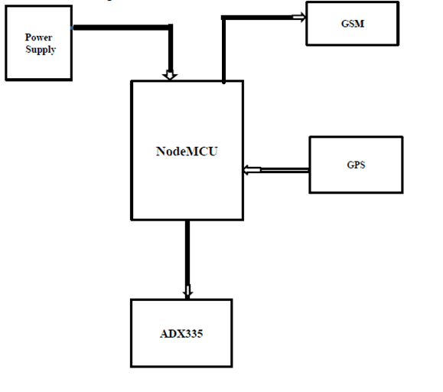

**Fig. 3.1 A block schematic of Vehicle Accident Alert System**

* 1. **Implementation**

The hardware setup involves connecting the NodeMCU, GSM module, GPS module, and accelerometer according to the system design. Software implementation includes programming the NodeMCU to interface with the modules, monitor accelerometer data, and trigger alerts when accident criteria are met. Additionally, a user interface may be developed to configure system settings and view accident alerts [1-2].

* 1. **Working Principle**

The setup will be meticulously outlined through a comprehensive block diagram. An accident sensor serves as the primary detector, promptly relaying any incident to the microcontroller. Subsequently, the GPS system accurately determines the vehicle's latitude and longitude, facilitating precise location identification. This information is then transmitted via GSM to a predetermined phone number stored in the EEPROM. For immediate system activation, a button sensor is employed for accident detection, accompanied by a buzzer for signaling. Timely medical assistance necessitates pinpointing the accident's exact position. Users have the flexibility to modify stored phone numbers as required. The microcontroller orchestrates alert message dissemination to predefined numbers through the GSM module, allowing users to pre-enter messages. Furthermore, a clear status display on an LCD screen ensures visibility of system operations. In instances of no casualties, message transmission can be halted using a switch, prompting the microcontroller to restart and initiate the process anew [1-4].

* 1. **Use Case**

Use Case Scenario: Vehicle Accident Alert System. The schematic of the Use Case is shown in Fig. 3.2.

**3.3.1 Use Case 1: User Profile Management**

- Actor: User

- Description: The user can update their personal details and emergency contacts stored in the system.

- Preconditions: The user must be logged into the system.

- Basic Flow:

1. User accesses the system interface.

2. User navigates to the profile management section.

3. User updates personal details such as name, address, and contact information.

4. User adds or modifies emergency contacts.

5. User saves changes to update the profile.

- Alternate Flow:

- If the user encounters any errors or issues while updating, they are prompted to retry or contact support for assistance.

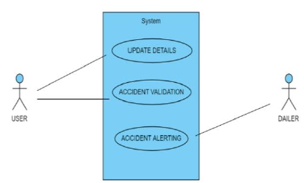

**Fig. 3.2 Use Case Diagram**

**3.3.2 Use Case 2: Emergency Dial Abortion**

- Actor: User

- Description: The user has the ability to abort the emergency dialing process to the responder using a control switch.

- Preconditions: An emergency dialing process is initiated.

- Basic Flow:

1. User activates the emergency dialing process through the system.

2. During the dialing process, the user decides to abort the call.

3. User activates the control switch designated for aborting the emergency dial.

4. The system discontinues the dialing process and notifies the user of the abortion.

- Alternate Flow:

- If the user accidentally triggers the abort switch, they can confirm the cancellation within a specified time frame to prevent unintended aborts.

**3.3.3 Use Case 3: Responder Waiting for Alert**

- Actor: Dialer/Responder

- Description: The responder monitors the system for accident alerts generated by the system.

- Preconditions: The responder must be logged into the system and assigned as a designated responder.

- Basic Flow:

1. Responder logs into the system and navigates to the designated section for monitoring accident alerts.

2. Responder awaits incoming accident alerts.

3. Upon receiving an accident alert, the responder acknowledges the alert and initiates the appropriate emergency response protocol.

- Alternate Flow:

- If the responder encounters any technical issues or delays in receiving alerts, they notify the system administrator for troubleshooting and resolution [1, 4, 8].

These use cases outline the functionalities and interactions of the Vehicle Accident Alert System from both user and responder perspectives, ensuring efficient management of user profiles, emergency dialing processes, and timely response to accident alerts.

1. **MERITS, DEMERITS AND CHALLENGES**

**4.1 Merits**

- Useful in automotive vehicles

- Immediate medication provision in case of remote areas

- Integration with vehicle alerting systems

**4.2 Demerits**

- False alarms may occur

- System reliability impacts due to dependency on GPS and GSM signals [7-9]

**4.3 Challenges**

- Accuracy of accident detection

- Reducing false alarms

- Limitations of GPS and GSM modules

- Synchronization between components of the system and emergency services [8-9]

1. **RESULT AND DISCUSSION**

The Fig. 5.1 depicts the hardware of implementation of the project work. Here the Arduino microcontroller is integrated with the components including accelerometer, vibration sensor, GSM module and GPS module. The accidental case is detected by the accelerometer and vibration sensor. The GPS identifies the location of the accident and then GSM establishes the network connection. With this setup, the geo-location will be sent to the registered mobile number. The message will be displayed on LCD in case of accident as shown in Fig. 5.2.

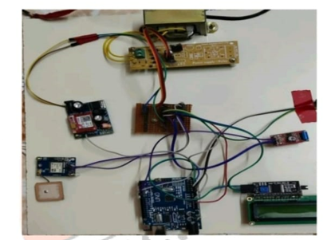

**Fig. 5.1 Hardware implementation of Vehicle Accident Alert System**

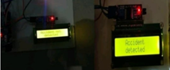

**Fig. 5.2 Accident case identification**

1. **CONCLUSION**

In conclusion, the GSM/GPS-based Vehicle Accident Alert System using NodeMCU demonstrates a significant solution to improve emergency response in vehicle accidents. By utilizing GPS and GSM technologies, the system enhances the effectiveness of accident alert systems, potentially reducing response times and saving lives. The development of an accident detection and alert system holds promise in improving emergency response times and saving lives. With the help of IoT technology and real-time monitoring capabilities, the proposed system aims to enhance road safety and reduce the impact of accidents. However, addressing technical challenges and ensuring system reliability are crucial for successful implementation. While challenges exist, ongoing research and development efforts aim to overcome these hurdles, paving the way for safer roads and enhanced emergency services.

1. **REFERENCES**
2. T. Kalyani, S. Monika, B. Naresh, and M. Vucha, "Accident Detection and Alert System," International Journal of Innovative Technology and Exploring Engineering (IJITEE), vol. 8, no. 5, pp. 271-275, Mar. 2019.
3. P. Parmar and A. M. Sapkal, "Real-time detection and reporting of vehicle collision," in Proc. IEEE International Conference on Intelligent Transportation Systems (ITSC), Yokohama, Japan, 2017, pp. 1067-1072.
4. M. S. Amin, J. Jalil, and M. B. I. Reaz, "Accident Detection and Reporting System using GPS, GPRS and GSM Technology," in Proc. IEEE International Conference on Informatics, Electronics & Vision (ICIEV), Dhaka, Bangladesh, 2012, pp. 640-643.
5. B. Gowshika, G. MadhuMitha, and J. Jayashree, "Vehicle accident detection system using GPS, GSM modem," International Research Journal of Engineering and Technology (IRJET), vol. 6, no. 3, pp. 4126-4129, Mar. 2019.
6. S. Nanda, H. Joshi, and S. Khairnar, "An IoT Based Smart System for Accident Prevention and Detection," in Proc. IEEE International Conference on Recent Advances in Electronics and Communication Technology (ICRAECT), Bangalore, India, 2018, pp. 179-182.
7. N. Yaacob, H. Haron, M. H. Ibrahim, M. A. Othman, M. I. Yusoff, and M. N. Taib, "Real-Time Wireless Accident Tracker using Mobile Phone," in Proc. IEEE 15th Student Conference on Research and Development (SCOReD), Putrajaya, Malaysia, 2017, pp. 279-283.
8. S. Sonika, K. Sathyasekhar, and S. Jaishree, "Intelligent accident identification system using GPS, GSM modem," International Journal of Advanced Research in Computer and Communication Engineering (IJARCCE), vol. 3, no. 2, pp. 232-237, Feb. 2014.
9. D. H. Patel, H. P. Joshi, K. M. Shah, and V. R. Shah, "IoT based Obligatory usage of Safety Equipment for Alcohol and Accident Detection," in Proc. IEEE International Conference on Electrical, Electronics, and Optimization Techniques (ICEEOT), Chennai, India, 2019, pp. 1514-1517.
10. A. Kumar, V. Jaganivasan, T. Sathish, and S. Mohanram, "Accident detection and alert system using GPS & GSM," International Journal of Pure and Applied Mathematics (IJOPAAM), vol. 119, no. 15, pp. 2251-2258, 2018.