**"Enhancing Electrochemical Machining Efficiency through Flow Pattern Analysis and Tool Optimization: A Comprehensive Study"**

**Md. Zakaur Rahman1, Vineet Kumar Dwivedi2**

1Scholar, Department of Mechanical Engineering, SAM College of Engineering and Technology, Bhopal, M.P, 462022, INDIA

2Head and Prof., Department of Mechanical Engineering, SAM College of Engineering and Technology, Bhopal, M.P, 462022, INDIA

**ABSTRACT**

Electrochemical Machining (ECM) has evolved into a pivotal technology for manufacturing intricate components across various industries due to its precision and versatility. This paper explores the optimization of ECM processes through a comprehensive analysis of flow patterns using different L-shaped tool configurations. The study aims to enhance machining efficiency and stability, crucial for applications like blisk manufacturing in aerospace industries. Four models of L-shaped tools are meticulously designed and analyzed using ANSYS software, considering factors such as slot dimensions and inlet velocities. The research investigates key parameters including temperature distribution, current density, material removal rate (MRR), turbulence, and passivation tendencies within the interelectrode gap (IEG). Results reveal that higher inlet velocities contribute to improved heat dissipation, higher current densities, increased MRR, and reduced passivation tendencies. Notably, Model 3, featuring an intermediate chamber and rounded slot corners, exhibits superior performance across multiple parameters. The study sheds light on the complex dynamics of ECM processes, providing valuable insights for optimizing tool designs and mitigating passivation effects. By leveraging advanced simulation techniques, this research contributes to enhancing ECM precision and efficiency, paving the way for advancements in modern manufacturing.

**Keywords:** Electrochemical Machining (ECM), Flow Pattern Analysis, Tool Optimization, Interelectrode Gap (IEG), Material Removal Rate (MRR), Turbulence

1. **INTRODUCTION**

Electrochemical Machining (ECM) stands as a prominent non-traditional machining process renowned for its precision, versatility, and ability to produce intricate shapes with exceptional surface quality. Originating in the 1950s, ECM has undergone significant advancements, emerging as a key technology in various industries such as aerospace, automotive, medical, and electronics. Unlike conventional machining methods that rely on mechanical forces to remove material, ECM utilizes electrochemical reactions to selectively dissolve material from workpieces. This unique approach enables ECM to machine complex geometries, including internal features and delicate structures, with unparalleled accuracy and minimal thermal or mechanical stress. The principle behind ECM involves an electrolytic cell where a conductive workpiece (anode) and a tool electrode (cathode) are immersed in an electrolyte solution. When a voltage is applied between the workpiece and the tool electrode, an electrochemical reaction occurs at the workpiece surface, resulting in the dissolution of material in the form of ions. The dissolved material is carried away by the electrolyte, leaving behind a precise and smooth machined surface. ECM offers several advantages over traditional machining methods, including the ability to machine materials regardless of their hardness or toughness, minimal tool wear, and the absence of burrs or residual stresses in the machined surface. Moreover, ECM is a versatile process capable of machining a wide range of materials, including metals, alloys, composites, and even difficult-to-machine materials such as superalloys and ceramics. In recent years, ECM has witnessed significant advancements in process control, electrode design, and electrolyte formulations, further enhancing its capabilities and applicability in various manufacturing sectors. Research efforts in ECM have focused on optimizing process parameters, improving surface finish, and exploring new applications in emerging industries. This research paper aims to provide a comprehensive overview of Electrochemical Machining, including its principles, methodologies, advancements, and applications in modern manufacturing. By delving into the intricacies of ECM, we seek to elucidate its capabilities, limitations, and future prospects, thereby offering valuable insights for researchers, engineers, and practitioners alike.The introduction should be typed in Times New with font size 10. In this section highlight the importance of topic, making general statements about the topic and presenting an overview on current research on the subject. The simplest way is to replace(copy-paste) the content with your own material. Your introduction should clearly identify the subject area of interest. **Zhang CY et al. [1]** Electrochemical machining (ECM) offers a cost-effective method for shaping heat-resistant, high-strength materials into intricate forms difficult to achieve via conventional machining. Widely utilized in aerospace industries, ECM is crucial for blisk manufacturing. This paper explores enhancing ECM precision and stability in blisk cascade passage machining by introducing a radial feeding electrode and a novel electrolyte flow mode termed "Π shape flow mode." Three flow field models are compared: traditional lateral flow mode, positive flow mode, and Π-shaped flow mode. Finite element fluid analysis reveals superior uniformity in electrolyte flow with the Π-shaped mode. Additionally, cathode deformation due to pressure differentials is analyzed. Experimental validation demonstrates the stability of the process, with less than 1% current fluctuation using the Π-shaped mode. Moreover, the Π-shaped mode yields a 70% higher cathode feeding velocity and reduces short-circuit occurrences. Achieving a surface roughness of only 0.15 μm and a machining error below 0.1 mm on the blisk hub confirms the efficacy of the Π-shaped flow mode in enhancing ECM quality, stability, and efficiency for blisk cascade passage machining. **X Yue et aal. [2]** Electrochemical mill-grinding, a modified version of traditional electrochemical machining, finds application in manufacturing helicopter transmission system parts. It reduces tool wear when machining hard-to-cut materials and can perform rough and finish machining consecutively. Machined flatness directly impacts tool wear and machining cycle, especially in finish machining. To enhance flatness, a new tool substrate with additional bottom outlet holes is proposed. Dynamic flow field simulation demonstrates increased electrolyte velocity at edge regions and decreased velocity at the middle region front, improving flatness. Validation experiments confirm improved flatness and surface roughness. Moreover, the new abrasive tool enhances flatness and surface roughness during finish machining. Successful machining of a glossy rectangle plane affirms the tool's capability for consecutive rough and finish machining. **A CD et al. [3]** This paper reviews turbulent flow computation, crucial in modern technology. Various methods for predicting turbulent flow and their applications are discussed, focusing on simulating either detailed turbulent motion or its overall effect on mean-flow behavior. Successes include two-equation models for simple hydrodynamic phenomena. Challenges remain for applications involving complex factors like curvature, buoyancy, and chemical reactions. New conceptual developments, such as multi-fluid models and full simulations, are needed. The paper covers Reynolds-Averaged Navier–Stokes (RANS), Very Large Eddy Simulation (VLES), Unsteady Reynolds-Averaged Navier–Stokes (URANS), Detached Eddy Simulation (DES), and hybrid LES/RANS techniques. **G H Yoon et al. [4]** A new finite element (FE)-based topology optimization (TO) method was developed for turbulent flow, utilizing the Reynolds-Averaged Navier-Stokes (RANS) equations. Despite advancements in fluidic TO, considering turbulent flow's impact remains crucial. This study introduces a turbulent FE model to capture complex fluid motion. Modifying the turbulent model to accommodate topology evolutions during optimization is key. Penalization terms were added to the original turbulent model to address these effects. Validation and evaluation involved optimizing various two-dimensional designs by minimizing turbulent kinetic or dissipation energies. Results demonstrate the feasibility of topology optimization for turbulent flow. **T M Salaheldin et al.** **[5]** A three-dimensional numerical model FLUENT is employed to simulate turbulent flow separation around vertical circular piers in clear water. Various turbulence models are tested, and results are compared with experimental data from the literature. Despite perceived limitations of the k-epsilon model in resolving three-dimensional open channel and geophysical flows, several variants perform satisfactorily in replicating measured velocity profiles. However, discrepancies are observed between model results and measured bed shear stress. The Reynolds stress model effectively simulates velocity and shear stress distributions, aiding in understanding complex flow fields and scour initiation processes around piers of diverse characteristics. **W H Graf et al. [6]** Local scour around bridge piers, a concern for hydraulic engineers, results from the interaction of three-dimensional turbulent flow around the cylinder and the mobile channel bed. Scouring occurs near the cylinder due to this interaction. This paper experimentally investigates the three-dimensional flow field in an equilibrium scour hole. An acoustic-Doppler velocity profiler (ADVP) measures velocities in the vertical symmetry plane before and after the cylinder. Vorticity calculations reveal a vortex system in the front and a trailing wake-vortex system of strong turbulence behind the cylinder. **D C Wilcox et al. [7]** The third edition of "Turbulence Modeling for CFD" is driven by its enduring popularity in universities worldwide and demand for courses based on the book. While new developments in the field have been infrequent since the first edition, notable advancements like detached-eddy simulation (DES) have been integrated. A major section on DES is added to Chapter 8, along with other revisions aimed at incorporating the latest developments in turbulence modeling, reflecting the author's dedication to enhancing the text. **K J Bathe et al. [8]** Introduce a procedure for adapting and repairing meshes in the solution of incompressible and compressible fluid flows, including fluid-structure interactions (FSI). Our approach encompasses highly nonlinear responses in solids and structures due to large deformations, nonlinear material behavior, contact, and temperature effects. The procedure is particularly useful for adjusting fluid meshes in pure computational fluid dynamics (CFD) solutions with high gradients or significant boundary layer effects, as well as FSI solutions with large structural deformations. Illustrated with various examples, our practical scheme offers a comprehensive solution for complex problems. **J Sawicki et al. [9]** The paper reports experimental findings on critical states in electrochemical machining (ECM), focusing on hydrodynamic conditions in the electrolyte flow between electrodes. ECM involves material removal through anodic dissolution, with the workpiece serving as the anode and the tool as the cathode. Proper selection of anode and cathode materials, electrolyte, and processing parameters ensures high efficiency and surface smoothness. However, inappropriate machining parameters can lead to critical states, primarily influenced by electrolyte flow between electrodes. The study evaluates critical states in ECM, particularly during machining of curved and rotating surfaces. **Qu N S et al. [10]** Electrochemical machining (ECM) is a cost-effective method for blisk manufacturing, involving channel and profile machining. Uneven allowance distribution post-channel machining affects profile machining quality. To enhance allowance uniformity, a method employing variable feed rates is developed. Feed rates dynamically adjust during machining based on side gap requirements at various depths, reducing allowance differences. Simulation of blisk channel dissolution with different feed rates yields prediction profiles. Relationship between feed rate, depth, and side gap informs feed rate adjustments. Contrast experiments show using variable feed rates reduces allowance differences in convex and concave parts by 62.2% and 67.4%, respectively. Variable feed rate ECM for bilks’ channels proves feasible and efficient. **M Chai et al. [11]** In electrochemical machining (ECM) for aircraft blades, the flow field distribution in the interelectrode gap significantly impacts machining accuracy and surface quality. Variations in process parameters like machining clearance, voltage, and solution concentration can lead to complex and unstable electrolyte fluid fields, making prediction and control of ECM accuracy challenging. To address this, 30 ECM experiments for cooling hole production were conducted, focusing on machining accuracy and stability. Additionally, a geometric model of the gap flow field was analyzed using computational fluid dynamics (CFD) to simulate electrolyte flow. The effects of flow velocity modes on cooling hole machining accuracy and stability were thoroughly investigated and determined.

* 1. **Objective**

Researchers have extensively explored material removal mechanisms and current density distributions in electrochemical machining (ECM) using various tool shapes and software. However, accurately predicting the flow pattern has remained a challenge. Passivation, particularly in complex-shaped workpieces, poses a significant hurdle in ECM processes. Understanding the machining variables within the interelectrode gap (IEG) is crucial. Therefore, there's a pressing need to comprehend these parameters, especially those related to flow patterns. Once the flow pattern is understood, designing tools and mitigating passivation becomes more feasible. Building upon this background and literature review, the present study aims to:

Optimize the design of an L-shaped tool and investigate the flow pattern.

Evaluate different tool models for enhanced machining efficiency and determining optimal inlet velocities.

* 1. **Scope of the Study**

In the present work is related to the flow pattern analysis of ECM with four different L shaped tool and studied the various parameters with inlet velocities 36, 43 and 48 m/s.

Current density distribution.

Velocity profile.

Temperature pattern.

Turbulence.

Shape changes of workpiece top surface.

Material Removal Rate (MRR).

1. **METHODOLOGY**

- Selection of L-shaped Tool: Chosen for relevance to ECM and potential insight into flow pattern dynamics within the interelectrode gap (IEG).

- Consideration of Four Slot Designs: Four distinct configurations with variations in dimensions and angles to analyze flow characteristics comprehensively.

- Modeling with ANSYS Design Modeler: ECM setup meticulously recreated in virtual environment with precise geometry definition.

- Meshing with ANSYS Mesh Module: Crucial step dividing computational domain into smaller elements for accurate simulation results.

- CFD Analysis with ANSYS CFX: Simulation of fluid flow within ECM setup predicts parameters like velocity, pressure, and turbulence.

- Observations and Discussions: Results examined, comparing flow patterns and parameters across different slot designs to gain insights into optimizing L-shaped tool design for ECM processes.

1. **MODELING AND ANALYSIS**

In our simulation process, we've developed four distinct models using the ANSYS Design Modeler Module. Each model represents a different configuration of the L-shaped tool:

1. Model 1: This tool has a central through hole.
2. Model 2: The tool has a slot in its face with rounded corners.
3. Model 3: Similar to Model 2, but with an added intermediate chamber.
4. Model 4: The tool's slot has sharp corners.

These models all start with the same initial workpiece shape: a circular piece with a 60 mm diameter and 20 mm height. We're using a NaCl solution as the electrolyte, which begins flowing from an inlet with a constant diameter of 3 mm. To simulate various scenarios, we're testing the models with three different inlet velocities: 36 m/s, 43 m/s, and 48 m/s. These velocities are selected based on the flow rate limits observed in ECM processes without encountering passivation issues. Throughout our analysis, the outer dimensions of the tool remain consistent across all models.

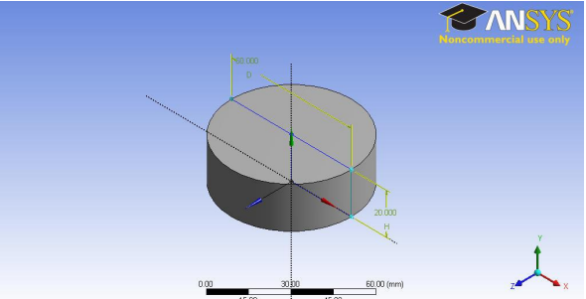

Fig. 3.1: Shape of workpiece used for simulation

* 1. **Model 1 – L Shaped Tool with Central Through Hole**

Model 1 is a simple L shaped model having a central through hole with a diameter of 3mm and height 50 mm. This center of the hole is fixed on (-7.5, -7.5) coordinate in the XZ plane. Fluid is flowing through the through hole and flow out through the IEG. Top view of the tool is shown in Figure 5.2 and 3D view is shown in Figure 3.3. Inter electrode gap (IEG) is for all model’s kept constant is 0.5mm that is shown in Figure 3.4.

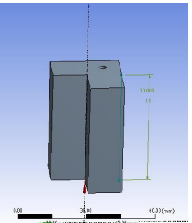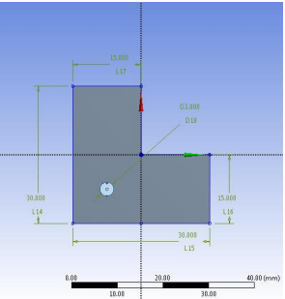

.

|  |  |
| --- | --- |
| Fig. 3.2: Top View of Tool | Fig. 3.3: Tool Model for Model 1 |

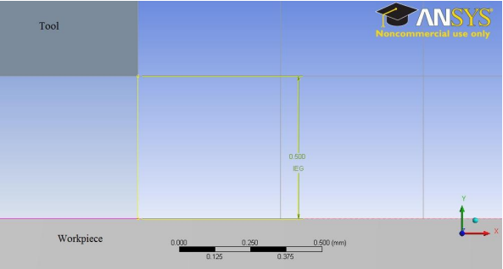

Fig. 3.4: IEG for all models

* 1. **Model 2 L- Shaped Tool Having Slot in the Tool Face with Rounded Corner**

Difference of Model 2 from Model 1 is that the bottoms face of the tool having grooves with rounded corners. In this model the central hole has 3 mm diameter and two grooves are connected with this as shown in the Figure 3.4. Those grooves are having a diameter of 0.8 mm and end corners of the grooves with a diameter of 3 mm. Dimensions of this tool is presented in the Figure 3.5. Height of the tool is same as that of previous model. According to tool design for ECM, distance between slot end and corners of workpiece want to keep at least 1.5 mm and the width of the slots are 0.8 mm for best results. These conditions are taken in to account for all tool designs.

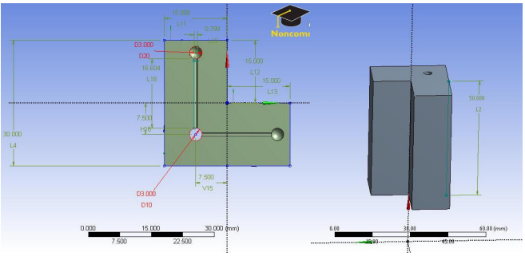

Fig. 3.5: Tool dimensions for Model 2

* 1. **Model 3 – L shaped Model Having Intermediate Chamber and Slot in the Tool Face with Rounded Corners**

Model 3 is entirely different from other models. In other models’ fluid is coming from the inlet and distributed to the grooves at bottom face of the tool. In Model 3 fluid is first come to the L shaped chamber then it flows to the IEG through slots provided in the bottom of the tool. Here the inlet diameter is given same as like other models but rounded corners in the slot have different dimensions. That design is shown in Figure 3.6. In that slit is in the bottom portion of the chamber. Chamber face dimensions are shown in Figure 3.7 and have a thickness of 1 mm and a height of 5 mm. Chamber constructed for Model 3 is shown in Figure 3.7. Slits in the Model 2 had two rounded end each having a diameter of 3 mm and there is a central rounded portion with a diameter of 5 mm.

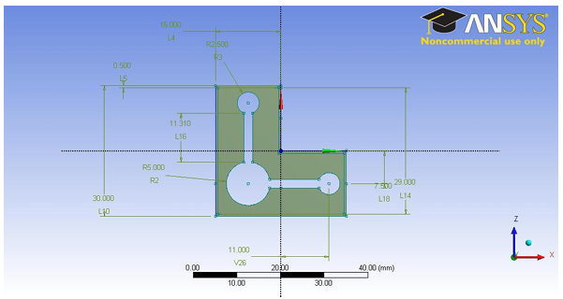

Fig. 3.6: Tool dimensions for Model 3

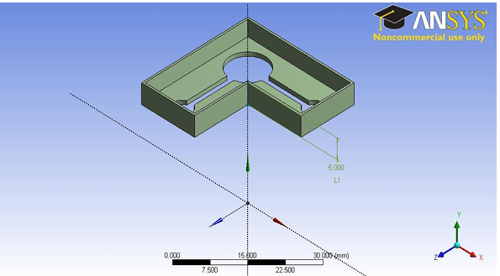

Fig. 3.7: Chamber in the Model 3

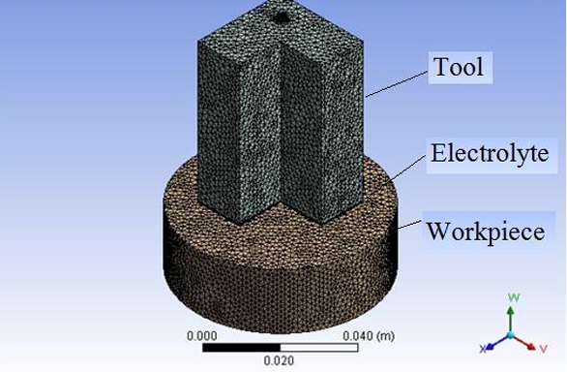

Fig. 3.8: Outer shape of meshed model for Models 1, 2 and 4.

1. **RESULTS AND DISCUSSION**

This chapter elucidates the parameters affecting the ECM process through charts and graphs. Various factors including velocity, current density, turbulent kinetic energy, turbulent eddy dissipation, shape change of workpiece, and Material Removal Rate (MRR) are discussed in relation to the inlet velocity. The analysis is conducted for four different models generated using the commercial software ANSYS.

* 1. **Effect on Velocity Profile**

Figures 4.1 to 4.4 illustrate velocity profiles within the Inter Electrode Gap (IEG) of models 1 to 4, ranging from 0 to 30 m/s. In Fig. 4.1, velocities near the central through hole reach approximately 30 m/s, with stagnation regions exhibiting minor velocity variations. Velocity decreases smoothly but drops below 5 m/s towards the tool tip, indicating potential passivation due to insufficient electrolyte flow, as per ECM theory. Passivated areas are evident within the model, highlighting regions prone to reduced machining efficiency.

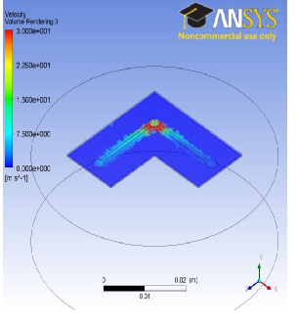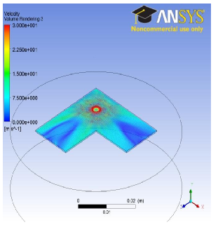

|  |  |
| --- | --- |
| Fig. 4.1: Velocity profile of Model 1 with an inlet velocity 36m/s. | Fig. 4.2: Velocity profile of Model 2 with an inlet velocity 36m/s. |

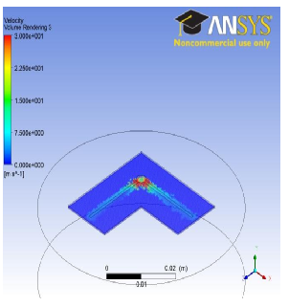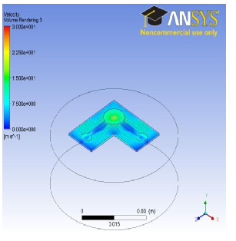

|  |  |
| --- | --- |
| Fig. 3.3: Velocity profile of Model 3 with an inlet velocity 36m/s | Fig. 3.4: Velocity profile of Model 4 with an inlet velocity 36m/s. |

In Model 2, the velocity near the groove is more than 5 m/s and in all other region it falls below 5 m/s, that means other areas will get passivated. In case of Model 3, from Fig. 4.3, it can be easily understood that the velocity variation is smooth and a small region is having velocity < 5 m/s. Here stagnation effect is less because first the electrolyte entering in to a small chamber and then it coming out through the grooves. The velocity profile in Model 4 is similar to Model 2 which means that except near the grooves all other areas will get passivated.

Among these four models, Model 3 is the best in the sense of velocity profile. Hence, extended simulation of Model 3 with higher velocities was conducted. The velocity distributions are shown in Fig. 4.5 and 4.6 for inlet velocity = 43 and 48 m/s, respectively. From these figures, it can be concluded that passivation tendency decreasing with increasing inlet velocity.

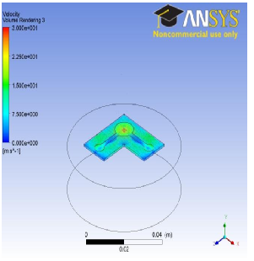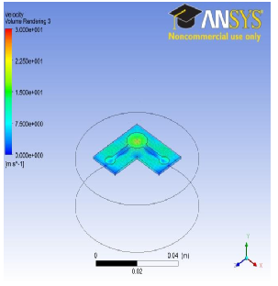

|  |  |
| --- | --- |
| Fig. 4.5: Velocity profile of Model 3 with an inlet velocity 43m/s. | Fig. 4.6: Velocity profile of Model 3 with an inlet velocity 48m/s. |

* 1. **Effect on Streamline**

The streamlines are generally representing the velocity flow pattern in a fluid flow. Figs. 6.7, 6.8, 6.9 and 6.10, are the bottom view of the 3D streamline pattern for Model 1, 2, 3 and 4, respectively.

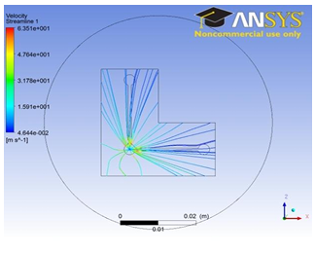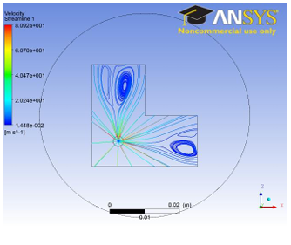

|  |  |
| --- | --- |
| Fig. 4.7: Streamline flow of Model 1 with an inlet velocity 36m/s | Fig. 4.8: Streamline flow of Model 2 with an inlet velocity 36m/s |

From Fig. 6.7, it can be understood that there is eddy formation in the flow pattern in the end region of the ‘L’ and velocity in the eddy region is less than 5m/s. In Fig. 4.8 and 4.10, the streamlines are almost similar to each other. These defects cause passivation within the IEG. In Fig. 4.9, for Model 3, the streamlines are distributed in proper manner. The end of the groove the streamline arrangement is ambiguous in nature, so it needs some more clarification. From the inset figure, it is evident that the flow is from top upper chamber to bottom in IEG and it gets distributed throughout. From the above figures, it can be understood that Model 3 is the best, so we continue the simulation of Model 3 with increasing inlet velocities 43 m/s and 48 m/s.

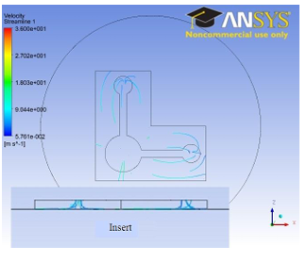

Fig. 4.9: Streamline flow of Model 3 with an inlet velocity 36m/s

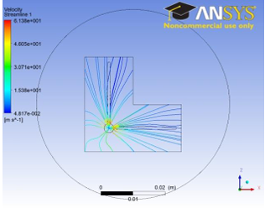

|  |  |
| --- | --- |
| Fig. 4.10: Streamline flow of Model 4 with an inlet velocity 36m/s | Fig. 4.11: Streamline flow of Model 3 with an inlet velocity 43 m/s |

1. **CONCLUSION**

Several key observations from the analysis of the electrochemical machining process with L-shaped tool models:

i. **Maximum Temperature:** There's a decreasing trend in maximum temperature within the inter electrode gap (IEG) as the inlet velocities increase across all models. This suggests that higher velocities contribute to better heat dissipation and cooling within the system.

ii. **Maximum Current Density:** The maximum current density tends to increase as the inlet velocities rise. This could be attributed to increased electrolyte flow rates, resulting in higher current densities within the machining region.

iii. **Material Removal Rate (MRR) and Turbulence:** Both MRR and turbulence show an increasing trend with higher inlet velocities. This indicates that faster flow rates lead to more effective material removal and increased turbulence within the system.

iv. **Passivation Tendency:** The tendency for passivation decreases across all models as the inlet velocities increase. Higher velocities may help prevent or reduce passivation effects by promoting better electrolyte flow and material removal.

v**. Best Model:** Model 3 emerges as the best tool design among the evaluated models based on the overall analysis of various parameters, including temperature, current density, MRR, turbulence, and passivation tendency. Its favorable characteristics suggest superior performance compared to the other models.

These observations provide valuable insights into the behavior of the electrochemical machining process and can guide further optimization efforts for improved efficiency and performance.

1. **REFERENCES**
2. T. Mohana Priya, Dr. M. Punithavalli & Dr. R. Rajesh Kanna, Machine Learning Algorithm for Development of Enhanced Support Vector Machine Technique to Predict Stress, Global Journal of Computer Science and Technology: C Software & Data Engineering, Volume 20, Issue 2, No. 2020, pp 12-20 Zhang CY, Zhang YJ, Chen XL, Yao JL, Li JF, Su GK, Zhao RL. Investigation of flow fields during the electrochemical machining of variable-section pit arrays. J Mater Process Technol 2020;276:116380.
3. Yue XK, Qu NS, Niu S, Li HS. Improving the machined bottom surface in electrochemical mill-grinding by adjusting the electrolyte flow field. J Mater Process Technol 2020;276:116413.
4. Argyropoulos CD, Markatos NC. Recent advances on the numerical modelling of turbulent flows. Appl Math Model 2015;39(2):693–732.
5. Yoon GH. Topology optimization method with finite elements based on the k-ε turbulence model. Comput Methods Appl Mech Eng 2020;361:112784.
6. Salaheldin TM, Imran J, Chaudhry MH. Numerical modeling of three-dimensional flow field around circular piers. J Hydraul Eng 2004;130(2):91–100.
7. Graf WH, Istiarto I. Flow pattern in the scour hole around a cylinder. J Hydraul Res 2002;40(1):13–20.
8. Wilcox DC. Turbulence modeling for CFD. third ed. Calif: DCW Industries; 2006. La C˜ anada.
9. Bathe KJ, Zhang H. A mesh adaptivity procedure for CFD and fluid-structure interactions. Comput Struct 2009;87(11–12):604–17.
10. Sawicki J, Paczkowski T. Effect of the hydrodynamic conditions of electrolyte flow on critical states in electrochemical machining. The European Physical Journal Conferences 2015;92:02078.
11. Qu NS, Hu Y, Zhu D, Xu ZY. Electrochemical machining of blisk channels with progressive-pressure electrolyte flow. Mater Manuf Process 2014;29:572–8.
12. Xu ZY, Zhu D, Shi XC. Optimization and experimental investigation on electrolyte flow mode in ECM of turbine blades. J Southeast Univ (Nat Sci Ed) 2008;38:434–8.