**COMPUTATIONAL INVESTIGATION OF ABRASIVE MACHINING PROCESS FROM 2 D CYLINDER WORK-PIECE MODELS TO 3D FLOW PASSAGE ANALYSIS**

**Mohit Katare1, Vineet Kumar Dwivedi2**

1Scholar, Department of Mechanical Engineering, SAM College of Engineering and Technology, Bhopal, M.P, 462022, INDIA

2Head and Prof., Department of Mechanical Engineering, SAM College of Engineering and Technology, Bhopal, M.P, 462022, INDIA

**ABSTRACT**

Abrasive Flow Machining (AFM) is a non-traditional machining process known for achieving intricate geometries and superior surface finishes. This paper explores AFM's principles, methodologies, advancements, and applications in modern manufacturing. Using Computational Fluid Dynamics (CFD) analysis, simulations are conducted for cylindrical workpieces and components with irregular features. The study aims to determine material removal rate (MRR), depth of indentation, radial force, and axial force through simulation parameters like abrasive flow medium properties, boundary conditions, and solver settings. Process variables such as extrusion pressure, media flow velocity, viscosity, abrasive concentration, and particle size significantly influence AFM precision finishing. Mathematical modeling and CFD simulations predict material removal efficiency, guided by tribology and fluid dynamics theories. Flow analysis with FLUENT anticipates outcomes, with strain rate tensor describing deformation rates influenced by fluid properties. Results indicate volume fraction and media flow speed affect strain rate, dynamic pressure, and velocity. Steeper strain rate slopes for volume fraction highlight abrasive concentration's importance. Granular flow simulations reveal rising granular pressure with volume fraction and abrasive diameter, while skin friction coefficient decreases. The study observes changes in surface roughness with increasing strokes in 2D models and increased indentation depth with higher extrusion pressure in 3D models. These findings contribute to understanding AFM's capabilities, guiding process parameter optimization for improved surface finish.

**Keywords:** 1. Abrasive Flow Machining (AFM), Computational Fluid Dynamics (CFD), Material Removal Rate (MRR), Surface Finish, Non-traditional Machining, Process Optimization

1. **INTRODUCTION**

In the realm of modern manufacturing, achieving intricate geometries, superior surface finishes, and precise dimensions often demands innovative machining techniques. Among these, Abrasive Flow Machining (AFM) stands out as a remarkable process that offers unique advantages in enhancing the quality and functionality of machined components. Originally developed in the 1960s, AFM has evolved into a sophisticated and versatile method, finding applications across diverse industries such as aerospace, automotive, medical, and mold and die making. AFM is a non-traditional machining process that utilizes a viscoelastic abrasive laden medium to remove material from workpieces through controlled flow under pressure. Unlike conventional machining methods, which often pose challenges in machining complex internal features and achieving high-quality surface finishes, AFM excels in addressing these limitations. By exploiting the fluid-like behavior of the abrasive medium, AFM effectively navigates through intricate passages and cavities, resulting in uniform material removal and exceptional surface finish characteristics. The fundamental principle of AFM revolves around the utilization of a specially formulated abrasive media, typically composed of a viscoelastic polymer carrier loaded with abrasive particles. This abrasive-laden media is forced through the workpiece's internal channels, either by hydraulic or pneumatic pressure, causing it to flow and interact with the workpiece's surface. As the abrasive medium flows through the passages, the entrapped abrasive particles act as cutting agents, gradually wearing away material and smoothing irregularities, thereby refining the surface finish and geometry of the workpiece. Throughout its evolution, AFM has undergone significant advancements in process control, abrasive media formulations, and tooling designs, further enhancing its efficacy and applicability. Today, AFM is not only employed for finishing operations but also for various shaping, deburring, and radiusing tasks, offering manufacturers a comprehensive solution for achieving precision components with exceptional surface integrity. This research paper aims to explore the principles, methodologies, advancements, and applications of Abrasive Flow Machining in contemporary manufacturing contexts. By delving into the intricacies of this fascinating process, we seek to elucidate its capabilities, limitations, and future prospects, thereby providing valuable insights for researchers, engineers, and practitioners alike.

Singh et al. [1] Electrical discharge machining (EDM) of high aspect ratio (AR) micro-holes in materials like Ti-6Al-4 V alloy faces challenges due to ineffective by-product removal and dielectric replenishment. Existing literature offers complex or costly solutions. This research synchronizes energy interactions between the tool electrode, dielectric, and work material in the inter-electrode gap (IEG) through controlled discharge energy input. Experimental indicators reveal the process's dynamic behavior, defining four machining zones. Achieving maximum depth (10 mm) and AR (17.4) without additional assistance enhances conventional die-sinking EDM capabilities for machining high AR micro-holes in Ti-6Al-4 V alloy. Sutowska et al. [2] This article innovatively examines the impact of curvature on abrasive water jet (AWJ) machining surfaces in brittle materials. Experimental studies on cutting a spiral shape in soda-lime glass reveal curvature's influence on inner and outer surface quality of the cutting kerf. Results highlight the importance of curvature for efficient AWJ machining. Outer surface irregularities exceed those of the inner surface, with differences in total height of irregularities ranging from 0.6 to 1.3 μm. This research provides valuable insights for optimizing cutting operations to prioritize shaping by internal surfaces, ensuring desired workpiece quality. Gupta et al. [3] Nonconventional machining processes like electric discharge, electrochemical, abrasive water jet, and laser beam machining offer unique features but pose sustainability challenges. These include high energy consumption, waste generation, and health risks. Innovative sustainable techniques such as dry EDM, green ECM, ice-jet, and underwater laser machining address these issues, enhancing quality, productivity, and sustainability. This review article surveys these processes, discusses sustainability challenges, and highlights advancements in sustainable techniques from over 80 articles spanning 1975 to 2017, urging further research and development for a more sustainable future in nonconventional machining. Prakash et al. [4] This research investigates coating Ti-64 alloy with a composite layer of TiO2-TiC-NbO-NbC using electric discharge coating (EDC) and machining processes. Varying Nb-powder concentration and EDC parameters influence surface integrity, including topography, micro-cracks, layer thickness, deposition, and micro-hardness. High peak current and Nb-powder concentration in EDC result in crack-free thick layers (215 μm) with enhanced mechanical properties, including wear and corrosion resistance. Coated layer hardness increases from 365 HV to 1465 HV, with improved adhesion strength (~118 N), enhancing Ti-64 alloy's wear resistance, suitable for orthopedic implants. Jin et al. [5] This review-based study employs a science mapping approach to evaluate recent C&D waste management research using 370 articles. It identifies influential journals, scholars, articles, and countries, revealing emerging research topics like BIM and Circular Economy. Mainstream research areas, gaps, and future research frameworks are discussed, emphasizing waste diversion performance evaluation and human factors integration. By offering a comprehensive overview of C&D waste management research since 2009, the paper serves as a multidisciplinary guide for practitioners and researchers, facilitating the linkage of current research areas with future trends. Sambharia et al. [6] Abrasive flow machining (AFM) is crucial for deburring, polishing, and radiusing surfaces and edges using a viscoelastic abrasive media. The cutting edges of abrasive grits remove burrs and irregularities, particularly in components with inaccessible cavities. This paper proposes a novel unidirectional AFM setup for finishing industrial components. Response surface methodology is applied to analyze the influence of process variables (finishing time, extrusion pressure, and media viscosity) on surface roughness improvement (ΔRa) and material removal. Microstructure analysis is conducted using scanning electron microscopy and X-ray diffraction on the finished components' surfaces. Kumar et al. [7] The unidirectional abrasive flow finishing process was applied to stainless steel SS316L and titanium alloy Ti-6Al-4V, common implant materials. Varied pressure and cycles were used with viscoelastic polymer-based abrasive media. Surface roughness, topography, and wettability were assessed, revealing significant differences with finishing cycles. Contact angle measurements informed surface energy analysis. Different wetting tendencies along finishing directions underscored surface roughness's influence. An empirical model using response surface methodology (RSM) was developed for output responses, average surface roughness (Ra), and material removed (MR), highlighting interactive effects of cycles and pressure on these parameters. Ali et al. [8] This paper introduces Thermal Additive Centrifugal Abrasive Flow Machining (TACAFM), a novel hybrid technique combining centrifugal force-assisted abrasive flow machining with electrical discharge machining (EDM). Incorporating Coriolis effect in the mathematical model enhances material removal prediction. Response surface methodology optimizes process parameters. An Ansys® 15 simulation model analyzes temperature effects around the work surface. Experimental results align well with the mathematical model, demonstrating an average 44.34% improvement in material removal and 39.74% improvement in surface finish. TACAFM offers promising advancements in finishing metallic machine components, enhancing performance and prolonging product life cycles. Fang et al. [9] This paper explores the application of abrasive suspension flow machining (ASFM) to grind diesel engine injector nozzles, aiming to smooth spray holes and enhance fuel flow. ASFM utilizes one-way flow for efficient production, offering lower slurry viscosity and abrasive concentration compared to traditional methods. To optimize grinding performance, proper viscosity and concentration are crucial. Design of experiments (DoE) is employed, combining orthogonal testing with non-linear regression to determine optimal parameters. Range analysis reveals ideal conditions for grinding efficiency and quality. Experimental verification confirms that optimized parameters markedly enhance ASFM's effectiveness and quality of grinding results. Zhang et al. [10] This study investigates abrasive flow machining (AFM) for titanium alloy artificial joint surfaces. Through response surface analysis, the impact of process parameters (abrasive particle size, concentration, processing time) on surface roughness and micro-topography is quantified. Results show coverage-constrained AFM markedly enhances surface quality, improving wear resistance and service life. Smaller abrasive particle size and higher concentration yield finer surface roughness. Processing time has the greatest influence, followed by concentration and particle size. Interaction between processing time and particle size is significant. Findings guide optimization of flow channel structure for AFM on titanium alloy artificial joint surfaces, facilitating process enhancement.

* 1. **Objective of the Present study**

In the present work efforts are complete in finishing of homogenous copper material.

The main objective of the thesis is as follows.

• Simulation of the Abrasive flow machining with CFD analysis for cylindrical work piece and component with irregular features.

• Determination of MRR, Depth of indentation, radial force, and axial force.

• Determination of optimum process parameters for minimizing depth of indentation.

1. **METHODOLOGY**

Method and analysis which is performed in your research work should be written in this section. A simple strategy to follow is to use keywords from your title in first few sentences.

* 1. **Simulation Setup**

The first step in this study involves setting up simulations of Abrasive Flow Machining (AFM) using Computational Fluid Dynamics (CFD) analysis. The simulations will be conducted for both cylindrical workpieces and components with irregular features.

* 1. **Model Development**

**a. Geometry Creation:** The geometries of the cylindrical workpiece and the components with irregular features will be created using CAD software. These geometries will accurately represent the real-world components to ensure realistic simulation results.

**b. Mesh Generation**: High-quality meshes will be generated for the geometries to ensure accurate numerical simulations. Special attention will be given to mesh refinement near the surfaces where abrasive flow interactions occur.

**c. Material Properties**: Material properties of the homogenous copper material will be incorporated into the simulation models, including density, viscosity, and elastic modulus.

* 1. **Simulation Parameters**

**a. Abrasive Flow Medium:** The properties of the abrasive flow medium, including viscosity and abrasive particle size distribution, will be defined based on experimental data or literature values.

**b. Boundary Conditions**: Boundary conditions such as inlet pressure, temperature, and outlet conditions will be set to mimic real-world AFM conditions.

**c. Solver Settings**: Proper solver settings will be chosen to ensure accurate and efficient simulation convergence.

* 1. **Analysis Parameters**

**a. Material Removal Rate (MRR):** The MRR will be calculated based on the volume of material removed from the workpiece during the simulation period.

**b. Depth of Indentation:** The depth of indentation caused by the abrasive particles on the workpiece surface will be measured and analyzed.

**c. Radial Force and Axial Force:** The radial and axial forces exerted on the workpiece by the abrasive flow will be determined and analyzed to understand the machining forces involved.

1. **FLOW ANALYSIS OF AFM FOR A 2D MODEL**

Fluid and Material which are used is presented in this section. Table and Fluid should be in prescribed format.

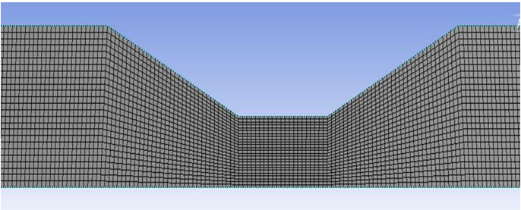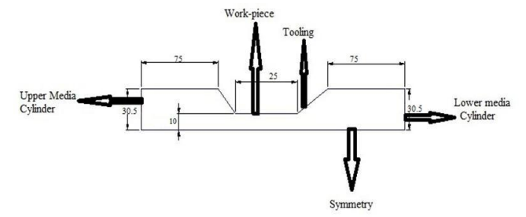

|  |  |
| --- | --- |
| Fig. 3.1: Symmetrical geometry taken up for the simulation (all dimensions in millimeters) | Fig. 3.2: Meshing of 2D computational domain |

* 1. **Assumptions of the Analysis**
* The media used for AFM is a mixture of semisolid carrier and abrasive particles with linear viscous properties.
* The media is isotropic and homogenous.
* The properties of the media are independent of temperature and are constant with respect to time and space.
* The media flow is taken as axisymmetric for the 2D geometry
  1. **Grid Independence Test**

The grid independence test is essential because the results of the numerical analysis are dependent on the grid size and number of grids. With an increase in the number of cells (control volumes), the error tends to be less and the time required for convergence increases. Refinement of the grid is not needed after the grid independence is achieved. A grid independence test has been carried out for the 2D geometry. Five types of grids are designed to observe the variation in the numerical results. The static pressure variation is observed at a particular point in the flow domain for the five grid sizes, i.e. 1905, 2397, 3380, 4656 and 5275. The value of static pressure varies significantly for 1905 number of cells. There is no variation in the flow parameters within 2397- 5275 numbers of cells and the value is found to be constant. The grid size having 3380 number of cells is taken into account for simulation. The variation of static pressure with grid numbers is shown in Fig.3.3.

|  |
| --- |
| Figure 3.3: Grid Independence Test |

* + AFM precision finishing influenced by process variables: extrusion pressure, media flow velocity, viscosity, abrasive concentration, and particle size.
  + Mathematical modeling and CFD simulation used to predict material removal efficiency.
  + Theories based on tribology and fluid dynamics guide prediction of polishing action and removal efficiency.
  + Difficulty in experimentally determining effects of all parameters.
  + Lack of precise knowledge on interphase laws during abrasive action.
  + Flow analysis with FLUENT aids in anticipating process outcomes.
  + Strain rate tensor describes rate of deformation, influenced by fluid viscosity and concentration.
  + Larger strain rates increase material removal efficiency.
  + Total pressure in tunnel and horizontal driving force affects particle movement.
  + Analysis of velocity and pressure predicts horizontal force on abrasive media.
  + Static pressure responsible for media flow, dynamic pressure for particle rolling.
  + Increase in particle rolling reduces material removal efficiency.
  + Dynamic pressure varies normal to flow, while static pressure varies along flow direction.
  + Dynamic pressure drives particle rolling due to large normal pressure gradient.
  + Contours of dynamic pressure approach zero near wall, affecting horizontal force on specimen surface.

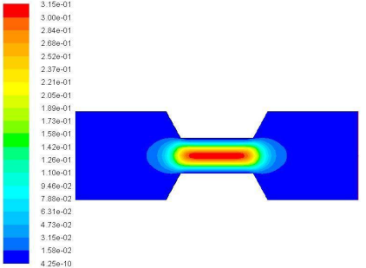

Fig. 3.4: Dynamic pressure contour (in Pa)

The color bar indicates pressure values, with red representing maximum and blue minimum. Increased horizontal velocity correlates with higher dynamic pressure, enhancing particle rolling. Particle rolling occurs when flow criterion is met, decreasing material removal efficiency. Simulation focuses on flow velocity for particle rolling analysis, assuming no-wall slip boundary condition. Strain rate and dynamic pressure concepts are discussed for their significance in flow simulation.

Fig. 3.5 illustrates dynamic pressure distribution, peaking at the flow domain center and decreasing near walls. Higher volume fractions correlate with increased dynamic pressure. Strain rate contours depict variations across the work-piece, aiding in understanding material behavior during AFM process.

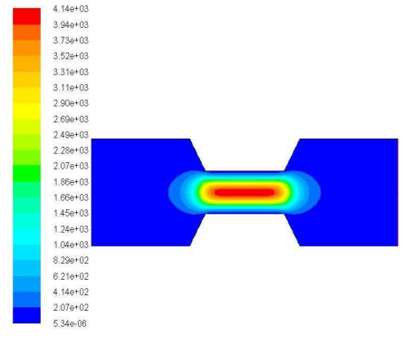

Fig. 3.5: Contour of dynamic pressure in Pa for volume fraction 0.3

1. **NUMERICAL SIMULATION OF A 3D MODEL**

For initial 3D simulations, abrasive powder is treated as a continuous phase, later analyzed using a mixture granular model. Abrasive particles are assumed continuous for this study. Geometry, is symmetrical around two planes. Meshed model details are depicted in Fig. 4.1 and 4.2 for computational efficiency.

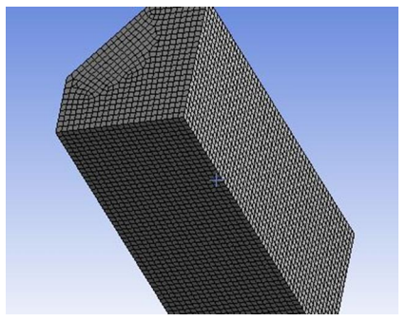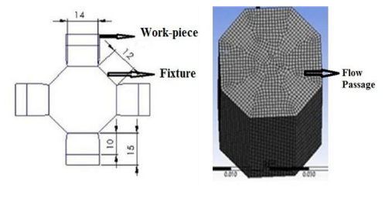

|  |  |
| --- | --- |
| Fig. 4.1 (a) Arrangement of work-pieces with fixtures (b) 3D meshed model for FLUENT analysis of the passage | Fig. 4.2: Meshing of 3D computational domain |

Fig. 4.3: Variation of static pressure with respect to number of grids

The dynamic pressure is found to increase from the wall towards the centre. The dynamic pressure value increases with the increase in volume fraction of the secondary phase. The contour plots in Fig. 28 illustrate the distribution of dynamic pressure for 0.2 and 0.3 volume fraction of the secondary phase for a particular range. The colour blocks show the distribution of dynamic pressure and its ranges for the two volume fractions.

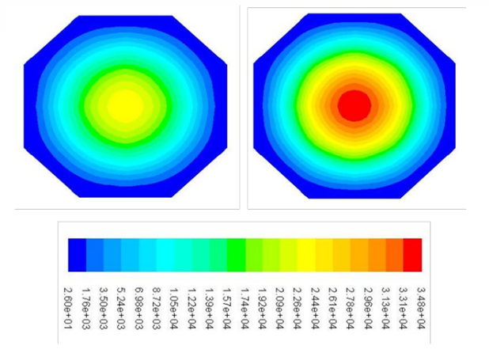

Fig. 4.4: Contours plot of dynamic pressure for 0.2 and 0.3 volume fractions

The value of strain rate increases with the increase in volume fraction. Front view of a symmetric section is viewed to observe the variation of strain rate. The comparison of the strain rate values for 0.2 and 0.3 volume fraction of the secondary phase can be depicted from the contour plots in Fig. 30. The color blocks provide the ranges of strain rate. It is evident from Fig. 30 that the strain rate value increases in the near wall region and decreases towards the center. The increase in strain rate in the near wall region increases the deformation. The value of strain rate increases with the increase in volume fraction.

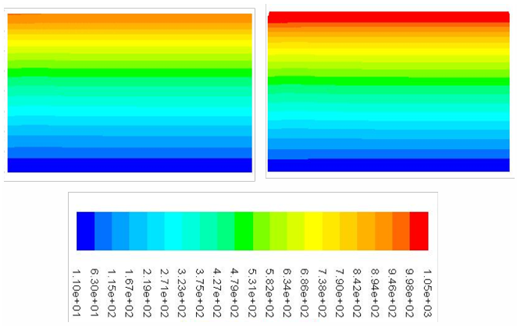

Fig. 4.5: Strain rate (in s-1) for 0.2 and 0.3 volume fractions

The colour distribution of strain rate for the volume fractions 0f 0.2 and 0.3 is shown in Fig. 4.6. The contours are shown for the wall only.

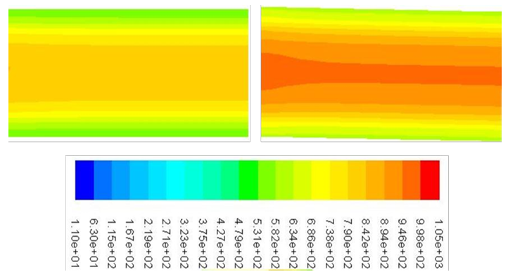

Fig. 4.6: Strain rate (in s-1) on the wall for 0.2 and 0.3 volume fractions of secondary phase

1. **CONCLUSION**

* Theoretical models developed for AFM workpieces, with CFD simulations using FLUENT.
* 2D model studied variable volume fraction and media flow speed effects:
* Strain rate, dynamic pressure, and velocity increase with volume fraction and flow speed.
* Negligible effects of dynamic pressure and velocity near walls; focus on strain rate for abrasion study.
* Steeper slope in strain rate for volume fraction indicates abrasive concentration's significance over flow speed.
* 3D model simulated for nongranular and granular flow:
* Nongranular flow: Strain rate increases near walls, more significant with higher volume fraction.
* Granular flow: Granular pressure rises with volume fraction and abrasive diameter; corundum yields highest pressure.
* Skin friction coefficient decreases with increasing volume fraction.
* Roughness change observed in 2D model with increasing strokes, linear trend theoretically but negligible experimentally.
* 3D model shows increased indentation depth with higher extrusion pressure.

1. **REFERENCES**
2. T. Mohana Priya, Dr. M. Punithavalli & Dr. R. Rajesh Kanna, Machine Learning Algorithm for Development of Enhanced Support Vector Machine Technique to Predict Stress, Global Journal of Computer Science and Technology: C Software & Data Engineering, Volume 20, Issue 2, No. 2020, pp 1220 Singh R, Dvivedi A, Kumar P. EDM of high aspect ratio micro-holes on Ti-6Al-4V alloy by synchronizing energy interactions. Mater Manuf Process 2020;35: 1188–203. https://doi.org/10.1080/10426914.2020.1762207.
3. Sutowska M, Kapłonek W, Pimenov DY, Gupta MK, Mia M, Sharma S. Influence of variable radius of cutting head trajectory on quality of cutting kerf in the abrasive water jet process for soda-lime glass. Materials (Basel) 2020;13:1–22. https://doi. org/10.3390/MA13194277.
4. Gupta K, Gupta MK. Developments in nonconventional machining for sustainable production: a state-of-the-art review. Proc Inst Mech Eng Part C J Mech Eng Sci 2019;233:4213–32. https://doi.org/10.1177/0954406218811982
5. Prakash C, Singh S, Pruncu CI, Mishra V, Krolczyk ´ G, Pimenov DY, et al. Surface modification of Ti-6Al-4V alloy by electrical discharge coating process using partially sintered Ti-Nb electrode. Materials (Basel) 2019;12:1–16. https://doi. org/10.3390/ma12071006.
6. Jin R, Yuan H, Chen Q. Science mapping approach to assisting the review of construction and demolition waste management research published between 2009 and 2018. Resour Conserv Recycl 2019;140:175–88. https://doi.org/ 10.1016/j.resconrec.2018.09.029.
7. Sambharia JK, Mali HS, Garg V. Experimental investigation on unidirectional abrasive flow machining of trim die workpiece. Mater Manuf Process 2018;33: 651–60. https://doi.org/10.1080/10426914.2017.1364847.
8. Kumar SS, Hiremath SS. Effect of surface roughness and surface topography on wettability of machined biomaterials using flexible viscoelastic polymer abrasive media. Surf Topogr Metrol Prop 2019;7:015004. https://doi.org/10.1088/2051- 672X/aaf6f6
9. Ali P, Walia RS, Murtaza Q, Singari Ranganath Muttanna. Material removal analysis of hybrid EDM-assisted centrifugal abrasive flow machining process for performance enhancement. J Brazilian Soc Mech Sci Eng 2020;42:1–28. https:// doi.org/10.1007/s40430-020-02375-6.
10. Fang M, Yu T, (Jeff) Xi F. An experimental investigation of abrasive suspension flow machining of injector nozzle based on orthogonal test design. Int J Adv Manuf Technol 2020;110:1071–82. https://doi.org/10.1007/s00170-020-05914- 6.
11. Zhang L, Huang Y, Chen G, Xu M, Xia W, Fu Y. Experimental study of coverage constraint abrasive flow machining of titanium alloy artificial joint surface. Proc Inst Mech Eng Part B J Eng Manuf 2019;233:2399–409. https://doi.org/10.1177/ 0954405419840553.