**ENERGY AND EXERGY ANALYSIS IN A THERMOS FLASK**

**1Kingsley E. MADU and 1Chike M. ATAH**

Corresponding email atahchike44@gmail.com

1Department of Mechanical Engineering, Chukwuemeka Odumegwu Ojukwu University, Uli, Anambra State.

**Abstract**

Materials with low thermal conductivity like aerogel, acrylic, aluminum silicate, superfine glass wool, and phenolic foam are often used as insulation materials in engineering and have noticed increasing applications in other spheres of life, like thermal insulation in buildings and vacuum

flasks. The objective of this research is to study the temperature variation of the coffee over 10 hours in a selected vacuum flask while varying the geometrical and material properties of the flask. In other words, change the parameters (without changing the fluid capacity) to minimize the heat loss over time. The range of the bottleneck radius used is from 40 mm to 60 mm, with a step size (increment) of 5 mm. The width of the whole flask is proportional to the bottleneck radius, with constant fluid capacity. The initial design used an outer and inner steel layer with plastic foam in between, and the bottleneck is made from nylon with a radius of 50 mm. This design allows the hot fluid to be at 55 C after 10 hours in atmospheric conditions. The temperature of the coffee in the vacuum flask made of steel layers with aerogel as insulation was 72.3 C after 10 hours, while the steel layers and CO2 insulation were 67.9 C and the acrylic layer and rogel were 77.89 C after a 10-hour duration in still air. This simulation was carried out using COMSOL, and the result shows that an acrylic layer and aerogel at a bottleneck radius of 60 mm were the best combination. Verification and validation were carried out to test for convergence of the numerical and analytical solutions.

**KEYWORDS**: Vacuum Flask, Thermal Insulation. Simulation, Thermal energy storage, thermo chemical energy storage, exergy, energy efficiency, exergy efficiency.

**INTRODUCTION**

A vacuum flask, commonly called a thermos flask or Dewar flask, was invented by James Dewar

James Dewar in 1892. Vacuum flasks’ main purpose is to keep the beverage hot or cold for long [1]. A vacuum flask consists of two flasks (vessels) that are placed within each other. There is a gap between them that is evacuated of air, creating a near-vacuum that reduces heat transfer by convection or conduction. Creating a near-vacuum that reduces heat transfer by convection or conduction; this influence leads to a constant temperature for the beverage for a long time. Some common materials used in most industries are metal, foam, plastic, and borosilicate glass, while the cover (opening) is made from cork or polyethylene plastic. The vacuum flask resembles a jug more than anything else. Most flasks contain a vacuum-sealed inner chamber and an exterior chamber comprised of plastic or metal that is surrounded by two layers of glass. The inner bottle's silver covering and the vacuum between its two sides prohibit heat from transferring by radiation or convection, respectively[2] . The glass walls’ thinness prevents heat from conditionally escaping or entering the flask. Supplemental insulation is provided by the casing that the flask is enclosed; this influence leads to a constant temperature for the beverage for a long time. Some common materials used in most industries are metal, foam, plastic, and borosilicate glass, while thess cover (opening) is made from cork or polyethylene plastic. The vacuum flask resembles a jug more than anything else. Most flasks contain a vacuum-sealed inner chamber and an exterior chamber comprised of plastic or metal that is surrounded by two layers of glass. The inner bottle's silver covering and the vacuum between its two sides prohibit heat from transferring by radiation or convection, respectively. The glass walls' thinness prevents heat from conditionally escaping or entering the flask. Supplemental insulation is provided by the casing that the flask is enclosed in [3].

Insulation, or more specifically, thermal insulation, is a general term used to describe substances

That act as a barrier between areas of markedly different temperatures to minimize heat absorption or loss. Thermal insulation materials, structures, and manufacturing techniques are being improved for use in low-temperature applications. Examples of low-temperature applications include storage tanks for cryogens, superconducting electric power transmission equipment, cold boxes for low-temperature industrial processes, and containers for food and other perishable items. Heat is transferred by convection through the circulatory system in both liquids and gases. The flow that develops because of density differences due to temperature fluctuations is known as free convection. External forces (wind, ventilators, etc.) cause forced convection to flow.

The thermal radiation process takes place when thermal energy is emitted, similarly to how light is released [4].Convection and radiation are the processes by which heat is lost to or obtained from the atmosphere, respectively, whereas conduction is the technique by which heat is transmitted through molecular interaction. Low thermal conductivity is a property of materials that include a lot of microscopic gaps that may convey gases or air. These gaps are too small to effectively transmit heat by convection or radiation, which reduces the conduction of energy. Natural or artificial materials can be used as thermal insulation. In a gas-containing volume where some of the air as well as other gases have been evacuated, "vacuum insulation" refers to a space that is only partially vacant [7,8,10].

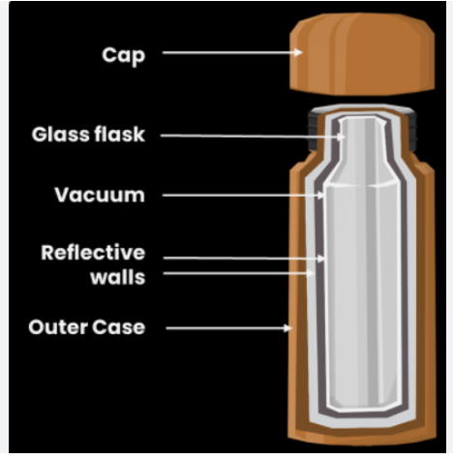

The vacuum flask is made up of two flasks that are nestled inside one another and connected at the top. Air is partially evacuated from the space between the two flasks, generating a partial vacuum that lessens temperature distribution, or convection. Typically, vacuum flasks are made

of metal, borosilicate glass, stainless steel foam, or plastic. Cork or polyethene plastic is used to plug the entrance to maintain the temperature of the fluid. Thus, heat transmission is reduced by the vacuum flask design. Conduction, convection, and radiation are the three methods of heat transmission; however, the vacuum flask design eliminates all of them [15]. The newest motion vacuum flask in stainless steel, 0.75L (capacity), the seal is leakproof, and it has excellent insulation thanks to the quality double-walled thermal liner made of Cromargan. The stainless steel 18/10 means drinks stay hot for 12 hours and cold for up to 24 hour

**PRINCIPLE OF THERMOS FLASK**

Thermos flasks keep hot liquids hot and cold liquids cold for long hours. It consists of a glass vessel with double walls. The glass vessel is enclosed by a metal or plastic cover for protection against damage. The space between the walls is vacuum which reduces the heat loss due to conduction and convection. The outer surface of the inner wall and the inner surface of the outer wall are silvered (shining)1[7]. The shining surfaces reduce heat loss due to radiation. An insulating stopper (cork) is used to close the mouth of the vessel. The vessel is kept over an insulating (cork) pad. It is therefore thermally insulated. Hence, heat does not leave or enter easily and hot liquids remain hot while cold liquids remain cold inside the flask.

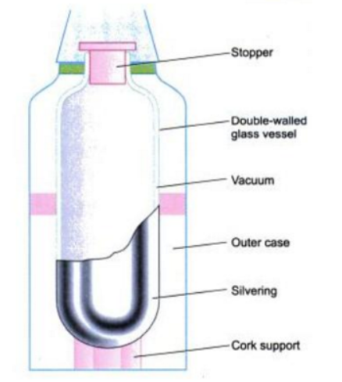

Thermodynamics permits the behavior, performance, and efficiency to be described for systems for the conversion of energy from one form to another. Conventional thermodynamic analysis is based primarily on the first law of thermodynamics, which states the principle of conservation of energy. An energy analysis of an energy conversion system is essentially an accounting of the energies entering and exiting. The exiting energy can be broken down into products and wastes. Efficiencies are often evaluated as ratios of energy quantities and are often used to assess and compare various systems. The thermodynamic losses that occur within a system often are not accurately identified and assessed with energy analysis

In this study, energy and exergy analyses of the closed-cycle infrared (IR) convective walnut drying were performed. The effects of the combined heat transfer, product–source distance, and temperature–relative humidity (RH) control on the food quality of walnuts and performance were investigated. Experiments were conducted with and without an IR lamp. The temperature and RH of the drying air were set at 40°C and 20%, respectively. The distance between the product and the IR source was changed to 20 cm and 30 cm. The coefficient of performance values of the whole system changed between 1.56 and 2.34. Exergy efficiencies varied between 60.81% and 88.19% without IR and 72.73%–78.54% with IR. Energy and time savings increased by 14.7% and 26.1%, respectively, with using IR at a 20 cm distance compared with the convective system. The fatty acid composition of walnut samples and chemical properties of walnut samples such as total phenolic content, oil, ash, color, antioxidant activity, peroxide values, free fatty acid, conjugated trienes, conjugated dienes, saponification value, and iodine number parameters were analyzed. Food analysis results of all dried walnuts were in the acceptable range. As a result, energy and time savings were achieved with the desired food quality.

Exergy is defined as the maximum amount of work that can be produced by a stream or system as it is brought into equilibrium with a reference environment, and it can be thought of as a measure of the usefulness or quality of energy. Exergy is consumed during real processes due to irreversibilities and conserved during ideal processes [20-25]. The exergy analysis nomenclature used here follows that proposed by Kotas et al. Exergy analysis is a powerful tool for developing, evaluating, and improving an energy conversion system. The growing energy supply and demand have created an interest toward the plant equipment efficiency and the optimization of existing thermal power plants. At present, most of the power plants are going to be designed by the energetic performance criterion which is based on the first law of thermodynamics. Energy losses taking place in a system can be easily determined by using exergy analysis. Exergy or rather the loss of exergy as heat, which means production of entropy, seems more useful to apply than entropy to describe the irreversibility of real processes. It has the same unit as energy and is an energy form, while the definition of entropy is more difficult to relate to concepts associated to our usual description of reality. In addition entropy is not clearly defined for ‘far from thermodynamic equilibrium systems’, particularly for living systems. Moreover, it should be mentioned that the self-organizing abilities of systems depend strongly on the temperature. Exergy takes the temperature into consideration as the definition shows, while entropy does not. It implies that exergy at 0 K is 0 and at minimum. Negative entropy is not expressing the ability of the system to do work (we may call it ‘the creativity’ of the system as creativity requires work), but exergy becomes a good measure of ‘the creativity’, which is increasing proportional with the temperature[9]. Furthermore, exergy facilitates the differentiation between low-entropy energy and high-entropy energy, as exergy is entropy-free energy.

Information contains exergy. Boltzmann showed that the free energy of information (it means exergy) that we actually possess (in contrast to the information we need to describe the system) is *kT* ln *I*, where *I* is the information we have about the state of the system, for instance, that the configuration is 1 out of *W* possible ones and *k* is Boltzmann’s constant = 1.3803 × 10−23 J/(molecules deg). It implies that one bit of information has the exergy equal to *kT* ln2. Transformation of information from one system to another is often almost an entropy-free energy transfer. If the two systems have different temperatures, then the entropy lost by one system is not equal to the entropy gained by the other system, while the exergy lost by the first system is equal to the exergy transferred and equal to the exergy gained by the other system, provided that the transformation is not accompanied by any loss of exergy. Also, in this case, it is obviously more convenient to apply exergy than entropy.

## Insulation

## Vacuum Flasks work by insulation. So, heat cannot enter or leave through conduction.

* The air trapped in the sponge/foam is a bad conductor of heat. This is good because it means that heat is not lost or gained.
* The plastic case of the flask is not a good conductor of heat, thus reducing heat loss. It provides additional insulation.

**The 3 ways thermal energy gets transferred**

Thermal energy can be transferred through **Conduction**, **Convection** or **Radiation**.  
  
**Conduction** -Transferred through a substance with the substance moving itself. The substance is heated and its particles gain energy and vibrate more. The vibrating particles then bump into nearby particles and make them vibrate more. This passes thermal energy through a substance from the hot end to the cold end.  
   
**Convection** - Transferred through fluids (liquids or gases) by the upward movement of warmer, less dense regions of fluid. The particles in liquids and gases can move from place to place. Convection happens when particles with a lot of thermal energy in a liquid or gas move, and take the place of particles that have less thermal energy. The thermal energy is transferred from hot places to cold places. (E.g. Radiators)  
  
**Radiation**- Transferred by Infra-Red (IR) Waves. All objects transfer thermal energy by infrared radiation. The hotter an object, the more IR Radiation it gives off. Unlike conduction and convection, no particles are involved. This means that thermal energy transfer by radiation can even work in places with no air (e.g. Space). This is how we can feel the Sun's heat even though it is extremely far away. Infrared cameras, which are used by police helicopters to find a suspect who is trying to hide or flee in the dark, work in the dark because they detect heat (Infra-Red), not the visible light spectrum.

The exergy concept has gained considerable interest in the thermodynamic analysis of thermal processes and plant systems since it has been seen that the first law analysis has been insufficient from an energy performance standpoint. The system energy balance is not sufficient for the possible finding of the system imperfection

**Problem Statement:**

The objective is to study the temperature variation of the coffee over 10 hours for a selected vacuum flask. Then, carrying out a parametric sweep on the geometrical and material properties of the flask to enhance its performance. In other words, change the parameters (without changing the fluid capacity)

**Comprehensive energy and exergy analyses/mathematical modeling**

In general, open systems have mass, heat, and work interactions, and closed systems have heat and work interactions. The mass conservation equation can be written for an open system (control volume) as follows:

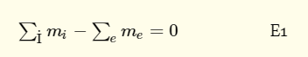

Energy, being subject to a conservation law (neglecting nuclear reactions), can be neither generated nor consumed. For a nonsteady flow process in a system during a finite time interval, energy balance can be written as follows

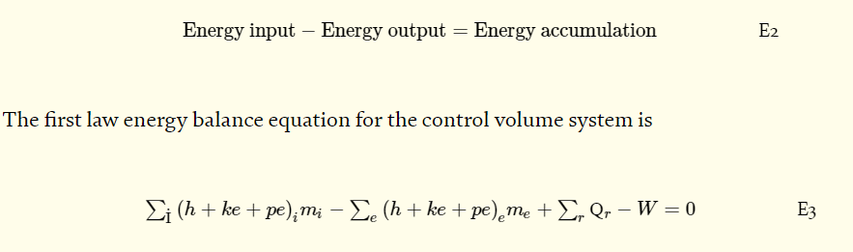

where *Ԛ*r is the heat transfer into the system across *r* region on the system boundary; *W* is the work (including all forms of work) transferred out of the system; mi and me *denote*, *respectively*, the rate of mass input and exits; and *h*, *ke*, and *pe* are the specific values of enthalpy, kinetic energy, and potential energy, respectively

For a nonsteady flow process in a system, exergy balance can be written as follows



Exergy is consumed due to irreversibilities. Exergy consumption is proportional to entropy creation. The main important difference between energy and exergy: energy is conserved, while exergy, a measure of energy quality or work potential, can be consumed.

The general exergy balance for the above system can also be expressed as



Assuming that flows are one-dimensional and the input and output terms in [Eq. (5)](https://www.intechopen.com/chapters/60220#E5) are net quantities, the following may be written:



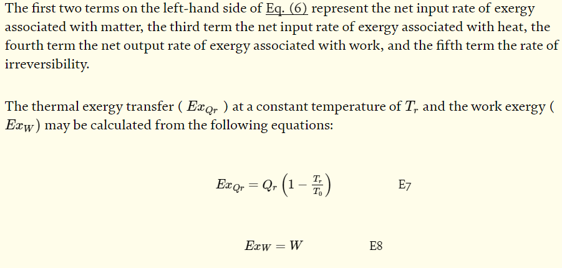

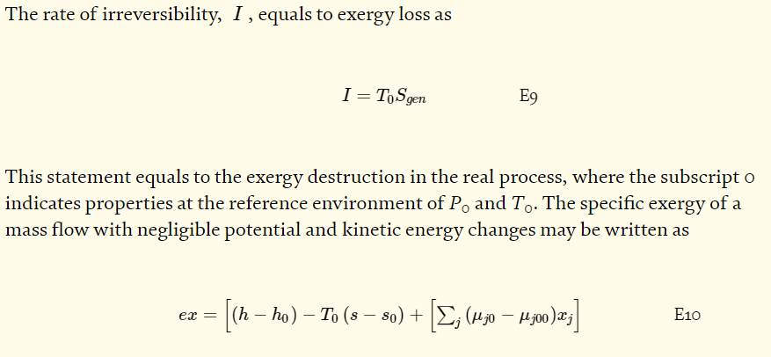

where xj denotes the mass fraction of species *j, s* is the specific entropy, μj0μ0 is chemical potentials for each of the *j* components, and the subscript 0 refers to a quantity evaluated with respect to a reference environment. It is assumed to be reversible processes in which its temperature T0, pressure *P*0, and the chemical potentials, μj00μ00 , for each of the *j* components presented remain constant. The reference environment is in stable equilibrium [

The energy or the first law efficiency 𝜂 of a system or system component is defined as the ratio of energy output to the energy input of system or system component, i.e.,

η=(Desired output energy/Input energy supplied)𝜂=Desired output energy/Input energy supplied E11

The second law efficiency is defined as

ζ=(Desired output/Maximum possible output)ζ=Desired output/Maximum possible output E12

Energy-related systems commonly have been designed and evaluated using the first law heat system. As a result, losses and inefficiencies are not evaluated realistically.

An exergy analysis should be conducted only after the validity of the mass, and energy balances has been confirmed. The thermodynamic analysis should be evaluated that an exergy balance is obtained by combining the corresponding energy and entropy balances

A simple procedure for performing a comprehensive exergy analysis of such a system involves the following steps:

* Subdivision of the process under consideration into each system component (process or subprocess), depending on the depth of detail and understanding desired from the analysis.
* Calculation of the conventional mass and energy balances on the process and definition of all basic quantities (e.g., work and heat) and properties (e.g., temperature and pressure).
* Based on the nature of the process, the acceptable degree of analysis complexity and accuracy, and select a reference environment model.
* Calculation of the energy and exergy values, relate to the selected reference environment model.
* Calculation of the exergy balances including the determination of exergy consumptions.
* Select the efficiency definitions, depending on the measures of merit desired, and evaluate the efficiencies.
* Detailed evaluation of each system component based on the results, and draw appropriate conclusions and recommendations relating to such issues as design changes, retrofit plant modifications, etc.

**Conclusions**

A thermos flask, a double-walled glass vessel, keeps hot fluid hot and cold fluid cold for an extended period. It contains a combination of layers that prevent heat transfer due to conduction, convection, and radiation. A thermos flask is design to prevent the contents of the flask from loss heat. A vacuum flask or thermos flask is designed so that it will not allowed heat loss by any means of conduction or radiation. The vacuum prevents the heat loss by conduction because vacuum is bad conductor of heat. The stopper it is tightly sealed. And the inner reflecting layer prevents the heat loss by radiation.

**References**

1. Kotas TJ. Exergy criteria of performance for thermal plant: second of two papers on exergy techniques in thermal plant analysis. International Journal of Heat and Fluid Flow. 1980;2(4):147-163
2. Siva Reddy V, Kaushik SC, Tyagi SK, Panwar NL. An approach to analyse energy and exergy analysis of thermal power plants: A review. Smart Grid and Renewable Energy. 2010;1:143-152
3. Rosen MA, Dincer I. Sectoral energy and exergy modeling of Turkey. Transactions of the ASME. 1997;119:200-204
4. Rosen MA. Energy- and exergy-based comparison of coal-fired and nuclear steam power plants. Exergy. 2001;1(3):180-192
5. Naterer GF, Regulagadda P, Dincer I. Exergy analysis of a thermal power plant with measured boiler and turbine losses. Applied Thermal Engineering. 2010;30:970-976
6. KE Madu, CM Atah [Effects of Variation of Ambient Temperature in Energy Interactions in a Closed System](https://scholar.google.com/citations?view_op=view_citation&hl=en&user=Va3CD90AAAAJ&cstart=20&pagesize=80&citation_for_view=Va3CD90AAAAJ:maZDTaKrznsC) International Journal of Progressive Research in Engineering Management and Science 03 2024 pp: 226-233
7. KE Madu, EI Nwankwo [Evaluation of Pump Losses: An Energy Principle - A Review](https://scholar.google.com/citations?view_op=view_citation&hl=en&user=Va3CD90AAAAJ&cstart=20&pagesize=80&citation_for_view=Va3CD90AAAAJ:L8Ckcad2t8MC) Equatorial Journal of Engineering, 85-92
8. K Madu [Evaluation of the Performance of a Spark-Ignition Four Cycle Engine, in a Tropical Environment](https://scholar.google.com/citations?view_op=view_citation&hl=en&user=Va3CD90AAAAJ&cstart=20&pagesize=80&citation_for_view=Va3CD90AAAAJ:u5HHmVD_uO8C) Equatorial Journal of Engineering (2018), 43-50
9. K Madu [Evaluation of the Behaviour of Steam Expanded in a Set of Nozzles, in a Given Temperature](https://scholar.google.com/citations?view_op=view_citation&hl=en&user=Va3CD90AAAAJ&citation_for_view=Va3CD90AAAAJ:_FxGoFyzp5QC) Equatorial Journal of Engineering (2018), 9-13
10. KE Madu, CM Atah [Evaluation of the Variable that affect Nozzle Efficiency](https://scholar.google.com/citations?view_op=view_citation&hl=en&user=Va3CD90AAAAJ&cstart=20&pagesize=80&citation_for_view=Va3CD90AAAAJ:k_IJM867U9cC) International Journal of Progressive Research in Engineering Management and Science 03 2024 pp: 393-401
11. Tsatsaronis G, Moung-Ho P. On avoidable and unavoidable exergy destructions and investment costs in thermal systems. Energy Conversion Management. 2002;43:1259-1270
12. Morosuk T, Tsatsaronis G. Advanced exergy analysis for chemically reaction systems-application to a simple open gas-turbine system. International Journal of Thermodynamics. 2009;12:105-111
13. Khaliq A, Kaushik SC. Thermodynamic performance evaluation of combustion gas turbine cogeneration system with reheat. Applied Thermal Engineering. 2004;24(13):1785-1795
14. Koroneos C, Spachos T, Moussiopoulos N. Exergy analysis of renewable energy sources. Renewable Energy. 2003;28(2):295-310
15. Ertesvag IS, Kvamsdal HM, Bolland O. Exergy analysis of a gas-turbine combined-cycle power plant with precombustion Co2 capture. Energy. 2009;30(1):5-39
16. Petrakopoulou F, Tsatsaronis G, Morosuk T, Carassai A. Conventional and advanced exergetic analysis applied to a combined power plant. Energy. 2012;41:146-152
17. Taner T, Sivrioğlu M. Energy-exergy analysis and optimisation of a model sugar factory in Turkey. Energy. 2015;93:641-654
18. KE Madu, CM Atah [Evaluation of the Variable that affect Nozzle Efficiency](https://scholar.google.com/citations?view_op=view_citation&hl=en&user=Va3CD90AAAAJ&cstart=20&pagesize=80&citation_for_view=Va3CD90AAAAJ:k_IJM867U9cC) International Journal of Progressive Research in Engineering Management and Science 03 2024 pp: 393-401
19. KE Madu CM Atah Effect of Sudden Pressure Drop in a Nozzle Flow International Journal of Scientific Research and Engineering Trends 2024 10 pp 93- 98
20. Madu K E and Atah C M Shear Property Failure Testing of Gasoline Engine Combustion Chamber Produced with Fique Fibre Reinforced Epoxy Resin Composite Material. International Journal of Research Publication and Reviews 2024 (5) (3) pp 1537-1545
21. KE Madu, EA Ani, EI Nwankwo, FO Udeani [Analytical Approach to Determining the Conditions for Maximum Discharge through a Chimney](https://scholar.google.com/citations?view_op=view_citation&hl=en&user=Va3CD90AAAAJ&cstart=20&pagesize=80&citation_for_view=Va3CD90AAAAJ:ULOm3_A8WrAC) Global Scientific Journals 8 (4), 1485-1496
22. KE Madu, EI Nwankwo, MU Orji, AC Aneke [Investigation of the Conditions that Trigger Cavitation in a Pump](https://scholar.google.com/citations?view_op=view_citation&hl=en&user=Va3CD90AAAAJ&cstart=20&pagesize=80&citation_for_view=Va3CD90AAAAJ:9ZlFYXVOiuMC) International Journal of Mechanical and Industrial Technology 7 (2), 1-7
23. KE Madu, EI Nwankwo [Effects of Friction on Critical Pressure Ratio of a Nozzle](https://scholar.google.com/citations?view_op=view_citation&hl=en&user=Va3CD90AAAAJ&cstart=20&pagesize=80&citation_for_view=Va3CD90AAAAJ:IWHjjKOFINEC) Journal of Industrial Technology 3 (1), 47-55.
24. Taner T. Energy and exergy analyze of PEM fuel cell: A case study of modeling and simulations. Energy. 2018;143:284-294
25. Rosen MA, Dincer I. Exergoeconomic analysis of power plants on various fuels. Applied Thermal Engineering. 2003;23:643-658
26. Cengel Y, Boles MA. Thermodynamics: An Engineering Approach, Fourth Edition. McGraw-Hill; 2001
27. Tsatsaronis G, Morosuk T. Advanced thermodynamic (exergetic) analysis. Journal of Physics: Conference Series. 2012;395(012160):1-8
28. Kaushik SC, Siva Reddy V, Tyagi SK. Energy and exergy analyses of thermal power plants: A review. Renewable and Sustainable Energy Reviews. 2011;15:1857-1872
29. Hepbasli A. Modeling of Sectoral Energy and Exergy Utilization. Energy Sources. 2005;27(10):903-912
30. International Energy Outlook. Report Number: DOE/EIA-0484, 2017, U.S. Energy Information Administration (EIA). 2017
31. Hasan HE, Ali VA, Burhanettin AD, Suleyman HS, Bahri S, Ismail T, Cengiz G, Selcuk A. Comparative energetic and exergetic performance analyses for coal-fired thermal power plants in Turkey. International Journal of Thermal Sciences. 2009;48:2179-2186
32. Terzi R, Tükenmez İ, Kurt E. Energy and Exergy Analyses of a VVER Nuclear Power Plant. International Journal of Hydrogen Energy. 2016;41:1-12
33. Seyitoglu SS, Dincer I, Kilicarslan A. Energy and exergy analyses of hydrogen production by coal gasification. International Journal of Hydrogen Energy. 2017;