**Integrating Wireless Sensor Networks, IoT, and Cloud Computing: A Comprehensive Review**

**Shilpa W. Mate1,Dr.N.K. Choudhari,2**

1Mtech Scholar, Electronics and Communication Engineering. P.B.C.O.E, Nagpur, Maharashtra, India

2Professor, Electronics and Communication Engineering. P.B.C.O.E, Nagpur, Maharashtra ,India

**ABSTRACT**

In recent years, there has been rapid development in wireless systems based on IoT (Internet of Things) technology across various sectors. IoT refers to a network where physical devices, sensors, and other objects can communicate with each other without human intervention. WSN (Wireless Sensor Network) plays a central role in IoT, finding applications across real-time scenarios. IoT and WSNs have become integral to both critical and non-critical applications, impacting almost every aspect of daily life. Typically, WSN nodes are small, battery-powered devices, making energy-efficient data aggregation techniques crucial for prolonging network lifespan. Numerous approaches and algorithms have been proposed for achieving energy-efficient data aggregation in IoT-WSN systems. This paper provides a literature review focusing on wireless networking aspects aimed at energy preservation and data aggregation.

**Keywords:** IoT, WSN, Cloud, IoT Technologies.

1. **INTRODUCTION**

Our daily lives have undergone significant transformations since the advent of wireless networking technology. The Internet of Things (IoT) stands out as one of the most rapidly advancing technologies of our time, allowing multiple devices to connect and interact in the physical world. This integration of IoT devices fundamentally alters our routines and environments, introducing a constant need for ubiquitous communication, particularly in bustling sectors.

IoT represents the seamless integration and communication among intelligent objects, fostering the development of novel technologies and applications. These objects, equipped with sensors and actuators (such as household appliances, security cameras, and environmental monitoring sensors), typically feature various transceivers, microcontrollers, and communication protocols for transmitting control and sensor data [1]. These sensors, operating in real-time, form interconnected networks to relay data to centralized repositories, where it is stored and made accessible to authorized users. Compared to traditional wired connections, this wireless ecosystem offers unprecedented flexibility and scalability.

In wireless networking systems, the characteristics of IoT using wireless technologies differ due to the high number of communication devices [2]. However, IoT-related traffic typically isn't highly critical because each IoT device senses and transmits data to an IoT Server. Nevertheless, the collective data produced by numerous objects can impact network efficiency over time, necessitating sustainable operation without constant human intervention.

Heterogeneous Wireless Sensor Networks (WSN) linking various intelligent sensors serve as the foundation for IoT-based systems, promising significant advancements [3]. The rapid proliferation of these devices has led to energy consumption challenges [4], drawing considerable attention. On one hand, the exponential increase in communication rates and information sharing has led to unsustainable rises in energy usage and carbon emissions [5]. On the other hand, sensor nodes must operate efficiently for extended periods (sometimes years) to meet various application requirements, such as environmental monitoring, agriculture, and surveillance [6]. The longevity of applications heavily relies on sensor energy consumption, as dead nodes can affect device compatibility and data accuracy. A typical sensor node comprises four main units: the processing unit, sensing/identification unit, communication unit, and power supply unit [7], [8], These components may also include secondary elements like filters, amplifiers, transducers, and comparators.

The sensing device gathers data from the environment, while the processing unit manages tasks such as data collection and manipulation. The communication unit transmits data to base stations (BS), and the power supply unit, often battery-based, powers all other components. The energy consumption of a specific sensor node depends on its operating state, which can be active, sleeping, or idle. The most energy-intensive state is the active mode, primarily due to information transmission and reception, while idle mode involves waiting for data packets from other nodes. Sleeping mode, on the other hand, consumes minimal energy as the node suspends processing activities and turns off communication units. However, other sources of energy dissipation, such as packet losses, collisions, and protocol overhead, also exist.

Energy efficiency is crucial for managing IoT systems, especially since battery energy sources predominantly power these networks. Therefore, optimizing energy efficiency and extending the lifespan of battery-operated sensor nodes have been long-standing research challenges [9], [10]. Medium Access Control (MAC) protocols focus on optimizing sensor node operations, while routing layer protocols facilitate data aggregation and transmission. Integrating various sensor also plays a key role for data acquired. The data can be stored in memory card later shared on wsn which saves power[14]. This paper provides a comprehensive review of wireless networking aspects, emphasizing energy preservation and data aggregation.

1. **IOT**

IoT stands for the Internet of Things. It refers to a network of interconnected devices that are embedded with sensors, software, and other technologies to collect and exchange data with other devices and systems over the internet. These devices can range from everyday objects such as household appliances and wearable devices to industrial machinery and infrastructure components. The data collected by IoT devices can be analyzed to provide insights, automate processes, and enable new services and applications across various domains including healthcare, transportation, agriculture, smart cities, and more. Ultimately, IoT aims to create a more interconnected and intelligent world by leveraging the power of data and connectivity.

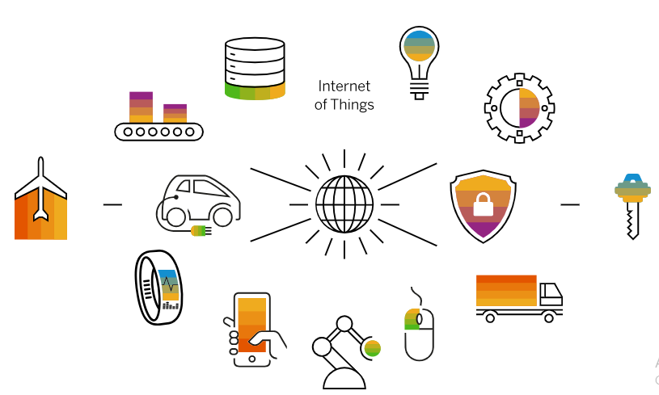

Fig: 1 Application of IoT

# **2.1 The Rise of IoT**

#### Ubiquitous Connectivity

The proliferation of high-speed internet, wireless technologies, and affordable sensors has made it possible to connect an increasing number of devices to the internet.

#### Advancements in Technology

Improvements in areas like artificial intelligence, cloud computing, and data analytics have enabled IoT devices to become more intelligent, autonomous, and data-driven.

#### Growing Demand

Consumers and businesses are increasingly embracing IoT solutions to improve efficiency, enhance user experiences, and drive innovation across various industries.

# **2.2 Key IoT Technologies**

#### Sensors

Sensors that can measure and collect data from the physical world, such as temperature, motion, or location.

#### Connectivity

Wireless communication protocols like Wi-Fi, Bluetooth, and cellular networks that enable IoT devices to connect to the internet.

#### Cloud Computing

Cloud platforms that provide the infrastructure and services to process, analyze, and store the vast amounts of data generated by IoT devices.

# **2.3 IoT Applications and Use Cases**

#### Smart Homes

IoT-enabled devices that automate and optimize home functions, such as lighting, climate control, and security.

#### Industrial Automation

IoT sensors and analytics used to improve efficiency, predict maintenance, and optimize operations in manufacturing and industrial settings.

#### Connected Healthcare

IoT-powered medical devices, wearables, and remote monitoring systems that enhance patient care and disease management.One application such as wireless health monitoring system[15].

#### Smart Cities

IoT technologies used to improve urban infrastructure, traffic management, waste reduction, and overall quality of life for citizens,

**3.Wireless Sensor Networks (WSNs)**

It play a crucial role in the Internet of Things (IoT) ecosystem by enabling the collection of real-time data from the physical world. Here's an overview of their role and significance:

Data Collection: WSNs consist of numerous sensor nodes distributed across a geographical area. These nodes are equipped with sensors to monitor various environmental parameters such as temperature, humidity, pressure, light, sound, and motion. They continuously collect data from their surroundings and transmit it wirelessly to a central data processing unit or gateway.

Monitoring and Surveillance: WSNs are widely used for monitoring and surveillance applications in diverse domains such as environmental monitoring, agriculture, healthcare, smart cities, and industrial automation. They enable real-time monitoring of environmental conditions, infrastructure health, crop growth, patient vital signs, traffic flow, and more, allowing stakeholders to make informed decisions and respond promptly to changes or emergencies.

Automation and Control: WSNs facilitate automation and control of physical systems by providing real-time feedback and control capabilities. For example, in industrial automation, WSNs can be deployed to monitor equipment performance, detect faults or anomalies, and optimize production processes through predictive maintenance and closed-loop control systems.

Resource Management: WSNs help optimize resource utilization and efficiency in various applications. For instance, in agriculture, WSNs can monitor soil moisture levels, weather conditions, and crop health to enable precision irrigation, pest management, and crop yield optimization. Similarly, in smart buildings, WSNs can regulate heating, ventilation, and lighting systems based on occupancy and environmental conditions to minimize energy consumption while maintaining comfort levels.

Environmental Sensing: WSNs play a vital role in environmental sensing and research by providing valuable data for climate studies, pollution monitoring, wildlife tracking, and natural disaster detection and mitigation. They enable scientists and researchers to gather extensive datasets over large geographical areas, leading to better understanding and management of environmental phenomena.

Infrastructure Monitoring: WSNs are deployed for structural health monitoring of buildings, bridges, dams, and other critical infrastructure. They help detect structural weaknesses, cracks, vibrations, and other anomalies in real-time, allowing for timely maintenance and preventing catastrophic failures.

Emergency Response and Disaster Management: WSNs support emergency response and disaster management efforts by providing early warning systems, situational awareness, and communication networks in crisis situations. They enable rapid deployment of sensors and actuators for detecting hazards, assessing damage, and coordinating rescue and relief operations.

Overall, Wireless Sensor Networks play a pivotal role in enabling the Internet of Things by providing the foundational infrastructure for collecting, transmitting, and processing real-time data from the physical world, thereby enabling a wide range of applications aimed at improving efficiency, safety, and quality of life.

**4** **Cloud computing**

**It** refers to the delivery of computing services—including servers, storage, databases, networking, software, analytics, and more—over the internet ("the cloud"). Instead of owning and maintaining physical hardware and infrastructure, users can access these resources on-demand from cloud service providers on a pay-as-you-go basis.

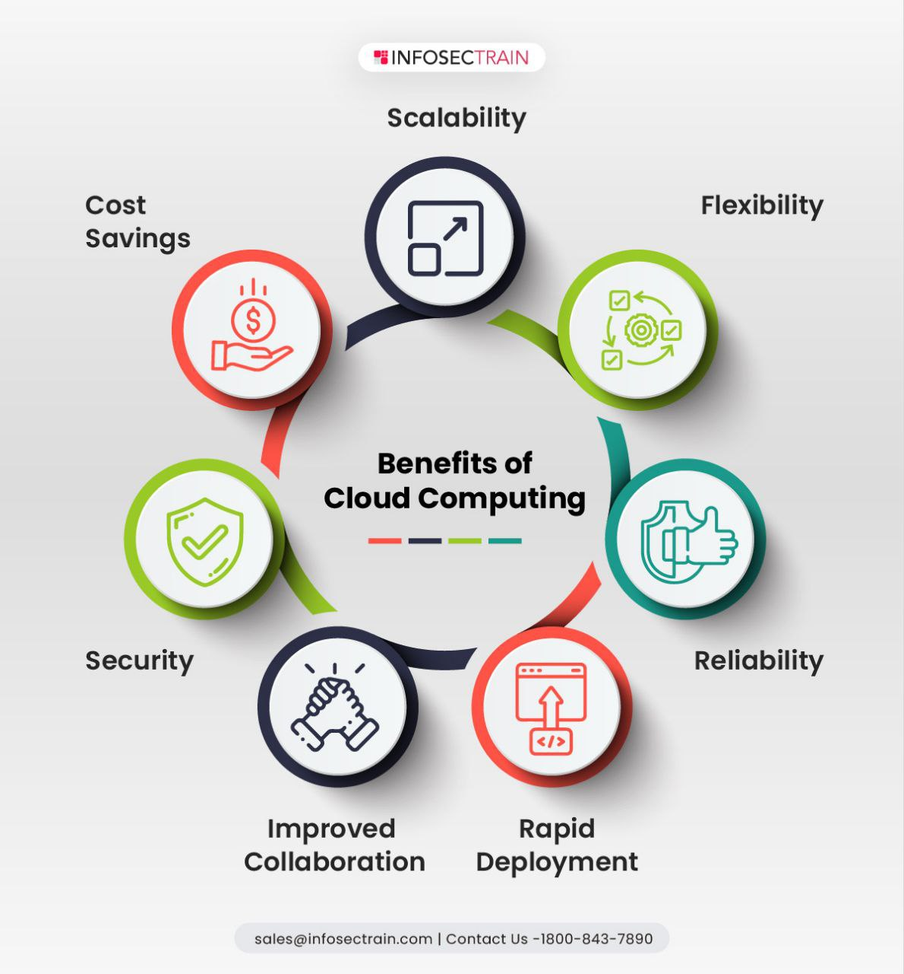

**Fig:2 Benefit of cloud computing**

The significance of cloud computing lies in its numerous benefits and transformative impact on businesses, organizations, and individuals:

Scalability: Cloud computing offers scalability, allowing users to quickly scale resources up or down based on demand. This elasticity enables organizations to handle fluctuating workloads efficiently without overprovisioning or under provisioning resources.

Cost-efficiency: Cloud computing follows a pay-as-you-go pricing model, where users only pay for the resources they consume. This eliminates the need for large upfront capital investments in hardware and infrastructure, reducing overall IT costs and improving cost predictability.

Flexibility and agility: Cloud computing provides flexibility and agility by enabling rapid deployment of new applications and services. Users can quickly provision resources, experiment with new ideas, and innovate without being constrained by physical infrastructure limitations.

Accessibility and collaboration: Cloud services can be accessed from anywhere with an internet connection, enabling remote work, collaboration, and access to resources across geographic locations. This fosters greater collaboration among teams and facilitates seamless communication and sharing of data.

Reliability and resilience: Leading cloud service providers offer robust infrastructure with redundant data centers and built-in failover mechanisms to ensure high availability and reliability. This reduces the risk of downtime and data loss, enhancing business continuity and resilience.

Security: Cloud providers invest heavily in security measures and compliance certifications to protect data and infrastructure from cyber threats and unauthorized access. They employ encryption, identity and access management, network security, and other security features to safeguard sensitive information.

Innovation and scalability: Cloud computing enables organizations to innovate rapidly by providing access to cutting-edge technologies such as artificial intelligence (AI), machine learning (ML), big data analytics, Internet of Things (IoT), and serverless computing. These technologies can be easily integrated into applications and services hosted on the cloud.

**5. Applications and Use Cases**

Smart Homes : IoT and WSN technologies enable intelligent home automation, energy management, and security.

Smart Cities: Integrated IoT and WSN systems can improve urban infrastructure, transportation, and public services.

Industrial IoT: IoT and WSN solutions enhance productivity, efficiency, and predictive maintenance in manufacturing.

Healthcare IoT: IoT and WSN technologies enable remote patient monitoring, personalized treatment, and improved outcomes.

1. **CONCLUSION**

As technology advances, the capabilities and applications of IoT, WSN, and cloud computing will continue to expand. The integration of IoT, WSN, and cloud will become more seamless, enabling increasingly intelligent and autonomous systems. The widespread adoption of these technologies will revolutionize industries, smart cities, and everyday life, improving efficiency and quality of life.

1. **REFERENCES**
2. Dhanaraju, M.; Chenniappan, P.; Ramalingam, K.; Pazhanivelan, S.; Kaliaperumal, R. Smart Farming: Internet of Things (IoT)-Based Sustainable Agriculture. Agriculture **2022**, 12, 1745. <https://doi.org/10.3390/agriculture12101745>.
3. Kalaivanan Karunanithy et al. Cluster-tree based energy efficient data gathering protocol for industrial automation using WSNs and IoT J. Indust. Informat. Integrat. (2020)
4. Hanady M. Abdulsalam et al. EmanAlRoumi, “Usage of mobile elements in internet of things environment for data aggregation in wireless sensor networks” omput. Electr. Eng.(2018)
5. Y. Cho et al.Energy Efficient IoT based on Wireless Sensor Networks for Healthcare Int. Conf. Adv. Commun. Technol. (ICACT) (2018)
6. H.W. Kim et al.Technology and Security of IoT J. Korea Instit. Informat. Secur. Cryptol. (2012)
7. S.A.H. Antar et al.Classification of Energy Saving Techniques for IoT-based Heterogeneous Wireless Nodes

Procedia Comput. Sci. (2020)

1. N. Kaur et al. An Energy-Efficient Architecture for the Internet of Things (IoT) IEEE Syst. J. (2017)
2. A.S. Abdul-Qawy et al. The Internet of Things (IoT): An Overview Int. J. Eng. Res. Appl. (IJERA) (2015)
3. X. Zhou ,Green Communication Protocols for Mobile Wireless Networks (2017)
4. M. Healy, T. Newe, E. Lewis, Wireless Sensor Node hardware: A review, in: 2008 IEEE Sensors, 621-624,
5. H.M. FahmyWireless Sensor Networks: Concepts. Applications, Experimentation and Analysis, Signal and Communication Technology (2016)
6. K.I. Kim, “Clustering Scheme for (m, k)-Firm Streams in Wireless Sensor Networks,” the Journal of information
7. Young-bok Cho et al. “An Adaptive Clustering Algorithm of Wireless Sensor Networks for Energy Efficiency”, Journal of The Institute of Internet Broadcast. Commun. (IIBC) (2017)
8. Saurabh S. Chakole, Asstt. Prof. Vivek R. Kapur, Asst. rof. Y. A. Suryawanshi, “ARM Hardware Platform for Vehicular Monitoring and Tracking”, 2013 International Conference on Communication Systems and Network

Technologies.

[15] K. P. Modi, S. S. Chakole, S. Sonaskar and N. A. Ukani, "An Application of Embedded System and IOT: Development of SpO2 based Simple Healthcare System," 2022 Smart Technologies, Communication and Robotics (STCR), Sathyamangalam, India, 2022, pp. 1-5, doi: 10.1109/STCR55312.2022.10009089.