**SMART VOICE ASSISSTIVE USING BCI TECHNOLOGY**

**Deepa S Bhat , Devika P, Manjula V, Deepika S, Thanmanyee Sudharshan**

1Asst Professor, Dept. Of Cse, Sambhram Institute of Technology, Bengaluru-560079, Karnataka, India.

2,3,4,5 Eighth Semester, Dept. Of Cse, Sambhram Institute of Technology, Bengaluru-560079, Karnataka, India. **ABSTRACT (Font-Times New Roman, Bold, Font Size -12)**

The AIM of this project is to restore communication ability of the people suffering from severe Neuromuscular disorders like amyotrophic lateral sclerosis, stroke which causes paralysis, locked-in syndrome. As they cannot interact with their environment even though their intellectual capabilities are intact. The development of BCI renders this technology feasible for patients suffering from neurological impairments causing to face many challenges in sensorimotor functions and communication with the environment.

**Keywords:** Analysis

1. **INTRODUCTION (Font-Times New Roman, Bold, Font Size -12)**

Brain-computer interfaces (BCI) are systems that allow communication between the brain and various machines. Invasive types of BCI are implanted directly into the brain during a neurosurgery, which detect the signal from a single area of brain cells. Electrocorticography uses electrodes placed on the exposed surface of the brain to measure electrical activity from the cerebral cortex. It is called semi-invasive but it still requires a craniotomy to implant the electrodes. For this reason it is used only when surgery is necessary for medical reasons. They use external sensors to measures brain activity. There are several non-invasive techniques used to study the brain, where EEG is the most common used because of the cost and hardware portability.

**METHODOLOGY**

SYSTEM MODEL

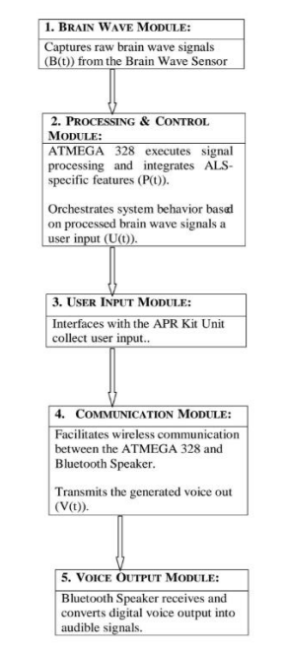

1. **MODELING AND ANALYSIS**

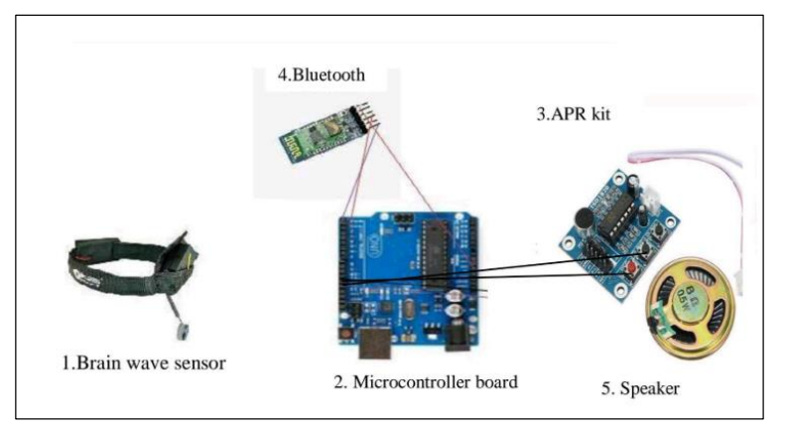

**Figure 1:** Architecture Model

**APPLICATION**

**ASSISTIVE TECHNOLOGY** - To assess how well the Neuro-Integrated system performs in comparison to current assistive technologies designed for Neuromuscular disorders by enabling direct data exchange between brain and computer providing strong security for confidential neural data.

**MEDICAL REHABILITATION** - Supporting the rehabilitation of individuals recovering through the system which can be applied on the patients suffering from severe neuromuscular injuries or diseases.

1. **RESULTS AND DISCUSSION**

IMPROVED COMMUNICATION: Enhanced voice-based communication for individuals with Neuromuscular disorders.

AUGMENTED ACCESSIBILITY: Increased accessibility to daily activities, addressing Neuromuscular disorders challenges.

CUSTOMIZABLE INTERACTION: Technology for varying degrees of Neurological impairment.

POSITIVE IMPACT ON QUALITY OF LIFE: Real-world improvements in Disabilities people.

PERFORMANCE BENCHMARKING: Comparative analysis with existing assistive technologies

1. **CONCLUSION**

A brain-computer interface (BCI) is a computer-based system that acquires brain signals, analyzes them, and translates them into commands that are relayed to an output device to carry out a desired action. It provides direct data exchange between brain and computer. The development of BCI renders this technology feasible for patients suffering from neurological impairments causing to face many challenges in sensorimotor functions and communication with the environment. The BCI’s have increased demand for advanced, adaptive and personalized rehabilitation. There are numerous applications of BCI in medical and non - medical fields out of which our work attempts to focus mainly on papers which detailed about providing virtual voice through the system which can be applied on the patients suffering from severe neuromuscular injuries or diseases.

1. **REFERENCES**

[1] For papers - S. Lee, M. Lee, J. Jeong and S. Lee, "Towards an EEG-based Intuitive BCI Communication System Using Imagined Speech and Visual Imagery," 2019 IEEE International Conference on Systems, Man and Cybernetics (SMC), Bari, Italy, 2019, pp. 4409-4414, doi:10.1109/SMC.2019.8914645.

[2] For papers – Sereshkeh, A.R., Trott, R., Bric out, A. and Chau, T., 2017. Eeg classification of covert speech using regularized neural networks. IEEE/ACM Transactions on Audio, Speech, and Language Processing, 25(12), pp.2292-2300.

[3] For links - https://www.researchgate.net/figure/a-The-number-of-published-brain-computer-interface-BCI-articles-for-eachyear-from_fig1_262963497