A SPECIAL STUDY ON IMPORT & EXPORT PROCEDURE AND DOCUMENTATION AT 5WAY LOGISTICS SOLUTIONS PVT. LTD.
Mohamed Ibrahim M, MBA (SLM)
Dr.D.Anitha Kumari, Assistant Professor
SCHOOL OF MANAGEMENT STUDIES
VELS INSTITUTE OF SCIENCE, TECHNOLOGY AND ADVANCED
STUDIES (VISTAS),CHENNAI - 600 117

I ABSTRACT
This study explores the complexities of import and export procedures, focusing on the importance of understanding these processes in today's globalized economy. It explains the fundamental concepts of import and export, the regulatory frameworks governing international trade, and the importance of import and export documentation. The study also examines the procedural aspects of shipping goods across borders, from pre-shipment to post-shipment procedures. It also discusses trade financing mechanisms, transportation modes, and risk management strategies used by businesses. The study aims to equip businesses, trade professionals, and policymakers with the knowledge and insights needed to navigate the complexities of international trade effectively.

II INTRODUCTION
This study highlights the importance of import and export documentation in international trade, highlighting its complexities and the need for businesses to navigate them effectively. Proper documentation ensures legal compliance, facilitates customs clearance, and mitigates risks associated with international trade. It streamlines supply chains, enhances risk management, and optimizes financial transactions. The study also emphasizes the importance of documentation in supply chain efficiency, quality control, and dispute resolution mechanisms. It provides valuable data for analysis and planning, enabling businesses to make informed decisions and capitalize on emerging opportunities in the global marketplace.
III INDUSTRY PROFILE
The shipping industry is a vital part of global trade and economic development, transporting commodities and finished products across domestic and international markets. With an estimated value of $700 billion and projected growth to $1.3 trillion by 2023, it plays a crucial role in facilitating the import and export of goods. India, with its strategic location and extensive coastline, is the 14th largest fleet in the world, handling petroleum, lubricants, oils, container shipping, steam coal, coking, and iron ore. The logistics sector, which has evolved significantly since the late 1940s, is a critical enabler of trade and commerce, contributing to economic growth and competitiveness. It optimizes processes like inventory management, freight transportation, and delivery to ensure efficient supply chain operations. India is poised to become a key player in the evolving global logistics landscape.
IV COMPANY PROFILE
5 Way Logistics Solutions is a leading global logistics provider that focuses on quality, safety, and timely delivery. They aim to exceed customer expectations by offering cost-effective and quality services, becoming a market leader in multimodal logistics. As a non-asset-based forwarder, they offer transportation services across various cargo channels and shipping methods, ensuring flexibility and choice for clients. They provide top-class global forwarding services, including customs clearance, freight forwarding, warehousing, and international air and sea transportation. Their policy is to offer efficient, competitively priced shipping, logistics, and marine services globally, ensuring quality and security.
1.3 OBJECTIVE OF STUDY

PRIMARY OBJETIVE
To analyses import and export procedure and documentation
SECONDARY OBJECTIVES
- To understand, what are documents needed for Import & Export for shipment.
- To know about the procedures for Import & Export for shipment.
- Analysis of the process of customs clearances through documentation for shipment.
- To identify the challenges and problems in Import & Export documentation and procedures.

VI NEED OF THE STUDY

Understanding import-export procedures and documentation is essential for businesses to comply with international trade laws and regulations, reduce costs associated with customs duties, taxes, and penalties, and expand their global customer base. It also enhances operational efficiency by reducing paperwork, processing time, and errors in customs clearance processes. Clear documentation promotes supply chain transparency, facilitating tracking and tracing of goods from origin to destination. Smooth import-export processes also contribute to customer satisfaction by ensuring timely delivery and minimizing disruptions in the supply chain.
VII. SCOPE OF THE STUDY
This text provides an in-depth analysis of the legal framework governing import and export activities, including customs regulations, tariffs, and trade agreements. It also covers import procedures, including pre-shipment requirements, customs clearance procedures, and documentation like licenses and permits. It also covers export procedures, including commercial invoices, packing lists, certificates of origin, and export licensing requirements. It also discusses documentation requirements, including bill of lading, customs declarations, and certificates of conformity.
VIII STATEMENT OF PROBLEMS
International businesses face numerous challenges, including customs complexities, regional regulations, language barriers, transportation delays, currency fluctuations, and lack of supply chain visibility. These issues hinder smooth operations, impacting financial forecasting and budgeting. Strategic solutions are needed to ensure business continuity and competitiveness in the global market, as these challenges require strategic solutions to overcome.
IX.REVIEW OF LITERATURE
This collection of articles explores international trade, logistics, and import-export operations from various perspectives. Topics include export procedures, documentation, transportation modes, intangible assets, exchange rate fluctuations, and exporting and firm performance. Some articles address specific business issues, like the COVID-19 pandemic's impact on import-export operations and container movement challenges. Methodologies include empirical analyses, case studies, theoretical investigations, and the development of new models and technologies. These studies contribute to a better understanding of global trade complexities and dynamics, offering insights and recommendations for practitioners and policymakers.
X.RESEARCH METHODOLOGY
The study on customs house agents uses a comprehensive research methodology, including literature reviews, interviews, surveys, and legal and regulatory document analysis. This approach provides a comprehensive understanding of the day-to-day practices, challenges, and experiences faced by these agents, providing valuable insights for policy decisions and enhancing trade facilitation efforts. Case studies and comparative analyses are also used to enrich the findings.

XI.DATA ANALYSIS AND INTERPRETATION
4.1.5 TABLE: Do you believe that import and export documentation is essential for facilitating international trade

FACTORS | NO OF RESPONSE | PERCENTAGES
AGREE | 16 | 50%
STRONGLY AGREE | 3 | 9.4%
NEUTRAL | 7 | 21.9%
DISAGREE | 3 | 9.4%
STRONGLY DISAGREE | 3 | 9.4%
TOTAL | 32 | 100%

4.1.5 CHART : Do you believe that import and export documentation is essential for facilitating international trade

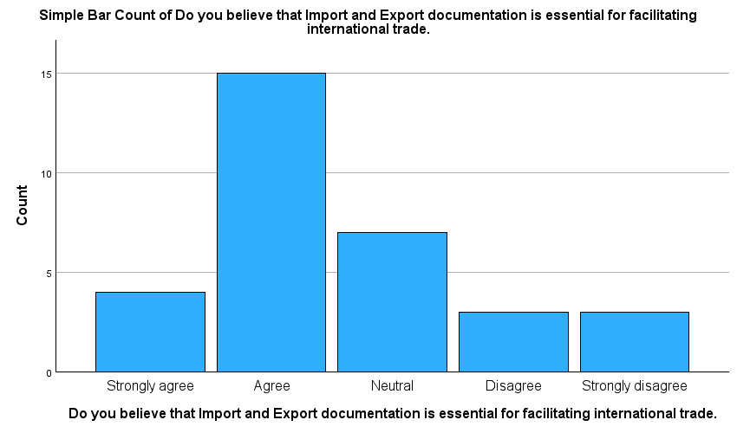

Inference: From the table we can see that 50% of them agree, 21.9% neutral and 9.4% of Strongly agree is the import and export documentation is essential for faciliting international trade
4.1.6 TABLE : Export documentation typically includes a commercial invoice, packing list, and certificate of origin.

FACTORS | NO OF RESPONSE | PERCENTAGES
AGREE | 17 | 53.1%
STRONGLY AGREE | 5 | 15.6%
NEUTRAL | 6 | 18.8%
DISAGREE | 4 | 12.5%
STRONGLY DISAGREE | 0 | %
TOTAL | 32 | 100%

4.1.6 CHART: Export documentation typically includes a commercial invoice, packing list, and certificate of origin.
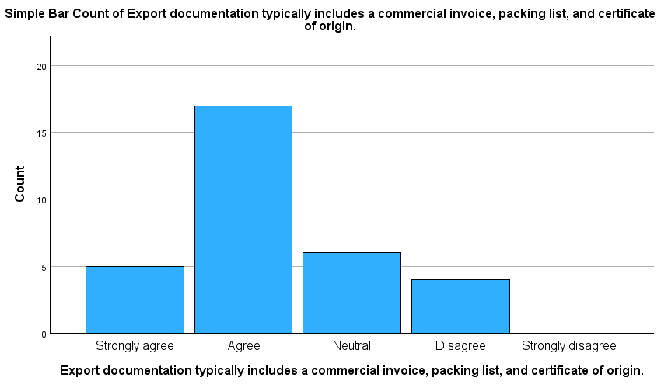

Inference: From the table we can see that 53.1% of agree, 18.8% of neutral,15.6% of strongly agree is the export documentation typically includes a commercial invoice, packing list, and certificate of origin.

4.1.7 TABLE : Proper documentation helps in tracking the movement of goods throughout the import and export process.

FACTORS | NO OF RESPONSE | PERCENTAGES
AGREE | 11 | 34.4%
STRONGLY AGREE | 8 | 25%
NEUTRAL | 8 | 25%
DISAGREE | 1 | 3.1%
STRONGLY DISAGREE | 4 | 12.5%
TOTAL | 32 | 100%

4.1.7 CHART : Proper documentation helps in tracking the movement of goods throughout the import and export process.

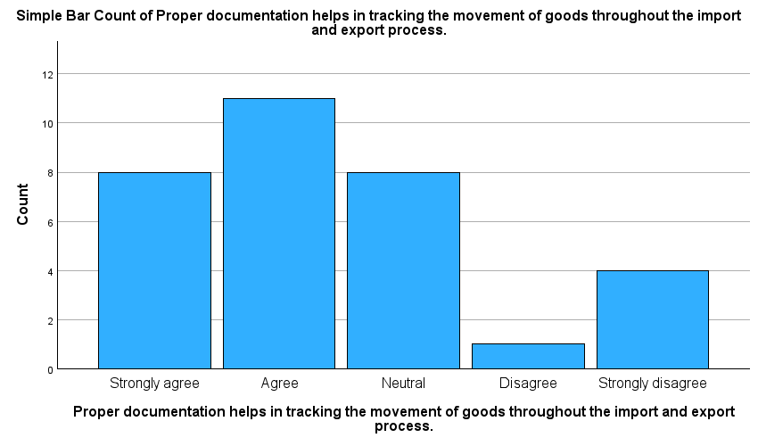

Inference: from the table we can see that 34.4% of agree,25% of strongly agree, 25% of neutral is the proper documentation helps in tracking the movement of goods throughout the import and export process.

XII.FINDINGS OF THE STUDY

- The majority of respondents 50% agree do you believe that Import and Export documentation essential for facilitating international trade.
- The majority of respondents 53.1% agree Export documentation typically includes a commercial invoice, packing list, and certificate of origin.
- The majority of respondents 34.4% agree Proper documentation helps in tracking the movement of goods throughout the import and export process.
WEIGHTED AVERAGE METHOD:
- It is inferred that majority of the repondents agree that the Do you believe that the update in import and export procedures
- It is inferred that majority of the repondents strongly agree that the analysis of the major drawbacks of digitization is network issues in producers
CORRELATION:
- Correlation is a statistical technique that evaluates the possibility of a two-way linear link between two continuous variables.1. The strength of the alleged linear link between the variables in issue is represented by a statistic known as the correlation coefficient, which is used to measure correlation.

XIII.SUGGESTIONS
- The regulatory environment analysis involves a thorough examination of import and export procedures in target markets, including customs regulations, trade agreements, tariffs, quotas, and other relevant trade policies.
- This study delves into successful documentation management strategies of importers and exporters, highlighting common challenges and strategies they employ to overcome them.
- Stakeholder interviews are conducted to gather information on key stakeholders involved in international trade, such as importers, exporters, customs officials, freight forwarders, and trade consultants.
- Gather insights into their experiences, pain points, and recommendations for improving documentation processes.

XIV.CONCLUSION
The study emphasizes the importance of import-export procedures and documentation in smooth international trade operations. It highlights the role of accurate documentation, regulatory compliance, and technology in streamlining processes and overcoming challenges like customs clearance delays and tariff complexities. Effective management of these procedures is crucial for businesses to navigate global commerce, expand their market reach, and optimize operational efficiency

BIBLIOGRAPHY
- Jones, G., & Smith, T. (2020). "International Trade: Procedures and Documentation." Publisher.
- Hill, C., & Jain, A. (2019). "Global Business Today: Import-Export Procedures." Publisher.
- Murphy, P. (2018). "The Handbook of International Trade and Finance: Import-Export Documentation." Publisher.
- Carbaugh, R. J. (2017). "International Economics: Import-Export Regulations and Procedures." Publisher.
- Daniels, J., Radebaugh, L., & Sullivan, D. (2020). "International Business: Import-Export Practices." Publisher.
WEBSITE:
www.shipingindia.coM
www.cargoportalservices.com
https://en.wikipedia.org
http://www.logisticstimes.net
https://articles.economictimes.indiatimes.com

