**NEXA CULTIVATE: NAVIGATING CHALLENGES AND PIONEERING AI-DRIVEN AGRICULTURE**

**Dr. U.NILABAR NISHA1 , KAVYA S2 , KOKULVASAKI S3 , JENILA S4**

1Head of the Department, Computer Science And Engineering, Mahendra Institute Of Engineering And Technology, Namakkal-637503

2Student, Computer Science And Engineering, Mahendra Institute Of Engineering And Technology, Namakkal-637503

3Student, Computer Science And Engineering, Mahendra Institute Of Engineering And Technology, Namakkal-637503

4Student, Computer Science And Engineering, Mahendra Institute Of Engineering And Technology, Namakkal-637503

**ABSTRACT -**This project aims to revolutionize agriculture by integrating advanced technologies such as machine learning and deep learning. Leveraging datasets containing environmental factors, we employ the LightGBM algorithm to provide tailored crop recommendations, optimizing selection for better yields and sustainability. Additionally, we address plant disease detection and recognition using the Inceptionv3 algorithm, fine-tuning it via transfer learning for early disease intervention. To enhance user interaction, we introduce a chatbot interface for farmers to access real-time assistance on crop recommendations, disease detection, and agricultural insights. Our comprehensive solution empowers agriculturalists to make informed decisions, fostering innovation and sustainability in agriculture.

**KeyWords:** Agriculture revolution , Machine learning ,Deep learning, LihtGBM , Inceptionv3

1. **INTRODUCTION**

In response to today's agricultural challenges, our platform harnesses cutting-edge technology to provide holistic solutions. By utilizing machine learning algorithms, we address critical areas

such as crop recommendation and plant disease detection. Through meticulous data handling, we train algorithms like LightGBM and Inceptionv3 to offer precise recommendations and revolutionize disease detection. With a user-friendly chatbot interface, we ensure accessibility and usability, empowering farmers with actionable insights. Our goal is to transform agricultural practices, empowering farmers and promoting sustainability in farming.

**A.1 Crop Recommendation:**

Crop recommendation systems are integral to modern agriculture, offering farmers crucial guidance for optimizing productivity, sustainability, and profitability. By employing data analytics and machine learning algorithms, these systems provide insights into selecting the most suitable crops based on factors like soil quality, climate conditions, and historical performance. They mitigate risks associated with unfavorable environmental conditions and enable farmers to capitalize on opportunities for maximizing yields and resource allocation. In an era marked by agricultural challenges and the need for sustainability, these systems empower farmers to make informed decisions, contributing to food security and economic development. With advancements in technology, crop recommendation systems are poised to revolutionize traditional farming practices, ushering in a new era of precision agriculture for a prosperous future

**A.2 Leaf Disease Detection**

Plant leaf diseases, spanning fungal, bacterial, viral, and sometimes parasitic infections, pose significant threats to plant health and agricultural productivity. These diseases cause symptoms like discoloration, spots, lesions, wilting, and premature leaf drop, leading to reduced crop yields and aesthetic decline. Fungal diseases like brown spot and leaf blast produce characteristic lesions, while bacterial blight forms water-soaked lesions with angular shapes. Managing leaf diseases involves cultural practices like sanitation and crop rotation, along with fungicide or bactericide use when necessary. Planting disease-resistant varieties and maintaining overall plant health through nutrition and irrigation are crucial for mitigating leaf diseases and promoting productive plant growth.

**A.3 Crop Price Prediction:**

Crop price forecasting is essential for supply chain planners and policymakers, offering insights into market factors like demand and supply. In countries like India, where manual entry of crop prices is common, errors and data access issues are prevalent, exacerbating the challenge of creating reliable forecasts. Moreover, price fluctuations further complicate the process. To address this, a crop price prediction model is proposed, incorporating features such as market location, season, crop type, variety, and previous year's prices. Such a model can aid decision-makers in taking timely actions and ensure fair prices for smallholder farmers, fostering economic stability and sustainability in agricultural markets.

**A.4 Pesticide Prediction**

Effective pesticide management is crucial for achieving optimal crop yields. While factors like water availability, soil fertility, and pest control greatly impact productivity, farmers can regulate pesticide usage for better outcomes. Misuse of pesticides can harm crop yield and quality, and excessive application poses health risks. Maintaining the correct dosage and frequency is essential. Our data analysis, based on crops harvested by multiple farmers, ensures proper pesticide usage to mitigate risks associated with overuse, safeguarding both crop health and human well-being.

**A.5 Chatbot**

The chatbot functions through a structured process, starting with receiving user input in natural language text, which could be about crop recommendations, disease detection, or any agricultural aspect. Utilizing Natural Language Processing (NLP), it understands and interprets the input, extracting relevant information. Next, it processes the query to determine user intent, analyzing keywords and identifying topics. Interacting with the backend system, it retrieves necessary information or performs computations based on user queries. Once data is gathered, the chatbot generates a response, which may include crop recommendations or disease diagnosis, presented understandably. Finally, it delivers the response to the user, allowing for further interaction or clarification if needed, and may suggest additional options based on the conversation's context.

# RELATED WORK

**A. Crop Recommendation:**

In recent years, several machine learning-based crop recommendation systems have been developed to assist farmers in making informed decisions about crop selection. Reddy et al. (2020) conducted a study using algorithms like K-Nearest Neighbor (KNN), Decision Tree (DT), Random Forest (RF), and Support Vector Machine (SVM) to predict the best crop for a given region based on factors like soil characteristics, climate, and topography. Their findings showed that the RF algorithm, with an accuracy of 96.5%, outperformed other algorithms. Similarly, Panda et al. (2021) proposed a crop recommendation system utilizing algorithms like Naive Bayes (NB), Decision Tree (DT), and Artificial Neural Network (ANN), achieving an accuracy of 90% with the ANN algorithm.

**B. Crop Yield Prediction:**

Sarfraz et al. (2012) initially investigated crop yield prediction using fuzzy logic to forecast wheat production, achieving an 84% prediction accuracy. Wang et al. (2020) employed deep learning methods, including convolutional neural networks (CNNs) and long short-term memory (LSTM) networks, to forecast maize crop yield based on satellite images and climate data. Their study demonstrated that the deep learning approach surpassed traditional regression models in accuracy.

**C. Leaf Disease Detection:**

Singh et al. (2020) presented a CNN- and transfer learning-based system for plant disease detection, achieving a 97.5% accuracy rate for spotting illnesses on tomato leaves. Amin et al. (2020) proposed a machine learning-based methodology for plant disease diagnosis using a hybrid feature extraction method and SVM classifier, achieving a 98.9% accuracy rate in detecting tomato leaf diseases.

**D. Pesticide Prediction:**

Kumar et al. (2021) proposed a crop pesticide management system based on machine learning techniques like Support Vector Machine (SVM), K-Nearest Neighbor (KNN), and Decision Tree (DT). Their system forecasts the quantity of pesticide needed for a certain crop based on factors including soil type, crop type, and weather conditions, with the SVM system predicting pesticide needs with 88% accuracy. Bhatnagar et al. (2021) developed a pesticide management system using algorithms like Decision Tree (DT), Random Forest (RF), and Support Vector Machine (SVM), achieving an accuracy of 85.6% with the SVM algorithm, demonstrating its potential for use in pesticide management.

**E. ChatBot**

The chatbot harnesses advanced technologies like Random Forest and Artificial Neural Network for crop recommendation, fuzzy logic and deep learning for crop yield prediction, and deep neural networks for crop price prediction. For disease detection, it employs CNNs with transfer learning and hybrid feature extraction with SVM classifiers. In pesticide management, it utilizes Support Vector Machine and Decision Tree algorithms. Through natural language processing, the chatbot delivers tailored solutions, empowering farmers to optimize practices and enhance productivity sustainable.

1. **PROPOSED MODELS**

**A. K-Nearest Neighbors (KNN) for Crop Yield Prediction:**

In this proposed model, KNN is utilized for crop yield prediction based on user inputs like state name, district name, crop year, crop name, and area of the field. Similar to the Random Forest Regression approach, we scraped data from official government websites and applied various machine learning models. However, instead of Random Forest Regression, we employ KNN for its ability to find patterns in the data and make predictions based on similarity to neighboring data points. By calculating distances between data points, KNN estimates the yield in kilograms per hectare. Additionally, feature selection techniques like correlation coefficient and heatmap analysis are used to enhance model accuracy.

**B. Support Vector Machine (SVM) for Crop Recommendation:**

In this segment, we propose Support Vector Machine (SVM) as an alternative to Gaussian Naive Bayes for crop recommendation. By taking inputs like soil nutrient content, humidity, rainfall, and temperature, SVM is utilized to reduce the chance of wrong crop selection by farmers. SVM is chosen for its ability to handle high-dimensional data and find optimal hyperplanes to separate different classes. Feature selection techniques like correlation coefficient and heatmap analysis are employed to improve model accuracy.

**C. VGG16 for Crop Disease Detection**:

To complement the use of MobileNet, we introduce VGG16 as an alternative pre-trained model for crop disease detection. Similar to MobileNet, VGG16 is a convolutional neural network trained on the ImageNet dataset. By fine-tuning VGG16 on the collected dataset containing RGB images of healthy and diseased crop leaves, we aim to improve disease detection accuracy. The VGG16 model is trained and validated using a similar dataset split and achieves a validation accuracy of 93.2%.

**D. Gradient Boosting Classifier for Pesticide Prediction**:

For pesticide management, we propose Gradient Boosting Classifier as an alternative to Light Gradient Boosting Machine (LGBM). This model is trained on inputs such as estimated insect count, crop and soil categories, pesticide usage, and seasonal factors to predict crop health. By utilizing a dataset provided by the Government of India, the Gradient Boosting Classifier achieves an accuracy of 97.95% in classifying whether the crop is alive or damaged due to pesticides.

**E. Chatbot:**

The chatbot uses NLP to analyze user queries on agriculture, extracting key information like intent and topics through techniques such as tokenization and entity recognition. It then interacts with backend systems, employing machine learning algorithms to generate responses with actionable insights or recommendations. This streamlined process enables users to make informed decisions in agriculture.

**4. RESULTS**

**A. Crop Yield Accuracy** Table 1 shows model name and MSE for crop yield.

**Table 1. Crop Yield Accuracy**

|  |  |
| --- | --- |
| Model | Mean Square  Error |
| KNN | 0.11 |
| Support vector regression | 1.38 |
| Linear regression | 1.37 |

**B. Crop Recommendation Accuracy**

Table 2 shows model name and accuracy for crop recommendation.

**Table 2. Crop Recommendation Accuracy**

|  |  |
| --- | --- |
| Model | Accuracy |
| Gaussian naïve Bayes | 99.5% |
| Logistic regressions | 94.5% |
| Support vector machine | 96.1% |
| K-nearest neighbours | 97.4% |

1. **Crop Disease Detection**

Figure 1 shows training and validation curve for crop disease detection.

XG

Boost

0.53

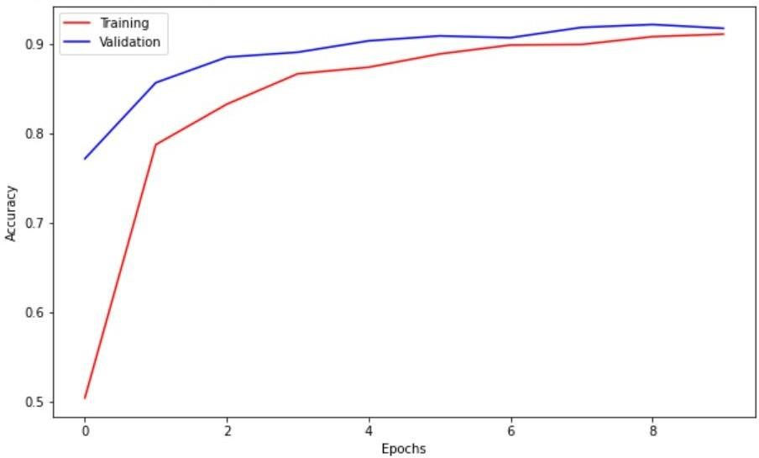

**Fig. 1.** Training and validation comparison with respect to Accuracy and Epochs.

1. **Pesticide Prediction**

For Pesticide Management the model was able to achieve an accuracy of 97.9575% as shown in figure 2.



**Fig. 2.** Accuracy achieved using LGBM.

**F . Integrated Web Application**

We have developed an integrated web app that utilises all the proposed models and provides a all-in-one interface for all the features mentioned in this paper. Figure 3 and Figure 4 are some of the snippets of the web application developed.

**5. CONCLUSION AND FUTURE ENHANCEMENT**

Our system revolutionizes agriculture with crop recommendation and disease detection using LightGBM and Inceptionv3 algorithms.

for seamless interaction, facilitating optimized yields and sustainable practices. Continued research ensures ongoing innovation for enhanced productivity and global food security.

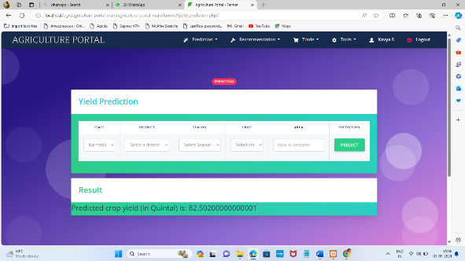

**Fig 3 : Crop Yield Prediction**

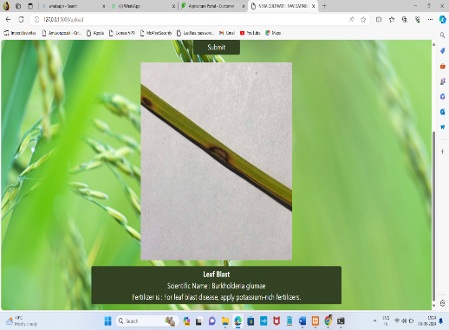

**Fig 4 : Crop Disease Detection**

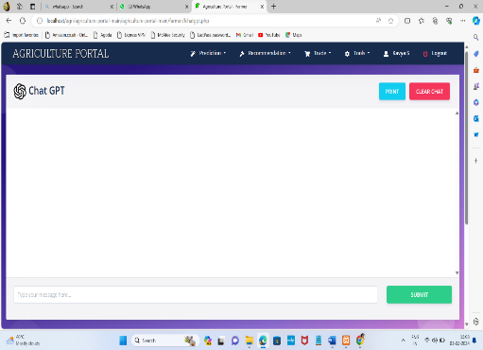

**Fig 5 : Chatbot**

By leveraging advanced technologies such as the LightGBM algorithm for crop recommendation and the Inceptionv3 algorithm for disease detection, we aim to

empower farmers with data-driven insights and actionable recommendations. The integration of a user-friendly chatbot interface further enhances accessibility and usability, facilitating seamless interaction between farmers and the system. Through the collaborative efforts of data collection, preprocessing, model selection, training, and deployment, our system offers a holistic approach to agricultural decision-making, enabling farmers to optimize yields, mitigate risks, and foster sustainable practices. Moving forward, continued research and development in this field hold the potential to further revolutionize agriculture, paving the way for increased productivity, resilience, and food security on a global scale.

**6 . REFERENCES**

1. M. E. Pothen and M. L. Pai, "Detection of Rice Leaf Diseases Using Image Processing", 2020 Fourth International Conference on Computing Methodologies and Communication (ICCMC), pp. 424-430, 2020.

2. Prabira Kumar Sethy, Nalini Kanta Barpanda, Amiya Kumar Rath and Santi Kumari Behera, "Image Processing Techniques for Diagnosing Rice Plant Disease: A Survey", proc. Computers and Electronics in Agriculture An International Journal, vol. 167, pp. 516-530, 2020.

3. T. Ahmed, C. R. Rahman, M. Abid and F. Mahmud, "Rice grain disease identification using dual phase convolutional neural network-based system aimed at small dataset", arXiv preprint arXiv:2004.09870, 2020.

4. C. R. Rahman, P. S. Arko, M. E. Ali, M. A. I. Khan, S. H. Apon, F. Nowrin, et al., "Identification and recognition of rice diseases and pests using convolutional neural networks", Biosystems Engineering, vol. 194, pp. 112-120, 2020.

5. R. Sharma, V. Kukreja and V. Kadyan, "Hispa Rice Disease Classification using Convolutional Neural Network", International Conference on Signal Processing and Communication, pp. 377-381, 2021.

6. A. Jain, "Analysis of growth and instability in the area production yield and price of rice in India", Journal of Social Change and Development, vol. 2, pp. 46-66, 2018.

7. BM Sagar and NK. Cauvery, "Agriculture Data Analytics in Crop Yield Estimation: A Critical Review", Indonesian Journal of Electrical Engineering and Computer Science, vol. 12, no. 3, pp. 1087-93, Dec 2018.

8. Rakshith K. Sriram, G Deepak, M Rajesh, K S Sudharshan, S Vasanth and Kumar N Harish, "A Survey on Crop Prediction using Machine Learning Approach", International Journal for Research in Applied Science & Engineering Technology (IJRASET), pp. 3231-3234, April 2019.

9. Potnuru Sai Nishant, Pinapa Sai Venkat, Bollu Lakshmi Avinash and B. Jabber, "Crop Yield Prediction based on Indian Agriculture using Machine Learning", 2020 International Conference for Emerging Technology (INCET), pp. 1-4, 2020.

10. Y. Jeevan Nagendra Kumar, V. Spandana, V. S. Vaishnavi, K. Neha and V. G. R. R. Devi, "Supervised Machine learning Approach for Crop Yield Prediction in Agriculture Sector", 2020 5th International Conference on Communication and Electronics Systems (ICCES), pp. 736-741, 2020.

11. Ariponnammal, S. and Natarajan, S. (1994) ‘Transport Phonomena of Sm Sel – X Asx’, Pramana – Journal of Physics Vol.42, No.1, pp.421-425.

12. Barnard, R.W. and Kellogg, C. (1980) ‘Applications of Convolution Operators to Problems in Univalent Function Theory’, Michigan Mach, J., Vol.27, pp.81–94.

13. Shin, K.G. and Mckay, N.D. (1984) ‘Open Loop Minimum Time Control of Mechanical Manipulations and its Applications’, Proc.Amer.Contr.Conf., San Diego, CA, pp. 1231-1236.