**DEVELOP AND EXAMINE THE TWO BANDS BIOLOGICAL ANTENNAS DEVELOPED SPECIFICALLY FOR IMPLANTATION USAGE**

**SHIVANGI GOYAL1, DR. RISHU BHATIA2**

**1** M.Tech Scholar,Ganga Institute Of Technology & Management Kablana Jhajjar,India

*Shivangegoyal817@gmail.com*

**2** Professor, Ganga Institute Of Technology & Management Kablana Jhajjar,India

[*rishu.ece@gangainstitute.com*](mailto:rishu.ece@gangainstitute.com)

## **ABSTRACT**

Implantable medical devices have transformed medical care by providing customized therapies and the ability to monitor patients continuously. Nevertheless, the power demands of these devices present considerable obstacles, especially in distant or deep-seated areas of the body. In order to tackle this issue, researchers have developed specialized two-band biological antennas that are designed for implantation purposes. These antennas provide improved capacities to harvest energy and transmit data.

This study specifically concentrates on the design, creation, and analysis of these cutting-edge antennas that function in two separate frequency ranges: microwave and ultrasonic. Efficient energy may be harvested from external electromagnetic fields using the microwave band, while high-speed data transmission within the body can be achieved using the ultrasonic band, overcoming problems such as tissue attenuation and signal loss.

The Efficiency and biocompatibility of the two-band biological antennas are thoroughly analyzed using computational modeling, prototyping, and in vitro research. The parameters of antenna size, shape, material composition, and implantation depth are methodically assessed in order to maximize energy efficiency, data transfer speeds, and overall reliability.

The outcomes of this study show that two-band biological antennas can be successfully used for implantation purposes, providing a reliable and effective method for powering and connecting with medical equipment that can be implanted in the body of human in real-life clinical situations. This technological progress has the capacity to greatly enhance the Efficiency, durability, and therapeutic outcomes of implantable medical devices, hence facilitating more efficient medical care interventions and patient care techniques.

**Key Words:** Biological antennas, Implantation applications, Dual-band antennas, Biocompatible materials, Wireless communication, Tissue engineering,

# INTRODUCTION

In the past few years, it have been notable advancements in the subject of implantable medical devices. These advancements have had a transformative impact on medical care by providing precise treatments, continuous monitoring, and better patient outcomes. These devices, which include pacemakers and brain implants, depend on many technology to operate efficiently inside the body of human. Nevertheless, a major obstacle that implantable devices encounter is the need to acquire an ample power source for functioning and establish dependable communication within the body, particularly in areas that are deeply embedded or far away.

Conventional power sources like batteries have restrictions in terms of their dimensions, duration of use, and the requirement for regular surgical replacements, which can jeopardize patient safety and the effectiveness of the device. Moreover, wireless communication within the body has substantial challenges, such as tissue attenuation and signal degradation, which can impede the transfer of crucial data and instructions among the implanted device and external monitoring systems.

In order to tackle these difficulties, scientists have been investigating innovative methods to improve the energy gathering and communication capacities of implantable medical devices. Biological antennas have become a potential option among these methods since they can easily connect with the body's biological environment and utilize external energy sources to power devices.

This thesis seeks to build and evaluate the effectiveness of two-band biological antennas that are specifically developed for implantation purposes. The antennas function in two separate frequency ranges: microwave and ultrasonic. The microwave frequency range is selected for its efficient energy extraction from external electromagnetic fields, while the ultrasound frequency range facilitates fast data transfer within the body, overcoming signal weakening and ensuring dependable Interfaces among the implantation devices and attached antennas.

The creation of these two-band biological antennas requires interdisciplinary research that includes antenna design, materials science, biomedical engineering, and computational modeling. This thesis aims to enhance the Efficiency, biocompatibility, and feasibility of implantation of the suggested antennas by employing theoretical analysis, computational simulations, prototyping, and in vitro testing.

This analysis adds to the progress of implantable medical device technology by providing a detailed explanation of the design principles, Efficiency features, and potential applications of two-band biological antennas. It offers new possibilities for improved patient care, remote monitoring, and therapeutic interventions. The outcomes of this investigation are significantramifications for the future advancement of implantable medical devices, facilitating the creation of medical care solutions that are more effective, dependable, and user-friendly.

**Problem Statement**

The design and analysis of two-band biomedical antennas for implantable purposes pose Multiple obstacles that require resolution. These challenges revolve around achieving optimal Efficiency, ensuring compatibility with the body of human, and complying with safety regulations.

One of the key challenges is the selection of appropriate operating frequencies and bands for the implantable antenna. In the field of biomedical applications, specific frequency bands are recommended to ensure reliable and interference-free communication. The WMTS band, the MedRadio band, and the ISM bands are commonly used in implantable medical devices. The implantable antenna must be capable of operating within these frequency bands to facilitate seamless communication among the implanted device and external systems.

Another challenge is the miniaturization of the implantable antenna. The size and form factor of the antenna play a crucial role in its successful integration within the body of human. The antenna should be compact to enable comfortable implantation and to minimize any discomfort or interference with the patient's daily activities. Moreover, a smaller antenna size allows for more flexibility in terms of implantation locations. However, miniaturization should not compromise the antenna's Efficiency or impede its ability to cover multiple frequency bands.

Implantable medical devices often rely on batteries for power, and it is essential to maximize the battery life to avoid frequent replacements or recharging. The implantable antenna should consume ultra-low power to ensure efficient energy utilization and prolong the lifespan of the implantable device. Power optimization techniques, such as impedance matching and efficient signal transmission, must be employed to minimize power losses and enhance energy efficiency.

The interaction among the implantable antenna and the body of human is a complex issue that needs careful consideration. The human being's body is composed of various sorts of tissues, each with varying electromagnetic Features . These tissues, including muscle, fat, and bone, can affect the transmission of electromagnetic signals. The implantable antenna must be designed to optimize signal transmission through these tissues, minimizing signal loss and ensuring reliable communication. Moreover, the antenna should be biocompatible, non-toxic, and non-irritating to prevent any adverse effects on the patient's health or immune response.

Safety is of paramount importance in the designing of implantable antennas. Regulatory bodies, such as the ICNIRP and the FCC have established SAR limits to ensure that the energy absorbed by the body remains within safe levels. The implantable antenna must adhere to these safety regulations and ensure that the SAR levels are within the recommended limits. Techniques for evaluating and mitigating SAR levels should be incorporated into the antenna design to guarantee patient safety.

In summary, the design and analysis of two-band biomedical antennas for implantable purposes pose several challenges. These include selecting suitable operating frequencies and bands, miniaturizing the antenna while maintaining optimal Efficiency, minimizing power consumption, optimizing signal transmission through the body of human, and ensuring compliance with safety regulations and SAR limits. Addressing these challenges is essential to develop effective and reliable implantable antennas that can revolutionize medical care and improve patient outcomes.

# OBJECTIVES

In today's society, the importance of prioritizing and maintaining good health cannot be understated. However, due to hectic lifestyles and busy schedules, many indivitwos tend to neglect their well-being, often neglecting routine health check-ups and monitoring. This gap in medical care management calls for innovative solutions, particularly in the form of implantable medical devices that can continuously track and monitor our health. These devices have the potential to revolutionize medical care by providing real-time data on vital parameters and enabling timely interventions. Among the essential components of these devices, biomedical Antennas are essential for enabling wireless communications and data transmission within the body. Therefore, the research objective of this study is to address the pressing need for reliable and efficient implantable biomedical antennas that can significantly contribute to improved health monitoring and disease management. To fulfill the research objective, a novel approach is proposed to design a CPW-fed two-band different types of slot antenna that can operate optimally across a wide range of tissue types. This antenna is specifically designed to accommodate tissues with varying water content, allowing it to function effectively in both low and high water content tissue environments. The two-band nature of the antenna enables it to exhibit return loss in the MedRadio band and ISM band,

which are recommended frequency ranges for biomedical applications. By providing a high bandwidth, the antenna ensures robust Efficiency even under harsh conditions, making it suitable for reliable health monitoring applications.

Another crucial aspect of developing implantable medical devices is assessing their biocompatibility to ensure they are safe and compatible with the body of human. In this regard, the proposed antenna demonstrates promising features. The antenna's specific absorption rate (SAR) is evaluated according to IEEE standards to ensure it falls within acceptable limits and does not cause any harm to the surrounding tissues. Additionally, the antenna's flexibility is assessed to ensure it can withstand the dynamic movements and deformations within the body without compromising its Efficiency. These evaluations confirm the applicability of the proposed antenna as a reliable and safe biomedical antenna for implantation.

In the context of implantable devices, the interaction among the antenna and the surrounding tissues is a critical consideration. To mitigate any potential risks associated with direct contact among the antenna's metal components and the tissue of body s, a dielectric superstrate layer is introduced above the printed antenna. This layer acts as a barrier, preventing direct contact and minimizing any adverse effects on the tissues. Furthermore, the antenna is coated with a biocompatible material, such as zirconia, to enhance its biocompatibility and ensure it can be safely implanted inside the body of human.

By achieving these research objectives, This work seeks to provide a valuable contribution to the field advancement of implantable biomedical antennas and, consequently, the field of medical care technology. The development of reliable and efficient antennas can significantly improve the accuracy and effectiveness of health monitoring systems. Continuous and real-time monitoring provided by these devices can help indivitwos manage chronic conditions, detect abnormalities at an early stage, and Facilitate medical care professionals in delivering immediate responses.. Moreover, these advanced implantable devices have the potential to reduce medical care costs by minimizing the need for frequent hospital visits and enabling remote monitoring, resulting in better overall medical care management for indivitwos suffering from chronic diseases.

In summary, the research objective of this study is to design, characterize, and evaluate a CPW- fed two-band circular ring slot antenna for use in implantable medical devices. The focus lies in developing an antenna that can operate effectively in different tissue types, exhibit desirable return loss in recommended frequency bands, comply with SAR limits, demonstrate flexibility, and ensure biocompatibility. By addressing these objectives, this research seeks to contribute to the ongoing efforts in developing advanced implantable biomedical antennas that can enhance the accuracy, reliability, and safety of health monitoring systems, ultimately improving the overall quality of medical care.

# LITERATURE REVIEW

**Frequency Bands for Biomedical Applications**

Biomedical antennas utilize specific frequency bands to enable reliable wireless communication in medical applications. The WMTS band operates within the frequency range of 1427 MHz to 1432 MHz. This band is dedicated to wireless medical telemetry, ensuring secure and efficient communication among medical devices and monitoring systems.

ISM bands, specifically the range of 2.4 GHz to 2.5 GHz, are widely used in biomedical applications. These bands support wireless data transfer in medical devices and systems. The ISM bands are commonly employed for wireless sensors, medical implants, and remote monitoring.

By adhering to the allocated frequency bands, biomedical antennas ensure effective and regulated wireless communication in the field of medical technology. It is crucial to consider and comply with local regulations and licensing requirements when designing and operating biomedical antennas within these frequency ranges.

**Tissue Classification Based on Water Content**

significant impact when assessing Low Water Content Tissues: Other tissues, such as fats and bones, have a lower water content compared to high water content tissues. These tissues exhibit lower permittivity and conductivity. Fats, in particular, have a lower permittivity due to their lower water content and more significant proportion of lipids. Bones, on the other hand, have a higher permittivity compared to fats but lower than high water content tissues. The lower water content in these tissues reduces their ability to store electric charges and leads to lower polarization and conductivity.

The classification of tissues based on water content is crucial for the design of implantable antennas as it affects the Interface involving an antenna and neighbouring tissues occurs. The variations in tissue Features influence the antenna's impedance matching, radiation pattern, and efficiency. For example, the presence of high water content tissues near the antenna can significantly impact its resonant frequency and impedance. Additionally, the absorption and attenuation of electromagnetic waves within tissues are strongly influenced by their water content.

To ensure optimal Efficiency of implantable antennas, it is necessary to consider the different electrical Features of tissues based on their water content. This understanding helps in selecting appropriate antenna designs, operating frequencies, and placement strategies. For instance, the antenna's geometry and size can be optimized to account for the specific dielectric Features of tissues in the surrounding environment. Moreover, knowledge of tissue classification based on water content aids in predicting the transmission features and potential interference within the body.

In conclusion, tissue classification based on water content is a fundamental consideration in the design of implantable antennas. High water content tissues exhibit higher permittivity and conductivity, while low water content tissues have lower permittivity. These variations in tissue Features influence the antenna's Efficiency and interaction with the surrounding environment. By considering tissue classification, designers can develop implantable antennas that are optimized for specific tissue types, leading to improved Efficiency and compatibility within the body of human.

**Impact of Tissue Features on Antenna Efficiency**

The Efficiency of implantable antennas is highly influenced by the Features of the surrounding tissues in which they are implanted. The dielectric constant, or permittivity, of tissues plays a crucial role in determining the transmission features of electromagnetic waves. Tissues with higher dielectric constants, such as high water content tissues, have a greater ability to store electric charges and exhibit increased polarization in the presence of an electric field. This affects the impedance matching of the antenna and can lead to changes in its resonant frequency. Therefore, the dielectric constant of the surrounding tissues must be carefully held during antenna design to ensure optimal Efficiency.

Another important property is the loss tangent, which is a measure of the dielectric losses within a material. Tissues with higher loss tangents, such as high water content tissues, exhibit greater dielectric losses. These losses can impact the efficiency of the antenna by reducing the amount of electromagnetic energy that is radiated or received. Designers must take into account the loss tangent of the surrounding tissues to minimize energy losses and maximize antenna Efficiency.

The electrical conductivity of tissues is also a critical factor. It determines their ability to conduct electric current. High water content tissues, which have higher conductivity due to the presence of ions and electrolytes, can significantly impact the impedance matching of the antenna. The conductivity of the tissues affects the radiation efficiency and the amount of power transferred to or from the antenna. Proper consideration of the electrical conductivity of the surrounding tissues is crucial to ensure optimal antenna Efficiency .

Although the magnetic Features of biological tissues are generally considered negligible at the frequencies used in biomedical applications, the relative permeability of tissues should still be taken into account as shown

in Table I. The permeability affects the transmission of magnetic fields and can influence the antenna's electromagnetic waves and impedance [9]. While the impact of permeability on antenna Efficiency is typically minimal, it should still be considered in certain scenarios.

In addition to the indivitwo tissue Features , the heterogeneity of tissues in the body of human is another factor to consider. Tissues are not uniform, and their Features can vary spatially. This tissue heterogeneity can introduce additional challenges in antenna design and Efficiency. Designers must consider the variability of tissue Features and account for potential changes in the surrounding environment to ensure robust and reliable antenna operation.

To mitigate the impact of tissue Features on antenna Efficiency, several design techniques and strategies can be employed. These include optimizing the antenna geometry, adjusting the feed structure, incorporating matching networks, and utilizing advanced materials. Numerical modelling and simulation tools can also be employed to predict the antenna's behaviour in different tissue environments and aid in the design process.

**Table I. Human Tissue Types**

|  |  |  |  |
| --- | --- | --- | --- |
| **S. No.** | **Human Tissue Type** | **Relative Permittivity** | **Conductivity (S/m)** |
| **1.)** | Cortical Bone  (High Water Content) | 11.42 | 0.38 |
| **2.)** | Visceral fat  (Low water Content) | 5.29 | 0.10 |

In conclusion, the Features of surrounding tissues can greatly influence the operation of implanted antennas.The dielectric constant, loss tangent, electrical conductivity, and permeability of tissues affect the impedance matching, radiation efficiency, and resonant frequency of the antenna. Tissue heterogeneity further complicates the design process. By considering these factors and employing appropriate design techniques, it is possible to develop implantable antennas that are optimized for specific tissue environments, leading to improved Efficiency and reliable operation in biomedical applications.

**Design Considerations for Implantable Biomedical Antennas**

Design considerations plays a vital part in the development of implantable biomedical antennas to ensure optimal Efficiency and compatibility with the body of human. These antennas are specifically designed to meet several key requirements, including compactness, flexibility, planarity, human safety, high bandwidth, and gain capabilities. Achieving these objectives involves addressing various challenges and incorporating specific techniques to ensure the effectiveness of these antennas. In this section, we will discuss the important design considerations that contribute to the successful implementation of implantable biomedical antennas.

A key problem in the construction of implantation antennas is achieving size reduction without compromising Efficiency. The size of the antenna is a critical factor as it needs to be small enough to fit comfortably inside the body of human. To overcome this challenge, researchers have developed innovative techniques to reduce

the size of these antennas. One such technique involves the use of dielectric materials with a high dielectric constant or relative permittivity. By carefully selecting a material with a higher permittivity, the capacitance among metallic patches increases. This, in turn, decreases the resonant frequency of the antenna, allowing for a smaller size while maintaining the desired Efficiency features.

Another efficient method for reducing size is the utilisation of slotting techniques. Researchers have employed several slotting approaches to reduce the dimensions of implanted antennas. These techniques entail the incorporation of slots in the ground plane of the antenna or the creation of several slots in the patch. By incorporating these slots, the overall size of the antenna can be reduced without compromising its Efficiency. This approach effectively reduces the physical footprint of the antenna, making it more suitable for implantation while maintaining its functionality.

Increasing the current path length of the antenna radiator is another effective approach for reducing the size of implantable antennas. By increasing the current path length, the resonant frequency of the antenna decreases, leading to size reduction. Design techniques such as curved lines, loops, spirals, helices, meanders, and slots can be employed to increase the current path length. These techniques effectively reduce the physical dimensions of the antenna while still maintaining its resonant features.

Wideband capability is essential for implantable antennas as it enables them to provide mobility and flexibility in various applications. To achieve a wide bandwidth, designers employ various methods as shown in Table II. By choosing a material with a lower permittivity, the antenna's bandwidth can be increased. Another technique involves increasing the thickness of the substrate or superstrates, which can effectively broaden the antenna's bandwidth. Additionally, cutting slots or introducing notches in the antenna structure can also help increase the bandwidth. Probe feeding is another method that can enhance the antenna's wideband Efficiency by providing a broader frequency response.

In order to achieve efficient communication and monitoring within the body of human, it is essential to optimise the gain of the antenna. Implantable antennas function inside the intricate environment of the body of human, which can lead to a decline in radiation features. Hence, it is crucial for the antenna's gain to be marginally greater than the gain in free space in order to ensure dependable short-range communication with external devices. Various techniques can be utilised to increase the antenna's gain. These methods consist of raising The overall height of the substrates is increased by using antenna arrays and incorporating electromagnetic bandgap  superstrates. The practical areas of the antenna is improved through approaches like adding parasitic patches and creating meander borders. or the use of metamaterials. These methods significantly enhance the antenna's amplification and guarantee strong communication and monitoring abilities inside the body of human.

**Microstrip patch antenna**

A patch antenna with a microstrip is a flat antenna that is frequently used for numerous wireless communication uses. The construction involves the process of etching a conducting patch on one side of a dielectric substrate, while having a ground plane on the opposite side. Below is a brief overview of microstrip patch antennas:

Structure: A microstrip patch antenna is composed of a metallic patch positioned on a dielectric substrate, usually made of a thin and low-loss material. The conducting patch typically has a rectangular or circular form, although alternative shapes such as square, elliptical, or triangular patches can also be employed. The ground plane is positioned on the reverse side of the substrate.

Radiation Mechanism: The radiation from a microstrip patch antenna occurs due to the interaction among the electromagnetic fields on the patch and the ground plane. When a high- frequency signal is applied to the patch, it creates an alternating electric field. The combination of the electric field and the ground plane generates an electromagnetic wave, which radiates into free space.

Advantages:

* + 1. Low profile and lightweight: Microstrip patch antennas are planar and have a low profile, making them suitable for applications where size and weight are critical factors.
    2. Antennas which can be easily fabricated by utilising printed circuit board technologies. This allows for cost-effective mass production.
    3. Low cost: The materials used in microstrip patch antennas, such as the dielectric substrate and metallic patch, are inexpensive, making them cost-effective for many applications.
    4. Versatility: It is possible to create patches of microstrip antennas and optimized for specific frequency bands, making them versatile for different wireless communication systems.
    5. Integration: microstrip patches for antennas may be readily incorporated with other components on the same substrate, such as amplifiers, filters, or switches, enabling the development of compact and integrated systems.

**Design Considerations:**

1. Patch shape and size: The shape and size of the patch determine the resonant frequency and radiation features of the antenna. Different shapes and sizes can be used to achieve desired Efficiency parameters.
2. Substrate material and thickness: The selection of dielectric substrates has a direct impact on the antenna's effectiveness, encompassing factors such as bandwidth, effectiveness, and radiation patterns. The dielectric constant and loss tangent of the substrate material are important considerations.
3. Feed mechanism: The feed mechanism, such as a coaxial probe or a microstrip feed line, determines how the signal is coupled to the patch. The feed location and impedance matching techniques are critical for optimizing the antenna's Efficiency.
4. Ground plane size: The size and shape of the ground plane influence the antenna's electromagnetic waves and impedance features. A larger ground plane can help improve antenna Efficiency.
5. Impedance matching: Proper impedance matching among the antenna and the feed line is essential for maximizing power transfer and minimizing reflections.

Microstrip patch antennas are frequently utilised in wireless communication systems, including Wi-Fi, Bluetooth, and satellite communication. Microstrip patch antennas are commonly used in conjunction with CPW (Coplanar Waveguide) feed lines to achieve an efficient and practical antenna system. Here's an explanation of how a microstrip antenna can be integrated with a CPW feed:

1. Microstrip Antenna Basics: A microstrip patch antenna consists of a radiating patch, typically a metal conductor, placed on one side of a dielectric substrate. The patch is usually fed using a transmission line, which is a metallic strip that gives the necessary RF signal to the patch for radiation.
2. Introduction of CPW Feed: To connect the microstrip patch antenna to the external RF circuitry, a transition is required among the microstrip transmission line and the CPW feed line. The CPW feed line is a type of transmission line The structure comprises of a conductive strips positioned on a dielectric the substrate, with grounding planes on both sides.
3. Transition Structure: The transition structure is designed to convert the signal from the microstrip transmission line to the CPW feed line. It typically involves tapering the Microstrip width transmission line and integrating it with the CPW structure. The purpose of this transition is to match the impedance and ensure efficient power transfer among the microstrip antenna and the CPW feed line.
4. Impedance Matching: Impedance matching is a critical aspect of connecting the microstrip antenna to the CPW feed. The impedance of the microstrip patch antenna and the CPW feed line should be properly matched to minimize signal reflections and maximize power transfer. Techniques such as quarter-wavelength transformers or matching networks are employed to achieve impedance matching.
5. RF Signal Flow: Once the transition structure and impedance matching are accomplished, the RF signal from the CPW feed line is efficiently coupled to the microstrip patch antenna. The radiating patch of the microstrip antenna converts the electrical signal into electromagnetic waves for transmission or reception.

By integrating a microstrip patch antenna with a CPW feed line, it is possible to achieve a compact and well-matched antenna system. The microstrip antenna gives the radiating element, while the CPW feed line facilitates the connection among the antenna and the external circuitry. This integration enables effective RF signal transmission and reception in Usage encompassing communication via wireless systems, radar systems, and other similar domains.

**CPW Antenna**

A CPW (Coplanar Waveguide) antenna is a type of planar antenna that utilizes a coplanar waveguide structure for the transmission and reception of electromagnetic waves. It is commonly used in microwave and RF (radio frequency) applications.

Here are some key features and features of CPW antennas:

1. Structure: A CPW antenna consists of a conducting strip (also called the centre strip) Positioned on a dielectric the substrate, with a ground plane located on the other side of the substrate. The conducting strip and the surface plane are situated on a common plane, thus forming a coplanar structure.
2. Coplanar Waveguide (CPW): The CPW structure consists of a conducting strip sandwiched among two ground planes. The conducting strip is separated from the ground planes by gaps known as the signal and ground gaps. The geometry of the CPW structure affects the electrical features of the antenna, including impedance and radiation pattern.
3. Broadband Operation: CPW antennas are known for their broad bandwidth capabilities. The geometry of the CPW structure allows for a wider range of frequencies to be efficiently transmitted and received.
4. Balanced Transmission Line: CPW antennas provide a balanced transmission line configuration, which means the signal and the ground planes are symmetrical with respect to the centre strip. This balanced design helps minimize common-mode radiation and improves antenna Efficiency.
5. Low Radiation Loss: CPW antennas offer low radiation loss compared to other planar antenna types. This is due to the presence of the ground planes, which confine and guide the electromagnetic waves along the conducting strip.
6. Design Flexibility: CPW antennas offer design flexibility in terms of dimensions and substrate selection. By arranging the width and spacing of the conducting strip and ground planes, as well as the dielectric Features of the substrate, the antenna's electrical features can be tailored to specific requirements.
7. Integration with Circuit Components: CPW antennas can be easily integrated with other microwave components and circuits on the same substrate, such as amplifiers, filters, or switches. This integration capability makes CPW antennas suitable for applications requiring compact and integrated systems.

CPW antennas are utilised in diverse industries such as systems for wireless communication, radar systems, and communications via satellite. RFID (radio frequency identification), and many other microwave and RF applications.

# METHODOLOGY

* 1. **Introduction**

The design of implantable biomedical antennas involves addressing various constraints and employing specific techniques to ensure optimal Efficiency and patient safety. This chapter explores the intricacies of antenna design and the selection of appropriate geometries, considering size constraints, specific absorption rate (SAR) limits, the use of biocompatible materials, and design techniques to achieve desired Efficiency features.

* 1. **Constraints in Antenna Design**

The design of implantable biomedical antennas is influenced by several constraints that must be carefully considered. One key constraint is the compact and conformal size of the antenna, which must be small enough to integrate seamlessly into the body of human without causing discomfort or hindering normal physiological functions. However, the size of the antenna directly affects its electromagnetic radiation features, requiring a balance among size reduction and maintaining optimal Efficiency.

Another important constraint is the energy absorbed by living tissue, which is quantified by the Specific Absorption Rate (SAR). Regulatory standards such as IEEE C95.1-1999 and IEEE C95.1-2005 provide guidelines and limits for SAR values to ensure patient safety. Antennas must operate within SAR limits, which define the amount of electromagnetic energy absorbed per unit mass of tissue.

The choice of materials is also critical for implantable biomedical antennas. Biocompatible materials such as Poly di methyl siloxane, Poly tetra fluoro ethylene, Macor, alumina, zirconia, and LTCC are used to minimize adverse reactions and ensure patient well-being.

* 1. **Design Techniques**

To overcome size constraints and achieve compact antenna designs, various techniques are employed. Slotting techniques in the ground and patch structures of the antenna help reduce its physical dimensions while maintaining resonance at the desired operating frequency. Materials with high dielectric constants can decrease the operating frequency by increasing the capacitance of the antenna.

Extending the existing path distance is another strategy to reduce antenna size. This can be achieved by incorporating intricate geometries such as loops, curved lines, spirals, meandered helices, and slots within the antenna structure. These geometries elongate the current path, enabling size reduction while maintaining Efficiency.

Achieving a wide bandwidth is crucial for implantable antennas to operate effectively in low Signal-to-Noise Ratio (SNR) environments. Techniques such as using low dielectric constant materials, introducing slots and notches, and increasing substrate thickness enhance the antenna's bandwidth. However, there is a trade-off among size reduction and bandwidth, necessitating careful optimization.

Merging resonant frequencies is another approach to increase antenna bandwidth. By combining two or more resonant frequencies, the antenna can operate across a broader frequency range, facilitating efficient communication and monitoring.

Various methods can be employed to enhance the antenna's gain, which determines its ability to transmit and receive signals effectively. These methods include raising the substrate's height using Electromagnetic Band Gap (EBG) superstrates, creating arrays of antennas, meandering the edges of the antenna structure, and employing parasitic patches. These techniques optimize the electromagnetic waves and improve the antenna's Efficiency.

* 1. **Proposed Antenna Design**
     1. **Proposed Antenna Design for two band circular ring slot**

The proposed antenna design encompasses a carefully crafted geometry that takes into account the previously discussed constraints and incorporates various design techniques to achieve optimal Efficiency. Fig. 4.1 visually represents the proposed antenna geometry, while TableIII gives detailed dimensions for reference. The chosen substrate material is Poly Di- methyl siloxane, known for its biocompatibility and suitable height (h) for implantation.

One of the key design considerations is achieving a compact antenna size without compromising Efficiency. To address this, the proposed design incorporates three concentric circular-ring slots. These slots serve multiple purposes in the antenna design. Firstly, they contribute to size reduction by introducing slots in both the ground and patch structures. These slots effectively decrease the physical dimensions of the antenna while preserving the desired resonance features. Additionally, the use of high dielectric constant materials aids in reducing the antenna size further by decreasing the operating frequency through increased capacitance.

Furthermore, the suggested antenna not only aims to decrease in size, but also design focuses on optimizing the antenna's Efficiency by increasing the current path length. This is achieved through the incorporation of intricate geometries within the antenna structure. These geometries include loops, curved lines, spirals, meandered helices, and slots. By carefully designing the current path, the antenna achieves a compact size while maintaining its functionality.

To ensure impedance matching among the device and the antenna, a Coplanar Waveguide feed line is employed. The gap among the coplanar ground plane and the strip, denoted as Sc, is meticulously determined to achieve optimal Efficiency. Furthermore, a tuning stub of specific length (t) is strategically placed at the center of the antenna, at a chosen distance (d) from the strip. The selection of an appropriate value for d is crucial to achieving optimal impedance matching and overall antenna Efficiency.

To enable two-band resonance, the proposed antenna design incorporates three circular slots, denoted as S1, S2, and S3, with carefully chosen widths. These slots are carefully positioned and polarized in the same plane to achieve resonance in specific frequency bands. The mean perimeter of these slots determines the two-band region of operation. By enforcing multiple resonances for different types of tissue, the antenna can effectively operate within specific frequency ranges, facilitating efficient communication and monitoring within the body of human.

The proposed antenna design is thoroughly evaluated through measured outcomes, considering specific tissue parameters as outlined in Table III. These measured outcomes provide empirical evidence of the antenna's Efficiency and validate its suitability for implantable biomedical applications. By meeting the desired specifications and demonstrating reliable communication capabilities within the body of human, the proposed antenna design showcases its potential for enhancing biomedical monitoring and medical care.

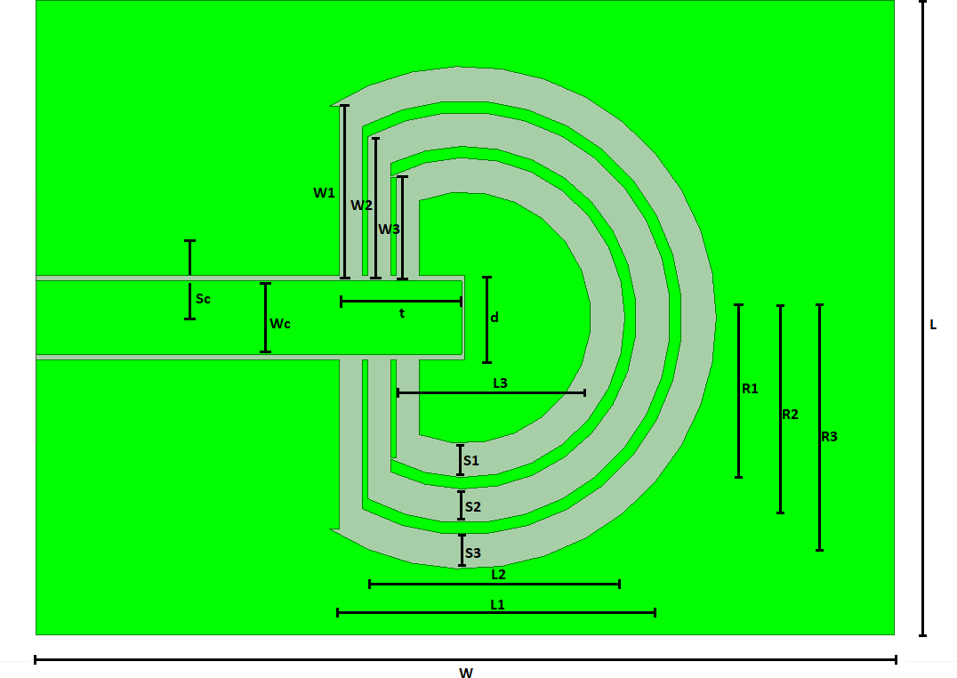

**Fig.4.1** Dimensions of proposed antenna

**Table III. Dimensions of circular slot antenna**

|  |  |  |
| --- | --- | --- |
| **S.No.** | **Proposed antenna** | |
| ***Parameters*** | ***Dimensions*** |
| **1** | L1, W1 (mm, mm) | 35, 20 |
| **2** | L2, W2 (mm, mm) | 30, 15 |
| **3** | L3, W3, (mm, mm) | 24.5, 10 |
| **4** | S1, S2, S3 (mm, mm, mm) | 2, 2, 2 |
| **5** | Tuning Stub (t or Ls)(mm) | 8.8 |
| **6** | R1, R2 ,R3 (mm, mm, mm) | 14,18,22 |
| **7** | h, Wc, Sc (mm, mm, mm) | 1.6, 6.4, 0.5 |
| **8** | W × L (mm, mm) | 65.5 × 72 |
| **9** | εr (Poly Di-methyl siloxane) | 4.3 |

In conclusion, the proposed antenna design integrates various design techniques and considerations to overcome size constraints, optimize Efficiency, and ensure biocompatibility. Through the careful selection of materials, incorporation of specific geometries, and adherence to impedance matching principles, the antenna design achieves a compact size, wide bandwidth, and reliable communication within the body of human. The measured outcomes further support the effectiveness of the proposed design, highlighting its potential impact in the field of implantable biomedical antennas.

* + 1. **Proposed Antenna Design for two band polygonal ring slot**

The proposed antenna, as depicted in Figure 4.2, exhibits a typical size of 53.5 mm × 62.5 mm and features specific dimensions listed in Table IV. For the substrate material, FR4 epoxy is chosen with a selected height (h). The substrate incorporates three concentric polygonal-ring slots, utilizing a high dielectric constant material to achieve a compact antenna size. These three concentric rings play a crucial role in establishing a longer current path within the antenna structure.

To ensure proper impedance matching among the antenna and the device, a Coplanar Waveguide feed line is employed. The gap among the coplanar ground plane and the strip, denoted as Sc, is carefully determined. Additionally, a tuning stub of length t is strategically placed at the center of the antenna, with a chosen distance (d) from the strip. This careful selection of d, set to 0.3 mm, helps achieve optimal Efficiency and impedance matching.

To enable two-band resonance, the proposed antenna design incorporates three polygonal-ring slots, denoted as S1, S2, and S3, with approximate widths. These slots are positioned and polarized in the same plane to achieve resonances within the MedRadio and ISM bands. The mean perimeter of these polygonal rings determines the two-band region of operation. This design approach allows for efficient communication and monitoring within the desired frequency ranges.

A superstrate layer made of FR4 epoxy, with a specific height (h), is placed above the printed antenna. This layer acts as an additional dielectric medium, sandwiching the printed antenna among the substrate and superstrate layer, as shown in Figure 4.4. The presence of the superstrate layer further enhances the Efficiency and functionality of the antenna. Considering the intended application of this antenna for implantation within human tissue, all models and measurements are conducted within the radiative environment of visceral fat. The measured outcomes of the proposed two-band polygonal-ring slot antenna are demonstrated within the visceral fat, which exhibits a specific dielectric constant (εr) of 5.29 and a conductivity (σ) of 0.1 S/m. To ensure biocompatibility, the proposed antenna is coated with zirconia, which possesses a dielectric constant (εr) of 22 and has a thickness of approximately

0.5 mm, as illustrated in Figure 4.4. These modifications and measurements validate the antenna's suitability for use as an implantable device, adhering to relevant standards and requirements.

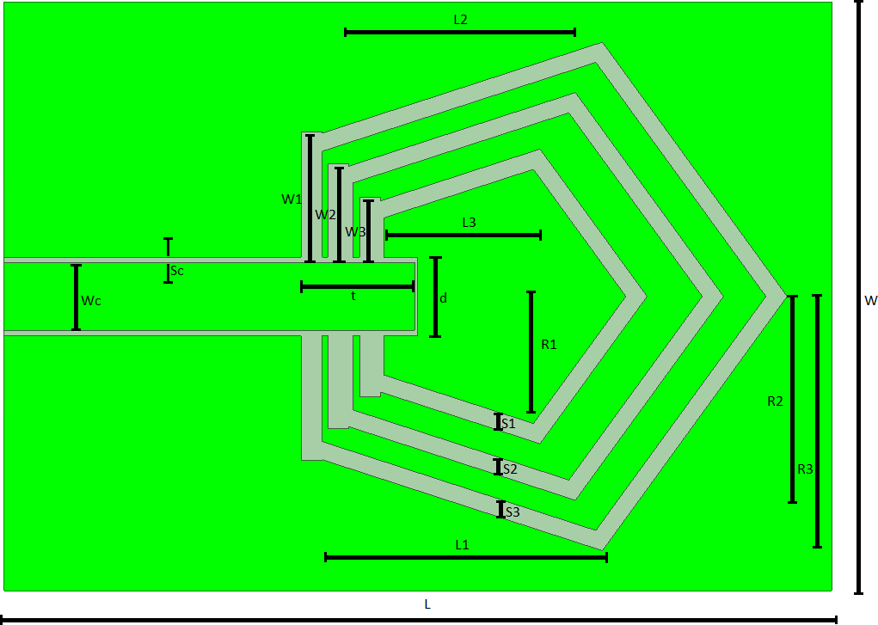

**Fig. 4.2** Dimensions of proposed antenna

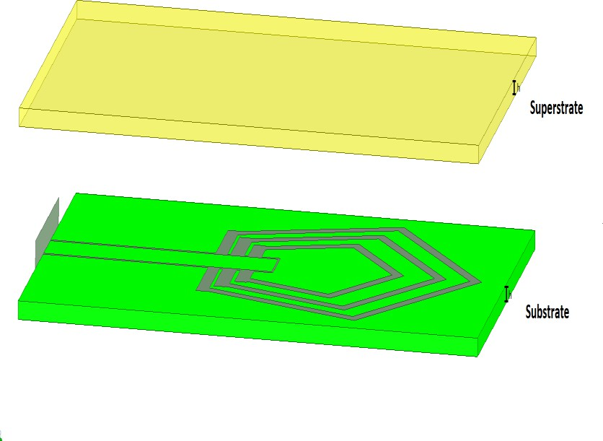

**Fig. 4.3** Different layers of antenna

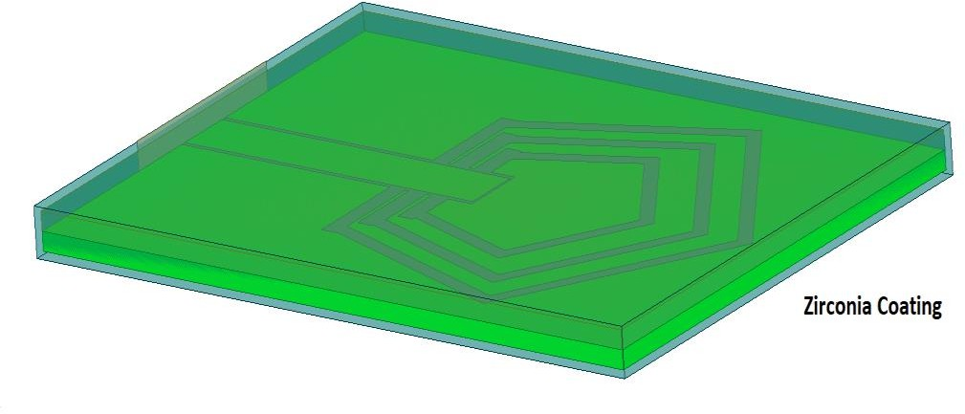

**Fig. 4.4** Antenna with Zirconia coating

**Table IV. Dimensions of polygonal slot antenna**

|  |  |  |
| --- | --- | --- |
| **S.No.** | **Proposed antenna** | |
| ***Parameters*** | ***Dimensions*** |
| **1** | L1, W1 (mm, mm) | 27.5, 15 |
| **2** | L2, W2 (mm, mm) | 22.5, 10 |
| **3** | L3, W3 (mm, mm) | 17.5, 5 |
| **4** | S1, S2, S3 (mm, mm, mm) | 2, 2, 2 |
| **5** | Tuning Stub (t or Ls)(mm) | 8.8 |
| **6** | R1, R2 ,R3(mm, mm, mm) | 14,18,22 |
| **7** | h, Wc, Sc(mm, mm, mm) | 1.6, 6.4, 0.5 |
| **8** | W × L (mm×mm) | 53.5 × 62.5 |

In summary, the proposed antenna design incorporates specific dimensions, material choices, and geometries to achieve a compact size, wide bandwidth, and effective two-band resonance. The carefully designed substrate, CPW feed line, tuning stub, and polygonal-ring slots contribute to optimal Efficiency and impedance matching. The addition of a superstrate layer and the zirconia coating ensure the antenna's compatibility with human tissue and enhance its functionality. The measured outcomes within the visceral fat environment validate the antenna's Efficiency and validate its potential for use as a reliable implantable device.

* + 1. **Proposed Antenna Design for two band triangular ring slot**

The proposed design of the antenna is described in detail in this section. Table V gives the dimensions of the antenna, which has a typical size of 79 mm x 45 mm. The antenna is fabricated using a substrate made of FR4 epoxy material, with a specified height (h) as shown in Figure 4.5. The substrate features three concentric triangular-ring slots, which contribute to achieving a compact antenna size. The utilization of a material with a high dielectric constant allows for reducing the overall dimensions of the antenna.

The primary objective of the antenna design is to establish a long current path, and this is accomplished by employing three concentric rings. The coplanar waveguide (CPW) feed line is carefully tuned to match the characteristic impedance of the device with the antenna, ensuring efficient signal transfer. The distance among the coplanar ground plane and the strip width (Sc) is also optimized for optimal antenna Efficiency. Additionally, a tuning stub of specific length (t) is placed at the center of the antenna, maintaining a distance (d) from the strip. In this design, the selected value for d is 0.3 mm.

To achieve a two-band operation with resonant frequencies in the MedRadio and ISM bands, the approximate values of the triangular slot widths (S1, S2, and S3) are chosen accordingly. The three triangular-ring slots are arranged in the same plane, resulting in their polarization being aligned. The mean perimeter of these slots determines the two-band region.

A superstrate layer made of dielectric FR4 epoxy with the same height (h) as the substrate is placed above the printed antenna. This configuration, as shown in Figure 4.6, sandwiches the printed antenna among the substrate and the superstrate layer.

The measured outcomes of the proposed two-band triangular-ring slot antenna are demonstrated under cortical bone tissue conditions. The specific features of the cortical bone tissue include a dielectric constant (εr) of 11.42 and a conductivity (σ) of 0.38 S/m. The antenna is coated with zirconia, a material with a dielectric constant (εr) of 22, and a thickness of approximately 0.5 mm, as illustrated in Figure 4.7. The outcomes obtained indicate that the proposed antenna design can be effectively utilized as an implantable device, offering potential applications in medical contexts.

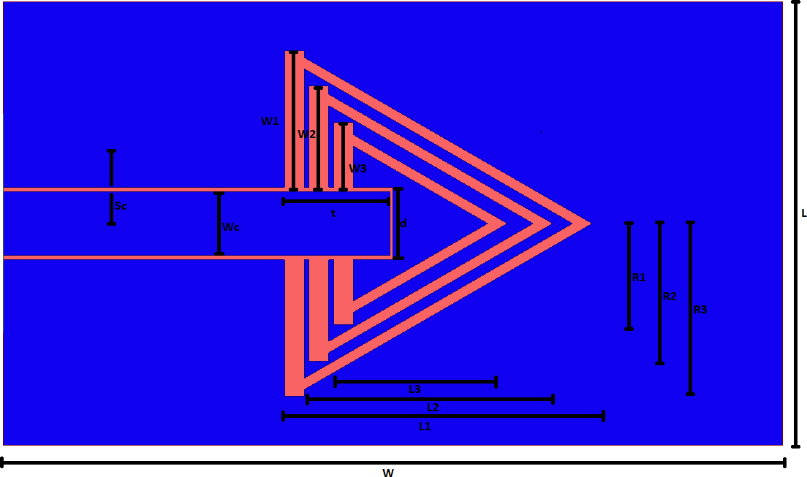

**Fig.4.5** Dimension of proposed antenna

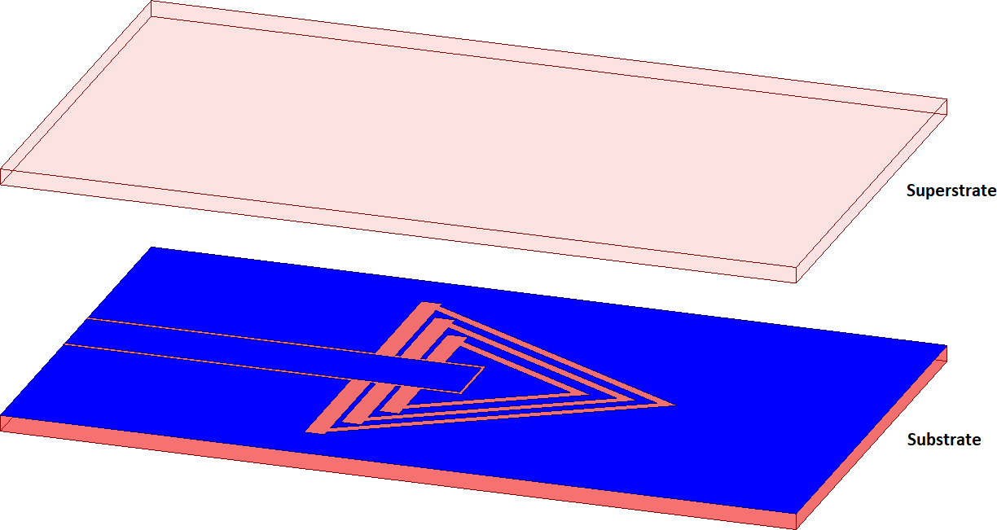

**Fig.4.6** Different layers of antenna

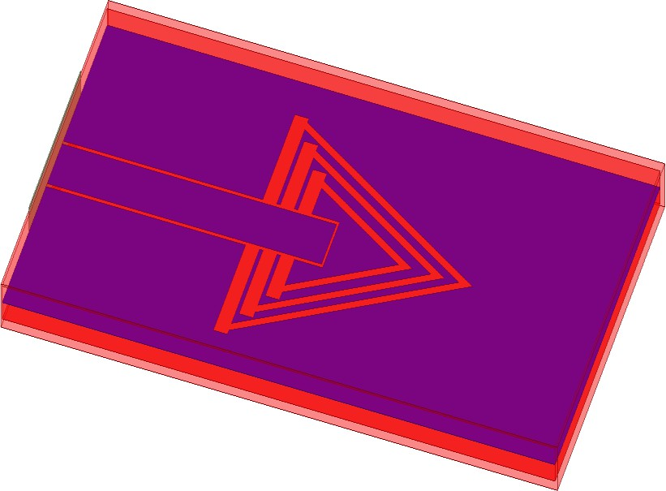

**Fig.4.7** Antenna with Zirconia coating

**Table V. Dimensions of triangular slot antenna**

|  |  |  |
| --- | --- | --- |
| **S.no** | **Proposed antenna** | |
| **Parameters** | **Dimensions** |
| **1.)** | **L1, W1 (mm, mm)** | 35, 22 |
| **2.)** | **L2, W2 (mm, mm)** | 28, 17 |
| **3.)** | **L3, W3 (mm, mm)** | 20.5, 12 |
| **4.)** | **S1, S2, S3 (mm, mm, mm)** | 2, 2, 2 |
| **5.)** | **Tuning Stub (t or Ls) (mm)** | 10.23 |
| **6.)** | **R1, R2 ,R3 (mm, mm, mm)** | 11, 14, 15 |
| **7.)** | **h, Wc, Sc(mm, mm, mm)** | 1.6, 6.4, 0.5 |
| **8.)** | **W × L (mm×mm)** | 45 **×** 79 |

# RESULT AND CONCLUSIONS

* 1. **Result and Discussion for two band circular ring slot biomedical antenna**
     1. **Wideband Return Loss Efficiency**

The Efficiency of the proposed antenna design is evaluated in terms of its wideband return loss features. The operating frequency range for both cortical bone and visceral fat tissues falls within the MedRadio frequency range and ISM bands, as shown in Figure 5.1 and Figure 5.2 respectively. The frequency range spans from 401 MHz to 457 MHz and from 2350 MHz to 3420 MHz, exhibiting variations in electromagnetic Features and antenna Efficiency.

The resonant frequencies, denoted as f1 and f2, are observed for both tissue types, as indicated in Table VI. These resonant frequencies correspond to the frequencies at which the antenna exhibits optimal Efficiency and impedance matching. The presence of resonant frequencies within the desired frequency ranges ensures efficient communication and signal transmission within the body.

Furthermore, the fractional bandwidth for both tissue types is significant. This high fractional bandwidth offers the advantage of using the antenna in harsh conditions inside the body, where signal transmission may encounter various obstacles and challenges. The wide bandwidth enables robust and reliable communication within different tissue environments.

The antenna's efficiency in terms of loss of return is maintained for both cortical bone tissue and visceral fat tissue. This indicates that the The antenna has the ability to operate efficiently across a wide range of tissue types. The ability to maintain consistent return loss Efficiency ensures that the antenna can efficiently transmit and receive signals within different tissues, contributing to reliable and accurate biomedical applications.

In conclusion, the outcomes demonstrate that the proposed antenna design exhibits desirable Efficiency in terms of wideband return loss features. The operating frequencies within the MedRadio and ISM bands, resonant frequencies, and high fractional bandwidth make the antenna suitable for use in various tissue types. The antenna's capability to maintain consistent return loss Efficiency across different tissues enhances its effectiveness and reliability in biomedical applications.

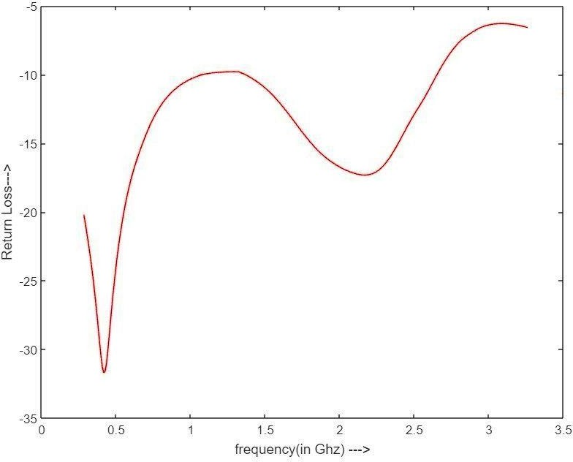

**Fig.5.1** S11 plot for cortical bone tissue

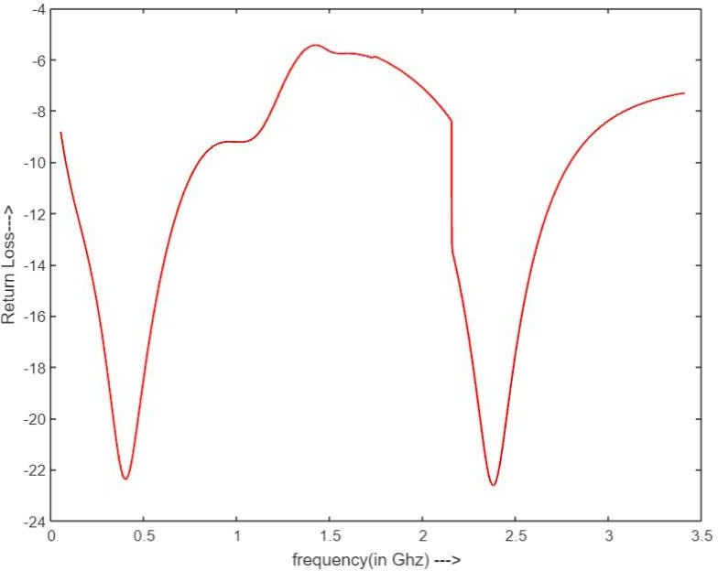

**Fig.5.2** S11 plot for visceral fat tissue

**Table VI. Parameters on human tissue**

|  |  |  |  |
| --- | --- | --- | --- |
| **S.No.** | **Proposed antenna** | | |
| ***Parameters*** | ***Cortical bone*** | ***Visceral fat*** |
| **1** | f1(Mhz) , fractional bandwidth | 401, 1.39 | 403, 1.64 |
| **2** | f2(Mhz) , fractional bandwidth | 2441, 0.38 | 2472, 0.25 |

* + 1. **SAR Efficiency**

The SAR Efficiency of the proposed antenna is evaluated by analyzing the average Specific Absorption Rate (SAR) value. The SAR value indicates Ionising waves refers to the quantity of energy that is taken in by biological tissue during exposure to electromagnetic waves. Compliance with safety standards, such as the limit set by IEEE C95.1-2005, is crucial to ensure the safety of patients.

Upon analysis, it is observed that the average SAR value for the entire region of the antenna is below the limit specified by IEEE C95.1-2005. The SAR value is found to be less than 1.8414 W/kg, as depicted in Figure 5.3. This value is well within the safety limit set by IEEE C95.1- 2005 for 10 grams of tissue.

By adhering to the SAR limits, the proposed antenna design demonstrates its suitability for biomedical applications, ensuring the safety of patients while effectively transmitting and receiving signals within the desired frequency range. The compliance with SAR standards further validates the viability of the antenna for use in implantable devices within the body of human.

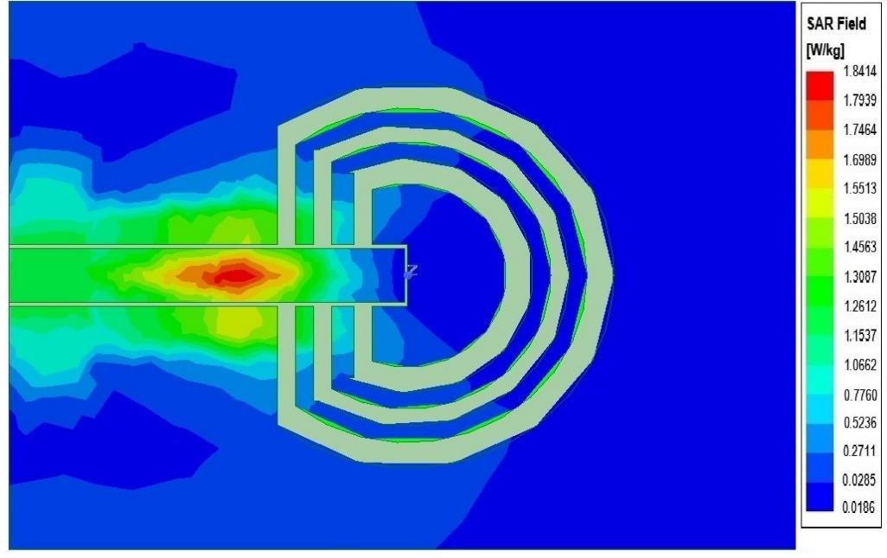

**Fig.5.3** SAR distribution pattern

* + 1. **Bendability**

The bendability of the antenna is a crucial aspect to consider, especially for implantable devices where flexibility is required to accommodate different anatomical structures. Maintaining the same characteristic frequency bands even when the antenna is bent is a significant challenge that needs to be addressed.

In order to evaluate the flexibility of the suggested antenna configuration, tests were conducted using cortical bone tissue and visceral fat tissue as representative mediums. The frequency band Efficiency was evaluated by bending the antenna at different angles as shown in Figure 5.4. It was found that even when bent up to 30 degrees, the frequency bands exhibited minimal deterioration for both cortical bone tissue and visceral fat tissue.

Table VII gives the resonant frequencies and fractional bandwidths for cortical bone tissue and visceral fat tissue. These values indicate the operating frequencies and the bandwidth coverage of the antenna for each tissue type.

Figures 5.5 and 5.6 illustrate the return loss Efficiency of the antenna for cortical bone tissue and visceral fat tissue, respectively. The return loss is a measure of the reflected power from the antenna, and it indicates the antenna's efficiency in transmitting and receiving signals. The plots demonstrate the maintained return loss Efficiency even when the antenna is bent, further confirming its bendability and robustness.

The ability of the antenna to maintain its characteristic frequency bands and return loss Efficiency, even under bending conditions, is crucial for ensuring reliable communication and monitoring within the body of human. This flexibility allows the antenna to conform to the surrounding tissues and organs, enhancing patient comfort and overall Efficiency of implantable devices.

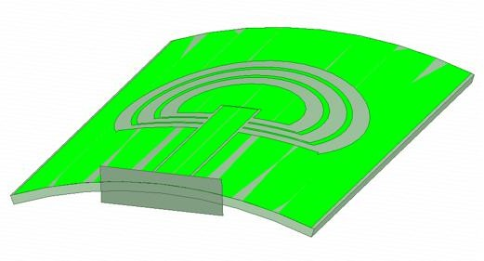

**Fig.5.4** Bended antenna

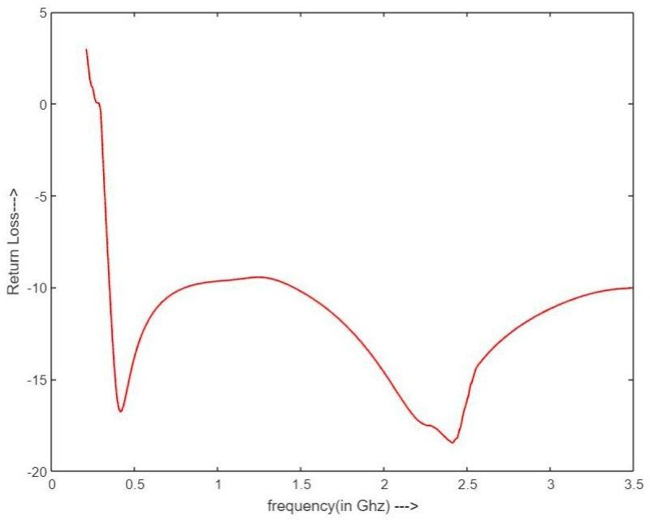

**Fig.5.5 S11 plot after bending for cortical bone**

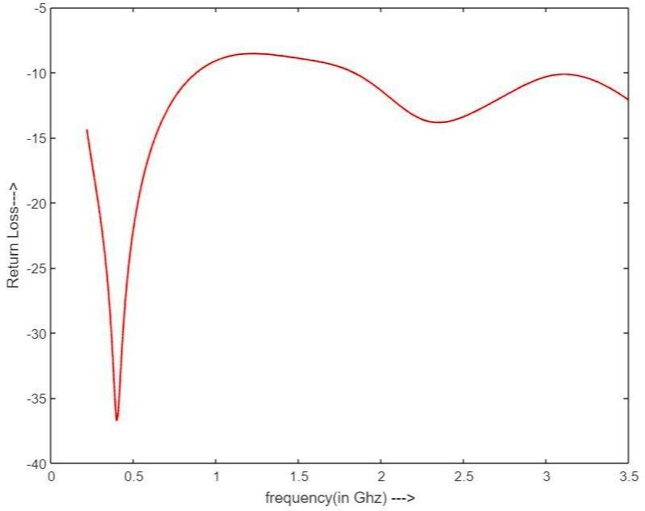

**Fig.5.6** S11 plot after bending for visceral fat

**Table VII.** Parameters after bending

|  |  |  |  |
| --- | --- | --- | --- |
| **S.No.** | **Proposed antenna after bending** | | |
| ***Parameters*** | ***Cortical bone*** | ***Visceral fat*** |
| **1** | f1 (Mhz) , fractional bandwidth | 401, 0.93 | 403, 1.223 |
| **2** | f2 (Mhz) , fractional bandwidth | 2413, 0.72 | 2458, 0.48 |

* 1. **Result and Discussion for two band polygonal ring slot antenna**
     1. **Wideband Return Loss Efficiency**

Based on the obtained outcomes, it is evident that the proposed antenna design operates within the Med Radio frequency range and ISM bands, demonstrating its suitability for implantable applications. The antenna's Efficiency was evaluated both without coating and with a zirconia coating, as depicted in Figure 5.7 and Figure 5.8, respectively. All simulations were conducted within the environment of visceral fat tissue, which is a relevant medium for implantable antennas.

Slight variations in electromagnetic (EM) Features and antenna Efficiency were observed within the frequency range of 401-457 MHz and 2350-3420 for both cases (without coating and with coating). These variations can be attributed to the specific features of the visceral fat tissue and its impact on the antenna's electromagnetic behavior.

Table VIII gives the resonant frequencies (f1 and f2) for the antenna without coating and with coating. These frequencies indicate the specific operating points at which the antenna exhibits maximum efficiency and resonance within the given frequency range. Additionally, the fractional bandwidth for both cases is observed to be high, which is advantageous for implantable antennas as it allows for reliable operation even in harsh conditions within the body of human.

Furthermore, the return loss Efficiency, which reflects the antenna's ability to effectively transmit and receive signals, was found to be well-maintained for visceral fat tissue. This indicates that the antenna is capable of functioning efficiently within different regions of the visceral fat tissue, making it suitable for implantation in various areas of the body of human.

In summary, the findings indicate that the suggested antenna design, both with and without coating, exhibits favourable Efficiency features within the specific environment of visceral fat tissue. These findings support the antenna's potential for serving as an implantable antenna, enabling reliable wireless communication and monitoring within the body of human.

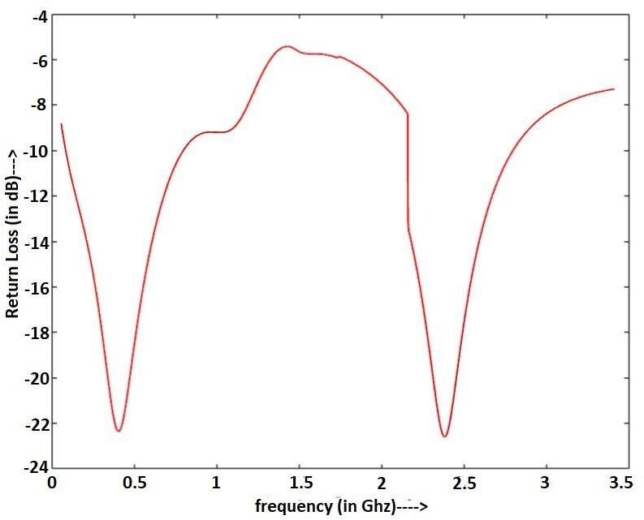

**Fig.5.7** S11 plot without coating

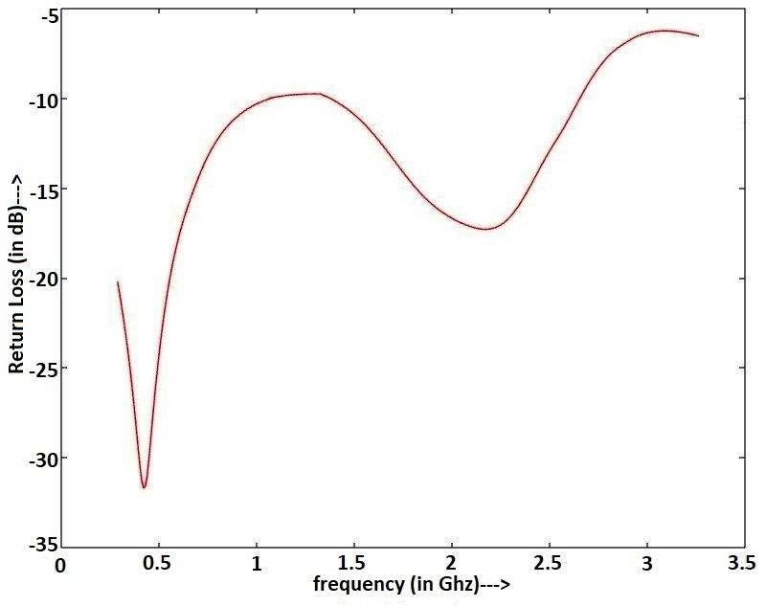

**Fig.5.8** S11 plot with coating

**Table VIII.** Parameters on human tissue

|  |  |  |  |
| --- | --- | --- | --- |
| **S.No.** | **Proposed antenna** | | |
| ***Parameters*** | ***Without coating*** | ***With coating*** |
| **1** | f1(Mhz) , fractional bandwidth | 403, 1.64 | 401, 1.39 |
| **2** | f2(Mhz) , fractional bandwidth | 2472, 0.25 | 2441, 0.38 |

* + 1. **Bendability**

Flexibility is a crucial requirement for implantable antennas as they need to adapt to the dynamic and curved surfaces within the body of human. Maintaining consistent Efficiency, particularly in terms of characteristic frequency bands, even when the antenna is bent poses a challenging barrier. In this study, the bendability of the antenna design was tested to assess its ability to retain its operating features under bending conditions.

The outcomes indicate that both the coated and non-coated antenna designs exhibit minimal deterioration in the frequency bands when subjected to bending up to 30 degrees. Figure 5.9 illustrates the bending of the antenna, highlighting its flexibility and ability to conform to curved surfaces. Table IX presents the resonant frequencies and fractional bandwidths of the antenna after bending, providing insights into its Efficiency under bent conditions.

The return loss Efficiency, which is indicative of the antenna's impedance matching and signal transmission efficiency, was evaluated for both the non-coated and coated designs. Figure 5.10 demonstrates the return loss Efficiency for the antenna without coating, while Figure 5.11 shows the Efficiency for the coated antenna. These figures provide visual representations of the antenna's Efficiency under bent conditions.

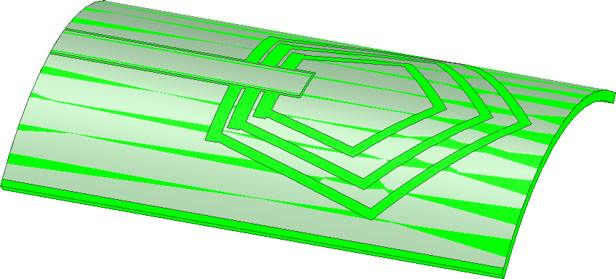

**Fig.5.9** Bended antenna

Overall, the findings suggest that the proposed antenna design maintains its characteristic frequency bands and exhibits satisfactory return loss Efficiency even when subjected to

bending up to 30 degrees. This bendability is a desirable feature for implantable antennas, as it allows for conforming to the contours of different tissues within the body of human while ensuring reliable wireless communication and monitoring capabilities.

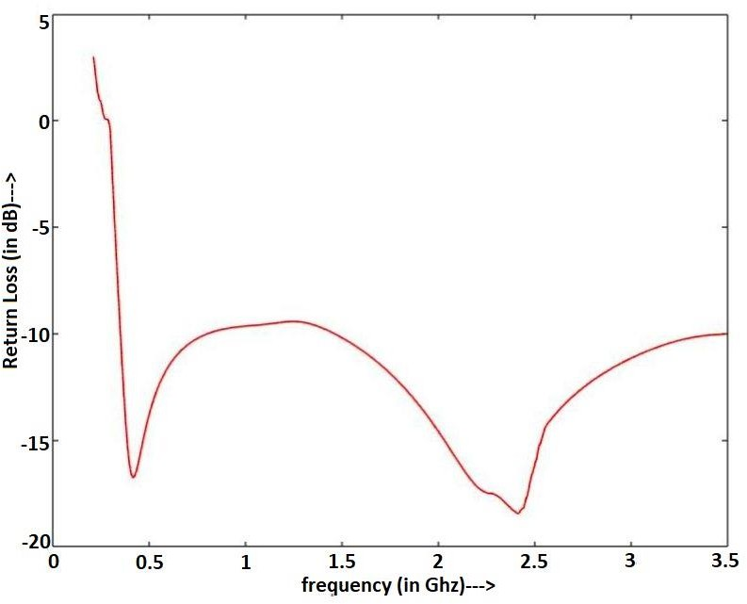

**Fig.5.10** S11 plot without coating after bending

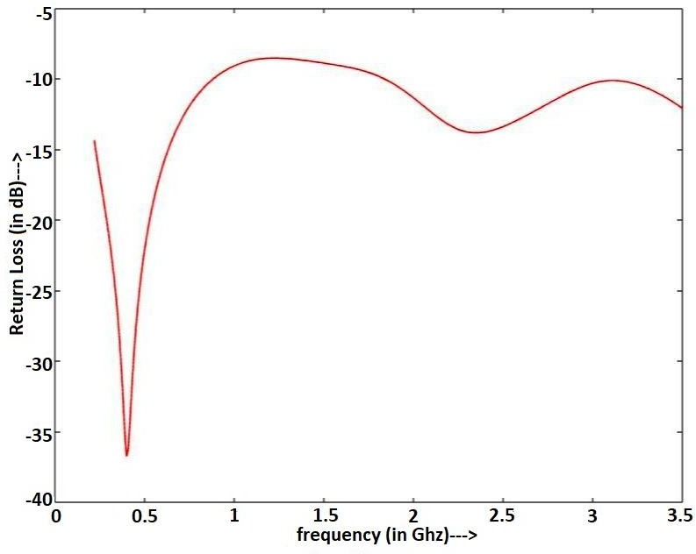

**Fig.5.11** S11 plot with coating after bending

**Table IX.** Parameters after bending

|  |  |  |  |
| --- | --- | --- | --- |
| **S.No.** | **Proposed antenna after bending** | | |
| ***Parameters*** | ***Without coating*** | ***With coating*** |
| **1** | f1(Mhz) , fractional bandwidth | 401, 0.93 | 403, 1.223 |
| **2** | f2(Mhz) , fractional bandwidth | 2413, 0.72 | 2458, 0.48 |

**Conclusions**

In this chapter, we summarize the key findings and conclusions from our study on the proposed unique design of an implantable and conformal antenna. The antenna design was aimed at resolving the challenge of using a single antenna in a wide range of tissues within the body of human. Through extensive analysis and evaluation, we have established the distinctive nature and Efficiency of this antenna design.

First and foremost, the antenna design exhibited perfect return loss Efficiency in both types of tissues, confirming its suitability for implantable applications. This characteristic is crucial for ensuring efficient signal transmission and reception within the body. The antenna's ability to maintain good return loss Efficiency across different tissue types highlights its versatility and effectiveness in a wide range of physiological environments.

Furthermore, the high bandwidth achieved by the antenna design is a significant advantage, enabling its reliable operation in harsh conditions within the body. The antenna demonstrated good response in both the MedRadio band and the ISM band, expanding its usability and compatibility with various medical devices and wireless communication systems. The ability to operate effectively in these frequency bands is essential for enabling seamless communication and monitoring within the body of human.

Safety is a paramount concern when considering implantable devices, and the proposed antenna design addresses this aspect through the evaluation of SAR values. The SAR values obtained for the antenna design were within the limits defined by IEEE standards, ensuring that the antenna operates safely within the body without posing any harm to the surrounding tissues. This compliance with safety standards enhances the antenna's suitability for medical applications, providing confidence in its use for long-term implantation.

Moreover, the flexibility of the antenna design offers great potential for its deployment in various parts of the body. The antenna demonstrated good bendability, allowing it to withstand bending angles of up to 30 degrees without significant deterioration in its characteristic frequency bands. This flexibility opens up opportunities for the antenna to be utilized in different anatomical regions, accommodating the specific requirements of diverse medical applications.

In summary, the proposed unique design of the implantable and conformal antenna has shown exceptional Efficiency and versatility. Its perfect return loss, high bandwidth, compliance with safety standards, and bendability make it a promising candidate for a wide range of tissues within the body of human. The design considerations and techniques employed in this antenna pave the way for advancements in implantable biomedical antennas and contribute to the improvement of biomedical monitoring and medical care outcomes.

# REFERENCES

1. Y. Tanabe, T. Chang, A. J. Yeh, and A. S. Y. Poon, “A small twoband asymmetric dipole antenna for 13.56 MHz power and 2.45 GHz data transmission,” IEEE Antenn. Wireless Propag. Lett., vol. 13, pp. 1120–1123, 2014.
2. Z. Bao, Y. X. Guo, and R. Mittra, “An ultrawideband conformal capsule antenna with stable impedance matching,” IEEE Trans. Antennas Propag., vol. 65, no. 10, pp. 5086 – 5094, Oct. 2017.
3. J. Faerber et al., “In vivo characterization of a wireless telemetry module for a capsule endoscopy system utilizing a conformal antenna,” IEEE Trans. Biomed. Circuits Syst., vol. 12, no. 1, pp. 95–105, Feb. 2017.
4. M. K. Magill, G. A. Conway, and W. G. Scanlon, “Tissue-independent implantable antenna for in-body communications at 2.36–2.5 GHz,” IEEE Trans. Antennas Propag., vol. 65, no. 9, pp. 4406–4417,Sep.2017.
5. S. Bakogianni and S. Koulouridis, “On the design of miniature MedRadio implantable antennas,” IEEE Trans. Antennas Propag., vol. 65, no. 7, pp. 3447–3455,Jul.2017.
6. P. Blanos, "Miniaturization of implantable antennas for medical applications," National Technical University of Athens, School of Electrical & Computer Engineering, 2013.
7. Nicolaos G. alexopoulos and David r. jackson, “Fundamental Superstrate (Cover) Effects on Printed Circuit Antennas,” IEEE Transactions on Antennas and Transmission, vol. AP-32, NO. 8, august 1984.
8. Alvaro Della Bona , Oscar E. Pecho and Rodrigo Alessandretti, “Zirconia as a Dental Biomaterial,” Materials 2015, 8, 4978-499.
9. Igor Kosacki, Toshio Suzuki, Vladimir Petrovsky, Harlan U. Anderson, “Electrical conductivity of nanocrystalline ceria and zirconia thin films,” Solid State Ionics 136–137 (2000) 1225–1233.
10. Jingchen Wang , Mark Leach , Eng Gee Lim, Zhao Wang, Rui Pei , and Yi Huang, “An Implantable and Conformal Antenna for Wireless Capsule Endoscopy,” IEEE Antennas and Wireless Transmission Letters, vol. 17, no. 7, July 2018.
11. A. Kiourti and K. S. Nikita, “A review of implantable patch antennas for biomedical telemetry: challenges and solutions,” IEEE Antennas and Transmission Magazine, vol. 54, no. 3, pp. 210–228, 2012.
12. Akhilesh Verma, Ravi Kumar Arya, Rajarshi Bhattacharya, Srinivasa Nallanthighal Raghava, “Compact PIFA Antenna with High Gain and Low SAR using AMC for WLAN/C- band/5G Applications,” IETE Journal of Research, 2021.
13. Seo, Y., Wang, Z.J. Measurement and evaluation of specific absorption rate and temperature elevation caused by an artificial hip joint during MRI scanning. Sci Rep 11, 1134 (2021).
14. K. A. Psathas, A. Kiourti and K. S. Nikita, "Biocompatibility of implantable antennas: Design and Efficiency considerations," The 8th European Conference on Antennas and Transmission (EuCAP 2014), 2014, pp. 1566-1570.
15. C. Liu, Y. X. Guo, and S. Xiao, “A hybrid patch/slot implantable antenna for biotelemetry devices,” IEEE Antennas Wireless Propag. Lett., vol. 11, pp. 1646–1649, 2012. Mill Valley, CA: University Science, 1989.
16. R. Li and S. Xiao, “Compact slotted semi- circular antenna for implantable medical devic- es,” Electron. Lett., vol. 50, no. 23, pp. 1675– 1677, 2014.