**COAL MINE WORKER SAFETY MONITORING AND ALERTING SYSTEM USING IoT Technology**

1U.Chandra mouli,2M.Namratha,3N.Rahim Kumar ,4U.Teja,5P.Venkata Kalyan,6Dr.Virender Singh

1,2,3,4,5 U.G. Scholar, Department of ECE, N S Raju Institute of Technology, Visakhapatnam, A.P., India

6Assoc. Professor, Department of ECE, N S Raju Institute of Technology, Visakhapatnam, A.P., India

**ABSTRACT:**

**Coal mine safety is a critical issue due to the high-risk nature of mining operations. This paper presents an IoT-based coal mine safety monitoring and alerting system that integrates various sensors and components to ensure real-time monitoring and alerts for hazardous conditions. The system uses an MQ135 sensor for gas detection, DHT11 for temperature and humidity monitoring, Node MCU for IoT connectivity, GSM module for sending SMS alerts, RF module for short-range communication, a buzzer for audible alerts, Arduino Uno as the central controller, a 16x2 LCD display for local information, and Thing Speak for data visualization. The system sends alerts via GSM to a designated number when unsafe conditions are detected, providing real-time data on a Thing Speak webpage for remote monitoring and analysis.**

**Keywords—Internet of Things (IoT) Technology, Sensors, Arduino UNO, Wireless Sensor Network (WSN), Node MCU, Coal Mine Safety, Monitoring, Alerting, Thing Speak.**

**1.INTRODUCTION**

Coal mining involves significant risks, including the accumulation of harmful gases, high temperatures, and humidity, which can lead to dangerous conditions. Traditional safety monitoring methods often lack real-time capabilities and automated alerting, potentially leading to delayed responses in emergencies. This paper describes a system that uses IoT technology to monitor environmental factors and alert stakeholders when safety thresholds are exceeded. With the integration of sensors, GSM communication, and data visualization, the system aims to enhance coal mine safety and reduce the risk of accidents.

**2.LITERATURE SURVEY**

To lessen the possibility of any possible hazards, a system that uses a Low Power Wireless Sensor Network (WSN) to monitor underground coal mines should be built. This system is able to provide an intelligent monitoring and protection unit for underground coal mines through the use of a Zigbee-based wireless sensor network. The system's use of a wireless sensor network makes this unit feasible. The system is composed of

multiple discrete nodes that can establish connections with each other through wireless networks. Once the network is installed and brought online in the mines, underground coal miners are furnished with an efficient safety and monitoring system. Dheeraj et al. introduced a safety system for underground mining workers utilizing Internet of Things (IoT) technology, employing an ESP8266 WiFi chip connected to a microcontroller module. This system integrates three sensors - temperature screening sensors, ultrasonic sensor, and smoke sensor - strategically placed underground for continuous monitoring of environmental conditions. Any deviations trigger alerts to workers and higher authorities, ensuring prompt response to potential hazards . Leveraging IoT and Wireless Sensor Network (WSN) technologies, the recorded data is seamlessly transmitted to cloud storage systems, enabling remote access and real-time monitoring by management personnel.

**3. PROBLEM STATEMENT**

Coal is one of the most significant raw resources and commodities in a variety of industries. It can be utilised for the production of power as well as a variety of by-product chemicals and minerals. Around the world, there are numerous coal mining accidents that result in fatalities and financial losses. Therefore, we can greatly lessen the risks and hazards by utilising the most recent technologies.

**4. EXISTING SYSTEM**

Gas sensors in sensor networks are used to identify dangerous gases like sulphur dioxide, carbon monoxide, and methane. They are dispersed throughout the mine and feed a central monitoring system with real-time data. Temperature and Humidity Sensors Keep an eye on the outside world to guarantee safe working conditions and spot possible hazards like equipment overheating or heatstroke. Dust sensors: Lower respiratory risks by detecting airborne particle matter. Noise sensors: Keep an eye on decibel levels to spot noisy environments that could be harmful to your hearing. Wearable Technology: Vital Signs Monitoring: Wearable technology keeps an eye on employees' body temperatures, heart rates, and other vital signs. Should these measurements go above safe bounds, notifications can be routed to a central monitoring system. Wearables frequently come equipped with panic buttons that employees can use to signal an emergency or ask for help.

**5. PROPOSED SYSTEM**

The proposed IoT miner safety helmet is a state-of-the-art solution designed to improve the safety and well-being of miners working in challenging and potentially hazardous environments. This system integrates key components, including gas sensors, temperature sensors, and MQ135 sensors, along with a GSM module. The GSM module is used to send alert messages to control station workers, as well as to other key contacts such as nearby hospitals, police stations, and fire stations. This feature ensures rapid emergency response in the event of dangerous conditions in coal mines, providing crucial information about the status of underground miners to facilitate their rescue and enhance overall safety.

**6. METHODOLOGY**

The sensors in the helmet collect data and send it to the Arduino Uno board for processing. If any sensor values exceed the programmed threshold, the system triggers an alert. This alert is transmitted to the control station via an RF module, which uses an RF transmitter in the helmet and an RF receiver at the control station. If the sensor values exceed the threshold, the control station activates a buzzer as an audible warning. Additionally, the sensor data from the helmet is sent to the ThingSpeak cloud platform via a NodeMCU module for remote monitoring and analysis. At the control station, which is also based on Arduino Uno, a Bimmediate notification system. Each component, including the helmet and the control station, has its own independent power supply, ensuring continuous operation even in the event of power interruptions or failures.

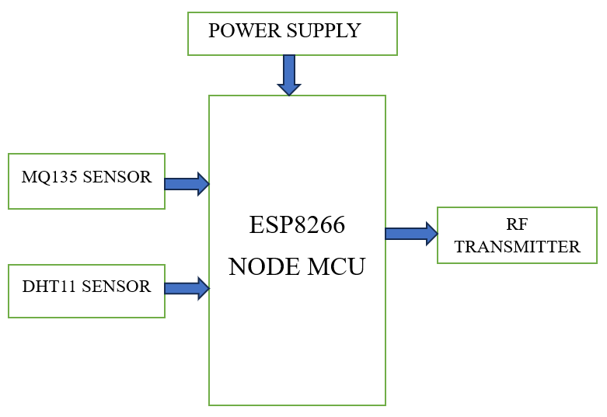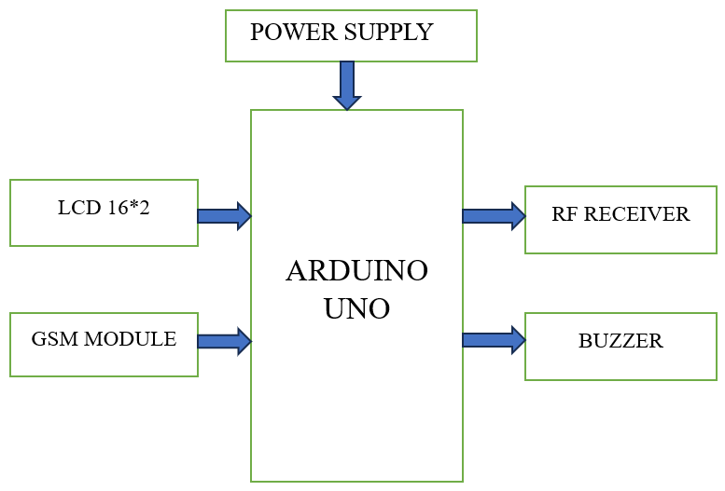

Fig.1 Block diagram for Coal mine worker smart helmet Fig.2 Block diagram for Control station

**7. HARDWARE COMPONENTS**

The system's architecture revolves around real-time monitoring and alerting capabilities. The following components are used:

1. **MQ135 Gas Sensor:** This sensor detects various harmful gases such as methane, ammonia, and benzene. It is crucial for monitoring gas levels in coal mines.
2. **DHT11 Temperature and Humidity Sensor:** This sensor provides real-time data on temperature and humidity, helping identify conditions that may lead to heat-related incidents or equipment failures.
3. **Node MCU:** A microcontroller with integrated Wi-Fi capabilities, allowing for IoT communication and remote monitoring.
4. **GSM Module:** This module sends SMS alerts to a predefined phone number when hazardous conditions are detected.
5. **RF Module:** Provides short-range communication within the system, allowing for additional alerting and integration with other devices.
6. **Buzzer:** An audible alarm that sounds when dangerous conditions are detected, alerting workers and supervisors.
7. **Arduino Uno:** The main control unit responsible for collecting data from sensors, processing information, and triggering alerts**.**
8. **LCD 16** **x 2:** The 16x2 LCD module is a commonly used alphanumeric display with 16 columns and 2 rows, ideal for showing text and basic symbols in electronic projects, controlled by a microcontroller through interface pins.

**8. SOFTWARE USED**

1. **Arduino IDE :** Software for writing, uploading, and managing code on Arduino boards.
2. **Thing Speak Cloud:** Cloud-based platform for collecting, storing, analyzing, and visualizing data from IoT devices

**9. HARDWARE MODEL**

|  |  |
| --- | --- |
|  |  |

Fig.3 Coal mine worker smart helmet Fig.4 Control station for monitoring and alerting

**10. FUTURE SCOPE**

In modern mining operations, the integration of IoT technology offers multifaceted safety benefits. Real-time monitoring and alerts are facilitated through IoT sensors, which continuously gather data on environmental conditions such as temperature, humidity, air quality, and toxic gas levels. This data serves as a crucial early warning system, enabling timely notifications to workers about unsafe conditions or potential dangers, thus allowing for prompt evacuation or mitigation measures. Additionally, wearable IoT devices play a vital role in safeguarding workers by monitoring their vital signs, including heart rate, body temperature, and blood oxygen levels, while also tracking their location within the mine. This real-time health and location data enables rapid response in the event of accidents or health emergencies. Moreover, the wealth of data collected by IoT sensors allows for the application of predictive analytics and machine learning algorithms. By identifying patterns and predicting potential hazards, proactive measures can be implemented to prevent accidents before they occur. Furthermore, IoT facilitates enhanced communication systems within the mine, integrating with smart devices and applications to enable swift and efficient communication between workers and central control, particularly critical during emergency situations. Lastly, IoT technology enables remote control and automation of mining equipment, reducing the need for human presence in hazardous areas and thereby enhancing overall safety measures. Together, these IoT applications significantly contribute to the safety and well-being of mining personnel while optimizing operational efficiency.

**11. RESULTS**

|  |  |
| --- | --- |
|  |  |

Fig.5 Sensor values monitoring from Thing Speak Fig.6 Alert message from GSM Module

**12. CONCLUSION**

Coal mining safety and alert system using Internet of things (IoT) has planned to implement with some hardware setup for who works in a coal mining without any safety measures. From the proposed system, the security and safety monitoring system were implemented with various sensors and microcontrollers for better execution of the results. The proposed research executed successfully with higher accuracy in detection of gas, temperature, humidity, and the data are recorded and converted as electric signal and transferred to the mine workers to alert them and also higher officials at monitoring workstation also receive the same using WSN and IOT for faster protection in early stage. In future research, have to enhance the communication disconnection due to signal loss under tunnel. As a consequence of this, contemporary mining operations have an obligation to place a high priority on the safety of their workforce and mining infrastructure. The safety of coal mine employees is continuously monitored, and any new findings are uploaded to an Internet of Things (IoT) platform utilizing data obtained from sensors such as Arduinos and detectors of gas, temperature, and humidity. When this tactic is used, it ensures that workers are kept safe from danger.

**13. REFERENCES**

|  |
| --- |
| 1. T. Thilagavathi, "Internet of Things Based Coal Mine Safety Monitoring and Alerting System," *International Journal of Research in Engineering, Science and Management*, vol. X, no. Y, 2023, DOI: 10.5281/zenodo.98549498 2. J. Pudke, S. N. Bhagat, and S. L. Nalbalwar, "LabVIEW Based Coal Mine Monitoring and Alert System with Data Acquisition," *Journal of Electronics and Telecommunication Engineering*, Dr. Babasaheb Ambedkar Technological University, Maharashtra, India, 2023. 3. Nagarajapandian M,Ishana A, Jeevika K "Health & Environment Monitoring and Alerting System for Mine Workers: From Proof of Concept to Experimental Validation," in *Proceedings of IEEE Conference*, ISBN 979-8-3503-3331-2, 2023. 4. Srivastav, S. Shrivastava, and A. Kumar, "Coal Mine Safety Monitoring and Alerting System," Electrical Engineering Department, SRMCEM, Lucknow, India, 2023. 5. K. Chaitanya Varma and C. V. V. S. Srinivas, "A Wearable Alert System for Underground Mining Workers based on Arduino with GSM," Department of ECE, Vishnu Institute of Technology, Bhimavaram, India, 2023. 6. R., H. R. Varunkumar, K. B. Y., and P. R., "Coal Mine Safety Monitoring and Alerting System," Department of Electronics and Communication Engineering, Dr. Ambedkar Institute of Technology, Bengaluru, Karnataka, India, 2023. 7. T. Manasa, J. Kadali, N. Syed, G. K. Raju, and K. Jamal, “IoT based coal mine safety monitoring and warning system,” in 2022 Sixth International Conference on I-SMAC (IoT in Social, Mobile, Analytics and Cloud) (I-SMAC), IEEE, 2022, pp. 11–15. 8. W. Chen and X. Wang, “Coal mine safety intelligent monitoring based on wireless sensor network,” *IEEE Sensors Journal*, vol. 21, no. 22, pp. 25 465–25 471, 2020. 9. M. Shakunthala, C. Raveena, and B. Saravanan, "IOT Based Coal Mine Safety Monitoring and Controlling," *Annals of R.S.C.B*, vol. 25, no. 4, 2021. 10. S.U. Suganthi and G. Valarmathi, "Coal mine safety system for mining workers using LORA and WUSN," in *Materials Today: Proceedings*, 2021. 11. H. Ansari and K. Shaikh, "IOT Based Coal Mine Safety Monitoring and Alerting System," *International Journal of Scientific Research in Science, Engineering and Technology*, 2021. 12. T. M. S. Sri and K. K. Kumar, "Design and development of coal mine safety system using wireless technology," *International Journal of Research*, 2020. 13. D. Kavitha et al., "Safety monitoring system in mining environment using IoT," in *Journal of Physics: Conference Series*, vol. 1724, no. 1, IOP Publishing, 2021. |