**AN ANALYSIS ON INTERNATIONAL LOGISTICS OPERATION AT SASHMA GLOBAL PRIVATE LIMITED , CHENNAI**

Bhuvankumar A, MBA (SLM),

Dr.D.Anitha Kumari, Assistant Professor

SCHOOL OF MANAGEMENT STUDIES ,

VELS INSTITUTE OF SCIENCE TECHNOLOGY AND ADVANCED STUDIES (VISTAS), CHENNAI – 600117.

**ABSTRACT**

In the global economy, international logistics operations are essential because they make it easier for commodities to flow across borders and link markets all over the world. In order to improve productivity and competitiveness in the fast-paced corporate world of today, this abstract examines important tactics for improving international logistics operations. It looks at the difficulties and complications involved in handling supply chain visibility, inventory management, transportation, and customs clearance on a worldwide basis. The concept promotes creative ways to reduce risks and streamline operations, such supply chain collaboration, digitization, and sustainability efforts. It does this by drawing on best practices and new trends. Through the implementation of a comprehensive strategy that incorporates technology, data analytics, and strategic alliances, companies may discover novel avenues for expansion and collaboration.

1. **INTRODUCTION**

International logistics operations involve the planning, execution, and management of the movement of goods, services, and information across borders. This complex process encompasses various activities, such as transportation, customs clearance, warehousing, and distribution. Cross-border transportation of products, services, and information must be planned, carried out, and managed as part of international logistics operations. This intricate procedure includes a number of tasks, including distribution, warehousing, shipping, and customs clearance. In order to assure the timely and economical flow of goods, effective international logistics is essential to global supply chain management. These operations are made more difficult by elements like cultural diversity, regulatory compliance, and a variety of transportation options. Successful worldwide coordination of these activities demands a strategic strategy.Worldwide logistics operations are essential to enabling worldwide trade and business in today's linked globe. The competitiveness is determined by the efficiency and efficacy of logistics operations, which span from the transportation of raw materials to the delivery of completed items. For companies involved in international commerce, timely delivery, cost-effectiveness, and customer happiness depend heavily on the successful management of international logistics. It entails negotiating a variety of obstacles, including inconsistent laws, cultural disparities, distance, and different forms of transportation. Strategic planning, coordination, and the frequent use of partnerships and technology to streamline operations and get around obstacles are all necessary for successful international logistics operations. Businesses may increase productivity, save expenses, and obtain a competitive advantage in the global market by putting best practices into effect.

**OBJECTIVE OF THE STUDY**

* To examine Supply Chain Efficiency and optimization
* To analyse the standardized managing inventory
* To study strong partnerships with global suppliers and distributors
* To determine lead times in exporting cargos
* To study and analyse the strategies for reducing the transportation costs of supplying goods.

**NEED OF THE STUDY**

Understanding international logistics operations is essential due to the interconnectedness of the current global economy. Good logistics are critical for companies managing complex supply chains that span several countries and continents. With a strong grasp of international logistics, businesses can ensure on-time product delivery, optimize transportation routes, and save costs. International logistics also necessitates compliance with several laws and unique customs procedures for each country. It is important to comprehend these regulations in order to avoid supply chain disruptions, penalties, and delays. Furthermore, effective logistics management lowers the risk associated with natural catastrophes, transportation delays, and geopolitical instability. To put it simply, an understanding of international logistics operations is essential for companies looking to succeed in the global economy. It gives them the information and abilities they need. Companies trade internationally to gain access to new markets, get supplies, save expenses, or strengthen their positions in the market. Doing business internationally, however, comes with challenges because of distance, various legal frameworks, cultural variances, and disparate transportation systems. The global economy is intertwined, making it necessary for enterprises to effectively manage the challenges of cross-border commerce in order to maintain growth and competitiveness. This calls for the necessity for international logistics operations. Supply chain management requires international logistical operations, which include sourcing, manufacturing, shipping, warehousing, and distribution. These activities are coordinated and integrated. By facilitating the smooth movement and coordination of goods and materials across widely separated sites, they maximize the effectiveness and agility of the supply chain. technological developments like digitization and the Internet of Things.

**SCOPE OF THE STUDY**

The project represents and emphasizes how international logistics operations, which involve the transfer of resources, information, and items across national borders, entail a variety of activities and procedures. The storage, handling, and delivery of items at different points in the supply chain are the main objectives of warehousing and distribution activities in international logistics operations. The paperwork, declaration, and processing of products via customs checkpoints at international borders are essential elements of international logistics operations, including customs clearance and compliance activities. The goals of supply chain visibility and information management are to improve communication, cooperation, and transparency throughout the network of supply chains. In international logistics operations, risks that might impair business operations or disrupt supply chain operations are identified, evaluated, and mitigated through risk management and compliance activities.

**STATEMENT OF THE PROBLEM**

The complex interconnectivity of international commerce and transportation networks presents a multitude of obstacles for international logistics operations. Navigating the intricate network of import/export limitations, customs laws, and trade obstacles between nations is one of the biggest challenges. This calls for painstaking attention to detail and frequently leads to delays, extra expenses, and problems with compliance. Inadequate infrastructure, crowded ports, and shaky transportation networks can also make these inefficiencies and delays worse, impeding the efficient cross-border movement of commodities. Additionally, it is difficult to trace shipments in real time, predict interruptions, and react quickly to problems due to the absence of real-time visibility and tracking capabilities throughout the supply chain.   
International logistics operations face several obstacles due to the complexity of customs and differing rules, necessitating careful navigation and compliance to assure seamless.

1. **REVIEW OF LITERATURE**

Many corporations have already started making significant adjustments to their foreign distribution systems, and more extensive ones are probably on the horizon. International shippers will have new chances to rethink their current distribution routes in an effort to cut order cycle days and shipment costs because to the recent deregulation of US ocean liner firms. Furthermore, it is evident that for many businesses, international logistics will play a bigger role in the physical distribution function as the US continues to transition to a technology and service-based economy, which suggests that it will produce fewer goods domestically and import more from abroad.There is pressure on shipping companies to increase the geographic scope of their offerings and make investments in value-added services. The former, discussed by several logistics businesses. implementation of the logistical technique in the global network for freight transportation. Intense competition in the transportation sector necessitates a thorough evaluation and the adoption of novel strategies for logistics firms and commercial organizations engaged in products marketing. Producers and trading businesses are compelled to increase their trade and economic relationships with other areas in order to sustain the amount of domestic sales and production to the external one. Establishing free trade and economic ties has become much easier with the integration of the global economy and policy orientation of foreign trade toward free trade; the only remaining question is how quickly and efficiently, at the lowest possible cost, it is necessary to place the goods in the right region for the customer. Globalization is becoming more and more profits.

1. **METHODOLOGY**

Methodology is a systematic approach to solving the research problem. It can be conducted as a science as research is done scientifically. The research methodology is very essential to collect information. In a descriptive composition, a researcher is solely interested in describing the situation or case under their research study. It is a theory-based design method created by gathering, analyzing, and presenting collected data. This allows a researcher to provide insights into the why and how of research. Descriptive design helps others better understand the need for the research. If the problem statement is not clear, you can conduct exploratory research.

In survey research, sampling is the process of using a subset of a population to represent the whole population. Sampling allows large-scale research to be carried out with a more realistic cost and time frame because it uses a smaller number of individuals in the population to stand in for the whole. However, when you decide to sample, you take on a new task. You have to decide who part of your sample is and how to choose the people who will be represent the whole population. How you go about that is what the practice of sampling is all about.

1. **DATA COLLECTION METHOD**
2. **Primary Data Collection**

* Surveys and Questionnaires
* Interviews
* Observations
* Experiments

1. **Secondary Data Collection**

* Published Sources
* Online Databases
* and Institutional Records
* Government Publicly Available Data
* Past Research Studies

1. **Limitation of the Study**

* The study may be limited to specific geographic region and company which may not be representatives of the global market this can limit the generalizability of the findings and conclusions of the study
* Period of study was restricted to three months
* Findings of the exploration may change because of age, work experience, designation and so on
* Since logistics and shipping company has less no. of employee it is difficult to collect the required samples
* Proper data were not provided from the side of organization as it is confidential.
* The study is based on the data collected from respondents and a journal hence the reliability of the data is not probed into. Utmost care has to be taken while extending the results to the other areas**.**
* Since logistics and shipping company has less no.of employee it is difficult to collect the required sample.

**Tables and Chart Analysis**

**TABLE – 1**

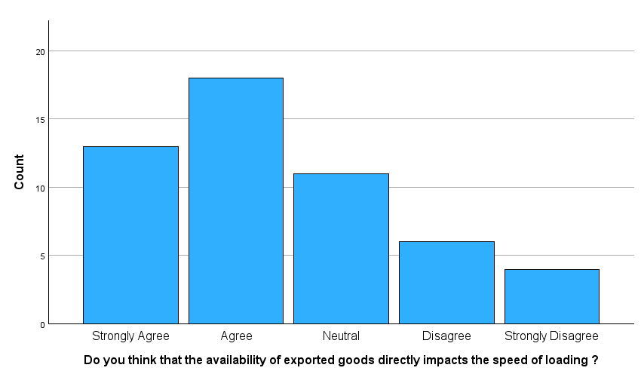

|  |  |  |
| --- | --- | --- |
| **STATEMENT** | **RESPONSES** | **PERCENTAGE** |
| STRONGLY AGREE | 13 | 24.07% |
| AGREE | 20 | 37.03% |
| NEUTRAL | 11 | 20.37% |
| DISAGREE | 6 | 11.11% |
| STRONGLY DISAGREE | 4 | 7.42% |

**Interpretation:**

From this table, it seems that a significant portion of respondents either agree or strongly agree with the statement, while a smaller percentage are neutral, disagree, or strongly disagree. This table provides insights into the distribution of responses and the level of agreement or disagreement among the respondents regarding the statement.

Top of Form

**TABLE -2**

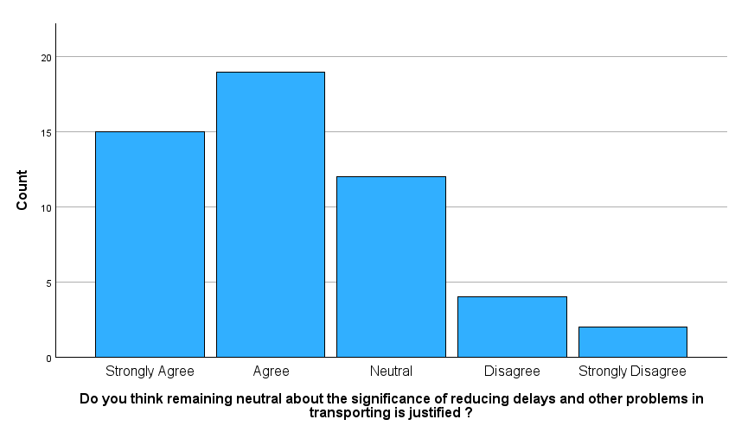

|  |  |  |
| --- | --- | --- |
| **STATEMENT** | **RESPONSES** | **PERCENTAGE** |
| STRONGLY AGREE | 15 | 27.77% |
| AGREE | 20 | 37.03% |
| NEUTRAL | 13 | 24.07% |
| DISAGREE | 4 | 7 .40% |
| STRONGLY DISAGREE | 2 | 3.73% |

**Interpretation:**

From this table, it appears that a significant portion of respondents either agree or strongly agree with the statement, while a smaller percentage are neutral, disagree, or strongly disagree. This table provides insights into the distribution of responses and the level of agreement or disagreement among the respondents regarding the statement.

Top of Form

**Findings**

* The majority of the respondent are saying facing a problem is neutral
* The majority of the respondent are saying facing issues and delays are neutral.

**Suggestions**

**Quantitative Analysis of Operational Delays:** Conducting a detailed study on the specific causes of operational delays could help in identifying targeted improvements in logistics management.

**Customer Satisfaction Surveys:** Regular, detailed customer satisfaction surveys could help track changes in userperceptions over time and identify new areas.

1. **CONCLUSION**

In conclusion, a comprehensive analysis of international logistics operations can provide insights into their strengths, weaknesses, opportunities, and threats. International logistics operations involves synthesizing various factors such as efficiency, effectiveness, cost-effectiveness, risk management, and customer satisfaction. Drawing conclusions based on this analysis can inform strategic decision-making and identify areas for improvement to optimize performance and achieve business objectives.The use of technology such as tracking systems, inventory management software, and data analytics can significantly enhance the efficiency and visibility of international logistics operations. This study has been undertaken to understand the overall effectiveness of the stevedoring in import at Sashma Global Pvt.Ltd . For this purpose, responses from the employees have been collected and analyzed. Based upon the findings out of the research, few valuable suggestions have been given to the management of Sashma Global Pvt.Ltd to improve the overall effectiveness of the stevedoring in import at Sashma Global Pvt.Ltd.The export operation in International Logistics is an important aspect of the global business industry. Iron ores is a critical component in the production of tools , spare parts and steel-based products, and exporting it allows for the efficient distribution of resources across different regions of the world. However, there are also potential risks and challenges associated with exporting such as damages handling and the need to comply with various regulatory requirements.