**SENTIMENT ANALYSIS of NEWS HEADLINES OF STOCK**

*Ashwani Kumar Akela Kunal Jain*

*MIT Art,Design and Technology MIT Art,Design and Technology*

*University ,Pune University ,Pune*

[*ashwanikrakela9@gmail.com*](mailto:ashwanikrakela9@gmail.com)[*kunal947026@gmail.com*](mailto:kunal947026@gmail.com)

*Tejas Mandavakar Harsh Kabir*

*MIT Art Design and Technology MIT Art Design and Technology*

*University ,Pune University,Pune*

*harshkabir101@gmail.com* [*Tejasmandavakar39@gmail.com*](mailto:Tejasmandavakar39@gmail.com)

Abstract —

Modern technological era has reshaped traditional lifestyle in several domains. The medium of publishing news and events has become faster with the advancement of Information Technology (IT). IT has also been flooded with immense amounts of data, which is being published every minute of every day, by millions of users, in the shape of comments, blogs, news sharing through blogs, social media micro-blogging websites and many more. Manual traversal of such huge data is a challenging job; thus, sophisticated methods are acquired to perform this task automatically and efficiently. News reports events that comprise of emotions – good, bad, neutral. Sentiment analysis is utilized to investigate human emotions (i.e., sentiments) present in textual information. This paper presents a lexicon-based approach for sentiment analysis of news articles. The experiments have been performed on BBC news dataset, which expresses the applicability and validation of the adopted approach

Abstract Social networking platforms have become an essential means for communicating feelings to the entire world due to rapid expansion in the Internet era. Several people use textual content, pictures, audio, and video to express their feelings or viewpoints. Text communication via Web-based networking media, on the other hand, is somewhat overwhelming. Every second, a massive amount of unstructured data is generated on the Internet due to social media platforms. The data must be processed as rapidly as generated to comprehend human psychology, and it can be accomplished using sentiment analysis, which recognizes polarity in texts. It assesses whether the author has a negative, positive, or neutral attitude toward an item, administration, individual, or location. In some applications, sentiment analysis is insufcient and hence requires emotion detection, which determines an individual’s emotional/mental state precisely. This review paper provides understanding into levels of sentiment analysis, various emotion models, and the process of sentiment analysis and emotion detection from text. Finally, this paper discusses the challenges faced during sentiment and emotion analysis

Keywords Afective computing · Natural language processing · Opinion mining · Pre-processing · Word embedding

INTRODUCTION

With the emergence of the Internet, web and mobile technologies, people have changed their way of consuming news. Traditional physical newspapers and magazines have been replaced by virtual online versions like online news and weblogs. Readers are more inclined to use online sources of news mainly due to two key features: interactivity and immediacy [1]. In this day and age, people want to consume as much news, from as many sources, as they possibly can, on matters that are important to them or matters that catch their attention. Interactivity refers to the inherent tendency depicted by the masses that makes them consume news of their interest. Immediacy is a feature that represents the need of people to be informed about news with no delay in time [2]. The world we live in and the technology we are accustomed to, allows people to benefit from these features by providing them instant news on events as they happen in real-time. Online news websites have developed effective strategies to draw peoples’ attention [3]. Online news expresses opinions regarding news entities, which may comprise of people, places or even things, while reporting on events that have recently occurred [4]. For this reason interactive emotion rating services are offered by various channels of several news websites, i.e., news can be positive, negative or neutral [5]

Sentiment Analysis or Opinion Mining is a way of finding out the polarity or strength of the opinion (positive or negative) that is expressed in written text, in the case of this paper – a news article [3] [4]. Manual labelling of sentiment words is a time-consuming process. There are two popular approaches that are utilized to automate the process of sentiment analysis. The first process makes use of a lexicon of weighted words and the second process is based on approaches of machine learning. Lexicon based methods use a word

stock dictionary with opinion words and match given set of words in a text for finding polarity. As opposed to machine learning methods, this approach does not need to preprocess data not does it have to train a classifier [6]. This research is based on a method for Lexicon-based sentiment analysis of news articles The remainder of this paper is organized as follows: Section II presents related work conducted in sentiment analysis for news articles. Section III presents the proposed methodology and experiment setup of this paper. Results have been presented in Section IV followed by limitations of the research in Section V. Finally, Section VI presents the conclusion of this research.

Human language understanding and human language generation are the two aspects of natural language processing (NLP). The former, however, is more difficult due to ambiguities in natural language. However, the former is more challenging due to ambiguities present in natural language. Speech recognition, document summarization, question answering, speech synthesis, machine translation, and other applications all employ NLP (Itani et al. 2017). The two critical areas of natural language processing are sentiment analysis and emotion recognition. Even though these two names are sometimes used interchangeably, they differ in a few respects. Sentiment analysis is a means of assessing if data is positive, negative, or neutral. In contrast, Emotion detection is a means of identifying distinct human emotion types such as furious, cheerful, or depressed. “Emotion detection,” “affective computing,” “emotion analysis,” and “emotion identification” are all phrases that are sometimes used interchangeably (Munezero et al. 2014). People are using social media to communicate their feelings since Internet services have improved. On social media, people freely express their feelings, arguments, opinions on wide range of topics. In addition,

many users give feedbacks and reviews various products

and services on various e-commerce sites. User's ratings and reviews on multiple platforms encourage vendors and service providers to enhance their current systems, goods, or services. Today almost every industry or company is undergoing some digital transition, resulting in vast amounts of structured and unstructured increase data. The enormous task for companies is to transform unstructured data into meaningful insights that can help them in decision-making (Ahmad et al. 2020) For instance, in the business world, vendors use social media platforms such as Instagram, YouTube, Twitter, and Facebook to broadcast information about their product and efficiently collect client feedback (Abdelhadi and Sialadenitis 2021). People’s active feedback is valuable not only for business marketers to measure customer satisfaction and keep track of the competition but also for consumers who want to learn more about a product or service before buying it. Sentiment analysis assists marketers in understanding their customer's perspectives better so that they may make necessary changes to their products or services (Jang et al. 2013; Al Ajrawi et al. 2021). In both advanced and emerging nations, the impact of business and client sentiment on stock market performance may be witnessed. In addition, the rise of social media has made it easier and faster for investors to interact in the stock market. As a result, investor's sentiments impact their investment decisions which can swiftly spread and magnify over the network, and the stock market can be altered to some extent (Ahmed 2020). As a result, sentiment and emotion analysis has changed the way we conduct business (Bhardwaj et al. 2015). In the healthcare sector, online social media like Twitter have become essential sources of health-related information provided by healthcare professionals and citizens. For example, people have been sharing their thoughts, opinions, and feelings on the Covid-19 pandemic (Garcia and Berton 2021). Patients were directed to stay isolated from their loved ones, which harmed their mental health. To save patients from mental health issues like depression, health practitioners must use automated sentiment and emotion analysis (Singh et al. 2021). People commonly share their feelings or beliefs on sites through their posts, and if someone seemed to be depressed, people could reach out to them to help, thus averting deteriorated mental health conditions. Sentiment and emotion analysis plays a critical role in the education sector, both for teachers and students. The efficacy of a teacher is decided not only by his academic credentials but also by his enthusiasm, talent, and dedication. Taking timely feedback from students is the most effective technique for a teacher to improve teaching approaches (Sangeetha and Prabha 2020). Open-ended textual feedback is difficult to observe, and it is also challenging to derive conclusions manually. The findings of a sentiment analysis and emotion analysis assist teachers and organizations in taking corrective action. Since social site's inception, educational institutes are increasingly relying on social media like Facebook and Twitter for marketing and advertising purposes. Students and guardians conduct considerable online research and learn more about the potential institution, courses and professors. They use blogs and other discussion forums to interact with students who share similar interests and to assess the quality of possible colleges and universities. Thus, applying sentiment and emotion analysis can help the student to select the best institute or teacher in his registration process (Archana Rao and Bag Lodi 2017). Sentiment and emotion analysis has a wide range of applications and can be done using various methodologies. There are three types of sentiment and emotion analysis techniques: lexicon based, machine learning based, and deep learning based. Each has its own set of benefits and drawbacks. Despite different sentiment and emotion recognition

techniques, researchers face significant challenges, including dealing with context, ridicule, statements conveying several emotions, spreading Web slang, and lexical and syntactical ambiguity. Furthermore

because there are no standard rules for communicating feelings across multiple platforms, some express them with incredible effect, some stifle their feelings, and some structure their message logically. Therefore, it is a great challenge for researchers to develop a technique that can efficiently work in all domains. In this review paper, Sect. 2, introduces sentiment analysis and its various levels, emotion detection, and psychological models. Section 3 discusses multiple steps involved in sentiment and emotion analysis, including datasets, preprocessing of text, feature extraction techniques, and various sentiment and emotion analysis approaches. Section 4 addresses multiple challenges faced by researchers during sentiment and emotion analysis. Finally, Sect. 5 concludes the work

**RELATED WORK**

Many researchers have contributed in news sentiment analysis using different approaches. A brief discussion on the work done previously on sentiment analysis is provided in this section. Reis, Olmo Benevenuto, Prates and An proposed a methodology to discover the relationship between sentiment polarity and news popularity [3]. Using different sentiment analysis methods, an experiment was conducted by utilizing the content of 69,907 headlines generated by four most reputed media corporations –The New York Times, BBC, Reuters, and Daily mail. Extracting features from text of news headlines, the research analysed the sentiment polarity of these headlines. The research concluded that the polarity of the headline had a great impact on the popularity of the news article. The research found that negative and positive news headlines gained greater interest than news headlines that had a neutral tone. Godbole, Srinivasa, and Sekine built an algorithm based on sentiment lexicons which could help in finding the sentiment words and entities associated in the text corpus of news and blogs by looking at the co-occurrence of entity and sentiment word in the same sentence [4]. Seven dimensions comprising of general, health, crime, sports, business, politics, and media were selected for sentiment analysis from news and blogs. Two trends were analysed in the experiment - 1) Polarity: sentiment associated with entity is positive or negative and 2) Subjectivity: how much sentiment an entity garner. Score for both polarity and subjectivity were calculated. Islam, Ashraf, Abir and Mottaki proposed an approach to classify online news. Sentiment analysis was done at sentence level and a dynamic dictionary with predefined positive and negative words was used to get help for finding sentiment polarity [6]. Following steps was carried out for news article classification. 1) Selection of an online news article. 2) Extraction of sentences from the news articles. Sentences can be simple, compound, complex and compound complex. 3) Search for positive words, phrases or clauses in those sentences and finding their polarities. 4) Combining the polarities of all sentences to get the final polarity of news article. 91% accurate results were collected for classification of news articles. Meyer, Bikash, Dai performed fine grained sentiment analysis of financial news headline using machine learning approach and lexicon-based approach. A total of eight experiments were conducted to find more accurate results. Results from both approaches were also compared [8]. For lexicon-based approach, Bag of Words (BOW) model along with General Inquirer Lexicon (H4N) was used to determine sentiment polarities. For machine learning approach, Parts of Speech (POS) syntactic model was used. In the experiments concluded that more accurate results were obtained by using machine learning approach. Shiras, Jagdale, and Deshmukh proposed a methodology for sentiment analysis on document level so that polarity of an entire news article could be determined [9]. The paper explored a dataset of 2225 documents. After text pre-processing through tokenization, stop word removal and stemming, post-processing was done on the entire news article. In this step the sentiment score of the article was assigned based on this sentiment score. The news articles were categorized as positive, negative or neutral. Agarwal, Sharma, Sikka and Dhir performed opinion mining using python packages to classify words and Senti -WordNet 3.0 to identify the positive and negative words so that total impact i.e. positive or negative sentiment in news headline can be evaluated [10]. The impact of news headlines has been analysed using two algorithms. Algorithm 1: Preprocessing of each word Select news headline, then pre-process each word in it using POS tagger and perform Lemmatization, and Stemming. This is done using Natural Language Tool Kit (NLTK).

**Algorithm 2:**

Analysing news headlines After pre-processing pass each word in to Senti WordNet 3.0 dictionary to find positive, negative, and objective scores. If positive score negative score then marks news headline as positive. And if positive score < negative score then marks news headline as negative. Lei, Rao, Li, Quan, and Wenyen have built a model for detecting social emotions induced by news articles, tweets etc. [11]. The model comprises of modules for document selection, tagging of parts of speech, and lexicon generation based on social emotions. This model first creates a training set from corpus of news documents then applies techniques of POS tagging and feature extraction. After this step social emotion lexicons have been generated through calculation of the probabilities of the emotions based on the document. To test the accuracy of the model, a dataset of 40,897 news articles collected from the societal channel has been used.

**RESEARCH METHODOLOGY**

The methodology used for sentiment analysis of news articles in this paper is based on the Lexicon-based approach. Sentiment analysis can generally be carried out using supervised or unsupervised approaches. A supervised approach comprises of a set of labelled training data that is used to build a classification model with the intent of using this model to classify new data for which labels are not present. Unsupervised or Lexicon-based approaches to sentiment analysis do not require any training data. In this approach, the sentiments conveyed by a word are inferred on grounds of the polarity of the word. In case of a sentence or a document, the polarities of the individual words that compose the document collectively convey the sentiment of the sentence or the document. Thus, the polarity of a sentence is the accumulative total (sum) of polarities of the individual words (or phrases) in the sentence [12]. This approach utilizes some predefined lists of words such that each word in the list is associated with a specific sentiment. Further this approach can use the following methods: 1. Dictionary-based methods: in these methods’ lexicon dictionary is used to find out the positive opinion words and negative opinion words. 2. Corpus-based methods: in these methods large corpus of words is used and based on syntactic patterns other opinion words can be found within the context. Sentiment analysis can be done on document level, sentence level, word level or phrase level. This paper explores sentiment analysis on the document level. Like [13] [14], this research identifies whether the documents new articles expressed opinions are positive, negative, or neutral. The dictionary-based approach has been used for sentiment analysis of news articles utilizing the word Net lexical dictionary. The experiment for this research was carried out using the Rapid Miner tool. The methodology for this experiment has been presented in Fig.1.

The methodology comprised of 5 steps, starting with data collection. The BBC News dataset has been used for this experiment. The next step was preprocessing the collected data to reduce inconsistencies in the dataset. The polarity of the words in the collected news articles was computed next using the word Net lexical dictionary. The steps have been explained in detail below. A. Data Collection the BBC News dataset was utilized for this experiment. The dataset is available online at http://mlg.ucd.ie/datasets/bbc.html. This data set comprises of a total of 2225 documents that comprise of news articles reported on the BBC news website between the years 2004- 2005. The news stories belong to 5 (five) topical areas. The dataset comprises of the following class labels: business, entertainment, politics, sport, and tech

B. Text Pre-processing News articles in the dataset were pre-processed. Preprocessing is a necessary step to clean text (lessen noise of text) and to reduce inconsistencies from it so that this cleansed data can more effectively be utilized in text mining or sentiment analysis task [15]. The entire preprocessing task was carried out using the Rapid miner tool which provides a vast set of operators for preprocessing tasks. The first preprocessing task was tokenizing the text in news articles into a set of tokens by using the “Tokenize” operator. Tokenizing breaks a sequence of sentences (combination of strings) into individual components such as words, phrases or symbols which are termed tokens. Apart from individual words and phrases, tokens can even comprise of entire sentences. During tokenization some characters, such as punctuation marks, are discarded. After tokenization, the text of the entire documents was changed to a lower-case format using the “Transform

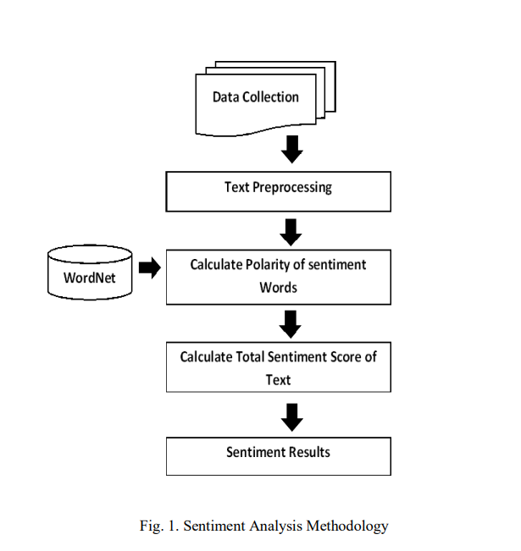

cases” operator. Stop words from the text were removed using “filter stop word (English)” operator. The next task was reducing inflected or derived words through a process called Stemming. Stemming of words was done using the “stem (word Net)” operator. C. Calculate Polarity of Sentiment of Sentiment words After preprocessing, the statistical technique known as Term Frequency-Inverse Document Frequency (TF-IDF) has been used. In TF-IDF term frequency is counted [16]. According to this technique words that occur frequently in a document are considered important and a weight is given to these words. Using TF-IDF important words or terms in a document were identified and assigned a weightage according to the occurrence of various words in the news article. After identification of important words, a dictionary has been used for assigning sentiment score to the discovered words. The WordNet dictionary, which is also known as a lexical database for English language, has been used in this experiment. WordNet contains more than 118,000 different word forms and more than 90,000 different word senses [17]. WordNet provides accurate results to find opinion words in a given text and to give sentiment score to them.

D. Calculate Total Sentiment Score According to the principle of document level sentiment analysis, each individual document is tagged with its respective polarity. This is generally done by finding polarities of each individual words/phrases and sentences and combining them to predict the polarity of whole document. Treating each new article as a document, the sentiment conveyed in the article has been computed by combining polarities of individual words/phrases and sentences in news articles. The sentiment score of whole news article has been calculated using the “extract sentiment” operator. This operator provides results about sentiments: text having a sentiment score of -1 is considered negative and text having a sentiment score of +1 is positive. This operator provided accurate results by using Senti WordNet 3.0.0 dictionary which is an extension of the word Net dictionary. WordNet and Sent WordNet are connected by Synced IDs. Also, by using Score sentiment function based on WordNet and Sent WordNet dictionary, total sentiment score of news article was calculated. E. Sentiment Results News articles were classified in to positive, negative and neutral classes by looking at their total sentiment score. News articles sentiment was then calculated as the average value of total word sentiments.

Process of sentiment analysis and emotion detection Process of sentiment analysis and emotion detection comes across various stages like collecting dataset, pre-processing, feature extraction, model development, and evaluation, as shown in Fig. 3. 3.1 Datasets for sentiment analysis and emotion detection Table 2 lists numerous sentiment and emotion analysis datasets that researchers have used to assess the effectiveness of their models. The most common datasets are Seme Val, Stanford sentiment treebank (SST), international survey of emotional antecedents and reactions (ISEAR) in the Feld of sentiment and emotion analysis. Seme Val and SST datasets have various variants which differ in terms of domain, size, etc. ISEAR was collected from multiple respondents who felt one of the seven emotions (mentioned in the table) in some situations. The table shows that datasets include mainly the tweets, reviews,

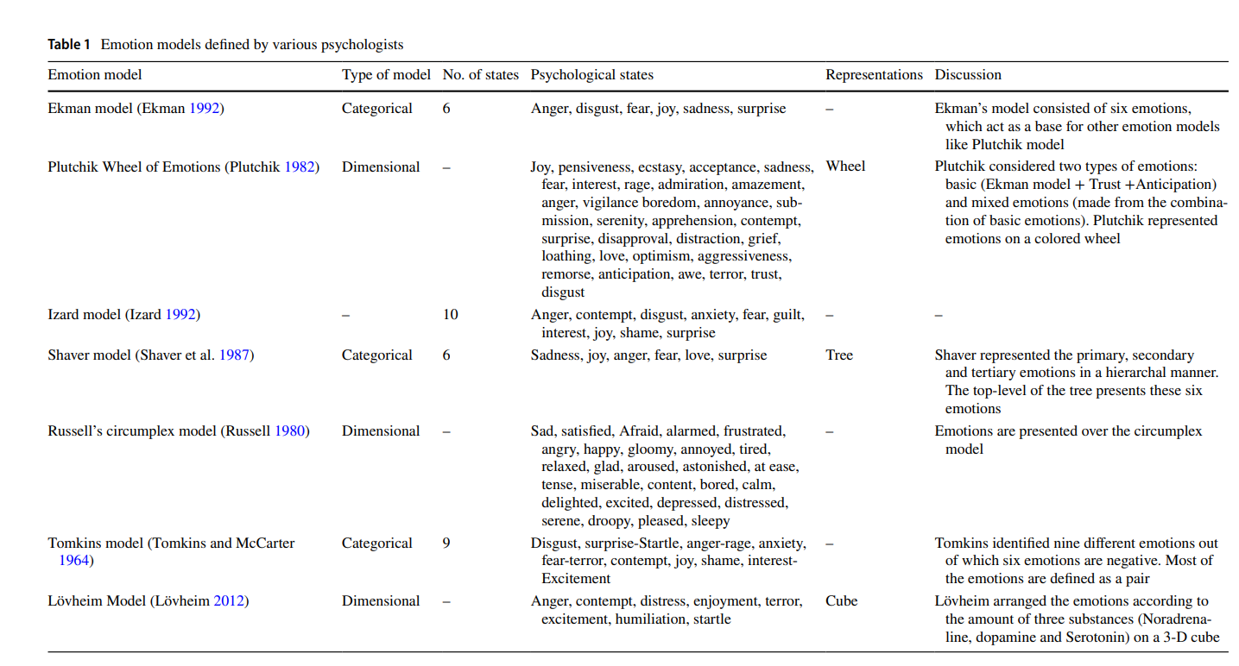

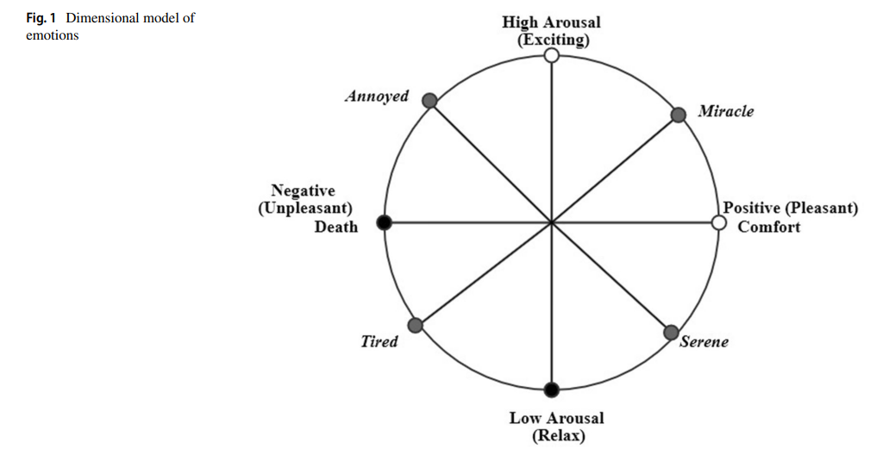

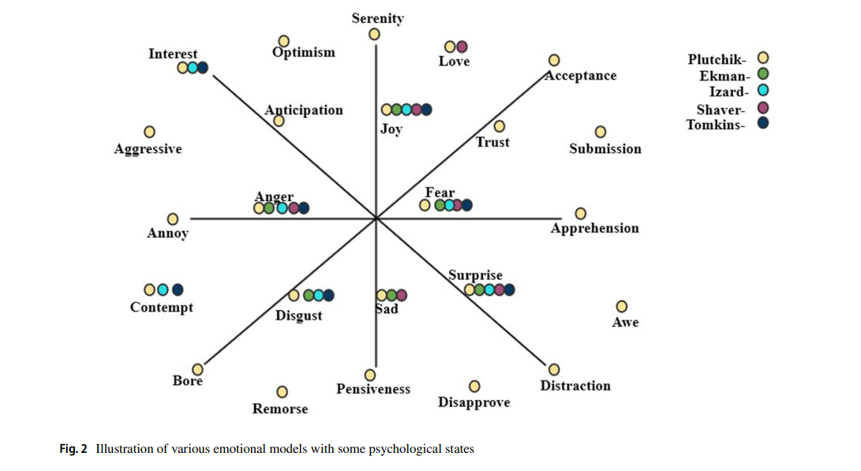

feedbacks, stories, etc. A dimensional model named valence, arousal dominance model (VAD) is used in the Emo Bank dataset collected from news, blogs, letters, etc. Many studies have acquired data from social media sites such as Twitter, YouTube, and Facebook and had it labelled by language and psychology experts in the literature. Data crawled from various social media platform's posts, blogs, e-commerce sites are usually unstructured and thus need to be processed to make it structured to reduce some additional computations outlined in the following section

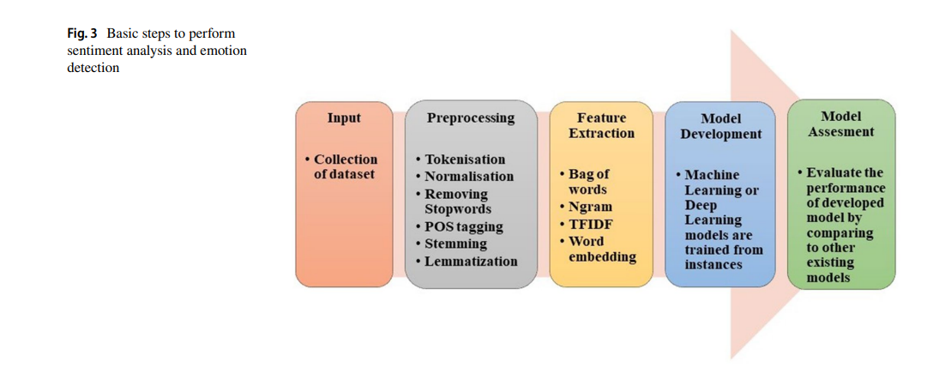

Pre‑processing of text

On social media, people usually communicate their feelings and emotions in effortless ways. As a result, the data obtained from these social media platform's posts, audits, comments, remarks, and criticisms are highly unstructured, making sentiment and emotion analysis difficult for machines. As a result, pre-processing is a critical stage in data cleaning since the data quality significantly impacts many approaches that follow pre-processing.

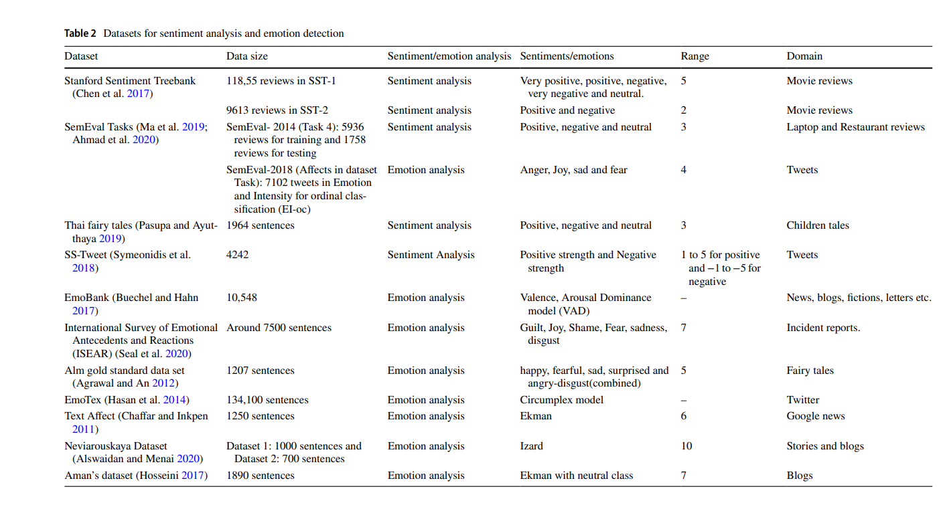

The organization of a dataset necessitates pre-processing, including tokenization, stop word removal, POS tagging, etc. (Abdi et al. 2019; Bhaskar et al. 2015). Some of these pre-processing techniques can result in the loss of crucial information for sentiment and emotion analysis, which must be addressed. Tokenization is the process of breaking down either the whole document or paragraph or just one sentence into chunks of words called tokens (Nagarajan and Gandhi 2019). For instance, consider the sentence “this place is so beautiful” and post-tokenization, it will become 'this,' "place," is, "so," beautiful.’ It is essential to normalize the text for achieving uniformity in data by converting the text into standard form, correcting the spelling of words, etc. (Ahuja et al. 2019). Unnecessary words like articles and some prepositions that do not contribute toward emotion recognition and sentiment analysis must be removed. For instance, stop words like "is," "at," "an," "the" have nothing to do with sentiments, so these need to be removed to avoid unnecessary computations (Bhaskar et al. 2015; Abdi et al. 2019). POS tagging is the way to identify different parts of speech in a sentence. This step is beneficial in finding various aspects from a sentence that are generally described by nouns or noun phrases while sentiments and emotions are conveyed by adjectives (Sun et al. 2017). Stemming and lemmatization are two crucial steps of pre-processing. In stemming, words are converted to their root form by truncating suffixes. For example, the terms "argued" and "argue" become "argue." This process reduces the unwanted computation of sentences (Kratz Wald et al. 2018; Akilandeswari and Jothi 2018). Lemmatization involves morphological analysis to remove inflectional endings from a token to turn it into the base word lemma (Ghanbari-Adivi and Mosleh 2019). For instance, the term "caught" is converted into "catch" (Ahuja et al. 2019). Symeonidis et al. (2018) examined the performance of four machine learning models with a combination and ablation study of various pre-processing techniques on two datasets, namely SS-Tweet and Seme Val. The authors concluded that removing numbers and lemmatization enhanced accuracy, whereas removing punctuation did not affect accuracy.

**Feature extraction**

The machine understands text in terms of numbers. The process of converting or mapping the text or words to real valued vectors is called word vectorization or word embedding. It is a feature extraction technique wherein a document is broken down into sentences that are further broken into words; after that, the feature map or matrix is built. In the resulting matrix, each row represents a sentence or document while each feature column represents a word in the dictionary, and the values present in the cells of the feature map generally signify the count of the word in the sentence or document. To carry out feature extraction, one of the most straightforward methods used is 'Bag of Words' (BOW), in which a fixed-length vector of the count is defined where each entry corresponds to a word in a pre-defined dictionary of words. The word in a sentence is assigned a count of 0 if it is not present in the pre-defined dictionary, otherwise a count of greater than or equal to 1 depending on how many times it appears in the sentence. That is why the length of the vector is always equal to the words present in the dictionary. The advantage of this technique is its easy implementation but has significant drawbacks as it leads to a sparse matrix, loses the order of words in the sentence, and does not capture the meaning of a sentence (Bandha Kavi et al. 2017; Abdi et al. 2019). For example, to represent the text “are you enjoying reading” from the pre-defined dictionary I, Hope, you, are, enjoying, reading would be (0,0,1,1,1,1). However, these representations can be improved by pre-processing of text and by utilizing n-gram, TF-IDF. The N-gram method is an excellent option to resolve the order of words in sentence vector representation. In an n-gram vector representation, the text represented as a collaboration of unique n-gram means groups of n adjacent terms or words. The value of n can be any natural number. For example, consider the sentence “to teach is to touch a life forever” and n = 3 called trigram will generate 'to teach is,' 'teach is to,' 'is to touch,' 'to touch a,' 'touch a life,' 'a life forever.' In this way, the order of the sentence can be maintained (Ahuja et al. 2019). N-grams features perform better than the BOW approach as they cover syntactic patterns, including critical information (Chafer and Inkpen 2011). However, though n-gram maintains the order of words, it has high dimensionality and data sparsity (Le and Nikolov 2014). Term frequency-inverse document frequency, usually abbreviated as TFIDF, is another method commonly used for feature extraction. This method represents text in matrix form, where each number quantifies how much information these terms carry in each document. It is built on the premise that rare terms have much information in the text document (Liu et al. 2019). Term frequency is the number of times a word w appears in a document divided by the total number of words W in the document, and IDF is log (total number of documents (N) divided by the total number of documents in which word w appears (n)) (Songdo and Jin 2008). Ahuja et al. (2019) implemented six pre-processing techniques and compared two feature extraction techniques to identify the best approach. They applied six machine learning algorithms and used n-grams with n = 2 and TF-IDF for feature extraction over the SS-tweet dataset and concluded TF-IDF gives better performance over n-gram. The availability of vast volumes of data allows a deep learning network to discover good vector representations. Feature extraction with word embedding based on neural networks is more informative. In neural network-based word embedding, the words with the same semantics or those related to each other are represented by similar vectors. This is more popular in word prediction as it retains the semantics of words. Google’s research team, headed by Tomas Nikolov, developed a model named Word2Vec for word embedding. With Word2Vec, it is possible to understand for a machine that “queen” + “female” + “male” vector representation would be the same as a vector representation of “king” (Souma et al. 2019). Other examples of deep learning-based word embedding models include Glove, developed by researchers at Stanford University, and Fast Text, introduced by Facebook. Glove vectors are faster to train than Word2vec. Fast Text vectors have better accuracy as compared to Word2Vec vectors by several varying measures. Yang et al. (2018) proved that the choice of appropriate word embedding based on neural networks could lead to significant improvements even in the case of out of vocabulary (OOV) words. Authors compared various word embeddings, trained using Twitter and Wikipedia as corpora with TF-IDF word embedding.

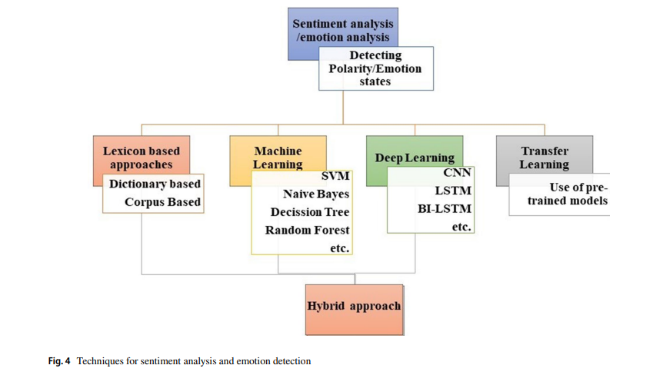

**EXPERIMENTAL WORK & RESULTS**

News articles having a sentiment score of 0 were considered as neutral and news articles with a score of +1 were treated as positive whereas news articles having a sentiment score of -1 have been treated as negative. The results of the experiment have been presented in Table 1

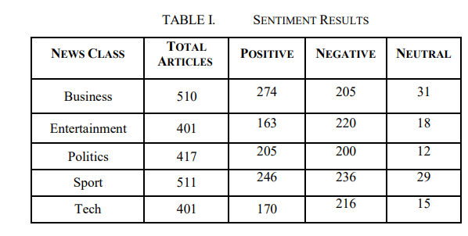

It was observed that most new articles fell into the negative or positive categories with a minor percentage of articles having neutral sentiments. Most news articles in the Entertainment and Tech category exhibited negative sentiments, whereas the categories of business and sports comprised of most articles depicting positive sentiments. The category of politics had almost an equal proportion of articles exhibiting positive as well as negative sentiments. The results of sentiment analysis have been graphically represented in Fig.2

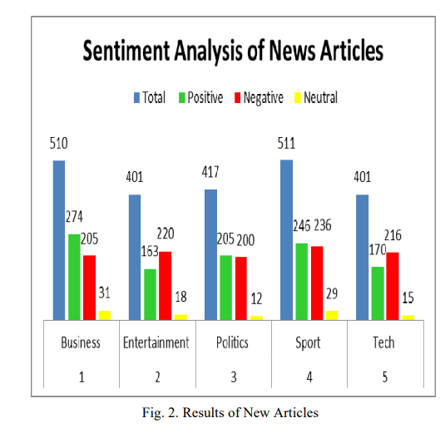

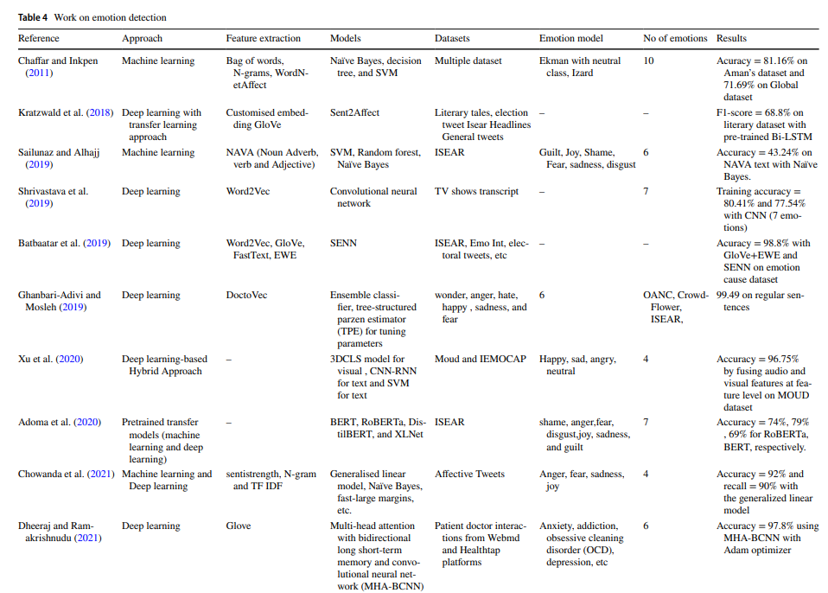

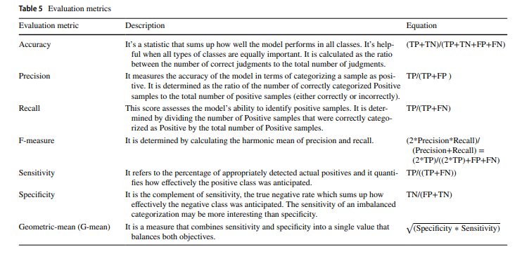

The analysis of news articles headlines from different outlets was constrained by headlines availability in outlets domains. The temporal coverage of outlet headlines fulfilling our inclusion criteria is shown in Figure S 1

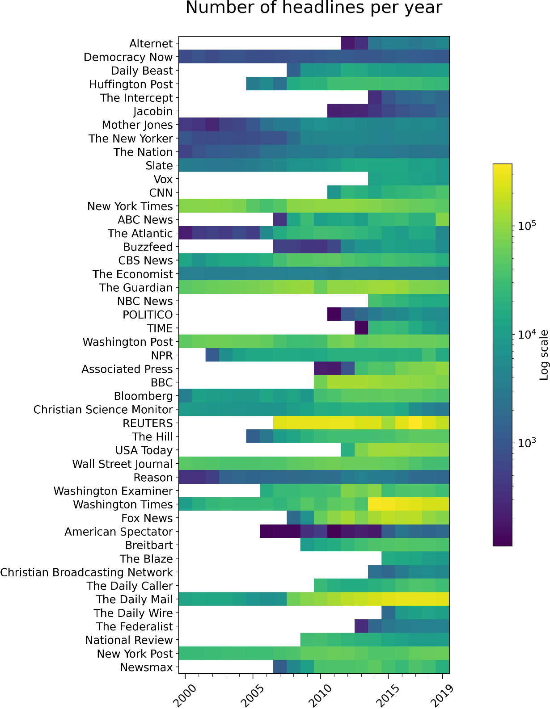

**Headlines length**

In total, we analyzed 23+ Million headlines from 47 news media outlets over the period 2000–2019. Average headline length in number of characters was 58.3. See Figure S 2 for detailed distribution.

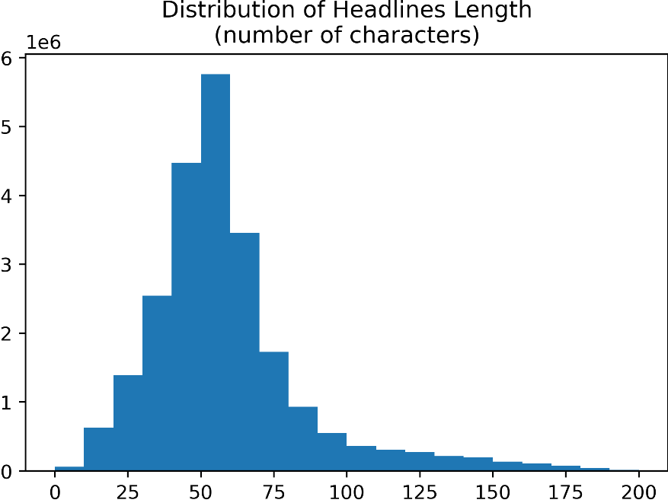

Average headline length in number of tokens (i.e. unigrams) was 9.4. See Figure S 3 for detailed distribution.

**Validity of automated emotion labelling**

To measure the validity of the Transformer model annotations [2] for predicting the emotion of headlines, we selected a random and balanced (equal probability of an outlet being chosen) subset of headlines in our data set (N=5,353) and annotated each headline with an emotion label as judged by US English-speaking human raters recruited through Mechanical Turk. These human annotations are used as ground truth to benchmark the performance of the model against them, see Table S 1.

Table S 1 Classification performance of the DistilRoBERTa Transformer language model fine-tuned for emotion annotation [2] on a subset (N=5,353) of headlines in our data set annotated for emotion category ground truth by human raters.

Table S 2 shows the simulated performance metrics of weighted random guessing on the human annotated headlines for each emotional category. For all emotional categories except *surprise*, the performance of the model (see Table S 1) is better than weighted chance guessing (see Table S 2). For that reason, the *surprise* category is dropped from subsequent analysis in the main manuscript. The confusion matrix of the Transformer model for the task of emotion predictions is shown in Figure S 4.

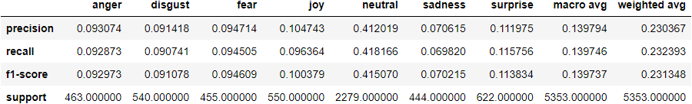

Table S 2 Classification performance of weighted random guessing on a subset (N=5,353) of headlines in our data set annotated for emotion category ground truth by human raters.

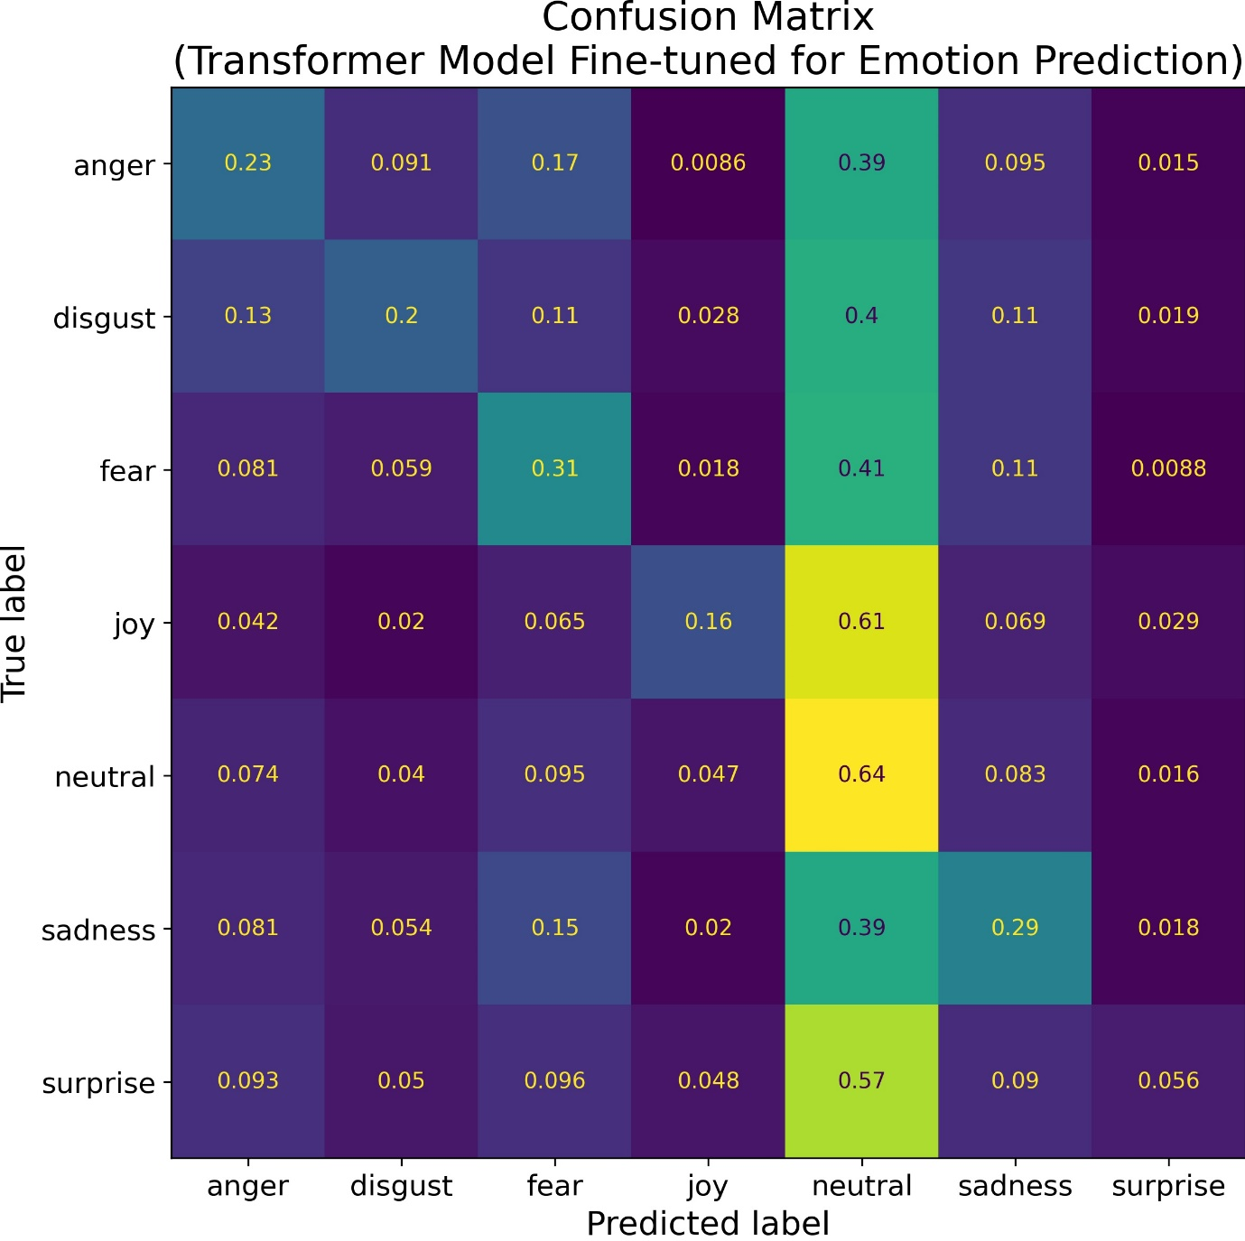

Figure S 4 The fractions in the main diagonal of the matrix denote the percentage of headlines in each emotion category correctly classified by the Transformer DistilRoBERTa-base model when using the human annotations as ground truth. Model performance is above chance guessing for all emotion categories except “surprise”.

**Interrater agreement between humans for emotion labelling**

The emotion annotation task with Ekman’s 6 basic emotions (anger, disgust, fear, joy, sadness, and surprise) plus neutral on news media headlines is inherently subjective and interrater agreement between human annotations is low. That is, often human raters disagree on whether the emotional undertones of a headline denote anger, fear, disgust, or sadness for instance. In a subset of the human emotion annotations in our data set with two human ratings per headline (N=1,016), interrater agreement was 36% (Cohen’s Kappa: 0.16, Matthew’s correlation coefficient: 0.16), see Table S 3. Like with automated emotion labelling, these metrics are relatively low but substantially above chance guessing (compare human interrater agreement in Table S 3 with chance guessing of ground truth labels in Table S 2). Agreement between human raters was like agreement between human raters and the model, see Table S 3 and Table S 1. The confusion matrix between human emotion predictions is shown in Figure S 5.

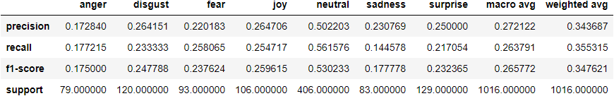

Table S 3 Human interrater agreement performance on the task of annotating the emotional category of headlines (N= 1,016) annotations. One of the human ratings is used as ground truth and the other is used as a prediction in order to compute a classification report that can be compared with automated emotion annotation.

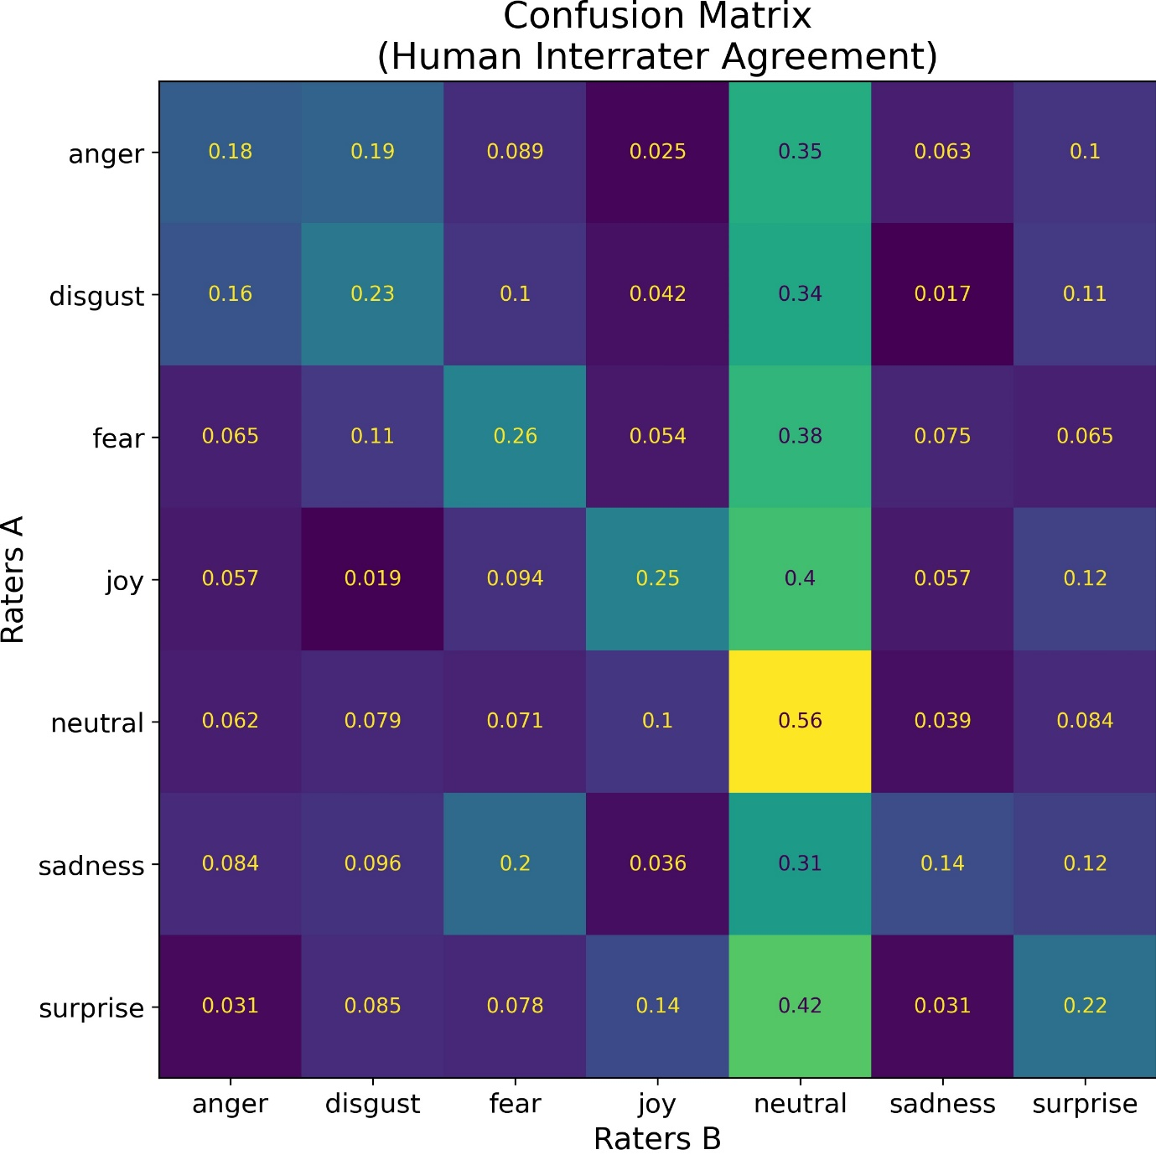

Figure S 5 The numbers in the main diagonal denote the fraction of headlines in each emotional category with the same emotion annotation between both human raters.

**Ability of the emotion annotation model with low recall and precision to detect ground truth patterns in emotional dynamics of headlines when averaging predictions over a large number of headlines**

To demonstrate that the model predictions of emotion when aggregated over a large number of headlines are able to track the emotion dynamics of headlines over time, despite its low recall and precision metrics, we carry out a simulation of emotion annotation using the actual true positive and false positive rates of the model on the 5,353 headlines annotated for emotion by humans through Mechanical Turk. We generate hardcoded ground-truth illustrative dynamics of headlines emotions using the trends contained in Figure 3 of the main manuscript. But any other trends should show the same effects described below. When the simulated predictions derived from the true positive and false positive rates of the model are averaged over a small number of headlines per year (N=100), the average of model predictions (blue continuous trend) fails to capture the underlying ground truth

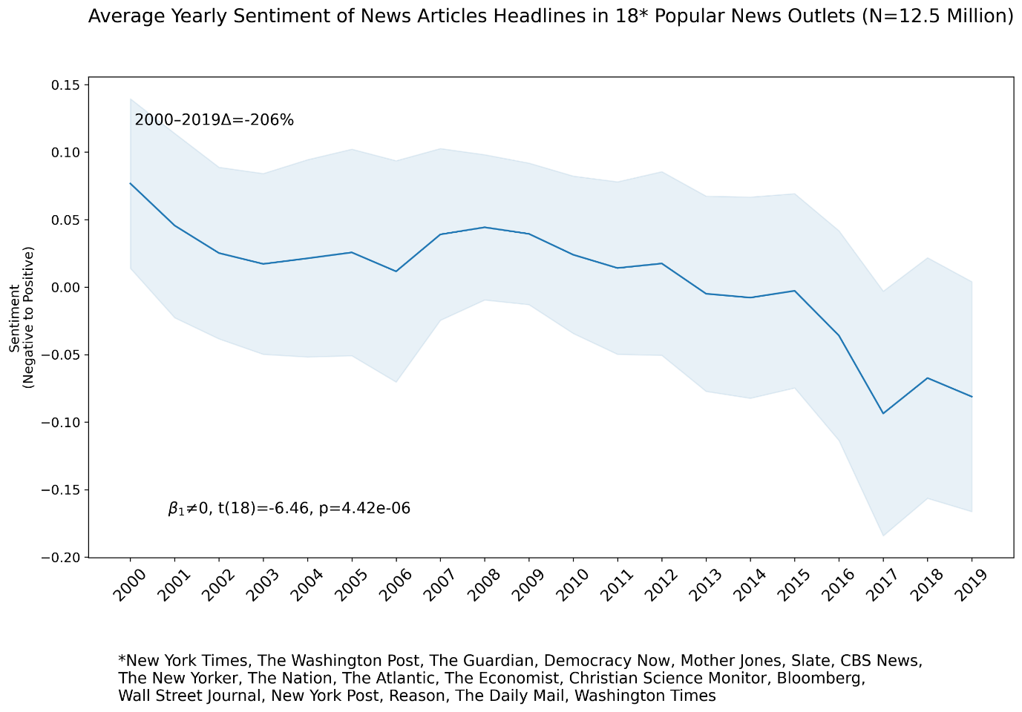

Figure S 11 The solid blue line shows the average yearly sentiment of headlines across 18 popular news media outlets. The shaded gray area indicates the 95% confidence interval around the mean. A statistical test for the null hypothesis of zero slope is shown on the bottom left of the plot. The percentage change on average yearly sentiment across outlets between 2000 and 2019 is shown on the top left of the plot.

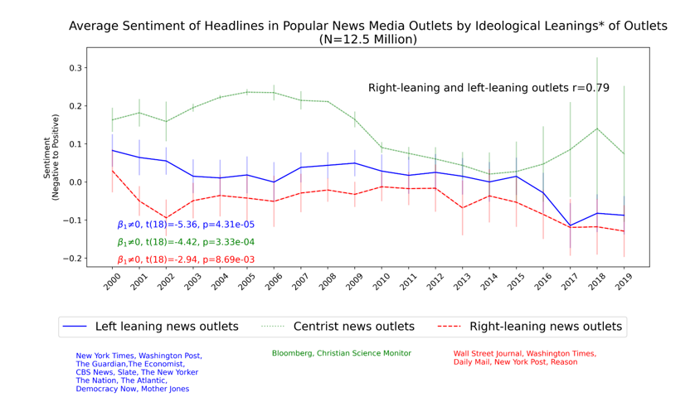

**VI. CONCLUSION**

In this paper, a review of the existing techniques for both emotion and sentiment detection is presented. As per the paper’s review, it has been analysed that the lexicon-based technique performs well in both sentiment and emotion analysis. However, the dictionary-based approach is quite adaptable and straightforward to apply, whereas the corpusbased method is built on rules that function effectively in a certain domain. As a result, corpus-based approaches are more accurate but lack generalization. The performance of machine learning algorithms and deep learning algorithms depends on the pre-processing and size of the dataset. Nonetheless, in some cases, machine learning models fail to extract some implicit features or aspects of the text. In situations where the dataset is vast, the deep learning approach performs better than machine learning. Recurrent neural networks, especially the LSTM model, are prevalent in sentiment and emotion analysis, as they can cover long-term dependencies and extract features very well. But RNN with attention networks performs very well. At the same time, it is important to keep in mind that the lexicon-based approach and machine learning approach (traditional approaches) are also evolving and have obtained better outcomes. Also, pre-processing and feature extraction techniques have a significant impact on the performance of various approaches of sentiment and emotion analysis There are many directions in sentiment analysis that can be explored. This paper explored sentiment analysis of news and blogs using a dataset from BBC comprising of new articles between the year 2004 and 2005. It was observed that categories of business and sports had more positive articles, whereas entertainment and tech had most negative articles. Future work in this regard will be based on sentiment analysis of news using various machine learning approaches with the development of an online application from where users can read news of their interests. Also, based on sentiment analysis methods, readers can customize their news feed.

**VII. REFERENCE**

[1] M. Karlsson, The immediacy of online news, the visibility of journalistic processes and a restructuring of journalistic authority. Journalism, 12(3), 279-295, 2011.

[2] A. Kohut, C. Doherty, M. Dimock and S. Keeter, Americans spending more time following the news. Pew Research Center, 2010.

[3] J. Reis, P. Olmo, F. Benevenuto, H. Kwak, R. Prates, and J. An, Breaking the news: first impressions matter on online news. In ICWSM ’15, 2015.

[4] N. Godbole, M. Srinivasaiah, and S. Sekine, Large-scale sentiment analysis for news and blogs. In International Conference on Weblogs and Social Media, Denver, CO, 2007.

[5] J. Lei, Y. Rao, Q. Li, X. Quan, and L. Wenyin, “Towards building a social emotion detection system for online news,” Future Generation Computer Systems, vol. 37, pp. 438–448, 2014.

[6] M. U. Islam, F. B. Ashraf, A. I. Abir and M. A. Mottalib, "Polarity detection of online news articles based on sentence structure and dynamic dictionary," 2017 20th International Conference of Computer and Information Technology (ICCIT), Dhaka, 2017, pp. 1-5. doi: 10.1109/ICCITECHN.2017.8281777

[7] V. Kharde, and P. Sonawane, “Sentiment analysis of twitter data: a survey of techniques,” International Journal of Computer Applications, vol. 139, no. 11, pp. 5–15, 2016.

[8] B. Meyer, M. Bikdash, and X. Dai, “Fine-grained financial news sentiment analysis,” SoutheastCon 2017, 2017.

[9] V. S. Shirsat, R. S. Jagdale and S. N. Deshmukh, "Document Level Sentiment Analysis from News Articles," 2017 International Conference on Computing, Communication, Control and Automation (ICCUBEA), Pune, 2017, pp. 1-4. [

10] A. Agarwal, V. Sharma, G. Sikka and R. Dhir, "Opinion mining of news headlines using SentiWordNet," 2016 Symposium on Colossal Data Analysis and Networking (CDAN), Indore, 2016, pp.1-5.doi: 10.1109/CDAN.2016.7570949

[11] J. Lei, Y. Rao, Q. Li, X. Quan, and L. Wenyin, “Towards building a social emotion detection system for online news,” Future Generation Computer Systems, vol. 37, pp. 438–448, 2014.

[12] Musto, C., Semeraro, G., and Polignano, M, A comparison of lexiconbased approaches for sentiment analysis of microblog posts. Information Filtering and Retrieval, 59. 2014.

[13] A. Dandrea, F. Ferri, P. Grifoni, and T. Guzzo, “Approaches, tools and applications for sentiment analysis implementation,” International Journal of Computer Applications, vol. 125, no. 3, pp. 26–33, 2015

[14] M. Devika, C. Sunitha, and A. Ganesh, “Sentiment analysis: a comparative study on different approaches,” Procedia Computer Science, vol. 87, pp. 44–49, 2016.

[15] E. Haddi, X. Liu, and Y. Shi, “The Role of Text Pre-processing in Sentiment Analysis,” Procedia Computer Science, vol. 17, pp. 26–32, 2013.

[16] K. Ghag and K. Shah, “SentiTFIDF – Sentiment classification using relative term frequency inverse document frequency,” International Journal of Advanced Computer Science and Applications, vol. 5, no. 2, 2014.

[17] G. A. Miller, “WordNet: a lexical database for english,” Communications of the ACM, vol. 38, no. 11, pp. 39–41, Jan. 1995.

[18] Z. Madhoushi, A. R. Hamdan, and S. Zainudin, “Sentiment analysis techniques in recent works,” 2015 Science and Information Conference (SAI), 2015.

[19] D.M.E.D.M. Hussein, “A survey on sentiment analysis challenges,” Journal of King Saud University - Engineering Sciences, vol. 30, no. 4, pp. 330–338, 2018.

[20] Kravchenko D, Pivovarova L, “DL Team at SemEval-2018 task 1: tweet affect detection using sentiment lexicons and embeddings”. In: Proceedings of the 12th international workshop on semantic evaluation. Association for Computational Linguistics, pp 172–176, 2018

[21] Andreevskaia A. and Bergler S. “Mining WordNet for a fuzzy sentiment: Sentiment tag extraction from WordNet glosses”, in Proceedings of the European Chapter of the Association for Computational Linguistics (EACL), 2006.

[22] Li, Fangtao, Minlie Huang, and Xiaoyan Zhu. "Sentiment analysis with global topics and local dependency". in Proceedings of the TwentyFourth AAAI Conference on Artificial Intelligence (AAAI-2010). 2010

Adoma AF, Henry N-M, Chen W (2020) Comparative analyses of Bert, Roberta, distiller, and xlnet for text-based emotion recognition. In: 2020 17th International Computer Conference on Wavelet Active Media Technology and Information Processing (ICCWAMTIP), IEEE, pp 117–121. https://doi.org/10.1109/ ICCWAMTIP51612.2020.9317379

Bernabé-Moreno J, Tejeda-Lorente A, Herce-Zelaya J, Porcel C, Herrera-Vidmar E (2020) A context-aware embeddings supported method to extract a fuzzy sentiment polarity dictionary. Know Based sits 190:105236

Plutchik R (1982) A psych evolutionary theory of emotions. https:// doi.org/10.1177/053901882021004003

Li Z, Xie H, Cheng G, Li Q (2021) Word-level emotion distribution with two schemas for short text emotion classification. Knowledge-Based sits 227:107163 Liu Y, Wan Y, Su X (2019) Identifying individual expectations in service recovery through natural language processing and machine learning. Expert system Appl 131:288–298

Tang D, Qin B, Liu T (2015) Learning semantic representations of users and products for document level sentiment classification. In: Proceedings of the 53rd annual meeting of the association for computational linguistics and the 7th international joint conference on natural language processing (Volume 1: Long Papers), pp 1014–1023

Viegas F, Alvim MS, Canuto S, Rosa T, Gonçalves MA, Rocha L (2020) Exploiting semantic relationships for unsupervised expansion of sentiment lexicons. Inf system 94:101606 Xu G, Li W, Liu J (2020) A social emotion classification approach using multi-model fusion. Future Gen Compute sits 102:347–356 Yang X, Macdonald C, Ounis I (2018) Using word embeddings in twitter election classification. Inf Retrieve J 21(2–3):183–207 Ye Q, Zhang Z, Law R (2009) Sentiment classification of online reviews to travel destinations by supervised machine learning approaches. Expert system Appl 36(3):6527–6535 Zhang D, Si L, Rego VJ (2012) Sentiment detection with auxiliary data. Inf Retrieve 15(3–4):373–390

Shamantha RB, Shetty SM, Rai P (2019) Sentiment analysis using machine learning classifiers: evaluation of performance. In: Proceedings of the 2019 IEEE 4th international conference on computer and communication systems (ICCCS), IEEE, pp 21–25 Sharma P, Sharma A (2020) Experimental investigation of automated system for twitter sentiment analysis to predict the public emotions using machine learning algorithms.

Mater Today Proc Shaver P, Schwartz J, Kirson D, O’Connor C (1987) Emotion knowledge: further exploration of a prototype approach. J Pers Soc Psyche 52(6):1061 Shelke NM (2014) Approaches of emotion detection from text. Int J Compute Sci Inf Techno 2(2):123–128 Shiras VS

Jagdale RS, Deshmukh SN (2019) Sentence level sentiment identification and calculation from news articles using machine learning techniques. In: Computing, communication, and signal processing. Springer, pp 371–376 Shrivastava K, Kumar S

Jain DK (2019) An effective approach for emotion detection in multimedia text data using sequence based convolutional neural network. Multum Tools Appl 78(20):29607–29639 Singh M

Jakhar AK, Pandey S (2021) Sentiment analysis on the impact of coronavirus in social life using the Bert model. Soc Newt Anal Min 11(1):1–11 Songdo T

Jin Z (2008) An empirical study of sentiment analysis for Chinese documents. Expert Sits Appl 34(4):2622–2629 Souma W, Venessa I, Aoyama H (2019) Enhanced news sentiment analysis using deep learning methods. J Compute Soc Sci 2(1):33–46 Soumya S, Pramod KV (2020)

Sentiment analysis of Malayalam tweets using machine learning techniques. ICT Express 6(4):300–305 Stropharia C, Vali tutti A, et al. (2004) Wordnet affect: an affective extension of wordnet. In: Lerch, Cite seer, vol 4, pp 1083–1086 Sun S, Luo C, Chen J (2017) A review of natural language processing techniques for opinion mining systems. Inf Fusion 36:10–25 Symeonidis S, Ferrocyanides D, Arampatzis A (2018) A comparative evaluation of pre-processing techniques and their interactions for twitter sentiment analysis. Expert sits Appl 110:298–310