**CHALLENGES FACED BY CUSTOMS HOUSE AGENT DURING IMPORT AND EXPORT CLEARANCE AT VELS SHIPPING SERVICES PRIVATE LIMITED, CHENNAI**

**NANDHA KUMAR S, MBA (SLM)**

**Dr.D.Anitha Kumari, Assistant Professor SCHOOL OF MANAGEMENT STUDIES**

**VELS INSTITUTE OF SCIENCE, TECHNOLOGY AND ADVANCED STUDIES (VISTAS),CHENNAI - 600 117**

1. **ABSTRACT**

Customs House Agents face numerous challenges in facilitating import and end logistical constraints can hinder effective coordination. Additionally, routine inspections and audits disrupt clearance timelines, and geopolitical factors and trade disruptions add uncertainty. Overcoming Texport clearance, including regulatory compliance, documentation complexity, diverse customs procedures across jurisdictions, effective communication, and the integration of evolving technologies. Language barriers ease challenges requires adaptability, technological proficiency, and collaborative engagement to ensure the smooth flow of goods across borders.

# INTRODUCTION

Customs House agents face numerous challenges in facilitating import and export clearance, including regulatory changes, documentation complexity, technological advancements, and geopolitical factors. These include adapting to updated customs procedures, managing documentation compliance, and integrating new technologies. Factors like fluctuating tariff classifications, political changes, and capacity issues complicate the clearance process. Communication issues with customs authorities and port issues like clearance delays and

inadequate infrastructure exacerbate the situation. Addressing these challenges requires agents to stay informed, maintain flexibility, and continuously update their practices.

# INDUSTRY PROFILE

Customs brokerage agents play a crucial role in international trade by enabling the seamless transfer of commodities across borders. Their area of expertise lies in customs laws and paperwork, guaranteeing adherence to both domestic and global requirements. These experts streamline the clearance process by serving as a point of contact for importers and exporters and government agencies. Preparing and filing the necessary paperwork, figuring out taxes and charges, and liaising with other stakeholders are among the main roles. Customs brokers need to demonstrate a thorough awareness of tariff classifications and trade agreements, as well as keep up with the latest changes to trade rules and regulations. Solving problems pertaining to shipments, including delays in customs clearance or inconsistencies in compliance, requires strong communication and problem- solving abilities. They frequently collaborate closely with shippers, freight forwarders, and governmental organizations to guarantee the effective and legal transportation of commodities.

# COMPANY PROFILE

Established in 2015, Vel's Shipping Services is a leading player in the Chennai trade sector with a focus on logistics, clearing, and forwarding services. With a dedication to quality, the business has emerged as a reputable clearing and forwarding agent in the Chennai shipping industry, providing exceptional service standards. Our main objective is to offer a competitive edge and 100% client satisfaction by offering top- notch shipping, clearing, transportation, and logistics services. We work to give our clients end-to-end shipping and logistics solutions by providing a wide range of services, such as air freight, ocean freight, road transportation, shipping ISF filing, and custom clearance. Because of our extensive global network, block space agreements, and collaborations with significant ocean carriers, we are able to provide dependable.

# OBJECTIVES OF THE STUDY

**PRIMARY OBJECTIVES**

To analyses the challenges faced by customs house agent during export and import clearance.

**SECONDARY OBJECTIVES**

1. To understand the documentation process carried out the vels shipping services pvt ltd.
2. To assess the role of customs house agent in the export and import process.
3. To know the challenges faced during the time of customs house agent
4. To identify the various problems faced by CHA while handling the goods
5. To provide suggestion to overcome the challenges in CHA

# NEED OF THE STUDY

A crucial part of ensuring efficient import and export clearance procedures are customs house agents. They frequently deal with a variety of difficulties, though, which might make operations less effective. A notable obstacle is the ever-changing regulatory landscape. Agents must be informed in order to assure compliance and prevent fines due to the constant changes in customs regulations, taxes, and trade agreements. The intricacy of the paperwork and clearance processes is another problem. While navigating complex customs procedures, agents must carefully handle a range of documents, including invoices, packing lists, and certificates of origin. Documentation errors or delays may cause shipment delays.

# STATEMENT OF PROBLEM

Importers and exporters and customs officials, customs house agents (CHAs) are essential to the ease of import and export clearance procedures. But frequently, they encounter a number of difficulties that impede efficient operations. The regulatory environment's continual change is one major challenge. In order to maintain compliance and prevent delays or penalties, CHAs must stay up to date on the sometimes changing and intricate legislation and processes pertaining to customs. Dealing with several nations, each with its own set of regulations and standards, exacerbates this

complexity. The substantial documentation needed for clearance presents another difficulty. Documentation that is erroneous or incomplete may cause delays, inspections, or even the seizure of products.

# SCOPE OF THE STUDY

A Customs House Agent’s (CHA) job is essential to the efficient processing of import and export clearance procedures. Nevertheless, CHAs operate with a number of difficulties. First off, it might be intimidating to navigate intricate and often shifting tariffs and laws related to customs. Another difficulty is the abundance of paperwork needed for clearance, including invoices, bills of shipping, and certificates of origin. These documents may contain errors or inaccuracies that result in fines or delays. CHAs must also adjust to new electronic systems and software in order to file and track shipments as a result of the onset of digitalization. To guarantee this, ongoing training and updates are needed.

# REVIEW OF LITERATURE

The survey of the literature includes a wide variety of research that look at different facets of international trade and logistics. The MENA region’s market potential for exporting animal feed, laws governing dual-use items, the effects of digitization on freight forwarding, the sustainability of maritime transportation, the difficulties faced by freight forwarders during the customs clearance process, and initiatives to stop corruption in customs procedures are just a few of the topics covered. These studies provide light on both opportunities and obstacles in modern international business by providing insights on trade facilitation, regulatory compliance, technological improvements, and the role of customs in global trade.

# RESEARCH METHODOLOGY

The research methodology that is being utilized includes a range of approaches, protocols, and techniques for the purpose of collecting and interpreting data in order to improve understanding or yield novel insights. It combines mixed, qualitative, and quantitative approaches, each of which uses a different set of tools to collect data. While qualitative research explores living experiences and emotions to understand difficult concepts, quantitative research concentrates on numerical data for statistical analysis. Both are combined in mixed methods research to provide a thorough knowledge. Finding knowledge gaps and developing specific, quantifiable research questions are made easier with the help of this methodology. A suitable design, such as surveys, interviews, or case studies, is chosen based on the research challenge, and data collecting is then carried out using the chosen method. Within the framework of logistics for both inbound and outgoing supply chains, return materials authorization (RMA), and research methods.

# DATA ANALYSIS AND INTERPRETATION

**TABLE 1: SIMPLIFYING CUSTOMS PROCEDURES AND PAPERWORK CAN MAKE THE CHA'S ROLE MORE EFFICIENT.**

|  |  |  |
| --- | --- | --- |
| **PARTICULARS** | **FREQUENCY** | **PERCENTAGE** |
| Yes | 38 | 79.2 |
| No | 6 | 12.5 |
| Maybe | 4 | 8.3 |
| Total | 48 | 100 |

**CHART 2: SIMPLIFYING CUSTOMS PROCEDURES AND PAPERWORK CAN MAKE THE CHA'S ROLE MORE EFFICIENT**

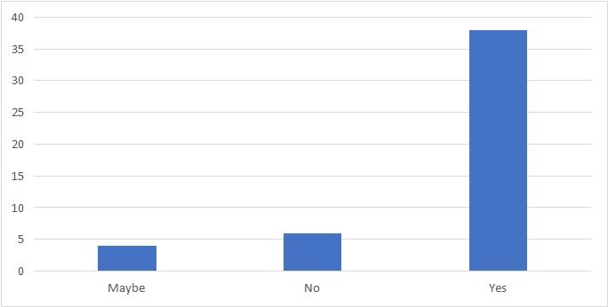

**INFERENCE:**

From the above table chart inferred that 79.2% of the respondents are Yes and 8.3% of the respondents are from the Maybe to simplifying customs procedures and paperwork can make the cha's role more efficient.

**TABLE 2: ENHANCING COMMUNICATION CHANNELS BETWEEN CHAS AND IMPORTERS/EXPORTERS CAN HELP IN UNDERSTANDING REQUIREMENTS BETTER.**

|  |  |  |
| --- | --- | --- |
| **PARTICULARS** | **FREQUENCY** | **PERCENTAGE** |
| Agree | 18 | 37.5 |
| Strongly agree | 27 | 56.3 |
| Neutral | 2 | 4.2 |
| Disagree | 1 | 2.1 |
| Strongly disagree | 0 | 0 |
| Total | 48 | 100 |

**CHART 2: ENHANCING COMMUNICATION CHANNELS BETWEEN CHAS AND IMPORTERS/EXPORTERS CAN HELP IN UNDERSTANDING REQUIREMENTS BETTER.**

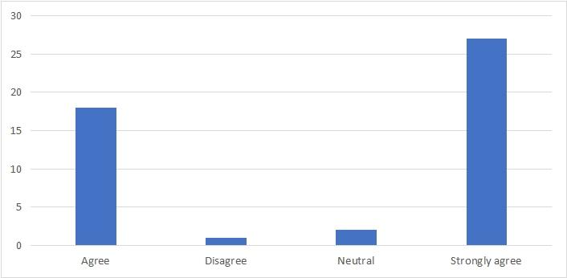

**INFERENCE:**

From the above table chart inferred that 56.3% of the respondents are strongly agree and 2.1% of the respondents are from the Disagree to enhancing communication channels between CHA and importers/exporters.

**TABLE 3: IMPLEMENTING ADVANCED TECHNOLOGY SOLUTIONS CAN STREAMLINE CUSTOMS CLEARANCE PROCESSES**

|  |  |  |
| --- | --- | --- |
| **PARTICULARS** | **FREQUENCY** | **PERCENTAGE** |
| Yes | 30 | 62.5 |
| No | 3 | 6.3 |
| Maybe | 15 | 31.3 |
| Total | 48 | 100 |

**CHART 3: IMPLEMENTING ADVANCED TECHNOLOGY SOLUTIONS CAN STREAMLINE CUSTOMS CLEARANCE PROCESSES**

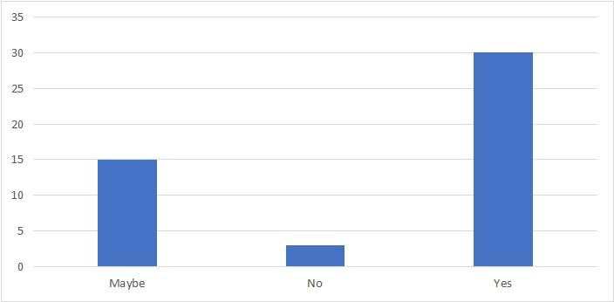

**INFERENCE:**

From the above table chart inferred that 62.5% of the respondents are Yes and 6.3% of the respondents are from the Maybe to implementing advanced technology solutions can streamline customs clearance processes.

**XII. FINDING OF THE STUDY**

* The majority respondents of 79.2% Yes Simplifying customs procedures and paperwork can make the CHA's role more efficient.
* The majority respondents of 56.3% strongly agree Enhancing communication channels between CHAs and importers/exporters can help in understanding requirements better.
* The majority respondents of 62.5% Yes Implementing advanced technology solutions can streamline customs clearance processes.

**WEIGHTED AVERAGE METHOD:**

* Here, the weighted average for the statement is agrees, now the most of the members agree for the adequate notice for any changes in terms and condition. Therefore, many members agree for the new terms and condition.
* Here, the weighted average for the statement is yes, now most of the members yes for the adequate notice for any changes in terms and condition. Therefore, many members yes for the new terms and condition.

**CHI-SQUARE:**

* There is no significant association between the customs duties and taxes are often unpredictable communication with customs officials can be challenging due to language barrier.
* There is no significant association between creating a feedback mechanism for clients to rate and review CHA can help in improving service quality and enhancing communication channels between CHA and importers exports can help in understanding requirements betters.

**CORRELATION:**

There is a significant relationship between are you willing to adapt your product offerings and marketing and are you aware of any competitive advantages challenges faced by customs clearance during import and export clearance.

**XXI. SUGGESTIONS**

* + Analyze the current documentation protocols, which include forms, templates, and software systems used for record-keeping, in order to gain an understanding of the documentation process in your organization. To find opportunities for improvement, evaluate these processes' lucidity, thoroughness, and effectiveness.
  + It's important to understand a customs house agent's (CHA) role in assisting seamless customs clearance when it comes to import-export procedures. This include getting the required paperwork ready and filed, liaising with authorities, and making sure rules are followed.
  + Challenges faced by CHAs may include changing regulations, complex paperwork, and time-sensitive deadlines. Identifying these hurdles is essential for devising effective solutions.
  + Common problems for CHAs include delays in customs clearance, incorrect documentation, and communication issues with authorities or clients.
  + To get over these obstacles, think about funding CHA staff training courses so they can remain current on legislation. Use technological solutions to expedite paperwork procedures and provide real-time shipment tracking. To resolve problems quickly, CHAs, clients, and customs authorities should establish good lines of communication.

**XIV. CONCLUSION:**

For the reason that to streamline import and export clearance procedures, customs house agents are essential since they manage a complicated web of rules, paperwork, and logistics. There are several obstacles they have to overcome during these procedures. First and foremost, regulatory compliance is a major challenge because customs laws are frequently complex and dynamic. It takes skill and diligence to ensure adherence to these changes and to stay up to date. Furthermore, in order to prevent fines and delays, accurate and effective documentation management is crucial. Second, logistical issues that can obstruct the efficient flow of commodities include port traffic jams, delays in transit, and coordination with several parties. These logistical obstacles must be skillfully negotiated by customs house agents in order to guarantee prompt clearance and delivery. Additionally, the worldwide scope of commerce presents challenges pertaining to disparities in culture, hindrances in communication, and diverse.