E-GOVGUARD (EGG): Sales Insights Data Analysis in Power BI
Prof. A. D. Bhange¹, Amit Singh Patel², Rohan Durgam³, Sayali Ihare⁴, Samradnyee Kapsikar⁵, Abhishek Katre⁶*
¹Assiatant Professor, Department Of Computer Science & Engineering, KDK College Of Engineering, Nagpur
^{2,3,4,5,6}Students, Department Of Computer Science & Engineering, KDK College Of Engineering, Nagpur
¹Email: samkapsikar24@gmail.com ²Email: Iharesayali@gmail.com
ABSTRACT
Sales Insights data analysis in Power BI aims to provide a comprehensive understanding of sales performance through data analysis, leveraging Power BI's robust analytics and visualization capabilities. This project aims to uncover key metrics and trends in sales data and provide useful information for strategic decision making. The project uses a structured methodology that ensures a systematic approach to data collection, exploration, cleaning, transformation and visualization to derive meaningful indicators. Marketing is growing dynamically and he has difficulty tracking sales, he needs more precise information about the company's sales and then makes the necessary decisions. Power BI Quick Insights feature is an innovative feature based on a growing number of advanced analytics algorithms. Analyzing sales data provides an understanding of the product your customers are purchasing and helps you analyze why they behave in certain ways. The insights gained from this analysis can guide strategic decision-making and improve overall sales effectiveness. The project aims to demonstrate how we can use Power BI with sales analytics data using SQL queries for data cleansing and DAX query language and how it performs in presenting the dashboard to end users. So, in this project we created a dashboard to know the trends and business performance and the ups and downs of the market and also to see graphically which products are selling the most, which products are selling the most in certain regions and how the Performance of the respective products is market. The project presents a large data set in the form of a visualization that helps in business decisions. The aim of the project is to provide companies with a deeper understanding of their sales processes through this analysis, giving them the opportunity to optimize strategies and improve overall sales effectiveness.

- INTRODUCTION
AtliQ Hardware is a company that supplies hardware peripherals to various customers such as Nomad Stores and Excel Stores. These are all customers and this is a hardware company that supplies them with computers and other network peripherals. For example, they have a headquarters in Delhi, India, and they have regional offices in different states of India, and the sales of this company are declining Reason happened. The introduction sets the stage by highlighting the importance of data analysis to optimize sales strategies. Describes the goals of the project and emphasizes the value of using Power BI for its analysis and visualization capabilities. In addition, the introduction provides context on the data set used, the industry or business sector under consideration, and the scope of the analysis. Boot Camp was interesting and we were assigned tasks. We are a team of 3 who are supposed to work on a specific task. We started by getting to know each other, choosing a team leader and an assistant, and also determining the schedule for the meeting. The assigned task was: “Select a product sales information analysis, discard data, clean it and visualize it using Excel and Power BI.” In today's competitive business landscape, companies are increasingly relying on data-driven insights to make informed decisions. The Sales Insights data analytics project focuses on leveraging the power of Power BI, a robust business analytics tool, to gain valuable insights into sales performance. The project involves examining sales data to discover patterns, identify opportunities and address challenges in the sales process. The Sales Insights Data Analytics project in Power BI creates the context for leveraging advanced analytics to generate meaningful, actionable sales insights. In an era dominated by data-driven decision making, this project recognizes the critical role that comprehensive sales analytics plays in optimizing business strategies. Leveraging the capabilities of Power BI, a powerful business intelligence tool, the project aims to unlock the potential hidden in sales data. This introductory section emphasizes the importance of understanding sales performance trends, identifying key metrics, and visualizing patterns to make strategic decisions. The introduction sets the stage for a thorough examination of the data set and highlights the goals of the project, the importance of the chosen analysis tool, and the potential impact of the insights gained in improving overall sales effectiveness. In the dynamic landscape of modern businesses, the ability to extract useful information from large data sets has become critical to organizational success. The Sales Insights Data Analytics project, conducted in Power BI, represents a strategic effort to harness the power of data to unravel the nuances of sales performance. This introduction sets the stage for the project and provides insight into the importance of leveraging advanced analytics tools like Power BI to gain invaluable insight into sales data. Power BI is the technical and procedural representation of data. It is an infrastructure that collects, stores and analyzes the data generated by a company's activities. Power BI analyzes all the data generated by a company and presents easy-to-understand reports, performance metrics and trends that inform management decisions. BI components and software come in a variety of Power Query, Power Map, Power Pivot, Power Q&A, and Power BI desktops. There are many other parts of Power BI, such as Power BI.com websites and Power BI Mobile Apps. Power BI is cloud-based data analytics that can be used for reporting and data analysis from a variety of data sources. Power BI is so simple and easy to use that even business analysts and advanced users can work with it and reap the benefits. On the other hand, Power BI is powerful and sophisticated enough that BI developers can use it in enterprise systems for complex data combinations and modeling scenarios.
Aim :
We are a team of 5 who are supposed to work on a specific task. We started by getting to know each other, choosing a team leader and an assistant, and also determining the schedule for the meeting. The assigned task was: “Select a product sales information analysis, discard data, clean it and visualize it using Excel and Power BI.” In today's competitive business landscape, companies are increasingly relying on data-driven insights to make informed decisions. The Sales Insights data analytics project focuses on leveraging the power of Power BI, a robust business analytics tool, to gain valuable insights into sales performance. The project involves examining sales data to discover patterns, identify opportunities and address challenges in the sales process. The Sales Insights Data Analytics project in Power BI creates the context for leveraging advanced analytics to generate meaningful, actionable sales insights. In an era dominated by data-driven decision making, this project recognizes the critical role that comprehensive sales analytics plays in optimizing business strategies. Leveraging the capabilities of Power BI, a powerful business intelligence tool, the project aims to unlock the potential hidden in sales data. This introductory section emphasizes the importance of understanding sales performance trends, identifying key metrics, and visualizing patterns to make strategic decisions. The introduction sets the stage for a thorough examination of the data set and highlights the goals of the project, the importance of the chosen analysis tool, and the potential impact of the insights gained in improving overall sales effectiveness. In the dynamic landscape of modern businesses, the ability to extract useful information from large data sets has become critical to organizational success. An automated dashboard that provides fast, timely information to support data-driven decision making. Data Visualization for Data Analysis (DAX) was performed in Microsoft Power BI Desktop tools and software –
1. MySQL
2. Microsoft Power BI
3. Power Query Editor
4. DAX language Providing direct information to users.
Another visualization tool used is the stacked histogram, which is useful for quickly comparing two or more series of measurements. Here we have used this chart to create a cumulative view of Profits, Sales and Sales per month which gives us an idea about the variability of Profits, Sales and Sales per month. In October, the company increased profit, sales and revenue compared to other months. To see the benefits of a particular pie chart, an image is shown. It is used to illustrate the contribution of different values to the total. It provides a clear picture of the company's profits at the national level. The next visualization used here is a line chart. It gives you a plan to understand your monthly profit. It is used to show how information changes over time. With one click on any visual, it gives the all information that the dashboard contains. Multiple Tech Approach We used a multi-technology approach based on a docking container. Vue + Node was used to manage data on the web and Python was used to clean, store, process and analyze data along with scheduled cron jobs. Once the data is analyzed, the warehouse also stores basic, non-aggregated results. Filtered Style Views The web portal uses a MySQL database for display to the end customer. In the beginning we used grids, charts and monthly views. The backend used Danfo and Tensors to ensure that all data operations run smoothly and quickly. Filters could be dynamic, and the entire dashboard allowed users to drill down at will, apply specific filters, and get raw or visible data.
AtliQ Hardware is a company that supplies hardware peripherals to various customers such as Nomad Stores and Excel Stores. These are all customers and this is a hardware company that supplies them with computers and other network peripherals. For example, they have a headquarters in Delhi, India, and they have regional offices in different states of India, and the sales of this company are declining reason happened. The introduction sets the stage by highlighting the importance of data analysis to optimize sales strategies. Describes the goals of the project and emphasizes the value of using Power BI for its analysis and visualization capabilities. In addition, the introduction provides context on the data set used, the industry or business sector under consideration, and the scope of the analysis.
Computation Engine We made the computation engine dynamic so that you can define specific master or control Excel files and upload these files to the portal to define the calculation flow. This makes it a cost-effective platform for entrepreneurs looking to improve their workflows.
We will cover project planning and data discovery aspect of our sales insights data analysis project. Once sales directory of AtilQ hardware has decided to invest in data analysis project he will do a meeting with IT director, data analytics team to come up with a plan.
Data analyst team approaches IT team within organisation who owns software system that keep a track of sales records. These records are stored in mysql database. Power BI can be plugged to this database to pull necessary information required for data analysis.
The Sales Insights Data Analytics project, conducted in Power BI, represents a strategic effort to harness the power of data to unravel the nuances of sales performance. This introduction sets the stage for the project and provides insight into the importance of leveraging advanced analytics tools like Power BI to gain invaluable insight into sales data. Power BI is the technical and procedural representation of data. It is an infrastructure that collects, stores and analyzes the data generated by a company's activities. Power BI analyzes all the data generated by a company and presents easy-to-understand reports, performance metrics and trends that inform management decisions. BI components and software come in a variety of Power Query, Power Map, Power Pivot, Power Q&A, and Power BI desktops. There are many other parts of Power BI, such as Power BI.com websites and Power BI Mobile Apps. Power BI is cloud-based data analytics that can be used for reporting and data analysis from a variety of data sources. Power BI is so simple and easy to use that even business analysts and advanced users can work with it and reap the benefits. On the other hand, Power BI is powerful and sophisticated enough that BI developers can use it in enterprise systems for complex data combinations and modeling scenarios.
The Sales Insights data analytics project methodology in Power BI is based on a systematic and structured approach. The process begins with data capture, where sales data is collected from various sources including transaction, customer and product details. A comprehensive data mining phase is then carried out to understand the structure of the data set, identify variables and detect potential patterns. A thorough data cleansing process then removes any missing values, outliers or inconsistencies to ensure data integrity. The next step is to transform the data to derive appropriate metrics and indicators that enable meaningful analysis. Power BI's robust capabilities are then leveraged to create interactive dashboards with appropriate visualizations and filters. The analysis phase examines key performance indicators, trends, and patterns in sales data. The conclusions drawn from this analysis are presented in a coherent manner and highlight practical recommendations to improve business performance. Finally, the methodology takes into account any limitations of the analysis and suggests opportunities for future research or improvements to ensure a complete and in-depth examination of sales data through the lens of Power BI. The methodology section describes the step-by-step approach we take to run a Sales Insights data analysis project in Power BI. The methodology is structured to allow a logical and systematic progression through the different phases of the analysis. The most important steps include:
1. Data Collection: Describe how sales data was collected, including data sources and initial challenges.
2. Data Mining: Discuss the process of examining a data set to understand its structure, variables, and potential information. This includes identifying gaps or outliers in the data.
3. Data Cleansing: Explain the steps to clean the data, including handling missing values and ensuring data integrity.
4. Data Transformation: Explain how the data was transformed to obtain appropriate metrics and indicators for sales analysis. This can include aggregating or creating calculated fields.
5. Creating Power BI Dashboards: Describe the design and development of Power BI dashboards, highlighting the selection of visualizations and interactions to convey meaningful information.
6. Analysis and Insights: Present the results of data analysis, including key performance indicators (KPIs) and actionable insights.
7. Limitations and Future Work: Recognize any limitations of the analysis and suggest areas for future research or improvements.
8. ETL (Extract, Transform, Load): Once we know the basic functions of the data we have to work with, I import the MySQL database into Power BI to perform the necessary transformations and get a reliable and useful framework table.
9. Data warehouse : Basically we take the data from Mysql which is also known as OLTP which is Online Transaction Processing System. It is a very critical system. People pull the data from OLTP which is Mysql, in our case they do all the transformation which is ETL and after doing that transformation they store the data in a data warehouse. There are many data warehouses such as Tara data or snowflake and so on & for doing this transformation people uses tools such as Apache knife or even python and pandas.
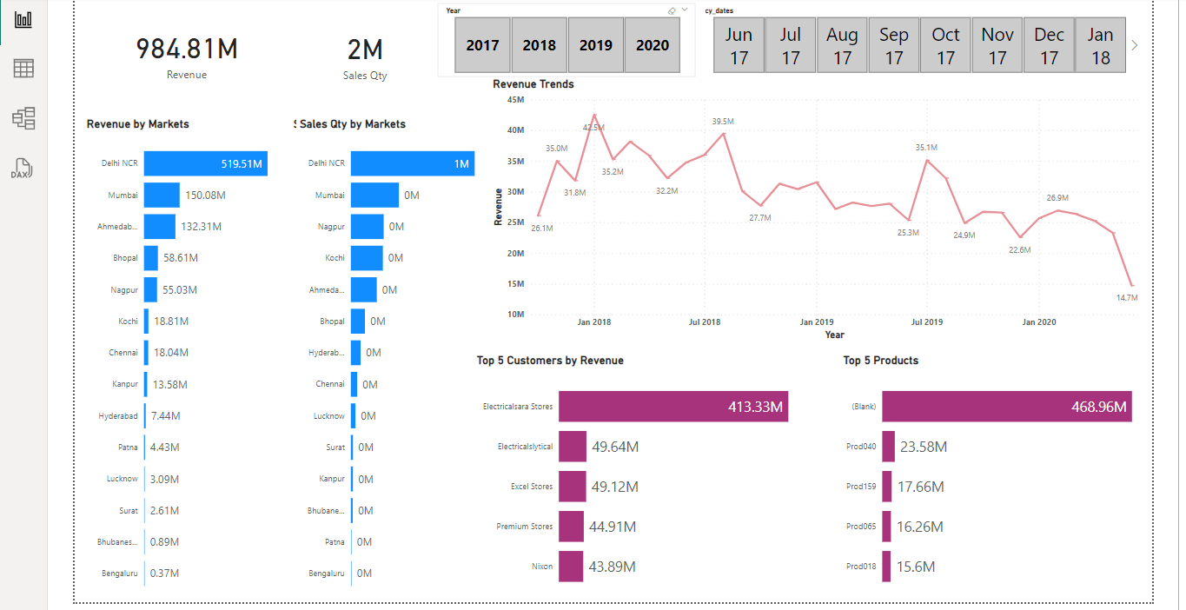
- CONCLUSION
Additionally, Power BI also helps you make better and faster decisions, resulting in higher customer satisfaction in today's industry. Each organization has its own individual data. Power BI can perform different functions depending on the purpose, making data more effective and efficient. Power BI can be used in the medical industry to analyze data from a large number of patients. It helps extract useful information from data from huge database collections. In the future, the scope of data analysis will expand and organizations will adapt it on a large scale to ensure sustainable development. Power BI is an absolute approach to making business intelligence and data analysis more understandable. Organizations can easily select records with minimal time and effort. Power BI meets the non-manual requirements to meet your data analysis needs.
• Sales in 2020 fell significantly compared to 2019 by around 57.7%.
• Highest sales in markets like Delhi NCR, Mumbai, Ahmedabad, Bhopal, Nagpur etc.
• Largest quantity sold in markets like Delhi NCR, Mumbai, Nagpur, Kochi, Ahmedabad etc.
• Most sales occurred in January, followed by November and March.
References
[1] Adamala, S. & Cidrin, L. (2011). Key Success Factors in Business Intelligence. Journal of Intelligence Studies in Business, Vol. 1(1).

[2] Alaskar, T., & Efthimios, P. (2015). Business Intelligence Capabilities and Implementation Strategies. International Journal of Global Business, Vol. 8 (1), pp. 34- 45.

[3] https://ir.inflibnet.ac.in/bitstream/1944/2116/1/24.pdf

[4] https://www.ijraset.com/research-paper/data-analysis-and-visualization-of-sales-dataset-usingpower-bi

[5]https://www.researchgate.net/publication/264555968_Big_Data_Analytics_A_Literature_Review_Pape r

[6] https://journalofbigdata.springeropen.com/articles/10.1186/s40537-021-00553-4

[7]https://thesai.org/Downloads/Volume7No2/Paper_67A_Survey_on_Big_Data_Analytics_Challenges.pdf

[8] https://journalofbigdata.springeropen.com/articles/10.1186/s40537-015-0030-3

[9] https://hevodata.com/learn/10-best-power-bi-reports-examples/

[10] https://powerbi.microsoft.com/en-us/

[11] https://rigorousthemes.com/blog/best-power-bi-dashboard-examples/

[12] https://inblog.in/Power-BI-Projects-HdlkEZeaXK

