**SPEECH TO TEXT CONVERSION AND SENTIMENT ANALYSIS**

Sahil Kashyap, Harsh Agnihotri, Aadil Shamim Khan, Akshit Kakran

Maharaja Surajmal Institute

Affiliated to GGSIP University

**--------------------------------------------------------------------------------------------------------------------------**

**Abstract**

In the past It works as two separate modules, where not much work has been done on speech-to-text conversion and sentiment analysis. Additionally, sentiment analysis studies are almost limited to video reviews and Twitter sentiment analysis. Here we bring the two together and try to broaden the perspective of thinking.

--------------------------------------------------------------------------------------------------------------------------

**Introduction**

This article provides a psychological evaluation of speech designed to capture and share thoughts in conversation. Using advanced machine learning and signal processing techniques, our bodies can identify emotions in different speech patterns, from happiness to anger. We confirmed its high precision and memorability through rigorous analysis of various datasets. The system has great potential applications in human-computer relations, customer service, mental health services, and business research. We discuss its implications, challenges, and future directions, highlighting its role in transforming user experience across multiple domains.

In an era dominated by digital communication, understanding and analysing user sentiments have become paramount for businesses across various industries. This project, VoiceSentix, endeavours to address the challenges associated with manual sentiment analysis of voice data.

Through the integration of advanced technologies, the web portal aims to provide businesses with a comprehensive solution for real-time voice sentiment analysis

--------------------------------------------------------------------------------------------------------------------------

**--------------------------------------------------------------------------------------------------------------------------**

**Methodology**

1) Tokenization:

Tokenization means dividing or parsing the original document into smaller units called units or blocks. This breaks the text into symbols that help understand the NLP structure. Stop words have been removed from the table to reduce noise and reduce the size of the feature set. Text Blob is a library that can be used to manipulate text files in Python. Analysis, part of speech tagging, classification and translation etc. It provides many APIs for

2) Radicalization

Stemming is a process that extracts the initial form of a word (for example, a simple word) by removing prefixes and suffixes. This way of stemming can reduce the size of the index and improve the retrieval accuracy

3) Lemmatization

The stemming technology is similar to the stemming technology. The output we get after lemmatization is called "LEMMA" and it is the root (output of root extraction) not the root. After lemmatization we will get a valid word with the same meaning. This means that after applying lemmatization we will get a valid word.

4) Polarity

The most important and important part of using thinking theory is to find/identify the text and understand the thoughts and feelings it says. Therefore, we evaluate emotions according to positive or negative, which is called polarity. From the sign of the charge polarity we can prove whether the overall sentiment is positive, negative or neutral.

--------------------------------------------------------------------------------------------------------------------------

**Content and configuration**

1) Pre-processing: Converting the input analog signal into a digital signal for processing. The received signal will be sent to further processing to use filters to smooth the signal and remove noise. Therefore, the strength of the signal increases at high frequency.

2) Speech model: extract features from dynamic time warping, Mel Frequency Cepstrum Coefficients (MFCC) and Linear Predictive Coding (LPC). Various tools and/or APIs are used. We use Google speech recognition in this project.

3) Speech to text change: Cuckoo uses different methods/algorithms such as Search Optimization [9] and Hidden Markov Model (HMM) based on Artificial Neural Network Classifier (ANN).

4) Sentiment Analysis: The method used in sentiment analysis of articles is the natural language processing (NLP) method. In the field of computer science and artificial intelligence, NLP focuses on all interactions between computers and different human languages. There are many public libraries (such as SENTIWORDNET) that assign emotional polarity values ​​to each word in a text.

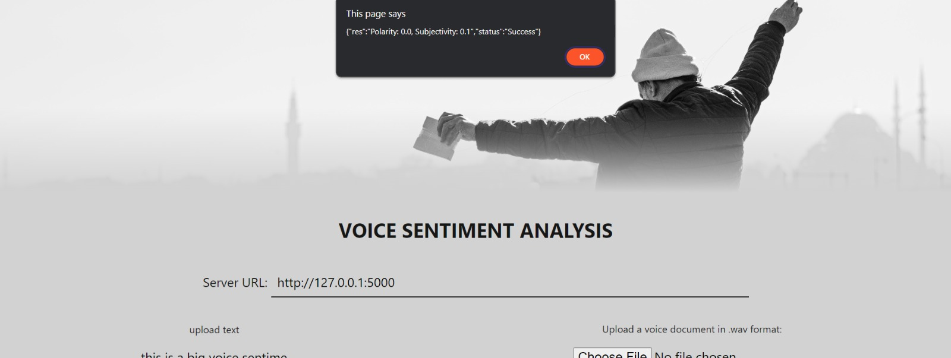

1) Speech recognition:

This model uses GOOGLE SPEECH API or speech library talk recognition to convert speech to text. location, distribution) function reduces background noise and improves identification accuracy.

2) Sentiment analysis:

This model uses the Text BLOB library to analyse the sentiment of the text. The POLARITY () function returns a numeric value that represents sensitivity; higher values ​​represent positive sentiment; lower values ​​represent negative sentiment. Optional: GOOGLE Search API

Although not used directly for speech recognition and sentiment analysis, this API allows integration of GOOGLE search functionality into the body

* PYTHON Speech Recognition Library: Using PIP to load speech recognition install. For Linux: Install PYAUDIO using PIP Install PYAUDIO.
* TEXTBLOB library: This sound library already exists. Installed speech library may already be in Installed Conversation Library, may already exist Installed Conversation Library may already be in Installed Conversation Library, may already exist Installed Conversation Library: Library This may already have Installed Conversation Library functionality.
* PYAUDIO library is required to capture audio input from the microphone.
* TEXTBLOB is a powerful library that provides better analysis of various functions of the language than you could ever imagine.

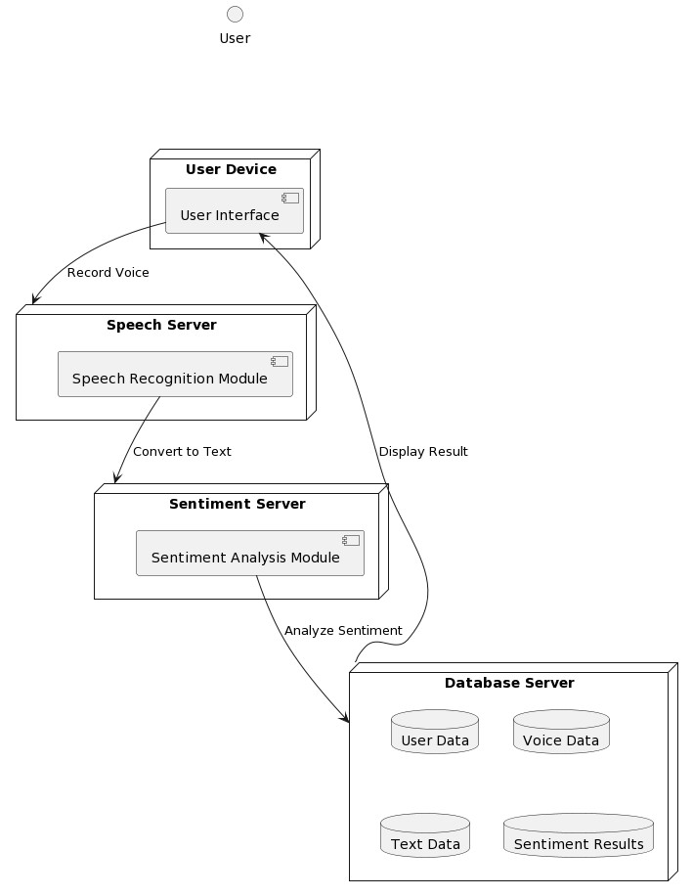

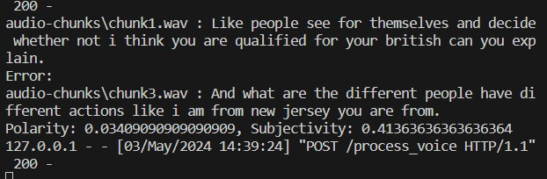

**--------------------------------------------------------------------------------------------------------------------------**

**--------------------------------------------------------------------------------------------------------------------------**

**Results**

1. Speech Recognition: Inputs from different speakers are shown below. The audio model shows that the audio and sound of the audio are captured in a controlled environment unaffected by external noise. These phrases are transcribed into text along with the time it takes for the speaker to say the sentence, as shown in the table below (.
2. Emotional analysis: extract the text from the data and refer to its poles (personal opinion, judgment or opinion) for emotional analysis, including runtime
3. Final result: complete. test the output is defined by all the thoughts of the input provided by the speaker. The emotions described in these situations are positive, negative and neutral.

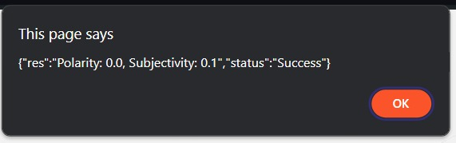

--------------------------------------------------------------------------------------------------------------------------

**Conclusion**

In summary, the development and use of speech emotion analysis system, Great progress in the field of natural language processing and reasoning. To count. The system demonstrated the ability to identify emotional content in human speech using machine learning algorithms and advanced processing techniques. , sadness, anger, etc. with high accuracy. These features have great potential in many applications including market research, customer development, psychological care and more. While it's good at controlling, more improvements are needed to increase its power in a global environment with different voices, languages ​​and background noise. Additionally, ethical considerations regarding privacy and consent must be carefully considered when using this technology.

--------------------------------------------------------------------------------------------------------------------------

--------------------------------------------------------------------------------------------------------------------------

**References**

* Google. (n.d.). Google Speech API.
* Jurafsky, D., & Martin, J. H. (2014). Speech and language processing. Pearson Education.
* Kaggle. (n.d.). Sentiment Analysis.
* Kelleher, J. D., Mac Namee, B., & D'Arcy, A. (2015). Fundamentals of machine learning for predictive data analytics. MIT Press.
* NLTK. (n.d.). Natural Language Toolkit.
* Pang, B., & Lee, L. (2008). Opinion mining and sentiment analysis. Foundations and Trends in Information Retrieval, 2(1-2), 1-135.
* Socher, R., Perelygin, A., Wu, J., Chuang, J., Manning, C. D., Ng, A., & Potts, C. (2013). Recursive deep models for semantic compositionality over a sentiment treebank. Proceedings of the 2013 Conference on Empirical Methods in Natural Language Processing, 1631-1642.
* TextBlob. (n.d.). TextBlob Library.
* Towards Data Science. (n.d.). Sentiment Analysis.

**--------------------------------------------------------------------------------------------------------------------------**