**THE CHALLENGES THAT ENHANCE THE EFFICIENCY OF PROJECT CARGO MANAGEMENT *Siranjeevi J ** Dr.D.Anitha kumari\***

**\*Siranjeevi J, MBA Shipping and logistics management, Vels Institute of Science and Technology and Advanced Studies (VISTAS), Pallavaram, Chennai,** [**siranjeevijeeva4@gmail.com**](mailto:siranjeevijeeva4@gmail.com)

**\*Corresponding Author: Dr.D.Anitha kumari, Associate Professor, School Management studies, Vels Institute of Science and Technology and Advanced Studies (VISTAS), Pallavaram, Chennai** [**anitha.sms@velsuniv.ac.in**](mailto:anitha.sms@velsuniv.ac.in)

**I. Abstract:**

Managing project cargo, which involves transporting large, heavy, high-value, or complex equipment, is a vital aspect of the logistics and supply chain sector. This project investigates the challenges that, when properly addressed, can improve the efficiency of project cargo management. These challenges include complex route planning, adherence to regulations, integrating technology, managing risks, and coordinating with stakeholders. Through a thorough examination of current practices, case studies, and new technologies, this study pinpoints key areas for enhancement. The findings indicate that using advanced digital tools, improving communication channels, and implementing best practices in risk management can greatly enhance project cargo operations. This project highlights the need for a comprehensive approach that includes strategic planning, technological advancements, and collaborative efforts to overcome logistical challenges, ensuring project cargo is delivered on time and within budget.

**II. Introduction**

Project cargo, also referred to as project logistics or project freight, encompasses the transportation of large, complex, or high-value goods for construction projects and other industries requiring specialized handling and coordination. Due to the scale and complexity of these shipments, project cargo poses unique challenges compared to traditional cargo transportation. Research indicates that project cargo transportation is generally more expensive than conventional cargo due to its oversized nature and non-standard.   
  
In the oil and gas, mining, wind, solar, and mineral industries, complicated, heavy equipment is handled and transported under the term "project cargo." Planning, engineering, and specialized transportation are all involved. The procedure includes several equipment shipments, rail, and barging alternatives, all of which arrive at the project site.

Project cargo handling involves many steps, including planning, surveying, packing, shipping, and keeping up the appropriate network of partners and colleagues. It can quickly become burdensome. It can be quite difficult to ensure that everything goes as planned, on schedule, and within budget, especially when project locations are frequently difficult to thoroughly examine.

Depending on the project's size, location, nature, and other variables, managing project logistics can often become difficult in several ways. A lot of precise calculations, site handling, road development, and specialist equipment may be needed when dealing with over-dimensional cargo, big lifts, and other equipment.

From the point of loading to the point of discharge, we pool our resources to offer comprehensive solutions for your unique cargo needs, guaranteeing the operational effectiveness of the shipped goods.

**III. OBJECTIVE OF THE STUDY**

**PRIMARY OBJECTIVE:**

To understand the enhance operational efficiency, ensuring timely and cost-effective delivery of project cargo.

**SECONDARY OBJECTIVE:**

* To understand the process of carrying the project cargo
* To know the issues in association with the handling of project cargo
* To identify the risk in transferring the project cargo management
* To assess the various products categorized under project cargo

**IV. NEED OF THE STUDY:**

The study on project cargo logistics operation is essential to understand the effectiveness of project cargo handling. It provides insights into the transportation processes for oversized, critical, and high-value cargo items, emphasizing the need for specialized storage, lifting, and transporting. The study highlights the importance of integrated planning approaches, end-to-end visibility, transport routing management, variability management, and technical safety considerations in project cargo logistics. Overall, the study sheds light on the challenges and critical aspects of project cargo handling, underscoring the need for expertise, proper equipment, and strategic networking to ensure the successful delivery of project cargo.

**V. SCOPE OF THE STUDY**

The scope of the study includes the planning of project cargo logistics, which necessitates an integrated approach considering aspects like total end-to-end visibility, transport routing management, variability management, integrated international and domestic workflow, and technical safety considerations.

The study of project cargo logistics operations provides insights into the challenges and requirements of handling project cargo effectively, emphasizing the need for meticulous planning, specialized equipment, experienced personnel, and technological advancements to ensure the successful transportation of large, heavy, and high-value cargoes for infrastructure projects.

**VI. STATEMENT OF THE PROBLEM:**

It is necessary to evaluate the knowledge, expertise, and resources of these partners. Identify the assembly and consolidation points to streamline the logistics process. securing adequate insurance for the undertaking to lower risks and provide monetary stability. Assessing project freight handling expenses and hazards to optimize risk mitigation and budgetary strategies. Unexpected expenses including taxes, customs charges, and storage fees could cause project cargo handling expenditures to exceed budget. The intricate nature of project cargo, characterized by its unique size, weight, and handling requirements, these challenges demand tailored solutions for successful execution.

**VII. REVIEW OF LITERATURE**

**Densberger and Bachkar (2022)** highlight the global trend towards net-zero emissions from port operations due to environmental justice concerns and climate change. They argue that cooperation, state laws, technological commercialization, increased financing, workforce development, and resiliency planning are necessary to achieve the goal of all California ports having zero-emission cargo handling equipment by 2035. This essay examines the first wind farm project in the United Arab Emirates and the use of logistics barges as an affordable, adaptable, and successful remedy. **Turbaningsih, Buana, Iqbal Nur, & Pertiwi (2022)** suggest an optimization model for project logistics, focusing on multimodal transport for heavy manufacturing sectors. **Mlimbila, J., & Mbamba, U. O. (2018)** investigate the impact of information systems on port operations in Tanzania's Dar es Salaam. They found that using information systems improves on-time delivery, lowers shipping and trucking costs, boosts trade volume, and strengthens organizational logistical capacity. The results suggest that ports should increase personnel ability to handle information systems effectively to improve port performance.

**VIII. RESEARCH METHODOLOGY**

This study uses a descriptive research design to explore the characteristics of individuals, situations, or groups in the freight forwarding industry. The research design includes surveys and fact-finding inquiries to accurately depict the current state of affairs. The sample design includes respondents from Swift Cargo Pvt Ltd in Chennai, with a sample size of 50. Data collection methods include primary and secondary sources, with primary data gathered through structured questionnaires and secondary data.  
  
The questionnaire design covers six parts, covering personal details of employees and their perceptions of various issues related to freight forwarding. Hypotheses are formulated to explore relationships between different variables, and several hypotheses are presented to investigate various aspects of the research problem. Statistical tools used for data analysis include percentage analysis, chi-square analysis, correlation analysis, and weighted average calculation. SPSS (Statistical Package for the Social Sciences) is used as the primary statistical tool for data analysis, offering features for descriptive statistics, inferential statistics, and data visualization.

**IX. DATA ANALYSIS AND INTERPRETATION**

**Table No 1 How effectively do current project cargo management workflows address efficiency and waste reduction concerns**

|  |  |  |  |
| --- | --- | --- | --- |
| **S. No** | **Statement** | **Frequency** | **Percentage** |
| 1 | Strongly agree | 6 | 12 |
| 2 | Agree | 16 | 32 |
| 3 | Neutral | 28 | 56 |
| 4 | Disagree | 0 | 0 |
| 5 | Strongly Disagree | 0 | 0 |
|  | **TOTAL** | **50** | **100** |

**Chart No 1 How effectively do current project cargo management workflows address efficiency and waste reduction concerns**

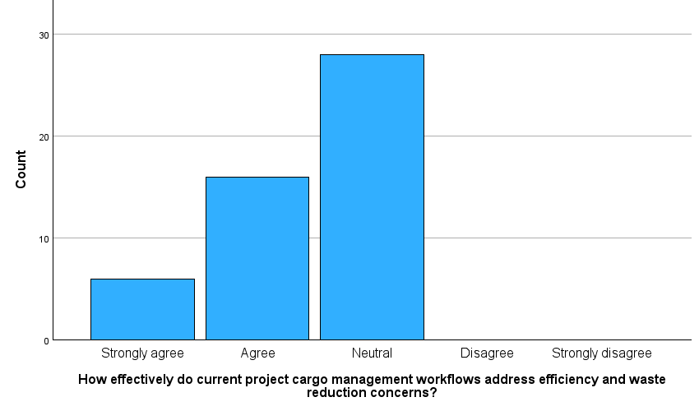

**INTERPRETATION**

From the above table and chart inferred that 12% of the respondent are strongly agree this statement, 32% of the respondent are agree with this statement, 56% of respondent are neutral about this statement. Hence, we conclude that the majority of the respondents are neutral with the above statement

**Table No 2 Do you conclude that implementing eliminate waste can optimize project cargo workflows for better efficiency**

|  |  |  |  |
| --- | --- | --- | --- |
| **S. No** | **Statement** | **Frequency** | **Percentage** |
| 1 | Strongly agree | 6 | 12 |
| 2 | Agree | 27 | 54 |
| 3 | Neutral | 15 | 30 |
| 4 | Disagree | 1 | 2 |
| 5 | Strongly Disagree | 1 | 2 |
|  | **TOTAL** | **50** | **100** |

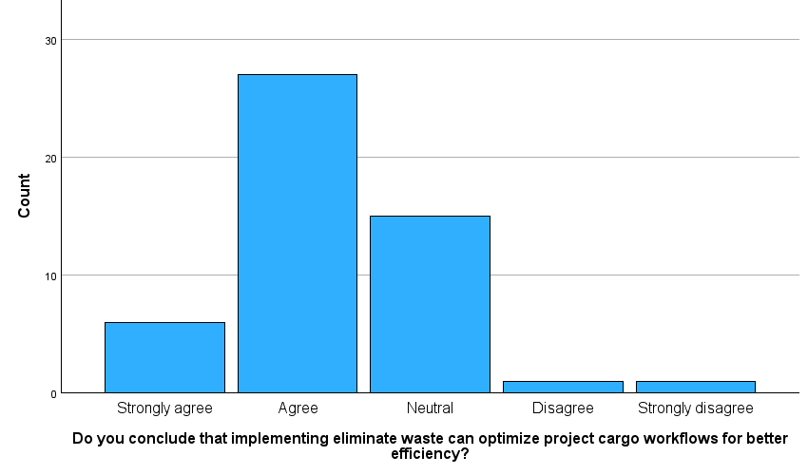**Chart No 2 Do you conclude that implementing eliminate waste can optimize project cargo workflows for better efficiency**

**INTERPRETATION**

From the above table and chart inferred that 12% of the respondent are strongly agree this statement, 54% of the respondent are agree with this statement, 30% of respondent are neutral with this statement, 2% of the respondent are disagree with this statement, 2% of respondent are strongly disagree this statement. Hence, we conclude that the majority of the respondents are agree with the above statement.

**Table No 3 How confident are you that the current project cargo management workflows adequately prioritize efficiency and waste reduction**

|  |  |  |  |
| --- | --- | --- | --- |
| **S. No** | **Statement** | **Frequency** | **Percentage** |
| 1 | Strongly agree | 4 | 8 |
| 2 | Agree | 28 | 56 |
| 3 | Neutral | 17 | 34 |
| 4 | Disagree | 1 | 2 |
| 5 | Strongly Disagree | 0 | 0 |
|  | **TOTAL** | **50** | **100** |

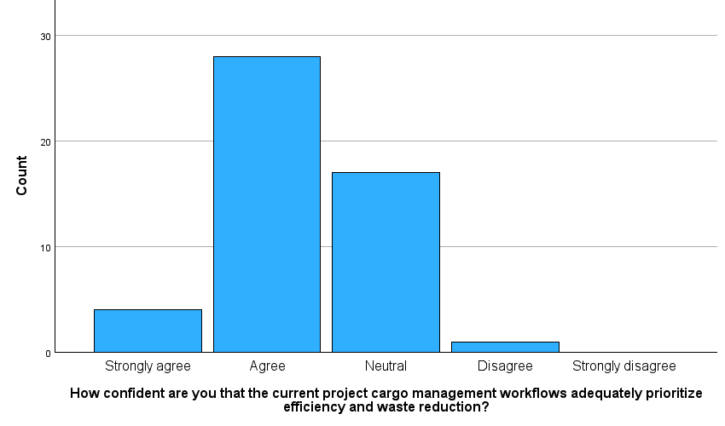**Chart No 3 How confident are you that the current project cargo management workflows adequately prioritize efficiency and waste reduction**

**INTERPRETATION**

From the above table and chart inferred that 8% of the respondent are strongly agree this statement, 56% of the respondent are agree with this statement, 34% of respondent are neutral with this statement, 2% of the respondent are disagree with this statement. Hence, we conclude that the majority of the respondents are agree with the above statement.

**X. FINDINGS OF THE STUDY**

**FINDINGS**

* 56% of the respondents are neutral with the workflows address efficiency and waste reduction concerns.
* 54% of the respondents are agree with eliminate waste can optimize project cargo workflows for better efficiency.
* 56% of the respondents are agree with the workflows adequately prioritize efficiency and waste reduction.

**CHI SQUARE**

Test statistics values surpass 0.5; null hypothesis remains unchallenged. Hence, insufficient evidence to suggest a notable correlation between tracking shipment and market dominance.

Values surpassing 0.5; null hypothesis remains unaltered. Insufficient evidence to deduce a significant association between shipper over partnership and obtaining timely results.

Test statistics values exceed 0.5; null hypothesis persists. Thus, inadequate evidence to infer a significant correlation between tracking and fees presented.

**WEIGHTED AVERAGE**

• The findings indicate a clear inclination among members towards establishing direct connections with shippers as opposed to forming alliances with freight forwarders.

• The outcomes suggest a consensus among members regarding the importance of providing adequate notice for any changes to the terms and conditions. Most respondents seem to support this requirement, reflected by the average agreement score of 3.5.

**CORRELATION TEST**

Suggests absence of a notable correlation between respondents' readiness to adjust their product offerings and marketing approaches and their recognition of competitive advantages in their animal feed product.

Based on the gathered data, there's inadequate proof to assert a significant link between these variables within the studied population.

**XI. SUGGESTIONS**

* Each project may have unique cargo requirements based on size, weight, destination, and timeline.
* Efficient management involves streamlining processes, optimizing routes, and minimizing delays.
* Project cargo management involves inherent risks such as damage, theft, or delays.
* Effective communication among stakeholders, including shippers, carriers, suppliers, and project managers, is crucial.
* Efficiently allocating resources, including manpower, equipment, and finances, is essential for project success.
* Negotiate favorable terms and agreements to minimize delays and cost overruns.
* Enhancing their skills and knowledge will improve overall efficiency and ensure compliance with industry regulations.
* Encourage proactive problem-solving among team members to resolve challenges before they escalate and impact project timelines.

**XII. CONCLUSION**

In conclusion, the challenges faced in project cargo management, while numerous and diverse, serve as catalysts for advancing efficiency and refining logistics strategies. From navigating complex regulatory environments and ensuring precise risk management to leveraging cutting-edge technologies and optimizing resource allocation, each challenge presents a unique opportunity for growth and improvement. Therefore, the path to enhanced efficiency in project cargo management is not just about overcoming obstacles but about transforming these challenges into stepping stones for future success.