**REBECCA P A, MBA Shipping and logistics management, Vels Institute of Science and Technology and Advanced Studies (VISTAS), Pallavaram, Chennai, rebeccaantony95@gmail.com**

**Corresponding Author: Anitha Kumari D, Professor, School Management studies, Vels Institute of Science and Technology and Advanced Studies (VISTAS), Pallavaram, Chennai,** [**anitha.sms@velsuniv.ac.in**](mailto:anitha.sms@velsuniv.ac.in)

**I** **ABSTRACT**

*For firms to guarantee successful supply chain management across borders, international logistics offers a wide range of obstacles. A significant challenge is adhering to rules, which include various import/export laws, documentation specifications specific to every nation, and various customs processes. Oftentimes, these complications lead to further expenses and delays. Infrastructure constraints, particularly in developing nations, are a major barrier as well. These include insufficient ports and transportation networks. Bottlenecks in logistics can result from limitations on the free flow of products. Language and cultural barriers can make it difficult for stakeholders and partners throughout the world to coordinate because of communication issues. To improve global trade efficiency and optimize international logistics operations, overcoming these challenges requires creative thinking, tactical alliances, and innovative technologies.*

***Keywords:*** *supply chain, transportation, cultural barrier, logistics and technologies*

**II INTRODUCTION**

Firms that operate internationally face a variety of difficulties while navigating the complexity of international logistics. Strategic preparation and careful analysis are necessary at every stage of the supply chain, from complex customs requirements to a range of cultural norms. Managing a variety of transportation networks—which include air, sea, and land routes, each with unique logistical obstacles—is one of the biggest issues. A further level of complexity is created by the coordination of inventory

across time zones and geographic regions, which frequently calls for complicated systems and technology. Furthermore, the performance and cost-effectiveness of international logistics operations can be strongly impacted by geopolitical concerns, such as changing trade regulations and changes in the world economy.

**III OBJECTIVE OF THE STUDY**

* To analyze the factors affecting international logistics.
* To study the importance of international logistics.
* To study how difficulties with international logistics affect the quality of customer service and satisfaction.
* To analyze the challenges that come with differences in culture and language while doing overseas logistics operations.
* To implement new strategies to enhance the international logistics service.

**IV NEED FOR THE STUDY**

In today's business environment, when globalization and integrated supply chains are the norm, understanding the difficulties associated with international logistics is essential. Businesses have several challenges when they grow internationally in terms of successfully and economically controlling the flow of commodities. Reducing expenses, preserving competitiveness, and improving supply chain performance all depend on an understanding of these issues. Important factors to take into consideration in international logistics are supply chain resilience, transportation infrastructure, consumer satisfaction, and regulatory compliance. Companies may guarantee on-time delivery, manage complicated regulatory settings, reduce risks, and improve customer experience by recognizing and resolving these issues. Furthermore, technological developments present chances to enhance visibility and expedite procedures in global logistics operations. Considering the effects that logistics and transportation have on the environment, sustainable methods are also essential. In the final analysis, understanding about the difficulties encountered in international logistics helps businesses become more competitive in the global market, adjust to shifting market dynamics, and improve operational efficiency.

**V SCOPE OF THE STUDY**

The study "Challenges Faced in International Logistics" explores the challenges of managing cross-border logistics operations, focusing on transportation, regulatory compliance, cultural barriers, and geopolitical instability. It uses a mixed-method approach, including surveys, case studies, and interviews with logistics professionals and industry experts. The research highlights the financial implications for multinational firms, technological developments, and government initiatives aimed at easing these challenges. The aim is to provide recommendations for more robust international logistics practices, fostering global commerce and economic progress.

**VI REVIEW OF LITERATURE**

Gabriel, D. H., & Parthiban, M. (2020). A Literature Review on Global Challenges for Third Party Logistics (TPL or 3PL). *Asian Review of Mechanical Engineering*, *9*(2), 27-30. This comprehensive analysis of the international difficulties that TPLs encounter is based on several sources, such as book chapters, conference papers, and publications. It highlights problems including cutting lead times, adjusting to new technology, and altering industrial dynamics. The review draws attention to the discrepancy between customer satisfaction and service quality. It recommends putting more emphasis on labor development, resource sharing, and service chain alignment. The purpose of the review is to inform and assist future scholars in identifying research needs. TPLs are still competent logistics providers, but this suggests longer-term, more reliable relationships with clients are required.

Toan, T. T. (2023). Opportunities and challenges for quality of human resource in

public sector of Vietnam’s logistics industry. *International journal of public sector performance management*. By 2025, the logistics sector in Vietnam is expected to grow at a pace of 15%–20% annually and contribute 8%–10% to GDP, according to Government Decision No. 200/2017/QD-TTg. The worldwide logistics business is undergoing a transformation owing to the IR 4.0 trend, which integrates virtual management systems and artificial intelligence. Vietnam may become more competitive and establish a competitive commercial position in the global supply chain by taking note of other nations' experiences. Singapore's success highlights the need for investment in these sectors by showing the significance of investing in people and technology.

Danyluk, M. (2019). Fungible space: Competition and volatility in the global logistics network. International Journal of

Urban and Regional Research, 43(1), 94-111. The paper examines how the logistics revolution and economic globalization have fueled increased interspatial rivalry in the sector. It looks at how the Panama Canal is getting bigger and how North American ports are competing to get bigger container ships. According to the author, this approach to growth is an example of capitalism's propensity to create "fungible space," or locations that may be substituted for one another. Logistics-oriented development is a dangerous growth model for cities, nevertheless, as this dialectic of spatial fungibility and local distinctiveness strengthens rivalry for volatile commodity flows. These dangerous activities have put the safety of laborers and vulnerable communities at risk.

Jung, H., Kim, J., & Shin, K. (2019). Importance analysis of decision-making factors for selecting international freight transportation mode. The Asian Journal of Shipping and Logistics, 35(1), 55-62. Korean Low-Cost Carriers (LCCs) are obtaining permits for international freight delivery services, creating fierce rivalry in the international freight service sector. Due to exorbitant expenses, many shippers prefer automobile ferry services even if air transportation offers a higher level of service. This study compares vehicle ferry services with international transportation services to see if low-cost carriers (LCCs) can offer a competitive advantage. For shippers shipping goods from Korea to China, Japan, and Russia, a questionnaire was created. Convenience and reliability were found to be important considerations when choosing a method of transportation. This study can assist LCCs develop

competitive strategies with auto ferry services.

Kot, M. (2021, May). Threats In International Logistics–Study During Covid-19 Pandemic Time. In Proceedings of the 37th International Business Information Management Association Conference (IBIMA) (pp. 30-31). Operating a business includes risk, which is influenced by several factors. Entrepreneurs that are responsible should take steps to lower risk and increase success. Businesses ought to assess the market and any risks to guard against them. International logistics are impacted by the current crisis, with trade restrictions and border delays posing the biggest risks. More than half of those surveyed are ready for trade limitations and delays at borders notwithstanding the current crisis. To reduce risks, entrepreneurs have increased stock levels, made cash reserves, and made plans for any market fluctuations.

**VII STATEMENT OF THE PROBLEM**

The study of international logistics is required to understand the challenges faced in international logistics and the statement of analysis helps to understand the customs regulations across borders and delays & higher expenses. This helps to resolve this by collaborating with custom brokers and logistics partners to reduce risks faced in international logistics.

**VIII RESEARCH GAP**

The limitations of the study are as follows. Obtaining necessary samples was challenging because the logistics and shipping companies have fewer employees. The period of the study is restricted to 2 months. So, all the areas cannot be covered in this study. Some of the data has not been collected accurately as the information is sensitive.

**IX RESEARCH METHODOLOGY**

Research methodology refers to the methodical approach and framework that scientists employ to gather, examine, and evaluate data in an organized manner. It includes the general methodology and methods used in a research investigation. A strong research methodology offers a defined road map for carrying out the study and guarantees the validity and dependability of findings. Researchers discuss possible study limits and ethical issues in addition to outlining the methodology for collecting data. As such, it plays a key role in every research project, assisting the investigator throughout the whole process, from developing research questions to showing findings. The proposed research is primarily descriptive in design. It outlines the procedures for gathering, measuring, and analyzing data to effectively test hypotheses.

**X PERCENTAGE ANALYSIS**

1. **Difficulties faced during international logistics customs clearance.**

**TABLE 1**

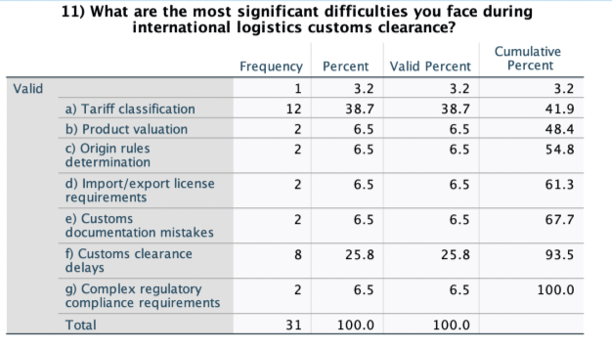

**Difficulties faced during international logistics customs clearance.**

**CHART 1**

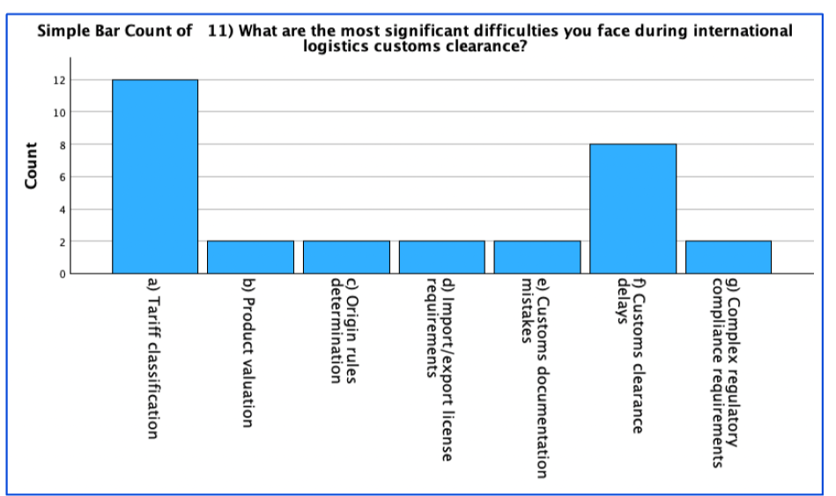

**INFERENCE:**

From the above table and chart inferred that 38.7% of the respondents tariff classification is difficulties faced during international logistics customs clearance and 25.8% of the respondents customs clearance delays is difficulties faced during international logistics customs clearance and 6.5% of the respondents product valuations, origin rules determination, import/ export license requirements, complex regulatory compliance requirements, customs documentation mistakes is difficulties faced during international logistics customs clearance.

1. **COMMUNICATION TECHNIQUES FOR EFFECTIVE COMMUNICATION AMONG THE STAKEHOLDERS.**

**TABLE 2**

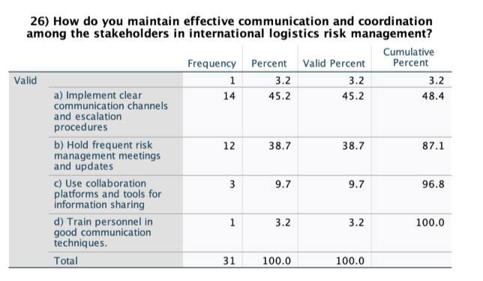

**COMMUNICATION TECHNIQUES FOR EFFECTIVE COMMUNICATION AMONG THE STAKEHOLDERS.**

**CHART 2**

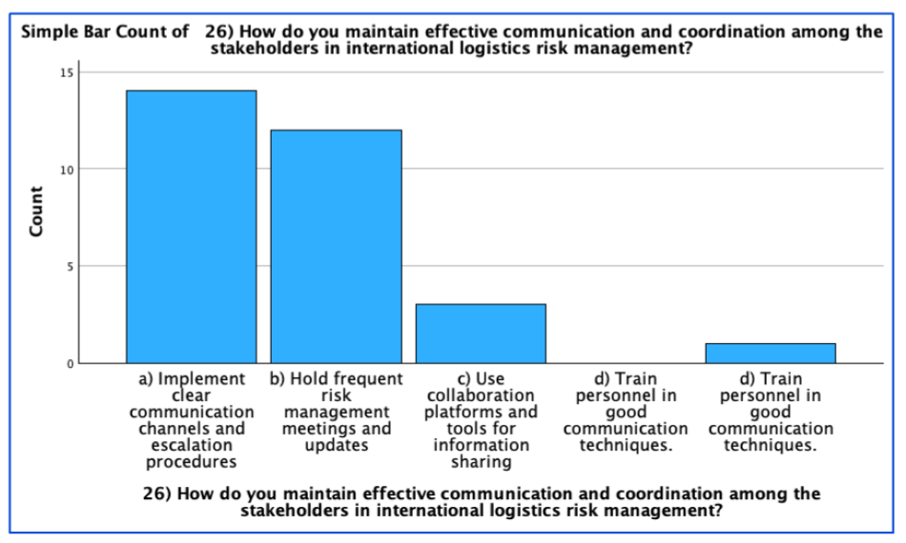

**INFERENCE:**

From the above table and chart inferred that 45.2% of the respondents implements clear communication channels and escalation procedures for effective communication among the stakeholders and 38.7% of the respondents hold frequent risk management meetings and updates for effective communication among the stakeholders and 9.7% of the respondents use collaborations platforms and tools for information sharing for effective communication among the stakeholders and 3.2% of the respondents train personnel in communication techniques for effective communication among the stakeholders .

**CHI SQUARE TEST**

1. Comparing the two variables is the typical challenges do you encounter while arranging shipments of air freight across international borders and the typical difficulties do you run across while arranging shipments of sea freight across international borders.

**TABLE 3**

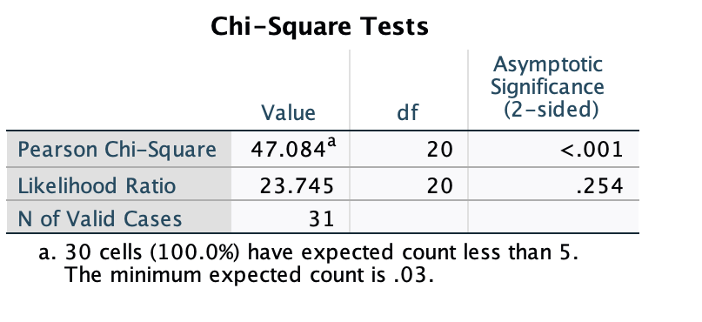**INFERENCE:**

The test was conducted to determine if there is a significant association between sea freight and air freight challenges across international borders. The Pearson Chi- square test statistic is 47.884 and 20 degrees of freedom. The like hood ratio test statistics is 23.745 and 20 degrees of freedom. If the calculated value is 0.5> reject null (h0).

Result: Here, there is an association between sea freight and air freight challenges across international borders. Reject the null hypothesis and accept the alternative hypothesis.

1. Comparing the two variables is the primarily serve with project freight logistics services and relevance of risk management in international logistics.

**TABLE 4**

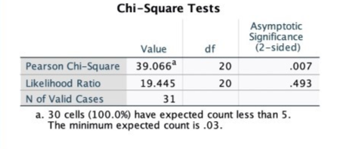**INFERENCE:**

The test was conducted to determine if there is a significant association between primarily serving with project freight logistics services and relevance of risk management in international logistics on a scale of 1to 5. The Pearson Chi- square test statistic is 39 .066 and 20 degrees of freedom. The like hood ratio test statistics is 19.445 and 20 degrees of freedom. If the calculated value is 0.5> reject null (h0).

Result: Here, there is an association between primarily serving with project freight logistics services and relevance of risk management in international logistics. Reject the null hypothesis and accept the alternative hypothesis.

**XI CONCLUSION**

In conclusion, the study on the difficulties in international logistics paints a picture of the sector that is characterized by complex supply chain networks and rules. Logistical systems are further complicated by the tight adherence to several import/export rules and customs processes that are required due to the intricate interconnectedness of global activities. Furthermore, it is challenging to transfer items effectively due to inconsistent storage rules and transportation infrastructure, which results in increased costs and delays.

Technology, with all its promise, nevertheless faces integration challenges in the form of incompatibilities and concerns over data security in international operations. Maintaining open lines of communication between stakeholders and the supply chain is another constant problem. Risk management becomes essential when one is subjected to external forces and geopolitical issues.

**XII REFERNCES**

* Gabriel, D. H., & Parthiban, M. (2020). A Literature Review on Global Challenges for Third Party Logistics (TPL or 3PL). *Asian Review of Mechanical Engineering*, *9*(2), 27-30.
* Toan, T. T. (2023). Opportunities and challenges for quality of human resource in public sector of Vietnam’s logistics industry. *International journal of public sector performance management*.
* Danyluk, M. (2019). Fungible space: Competition and volatility in the global logistics network. International Journal of Urban and Regional Research, 43(1), 94-111.
* Jung, H., Kim, J., & Shin, K. (2019). Importance analysis of decision-making factors for selecting international freight transportation mode. The Asian Journal of Shipping and Logistics, 35(1), 55-62.
* Kot, M. (2021, May). Threats in International Logistics–Study During Covid-19 Pandemic Time. In Proceedings of the 37th International Business Information Management Association Conference (IBIMA) (pp. 30-31).
* [**https://lsc-india.com/logistics-industry-overview**](https://lsc-india.com/logistics-industry-overview)
* [**https://www.alliedmarketresearch.com/logistics-market**](https://www.alliedmarketresearch.com/logistics-market)
* [**https://www.wikipedia.org/**](https://www.wikipedia.org/)