**A Study on Challenges in Air Cargo and Hub Operations**

**RITHIKA M P, MBA Shipping and logistics management, Vels Institute of Science and Technology and Advanced Studies (VISTAS), Pallavaram, Chennai, rithikamathi98@gmail.com**

**Corresponding Author: Anitha Kumari D, Professor, School Management studies, Vels Institute of Science and Technology and Advanced Studies (VISTAS), Pallavaram, Chennai,** [**anitha.sms@velsuniv.ac.in**](mailto:anitha.sms@velsuniv.ac.in)

**I ABSTRACT**

*The air cargo sector is essential to international trade and logistics because it makes it possible to move goods over long distances quickly. However, in spite of its significance, this industry faces a number of difficulties that affect its efficacy and efficiency. With an emphasis on issues like infrastructure constraints, regulatory complexities, security concerns, environmental sustainability, and technological advancements, this study explores the primary challenges faced in air cargo and hub operations. By analysing these challenges, this study aims to provide insights into potential strategies and solutions for improving the performance and resilience of air cargo and hub operations in the face of evolving global demands and trends. Through a comprehensive review of literature and case studies, this research seeks to contribute to a better understanding of the complexities within the air cargo industry and offer recommendations for addressing its pressing challenges.*

*Keywords: Air cargo, sustainability, hub operation and security concern*

**II INTRODUCTION**

The project "Air Cargo and Hub Operation" studies the various processes of the air cargo sector, focusing on hub operations. Air cargo is essential for connecting companies, facilitating trade, and accelerating supply chains in the modern, globalised world. As hubs are key locations where cargo is effectively sorted, consolidated, and distributed, it is essential to understand the dynamics of hub operations. Aspects of air cargo and hub operations, such as technological developments, legal frameworks, logistical challenges, and the economic effects at the local and global levels, will all be studied in this project. The objective is to study these factors in order to offer suggestions for improving hub operations, increasing productivity, and eventually helping to ensure the smooth transportation of cargo by air.

**III OBJECTIVES**

* To study the way new technologies (such as automation, block chain, and the Internet of Things) are impacting air cargo and hub operations, and identify any challenges or opportunities that come with implementing them.
* To study the current legal frameworks controlling air cargo and hub operations to find areas, that could use improvement and identify any challenges.
* To study the challenges regarding safety and security of air cargo, taking into account cyber and physical risks, and provide solutions.
* To evaluate how air freight operations are integrated into larger supply chain networks, noting any difficulties with cooperation, coordination, and communication

**IV NEED FOR STUDY**

Researching the challenges related to air cargo and hub operations is essential to the growth and efficiency of the sector. Considering the growth of e-commerce and the expansion of global trade, being aware of these challenges helps prepare for and reduce future obstacles. Increasing productivity and reducing costs are critical outcomes that are essential for companies and customers equally. In addition, it is important to ensure security and safety when managing different kinds of goods. Attention must be paid to technical improvements, environmental concerns, infrastructure development, and regulatory compliance.  This study encourages innovation, improves sustainable practices, and promotes global supply chains—benefiting all parties involved in the air cargo ecosystem.

**V SCOPE OF THE STUDY**

The "Air Cargo Hub Operation" research includes a review of the infrastructure needs, operational procedures, technological adoption, regulatory compliance, environmental effects, and profitability related to establishing and managing an air cargo hub. The air freight industry's logistical challenges, security measures, and efficiency optimization will be the main areas of analysis. The "Air Cargo Hub Operation" research includes a comprehensive review of operations, infrastructure needs, technological integration, regulatory compliance, environmental factors, and economic feasibility. Its goal is to examine the difficulties involved in setting up and running an air freight hub, with a focus on optimizing efficiency, putting strong security measures in place, and getting beyond logistical challenges. The study aims to offer valuable perspectives on optimizing supply chain dynamics, encouraging business development, and ensuring sustainable growth in the air cargo sector.

**VI REVIEW OF LITERATURE**

The study of (Feng, B., Li, Y., & Shen, Z. J. M., 2015) they analyze the literature on air freight operations and contrasted cutting-edge ideas with actual operational procedures. After providing an overview of the air cargo sector, they examine how the features of air cargo operations differed from those of air passenger operations.

In another study(Scholz, A. B., & von Cossel, J., 2011) the air freight industry has grown extremely quickly, moving from being a mere outcome to an independent industry. New goods terminals are an investment for airport operators, and they must be effectively financed by airport fees. Airports must therefore be financially aware of their position within the network of the operating airline.

In the research of (Chen, G., Cheung, W., Chu, S. C., & Xu, L.,2017**)** the international logistics community is increasingly evaluating the selection of transshipment hubs, considering factors such as the company's country of origin, air and sea transportation options, and the opinions of logistics stakeholders. The choice must support service reliability and cost management, align with shippers and goods forwarders' perspectives, and consider qualitative and quantitative aspects.

In this research (Brandt, F., & Nickel, S. 2019) they introduced the Air Cargo Load Planning Problem (ACLPP), which cargo-transporting airlines have to solve. In a business that was practically relevant but highly competitive, this was challenging to plan.

In another study of (Hsu, C. I., & Wang, C. C.2013) in order to minimize the overall cost of logistics, this study created a number of models for planning an air cargo network that includes flight frequencies, types of aircraft, and routes. The hub-and-spoke network architecture takes time value of goods, economies of scale, and route distance into account. The results of the evaluation illustrated how a hub-and-spoke system's flow consolidation may worsen the effects of demand variations. When using a hub-and-spoke system, airlines have to schedule their flights and routes with sufficient flexibility to deal with unexpected events.

**VII STATEMENT OF THE PROBLEM**

Air cargo hubs regularly experience congestion owing to heavy cargoes, resulting in delays, longer processing times, and more severe operating efficiency. Hub operators face increasing pressure to adopt sustainable practices and decrease their environmental effect, but striking a balance between environmental considerations and operational efficiency remains a significant challenge. To be successful in the highly competitive air cargo sector, hub operators must continually react to market changes, price pressures, and new competitors.

**VIII Percentage Analysis:**

1. Factors to be considered when choosing a route for air cargo operations.

Table No:1

|  |  |  |  |  |  |
| --- | --- | --- | --- | --- | --- |
|  | | | | | |
|  | | Frequency | Percent | Valid Percent | Cumulative Percent |
| Valid | Cost | 9 | 23.1 | 23.1 | 23.1 |
| Time | 13 | 33.3 | 33.3 | 56.4 |
| Accessibility | 9 | 23.1 | 23.1 | 79.5 |
| Security | 8 | 20.5 | 20.5 | 100.0 |
| Total | 39 | 100.0 | 100.0 |  |

Chart No: 1

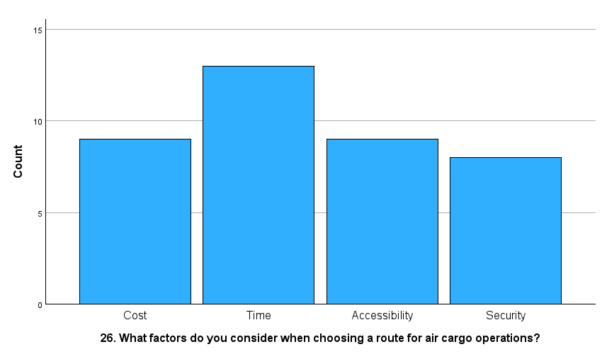

INFERENCE: From the above table and chart, inferred that 33.3% of the respondents considered time is the highest factor when choosing a route for air cargo operations and 23.1% responded cost and accessibility and 20.5% of the respondents considered security is the lowest factor when choosing a route for air cargo operations.

1. Factors that affect the decision of locating the air cargo hub

|  |  |  |  |  |  |
| --- | --- | --- | --- | --- | --- |
| Table No: 2 | | | | | |
|  | | Frequency | Percent | Valid Percent | Cumulative Percent |
| Valid | Proximity to major markets | 5 | 12.8 | 12.8 | 12.8 |
| Availability of infrastructure | 16 | 41.0 | 41.0 | 53.8 |
| Government incentives | 10 | 25.6 | 25.6 | 79.5 |
| Operational costs | 8 | 20.5 | 20.5 | 100.0 |
| Total | 39 | 100.0 | 100.0 |  |

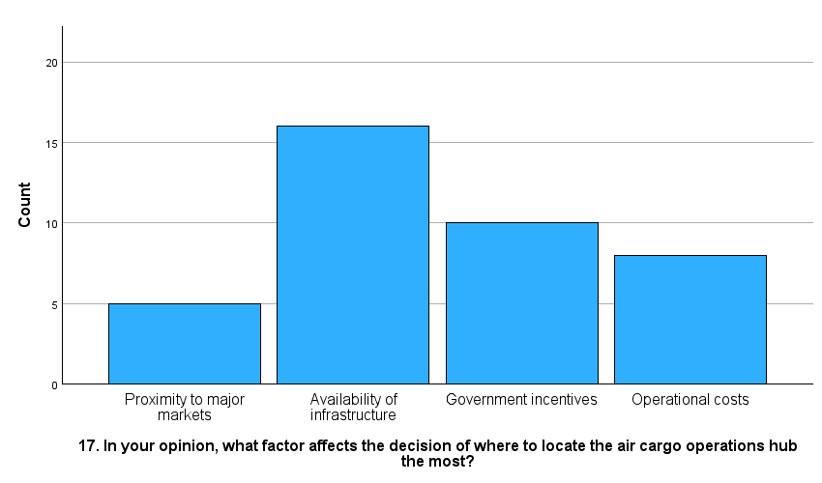

Chart No: 2

**Inference:**

From the above table and chart, inferred that 41% of the respondents shared their opinion as availability of infrastructure that affect the decision of locating the air cargo hub and 25.6% responded government incentives and 20.5% responded operational costs and 12.8% responded proximity to major markets affects the decision of locating the air cargo hub.

**CHI SQUARE TEST:**

1. Comparing the two variables is the biggest challenge in air cargo hub operations and the main advantage of having a consolidated air cargo hub

Table No: 3

|  |  |  |  |
| --- | --- | --- | --- |
| **Chi-Square Tests** | | | |
|  | Value | df | Asymptotic Significance (2-sided) |
| Pearson Chi-Square | 9.561a | 9 | .387 |
| Likelihood Ratio | 13.316 | 9 | .149 |
| N of Valid Cases | 39 |  |  |
| a. 16 cells (100.0%) have expected count less than 5. The minimum expected count is 1.23. | | | |

**Inference:**

The test was conducted to determine if there is a significant association between the challenge of having an air cargo hub and the advantage of having a consolidated air cargo hub. The Pearson Chi-square test statistic is 9.561 with 9 degrees of freedom. The likehood ratio test statistics are 13.316 and 9 degrees of freedom. If the calculated value is >0.5, reject null (h0).

**Result:** Here, there is an association between the challenge of having an air cargo hub and the advantage of having a consolidated air cargo hub. Reject the null hypothesis and accept the alternative hypothesis.

1. Comparing the two variables in the area of air cargo operation requires most innovation and challenges specific to cross-border operations in air cargo hubs.

|  |  |  |  |
| --- | --- | --- | --- |
| Table No: 4 | | | |
|  | | | |
|  | Value | Df | Asymptotic Significance (2-sided) |
| Pearson Chi-Square | 7.192a | 9 | .617 |
| Likelihood Ratio | 7.715 | 9 | .563 |
| N of Valid Cases | 39 |  |  |
| a. 16 cells (100.0%) have expected count less than 5. The minimum expected count is .36. | | | |

**Inference:**

The test was conducted to determine if there is a significant association between area of air cargo operation requires most innovation and challenges specific to cross-border operations in air cargo hubs. The Pearson Chi- square test statistic is 7.192 with 9 degrees of freedom. The likehood ratio test statistics is 7.715 and 9 degree of freedom. If the calculated value is <0.5, accept null (h0).

**Result:** Here, there is no association between areas of air cargo operation requires most innovation and challenges specific to cross-border operations in air cargo hubs. Accept the null hypothesis and reject the alternative hypothesis.

**IX RESEARCH GAP**

This study has the following limitations: Air cargo shipments are included in the analysis. The company withheld some of the data because it was confidential. The study is scheduled for a maximum of two months. Therefore, not all sections of the subject can be explored. Because of the fluctuations in air freight shipments, it is not possible to precisely anticipate the studied data for the future.

**X RESEARCH METHODOLOGY**

A research technique is a methodical approach to handling a research topic. It is possible to think of it as an industry that investigates the methods used in scientific research. This paper analyses the several processes that a researcher often takes to investigate his research problem and the reasoning behind them. The planned study is primarily descriptive in nature. In order to make research as efficient as possible, research design is necessary since it makes the various research methods perform effectively.

**XI CONCLUSION**

In summary, the challenges related to air cargo and hub operations are complicated and require comprehensive solutions in order for the sector to grow successfully. Stakeholder collaboration is required to overcome difficulties ranging from technical improvements to regulatory compliance and logistical restrictions. To get through these challenges, strategies that make use of innovative technologies, effective procedures, and flexible infrastructure are needed. The long-term reliability and efficiency of air cargo and hub operations also depend on encouraging innovation, improving teamwork, and investing in sustainable practices. The industry can take advantage of new opportunities and improve operational effectiveness by recognizing and proactively addressing these issues, which will ultimately ensure a more robust and resilient air freight setting in the future.

**XII REFERENCE**

* Air cargo operations: Literature review and comparison with practices. Transportation Research Part C: Emerging Technologies, 56, 263-280.
* The air cargo load planning problem-a consolidated problem definition and literature review on related problems. European Journal of Operational Research, 275(2), 399-410.
* Reliability analysis of network design for a hub-and-spoke air cargo network. International Journal of Logistics Research and Applications, 16(4), 257-276.
* Assessing the importance of hub airports for cargo carriers and its implications for a sustainable airport management. Research in Transportation Business & Management, 1(1), 62-70.
* Transshipment hub selection from a shipper's and freight forwarder's perspective. Expert systems with applications, 83, 396-404