**Detection Of Face Morphing**

**Using Deep Learning**

**Mr.A.Ramesh1,.. Bheema Sri Lakshmi2,.. Dasari Narendar3,**

**Moinuddin Mohammed Najeeb 4, Vudaru Sai 5**

*1Associate. Professor, CSE Dept, ACE Engineering College, Hyderabad, India*

*a.ramesh@aceec.ac.ia*

*2Student, CSE Dept, ACE Engineering College, Hyderabad, India*

*Srilaxmibheema6@gmail.com*

*3 Student, CSE Dept, ACE Engineering College, Hyderabad, India*

*lukkynarendar@gmail.com*

*4 Student, CSE Dept, ACE Engineering College, Hyderabad, India*

*Moinnajeeb472@gmail.com*

*5 Student, CSE Dept, ACE Engineering College, Hyderabad, India*

*Saivudaru2001@gmail.com*

**1.ABSTRACT**

Identification by biometric features has become more popular in the last decade. High quality video and fingerprint sensors have become less expensive and are nowadays standard components in many mobile devices. Thus, many devices can be unlocked via fingerprint or face verification. The state-of-the-art accuracy of biometric facial recognition systems prompted even systems that need high security standards like border control at airports to rely on biometric systems.

While most biometric facial recognition systems perform quite accurate under a controlled environment, they can easily be tricked by morphing attacks. The concept of a morphing attack is to create a synthetic face image that contains characteristics of two different individuals and to use this image on a document or as reference image in a database. Using this image for authentication, a biometric facial recognition system accepts both individuals. In this paper, we propose a morphing attack detection approach based on convolutional neural networks.

We present an automatic morphing pipeline to generate morphing attacks, train neural networks based on this data and analyze their accuracy. The accuracy of different well-known network architectures is compared and the advantage of using pretrained networks compared to networks learned from scratch is studied.

**2.INTRODUCTION**Biometric facial recognition systems are nowadays present in many areas of daily life. They are used to identify people, find pictures of the same person in your digital image collection, to make suggestions for tagging people in social media or for verification tasks like unlocking a phone or a computer

Apart from these consumer market applications,

biometric facial recognition systems found also their way into sovereign tasks like automatic border control at airports. In particular, for these tasks the verification system has to be reliable and secure. Even though biometric facial recognition systems achieve false rejection rates below 1% at a false acceptance rate of 0.1% in a controlled environment [1], they can easily be tricked by a specific attack, known as morphing attack [2]. The concept of this attack is to create a synthetic face image that is, in the eye of the recognition system, similar to the faces of two different individuals. Thus, both can use the same synthetic face image for authentication. This attack is usually performed by creating a face image that contains characteristics of both faces, for example by face morphing. Since such an attack has a drastic impact on the authenticity of its underlying system, its automatic detection is of outmost importance. The detection of attacks by image manipulation has been studied for various tasks. Several publications deal with the detection of resampling artifacts [3, 4], the use of specific filters, e.g. median filters [5], or JPEG-double compression [6, 7]. Beside these analyses based on signal theory,

several authors proposed image forgery detection methods based on semantic image content by analyzing reflections and shadows [8, 9]. Recently, the detection and analysis of forged face images with the purpose of tricking a facial recognition system became interesting to many researchers, which were certainly influenced by the publication of a manual for morphing attacks from Ferrara et al. [2]. Markeshia et al. [10] proposed an approach for automatic generation of facial morphs and their detection based on the distribution of Benford features extracted from quantized DCT coefficients of JPEG-compressed morphs. Raghavendra et al. [11] presented a morphing detection method based on binary statistical images features and evaluated its accuracy on manually created morphed face images.

# 3.PROBLEM STATEMENT

Face recognition systems (FRSs), integral to real-time applications such as border control, face a significant vulnerability in the form of face morphing attacks. Malicious actors can exploit this weakness by generating morphed face images to obtain electronic machinereadable travel documents (eMRTDs) or e-passports. This allows them to cross borders undetected, presenting a serious threat to security. The survey aims to systematically review the progress in face morphing attacks, covering morph generation and detection techniques. It addresses the urgent need for effective morph attack detection (MAD) algorithms, emphasizing a stringent taxonomy and the importance of standardized benchmarks for evaluation. By exploring competitions, vulnerability assessments, and performance metrics, the survey provides a comprehensive understanding of the current landscape. The identified open challenges underscore the ongoing necessity for research and development to ensure the resilience of biometric systems in the face of evolving threats.

## 3.1 EXISTING SYSTEM

The development and implementation of Morph Attack Detection (MAD) algorithms. These algorithms aim to detect morphed face images used for bypassing Face Recognition Systems (FRSs) in automatic border control gates. The system includes techniques for generating morphed face images as well as state-of-the-art MAD algorithms based on a comprehensive taxonomy. Additionally, the system provides access to public databases for benchmarking new MAD algorithms in a reproducible manner. The system also includes vulnerability assessments, performance evaluation metrics, outcomes of competitions, and benchmarking results. It addresses the challenges in face morphing attacks and aims to improve the security of biometric systems.

## 3.2 PROPOSED SYSTEM

The proposed system aims to enhance the security of face recognition systems (FRSs) by developing advanced techniques for detecting face morphing attacks. The system will utilize state-of-the-art deep learning algorithms, such as convolutional neural networks (CNNs) and generative adversarial networks (GANs), to improve the accuracy of morphed face image detection. Additionally, the proposed system will include a comprehensive database of morphed face images for training and testing purposes. To ensure the effectiveness of the system, it will also incorporate real-time monitoring capabilities and will be designed to integrate seamlessly with existing FRSs, particularly in critical applications such as border control. Furthermore, the system will provide detailed vulnerability assessments, performance evaluation metrics, and regular updates to address emerging threats in biometric security.

**4..LITERATURE SURVEY**

**Title: -**[Morphing](https://ieeexplore.ieee.org/abstract/document/9794509/) [attack](https://ieeexplore.ieee.org/abstract/document/9794509/) [potential](https://ieeexplore.ieee.org/abstract/document/9794509/)

**Description: -** In security systems the risk assessment in the sense of common criteria testing is a very relevant topic; this requires quantifying the attack potential in terms of the expertise of the attacker, his knowledge about the target and access to equipment. Contrary to those attacks, the recently revealed morphing attacks against Face Recognition Systems (FRSs) cannot be assessed by any of the above criteria. But not all morphing techniques pose the same risk for an operational face recognition system. This paper introduces with the Morphing Attack Potential (MAP) a consistent methodology, that can quantify the risk, which a certain morphing attack creates.

**Disadvantages: -** The model introduces the Morphing Attack Potential (MAP) as a methodology to quantify the risk posed by morphing attacks against Face Recognition Systems (FRSs). While it addresses the limitations of traditional risk assessment criteria in evaluating morphing attacks, the abstract has some notable disadvantages. Firstly, it lacks specific details about how MAP is calculated or what factors it considers in quantifying the risk. Additionally, there is no mention of the methodology's reliability or validation. The abstract could benefit from providing more information on the practical implementation of MAP, its applicability across different morphing techniques, and any experimental results demonstrating its effectiveness. Furthermore, clarity on how MAP contributes to addressing the specific challenges posed by morphing attacks would enhance the abstract's comprehensibility.

**Title: -**On resampling detection in re-compressed images

**Description: -** Resampling detection has become a standard tool in digital image forensics. This paper investigates the important case of resampling detection in re-compressed JPEG images. We show how blocking artifacts of the previous compression step can help to increase the otherwise drastically reduced detection performance in JPEG compressed images. We give a formulation on how affine transformations of JPEG compressed images affect state-of- the-art resampling detectors and derive a new efficient detection variant, which better suits this relevant detection scenario. The principal appropriateness of using JPEG pre-compression artifacts for the detection of resampling in re- compressed images is backed with experimental evidence on a large image set and for a variety of different JPEG qualities.

**Disadvantages:** The model provides insights into the investigation of resampling detection in re-compressed JPEG images, with a focus on utilizing blocking artifacts from the previous compression step to improve detection performance. However, it has some notable disadvantages.

Firstly, it lacks clarity in explaining the specific mechanisms by which blocking artifacts aid in detection improvement. The abstract could benefit from a more detailed explanation of the proposed formulation and how affine transformations in JPEG compressed images impact state-of-the-art resampling detectors.

**Title: -**[Exposing](https://link.springer.com/chapter/10.1007/978-3-540-77370-2_21) [digital](https://link.springer.com/chapter/10.1007/978-3-540-77370-2_21) [forgeries](https://link.springer.com/chapter/10.1007/978-3-540-77370-2_21) [through](https://link.springer.com/chapter/10.1007/978-3-540-77370-2_21) [specular](https://link.springer.com/chapter/10.1007/978-3-540-77370-2_21) [highlights](https://link.springer.com/chapter/10.1007/978-3-540-77370-2_21) [on the eye](https://link.springer.com/chapter/10.1007/978-3-540-77370-2_21)

**Description: -** When creating a digital composite of two people, it is difficult to exactly match the lighting conditions under which each individual was originally photographed. In many situations, the light source in a scene gives rise to a specular highlight on the eyes. We show how the direction to a light source can be estimated from this highlight. Inconsistencies in lighting across an image are then used to reveal traces of digital tampering.

**Disadvantages: -** The model discusses the challenges of precisely matching lighting conditions in digital composites of two people and proposes a method to estimate the direction to a light source using specular highlights on the eyes. While the idea is interesting, the abstract has several disadvantages. Firstly, it lacks specificity in describing the proposed method; details on the techniques used for estimating light direction and identifying inconsistencies in lighting are not provided. This absence of technical details hinders the reader's understanding of the novelty and effectiveness of the approach.

**Title: -**[Analyzing](http://openaccess.thecvf.com/content_cvpr_2016/html/Bach_Analyzing_Classifiers_Fisher_CVPR_2016_paper.html) [classifiers:](http://openaccess.thecvf.com/content_cvpr_2016/html/Bach_Analyzing_Classifiers_Fisher_CVPR_2016_paper.html) [Fisher](http://openaccess.thecvf.com/content_cvpr_2016/html/Bach_Analyzing_Classifiers_Fisher_CVPR_2016_paper.html) [vectors and](http://openaccess.thecvf.com/content_cvpr_2016/html/Bach_Analyzing_Classifiers_Fisher_CVPR_2016_paper.html) [deep neural](http://openaccess.thecvf.com/content_cvpr_2016/html/Bach_Analyzing_Classifiers_Fisher_CVPR_2016_paper.html) [networks](http://openaccess.thecvf.com/content_cvpr_2016/html/Bach_Analyzing_Classifiers_Fisher_CVPR_2016_paper.html)

**Description: -** Fisher vector (FV) classifiers and Deep Neural Networks (DNNs) are popular and successful algorithms for solving image classification problems. However, both are generally considered black box ‘predictors as the non-linear transformations involved have so far prevented transparent and interpretable reasoning. Recently, a principled technique, Layer-wise Relevance Propagation (LRP), has been developed in order to better comprehend the inherent structured reasoning of complex nonlinear classification models such as Bag of Feature models or DNNs. In this paper we (1) extend the LRP framework also for Fisher vector classifiers and then use it as analysis tool to (2) quantify the importance of context for classification,(3) qualitatively compare DNNs against FV classifiers in terms of important image regions and (4) detect potential flaws and biases in data. All experiments are performed on the PASCAL VOC 2007 and ILSVRC 2012 data sets.

**Disadvantages: -** The model mentions experiments on specific datasets (PASCAL VOC 2007 and ILSVRC 2012), but it does not provide any results or findings from these experiments, leaving the reader without a sense of the outcomes.

**Title: -**[A multi-](https://link.springer.com/chapter/10.1007/978-3-319-53465-7_1) [purpose](https://link.springer.com/chapter/10.1007/978-3-319-53465-7_1) [image](https://link.springer.com/chapter/10.1007/978-3-319-53465-7_1) [counter-](https://link.springer.com/chapter/10.1007/978-3-319-53465-7_1) [anti-forensic](https://link.springer.com/chapter/10.1007/978-3-319-53465-7_1) [method](https://link.springer.com/chapter/10.1007/978-3-319-53465-7_1) [using](https://link.springer.com/chapter/10.1007/978-3-319-53465-7_1) [convolution](https://link.springer.com/chapter/10.1007/978-3-319-53465-7_1) [al neural](https://link.springer.com/chapter/10.1007/978-3-319-53465-7_1) [networks](https://link.springer.com/chapter/10.1007/978-3-319-53465-7_1)

**Description: -** During the past decade, image forensics has made rapid progress due to the growing concern of image content authenticity. In order to remove or conceal the traces that forensics based on, some farsighted forgers take advantage of so-called anti-forensics to make their forgery more convincing. To rebuild the credibility of forensics, many countermeasures against anti- forensics have been proposed. This paper presents a multi-purpose approach to detect various anti- forensics based on the architecture of Convolutional Neural Networks (CNN), which can automatically extract features and identify the forged types. Our model can detect various image anti-forensics both in binary and multi-class decision effectively. Experimental results show that the proposed method performs well for multiple well- known image anti-forensic methods.

**Disadvantages: -** The model does not address the broader context of ethical considerations related to image forensics, such as potential misuse or privacy concerns. A brief discussion on the ethical implications of developing anti-forensic detection methods would add depth to the abstract.

**Title: -**[Video](https://dl.acm.org/doi/abs/10.1145/2824840.2824843) [based facial](https://dl.acm.org/doi/abs/10.1145/2824840.2824843) [reanimation](https://dl.acm.org/doi/abs/10.1145/2824840.2824843)

**Description: -** Generating photorealistic facial animations is still a challenging task in computer

# 5.OBJECTIVE OF THE PROJECT

**Knowledge Dissemination:**

Disseminate knowledge about the potential risks and vulnerabilities faced by FRSs, especially concerning the use of face morphing attacks to manipulate electronic travel documents.

**Survey of Face Morphing Landscape:**

Present a systematic survey of the current state of face morphing attacks, covering both the generation of morphed face images and the development of detection algorithms.

**Taxonomy and Classification:**

Introduce a stringent taxonomy for the classification of morph attack detection (MAD) algorithms, providing a structured framework for understanding different techniques and approaches.

**Benchmarking and Evaluation:**

Emphasize the importance of standardized benchmarks and public databases for evaluating the effectiveness of MAD algorithms, including insights from competitions, vulnerability assessments, and performance metrics.

**Identification of Challenges:**

Highlight open challenges in the field, recognizing areas that require further attention and research to enhance the security of biometric systems against face morphing attacks

When the majority of nodes agree (aka gain consensus), the system updates itself accordingly (ie. adopting the new information into all copies of the ledger, or rejecting it). Distributed ledgers run without a central authority, revolutionizing the way we think of democracy.

# 6.ADVANTAGES AND LIMITATIONS

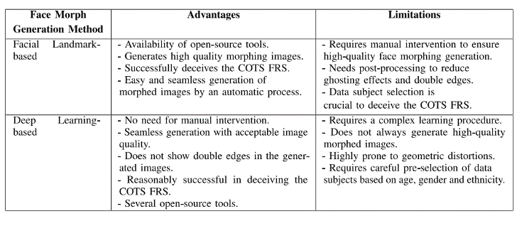

**7.SYSTEM DESIGN**

## 7.1.UML DIAGRAMS

### 7.1.1CLASS DIAGRAM

Figure 5:Class Diagram

### 7.1.2 USECASE DIAGRAM

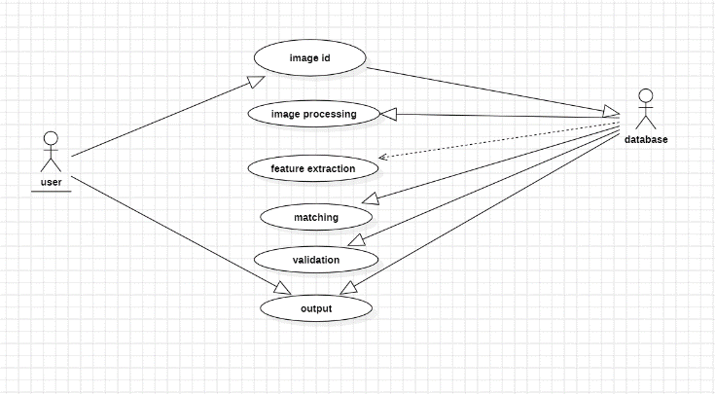

Figure 4:Usecase Diagram

### 7.1.3 COMPONENT DIAGRAM

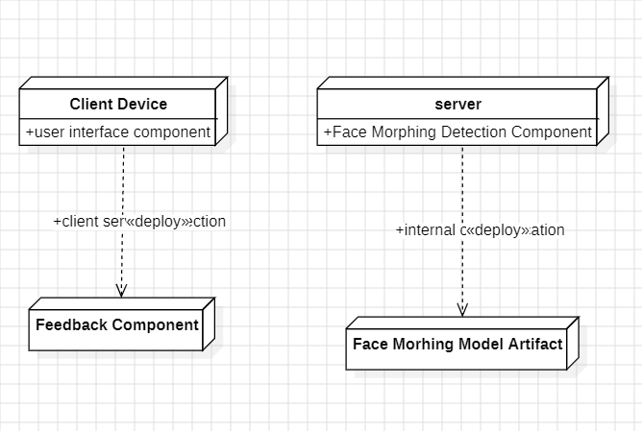

Figure 5:Component Diagram

### 7.1.4 ACTIVITY DIAGRAM

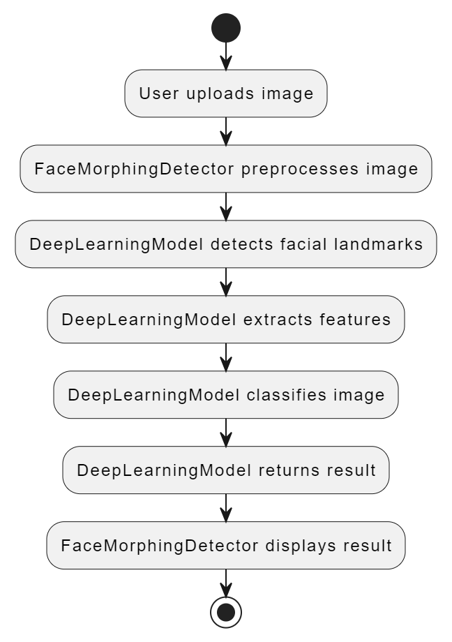

# 8.SOURCE CODE

**Face_landmark_Detection**

import sys

import os

import dlib

import glob

import numpy as np

from skimage import io

import cv2

from imutils import face_utils

class NoFaceFound(Exception):

"""Raised when there is no face found"""

pass

def calculate_margin_help(img1,img2):

size1 = img1.shape

size2 = img2.shape

diff0 = abs(size1[0]-size2[0])//2

diff1 = abs(size1[1]-size2[1])//2

avg0 = (size1[0]+size2[0])//2

avg1 = (size1[1]+size2[1])//2

return [size1,size2,diff0,diff1,avg0,avg1]

def crop_image(img1,img2):

[size1,size2,diff0,diff1,avg0,avg1] = calculate_margin_help(img1,img2)

if(size1[0] == size2[0] and size1[1] == size2[1]):

return [img1,img2]

elif(size1[0] <= size2[0] and size1[1] <= size2[1]):

scale0 = size1[0]/size2[0]

scale1 = size1[1]/size2[1]

if(scale0 > scale1):

res = cv2.resize(img2,None,fx=scale0,fy=scale0,interpolation=cv2.INTER_AREA)

else:

res = cv2.resize(img2,None,fx=scale1,fy=scale1,interpolation=cv2.INTER_AREA)

return crop_image_help(img1,res)

elif(size1[0] >= size2[0] and size1[1] >= size2[1]):

scale0 = size2[0]/size1[0]

scale1 = size2[1]/size1[1]

if(scale0 > scale1):

res = cv2.resize(img1,None,fx=scale0,fy=scale0,interpolation=cv2.INTER_AREA)

else:

res = cv2.resize(img1,None,fx=scale1,fy=scale1,interpolation=cv2.INTER_AREA)

return crop_image_help(res,img2)

elif(size1[0] >= size2[0] and size1[1] <= size2[1]):

return [img1[diff0:avg0,:],img2[:,-diff1:avg1]]

else:

return [img1[:,diff1:avg1],img2[-diff0:avg0,:]]

def crop_image_help(img1,img2):

[size1,size2,diff0,diff1,avg0,avg1] = calculate_margin_help(img1,img2)

if(size1[0] == size2[0] and size1[1] == size2[1]):

return [img1,img2]

elif(size1[0] <= size2[0] and size1[1] <= size2[1]):

return [img1,img2[-diff0:avg0,-diff1:avg1]]

elif(size1[0] >= size2[0] and size1[1] >= size2[1]):

return [img1[diff0:avg0,diff1:avg1],img2]

elif(size1[0] >= size2[0] and size1[1] <= size2[1]):

return [img1[diff0:avg0,:],img2[:,-diff1:avg1]]

else:

return [img1[:,diff1:avg1],img2[diff0:avg0,:]]

def generate_face_correspondences(theImage1, theImage2):

detector = dlib.get_frontal_face_detector()

predictor = dlib.shape_predictor('code/utils/shape_predictor_68_face_landmarks.dat')

corresp = np.zeros((68,2))

imgList = crop_image(theImage1,theImage2)

list1 = []

list2 = []

j = 1

for img in imgList:

size = (img.shape[0],img.shape[1])

if(j == 1):

currList = list1

else:

currList = list2

dets = detector(img, 1)

try:

if len(dets) == 0:

raise NoFaceFound

except NoFaceFound:

print("Sorry, but I couldn't find a face in the image.")

j=j+1

for k, rect in enumerate(dets):

shape = predictor(img, rect)

for i in range(0,68):

x = shape.part(i).x

y = shape.part(i).y

currList.append((x, y))

corresp[i][0] += x

corresp[i][1] += y

currList.append((1,1))

currList.append((size[1]-1,1))

currList.append(((size[1]-1)//2,1))

currList.append((1,size[0]-1))

currList.append((1,(size[0]-1)//2))

currList.append(((size[1]-1)//2,size[0]-1))

currList.append((size[1]-1,size[0]-1))

currList.append(((size[1]-1),(size[0]-1)//2))

narray = corresp/2

narray = np.append(narray,[[1,1]],axis=0)

narray = np.append(narray,[[size[1]-1,1]],axis=0)

narray = np.append(narray,[[(size[1]-1)//2,1]],axis=0)

narray = np.append(narray,[[1,size[0]-1]],axis=0)

narray = np.append(narray,[[1,(size[0]-1)//2]],axis=0)

narray = np.append(narray,[[(size[1]-1)//2,size[0]-1]],axis=0)

narray = np.append(narray,[[size[1]-1,size[0]-1]],axis=0)

narray = np.append(narray,[[(size[1]-1),(size[0]-1)//2]],axis=0)

return [size,imgList[0],imgList[1],list1,list2,narray]

**Face_landmark_Detection**

import numpy as np

import cv2

import sys

import os

import math

from subprocess import Popen, PIPE

from PIL import Image

def apply_affine_transform(src, srcTri, dstTri, size) :

warpMat = cv2.getAffineTransform(np.float32(srcTri), np.float32(dstTri))

dst = cv2.warpAffine(src, warpMat, (size[0], size[1]), None, flags=cv2.INTER_LINEAR, borderMode=cv2.BORDER_REFLECT_101)

return dst

def morph_triangle(img1, img2, img, t1, t2, t, alpha) :

r1 = cv2.boundingRect(np.float32([t1]))

r2 = cv2.boundingRect(np.float32([t2]))

r = cv2.boundingRect(np.float32([t]))

t1Rect = []

t2Rect = []

tRect = []

for i in range(0, 3):

tRect.append(((t[i][0] - r[0]),(t[i][1] - r[1])))

t1Rect.append(((t1[i][0] - r1[0]),(t1[i][1] - r1[1])))

t2Rect.append(((t2[i][0] - r2[0]),(t2[i][1] - r2[1])))

mask = np.zeros((r[3], r[2], 3), dtype = np.float32)

cv2.fillConvexPoly(mask, np.int32(tRect), (1.0, 1.0, 1.0), 16, 0)

img1Rect = img1[r1[1]:r1[1] + r1[3], r1[0]:r1[0] + r1[2]]

img2Rect = img2[r2[1]:r2[1] + r2[3], r2[0]:r2[0] + r2[2]]

size = (r[2], r[3])

warpImage1 = apply_affine_transform(img1Rect, t1Rect, tRect, size)

warpImage2 = apply_affine_transform(img2Rect, t2Rect, tRect, size)

imgRect = (1.0 - alpha) * warpImage1 + alpha * warpImage2

img[r[1]:r[1]+r[3], r[0]:r[0]+r[2]] = img[r[1]:r[1]+r[3], r[0]:r[0]+r[2]] * ( 1 - mask ) + imgRect * mask

def generate_morph_sequence(duration,frame_rate,img1,img2,points1,points2,tri_list,size,output):

num_images = int(duration*frame_rate)

p = Popen(['ffmpeg', '-y', '-f', 'image2pipe', '-r', str(frame_rate),'-s',str(size[1])+'x'+str(size[0]), '-i', '-', '-c:v', 'libx264', '-crf', '25','-vf','scale=trunc(iw/2)*2:trunc(ih/2)*2','-pix_fmt','yuv420p', output], stdin=PIPE)

for j in range(0, num_images):

img1 = np.float32(img1)

img2 = np.float32(img2)

points = []

alpha = j/(num_images-1)

for i in range(0, len(points1)):

x = (1 - alpha) * points1[i][0] + alpha * points2[i][0]

y = (1 - alpha) * points1[i][1] + alpha * points2[i][1]

points.append((x,y))

morphed_frame = np.zeros(img1.shape, dtype = img1.dtype)

for i in range(len(tri_list)):

x = int(tri_list[i][0])

y = int(tri_list[i][1])

z = int(tri_list[i][2])

t1 = [points1[x], points1[y], points1[z]]

t2 = [points2[x], points2[y], points2[z]]

t = [points[x], points[y], points[z]]

morph_triangle(img1, img2, morphed_frame, t1, t2, t, alpha)

pt1 = (int(t[0][0]), int(t[0][1]))

pt2 = (int(t[1][0]), int(t[1][1]))

pt3 = (int(t[2][0]), int(t[2][1]))

cv2.line(morphed_frame, pt1, pt2, (255, 255, 255), 1, 8, 0)

cv2.line(morphed_frame, pt2, pt3, (255, 255, 255), 1, 8, 0)

cv2.line(morphed_frame, pt3, pt1, (255, 255, 255), 1, 8, 0)

res = Image.fromarray(cv2.cvtColor(np.uint8(morphed_frame), cv2.COLOR_BGR2RGB))

res.save(p.stdin,'JPEG')

p.stdin.close()

p.wait()

**Face alignment**

import numpy as np

import scipy.ndimage

import os

import PIL.Image

def image_align(src_file, dst_file, face_landmarks, output_size=1024, transform_size=4096, enable_padding=True, x_scale=1, y_scale=1, em_scale=0.1, alpha=False):

# Align function from FFHQ dataset pre-processing step

# https://github.com/NVlabs/ffhq-dataset/blob/master/download_ffhq.py

lm = np.array(face_landmarks)

lm_chin = lm[0 : 17] # left-right

lm_eyebrow_left = lm[17 : 22] # left-right

lm_eyebrow_right = lm[22 : 27] # left-right

lm_nose = lm[27 : 31] # top-down

lm_nostrils = lm[31 : 36] # top-down

lm_eye_left = lm[36 : 42] # left-clockwise

lm_eye_right = lm[42 : 48] # left-clockwise

lm_mouth_outer = lm[48 : 60] # left-clockwise

lm_mouth_inner = lm[60 : 68] # left-clockwise

# Calculate auxiliary vectors.

eye_left = np.mean(lm_eye_left, axis=0)

eye_right = np.mean(lm_eye_right, axis=0)

eye_avg = (eye_left + eye_right) * 0.5

eye_to_eye = eye_right - eye_left

mouth_left = lm_mouth_outer[0]

mouth_right = lm_mouth_outer[6]

mouth_avg = (mouth_left + mouth_right) * 0.5

eye_to_mouth = mouth_avg - eye_avg

# Choose oriented crop rectangle.

x = eye_to_eye - np.flipud(eye_to_mouth) * [-1, 1]

x /= np.hypot(*x)

x *= max(np.hypot(*eye_to_eye) * 2.0, np.hypot(*eye_to_mouth) * 1.8)

x *= x_scale

y = np.flipud(x) * [-y_scale, y_scale]

c = eye_avg + eye_to_mouth * em_scale

quad = np.stack([c - x - y, c - x + y, c + x + y, c + x - y])

qsize = np.hypot(*x) * 2

# Load in-the-wild image.

if not os.path.isfile(src_file):

print('\nCannot find source image. Please run "--wilds" before "--align".')

return

img = PIL.Image.open(src_file).convert('RGBA').convert('RGB')

# Shrink.

shrink = int(np.floor(qsize / output_size * 0.5))

if shrink > 1:

rsize = (int(np.rint(float(img.size[0]) / shrink)), int(np.rint(float(img.size[1]) / shrink)))

img = img.resize(rsize, PIL.Image.ANTIALIAS)

quad /= shrink

qsize /= shrink

# Crop.

border = max(int(np.rint(qsize * 0.1)), 3)

crop = (int(np.floor(min(quad[:,0]))), int(np.floor(min(quad[:,1]))), int(np.ceil(max(quad[:,0]))), int(np.ceil(max(quad[:,1]))))

crop = (max(crop[0] - border, 0), max(crop[1] - border, 0), min(crop[2] + border, img.size[0]), min(crop[3] + border, img.size[1]))

if crop[2] - crop[0] < img.size[0] or crop[3] - crop[1] < img.size[1]:

img = img.crop(crop)

quad -= crop[0:2]

# Pad.

pad = (int(np.floor(min(quad[:,0]))), int(np.floor(min(quad[:,1]))), int(np.ceil(max(quad[:,0]))), int(np.ceil(max(quad[:,1]))))

pad = (max(-pad[0] + border, 0), max(-pad[1] + border, 0), max(pad[2] - img.size[0] + border, 0), max(pad[3] - img.size[1] + border, 0))

if enable_padding and max(pad) > border - 4:

pad = np.maximum(pad, int(np.rint(qsize * 0.3)))

img = np.pad(np.float32(img), ((pad[1], pad[3]), (pad[0], pad[2]), (0, 0)), 'reflect')

h, w, _ = img.shape

y, x, _ = np.ogrid[:h, :w, :1]

mask = np.maximum(1.0 - np.minimum(np.float32(x) / pad[0], np.float32(w-1-x) / pad[2]), 1.0 - np.minimum(np.float32(y) / pad[1], np.float32(h-1-y) / pad[3]))

blur = qsize * 0.02

img += (scipy.ndimage.gaussian_filter(img, [blur, blur, 0]) - img) * np.clip(mask * 3.0 + 1.0, 0.0, 1.0)

img += (np.median(img, axis=(0,1)) - img) * np.clip(mask, 0.0, 1.0)

img = np.uint8(np.clip(np.rint(img), 0, 255))

if alpha:

mask = 1-np.clip(3.0 * mask, 0.0, 1.0)

mask = np.uint8(np.clip(np.rint(mask*255), 0, 255))

img = np.concatenate((img, mask), axis=2)

img = PIL.Image.fromarray(img, 'RGBA')

else:

img = PIL.Image.fromarray(img, 'RGB')

quad += pad[:2]

# Transform.

img = img.transform((transform_size, transform_size), PIL.Image.QUAD, (quad + 0.5).flatten(), PIL.Image.BILINEAR)

if output_size < transform_size:

img = img.resize((output_size, output_size), PIL.Image.ANTIALIAS)

# Save aligned image.

img.save(dst_file, 'PNG'

output: 3

# 9.OUTPUT

**OUTPUT WINDOWS:**

# OUTPUT 1

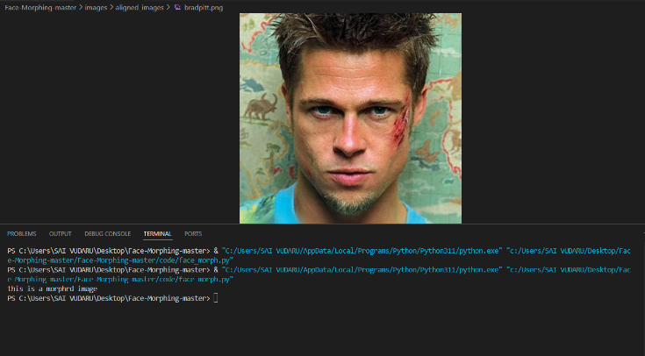

Figure 7:Output WindOW

**OUTPUT 2:**

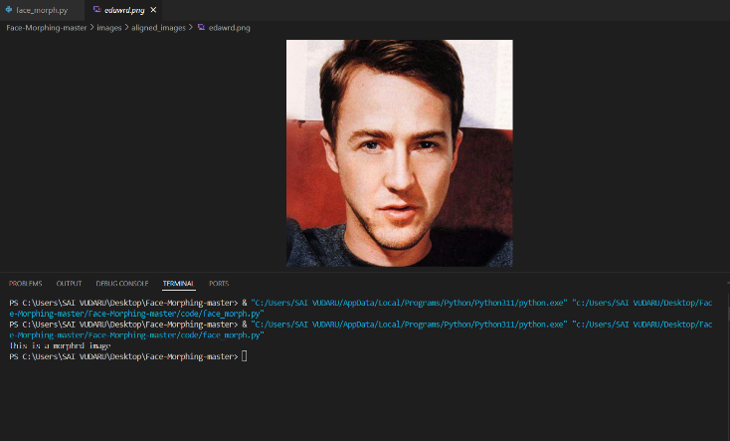

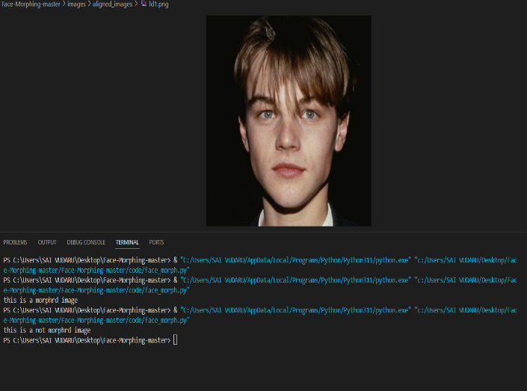

# 

# 9.CONCLUSION

# we proposed a morphing attack detection method based on deep convolution neural networks. A fully automatic face image morphing pipeline with exchangeable components was presented that was used to create training and test samples for the networks. Instead of detecting classical traces of tampering, e.g. caused by resampling or JPEG double compression, and their anti-forensic methods we focused on semantic artifacts. To avoid learning a detector for these classical tampering traces, all images were preprocessed by scaling, rotating and cropping, before feeding them to the network. In addition, we added different kinds of noise and blur to the training and test data. We trained three different convolutional neural network architectures from scratch and starting with pretrained networks. The FRR of our trained networks differ between 3.5% and 16.2% and the FAR between 0.8% and 2.2%. The VGG19 (pretrained) achieved for both rates the best result with a FRR of 3.5% and a FAR of 0.8%. The pretrained networks outperformed the networks trained from scratch for every architecture. This suggests that the features learned for object classification are also useful for detection of morphing attacks. In future work, we plan to analyze the decisions made by our networks. In particular, we plan to study the regions that contribute to the decision of a network and analyze the differences between different architectures and pretrained networks using the LRP toolbox.

# 10.REFERENCES

1. Spreeuwers, L.J., Hendrikse, A.J., Gerritsen, K.J.: Evaluation of automatic face recognition for automatic border control on actual data recorded of travellers at schiphol airport. In: Proceedings of the International Conference of Biometrics Special Interest Group (BIOSIG). (Sept 2012) 1–6

2. Ferrara, M., Franco, A., Maltoni, D.: The magic passport. In: IEEE International Joint Conference on Biometrics. (Sept 2014) 1–7

3. Popescu, A.C., Farid, H.: Exposing digital forgeries by detecting traces of resampling. IEEE Transactions on Signal Processing 53(2) (Feb 2005) 758–767

4. Kirchner, M., Gloe, T.: On resampling detection in re-compressed images. In: 2009 First IEEE International Workshop on Information Forensics and Security (WIFS). (Dec 2009) 21–25

5. Kirchner, M., Fridrich, J.: On detection of median filtering in digital images. Proc. SPIE 7541 (2010) 754110–754110–12

6. Luk´aˇs, J., Fridrich, J.: Estimation of primary quantization matrix in double compressed jpeg images. In: Proc. of DFRWS. (2003)

7. Farid, H.: Exposing digital forgeries from jpeg ghosts. IEEE Transactions on Information Forensics and Security 4(1) (March 2009) 154–160

8. Johnson, M.K., Farid, H.: Exposing digital forgeries through specular highlights on the eye. In: Information Hiding. Volume 4567 of Lecture Notes in Computer Science. (2008) 311–325

9. Kee, E., O’brien, J.F., Farid, H.: Exposing photo manipulation from shading and shadows. ACM Trans. Graph. 33(5) (September 2014) 165:1–165:21

10. Makrushin, A., Neubert, T., Dittmann, J.: Automatic generation and detection of visually faultless facial morphs. In: Proceedings of the 12th International Joint Conference on Computer Vision, Imaging and Computer Graphics Theory and Applications (VISIGRAPP 2017). (2017) 39–50