INTRODUCTION
Leaf springs, an ancient suspension method for wheeled vehicles, consist of arc-shaped spring steel. Originally called laminated or carriage springs, they date back to medieval times. These springs, often termed semi-elliptical or cart springs, feature a slender, arc-shaped length of spring steel with rectangular cross-sections. Positioned at the center of the arc, the axle provides support, while tie holes at each end facilitate attachment to the vehicle body. In heavy vehicles, leaf springs can comprise several layers of progressively shorter leaves for added strength. While primarily serving as locators and springs, they also offer some damping, albeit with uncontrolled interleaf friction. Attachment methods vary, from direct connection to the frame at both ends to attachment at one end—typically the front—with a shackle at the other end. The shackle compensates for the leaf spring's tendency to elongate when compressed, providing softer springiness. Some leaf springs feature a concave spoon end, though this is uncommon nowadays, intended for swiveling member support. Leaf springs commonly used in automobiles are semi-elliptical, composed of multiple cambered plates or leaves held together by a central band or bolt. Despite their efficacy, conventional steel leaf springs suffer from drawbacks such as weight, corrosion susceptibility, and limited damping capacity. To address these issues, researchers are exploring composite materials, offering advantages like reduced weight, improved fuel efficiency, superior damping, and corrosion resistance.
PROBLEM FORMULATION
The literature review on the composite material & its applications in automobile industry is more focused on the use of composite material & on the weight reduction of some parts of automobile. The research & analysis are conducted on replacement of leaf spring materials for the light duty vehicles like cars. The present study is proposed to be carried out for the heavy duty vehicles with Eicher Trucks specifications.
Objectives of the project work:
- Modeling and FE Analysis of conventional Steel leaf spring
- Numerical Analysis to validate the FE Model
- Modeling and FE Analysis of Composite Mono leaf spring
- Numerical Analysis of Composite Mono leaf spring
RESEARCH METHODOLOGY
In order to carry out the proposed work, the following methodology is adopted:
- Numerical Analysis of Conventional leaf spring of steel material
- FE Analysis of Conventional leaf spring: Modeling is done in Catia V5 and analysis is done using ANSYS Workbench for stress and deflection
- Validation of FE Analysis Simulations
- FE Analysis of Composite Mono leaf spring using validated model
- Results & Discussions
5.1 Design & Analysis of Conventional Multi Leaf Spring
Numerical Analysis:
Numerical analysis is carried out which will further assist to validate Finite Element model & analysis. The numerical procedure to obtain deflection at free end of the cantilever leaf spring is explained below:
A model of leaf spring suspension system is shown in Figure. In the figure leaves are shown with their effective length not with the true length.
Overall Dimensions:
The total no. of leafs: 8 (2 full length + 6 supporting)
Length of main leafs = 1120 mm
Camber at center = 180 mm
Radius of curvature for main leafs = 961.11 mm
Width = 50 mm
Thickness of individual leaf = 6 mm
The net deflection at the free end
Bending stress can be calculated as
5.2 Finite Element Modeling and Analysis of Multi Leaf Steel Spring:
The analysis focuses on testing the leaf suspension spring of a truck under static load conditions. Parameters such as spring length (L), thickness (t), width (b), and camber affect its behavior. The spring, symmetrical about the neutral axis, is modeled as a cantilever beam with load applied at its free end. Modeled in Catia, the IGES file is transferred to ANSYS Workbench for analysis, considering contact between the leaves. CAD modeling, a time-consuming process, is crucial, forming the basis for finite element modeling. Catia, a feature-based solid modeling system, allows for precise creation of the laminated leaf spring parts and assembly. Parts are assembled with proper constraints before converting to IGES format for Ansys analysis.
Material Properties for Conventional Multi Leaf Spring:
Table 1: Mechanical Properties of EN47
Mechanical Property | Value | Unit
Young's Modulus | 2.1*10⁵ | MPa
Poisson’s Ratio | 0.3
Yield Strength | 1034 | MPa
Tensile Strength | 1158 | MPa
Density | 7700 | Kg/m³

Finite Element Analysis of Multi Leaf Spring:
The leaf spring, modeled in Catia and imported to ANSYS Workbench in IGES format, employs solid elements for meshing. ANSYS automatically selects the appropriate element type. Mesh refinement, up to level 1, is applied for control. Only half of the symmetric multi-leaf spring is modeled as a cantilever in FEA, with a load of 6685 N applied at the free end. It's fixed at the central axle mounting point. Bonded contact between leaf surfaces allows slight sliding action, making this a nonlinear static structural analysis.The model of the spring after applying all the boundary conditions is shown below:
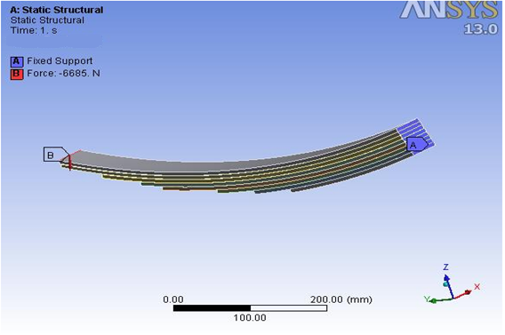
Figure 3: Model of Conventional Steel Leaf Spring
The static structural analysis results of FE analysis are shown in Figures below: 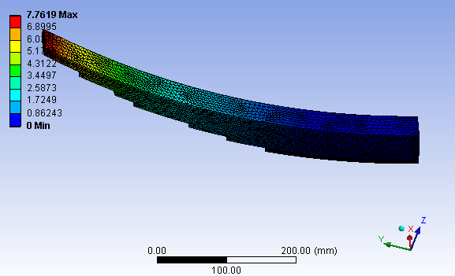 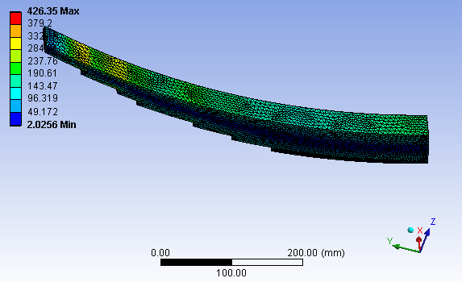
Figure 4: Deflection of Conventional steel Figure 5: Von Mises Stress for Conventional Leaf Spring Steel Leaf Spring
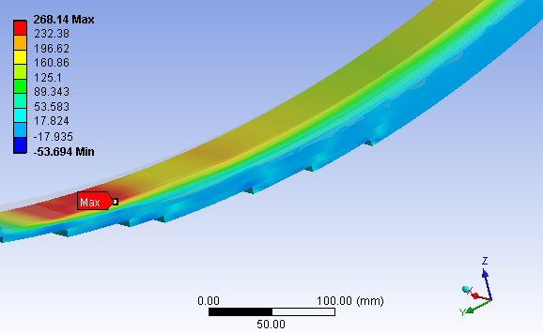
Figure 6: First Principal Stress (bending) for Conventional Steel Leaf Spring
VALIDATION OF FEA MODEL
The FE model predicts a maximum deflection of 7.762 mm at the free end, whereas numerical calculations yield 7.264 mm. Bending tensile stress at the fixed end is approximately 240 MPa in the FE model and yet to be calculated numerically. The disparity between the two methods is minimal, with a percentage error of 6.41% for maximum deflection and 10.9% for bending stress, well within acceptable limits. This validates the FE model for the analysis. The same methodology and model used for the conventional multi-leaf spring are applied to the finite element analysis of the composite mono-leaf spring.

5.3 COMPOSITE MONO LEAF SPRING
5.4 Finite Element Analysis of Composite Mono Leaf Spring
This work aims to replace conventional steel multi-leaf springs with composite mono-leaf springs to reduce vehicle weight without compromising performance or load capacity. Numerical criteria include limiting maximum deflection to 20 mm to maintain ground clearance and ensuring stresses stay within strength limits. Ground clearance affects vehicle handling and practicality, with higher clearance allowing for rougher terrain without damage. The mono-leaf spring, made of layered composite laminate, is symmetric, with only half modeled and analyzed. Parameters match those of conventional springs. Modeled as a cantilever, load applied at one end. SOLID185 elements used for three-dimensional modeling, capable of plasticity, stress stiffening, and large deflection. Material nonlinearity accounted for due to orthotropic properties. FE analysis aims to determine stresses and deflections in the mono-leaf spring. Thickness (number of layers) is adjusted for all materials to limit maximum deflection under 20mm. Results are depicted in Figures 8 to .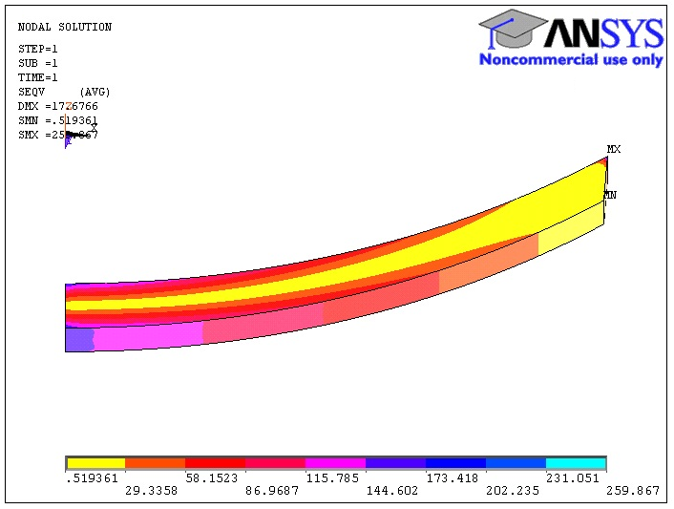 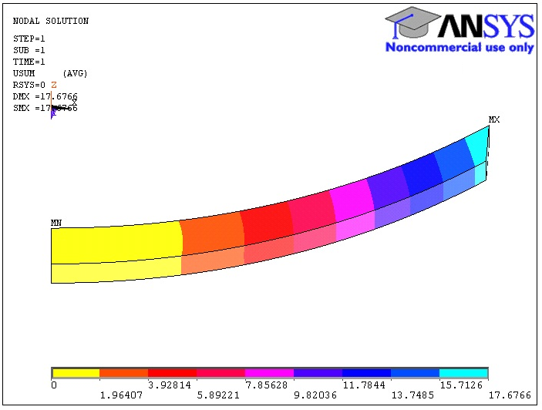
Figure 8: Von Mises Stress for E Glass Figure 9: Deformation of E Glass Epoxy
Epoxy Mono Leaf Spring Mono Leaf Spring
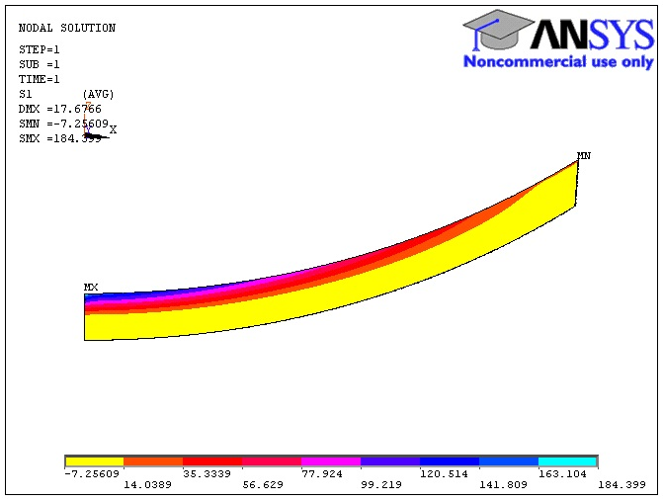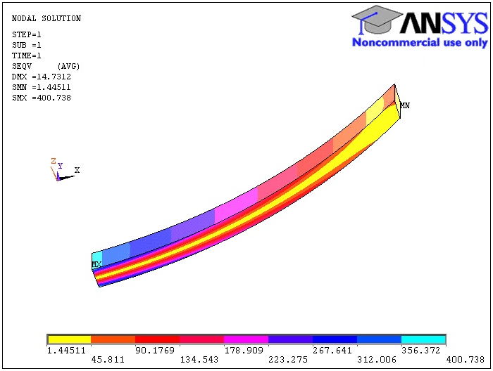
Figure 10: Principal Stress for E Glass Figure 11: Von Mises Stress for Carbon Epoxy Mono Leaf Spring Epoxy Mono Leaf Spring
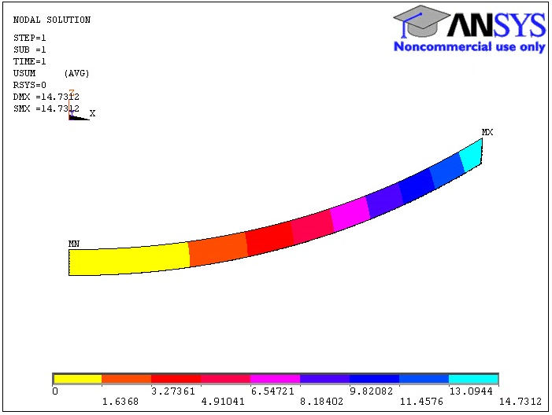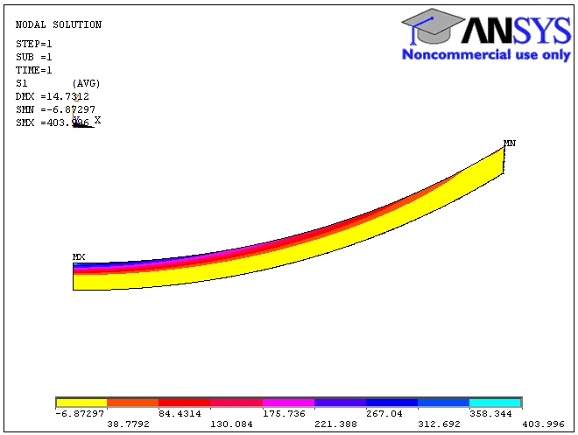
Figure 12: Deformation of Carbon Epoxy Figure 13: Principal Stress for Carbon Mono Leaf Spring Epoxy Mono Leaf Spring

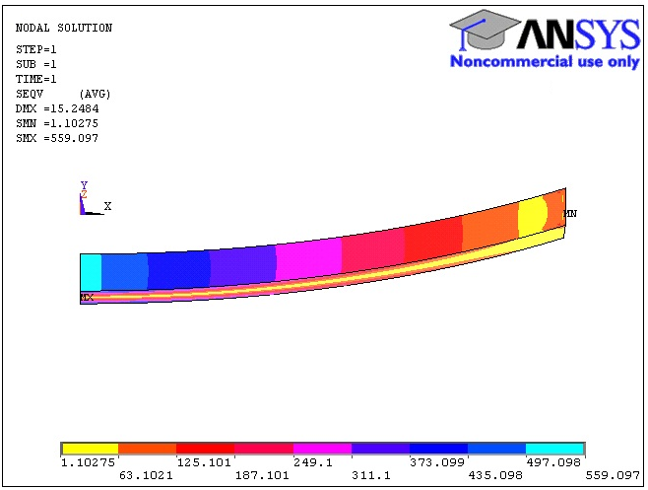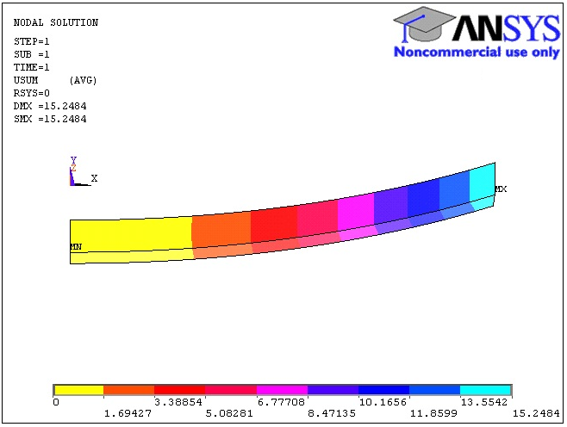
Figure 14:Von Mises Stress for Graphite Figure 15: Deformation of Graphite Epoxy Epoxy Mono Leaf Spring Mono Leaf Spring
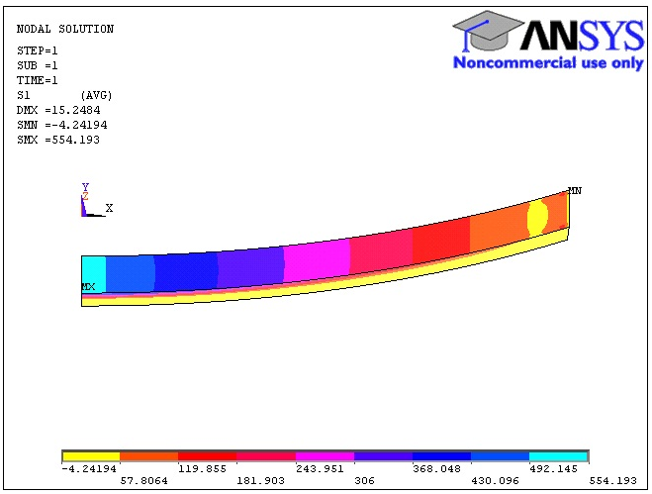
Figure 16: Principal Stress for Graphite Epoxy Mono Leaf Spring
In the analysis, the number of composite lamina layers is increased until the maximum deflection falls below 20 mm for all materials. Once achieved, in the second stage, further thickness increases are undertaken to reduce deflection. Two design constraints are applied: 1) the maximum principal stress should not exceed a set limit, and 2) the thickness of the mono-leaf spring should not exceed the total thickness of the conventional multi-leaf spring under consideration.
RESULTS & DISCUSSIONS
To address the persistent issue of heavy spring weight in suspension systems, introducing composite materials as replacements for steel in conventional leaf springs has been explored. Research has identified E-glass epoxy, Carbon epoxy, and Graphite epoxy as promising candidates due to their ability to store strain energy effectively. To achieve weight reduction targets, a model of the conventional steel leaf spring is initially created in Catia, transferred to Ansys Workbench, and analyzed under given boundary conditions. The FE analysis is complemented by numerical analysis, with results discussed below in Table 3: FE analysis and Numerical analysis results for Steel Multi Leaf Spring.
Table 3 : FE analysis and Numerical analysis results for Steel Multi Leaf Spring
 | Finite Element Analysis Results | Numerical results | Percentage Error
Maximum Bending Stress (MPa) | 240 | 213.84 | 10.9 %
Maximum Deflection | 7.762 | 7.264 | 6.41 %

The results obtained by numerical calculations and Finite Element Analysis are in close vicinity with each other. The difference is arising because the contact between surfaces of the leaves is not considered in numerical calculations. While doing Finite Element Analysis bonded contact is considered between the surfaces of leaves which allow slight sliding motion between the surfaces.
The factor of safety involved in the analysis is
…………….. Considering Von Mises Stress
The objective of this work is to replace the conventional steel multi leaf spring by composite mono leaf spring to achieve the goal of weight reduction. At the same time the vehicle performance and load carrying capacity should not get affected. The mono leaf spring is made of layered composite laminate. Considering the major aspect of weight reduction, following composites are selected and analyzed to replace conventional steel leaf spring.
- Carbon Fiber Epoxy Resin
- E Glass Fiber Epoxy resin
- Graphite Fiber Epoxy resin
For this analysis it is assumed that the maximum deflection should not go beyond 20 mm otherwise it will affect the ground clearance of the vehicle and the stresses should not go beyond the strengths.
The results of this analysis are discussed below:
Table 4: FE analysis and Numerical analysis results for E Glass Epoxy Mono Leaf Spring
 | Finite Element Analysis Results | Numerical results | Percentage Error
Maximum Bending Stress (MPa) | 184 | 188.5 | 2.44 %
Maximum Deflection | 17.67 | 20.2 | 14.31 %

Table 5 : FE analysis and Numerical analysis results for Carbon Epoxy Mono Leaf Spring
 | Finite Element Analysis Results | Numerical results | Percentage Error
Maximum Bending Stress (MPa) | 403 | 378 | 6.20 %
Maximum Deflection (mm) | 14.73 | 14.84 | 0.75 %

Table 6: FE analysis and Numerical analysis results for Graphite Epoxy Mono Leaf Spring
 | Finite Element Analysis Results | Numerical results | Percentage Error
Maximum Bending Stress (MPa) | 554 | 491 | 11.37 %
Maximum Deflection (mm) | 15.24 | 13.02 | 14.56 %

From above results, it is observed that the finite element analysis results and numerical calculation results are closely matching with each other. This validates the Finite Element Model of the mono leaf spring created for the analysis. The factor of safety involved in the design of each mono leaf spring can be calculated based on Von Mises Stress
Factor of safety for E Glass Epoxy Resin Mono Leaf Spring
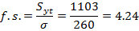
Factor of safety for Carbon Epoxy Resin Mono Leaf Spring
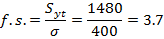
Factor of safety for Graphite Epoxy Resin Mono Leaf Spring
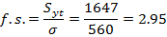
The factor of safety observed for E Glass Epoxy resin mono leaf spring is more as compared to other materials. At the same time thickness of the E Glass Epoxy resin mono leaf spring is more than the other mono leaf springs. The thickness of E Glass Epoxy resin mono leaf spring required to satisfy deflection constraint is 52 mm which is slightly greater than the conventional steel multi leaf spring i.e. 48 mm. It can be concluded that if there is no space constraint to accommodate this additional 4 mm thickness then the conventional steel multi leaf spring can be replaced by E Glass Epoxy resin mono leaf spring. If that is not possible then Carbon Epoxy Resin Mono Leaf Spring is the good option for replacement.
The basic purpose of this study is to replace the conventional multi leaf spring by composite mono leaf spring to reduced weight without affecting the performance of the vehicle. The comparison of the weight values obtained for all the springs is shown in Figure 17:
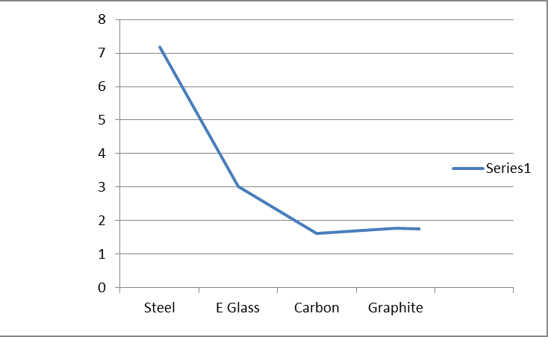
Figure 17: Comparison of weights for all the leaf springs
In Figure 17, the Y axis denotes weight in Kg. It is observed that as compared to the steel leaf spring all the leaf springs made of different composite materials are showing less weight. The percentage weight saving for each type of mono leaf spring is given in table 7.
Table 7: Percentage weight saving using mono leaf spring
Weight (Steel Leaf Spring in Kg) | Weight (Composite Mono Leaf spring Kg) | Percentage weight saving
7.18 | E Glass - 3.024 | 57.88 %
7.18 | Carbon – 1.62 | 77.43 %
7.18 | Graphite – 1.76 | 75.48 %

Conclusion:
The present work is carried out to perform numerical analysis & finite element analysis of conventional multi leaf spring & composite mono leaf spring. The current work is more focused on the deformation & stress calculations. The finite element model for both the conventional mulita leaf spring & composite mono leaf spring is validated by comparing its outcomes with the numerical analysis. The results obtained are well within the permissible limits. The weight reduction is one of the most important parameter considered in the design of heavy vehicles & in the current work; it is observed that the carbon fiber epoxy composite mono leaf spring is giving least weight as compared to all other materials chosen for analysis. So as far as weight reduction is considered, the conventional steel multi leaf spring can be replaced by Carbon Epoxy resin mono leaf spring. But the cost associated with carbon fibers is high as compared with other fibers.
Future Scope:
i. The current work can be extended for other sets of composite materials.
ii. The finite element analysis can be carried out by using Ansys APDL for more refined results.
iii. The optimization model can be built up by carrying out finite element analysis for more number of composites.

REFERENCES

Mangesh Bidve & Manish Billore, Design, analysis and optimization of a composite leaf spring for light vehicles, International Conference on Advanced Research in Industrial & Manufacturing Applications, February 2023

- Brighton Manaba & Vuyo T Hashe, A review of composite leaf springs for automotive vehicles, MATEC Web of Conferences 347, 00031 (2021)

- Sandeep Bhattacharjee, Suyog Kanitkar, Naveen Kalasapur & Vivek Patel, International Research Journal of Engineering and Technology, Volume: 04 Issue: 11, Nov 2017

- T.N.V. Ashok Kumar et al , “Design & material optimization of heavy vehicle leaf spring”, IJRMET,Volume 4, Issue 1, April 2014.

- Pankaj Saini, Ashish Goel & Dushyant Kumar, “Design & analysis of composite leaf spring for light vehicles ”, International Journal of Innovative Research in Science, Engineering & Technology, Volume 2, Issue 5,May 2013.

- Jadhav Mahesh et al, “Performance analysis of two mono leaf spring used for Maruti 800 vehicle”, IJITEE, Vol.2 , Issue1, December2012.

- K. Vishwanathan & H. Raghvendra Rao, “Optimization of heavy vehicle suspension system using composites”, IOSR-JMCE, Vol.8, Issue4, Sept-Oct 2013.

- Y.M.V. Santhosh Kumar & M. Vimal Teja, “Design & Analysis of composite leaf spring”, IJMIE, Volume 2, Issue 1, 2012.

- M.M. Patunkar & D.R. Dolas,”Modelling & analysis of composite leaf spring under the static load conditions by using FEA “ IJMIE, Volume 1, Issue 1, 2011.

- S.M. Rajmane & Nisar Shaikh,”Modelling & analysis of suspension system of TATA Sumo by using composite material under the static load condition by using FEA, IJEAT, volume 3, issue 3, Feb 2014.

