**Trash AI Camera Vision-Based Trash Classification and Detection System**

1 R. Ramakrishnan, 2 Jagadeesh. A, 3Sebinesh. T

1Associate Professor, Department of Master of Computer Applications, Sri Manakula Vinayagar Engineering College Puducherry-605 107, India.

2 PG Student, Department of Master of Computer Applications, Sri Manakula

Vinayagar Engineering College Puducherry-605 107, India.

3 PG Student, Department of Master of Computer Applications, Sri Manakula

Vinayagar Engineering College Puducherry-605 107, India.

[ramakrishnanmca@smvec.ac.in](mailto:ramakrishnanmca@smvec.ac.in) , [a.jagadeesh9585@gmail.com](mailto:a.jagadeesh9585@gmail.com) , [sebinesh.thiru@gmail.com](mailto:sebinesh.thiru@gmail.com) .

**ABSTRACT:**

Trash generally refers to discarded or waste materials that are no longer considered useful or valuable. It encompasses various items and substances that individuals or organizations dispose of, typically to discard or recycle them. The term trash is often used interchangeably with terms like garbage, waste, or rubbish. Improperly managed waste contributes to environmental issues, including pollution and the release of harmful substances, impacting ecosystems and public health. Existing waste management faces challenges in sorting and disposal practices, leading to inefficiencies in the overall process. The increasing volume of waste in urban areas poses a growing challenge, demanding innovative solutions to handle the scale and complexity of modern waste streams. In response to these challenges, the TrashAI project leverages advanced technologies such as Convolutional Neural Networks (CNNs) and Temporal Convolutional Networks (TCNs) to introduce a smarter and more efficient waste management system. These technologies provide the foundation for accurate trash classification, real-time detection, and intelligent waste segregation. The goal is to revolutionize waste management, automating and optimizing processes for accurate trash classification, real-time detection, and intelligent waste segregation. Through the development of a Municipality Web App, TrashAI centralizes monitoring and decision-making, facilitating a more sustainable and efficient approach to waste management. This initiative is poised to transform urban waste handling, promoting environmental consciousness and sustainable practices for smarter, cleaner cities.

**KEYWORDS:**

Deep Convolutional Neural Network (DNN), Stochastic Gradient Descent (SGD), Trash Detection

**1. INTRODUCTION**

Trash, Garbage, rubbish, or refuse is waste material that is discarded by humans, usually due to lack of utility. Garbage includes waste materials like kitchen or food scraps, boxes, tin, wood, paper, etc. which are not of use by humans. Indians generated 262 million tons of trash in 2015 (called "municipal solid waste," or MSW, as municipalities are the ones who haul and manage the stuff). That means generated 4.40 pounds of trash per person per day. To add some perspective, in 1960 generated only 2.68 pounds per person per day, so our consumption habits today are about 80 percent more wasteful than they were then. While the overall waste volume has increased, the percentage of materials being recycled stayed fairly level over the past few years at about 34 percent.

**1.2.1.1. Sources of Trash**

Sources of trash can be broadly classified into four types: Industrial, Commercial, Domestic, and Agricultural.

* **Industrial Trash**

These are the wastes created in factories and industries. Most industries dump their wastes in rivers and seas which cause a lot of pollution.

**Examples:** plastic, glass, etc.

* **Commercial Trash**

Commercial wastes are produced in schools, colleges, shops, and offices.

**Examples:** plastic, paper, etc.

Domestic Waste

The different household wastes that are collected during household activities like cooking, cleaning, etc. are known as domestic wastes.

**Examples:** leaves, vegetable peels, excreta, etc.

* **Agricultural Trash**

Various wastes produced in the agricultural field are known as agricultural wastes.

Examples: cattle waste, weed, husk, etc.

**1.2.1.2. Types of Trash**

Commonly waste is classified into two types: [Biodegradable and Non-biodegradable trash](https://byjus.com/chemistry/biodegradable-and-non-biodegradable/). These two kinds of trash are explained below:

* **Biodegradable Trash**

These are the wastes that come from our kitchen and they include food remains, garden waste, etc. Biodegradable waste is also known as moist waste. This can be composted to obtain manure. Biodegradable wastes decompose themselves over some time depending on the material.

* **Non-biodegradable Trash**

These are the wastes which include old newspapers, broken glass pieces, plastics, etc. Non-biodegradable waste is known as dry waste. Dry wastes can be recycled and can be reused. Non-biodegradable wastes do not decompose by themselves and hence are major pollutants.

**2. Existing System**

**Manual Sorting**

Waste sorting in traditional systems heavily relies on manual labor. Workers manually segregate different types of waste into categories such as paper, plastic, glass, and organic waste.

**Transportation:** Collected waste is transported to transfer stations or landfills using specialized vehicles.

**Sorting:** At transfer stations or landfills, waste is manually sorted by workers into broad categories such as recyclables (plastic, paper, glass, metal), organic waste (food scraps, yard waste), and non-recyclable/non-compostable waste.

**Processing:** Recyclable materials are further processed through various methods such as shredding, melting, or pulping to prepare them for recycling. Organic waste may undergo composting or anaerobic digestion to produce compost or biogas.

**Disposal:** Non-recyclable/non-compostable waste is typically disposed of in landfills, while recyclables and compostable materials are sent to recycling facilities or composting sites, respectively.

**Landfill Management**: Landfills require ongoing management to minimize environmental impact, including measures such as compacting waste, covering it with soil or other materials, and implementing systems for methane gas capture.

**3. Proposed System**

The proposed system, TrashAI, aims to revolutionize waste management through the integration of advanced image processing and deep learning techniques.

**TrashNet Model with CNN:**

To enhance the accuracy of trash classification, we propose the development of a TrashNet Model utilizing Convolutional Neural Networks (CNNs). This model will be trained on a diverse dataset containing labeled images of various trash types, ensuring adaptability to different environmental conditions.

**Real-Time Trash Detection with TCN:**

The real-time aspect of trash detection will be addressed through the implementation of Temporal Convolutional Networks (TCNs). By integrating object detection principles, the TCN will provide precise bounding box localization for identified trash items in images or video streams.

**Waste Segregation**

A dedicated waste segregation module employs intelligent algorithms to categorize waste items accurately, enhancing the efficiency of downstream recycling processes.

**Alert to Municipality**

In addition to the core components, the proposed TrashAI system will feature an integrated alert mechanism to notify the municipality or relevant authorities. When the system detects anomalies or specific issues in waste management, automated alerts will be triggered.

**4. Literature Survey**

Amarjot Singh, Devinder Kumar, Gitansh Khirbat, and Shubhanshu Shekhar. (2017) - This paper presents an approach to detect trash in remote sensing imagery using deep learning techniques, particularly convolutional neural networks (CNNs). Souvik Mandal, Anusha Panigrahi, Abhishek Kumar, and Somanath Mukherjee. (2019) - This review provides an overview of various deep learning techniques employed for trash detection, including CNNs, recurrent neural networks (RNNs), and their variants. by Hisham Elaraby, Abdullah Bamatraf, and Ibrahim Alrashed. (2020) - The authors propose a deep learning-based approach for trash classification to improve recycling quality. The study focuses on the application of CNNs for accurate classification. Chiranjibi Sitaula, Domenec Puig, and Vladimir Dobrynin. (2021) - This paper conducts a comparative study of different deep learning architectures for trash detection, including CNNs, recurrent neural networks (RNNs), and their combinations. The study evaluates the performance of these architectures on various datasets.M. Imran Mulla, Srinath N. K., Shreesha C. S., and Prajwal N. Rao. (2022)- The authors propose an automatic garbage classification system based on deep learning techniques. The system utilizes CNNs for trash classification and achieves promising results in terms of accuracy and efficiency. Muhammad Sarmad Hassan, Muhammad Usama, Muhammad Umar Farooq, and Shadab Alam. (2023)his paper presents a real-time trash detection system for smart cities based on deep learning. The system employs CNNs to detect and classify trash items from video streams, contributing to efficient waste management.

**5. Municipality Web App**

* The Municipality Web App serves as a centralized platform for efficient waste management.
* Designed for administrators and officers, it provides a user-friendly interface for comprehensive management of the entire waste management system.
* This platform facilitates real-time monitoring, data analysis, and decision-making to enhance the overall effectiveness of waste management strategies.

**6. TrashNet: Build and Train**

**6.1 Dataset Collection**

The first step involves collecting a diverse dataset comprising images of various trash types. This dataset serves as the foundation for training the TrashNet model.

**6.2 Import Dataset**

Import the collected dataset into the system, preparing it for further processing and model training.

**6.3 Preprocessing**

Apply preprocessing techniques, including greyscale conversion, resizing, noise filtering, and binarization, to optimize the dataset for effective model training.

**6.4 Trash Detection**

Utilize a Region Proposal Network (RPN) to detect trash objects within the preprocessed images, laying the groundwork for accurate identification.

**6.5 Feature Extraction**

Extract relevant features from the detected trash using a fully connected layer, incorporating the Gray Level Co-occurrence Matrix (GLCM) for enhanced feature representation.

**6.6 Build and Train: TrashNet**

Develop the TrashNet model using Convolutional Neural Networks (CNNs) and train it on the processed dataset. This step ensures the model's ability to accurately classify diverse trash types.

**6.7 Deploy Model**

Implement the trained TrashNet model for practical use, integrating it seamlessly into the waste management system.

**7. Trash Detector**

**7.1 Live Video Feed from Municipality CCTV Camera**

Access live video feeds from municipality CCTV cameras to provide real-time monitoring of waste management areas.

**8.2 Trash Prediction**

Utilize Temporal Convolutional Networks (TCNs) for real-time trash prediction with the TrashNet Model, enhancing the system's ability to dynamically identify and respond to changing waste scenarios.

**9. Trash Segregator**

**9.1 Categorize into Color Bins**

Implement an intelligent trash segregator that categorizes detected waste items into color-coded bins. This step streamlines the sorting process for more efficient waste management.

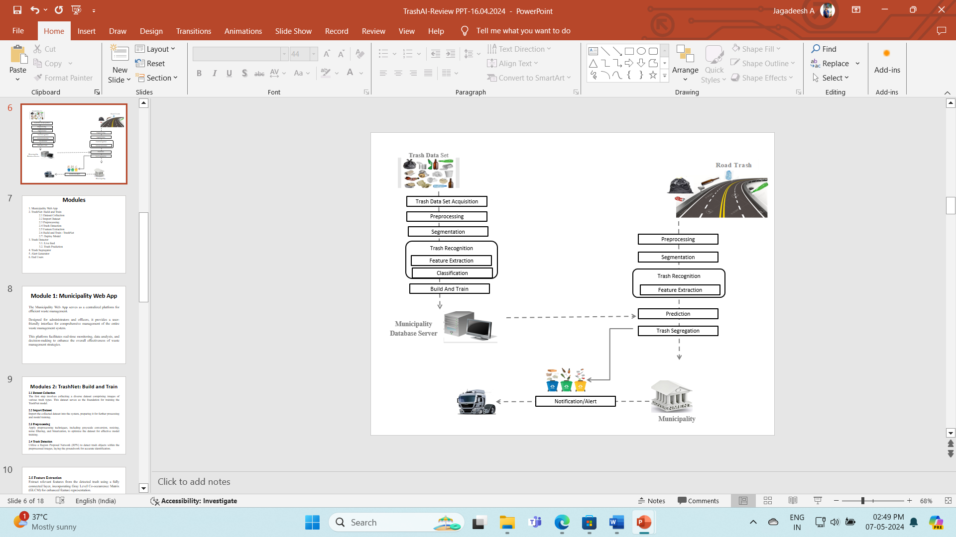

**Fig 1: Trash AI Architecture**

**9.2. SEQUENCE DIAGRAM**

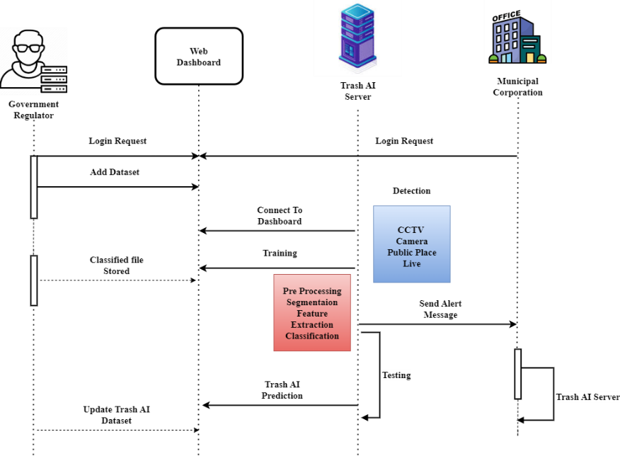

**Fig 2: Sequence Diagram for Trash AI**

**10. Alert Generator**

Automatically generate and dispatch alerts via SMS and email to municipality officers, ensuring immediate awareness and timely responses to critical waste management events or issues

**11. End Users**

**11.1 Admin**

The administrator serves as the primary manager, overseeing and directing the entire waste management system. This role involves monitoring system performance, analyzing data, and making informed decisions to optimize waste management strategies.

**11.2 Municipality Camera**

Municipality cameras provide access to live video feeds and system alerts. This interface allows users to actively engage with the system, responding to real-time events and contributing to effective waste management practices.

**12. CONCLUSION**

In conclusion, the TrashAI project represents a significant step towards modernizing waste management practices through the application of artificial intelligence and machine learning technologies. By addressing existing challenges and embracing emerging opportunities, the project paves the way for a more sustainable and efficient approach to waste management in urban environments. Throughout the project, significant milestones were achieved, including the development of a robust Municipality Web App, successful construction and training of the TrashNet model, and integration of real-time trash detection and segmentation capabilities. The system's ability to accurately classify and segregate waste items, coupled with proactive alert generation, demonstrates its potential to enhance waste management efficiency and environmental sustainability. Despite the achievements, several challenges were encountered during the project lifecycle, such as fine-tuning model parameters for optimal performance, addressing technical issues during system integration, and ensuring scalability and adaptability to diverse waste management setups. These challenges underscore the complexity of implementing AI-based solutions in real-world environments and emphasize the importance of iterative development and continuous improvement. Looking ahead, the TrashAI system holds immense potential for expansion and refinement. Future efforts should focus on enhancing model accuracy through additional data collection and augmentation, leveraging advanced algorithms for more sophisticated trash detection and segmentation, and incorporating feedback mechanisms to iteratively improve system performance.

**REFERENCE:**

1. X. Liang, Z. Tang, X. Zhang, M. Yu, and X. Zhang, "Robust hashing with local tangent space alignment for image copy detection", IEEE Trans. Depend. Sec. Comput., Aug. 2023.

2. X. Liang, Z. Tang, Z. Huang, X. Zhang and S. Zhang, "Efficient hashing method using 2D–2D PCA for image copy detection", IEEE Trans. Knowl. Data Eng., vol. 35, no. 4, pp. 3765-3778, Apr. 2023.

3. X. Lin et al., "Image manipulation detection by multiple tampering traces and edge artifact enhancement", Pattern Recognit., vol. 133, Jan. 2023.

4. Z. Zhang, Y. Qian, Y. Zhao, L. Zhu, and J. Wang, "Noise and edge-based dual branch image manipulation detection", arXiv:2207.00724, 2022.

5. X. Liu, Y. Liu, J. Chen and X. Liu, "PSCC-Net: Progressive spatial-channel correlation network for image manipulation detection and localization", IEEE Trans. Circuits Syst.Video Technol., vol. 32, no. 11, pp. 7505-7517, Nov. 2022.

6. H. Wu, J. Zhou, J. Tian, and J. Liu, "Robust image forgery detection over online social network shared images", Proc. IEEE/CVF Conf. Comput. Vis. Pattern Recognit. (CVPR), pp. 13430-13439, Jun. 2022.

7. F. Li, Z. Pei, X. Zhang and C. Qin, "Image manipulation localization using multi-scale feature fusion and adaptive edge supervision", IEEE Trans. Multimedia, pp. 1-15, 2022.

8. J. Wang et al., "ObjectFormer for image manipulation detection and localization", Proc. IEEE/CVF Conf. Comput. Vis. Pattern Recognit., pp. 2354-2363, 2022.

9. X. R. Chen, C. B. Dong, J. Q. Ji, J. Cao and X. R. Li, "Image manipulation detection by multi-view multi-scale supervision", Proc. IEEE Int. Conf. Comput. Vis., pp. 14165-14173, 2021.