**A Paper on Automatic Fire Fighting Robot Using Arduino**

***Basavaraj. K. Hosamani*1, *Abhijeet. R. Kokale*2,** Sahil***. D. Shikalgar3,*** ***Divya. D. Sawant4, Prof. A. D. Ghorapade5***.

*1B. Tech Student, Adarsh Institute of Technology & Research Centre, Vita, Maharashtra, India.*

*2B. Tech Student, Adarsh Institute of Technology & Research Centre, Vita, Maharashtra, India.*

*3B. Tech Student, Adarsh Institute of Technology & Research Centre, Vita, Maharashtra, India.*

*4B. Tech Student, Adarsh Institute of Technology & Research Centre, Vita, Maharashtra, India.*

*5Assistant professor, Department of Electronics & Telecommunication Engineering ,Adarsh Institute of Technology and Research Centre, Vita, Maharashtra, India.*

# ABSTRACT

The project's goal is to use Arduino to build and create a firefighting robot. The robot will have sensors to identify any fire and will be able to navigate within a designated region in order to put out the fire. An Arduino microcontroller will be used to drive the robot, which will be designed to move on its own and carry out firefighting duties. To spray water on the fire, the robot will be outfitted with a water tank, a pump, and a nozzle. In order to navigate towards the fire and sense its heat, it will also be equipped with infrared sensors. The robot's mobility and firefighting will be managed by the Arduino microcontroller, which will also handle the sensor data. Designing the mechanical structure of the project will entail.

**Keywords:** Arduino UNO, Robot, Flame Sensor, Fire Extinguisher, Water Pump.

# 1. INTRODUCTION

Fire emergencies may be deadly and destructive, requiring prompt response and efficient solutions. We will look at using Arduino to create an automated firefighting robot in this project. Because it can detect and extinguish fires on its own, this robot is an essential tool for fire safety and prevention. This robot uses a combination of sensors, motors, and intelligent control to detect flames and act swiftly to put them out. Controlling the fire can be done with a firefighting robot. This robot is capable of autonomous fire detection and water cannon control. Robots can move to the location of the fire to put it out thanks to certain sensors we use. The fire-flying robot's construction is identical to that of an RC vehicle controlled by Bluetooth. Three sensors are on the robot. One sensor on the robot's front side detects objects in front of it, and two other sensors at either front corner look for fire as well. The robot will sense and approach any spot where a sensor picks up fire. With four wheels, three sensors, a single water tank, a single nozzle.

# 2. BLOCK DIAGRAM

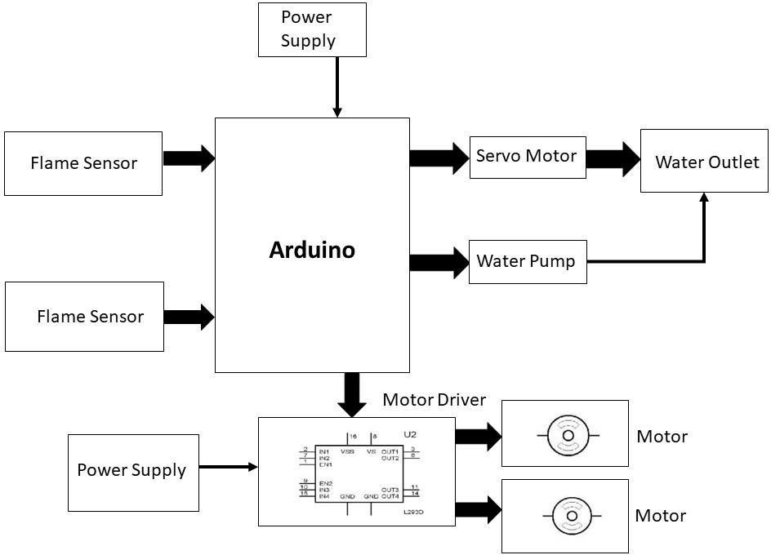

**Fig. Block Diagram**

**Arduino-** Arduino is an open-source electronics platform that's designed for creating interactive projects. It consists of both hardware and software.

**Flame sensor-** A flame detector is a type of sensor that can detect and respond to the presence of a flame. These detectors have the ability to identify smokeless liquid and smoke that can create open fire. For example, in boiler furnaces flame detectors are widely used, as a flame detector can detect heat, smoke, and fire.

**Servo motor**- A servo motor is a self-contained electrical device, that rotate parts of a machine with high efficiency and with great precision. The output shaft of this motor can be moved to a particular angle, position and velocity that a regular motor does not have.

**Water Pump-** A water pump is a machine that is used to transfer water from one location to another. This can be used to transfer water from one place to be used for drinking water or irrigation, or it can be used to remove water from an area to prevent damage.

**Water outlet**- Water outlet means a discharge opening through which water is supplied to a fixture, into the atmosphere (except into an open tank that is part of the water supply), to a boiler or heating system, or to any devices or equipment requiring water to operate but that are not part of the plumbing system.

**Motor-** An electric motor is an electrical machine that convert electrical energy into mechanical energy. Most electric motors operate through the interaction between the motor's magnetic field and electric current in a wire winding generate force in the form of torque applied on the motor's shaft.

# 3. COMPONENT REQUIRED

**3.1. Arduino UNO –**

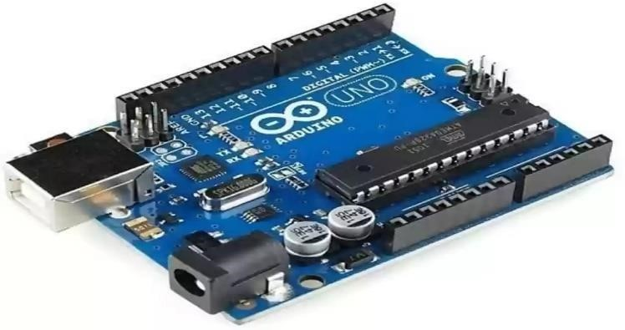

**Fig 3.1. Arduino UNO**

The open-source electronics platform Arduino is built on user-friendly hardware and software. Arduino boards have the ability to take inputs, such as a light from a sensor, a finger pressing a button, or a message from Twitter, and convert them into outputs, such as starting a motor, turning on an LED, or posting content to the internet.

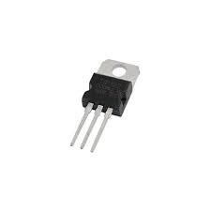**3.2. TIP – 122 Transistor-**

**Fig 3.2.TIP-122 Transistor**

The TIP122 is a Darlington pair NPN transistor. It functions like a normal NPN transistor, but since it has a Darlington pair inside it has a good collector current rating of about 5A and a gain of about 1000. It can also withstand about 100V across its collector- Emitter hence can be used to drive heavy loads. The Darlington pair inside this transistor is shown clearly as its internal circuit schematic below. As you can see, there are two transistors inside this TO-220 package in which the emitter of the first transistor is connected with the base of the second transistor and the collector of both transistors are connected together to form a Darlington pair. This increases the current gain and current rating of this transistor.

**3.3. Flame Sensor –**

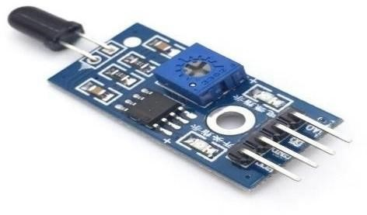

**Fig 3.3. Flame Sensor**

The flame sensor module is equipped with a photodiode for light detection and an op-amp for sensitivity adjustment. Its purpose is to detect fire and, upon detection, to emit a HIGH signal. After interpreting the signal, Arduino activates the LED and buzzer to send an alarm.

**3.4. Servo Motor –**

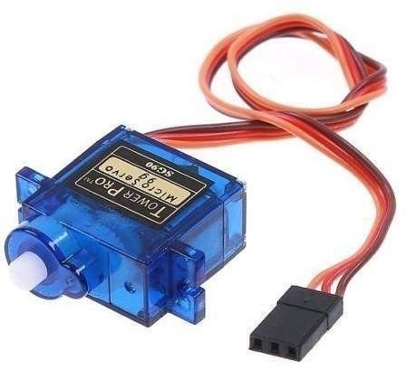

**Fig 3.4. Servo Motor**

The servomotor is a closed-loop device that uses positional feedback to regulate both position and rotational or linear speed. An electric signal, either digital or analog, controls the motor by dictating how much movement corresponds to the shaft's ultimate command position. A servo or error-sensing feedback control can improve a system's performance. In addition, a very complex controller is needed; this is often a separate module made especially for servomotor operation. DC motors with accurate angular position control are known as servomotors. These DC motors' gears gradually reduce their speed. The typical rotating cut-off angle of servomotors is between 90° and 180°. Additionally, some servomotors have a 360-degree rotational cut-off.

**3.5. L298 Motor Driver –**

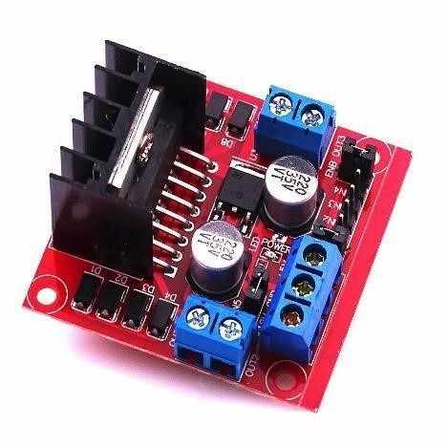

**Fig 3.5 L298 Motor Driver**

This high motor driver module, the L298N, may drive DC and stepper motors. An L298 motor driver integrated circuit and a 78M05-5V regulator make up this module. The L298N Module can operate up to four DC motors or two DC motors with directional and speed control. High voltage, high current twin full-bridge motor driver integrated circuit L298. It manages inductive loads like relays, solenoids, DC, and stepper motors and takes typical TTL logic levels (Control Logic). This IC has fifteen pins.

# 4. RESULTS AND DISCUSSION

In this section, A Novel Fire Fighting Robot with Arduino is implemented. The result analysis of presented robot is evaluated here. The Fig.1 shows the implemented novel Fire Fighting Robot with Arduino. This Robot can be moved remotely within Bluetooth Range. The Robot Stops Immediately and Starts Water Sprinkler or Dispenser whenever Flame is detected through Sensor modules. This system is powered using 12V/4.5Ah Battery and Charging of this battery is done using 12V Transformer power supply. This system is also equipped with Ultrasonic sensor to avoid collision between Obstacles. This Robot stops on Detection of Obstacle and start again on clearance.

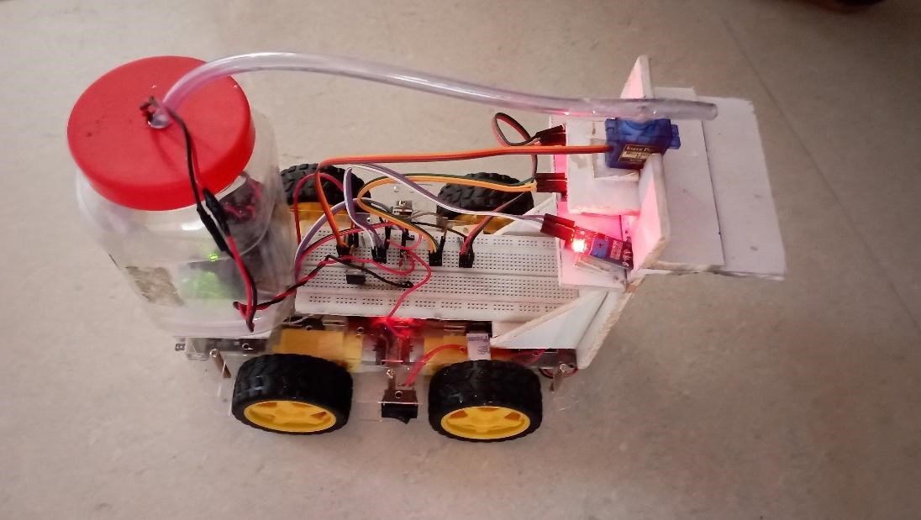

**Fig 4.1 Implemented novel Fire Fighting robot with Arduino**

When the Robot is moves in forward direction, then Ultrasonic Sensor is used to find any obstacle in the path. The Fig. 2 shows in the robot moving direction.

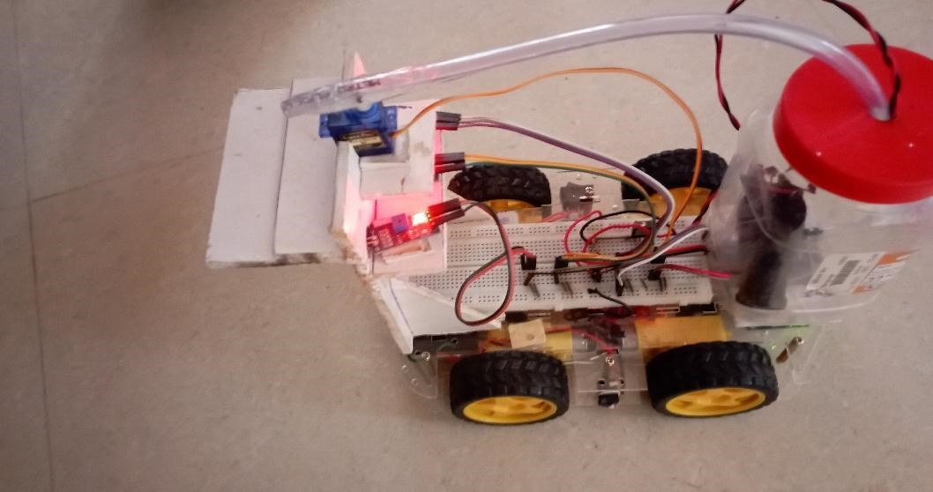

**Fig 4.2 Obstacles in Robot Moving Direction**

If there is an obstacle in the path then the Robot will stop. Now, direction of the Robot is changed by clicking the options in the mobile app which is shown in Fig. 3. If there are no obstacles in path then Robot moves.

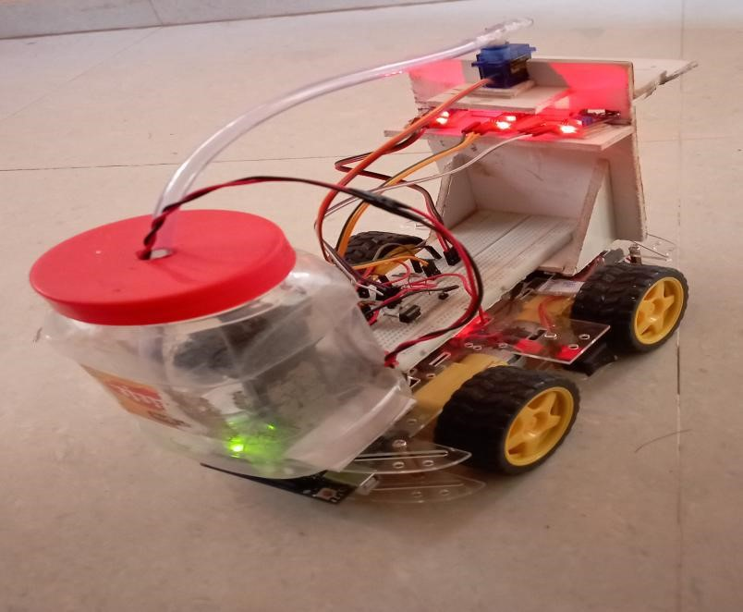

**Fig 4.3 Robot working in obstacles CAS**

Flame Sensor is used to detect fire. The robot moves the direction of fire and the fire is detected then Water sprinkler will starts sprinkling of the water the fire and is shown in Fig.4.

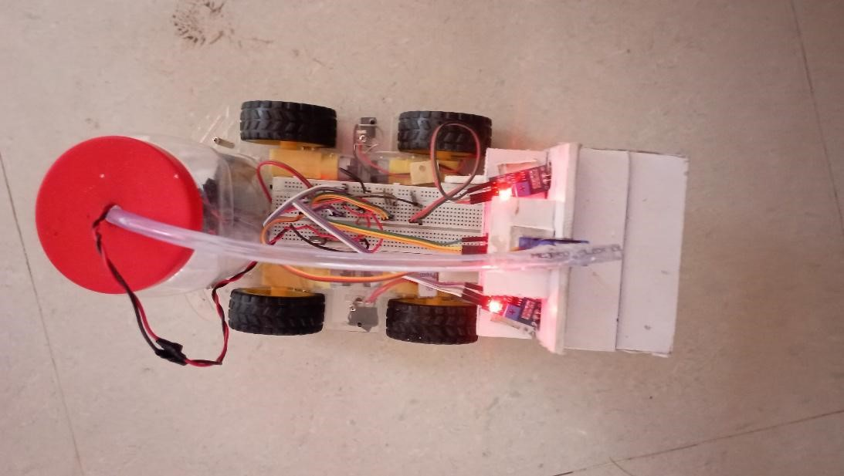

**Fig 4.4 Water Sprinkling during Fire**

If the fire is stops, then Robot stops sprinkling the water. Now, the Robot is moved to other location, where the fire is existing. The result of the research showed that this fire extinguisher robot could detect fire as far as it successfully extinguishes the fire. This robot will reduce the risk of injury for firefighters and possible victims and decrease the monetary losses, which increase considerably as fire duration increases. This Robot also avoids hitting obstacles or surrounding objects by using sensors. The robot can be used in a place that has a small entrance or in small spaces because it has a compact structure.

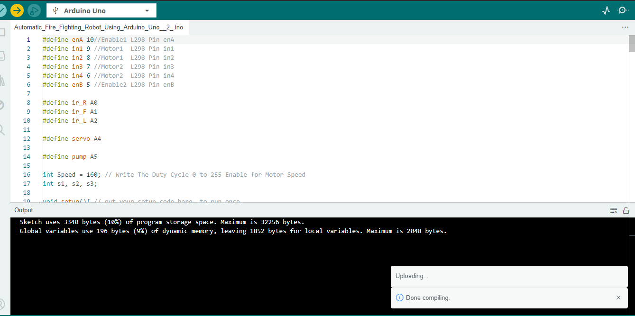

**Fig 4.5 Code Compiling**

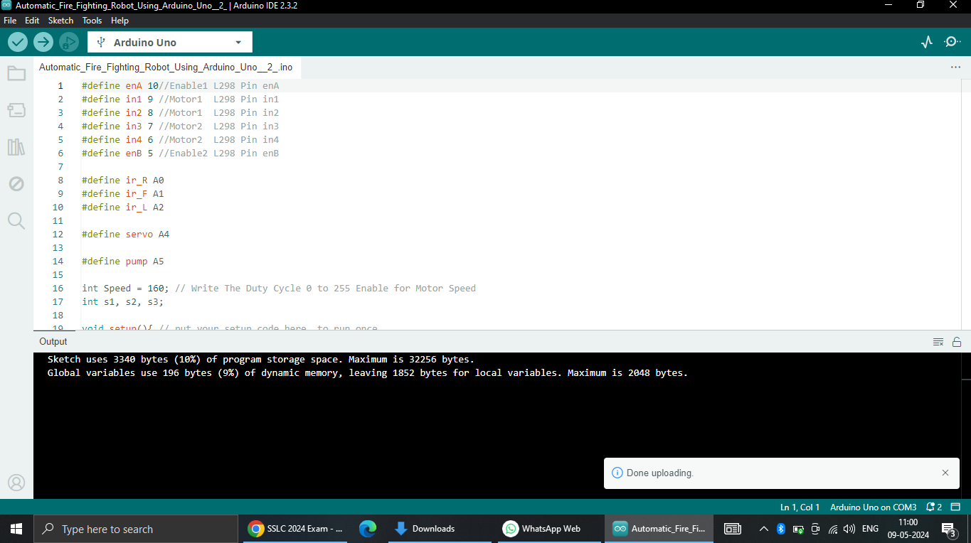

**Fig 4.6 Code Uploading**

# 5. Benefits of Project-

* It pinpoints the precise location of the fire's origin.
* It offers capable of detecting correctly with increased flexibility.
* It is cost-effective and dependable.
* It lessens the work that humans do.

# 6. Conclusion-

The Automatic Fighting Robot is a significant technology that has the potential to significantly increase fire and catastrophe safety. It recognizes and extinguishes fires on its own using a number of components, such as flame sensors, motors, and Arduino control. This research on the potential applications of technology to safeguard individuals and their belongings while offering practical solutions to fire emergencies.

# 7. Reference-

"Arduino Based Fire Fighting Robot," (ISSN: 2321-9653); IC Value: 45.98; SJ Impact Factor: 7.538; Anam Sheikh, Gopal Purohit, Vaishnavi C. Raut, Rehan Rashid Abdul, and Prof. C. H. Kidile Volume 10, Issue V, May 2022

Lokesh Venkata Ramana Alabhaktula, Veerraju Daliparthi, Tulasi Ravi Kumar, and Dulam Chandranaga Rakesh, "A novel firefighting robot with Arduino," e-ISSN 2320 –7876 www.ijfans.org Jan. 2021; Vol. 10, No. 1.

Mrs. Kondeti Chirunadh and Mr. G. Sai Varaprasad Goud Authors Miss G. Tejaswini and Mr. B. Srinivasa Rao, "Arduino based firefighting robot," e- ISSN: 2582-5208, volume:05/issue:06/june-2023.

"Arduino based autonomous firefighting robot," Volume:05/Issue:05/May-2023; Ms. Vidhya S, Roopashri CM, Yashaswini S, Sneha S, and Radha R; e- ISSN: 2582-5208.