**PERSONAL VOICE ASSISTANT**

**1.Prathmesh Bagalkote, 2 .Jagdish Kumbhar, 3.Yash Kolekar, 4 .Prakash Fulari**

**Brahmdevdada Mane Institute of Technology ,Belati, Solapur.**

**1. prathmeshbagalkote10@gmail.com, 2. kumbharjagdishg1714@gmail.com, 3. yash.kolekar70@gmail.com,4. prakashfulari27@gmail.com**

**Under guidance of :- Prof .** **S.S. Awtade**

**1.ABSTRACT:**

The project aims to develop a personal assistant for Windows-based systems. Personal Voice Assistant draws its inspiration from virtual assistants like Cortana for Windows, and Siri for iOS. It has been designed to provide a user-friendly interface for carrying out a variety of tasks by employing certain well-defined commands. Users can interact with the assistant either through voice commands or using keyboard input. As a personal assistant, Personal Voice Assistant assists the end-user with day-to-day activities like general human conversation, searching queries in google, Bing or yahoo, searching for videos, retrieving images, live weather conditions, word meanings, searching for medicine details, health recommendations based on symptoms and reminding the user about the scheduled events and tasks..

**2.INTRODUCTION**

AI voice assistant, also known as a virtual or digital assistant, is a device that uses voice recognition technology, natural language processing, and Artificial Intelligence (AI) to respond to people. Through technology, the device aggregates user messages, breaks them down, rates them, and gives meaningful feedback in return. Artificial intelligence can bring real conversations. Virtual assistants, understand natural language voice commands and performs tasks for users. These tasks, previously performed by a personal assistant or secretary, include dictation, reading text messages or exchanging email messages aloud, schedule appointments for end users. With the social media and other electronic devices. The AI assistant can also perform other activities, such as sending messages, answering phone calls, and getting directions. It also helps to read news and weather updates, open Google, You Tube, Stack Overflow, etc. , answer any questions, web scraping, play mu-sic, etc

**3. LITERATURE REVIEW**

To accomplish the application, the survey of different application done and collects requirements and got the information about various levels of project development and time assigned for each phase. The main objective of this study is to determine whether the proposed system is feasible or not. Solution strategies are usually generated without regard for feasibility because one cannot be both creative and critical at the same time. Hence feasibility analysis is a must to arrive at the most appropriate solution strategy. This feasibility analysis is done after the thorough study of the system. The planning objective is achieved through a process of information discovery that leads to reasonable estimation. Are detected. Author make a model

such as it captures the images of student showing happy, neutral contempt and disgust emotion. In the captured image facial features are extracted from each input image using Gabor filter bank. These extracted features are used for training the algorithm. Here support vector machine classifier supervised machine learning algorithm is used for training the dataset. Because it creates the best line or decision boundary that can segregate dimensional space into classes so that it can easily put the new data point in the correct category in the future. Although this definition emphasizes the digital style of a virtual assistant, the term virtual assistant or virtual personal assistant is additionally unremarkably wont to describe contract employees United Nations agency work from home and perform body tasks unremarkably performed by executives, assistant or secretary. Digital assistants can also be compared with other form of consumer-facing AI programming known as responsive advisors. Sensible adviser programs are topic oriented, whereas virtual assistants are task oriented. "Virtual assistants are typically cloud-based programs that require internet connected devices and/or applications to function". The technologies that power virtual assistants require vast amounts of knowledge, powering the platforms, as well as machine learning, language communication processes, and speech recognition arena. There are dedicated devices to provide virtual assistance. The most stylish on the market from Amazon, Google and Microsoft having Alexa, Google Siri and Cortana as AI voice assistants respectively given by each company.

## **4. SOFTWARE DESIGN**

Software architecture is the design and specification of rules by which software is build component of the system will behave and interact. It could be high level as detailed as naming the particular services to be development and what data we expect to pass in and out of each. A data flow diagram is graphical tool used to describe and analyze movement of data through a system. These are the central tool and the basis from which the other components are developed. The transformation of data from input to output, through processed, may be described logically and independently of physical components associated with the system. These are known as the logical data flow diagrams. The physical data flow diagrams show the actual implements and movement of data between people, departments and workstations. A full description of a system actually consists of a set of data flow diagrams. their therapy sessions in advance and gives therapists option to withdraw earnings. Python is an OOPs (Object Oriented Programming) based, high level, interpreted programming language. It is a robust, highly useful language focused on rapid application development (RAD). Python helps in easy writing and execution of codes. Python can implement the same logic with as much as 1/5th code as compared to other OOPs languages. Python provides a huge list of benefits to all. The usage of Python is such that it cannot be limited to only one activity. Its growing popularity has allowed it to enter into some of the most popular and complex processes like Artificial Intelligence (AI), Machine Learning (ML), natural language processing, Data science etc. Python has a lot of libraries for every need of this project. For JARVIS, libraries used are speech recognition

to recognize voice, Pyttsx3 for text to speech, selenium for web automation etc. Python is reasonably efficient. Efficiency is usually not a problem for small examples. If your Python code is not efficient enough, a general procedure to improve it is to find out what is taking most the time, and implement just that part more efficiently in some lower-level language. This will result in much less programming and more efficient code (because you will have more time to optimize) than writing everything in a low-level language makes use of a number of modules to offer a more thorough evaluation of a person's mental health. Second, our technology is always accessible, making it a practical choice for people who might not have access to traditional treatments. Third, because our Disadvantages: The lack of human interaction is one of the key drawbacks of our proposed approach. Although our chatbot module is intended to offer help and direction, it cannot take the place of the compassion and empathy of a qualified therapist. Furthermore, the ability of our speech and facial recognition modules to accurately discern an individual's emotional state may be limited. Finally, self reporting is used in our survey form module, which may not be totally accurate. Limitations: There are a few issues with our suggested solution, mostly with the technology. The quality of the input data, which may be

## **5. System Architecture**

Software architecture is the design and specification of rules by which software is build component of the system will behave and interact. It could be high level as detailed as naming the particular services to be development and what data we expect to pass in and out of each.

Architecture also includes establishing design considerations for development team.

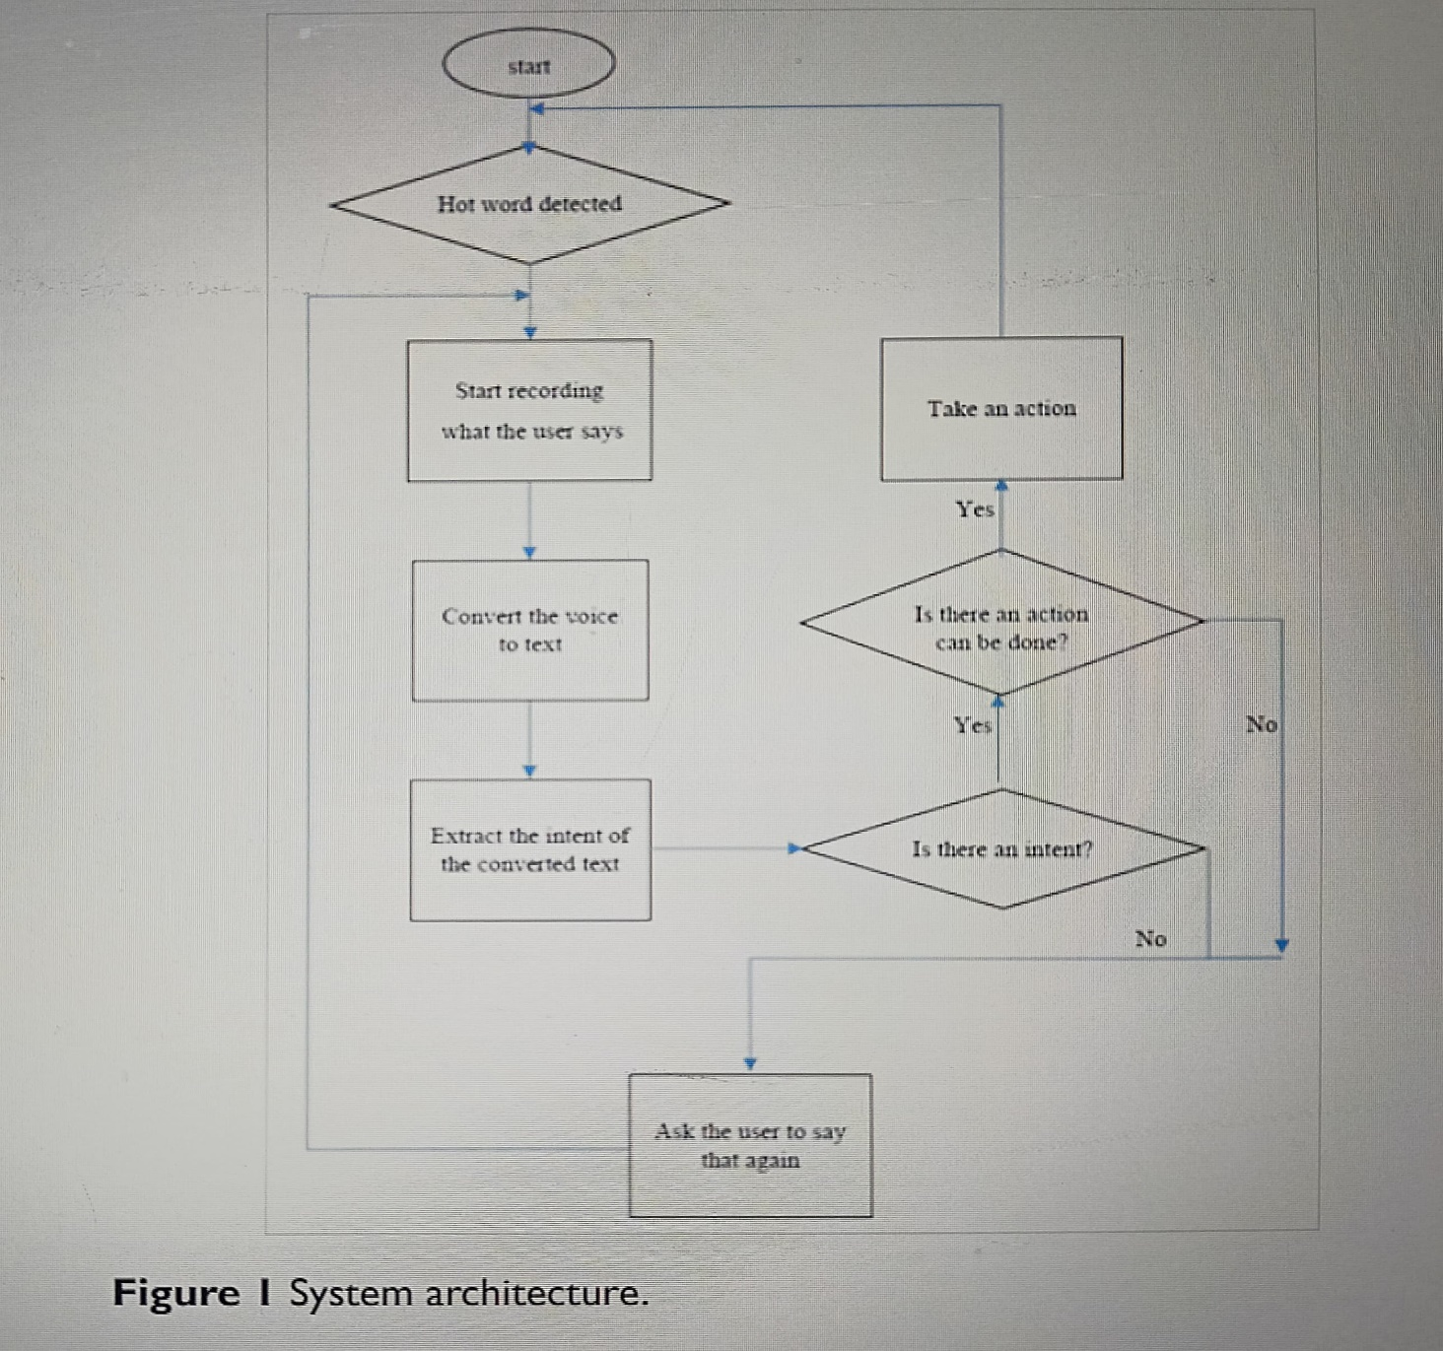

# **6. Results**

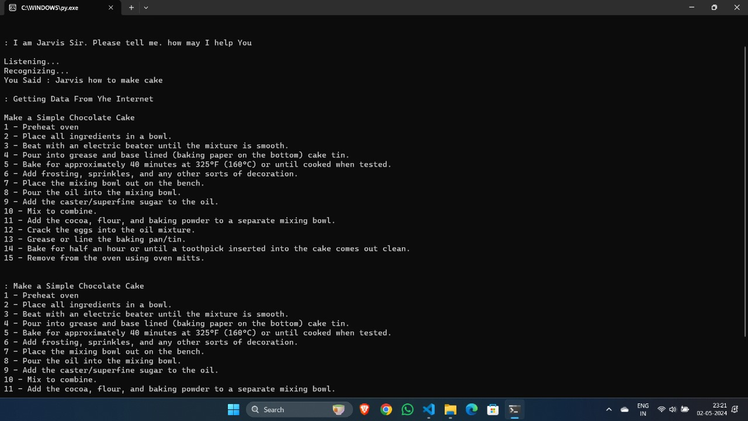

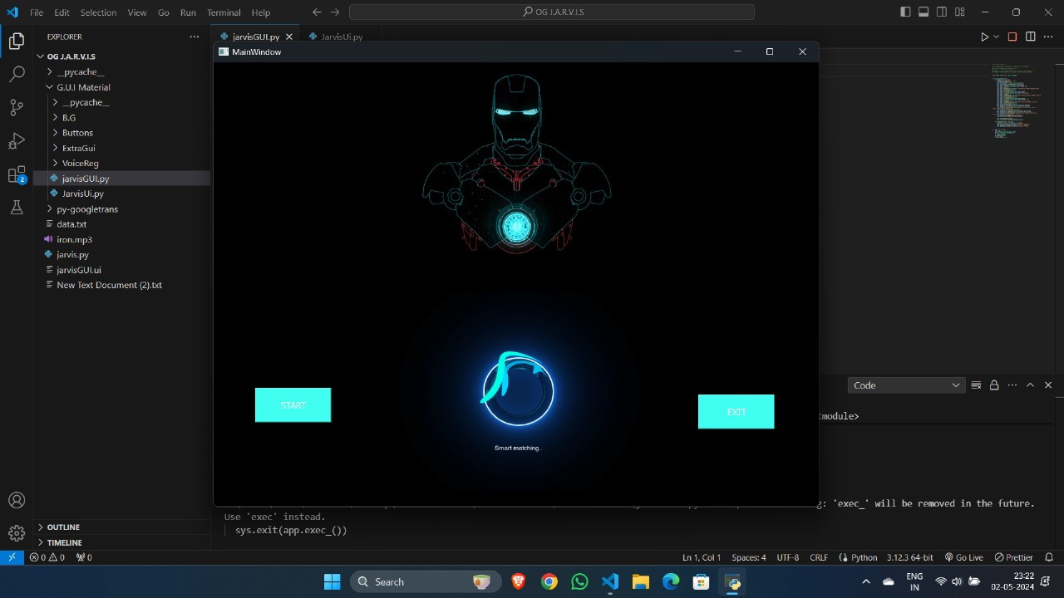

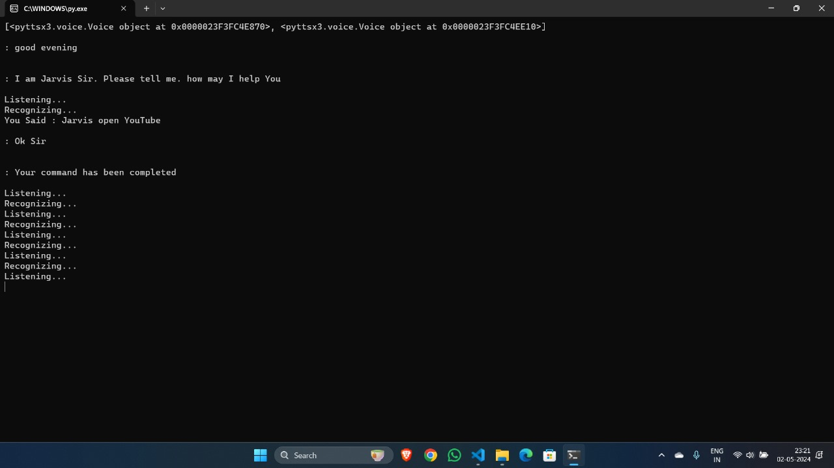

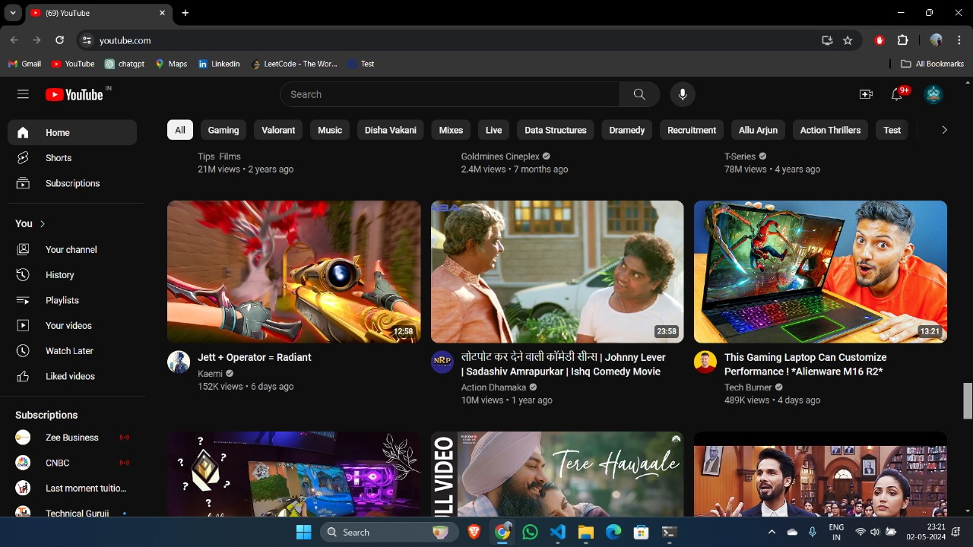

**5.Conclusion**

The project has been appreciated by all the users in the organization.It is easy to use, since it uses the GUI provided in the user dialog.User friendly screens are provided.The usage of software increases the efficiency, decreases the effort.It has been thoroughly tested and implemented.A Voice Activated Personal Assistant developed using python. This assistant currently works online and performs basic tasks like weather updates, stream music, search Wikipedia, open desktop applications, etc. The functionality of the current system is limited to working online only. The upcoming updates of this assistant will have machine learning incorporated in the system which will result in better suggestions with IoT to control the nearby devices similar to what Amazon’s Alexa does.

The project aims to develop a personal assistant for Windows-based systems. Personal Voice Assistant draws its inspiration from virtual assistants like Cortana for Windows, and Siri for iOS. It has been designed to provide a user friendly interface for carrying out a variety of tasks by employing certain well-defined commands. Users can interact with the assistant either through voice commands or using keyboard input. As a personal assistant, Personal Voice Assistant assists the end user with day-to-day activities like general human conversation, searching queries in google, Bing or yahoo, searching for videos, retrieving images, live weather conditions, word meanings, searching for medicine details, health recommendations based on symptoms and reminding the user about the scheduled events and tasks

## **6. REFERENCES**

**• Websites referred**

1. [www.stackoverflow.com](http://www.stackoverflow.com)

2. www.pythonprogramming.net

3. www.codecademy.com

4. [www.tutorialspoint.com](http://www.tutorialspoint.com)

5. [www.google.co.in](http://www.google.co.in)

**• Books referred**

1. Python Programming - Kiran Gurbani

2. Learning Python - Mark Lutz

**• Documents referred**

1. Designing Personal Assistant Software for Task Management using Semantic Web Technologies and Knowledge Databases - Purushotham Botla

2. Python code for Artificial Intelligence: Foundations of Computational Agents - David L. Poole and Alan K. Mackworth