

**END TO END PROCESS OPTIZIMATION IN FREIGHT FORWARDING OPERATIONS AT UNIQUE FREIGHT LINES, GUINDY CHENNAI.**

**AN PROJECT REPORT SUBMITTED TO**

**VELS INSTITUTE OF SCIENCE, TECHNOLOGY AND ADVANCED STUDIES**

**(VISTAS)**

**(Estd. U/s 3 of the UGC Act, 1956)**

***In partial fulfillment of the requirement***

***For the award of the degree of***

***MASTER OF BUSINESS ADMINISTRATION***

***SHIPPING AND LOGISTICS MANAGEMENT***

***Submitted by***

**MOHAMED ADHIL S**

**(22302117)**

**Under the guidance of**

**Dr.G. VEERAMANI**

**ASSOCIATE PROFESSOR - MBA**

**SCHOOL OF MANAGEMENT STUDIES**

**VISTAS**

**P.V. VAITHIYALINGAM ROAD,**

**OLD PALLAVARAM CHENNAI-600 117**

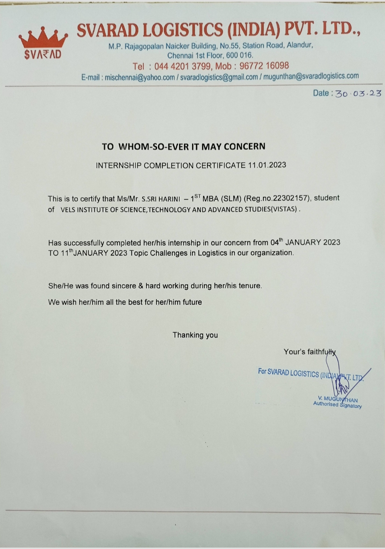**(2022-2024)**



**SCHOOL OF MANAGEMENT STUDIES**

**BONAFIDE CERTIFICATE**

This is to certify that Project report **on END TO END PROCESS OPTIZAMTION IN FREIGHT FORWARDING OPERATIONS AT UNIQUE FREIGHT LINES, GUINDY CHENNAI.** is a Bonafide record of work carried out by **MOHAMED ADHIL, 22302117. School of Management Studies** under **VISTAS** submitted in partial fulfilment of the requirements for the award of the degree of **Master of Business Administration in Shipping and Logistics Management** for the fourth semester during 2022-2024 under our guidance.

**Dr.G. Veeramani Dr. D. Anitha Kumari**

**Associate Professor -MBA Associate Professor**

**Internal Guide Programme Coordinator – MBA SLM**

**Thilak Rajan**

**CII Faculty**

**Dr.P.G. Thirumagal Dr. P.R.Ramakrishnan**

**HOD -MBA Dean**

**School of Management Studies and Commerce `**

**INTERNAL EXAMINER EXTERNAL EXAMINER**

**Project Completion Certificate**

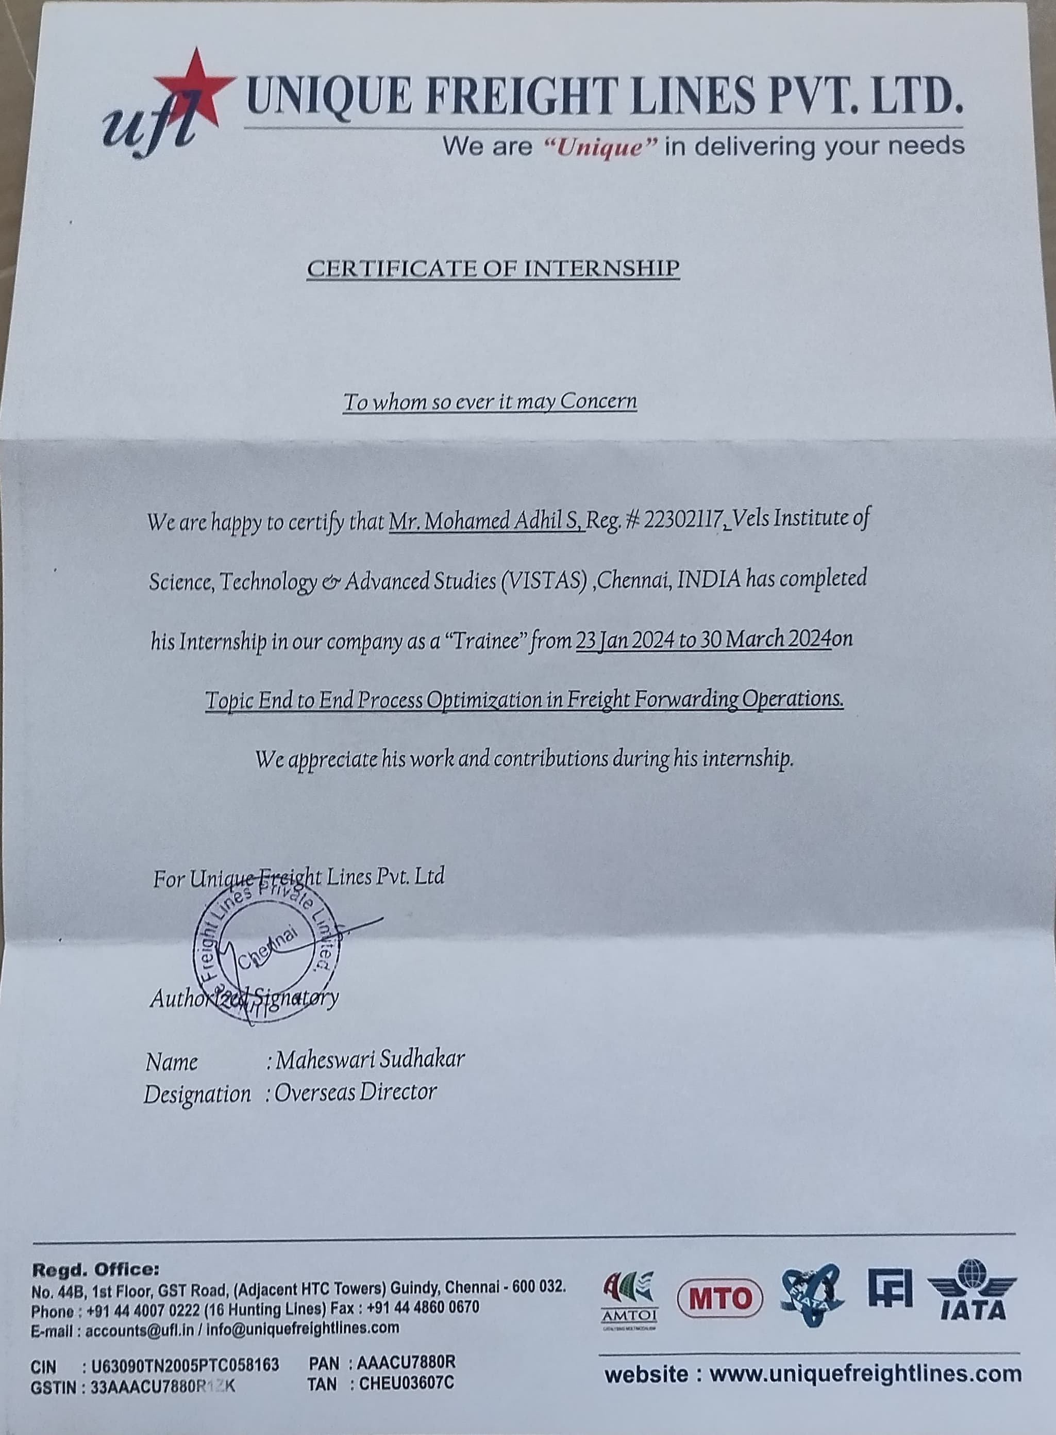

**DECLARATION**

I, Mohamed Adhil S,(22302117), a student of MBA - Shipping and Logistics Management , SCHOOL OF MANAGEMENT STUDIES, VISTAS here by, declare that the PROJECT work titled **End To End process optizimation in freight forwarding operations at Unique Freight Lines,Guindy Chennai. ,** submitted to the VISTAS in partial fulfilment of the requirement for the award of the degree of **Master of Business Administration in Shipping and Logistics Management**  is a record of Bonafide research carried out by me under the guidance of **Dr.G.Veeramani, Associate Professor –MBA,** **School Of Management Studies, VISTAS** and no part of it has been submitted for any other degree or diploma.

**Place: Chennai**

**Date:**

**MOHAMED ADHIL S**

**ACKNOWLEDGEMENT**

I am very much grateful to our Chancellor **Dr. Ishari K Ganesh,** **Dr. A. Jothi Murugan**, Pro Chancellor – Planning & Development, **Dr. Arthi K Ganesh**, Pro Chancellor – Academics and **Dr. Preethaa Ganesh**, Vice President for giving us an opportunity to study and encouraged us in all our efforts during the program.

I would like to express my deep gratitude to our Vice Chancellor **Dr.S.Sriman Narayanan,** Pro Chancellor **Dr. M. Bhaskaran** our Registrar **Dr. P.Saravanan** and Controller of Examinations **Dr. A. Udayakumar**, for all their endeavor in educating us in this esteemed organization.

I wish to express my gratefulness to **Dr. P.R Ramakrishnan**, Dean, School of Management Studies and Commerce, for the encouragement and guidance during the Internship. I would like to thank **Dr.P.G.Thirumagal,** AssociateProfessor & Head of the department , and **Dr. D. Anitha Kumari,Associate Professor -Programme Coordinator,** MBAShipping and Logistics Management, School of Management Studies for nurturing with a conducive environment and for her professional insights and updates to complete my Internship successfully.

I wish to express my humble thanks to my internal guide **Dr.G. Veeramani, Associate Professor – MBA**, School of management studies, VISTAS and External Guide **Thilak Rajan** with **CII Faculty** for her guidance throughout the Project.

I am indebted to my Company Guide **Maheswari Sudhakar, Overseas Director, Unique Freight Lines, Guindy Chennai.**

**MOHAMED ADHIL S**

|  |  |  |
| --- | --- | --- |
| **Chapter No** | **Title** | **PAGE NUMBER** |
| **I** | **Introduction** | **1** |
| **1.1 Industry Profile** | **8** |
| **1.2 Company Profile** | **19** |
| **1.3 Objectives of The Study** | **24** |
| **1.4 Need for The Study** | **25** |
| **1.5 Statement of The Problem** | **26** |
| **1.6 Scope of The Study** | **27** |
| **II** | **Review of Literature** | **28** |
| **III** | **Research Methodology** | **36** |
| **3.1Research Design** | **36** |
| **3.2 Descriptive Research** | **37** |
| **3.3 Data Collection Method** | **37** |
| **3.4 Case Study Analysis** | **38** |
| **3.5 Benefits** | **39** |
| **3.6 Limitations** | **39** |
| **IV** | **Data Analysis&Interpretation-Case Study** | **40** |
| **4.1 Birlasoft** | **40** |
| **4.2 Expo Group** | **46** |
| **4.3 Md Logistics&Nippon Express** | **48** |
| **4.4 Soft Freight Logic** | **51** |
| **4.5 Unique Freight Lines** | **53** |
| **V** | **Findings Of the Study** | **57** |
| **Recommendation&Suggestions** | **58** |
| **Impact** | **60** |
| **Conclusion** | **61** |
| **Bibliography** | **62** |

**Table of contents**

**INTRODUCTION**

Freight Forwarding

Freight forwarding is a crucial aspect of international trade and commerce, facilitating the movement of goods across borders efficiently and cost-effectively. It involves the coordination and management of various processes related to the transportation of cargo from the point of origin to the final destination.

Role of freight forwarding

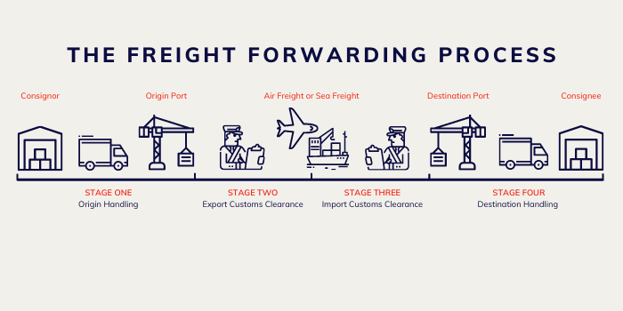

Source: <https://cdn.buttercms.com/rEBj1baLQoGWAURp26A0>

key roles freight forwarding plays:

1. **Logistics Coordination:** Freight forwarders are responsible for coordinating the entire logistics chain involved in transporting goods from the point of origin to the final destination. This includes selecting the most appropriate transportation modes (such as air, sea, road, or rail), arranging for pickup and delivery, and managing the movement of goods throughout the journey.

2. **Carrier Selection and Negotiation:** Freight forwarders leverage their industry expertise and network of carrier relationships to select reliable carriers that offer competitive rates and meet the specific requirements of each shipment. They negotiate contracts, book cargo space, and manage relationships with carriers on behalf of their clients.

3. **Documentation Management:** Freight forwarding involves a significant amount of documentation, including bills of lading, commercial invoices, packing lists, export/import permits, and customs declarations. Freight forwarders handle the preparation, processing, and submission of these documents, ensuring compliance with regulatory requirements and facilitating the smooth clearance of goods through customs.

4. **Customs Clearance:** Customs clearance is a critical aspect of international trade, involving the submission of various documents and compliance with import/export regulations. Freight forwarders liaise with customs authorities to ensure that shipments comply with regulatory requirements, pay duties and taxes, obtain necessary permits and licenses, and facilitate the timely release of goods from customs.

5. **Risk Management:** Freight forwarders play a key role in mitigating risks associated with transportation, including delays, damages, theft, and compliance issues. They implement risk management strategies, such as cargo insurance, tracking and monitoring systems, and contingency planning, to minimize disruptions in the supply chain and protect their clients' interests.

6. **Supply Chain Optimization:** Freight forwarders optimize supply chain operations by streamlining processes, minimizing transit times, reducing costs, and maximizing efficiency. They leverage their expertise in logistics and transportation management to identify opportunities for improvement, such as route optimization, consolidation of shipments, and inventory management, to enhance overall supply chain performance.

7. **Customer Service and Support:** Freight forwarders prioritize customer service and provide personalized support to their clients throughout the shipping process. They offer guidance and advice on shipping options, documentation requirements, and customs regulations, address inquiries and concerns promptly, and proactively communicate with clients to ensure transparency and satisfaction.

8. **Value-Added Services:** In addition to core transportation and logistics services, freight forwarders offer value-added services to meet the diverse needs of their clients. These may include warehousing and distribution, cargo consolidation/deconsolidation, packaging and labeling, freight tracking and monitoring, and supply chain consulting, providing comprehensive solutions to optimize the entire shipping process.

**Function of freight forwarding:**

The functions of freight forwarding encompass a wide range of activities that are integral to the efficient and smooth movement of goods across borders. These functions are essential for ensuring that shipments are transported safely, timely, and in compliance with regulatory requirements. Here are the key functions of freight forwarding:

1. **Booking and Reservation:** Freight forwarders handle the booking and reservation of cargo space with carriers, including airlines, shipping lines, trucking companies, and rail operators. They coordinate with these carriers to secure the necessary capacity for transporting goods based on the shipment's size, weight, destination, and preferred mode of transportation.

2. **Documentation Preparation:** Freight forwarders are responsible for preparing and processing the extensive documentation required for international shipments. This includes bills of lading, commercial invoices, packing lists, export/import permits, certificates of origin, and insurance certificates. They ensure that all documentation is accurate, complete, and compliant with the relevant regulations and requirements of the importing and exporting countries.

3. **Customs Clearance:** Customs clearance is a critical function of freight forwarding, involving the submission of documentation and compliance with customs regulations and procedures. Freight forwarders liaise with customs authorities to ensure that shipments meet all import/export requirements, pay duties and taxes, obtain necessary permits and licenses, and facilitate the timely release of goods from customs custody.

4. **Cargo Consolidation/Deconsolidation:** In cases where multiple shipments are combined into a single container (consolidation) or a container is broken down into individual shipments (deconsolidation), freight forwarders manage these processes efficiently. They coordinate the consolidation or deconsolidation of cargo, ensuring that each shipment is properly documented, labeled, and handled according to its specific requirements.

5. **Transportation Arrangements:** Freight forwarders select the most suitable transportation modes and routes for each shipment based on factors such as cost, transit time, nature of goods, and destination requirements. They arrange for the pickup and delivery of goods, schedule transportation services, and monitor the movement of shipments throughout the entire journey to ensure timely and secure delivery.

6. **Cargo Tracking and Monitoring:** Freight forwarders provide tracking and monitoring services to track the status and location of shipments in real-time. They utilize tracking technologies such as GPS, RFID, and electronic data interchange (EDI) to monitor the movement of goods, update clients on the progress of their shipments, and proactively address any issues or delays that may arise during transit.

7. **Risk Management:** Freight forwarders play a crucial role in mitigating risks associated with transportation, including delays, damages, theft, and compliance issues. They implement risk management strategies such as cargo insurance, packaging and labeling requirements, and contingency planning to minimize disruptions in the supply chain and protect their clients' interests.

8. **Customer Service and Support:** Freight forwarders provide personalized customer service and support to their clients throughout the shipping process. They offer guidance and advice on shipping options, documentation requirements, and customs regulations, address inquiries and concerns promptly, and proactively communicate with clients to ensure transparency and satisfaction.

**Types of freight forwarding:**

Freight forwarding encompasses various types of service providers, each specializing in different aspects of the transportation and logistics industry. These types of freight forwarding companies cater to different needs and preferences of shippers and consignees. Here are the main types of freight forwarding:

1**. Traditional Freight Forwarders :**

   - Description: Traditional freight forwarders offer a comprehensive range of logistics services, including transportation, customs clearance, documentation management, and warehousing.

   - Services: They handle all aspects of the shipping process, from booking cargo space with carriers to arranging for pickup and delivery, customs clearance, and documentation preparation.

   - Advantages: Traditional freight forwarders provide end-to-end solutions, offering convenience, expertise, and personalized support to their clients throughout the entire shipping process.

2. **Freight Brokers:**

   - Description: Freight brokers act as intermediaries between shippers and carriers, facilitating the booking of cargo space without directly handling the physical movement of goods.

   - Services: They match shippers with carriers based on the specific requirements of each shipment, negotiate rates, and manage the logistics coordination.

   - Advantages: Freight brokers offer flexibility and cost-effectiveness, allowing shippers to access a wide network of carriers and transportation options without the need for a long-term commitment.

3.  **Non-Vessel Operating Common Carriers (NVOCCs) :**

   - Description: NVOCCs specialize in ocean freight forwarding, issuing their bills of lading and consolidating shipments to offer competitive rates and efficient transportation solutions.

   - Services: They consolidate multiple shipments into full container loads (FCLs) or less-than-container loads (LCLs), manage the documentation and customs clearance, and coordinate the transportation of goods by sea.

   - Advantages: NVOCCs provide flexibility and cost savings for shippers by offering competitive rates, frequent sailings, and reliable transit times for ocean freight shipments.

4. **Customs Brokers:**

   - Description: Customs brokers focus primarily on customs clearance and compliance, ensuring that shipments meet regulatory requirements and facilitating the smooth clearance of goods through customs.

   - Services: They prepare and submit customs documentation, pay duties and taxes on behalf of importers/exporters, and liaise with customs authorities to resolve any issues or discrepancies.

   - Advantages: Customs brokers offer expertise and specialized knowledge in customs regulations and procedures, helping shippers navigate the complexities of international trade and avoid costly delys or penalties.

5. **Third-Party Logistics Providers (3PLs):**

   - Description: 3PLs offer end-to-end logistics solutions, including freight forwarding, warehousing, distribution, inventory management, and supply chain optimization.

   - Services: They provide a comprehensive range of logistics services tailored to the specific needs of their clients, leveraging technology, infrastructure, and expertise to optimize supply chain operations.

   - Advantages: 3PLs offer integrated solutions and economies of scale, allowing shippers to outsource their logistics requirements and focus on their core business activities.

**IMPORTANCE OF FREIGHT FORWARDING**

The importance of freight forwarding cannot be overstated in the context of global trade and commerce. It serves as a crucial intermediary function that facilitates the movement of goods from suppliers to consumers, regardless of geographical boundaries. Here are some key reasons why freight forwarding is essential:

1. **Global Trade Facilitation:** Freight forwarding enables international trade by providing the logistical infrastructure necessary for the transportation of goods across borders. Without freight forwarding services, the complexities of shipping goods internationally would be significantly magnified, hindering the flow of trade and economic activity.

2. **Efficiency and Optimization:** Freight forwarders specialize in optimizing the transportation process, selecting the most efficient routes, modes of transport, and carriers to ensure timely delivery while minimizing costs. By leveraging their expertise and networks, they streamline logistics operations, which is essential for businesses seeking to remain competitive in today's global marketplace.

3. **Risk Management:** Freight forwarding involves inherent risks such as delays, damages, theft, and compliance issues. Freight forwarders play a crucial role in mitigating these risks by implementing effective risk management strategies, ensuring compliance with regulations, securing cargo insurance, and proactively addressing potential challenges to minimize disruptions in the supply chain.

4. **Customs Compliance:** International trade is subject to numerous customs regulations and requirements imposed by different countries. Freight forwarders navigate the complexities of customs procedures, ensuring that shipments comply with import/export regulations, facilitating customs clearance, and minimizing the risk of delays or penalties associated with non-compliance.

5.**Documentation and Paperwork:** Freight forwarding requires extensive documentation, including bills of lading, commercial invoices, packing lists, export/import permits, and customs declarations. Freight forwarders handle the preparation, processing, and submission of these documents, ensuring accuracy, completeness, and compliance with regulatory requirements, thereby simplifying the shipping process for businesses.

6. **Customer Service and Support:** Freight forwarders provide personalized customer service and support to their clients throughout the shipping process. They offer guidance, advice, and assistance on shipping options, documentation requirements, and customs regulations, addressing inquiries and concerns promptly, and ensuring transparency and satisfaction.

**1.1 INDUSTRY PROFILE**

The shipping industry facilitates domestic and global manufacturing and trade via transportation of commodities and finished products, while also providing for the delivery of goods directly to consumers. A wide variety of commercial transport methods can be found in the shipping industry, from bulk transport of commodities in railcars to highly specialized "intermodal" container shipping. Four major modes of transport exist in this industry: marine, air, rail, and freight (trucking). A $700 billion industry is projected to grow to $1.3 trillion by 2020. In the United States alone, the $700 billion shipping industry is expected to be valued at $1.3 trillion by 2023. Demand for shipping continues to grow as global trade grows

Importance of shipping industry Around 90% of world trade is carried by the international shipping industry. Without shipping the import and export of goods on the scale necessary for the modern world would not be possible. Seaborne trade continues to expand, bringing benefits for consumers across the world through competitive freight costs. Thanks to the growing efficiency of shipping as a mode of transport and increased economic liberalization, the prospects for the industry ‘s further growth continue to be strong. There are over 50,000 merchant ships trading internationally, transporting every kind of cargo. The world fleet is registered in over 150 nations, and manned by over a million seafarers of virtually every nationality. Indian shipping Industry has become the 14th largest fleet in the world as per deadweight tonnage. The shipping fleet of India consists of around 515 vessels with a GRT of 7.06 million and dwt of 11.5 million Ones. It has about 616 ships, with a total capacity of 6.62 million tons Gross Registered Tonnage (GRT).

Out of which about 258 ships are engaged in overseas trade and the rest ply inland routes. The Indian shipping industry plays an important role in the Indian economy as almost 90% of the country’s international trade is conducted by the sea. Today, India has around 1071 ships with 722 coastal and 349 overseas ships; Indian coastal shipping is highly fragmented. "As on January 31, 2019, India had a fleet strength of 1,405 ships with dead weight tonnage (DWT) of 19.22 million (12.74 million GT) including Indian controlled tonnage, with Shipping Corporation of India (SCI) having the largest share of around 30.52 per cent. Of this, around 458 ships of 17.58 million DWT (11.26 million GT) cater to India's overseas trade and the rest to coastal trade".

India had a fleet strength of 1,400 vessels with gross registered tonnage (GRT) of 12.68 million in 2018, as compared to fleet strength of 1,371 vessels with 12.35 million GRT at the end of December 2017.Petroleum, lubricant, and oils are the most common products handled by the shipping industry in India, accounting for 33.7% of the total cargo handled. Container shipping comes in second, responsible for 19.7% of activities. This is followed by steam coal (13.7%), coking (7.6%), and Iron Ore (6.7%).

India is strategically located on the world’s shipping routes with a coastline of approximately 7,517 km. As of 2021, India owns over 30% global market share in the ship breaking industry and is home to the largest ship-breaking facility in the world at Alang. To promote India's shipping and port industry, the government has also introduced various fiscal and non-fiscal incentives for enterprises that develop, maintain and operate ports, inland waterways and shipbuilding in India. The Ports & Shipping industry in India is growing rapidly and contributing to economic progress. The ports sector in India is being driven by high growth in external trade. Read here to know the significance of the Indian Ports and Shipping sector for economic progress.

India has a coastline that is more than 7,517 km long, interspersed with more than 200 ports. Most cargo ships that sail between East Asia and America, Europe, and Africa pass through Indian territorial waters. India has become the fourth countryin the world to have its independent Regional Navigation Satellite System (IRNSS).

The scope and influence of logistics has evolved in the late 1940s. In the 1950s, and 60s, military was the only organization which used logistics. The scope of logistics has been extended beyond the army, as it has been recognized as one of the important tools for developing competitiveness. Competitive advantage means the company has the ability to differentiate itself, in the customer’s eyes, and also is operating at a lower cost and greater profit. Logistics facilitates in getting products and services as and when they are needed and desired to the customer. It also helps in economic transactions, serving as a major enabler of growth of trade and commerce in an economy. Logistics has come to be recognized as a distinct function with the rise of mass production systems. Production and distribution were earlier viewed as a sequential chain of extremely specialized activities. The role of logistics is to ensure availability of all the required materials before every step in this chain. Obviously, inventory of raw materials, semi-finished and finished goods is a must across this chain to ensure its smooth functioning. The concept of logistics has its base upon the systems approach. There is a single chain, with flow of materials starting from the supplier, then to the plant and finally to the end customer, and also these activities are done sequentially in order to achieve customer satisfaction at low cost. For this to be successful there has to be coordination in the activities of the department. With reference to an organization, an organization gets a concrete shape due to its structure.

In the earlier times, the suppliers in distribution activities were spread across the entire structure, thus resulting in an overlapping of activities and finally in unaccountable authority and responsibility. In today’s process driven organization, where the focus has shifted from functions to process, logistics has become an essential part of the process.

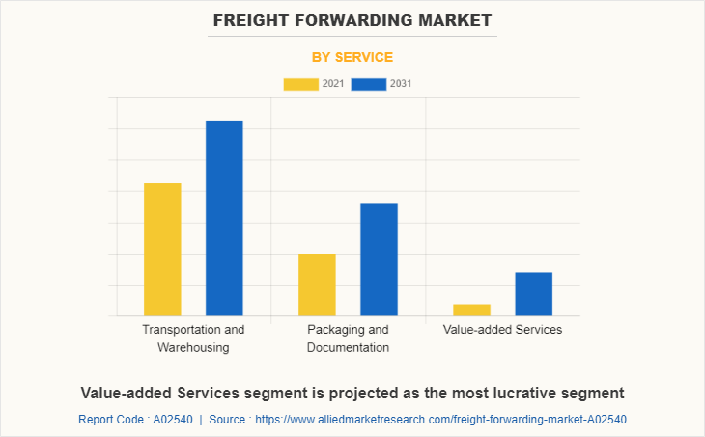

**Source:**<https://www.alliedmarketresearch.com/assets/sampleimages/service-A02540-6be14bf965f3ef2eae6a8184a477ee5c.png>

**Freight forwarder market**

**TOP FREIGHT FORWARDER IN INDIA (2023):**

According to the survey the below listed companies are the top freight forwarding companies in India.

1. **DHL Global Forwarding:** DHL has a significant presence in India with offices in major cities like Mumbai, Delhi, Chennai, Bangalore, Kolkata, and Hyderabad.

2. **Kuehne + Nagel: Kuehne + Nagel:** operates in India with offices located in cities such as Mumbai, Delhi, Chennai, Bangalore, Kolkata, and Ahmedabad.

3. **Expeditors:** Expeditors has offices in key Indian cities like Mumbai, Delhi, Chennai, Bangalore, Kolkata, and Hyderabad.

4. **DB Schenker:** DB Schenker has a network of offices across India, including locations in Mumbai, Delhi, Chennai, Bangalore, Kolkata, and Ahmedabad.

5. **UPS Supply Chain Solutions:** UPS has offices in major Indian cities such as Mumbai, Delhi, Chennai, Bangalore, Kolkata, and Hyderabad.

6**. Agility Logistics:** Agility operates in India with offices in cities like Mumbai, Delhi, Chennai, Bangalore, Kolkata, and Ahmedabad.

7**. Panalpina World Transport:** Panalpina, now part of the DSV Panalpina Group, has offices in key Indian cities including Mumbai, Delhi, Chennai, Bangalore, Kolkata, and Hyderabad.

8. **FedEx Trade Networks:** FedEx has a presence in India with offices in major cities such as Mumbai, Delhi, Chennai, Bangalore, Kolkata, and Hyderabad.

9. **CEVA Logistics:** CEVA Logistics operates in India with offices in Mumbai, Delhi, Chennai, Bangalore, Kolkata, and Pune, among other cities.

10. **Bolloré Logistics:** Bolloré Logistics has offices in India located in cities like Mumbai, Delhi, Chennai, Bangalore, Kolkata, and Hyderabad.

**TOP 10 FREIGHT FORWARDERS IN TAMIL NADU:**

1. **Agility Logistics:** Agility has offices in Chennai, the capital city of Tamil Nadu, which serves as a major hub for freight forwarding and logistics activities in the state.

2. DB Schenker: DB Schenker has a presence in Tamil Nadu with offices located in Chennai, providing freight forwarding and logistics services to businesses in the region.

3. **DHL Global Forwarding**: DHL has offices in Chennai, Tamil Nadu's largest city, offering a wide range of freight forwarding and logistics solutions to clients in the region.

4. **Expeditors:** Expeditors operates in Chennai, Tamil Nadu's primary commercial and industrial center, providing air and ocean freight forwarding services.

5**. FedEx Trade Networks:** FedEx has a presence in Chennai, Tamil Nadu's major port city, offering comprehensive freight forwarding and customs brokerage services to businesses in the state.

6. **Kuehne + Nagel:** Kuehne + Nagel has an office in Chennai, Tamil Nadu's key transportation and logistics hub, providing integrated logistics solutions to clients in the region.

7. **Panalpina World Transport:** Panalpina, now part of the DSV Panalpina Group, has an office in Chennai, Tamil Nadu's major seaport, offering air and ocean freight forwarding services.

8. **UPS Supply Chain Solutions**: UPS operates in Chennai, Tamil Nadu's primary logistics and distribution center, providing freight forwarding and logistics solutions to businesses in the state.

9. **Bolloré Logistics:** Bolloré Logistics has an office in Chennai, Tamil Nadu's key industrial and manufacturing center, offering freight forwarding and supply chain solutions.

10. **CEVA Logistics:** CEVA Logistics has a presence in Chennai, Tamil Nadu's major commercial and industrial hub, providing freight forwarding and contract logistics services.

**TOP 10 FREIGHT FORWARDERS IN WORLD:**

1. **DHL Global Forwarding:** DHL operates in over 220 countries and territories worldwide, with major hubs in cities like Bonn (Germany), Singapore, Hong Kong, and Miami (USA).

2. **Kuehne + Nagel:** Kuehne + Nagel has a global network covering more than 100 countries, with headquarters in Schindellegi, Switzerland, and key hubs in cities like Hamburg (Germany), Shanghai (China), and New York (USA).

3. **DB Schenker:** DB Schenker operates in over 140 countries with headquarters in Essen, Germany, and major hubs in cities like Frankfurt (Germany), Shanghai (China), and Chicago (USA).

4. **Expeditors:** Expeditors has operations in over 100 countries with headquarters in Seattle, Washington, USA, and major hubs in cities like Los Angeles (USA), Amsterdam (Netherlands), and Shanghai (China).

5. **UPS Supply Chain Solutions:** UPS operates in over 220 countries and territories worldwide, with headquarters in Atlanta, Georgia, USA, and major hubs in cities like Louisville (USA), Shanghai (China), and Cologne (Germany).

6. **Agility Logistics**: Agility operates in more than 100 countries, with headquarters in Kuwait City, Kuwait, and major hubs in cities like Dubai (UAE), Hong Kong, and Miami (USA).

7. **Panalpina World Transport**: Panalpina, now part of the DSV Panalpina Group, has operations in over 90 countries with headquarters in Basel, Switzerland, and major hubs in cities like Zurich (Switzerland), Atlanta (USA), and Shanghai (China).

8. B: FedEx operates in over 220 countries and territories worldwide, with headquarters in Memphis, Tennessee, USA, and major hubs in cities like Memphis (USA), Guangzhou (China), and Paris (France).

9. **CEVA Logistics:** CEVA Logistics operates in over 160 countries with headquarters in Marseille, France, and major hubs in cities like Houston (USA), Shanghai (China), and Singapore.

10. **Bolloré Logistics**: Bolloré Logistics has a global network covering over 100 countries, with headquarters in Puteaux, France, and major hubs in cities like Paris (France), Singapore, and Dubai (UAE).

**MARKET SIZE OF FREIGHT FORWARDER IN INDIA:**

As per a report published by Mordor Intelligence, the freight forwarding and logistics industry market size in India is estimated to be USD 317.26 billion in 2024.

Further, growing at a CAGR of 8.83%, the market size for the forecast period i.e., 2024 – 2029, is expected to reach USD 484.43 billion by 2029.This is comparatively higher than the previous year’s i.e., 2017 – 2023, that had a CAGR of 8.15%.

**Some other observations from the report**:

In 2022, around 90.35% share was taken up by non-temperature-controlled segment in warehousing for 2023-2029, the projected CAGR for temperaturecontrolled warehousing segment is 9.03% The domestic segment still occupies the majority share of CEP segment by destination – i.e., almost 66.33% in 202

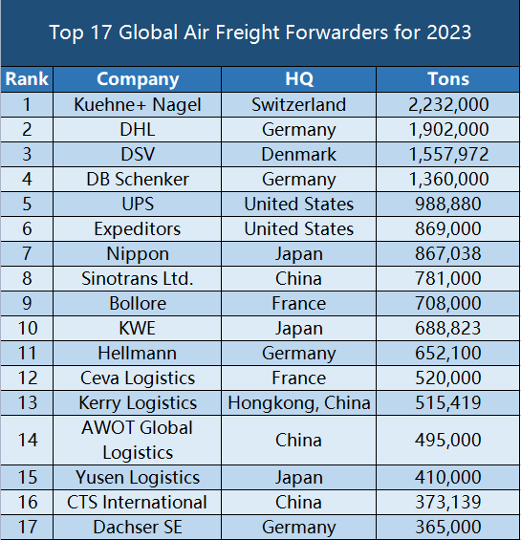

**Source:** <https://www.etowertech.com/data/upload/ueditor/20230626/%E5%9B%BE%E7%89%871.png>

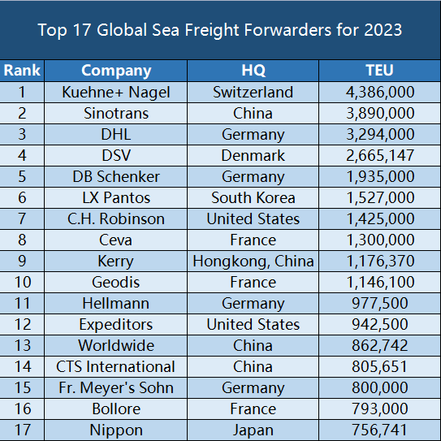

**Source:** <https://www.etowertech.com/data/upload/ueditor/20230626/%E5%9B%BE%E7%89%872.png>

**Objectives of logistics:**

**Logistics has the following objectives:**

**Reduction of inventory:** Inventory is one of the key factors which can affect the profit of an enterprise to a great extent. In the traditional system, firms had to carry a lot of inventory to satisfy the customer and to ensure excellent customer service. But, when funds are blocked in inventory, they cannot be used for other productive purposes. These costs will drain the enterprise’s profit. Logistics helps in maintaining inventory at the lowest level, and thus achieving the customer goal. This is done through small, but frequent supplies.

**Economy of freight:** Freight is a major source of cost in logistics. This can be reduced by following measures like selecting the proper mode of transport, consolidation of freight, route planning, long distance shipments etc.

**Reliability and consistency in delivery performance:** Material required by the customer must be delivered on time, not ahead of the schedule or behind the schedule. Proper planning of the transportation modes, with availability of inventory will ensure this.

**Minimum damage to products:** Sometimes products may be damaged due to improper packing, frequent handling of consignment, and other reasons. This damage adds to the logistics cost. The use of proper logistical packaging, mechanized material handling equipment, etc will reduce this damage.

**Quicker and faster response:** A firm must have the capability to extend service to the customer in the shortest time frame. By utilizing the latest technologies in processing information and communication will improve the decision making, and thus enable the enterprise to be flexible enough so that the firm can fulfill customer requirements, in the shortest possible time frame

**Logistics delivers value to the customer through three main phases:**

1. **Inbound logistics:** These are the operations, which precede manufacturing. These include the movement of raw materials, and components for processing from suppliers.
2. **Process logistics:** These are the operations, which are directly related to processing. These include activities like storage and movement of raw materials, components within the manufacturing premises.
3. **Outbound logistics:** These are the operations, which follow the production process. These include activities like warehousing, transportation, and inventory management of finished goods.

**GROWTH OF SHIPPING INDUSTRY IN INDIA**

In today’s world, shipping industry has grown as a huge industry where it is expected to grow at a compound annual growth rate 12.0%, at 2021 the market size value was USD 11.33 billion and it is forecasted to be USD 15.83 billion by 2028. In India according to the ministry of shipping 95% of India’s trade volume and 70%by value is done through maritime transport. In nov 2020, the Ministry of Shipping was renamed as the Ministry of Ports Shipping and Waterways. India has 12 major as such follows

Shipping industry is associated with the organizations such as

IMO (INTERNATIONAL MARITIME ORGANISATION), FIATA (INTERNATIONAL FEDERATION OF FREIGHT FORWARDERSASSOCIATIONS), IATA (INTERNATIONAL AIR TRANSPORT ASSOCIATION).

**IMO (INTERNATIONAL MARITIME ORGANISATION)**

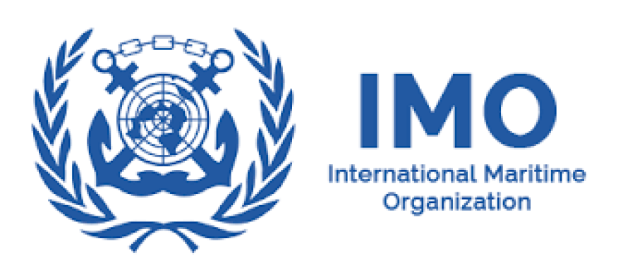

Source: <https://www.bing.com/images/blob?bcid=S9GAcE.BIPEGEwmgiuyr8yhUapCP.....3E>

**The International Maritime Organization (IMO)** is a specialized agency of the United Nations that is responsible for measures to improve the safety and security of international shipping and prevent marine pollution from ships. The IMO sets standards for the safety and security of international shipping. It oversees every aspect of worldwide shipping regulations, including legal issues, shipbuilding, and cargo size. The International Maritime Organization's objectives can be best summed up by its slogan—"Safe, secure, and efficient shipping on clean oceans." Basically, the IMO sets policy for international shipping and sets regulations on safety, security, and environmental best practices. The IMO is also involved in legal issues matters pertaining to international shipping, such as liability and compensation matters, and facilitating of international maritime traffic. The Assembly, the IMO's governing body, meets every two years to address issues in international shipping, and looking at the organization's budget. To break down the workload and to ensure each area of concern of the IMO is getting the attention it deserves, there are five committees tasked with making policies and developing, going over, and over hauling rules and guidelines. Those committees include the Technical Co- operation Committee, the Maritime Safety Committee, the Marine Environmental Protection Committee, the Legal Committee, and the Facilitation Committee. Furthermore, there are seven sub-committees working under these committees.

**FIATA (INTERNATIONAL FEDERATION OF FREIGHT FORWARDERS ASSOCIATIONS)**



Source: <https://seeklogo.com/images/F/FIATA-logo-D61CFBC1B6-seeklogo.com.png>

**FIATA** is a non-governmental organization, representing the freight forwarders of 150countries. It membership is of 109 association members, it represents over 40,000freight forwarding industry and logistics firms worldwide. FIATA is committed to representing the interest of its members by actively engaging with the World Trade Organization, United Nations agencies and other international organizations, transport organizations, global partners and governments to promote and protect the interest of the industry. FIATA is a reference source on international policies and regulations governing the freight forwarding and logistics industry. FIATA works at the international level to represent service providers who operate in trade logistics and supply chain management.

**1.2COMPANY PROFILE**

**UNIQUE FREIGHT LINES:**



**Source:** https://uniquefreightlines.com/index.html

**Unique freight lines** offer a complete range of international air and ocean freight services as well as integrated warehousing solutions from a single source supported by its strong management and network.

With a strong network of its offices and warehouses spread across India, they are everywhere you want us to be. Rapid expansion of global trade has meant radical changes in traditional buying procedures, and “established customer relationship’s”. These are watchwords in the logistics and transportation industry. This means we face new challenges in fulfilling our services and promise of quality to our clients everyday – which UFL had been doing it for their customers constantly since its inception.

Year on year, they have extended, our reach across India as well as worldwide, our substantial investments in IT and HR for the infrastructure and facility developments, professional training on sales and customer care to enhance the business and services had given us an edge for taking it to the next level.

It will be a perfect synchronization of your thoughts and our action. We walk the way you think with our UNIQUE way of services because for us every nanosecond and millimeter counts. Our proficiency in business will create an impression of professionalism and greater customer satisfaction.

**Services**

**Sea Freight**



Source: <https://uniquefreightlines.com/images/P66%20Sep%201995.jpg>

This company is one of the most efficient and well networked forwarders, offering to our customers specialized sea freight services after a careful analysis of their requirements. They give our customers the best of sea freight services on the most reliable shipping lines, offering the minimum transit time. A comprehensive range of our sea fright services include handling of:

* FCL Shipments to worldwide destinations
* LCL Export/Import Consolidation
* Buyers Consolidation
* Sea Freight Cargoes under all Inco terms
* Temperature Controlled Shipments
* Hazardous Cargo
* Project Cargoes, Break Bull, Fairs & Exhibitions, Removals & Relocations

**Air Freight**

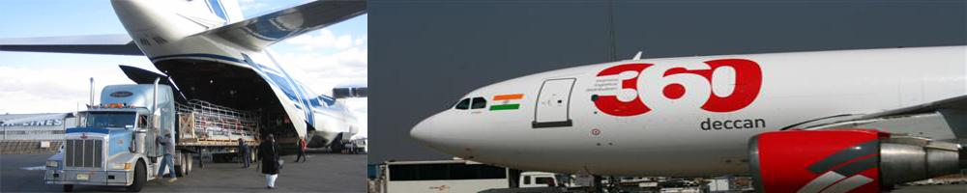

Source: <https://uniquefreightlines.com/images/aircraft_inner.jpg>

UFL are reputed for providing the best of Air Freight Services .Our smooth pre & post shipment procedures enables the fright quickly to the specified destination. We have contracts with leading carriers that enable us to cater to our customer’ requirements anytime anywhere across the world. We have business agreement for space and rates commitment with almost all major Air Carriers and they have consistently recognized our efforts in this field.

Our services include handling of

* Time Sensitive Shipments to worldwide destinations
* Air Export/Import Consolidation
* Buyers Consolidation
* Air Freight Cargoes under all possible Inco terms
* Temperature Controlled shipments
* Hazardous Cargoes
* Project Cargoes, Fairs & Exhibitions, Removals & Relocations

**Supply Chain Management**

Vendor Management and reporting purchase order fulfillment

Time-definite inventory replenishment program, demand and supply to shipping cycles and to lower Logistics cost

Re engineering the Logistics and supply chain by power specification analysis

**Warehousing & Distribution:**

UFL offers total logistics solution by simplifying your Global Logistics requirement. UFL has developed warehouse facilities at key in locations India. According to the needs of our customers we coordinate manufacturing, delivery, shipping, storage and distribution of goods. Our range of services include:

|  |  |  |
| --- | --- | --- |
| **Warehouse Management** | **3PL & 4 PL solution** | **ValueAdding Logistics** |
| Store and cross docking | -In-plant Logistics | -Bar-Coding. |
| Inventory Management | Contract Logistics | Tagging |
| Quality Control Platforms | Local distribution Management | Labelling |
| Temperature controlled storage and cold chain | Reverse Logistics | Refurbishing |
| Management |  | Repacking |
| Ware house Management Information System |  | Assembly Line Kitting |

**Cargo Consolidation**

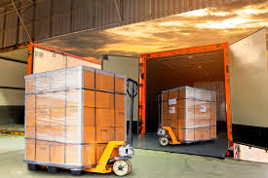

Source: <https://www.bing.com/images/blob?bcid=S4cQFNKqm.EGqxcxoNWLuD9SqbotqVTdPyg>

UFL also facilitate Cargo Consolidation (By Air/sea – Export / Import ) for our customer which includes the transportation or cargo to the stuffing point, stuffing of cargo in container, custom cargo will reach at the respective destination well before the time given by our reputed customer. We follow very

carefully all the important shipping instruction given and take care of cargo by warehouse it until the shipment is physically effected.

**Customs and Surface transport**

Our Custom Clearing department provides with best and timely clearance services for both export and import shipments. Convenience of the customer is taken care of by the finalization of the documents etc. and by saving the client administrative procedures. Our services include of

* Customs Documentation
* Cargo Examinations
* Survey, Fumigation, Palletizing, Quarantine & Origin Certificates etc
* Pick up/Deliveries by Road and Rail transports

**1.3 OBJECTIVES OF THE STUDY**

**Primary Objective:**

Identifying Operational Inefficiencies and Enhancing Performance in Freight Forwarding Processes at Progressive Freight Logistics Private Limited in Chennai

**Secondary Objectives:**

1. Analyze the existing challenges encountered by freight forwarders.

2. Assess the difficulties faced by freight forwarders in their interactions with carriers.

3. Evaluate the issues experienced by freight forwarders from corporate clients and individual customers.

4. Determine the satisfaction levels regarding customs clearance and the terms imposed by carriers on freight forwarders.

5. Propose actionable solutions to mitigate challenges and improve the operational landscape for freight forwarders.

**1.4 NEED FOR THE STUDY**

A study on end-to-end process optimization in freight forwarding operations is crucial due to the competitive pressure, complexity of the industry, cost reduction, customer expectations, regulatory compliance, and environmental impact. Optimizing processes can provide a competitive edge by reducing costs, improving efficiency, and offering better service to customers. The complexity of freight forwarding involves numerous interconnected processes, leading to inefficiencies, delays, and errors. Cost reduction can be achieved by eliminating wasteful activities, improving resource utilization, and negotiating better rates with carriers and suppliers. Customer expectations for timely delivery, accurate documentation, and transparent communication can be met by reducing transit times, minimizing errors, and providing real-time tracking and visibility of shipments. Regulatory compliance can be ensured by optimizing processes, reducing the risk of penalties, delays, and disruptions to operations. Additionally, optimizing freight forwarding processes can contribute to sustainability efforts by reducing fuel consumption, carbon emissions, and waste generation through efficient transportation routes, consolidation strategies, and resource optimization. Therefore, a study on end-to-end process optimization in freight forwarding operations is essential for addressing these challenges and achieving sustainability objectives.

**1.5 STATEMENT OF THE PROBLEM:**

The freight forwarding industry faces several challenges due to inefficiencies and complexities in its operational processes. Despite technological advancements, outdated methods, manual tasks, and fragmented systems persist, leading to issues in order processing, documentation handling, transportation management, and customs clearance. The lack of streamlined workflows, manual data entry, and fragmented systems exacerbate these problems, resulting in delays, errors, and increased costs. The fragmentation among stakeholders, including clients, carriers, and regulatory authorities, also hinders effective coordination. The evolving regulatory landscape adds complexity, with compliance with customs regulations, trade policies, and security measures requiring meticulous attention. Inefficient resource utilization further contributes to operational inefficiencies, with suboptimal allocation of personnel, vehicles, and storage facilities impacting cost-effectiveness and service quality. To address these challenges, a holistic approach involving technology, automation, streamlined workflows, and enhanced communication channels is needed. This approach aims to achieve end-to-end efficiency, reduce costs, improve compliance, and enhance service delivery.

**1.6 SCOPE OF THE STUDY**

• This study aids companies in pinpointing bottlenecks within freight-forwarding processes.

• It helps companies discover more efficient methods for freight forwarders to achieve their goals.

• The study delves into understanding the issues faced by freight forwarders.

• It facilitates data collection, trend analysis, and the development of actionable insights for enhancing operational efficiency and performance.

• The study will explore challenges such as delays in customs clearance, communication inefficiencies among stakeholders, and cargo damage or loss during transportation.

• By examining these challenges, the study seeks to uncover their root causes, analyze their impact on freight forwarding operations, and suggest practical solutions and recommendations for improvement.

**REVIEW OF LITERATURE:**

1. **Shi, X. (2011).**

Due to economic globalization, China's international freight forwarding sector must constantly innovate and improve in order to satisfy client demands. In order to maximize efficiency, this report examines the industry's present customs clearance procedure and proposes reforms to customs organizations and service procedures. To establish a thorough risk management system and support law-abiding businesses, the study makes use of risk theories, enhanced customs administration, and business process reengineering (BPR). By utilizing forward/backward shift and outward association of the operation process in the freight forwarding system, the ultimate goal is to develop an intelligent customs system.

2. **Wang, Y. (2010).**

The objective of this thesis is to analyze the current processes in Panalpina Chengdu Branch's order process, determine probable defects, and enhance it. Its main goals are operational and technological optimization; its secondary objectives include information flow analysis, defect analysis, employee and customer feedback, development recommendations, and enhancing information sharing and access among coworkers.

3.**Archetti, C. (2019).**

The demand for international transport has been steadily rising as a result of growing global trade and technological improvements, giving businesses access to a global client base. The necessity for quick international deliveries has grown due to the growth of e-commerce and global production, necessitating air travel. Using specialist suppliers and intermediaries, freight forwarding companies play a vital role in worldwide multimodal transportation. This PhD thesis examines the day-to-day challenges faced by freight forwarding firms, such as improving air transportation layouts, condensing several loose goods into transport units, and planning multiple shipments using mixed integer linear programming. Benchmark instances are subjected to both local searches and the suggested algorithm.

4. **Krajewska, M. A., & Kopfer, H. (2009).**

By incorporating subcontractors, the integrated operational transportation planning problem presented in this study goes beyond conventional vehicle routing and scheduling. It suggests using tabu search as a heuristic to solve this intricate problem by expanding tabu search to include particular kinds of moves. Analysis of the cost structure is done to find out if owning a fleet is financially profitable in the long run.

5.**Heinbach, C., Beinke, J., Kammler, F., & Thomas, O. (2022).**

By facilitating the digitization of transport management (RFTM), digital platforms (DPs) are upending the road freight industry. In order to better understand digital freight services and assist logistics firms, this research investigates DPs in the field of road freight transport. The study proposes a morphological box with 14 dimensions and eight DP kinds linked to RFTM using a grounded theory methodology. The results offer a thorough comprehension of DPs to improve decision-making and recommend future directions for data-driven and digitalized transport logistics research.

6.**Tsolaki, K., Vafeiadis, T., Nizamis, A., Ioannidis, D., & Tzovaras, D. (2022).**

The state-of-the-art in machine learning for supply chain, logistics, and freight transportation applications is examined in this paper. Arrival time, demand forecasting, vehicle routing, traffic flow prediction, industrial process optimization, and anomaly detection are all covered, along with an explanation of their development and uses.

7**.Wang, Y., Zhang, J., Assogba, K., Liu, Y., Xu, M., & Wang, Y. (2018).**

A collaborative multiple centers vehicle routing problem with simultaneous delivery and pickup (CMCVRPSDP) is presented in this study in an effort to reduce network operational costs and vehicle counts. A hybrid heuristic algorithm that combines NSGA-II and k-means is suggested. Using partial mapped crossover and swap mutation techniques, the algorithm performs genetic operations and creates a genuine coded population. Performance is better when compared to the conventional NSGA-II and MOPSO algorithms. In addition to lowering long-haul transportation, increasing vehicle loading rates, and promoting sustainable growth, the suggested profit allocation strategy also encourages the formation of a grand alliance.

8. **Wang, Y., & Sarkis, J. (2021).**

The editorial classifies digitalization tendencies into three categories: connecting, collaborating, and capitalizing. It examines these trends in freight transport and logistics. In addition to introducing special issue papers, it emphasizes new technologies that are influencing supply chain transformations. It also points out gaps in the literature and suggests areas for further study.

9.**Koh, L., Dolgui, A., & Sarkis, J. (2020).**

Blockchain technology is transforming business and data processes, and it has implications in logistics, transportation, and public administration. It is essential for a smooth procedure that permits the free movement of products and services across international borders. To meet these objectives, a digital infrastructure that includes pass-porting, cloud computing, payment systems, and intelligence management is required. The global supply chain may change as a result of this integration, improving trade ties. Studies conducted by the government, business, or academics can shed light on issues pertaining to public and private manufacturing and service sectors. Blockchain technology’s transdisciplinarity necessitates collaboration from various stakeholders and disciplines. This position paper summarizes future directions and scenarios for blockchain transitions in order to lay the groundwork for the adoption of blockchain in transportation and logistics. It does this by outlining important concepts and methodologies.

10.**Konstantakopoulos, G. D., Gayialis, S. P., & Kechagias, E. P. (2022).**

A critical component of supply chain operations, the vehicle routing problem (VRP) influences both customer satisfaction and distribution costs. The problem Is influenced by a number of factors that result in different varieties, including customers, external settings, and transportation demands. Algorithms are used by researchers to streamline supply chains and logistics. This research analyzes 334 and 263 papers published in the last ten years to offer a methodology for categorizing VRP variations and algorithms for freight transportation. Additionally, the study finds patterns and connections between algorithms and VRP variations.

11.**Ding, Y., Jin, M., Li, S., & Feng, D. (2021**

The research and applications of internet of things (IoT)-based smart logistics, such as intelligent freight transportation, warehousing, and delivery, are covered in this review paper. It emphasizes the importance and role of IoT, as well as the obstacles and future research needs. Technical difficulties, constrained IoT capacity, standards, data collection, processing, and security concerns are some of the challenges. The importance of additional study and advancement is emphasized throughout the report12.

**12 Mendoza Alcantara, A., Fernandes, A. M., & Hillberry, R. H. (2015).**

When it comes to shipping goods over international boundaries, cost savings come out ahead of time savings, according to a survey of 153 freight forwarding companies in Serbia. The company features, operational decisions, and circumstances at border crossings and terminals where imported items are approved for release were reported by the respondents. The analysis also discovered that the agreed-upon value of an extra day of delivery in Serbia is roughly equivalent to 1% of the shipment's total value. This emphasizes how crucial freight forwarders are to enabling global trade.

13. **Pečený, L., Meško, P., Kampf, R., & Gašparík, J. (2020).**

The multidisciplinary field of logistics improves corporate operations and helps businesses react swiftly to client and market demands. Logistic chains are being managed more and more through the application of optimization techniques, which lower expenses, boost productivity, and shorten operating times. The article’s objectives are to assess the logistic chain of a business, make recommendations for improving the transport process, and do it economically. The book, which focuses on the efficient use of transportation means, technologies, and human resources, is split into theoretical-methodological and applied sections. An analysis of optimum routes and recommendations for enhancing business processes round out the article.

14**.Simoni, M. D., Kutanoglu, E., & Claudel, C. G. (2020).**

The last mile of freight distribution is a critical part of the supply chain because of its significant costs and customers’ increasing expectations from e-commerce and same-day delivery services. Automated technologies in freight transportation represent an opportunity to develop more efficient systems characterized by the integration of different and complementary modes. In this study, we focus on the possibility of implementing an integrated truck-robot system for the last-mile delivery. This typology of problem shares similarities with truck-drone problems, although robots are characterized by much slower speeds and can perform several consecutive deliveries. Based on these particular features, a heuristic that efficiently identifies solutions based on initial truck tours and corresponding joint robot operations is presented. This solution approach leverages a special version of the “Weighted Interval Scheduling Problem,” which allows for a very efficient Dynamic Programming solution. The developed solution approach is adopted to analyze the influence on efficiency of different features concerning the robot’s design and operation, and the surrounding environment. The results show that robot-assisted last-mile delivery systems are quite efficient if robots are employed in heavily congested areas and appropriately retrofitted to accommodate several compartments in the robot’s storage.

15. **Rasulov, M., Masharipov, M., & Ismatullaev, A. (2021).**

The research and applications of internet of things (IoT)-based smart logistics, such as intelligent freight transportation, warehousing, and delivery, are covered in this review paper. It emphasizes the importance and role of IoT, as well as the obstacles and future research needs. Technical difficulties, constrained IoT capacity, standards, data collection, processing, and security concerns are some of the challenges. The importance of additional study and advancement is emphasized throughout the report.

16.**Cichosz, M., Wallenburg, C. M., & Knemeyer, A. M. (2020).**

This study looks at the obstacles and elements that make digital transformation (DT) successful in the logistics services sector. It employs a two-stage methodology, with an emphasis on case studies from nine international and global LSPs and a survey of the literature. The primary challenges are lack of resources and the intricacy of the logistical network, whereas the primary success element is an organizational culture that supports DT and a leader who shares that vision. The findings support the developing field of supply chain management and logistics through DT.

17.**Chen, J. (2020).**

This paper introduces the air transportation freight forwarder service problem (ATFFSP) and presents the freight forwarding companies’ optimization problems. A MILP formulation’s efficacy and performance are assessed using actual data from an Italian manufacturer. To improve service management, the feasibility of building a new warehouse is also investigated in the study.

18.**Archetti, C., & Peirano, L. (2020).**

This paper introduces the air transportation freight forwarder service problem (ATFFSP) and presents the freight forwarding companies' optimization problems. A MILP formulation's efficacy and performance are assessed using actual data from an Italian manufacturer. To improve service management, the feasibility of building a new warehouse is also investigated in the study.

19.**Antonov, А. А. (2020).**

A key component of the global economy, the digitization of maritime freight transportation procedures is covered in the text. Comparing sea transportation to air, rail, or road transportation, up to 90% of global trade benefits from its advantages. Giant vessels that can concurrently carry thousands of shipping containers’ worth of cargo have been built as a result of the building of giant vessels. Shipping is a well-liked mode of transportation since it’s economical, safe, environmentally friendly, and great for transferring big loads of freight. Digital technology, such digital connections, may lessen the need for freight forwarders to manually arrange shipments on behalf of numerous parties. But instead of producing game-changing consequences, these platforms have left the market extremely fragmented.

20**.Archetti, C., Peirano, L., & Speranza, M. G. (2022).**

Multimodal transportation has evolved as a result of increased demand for international trade and transportation brought about by globalization. The management of intricate transportation networks requires the use of optimization techniques. The body of research on the optimization of multimodal transportation is expanding as new technologies bring with them new difficulties. An overview of current research is given in this review of the literature, along with a list of issues and emerging patterns that warrant further investigation.

21.**Pečený, L., Meško, P., Kampf, R., & Gašparík, J. (2020).**

The multidisciplinary field of logistics improves corporate operations and helps businesses react swiftly to client and market demands. Logistic chains are being managed more and more through the application of optimization techniques, which lower expenses, boost productivity, and shorten operating times. The article’s objectives are to assess the logistic chain of a business, make recommendations for improving the transport process, and do it economically. The book, which focuses on the efficient use of transportation means, technologies, and human resources, is split into theoretical-methodological and applied sections. An analysis of optimum routes and recommendations for enhancing business processes round out the article.

22.**Castilla-Rodríguez, I., Expósito-Izquierdo, C., Melián-Batista, B., Aguilar, R. M., & Moreno-Vega, J. M. (2020).**

Complex infrastructures managing massive amounts of containers in international freight movement are known as maritime container terminals. Among the many logistical issues they deal with is quay crane scheduling. Numerous optimization algorithms fail to consider the influence and unpredictability of internal delivery vehicles. To assist terminal managers, an intelligent system that combines simulation tools and Artificial Intelligence techniques is suggested. The technology integrates an internal delivery vehicle impact and uncertainty-accounting simulation model with an evolutionary crane scheduling algorithm. This technology is versatile and flexible, offering better solutions for common problems.

23.**Le Carrer, N., Ferson, S., & Green, P. L. (2020).**

This research proposes a framework for optimizing ship scheduling and cargo loading decisions in shallow seas and tidal ports by integrating stochastic optimization techniques and decision theory. The model uses probabilistic risk minimization and net benefit maximization to analyze a bulk carrier’s voyage between N ports. Tested on two British ports, the method demonstrates robustness and approaches optimality more closely than usual techniques. Even with artificially inflated sea level variations, the technique is even more intriguing.

24.**Yan, B., Zhu, X., Lee, D. H., Jin, J. G., & Wang, L. (2020).**

With an emphasis on inbound container transshipment plans and train timetable templates, this study tackles the issue of sea-rail transshipment operation in seaport rail terminals. It suggests a rolling horizon technique with an adjustable horizon, a backtracking strategy, and an integer programming paradigm. The performance of transshipment operations is shown to be considerably impacted by the rail-mounted gantry crane handling capability. Extending train service duration and improving shunting engine operating capability helps mitigate insufficient handling capacity.

25.**Gruchmann, T., Pratt, N., Eiten, J., & Melkonyan, A. (2020).**

With the goal of improving logistics speed, cost, and predictability, new digital competitors are posing a global threat to the freight forwarding sector. Traditional logistics companies are evolving due to digitalization processes, which are creating decentralized, adaptable, and more effective services. In addition to presenting an expanded framework for digital sea freight business models and analyzing FreightHub, a fourth-party logistics company, this study offers managerial implications on the advantages and disadvantages of a digital transition in the context of marine transportation.

**RESEARCH METHODOLOGY**

**RESAERCH MEANING:**

• Research is defined as movement from the known to the unknown. It is an effort to discover something.

According to Clifford Woody "Research comprise defining and redefining problems formulating hypothesis

or suggested solutions, collecting/organizing and evaluating data making deduction & research conclusions

and at last carefully testing the conclusion to determine whether they fit the formulation hypothesis.

• Methodology denotes a specific method of collection and analysis of data. It is a way to systematically

solve the research problem. It is necessary for the researcher to know not only the research

methods/techniques but also the methodology.

**3.1 RESEARCH DESIGN:**

Research Design: The research design refers to the overall plan for conducting the research. It includes the

type of research, the research questions, the data collection methods, and the data analysis techniques. The

research design should be carefully planned and tailored to the specific research question being addressed.

**3.2DESCRIPTIVE RESEARCH:**

Descriptive research includes surveys and fact-finding enquiries of different kinds. The major purpose of descriptive research is description of the state of affairs as it exists at present. In social science and business research we quite often use Research Methodology: the term Ex post facto research for descriptive research studies. The main characteristic of this method is that the researcher has no control over the variables; he can only report what has happened or what is happening. Most ex post facto research projects are used for descriptive studies in which the researcher seeks to measure such items as, for example, frequency of shopping, preferences of people, or similar data. Ex post facto studies also include attempts by researchers to discover causes even when they cannot control the variables.

**3.3DATA COLLECTION METHOD**

**SECONDARY DATA:**

Secondary data analysis, however, is the use of data that was collected by someone else for some other purpose. In this case, the researcher poses questions that are addressed through the analysis of a data set that they were not involved in collecting. The data was not collected to answer the researcher’s specific research questions and was instead collected for another purpose. The same data set can therefore be a primary data set to one researcher and a secondary data set to a different researcher.

**3.4 CASE STUDY ANALYSIS:**

Case study analysis is a comprehensive methodological approach used to investigate a particular instance or phenomenon within its real-life context. It involves an in-depth exploration of a specific case to uncover its intricacies, dynamics, and outcomes. Typically employed in fields such as business, psychology, sociology, and medicine, case study analysis aims to provide rich, detailed insights that can inform decision-making, theory development, and problem-solving. The process begins with the careful selection of a relevant case, which could be an individual, a group, an organization, an event, or a process. Data collection methods vary but often include interviews, surveys, observations, documents, and archival records. Once the data is gathered, researchers meticulously analyze it, using qualitative methods such as thematic analysis or content analysis to identify patterns, themes, and relationships. Throughout this analysis, existing theories or frameworks may be applied to interpret the findings and understand the underlying mechanisms. The ultimate goal is to draw meaningful conclusions about the case, including its strengths, weaknesses, opportunities, and threats. These conclusions can have implications for theory, practice, or policy, and may also provide valuable insights for future research. The findings of the case study analysis are typically presented in a detailed report or presentation format, which includes a thorough description of the case, the research methods employed, the analysis process, and the resulting conclusions. Overall, case study analysis offers a robust methodological approach for delving deep into complex real-world phenomena and generating nuanced insights that contribute to knowledge advancement and informed decision-making

**3.5 Benefits:**

* Case study analysis provides an in-depth exploration of specific instances, allowing for a nuanced understanding and rich insights often overlooked in broader studies.
* It facilitates theory development and refinement by testing existing theories against real-world situations and proposing new hypotheses.
* Bridging the gap between theory and practice, it enhances the applicability and relevance of academic research, contributing to knowledge advancement.
* Enables investigation of complex phenomena within natural settings, enhancing ecological validity and reflecting real-life complexities.
* Facilitates the identification of patterns, trends, and unique factors influencing outcomes, enriching our understanding of causal relationships.
* Offers insights into practical implications and real-world applications, providing actionable recommendations for practitioners and policymakers.
* Promotes interdisciplinary collaboration and knowledge exchange, fostering innovation and creativity through diverse perspectives.

**3.6 Limitations:**

* The study relies on data from respondents and a journal, thus the reliability of the data is not thoroughly examined. Caution is necessary when extrapolating the results to other contexts.
* Due to the relatively small number of employees in logistics and shipping companies, gathering the necessary sample size can be challenging.
* There could be limitations in the accuracy and completeness of the data obtained, as it relies on self-reporting by employees and secondary sources.
* The time frame of the study may not allow for a comprehensive understanding of long-term trends or effects, particularly if the data collection period is limited.
* The study relies on data from respondents and a journal, thus the reliability of the data is not thoroughly examined. Caution is necessary when extrapolating the results to other contexts.

**DATA ANALYSIS &INERPRETATION**

**CASE STUDIES:**

**4.1BIRLASOFT**



**Source:** <https://th.bing.com/th/id/OIP.12btAYMBVNWSByBmrzE9RAHaDY?rs=1&pid=ImgDetMain>

**Birlasoft** is a global IT services provider that combines the power of domain expertise, enterprise solutions, and digital technologies to reimagine business potential. [As part of the **CK Birla Group**, a leading Indian business conglomerate, Birlasoft serves clients across various industries, including banking, high tech, manufacturing, capital markets, insurance, and more](https://www.birlasoft.com/).

key points about Birlasoft:

1. **Certified Great Place to Work**: Birlasoft has been **Great Place to Work® Certified** for the third time in a row. [Their commitment to excellence and employee satisfaction is evident in this recognition](https://www.birlasoft.com/).
2. **Enterprise Digital and IT Services**: Birlasoft combines domain knowledge, enterprise solutions, and digital technologies to drive business transformation. [They challenge the status quo, break conventions, and consistently exceed expectations](https://www.birlasoft.com/).
3. **Industry Solutions**:
   * **BFSI (Banking, Financial Services, and Insurance)**: Birlasoft offers solutions tailored for this sector, focusing on digital transformation, operational efficiency, risk mitigation, and superior customer experiences.
   * **Manufacturing**: Their exclusive **bMACH approach** empowers manufacturers to fast-track their Industry 4.0 journey, reimagine business models, transform product lifecycles, and digitize operations.
   * **Energy & Resources**: Leveraging expertise in IoT, automation, analytics, and AI, Birlasoft helps streamline processes across the value chain, ensuring sustained competitiveness and resilience.
   * [**Life Sciences & Healthcare**: Birlasoft integrates IoT, digital, analytics, applications, and cloud services to drive innovation, reduce expenses, and adhere to global quality and regulatory standards in pharmaceutical and medical devices sectors](https://www.birlasoft.com/)

**CHALLENGES FACED BY THE COMPANY**

**1.Issuing accurate quotations with quick turnaround while ensuring consistent profit margins.**

The process of issuing accurate freight forwarding quotations to shippers is challenging due to the intricacies of carriers' handling costs and pricing structures. Factors like shipment attributes, transit specifics, transport modes, and shipper specialized handling requirements must be considered. Consistent pricing requires complex rate definitions and collaboration between sales, commercial, and operations functions. This has led to delayed quotations and inability to ensure consistent profitability across jobs.

**2. Managing multiple transit modes and handling complex multi-leg scenarios.**

Freight forwarding operations involve transit across various transport modes, each with unique complexities and regulations. These decisions impact profitability, but freight forwarders often lack visibility into carrier rates and profit margins. To address these challenges, a robust operational logic is needed, including an end-to-end platform for the order-to-delivery process. The platform should provide a simple, intuitive interface for each persona to access key data, which is currently lacking in the client's organization.

**3.Inability to meet customer expectations and maintain profitability in long-term contracts.**

Long-term contracts in freight forwarding, which account for 60-70% of contract volume, can be affected by market shifts, supply chain disruptions, and demand fluctuations. To maintain profitability and retain long-term contracts, our client requires assistance in managing these contracts and meeting rising customer expectations. This includes shipment visibility, better shipping times, and better turnaround. We propose a solution that includes cost transparency, cost control, and improved visibility.

**4.Difficulty in harnessing enterprise-grade solutions like OTM for operational effectiveness.**

Oracle Transportation Management (OTM) is a powerful tool for freight forwarders, but they struggle to optimize operations in key areas like route planning, carrier selection, and shipment tracking. Manual retrieval of key data from different systems slows down processes and impacts service quality. The client faced challenges in order creation and planning, and poor collaboration among operations teams.

**5.Integration for End-to-End Efficiency**

Our client needed help to streamline the order-to-delivery process, despite the availability of enterprise-grade tools like OTM and CPQ Cloud. Integrating these tools required aligning complex pricing logic with transportation planning and execution, ensuring precision and consistent profitability. Manual data entry contributed to errors and wasted time. The client aimed to transition to a digitally enabled operating model.

**SOLUTION FOR THIS CASE STUDY**

Birlasoft saw the opportunity to build connected freight forwarding operations through an OTM and CPQ Cloud-integrated solution. Moreover, a role-specific dashboard with an intuitive menu enabled each individual in the organization to navigate crucial aspects of their jobs seamlessly.

The solution helped the client automate critical processes, like quote generation, quote approval, order and contract creation, and pricing management. It also helped them achieve better cost control with more efficient operations.

**Faster quote issuance with OTM-CPQ integration and automated quote approval.**

Birlasoft has developed an integrated solution using the RIQ module to fetch rates for multiple transit modes and carrier networks. This data is used in CPQ to issue detailed quotes for shipper requirements, including origin and destination handling, shipping speeds, and shipment attributes. The system also provides cost estimates based on different shipping methods, validates these against actual transit rates, and automates the quote approval process, ensuring spot contracts and jobs are profitable by default.

**Optimal route and mode selection and booking consolidation for maximal resource utilization.**

The integrated solution uses OTM to automatically select the best route for each job, considering factors like distance, transit times, carrier rates, and customer requirements. OTM handles logistics and transportation planning, meeting customer-specific requirements. Operations teams can consider available space, capacity, and product dimensions, consolidating bookings from different shippers for efficient container loading, minimizing wasted transit space, and reducing shipping costs.

**Reduced manual overheads with automated order creation in OTM.**

The integrated solution uses the CPQ Cloud API to automate the order creation process in OTM, automatically fetching critical data points against accepted quotations. This eliminates the need for manual input, saving time and reducing errors, resulting in faster and more precise operations.

**Improved profit margin control with job-level visibility into revenues and costs.**

The integration of OTM for order-to-cash and CPQ for quotation led to a comprehensive reporting feature providing three-dimensional margin visibility at the job level. The solution infers cost factors from OTM, enabling commercial teams to track planned, provisional, and actual costs against each job, enabling targeted cost optimization decisions and identifying profitable jobs, ultimately sharing insights with operations teams.

**IMPACT**

The integrated solution provided an end-to-end, fully integrated cloud-based solution for managing each aspect of freight forwarding – from quoting and booking to execution and tracking. This eliminated data silos, reduced manual overheads, and brought improvements across vital operational metrics.

**Improved profit margin control with job-level margin visibility.**

Our client improved profit margin control by 70% by implementing three-dimensional margin visibility at the job level, enabling better decision-making across all operational stages, and providing a holistic view of profit margins.

**Reduced cost deviations and fewer standalone bookings.**

The organization reduced cost deviations across jobs by 50% by comparing planned and actual transportation costs, and by consolidating bookings, resulting in cost savings from optimal container and vessel utilization.

**Faster quote issuance and transport order booking.**

The sales teams can issue accurate quotes 50% faster with precise rate structures and pricing management data, resulting in an 80% efficiency gain in quotation execution and a 70% acceleration in order booking through automated order creation.

**Cost savings through self-service supplier onboarding.**

The client has implemented a self-service platform for supplier onboarding and tender acceptance, resulting in a 20% cost savings for 100% of the suppliers.

**Improved tax compliance for GST and VAT.**

The client achieved 100% tax compliance and 90% improved the efficiency of their tax compliance processes through the integration of tax compliance into operations.

* 1. **Expo Group**:



Source: <https://th.bing.com/th/id/OIP.3i1_2e3tDGUPNGPfEYez5QHaDt?rs=1&pid=ImgDetMain>

**Overview:**

* **Expo Group**, based in Bangladesh, is a diversified conglomerate with interests spanning international freight forwarding, airlines GSA, aviation, cargo, warehousing, infrastructure development, and renewable energy.
* With over **2000 employees**, Expo Group has experienced steady growth over the last four years.

**Challenges Faced by the company:**

1. **Manual Processes**: Expo Group encountered significant time and effort being invested in sequential and repetitive processes that did not require human intelligence.
2. **Resource Drain**: These manual tasks consumed precious working hours, diverting focus from more valuable customer interactions.
3. **Error Occurrence**: The group faced a **17% error rate**, impacting accuracy due to human error.
4. **Compliance Challenges**: As business volumes increased, meeting compliance requirements (data tallying, audit logs, reports) became time-consuming and led to delays.

**Solution:**

* Expo Group recognized the need for technology intervention to automate non-productive tasks.
* **UiPath RPA** was chosen as the solution to address these challenges.
* The journey began with a successful **proof of concept (PoC)** for the customer booking system.
* Buoyed by this success, Expo Group proceeded to automate the **end-to-end freight forwarding process**.
* The repetitive nature and substantial volumes of this process made it an ideal candidate for automation.

**Results :**

1. **Working Hours Saved**: UiPath RPA helped Expo Group save **87.23% of working hours**.
2. **Employee Productivity**: By automating repetitive tasks, employees could focus on **result-oriented customer interactions**, enhancing both **customer satisfaction** and **productivity**.
3. **Error Reduction**: Expo Group achieved a **99.97% reduction in error rates**.
4. **Compliance Efficiency**: RPA streamlined compliance-related tasks, ensuring timely adherence to guidelines.

**4.3 MD logistics and Nippon Express**

**MD Logistics**:

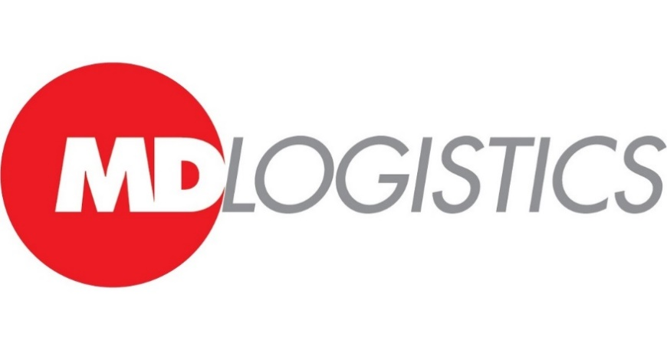

Source: <https://mma.prnewswire.com/media/463168/MD_Logistics_Logo.jpg?p=facebook>

**Background**: MD Logistics, a third-party logistics (3PL) partner, was acquired by **Nippon Express Group** in September 2020. As a wholly owned independent subsidiary of Nippon Express U.S.A., MD Logistics continues to operate with its brand and organizational structure intact.

**Services**: MD Logistics provides **warehousing services** domestically in the United States. Headquartered in the Midwest, they manage five warehouse locations: four in Plainfield, Indiana (serving the Midwest) and one in Reno, Nevada (serving the West Coast). Additionally, they plan to establish a warehouse in the Research Triangle Park region of North Carolina to enhance service for the East Coast.

**Industry Focus**: MD Logistics specializes in serving the **life sciences** and **consumer goods** markets. Their expertise lies in managing complex supply chains, including **cGMP warehousing** and **cold chain transportation services**.

**Strategic Goals**: The acquisition of MD Logistics aligns with Nippon Express’s **Business Plan 2023 “Dynamic Growth”**. Together, they aim to expand their geographical footprint, enhance domestic reach, and provide seamless supply chain solutions for their client.

**Nippon Express**:

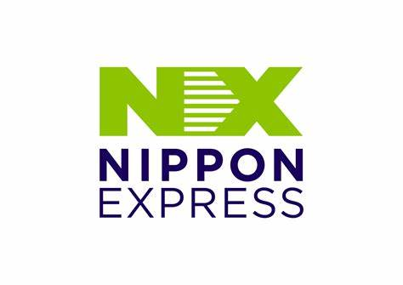

Source: <https://th.bing.com/th/id/OIP.u_JodtbQlLfYpV-N26LFFgAAAA?rs=1&pid=ImgDetMain>

**Overview**: Nippon Express is a publicly-traded, **global logistics company** headquartered in Tokyo, Japan. With operations in 48 countries worldwide, they have been connecting people, businesses, and communities through the transportation of goods since their founding in 1937.

**Services**: Nippon Express offers a wide range of **transportation and logistics services** across the globe. Their focus areas include freight forwarding, warehousing, distribution, and supply chain management.

**Strategic Vision**: Nippon Express aims to be recognized as a logistics company with a strong global presence. By integrating MD Logistics into their network, they can provide **integrated logistics** to customers worldwide, linking warehousing and distribution services seamlessly.

**CHALLENGE FACED BY THE COMPANY:**

Retail and consumer goods businesses must find an end-to-end supply chain solution with a variety of warehousing and freight forwarding partners in order to successfully import items from foreign producers for distribution in the United States.

**SOLUTION**

Working with a US-based 3PL provider, MD Logistics, and a global freight forwarder, Nippon Express, can provide numerous benefits to your global supply chain. These providers offer convenience, expertise, industry recognition, and flexibility. MD Logistics has over 26 years of experience as a leading 3PL in the retail and consumer goods industry, while Nippon Express has nearly 85 years of experience as a global freight forwarder. Both companies have extensive experience managing supply chains within these industries, with Nippon Express handling over 90% of overseas cargo destined to the US from Asian countries.

Industry recognition is crucial when choosing providers, as both companies have been included in the Armstrong & Associates Top 10 Freight Forwarders list for the past decade and among the Top 5 global for their expertise in handling air and ocean freight. MD Logistics has been named a Top 3PL by Inbound Logistics Magazine for the past decade.

Flexibility is also essential in the retail and consumer goods industry. Both MD Logistics and Nippon Express have the flexibility to respond to fluctuations in demand and consumer expectations. Their distribution solutions are tailored specifically to your business needs, and their freight forwarding solutions cater to your specific needs. For example, Nippon Express can combine air and transportation services to offer a multi-gateway service for customers shipping products to the US. If air freight space is tight at the destination, they can reroute the shipment to a delivery point with more space and finish the delivery via their expansive US transportation network.

**RESULTS:**

Disruptions can occur at any stage of the supply chain, and collaborating with a team of providers can enhance communication and prevent costly disruptions. A 3PL and freight forwarder with global expertise is crucial.

* 1. **SOFT FREIGHT LOGIC**

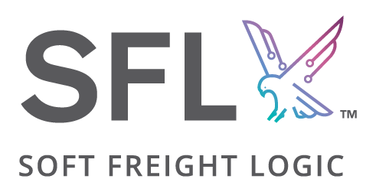

Source: <https://th.bing.com/th/id/OIP.GYhRx_b7dw6Mb9_AgZGH7gHaDy?rs=1&pid=ImgDetMain>

Soft Freight Logic (SFL) is a company specializing in **technology solutions for the logistics industry**, particularly focusing on the CargoWise One Enterprise Resource Planning (ERP) software.

Here's a breakdown of their services:

* **Client-facing tools:** SFL develops tools that improve the user experience for logistics businesses using CargoWise One. These tools might help with tasks like client relationship management (CRM) or tariff management.
* **Consultancy:** They offer consultancy services to help logistics businesses implement and configure CargoWise One effectively. This ensures the software is tailored to the specific needs of the business.
* **Support:** SFL provides ongoing support to businesses using CargoWise One. This could include helping with troubleshooting issues, training staff on how to use the software effectively, and answering questions.
* **Enhancements:** They develop additional features and functionalities beyond the base CargoWise One offering. This customization allows businesses to address specific challenges or workflows.
* **Integrations:** SFL can integrate CargoWise One with other software programs used by logistics businesses, creating a more streamlined workflow.
* **Business Analytics:** They offer tools and dashboards to help businesses gain insights from their CargoWise One data. This data analysis can be used to improve decision-making and identify areas for optimization.

**Key Points about Soft Freight Logic:**

* Focuses on the CargoWise One ERP for logistics.
* Offers client-facing tools, consultancy, support, and customizations.
* Integrates CargoWise One with other software.
* Provides business analytics tools for data-driven decision making.

**Soft Freight Logic doesn't directly handle freight forwarding operations themselves.** They provide the technology infrastructure and expertise to help logistics businesses using CargoWise One optimize their end-to-end processes.

**Problem:**

The company faced challenges in implementing CargoWise One in India, the largest country with 25 offices, due to the need for a specialist service partner with strong regional capabilities. The new policy required data integrity with master data and proper training of staff on all CargoWise One system features, as India was the most significant component of the global rollout.

**Solution:**

SFL successfully implemented CW1 on CRM, Freight Forwarding, and Finance Modules for the company, leveraging its regional presence and domain expertise. With 70 implementations of CargoWise and extensive knowledge of geo compliance, particularly Indian Taxation, the team provided software implementation, pre-go-live training, and post-go-live support. They also utilized Cargowise One experience to automate business processes, blueprinting, and remote setup, positioning key personnel in regional offices for data sanitization, audit reporting, and accurate master data entry processing.

**4.5 UNIQUE FREIGHT LINES**

Source: <https://uniquefreightlines.com/index.html>

Unique freight lines offer a complete range of international air and ocean freight services as well as integrated warehousing solutions from a single source supported by its strong management and network.

With a strong network of its offices and warehouses spread across India, we are everywhere you want us to be. Rapid expansion of global trade has meant radical changes in traditional buying procedures, and “established customer relationship’s”. These are watchwords in the logistics and transportation industry. This means we face new challenges in fulfilling our services and promise of quality to our clients everyday – which UFL had been doing it for their customers constantly since its inception.

Year on year, we have extended, our reach across India as well as worldwide, our substantial investments in IT and HR for the infrastructure and facility developments, professional training on sales and customer care to enhance the business and services had given us an edge for taking it to the next level.

It will be a perfect synchronization of your thoughts and our action. We walk the way you think with our UNIQUE way of services because for us every nanosecond and millimeter counts. Our proficiency in business will create an impression of professionalism and greater customer satisfaction.

**ABSTRACT FOR THIS CASE:**

* + Freight forwarding operations need to optimize their processes to become more efficient and competitive.
  + A case study examines how a freight forwarding company improved its operations through end-to-end process optimization.
  + The company faced challenges like communication issues and manual tasks.
  + They decided to make significant changes to streamline their operations.
  + They used advanced technologies like AI, machine learning, and automation.
  + These technologies helped with real-time shipment tracking, demand forecasting, and automated documentation.
  + They also used a cloud-based platform for better collaboration and data sharing.
  + However, they encountered challenges like resistance to change, technical difficulties, and data security concerns.
  + They overcame these challenges through training, cybersecurity measures, and change management.
  + The optimization led to cost savings, operational efficiencies, and improved customer satisfaction.
  + The company gained a competitive advantage in the market.
  + This case study shows the importance of technological innovation, organizational alignment, and change management in successful process optimization in freight forwarding.

**FACTORS THAT ARE AFFECTING IN THE COMPANY:**

While considering end-to-end process optimization in freight forwarding operations, there are several internal and external factors that are affecting the process flow in the company. These factors can greatly influence the efficiency, cost-effectiveness, and overall success of the optimization efforts.

**Internal Factors:**

**1.Technology Infrastructure:**

The technological capabilities within the freight forwarding company play a significant role. This includes the quality of the software systems used for managing operations, tracking shipments, and optimizing routes.

**2.Employee Skills and Training:**

The expertise and skill level of employees involved in the freight forwarding process are crucial. Proper training programs need to be in place to ensure that employees can effectively utilize the tools and systems available to them.

**3. Workflow and Processes**:

The existing workflow and processes within the company need to be thoroughly analyzed to identify inefficiencies and bottlenecks. Streamlining these processes can lead to significant improvements in overall efficiency.

**4. Resource Allocation:**

Proper allocation of resources such as manpower, vehicles, and equipment is essential for smooth operations. Optimizing resource allocation can help minimize costs and improve service quality.

**5. Data Management:**

Efficient data management practices are necessary for effective decision-making. This includes data collection, storage, analysis, and utilization to identify patterns, trends, and areas for improvement.

**External Factors:**

**1.Regulatory Environment:**

Compliance with regulations imposed by governments and industry bodies is crucial for freight forwarding operations. Changes in regulations can impact processes and require adjustments to ensure compliance.

**2. Market Demand:**

Fluctuations in market demand for freight services can influence operational requirements and resource allocation. Understanding market trends and customer needs is essential for optimizing processes accordingly.

**3. Supplier and Partner Relationships:**

Strong relationships with suppliers, carriers, and other partners in the supply chain are essential for smooth operations. Collaboration and communication with these entities can help streamline processes and improve efficiency.

**4. Infrastructure and Transportation Networks:**

The quality and availability of infrastructure, such as roads, ports, and railways, directly impact the efficiency of freight forwarding operations. Improvements in infrastructure can lead to faster transit times and lower costs.

**5. Technological Advancements:**

External technological advancements, such as innovations in transportation vehicles, tracking systems, and communication technologies, can present opportunities for optimization. Adopting new technologies can enhance efficiency and competitiveness.

By considering and addressing these internal and external factors, freight forwarding companies can effectively optimize their end-to-end processes, leading to improved efficiency, cost savings, and better service delivery.

**FINDINGS OF THE STUDY**

* The study focuses on improving the efficiency and effectiveness of freight forwarding activities in the logistics industry.
* Traditional freight forwarding processes suffer from significant inefficiencies such as manual tasks, redundant activities, and fragmented communication channels.
* These inefficiencies lead to delays, errors, and increased operational costs, highlighting the need for streamlining and automating processes.
* Technology plays a crucial role in optimizing freight forwarding operations, with advanced technologies like AI, machine learning, blockchain, and IoT offering opportunities for automation, visibility improvement, and better decision-making.
* Collaboration and integration among stakeholders within the supply chain ecosystem are essential for seamless end-to-end operations, emphasizing the importance of robust communication channels, real-time data sharing, and trust-based relationships.
* Data-driven insights are vital for driving continuous improvement initiatives, allowing freight forwarders to identify bottlenecks, make informed decisions, and enhance agility, responsiveness, and competitiveness.
* Regulatory compliance and risk management are critical considerations, requiring freight forwarders to navigate complex regulations, ensure international trade compliance, and mitigate risks associated with security, safety, and environmental factors.
* Developing robust compliance frameworks, investing in training, and adopting proactive risk management strategies are essential for sustainable operations and maintaining trust with customers and regulatory authorities.
* The study provides valuable insights into addressing inefficiencies, embracing technological innovations, fostering collaboration, leveraging data-driven insights, and prioritizing compliance and risk management to achieve operational excellence and deliver superior value to customers in a competitive marketplace.

**RECOMMENDATIONS AND SUGGESTIONS**:

**1. Embrace Digital Transformation:**

- Invest in robust digital platforms and technologies such as cloud-based systems, Internet of Things (IoT) devices, and artificial intelligence (AI) for real-time tracking, predictive analytics, and automation of routine tasks.

- Implement integrated software solutions that streamline the entire freight forwarding process, from quotation and booking to documentation management and invoicing.

**2. Enhance Supply Chain Visibility:**

- Leverage blockchain technology to enhance transparency and traceability across the supply chain, ensuring real-time visibility into shipment status, location, and condition.

- Collaborate with partners and stakeholders to establish data-sharing protocols and interoperable systems, facilitating seamless information flow and collaboration.

**3. Optimize Route Planning and Load Consolidation:**

- Utilize advanced route optimization algorithms and simulation models to minimize transit times, reduce fuel consumption, and optimize vehicle utilization.

- Implement load consolidation strategies to maximize container capacity and minimize empty space, thereby reducing transportation costs and environmental impact.

**4. Prioritize Customer Experience:**

- Enhance communication channels and customer service capabilities to provide timely updates, address inquiries, and resolve issues proactively.

- Offer value-added services such as real-time shipment tracking, customizable delivery options, and risk management solutions to meet evolving customer needs and preferences.

**5. Foster Collaboration and Partnerships:**

- Cultivate strategic partnerships with carriers, suppliers, customs brokers, and other stakeholders to leverage synergies, share resources, and access new markets.

- Collaborate with industry associations, regulatory bodies, and academia to stay abreast of emerging trends, regulatory changes, and best practices in freight forwarding.

**6. Implement Continuous Improvement:**

- Establish key performance indicators (KPIs) and metrics to measure performance across various stages of the freight forwarding process, such as on-time delivery, cargo damage rates, and customer satisfaction scores.

- Conduct regular performance reviews, root cause analyses, and process audits to identify opportunities for improvement and implement corrective actions iteratively.

**7. Invest in Talent Development:**

- Provide comprehensive training programs and professional development opportunities to equip employees with the necessary skills and knowledge to adapt to changing technologies and industry trends.

- Foster a culture of innovation, collaboration, and continuous learning to empower employees to contribute ideas, experiment with new approaches, and drive process improvements.

By implementing these recommendations and suggestions, freight forwarding companies can optimize their end-to-end processes, improve operational efficiency, and deliver superior value to customers in an increasingly competitive marketplace.

**IMPACT:**

Implementing these suggestions can greatly benefit freight forwarding companies in various ways. Firstly, by embracing digital changes and improving supply chain visibility, companies can make their operations smoother, reduce manual work, and minimize mistakes, ultimately boosting overall efficiency. Secondly, optimizing route planning and consolidating loads can cut down on fuel use, lower transportation expenses, and make better use of resources, leading to cost savings. Thirdly, focusing on improving customer experiences with better communication and added services can increase satisfaction and loyalty. Fourthly, building stronger partnerships with carriers and suppliers can create synergies and open up new opportunities, making the company more competitive. Lastly, promoting a culture of continuous improvement and investing in staff development can foster innovation and adaptability, helping the company stay ahead in the market. In summary, these recommendations can assist freight forwarding companies in streamlining processes, cutting costs, pleasing customers, and achieving sustainable growth.

**CONCLUSION:**

In conclusion, the case study "End-to-End Process Optimization in Freight Forwarding Operations" highlights the crucial need to align internal processes with external factors for improved operational efficiency, cost reduction, and customer satisfaction in the freight forwarding sector. By meticulously analyzing internal and external dynamics, strategic opportunities for improvement throughout the logistical workflow have been identified. Integration of digital technologies, supply chain visibility enhancements, route optimization, customer-centric initiatives, collaborative partnerships, continuous improvement, and talent development can unlock significant value and competitive advantage. Embracing innovation, adaptability, and agility is crucial for success in navigating the evolving global trade landscape. Implementing the insights and recommendations outlined in the project can position freight forwarding enterprises for sustainable growth and resilience in a complex business environment. Ultimately, end-to-end process optimization holds transformative potential, not only driving operational excellence but also fostering long-term customer relationships, enhancing industry competitiveness, and contributing to the efficiency and sustainability of global supply chains. The principles and strategies outlined in the project serve as a guiding framework for success in the evolving freight forwarding industry.

**BIBILOGRAPHY**

1. Process optimization in freight forwarding industry.
2. Analyzing and optimizing the order process at the freight forwarder.
3. *OPTIMIZATION PROBLEMS FOR FREIGHT FORWARDING COMPANIES* (Doctoral dissertation, UNIVERSITY OF BERGAMO).
4. Transportation planning in freight forwarding companies: Tabu search algorithm for the integrated operational transportation planning problem. *European Journal of Operational Research*, *197*(2), 741-751.
5. Data-driven forwarding: a typology of digital platforms for road freight transport management. Electronic Markets, 32(2), 807-828.
6. Utilizing machine learning on freight transportation and logistics applications: A review. ICT Express.
7. Collaboration and transportation resource sharing in multiple centers vehicle routing optimization with delivery and pickup. Knowledge-Based Systems, 160, 296-310.
8. Emerging digitalisation technologies in freight transport and logistics: Current trends and future directions. *Transportation Research Part E: Logistics and Transportation Review*, *148*, 102291.
9. Blockchain in transport and logistics–paradigms and transitions. International Journal of Production Research, 58(7), 2054-2062.
10. Vehicle routing problem and related algorithms for logistics distribution: A literature review and classification. Operational research, 22(3), 2033-2062.
11. ). Smart logistics based on the internet of things technology: an overview. International Journal of Logistics Research and Applications, 24(4), 323-345.
12. Understanding the operations of freight forwarders: evidence from Serbia. *World Bank Policy Research Working Paper*, (7311)
13. Optimisation in transport and logistic processes. Transportation Research Procedia, 44, 15-22.
14. Optimization and analysis of a robot-assisted last mile delivery system. Transportation Research Part E: Logistics and Transportation Review, 142, 102049.
15. Optimization of the terminal operating mode during the formation of a container block train. In E3S Web of Conferences (Vol. 264, p. 05025). EDP Sciences.
16. Digital transformation at logistics service providers: barriers, success factors and leading practices. The International Journal of Logistics Management, 31(2), 209-238.
17. Feasibility of telecommuting by improving operations self-management in air export freight forwarding.
18. Air intermodal freight transportation: The freight forwarder service problem. Omega, 94, 102040.
19. Digitization of processes of sea freight transportation.
20. Optimization in multimodal freight transportation problems: A Survey. European Journal of Operational Research, 299(1), 1-20
21. Optimisation in transport and logistic processes. Transportation Research Procedia, 44, 15-22.
22. Simulation-optimization for the management of the transshipment operations at maritime container terminals. Expert Systems with Applications, 139, 112852.
23. Optimising cargo loading and ship scheduling in tidal areas. European Journal of Operational Research, 280(3), 1082-1094.
24. Transshipment operations optimization of sea-rail intermodal container in seaport rail terminals. Computers & Industrial Engineering, 141, 106296.
25. 4PL digital business models in sea freight logistics: The case of Freighthub. Logistics, 4(2), 10.

Website links:

1.<https://uniquefreightlines.com/index.html>

2. <https://www.birlasoft.com/case-studies/reinventing-freight-forwarding-operations-with-otm-and-cpq-cloud>

3. <https://www.uipath.com/resources/automation-case-studies/expo-group-logistics-rpa>

4. <https://www.mdlogistics.com/2022/05/benefits-to-creating-an-end-to-end-supply-chain-solution-with-md-logistics-nippon-express/>

5. <https://resources.softfreightlogic.com/case-study/manual-logistics-workflow-automation/>

6. <https://www.google.co.in>