A Study on Financial Performance Analysis of Femtosoft Technologies

**Akula Hari Sesha Priyaa, 1 Dr. A. Narmadha,2 Assistant Professor**

Department of Management Studies, VELS Institute of Science, Technology & Advanced Studies (VISTAS), Chennai.

**Abstract :**

This study evaluates the financial performance of FemtoSoft Technologies, a leader in the technology industry, over a certain period of time. Through qualitative financial analysis including sample analysis and standard business models, this study aims to understand the financial health and resource utilization of the company. Key financial metrics such as performance, revenue, solvency and performance are analyzed to measure FemtoSoft's ability to generate profits, manage expenses and deliver good results. Factors such as market performance, technology development and startup strategy are also taken into account to gain a better understanding of FemtoSoft's competitive landscape. The results of this assessment can assist investors, stakeholders, and management in making investment decisions, strategic planning, and performance evaluation.

**Keywords** : Industry standards, financial condition, resource utilization, liquidity, profitability and solvency.

# INTRODUCTION:

Finance is defined as the management function of an organization concerned with providing funds and credit to the organization to achieve its objectives as satisfactorily as possible. Financial analysis refers to the evaluation of the viability, stability and profitability of a business, sub-business or project. The purpose of financial analysis in this study is to help diagnose the information contained in financial statements. It also helps in assessing the profitability and financial health of the company. Finance within an organization is the foundation of strategic decision-making and operational management and the engine of growth, sustainability and profitability. In this context, finance has a multifaceted role encompassing budgeting, financial planning and analysis, capital investment decisions, and risk management.

# REVIEW OF LITERATURE:

**Dr. V.P.T. Dhevika, Dr. O.T.V Latasri & H. Gayathri (2013):** A case study to analyze the financial position of City Union Bank over a period of five years. They concluded that the analysis showed the bank's profitability and financial stability. While it is a useful tool to measure the profitability of the company, the current ratio is not a better bank account to measure the income of banks and financial institutions.

**Aravind.R Dr. Srividya**, **(2013):** Analysis of the study on a Financial Ratios of Sakthi Finance Limited shows that ROE is a useful tool for assessing the profitability status of a company whereas current ratio is more suitable for assessing liquidity. For banks and non-bank financial companies.

**Balaji Parthasarathy (2004):**Case studies provide information on the different stages of development of the IT industry since 1984. In addition, domestic and overseas market sales, export revenue share, and IT industry sales share show the period before liberalization.

**Dr.Idhayajyothi, Dr. O. T. V. Latasri, N. Manjula, A. Meharaj Banu & R. Malini (2014):** A study on the financial performance of Ashok Leyland Limited (Cairo). To achieve this goal, we used ratio calculations such as activity, liquidity, profitability and leverage ratio. They found that by balancing capital expenditures and cash flow, companies can maintain good financial health even when IT product prices fall.

**Asma Khan & Jyoti Singhal (2015):** According to this study, HCL Technologies achieved satisfactory results excluding return on equity and long-term return on funds in a ratio analysis study of several selected IT companies over a period of five years. In terms of long-term fund returns, Mahindra performed well on the same comparative parameters while Wipro performed mediocre.

**Patel, A., & Shah, B. (2019):** This study makes a significant contribution to the literature by providing a comprehensive review to analyze the financial performance of the Indian textile industry. Their research

represents an important addition to the existing body of knowledge, aiming to provide a comprehensive understanding of the financial environment and the challenges facing companies in the sector.

**Dr. M. Ravichandran, M. Venkata Subramanian (2016):** This study investigated the financial performance of Force Motors with a focus on industry profitability factors. Financial statistics were then analyzed to provide a summary of the company's financial performance over a period of time. Increasing operating profit and administrative expenses and increasing selling and administrative expenses are two ways to improve productivity.

**Maisuria., & Allad. (2016):** The study, titled “Analysis of Profitability Ratios of Selected Indian IT Companies” examined data from 2010-11 to 2014-

15 and found differences in the profitability of companies. But the oracle pin. The company's financial performance in terms of net profit is satisfactory. The ratio and earnings per share are not satisfactory, but the return on capital and equity ratio are not satisfactory.

**Shenbagam & Kannappan (2015):** In this study, financial ratios were investigated in terms of profitability and asset status, and the research paper “A Study on financial status and performance analysis focusing on Tata Consultancy services”. showed that profitability was high and absolute liquidity was present. The ratios from 2011 to 2015 are categorized by year.

**K. P. Sinha Mintibahen Bijendra & Dr Deepika Singhvi (2017):** We carry out a profitability analysis of the Indian pharmaceutical industry over a period of seven years. Since the pharmaceutical industry is a defense

industry, the basis of its research is based on two factors: a) Significantly high R&D costs without guaranteed profits. They found that companies that rely heavily on research and development ultimately benefit.

# OBJECTIVES OF STUDY:

A study to evaluate the financial performance of Femtosoft Technologies.

To analyze and evaluate the financial performance of Femtosoft Technologies for a period of 5 years (2019-2020 to

2023-2024).

Measures short-term and long- term indicators of financial liquidity, solvency, and profitability.

Assess the company's financial dynamics in terms of profits, sales and costs.

# NEED OF STUDY:

Identifies the key financial strengths and weaknesses of FemtoSoft Technologies.

Evaluate FemtoSoft Technologies profitability and efficiency in using its resources.

Identifies potential areas for improvement in FemtoSoft Technologies' financial processes and resource allocation practices.

# SCOPE OF THE STUDY:

* Predict potential future outcomes based on financial statement analysis, allowing you to take proactive action. By predicting potential future outcomes based on

financial statement analysis, you can take proactive steps to capitalize on opportunities and mitigate risks.

* Contribute to the development of long-term financial strategies aimed at increasing Femtosoft's profitability and sustainability in the market.

# STATISTICAL TOOLS AND TECHNIQUES USED:

The following are major tools is used analysis and interpretation

* Ratio Analysis
* Working Capital Analysis
* Consolidated balance sheet
* Profit and Loss Account Statement.

**DATAANALYSIS&INTERPRETATIO N:**

**Ratio analysis:**

# TABLE2.1 CURRENT RATIO ANALYSIS:

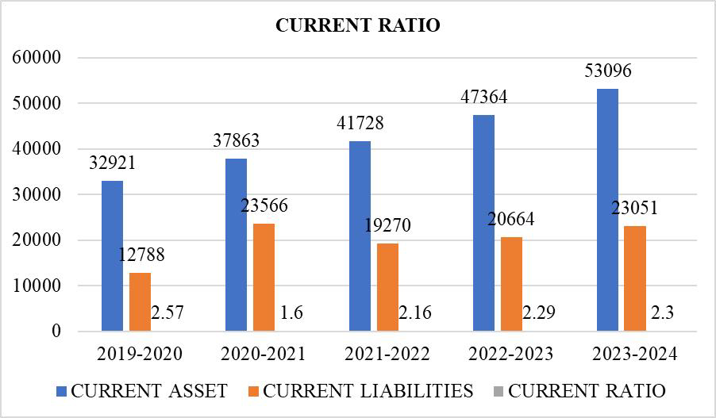

**INTERPRETATION:**

The company has witnessed a notable decline in its liquidity from 2019-20 to 2020-21 which is reflected in its current ratio decreasing from 2.57 to

1.60. However, although liquidity

continued to improve between 2020-21 and 2021-22, it still did not reach 2019-20 levels. The stability of the current ratio between 2022-23 and 2023-24 suggests that the company maintained a healthy liquidity position during this period.

# TABLE4.2: QUICK RATIO ANALYSIS

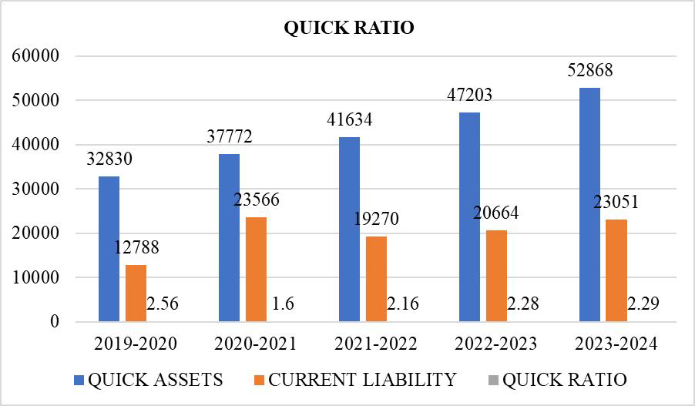

**INTERPRETATION:**

A company's quick ratio follows the same trend as its current ratio and reflects changes in liquidity over the years. The decline in the quick ratio from 2019-20 to 2020-21 indicates a decline in the company's ability to meet short-term liabilities with quick assets and an improvement in the subsequent years. The stability and slight increase in the quick ratio from 2022-23 to 2023-24 indicates continued improvement in liquidity, which is consistent with the stability of the current ratio over the same period.

**Working Capital Analysis:**

# TABLE 2.3: WORKING CAPITAL ANALYSIS:

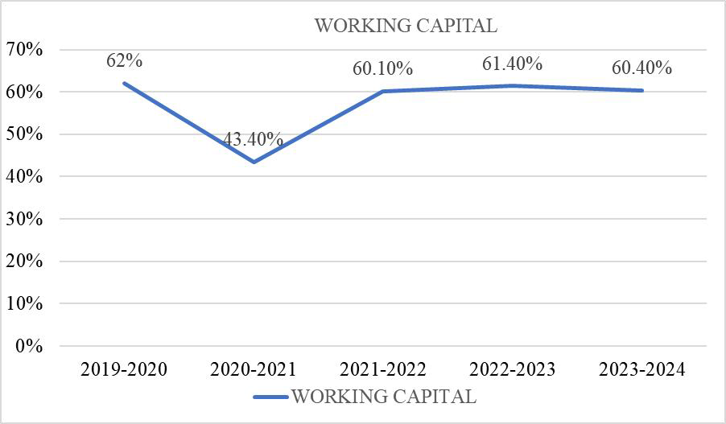

**INTERPRETATION:**

A company's quick ratio follows the same trends as its current ratio and reflects changes in liquidity over the years. A decrease in the quick ratio from 2019-20 to 2020-21 indicates a decrease in the ability of the company to meet its short-term obligations through quick accrual and improvement in subsequent years. The stability and slight increase in the quick ratio from 2022-23 to 2023-24 indicates continued improvement in liquidity, which is consistent with the stability of the current ratio over the same period.

**Consolidated balance sheet:**

# BALANCE SHEET AS ON 2023 - 2024

|  |  |
| --- | --- |
| **FemtoSoft**  **Technologies** |  |
| **Particulars** | **2023-2024** |
| Equity Capital | 543 |
| Reserves | 64,862 |
| **Borrowings** | **4,794** |

|  |  |
| --- | --- |
| items |  |
| **Total Assets** | **93,250** |

**Profit and loss account:**

|  |  |
| --- | --- |
| Long term  Borrowings | 4,105 |
| Short term  Borrowings | 140 |
| Lease Liabilities | 2,535 |
| Other  Borrowings | 8 |
| **Current**  **Liabilities** | **23,051** |
| Minority interest | -7 |
| Trade Payables | 6,428 |
| Advance from  Customers | 252 |
| Other liability  items | 16,378 |
| **Total Liabilities** | **93,250** |
| **Fixed Assets** | **34,619** |
| Land | 410 |
| Building | 5,064 |
| Plant | 1,952 |
| Equipment | 384 |
| Computers | 8,256 |
| Furniture and  fittings | 952 |
| Vehicles | 158 |
| Intangible  Assets | 27,392 |
| Gross Block | **52,591** |
| Depreciation | 17,972 |
| Cost of Work in  Progress | 40 |
| **Current Assets** | **53,096** |
| Investments | 5,495 |
| Inventories | 228 |
| Trade  receivables | 25,506 |
| Receivables  over 6m | 6,709 |
| Receivables  under 6m | 19,263 |
| Provision for  Doubtful | -466 |
| Cash  Equivalents | 14,724 |
| Short term loans | 148 |
| Other asset | 12,490 |

# PROFIT AND LOSS ACCOUNT STATEMENT AS ON 2023-2024

|  |  |
| --- | --- |
| **Femtosoft**  **Technologies** |  |
| **Profit and Loss**  **Statement** |  |
| **Particulars** | **2023-2024** |
| **Sales** | 1,01,456 |
| Sales Growth % | 18.45% |
| Expenses | 78,828 |
| Material Cost % | 2% |
| Raw material cost | 2,072 |
| Change in inventory | 67 |
| Manufacturing  Cost % | 17% |
| Employee Cost % | 54% |
| Other Cost % | 4% |
| **Operating Profit** | **22,628** |
| Operating Profit  Margin | 22% |
| **Other income** | **1,358** |
| Exceptional items | 265 |
| Other income  normal | 1,093 |
| Interest | 353 |
| Depreciation | 4,145 |
| Tax % | 24% |
| Profit before tax | **19,488** |
| **Net Profit** | **14,845** |
| Profit after tax | 14,845 |
| Profit from  Associates | 0 |
| Reported Net Profit | 14,845 |
| Minority share | 6 |
| EPS | 14,851 |
| Exceptional items  AT | -202 |
| Profit for PE | 14,643 |
| EPS in Rs | 54.73 |
| Dividend Payout % | 88% |

**FINDINGS**

* The company has shown fluctuations in its liquidity ratios, indicating that its ability to meet short- term obligations varies. Although there have been improvements in certain years, maintaining a stable liquidity position must be a priority.
* Profitability ratios are fluctuating, indicating problems maintaining a stable level of profitability. Identifying the root causes of these fluctuations and implementing appropriate strategies is critical to long-term profitability.
* The company has demonstrated varying degrees of efficiency in using its assets to generate sales revenue. In particular, the ratio of net fixed assets to sales has improved significantly, showing that the efficiency of fixed asset utilization has improved.
* The company's debt-to-asset ratio has fluctuated, indicating a change in its level of dependence on debt financing. It is important to manage debt levels carefully to avoid excessive financial leverage.

# SUGGESTIONS

* The company has experienced fluctuations in its liquidity ratios

over the years. To maintain a healthy liquidity position, a company must closely monitor its current and quick ratios and ensure that it has sufficient liquid assets to cover its short-term liabilities.

* Companies are experiencing volatility in their profitability, but it is important to understand the factors that influence these fluctuations. Strategies such as cost optimization, revenue enhancement, and efficient resource allocation can help improve profitability.
* As a result of the analysis, it was found that there was a difference in asset utilization rates such as return on assets and fixed asset sales ratio. Companies must focus on optimizing the use of their assets to maximize return on investment.
* The company's debt-to-assets ratio has fluctuated over the years. Maintaining a balance between debt and equity financing is important to minimize financial risk and ensure sustainable growth.
* The ratio of operating profit to capital employed has improved over the years, indicating improved efficiency in generating operating profit relative to capital

employed. Companies must continually focus on optimizing their use of capital to maximize profitability.

# CONCLUSION:

Overall, the company has performed well in managing its financial performance and improvements have been seen in some areas over time. However, there are also issues that need attention, such as managing stable products, developing good results, using good assets, and good debt management. By addressing these areas and using appropriate strategies, companies can strengthen their financial positions and achieve long-term growth.

# REFERENCES

* + Dr. V.P.T. Dhevika, Dr. O.T.V Latasri & H. Gayathri (2013). A Study on Financial Performance Analysis at City Union Bank. International Journal of Advanced Research in Management and Social Sciences – Vol.2, No. 7, 2278-

6236.

* + Aravind R and Dr. Srividya, A Study on Financial Performance of Sakthi Finance

Limited, Asia Pacific Journal of Marketing & Management Review, Vol.2(7), July 2013.ISSN 2319-2836.

* + Dr.Idhayajyothi, Dr. O. T. V. Latasri, N. Manjula, A. Meharaj Banu & R. Malini (2014). A Study on Financial Performance of Ashok Leyland Limited at Chennai. IOSR Journal of Business and Management (IOSRJBM) – Vol.16, Issue 6. Ver. I, 83-89.
  + Asma Khan & Jyoti Singhal (2015). Growth and Profitability Analysis of Selected IT

Companies.IRACST – International Journal of Commerce, Business and Management (IJCBM)- Vol. 4,No.3, 2319–2828.

* + Dr. M. Ravichandran M. Venkata Subramanian, A Study on Financial Performance Analysis of Force Motors Limited, IJIRST –International Journal for Innovative Research in Science &Technology, Vol.2, Issue 11, April 2016, ISSN

(online): 2349-6010.

* + Patel, A., & Shah, B. (2019). "Financial performance

analysis of Indian textile industry: A comprehensive review." Textile Management Quarterly, 2023(4), 110-125.

* + Maisuria., & Allad. (2016). Profitability ratio analysis of selected Indian IT companies. International Multidisciplinary E- Journal, 5(2), 207-220.
  + Shenbagam & Kannappan (2015) in his research paper titled “A study on financial position and performance analysis with special reference to Tata Consultancy Services” 1(7) pp. 98101.
  + K. P. Sinha Mintibahen Bijendra & Dr Deepika Singhvi (2017). Research Paper on Liquidity&Profitability Analysis of the Pharmaceutical Companies of India. International Journal of Scientific Research and Management (IJSRM)- Vol.5, Issue08, 6717-6724.
  + Balaji Parthasarathy, Globalising Information technology: The Domestic Policy Context for India’s Software Production and Export, Indian Institute of

Information Technology, Bangalore, 2004 © 2004 The Charles Babbage Institute for the History of Information Technology 211 Andersen Library, 222 – 21st Avenue South, Minneapolis, MN 55455 USA.