An Image Enhancement, Feature Extraction and Deep Neural Network Model for Crop Weed Classification

Satpal Singh1 and Harmeet Singh2

1Department of Computer Science, CT University, Ludhiana, Punjab, India.

2Department of Computer Science, CT University, Ludhiana, Punjab, India.

**Abstract.** The domain of agriculture is witnessing a drastic change in terms of technological use and precision agriculture which aims at leveraging data analytics for agricultural applications. One critically important application of precision agriculture happens to be crop-weed detection based on machine learning and deep learning based algorithms. One of the major challenges which automated crop-weed detection algorithms face is the effects of noise and disturbances typically through images captured through unmanned aerial vehicles (UAVs). This paper presents a an analysis of feature extraction followed by machine learning for detecting crop weeds. Noise removal and feature extraction has also been employed to bolster the training process. Alternatively, an attention based deep learning model has also been developed for weed detection. The attention based approach bas been developed with the aim of identifying the most critical information from large datasets which has the potential to enhance the training efficiency of the approach. A comparative analysis of both approaches in terms of classification accuracy has been presented. The experimental results clearly show that the proposed approach outperforms contemporary deep learning algorithms such as CNN, ResNet, YOLO and RCNN in terms of classification accuracy.

**Keywords: Precision Agriculture, Crop-Weed Detection, Feature Extraction, Deep Learning, Attention Based Deep Nets, Classification Accuracy.**

# I. INTRODUCTION

Agriculture is witnessing a rapid change with the inclusion of evolving technologies such as precision agriculture. Precision agriculture is a modern farming method that uses advanced technology and data analysis to optimize crop production and increase efficiency. The main goal of precision agriculture is to make the best use of resources such as water, fertilizer, and seeds to maximize yields while minimizing waste and environmental impact. Some of the key applications of precision agriculture include [1]:

1. Soil mapping: precision agriculture starts with a comprehensive analysis of soil type, composition, and fertility, which helps farmers make informed decisions about what to plant and how to care for their crops.
2. Variable-rate planting: precision agriculture allows farmers to plant seeds at different rates based on the conditions of each field, which can help to maximize yields and minimize waste.
3. Precision irrigation: by using data and analysis to track soil moisture levels, farmers can make informed decisions about when and how much to water their crops, which helps to conserve water and minimize waste.
4. Crop monitoring: precision agriculture allows farmers to monitor the growth and health of their crops in real-time, which helps them to identify and address potential problems before they become serious [2].
5. Yield mapping: precision agriculture helps farmers to accurately map yields and identify areas of the field that are producing less, which can help to inform future planting decisions and optimize production.
6. Weed and Pest Management: using image processing and machine learning techniques, the tedious job of crop weed classification can be automated and hastened thereby increasing the productivity of the system.

Overall, precision agriculture represents a major step forward in the development of sustainable and efficient farming practices, and has the potential to revolutionize the way that food is grown and produced around the world. While there are several avenues to utilize precision agriculture, one of the most common yet important domains is crop weed classification. It is critically important as weeds destroy the main crop in case it is not detected and rooted out in the initial stages [3].

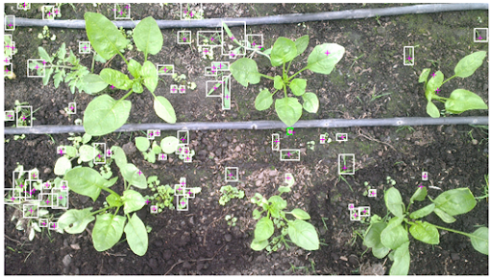

**Fig.1 A typical illustration of crop weed detection.**

Figure 1 depicts the scenario where image identification and machine learning can be used to identify potential weeds in crops.

# II. THEORITICAL BACKGROUND FOR AUTOMATED CROP-WEED CLASSIFICATION

This section presents a theoretical background of the use of machine learning models for crop weed classification, the common techniques and salient features.

The idea behind crop weed classification is the process of identifying weeds present in agricultural fields and separating them from crops. This is a crucial task in precision agriculture, as it helps farmers to manage weed infestations, reduce herbicide use, and increase crop yields. Machine learning algorithms have been widely used in recent years to automate the weed classification process. Automated crop-weed classification has gained prominence with advanced image processing techniques coupled with machine learning. Crop weed classification is the process of separating crops from weeds in an agricultural field. Machine learning is a subfield of artificial intelligence that uses algorithms and statistical models to enable computers to learn from and make predictions based on data. In the context of crop weed classification, machine learning algorithms can be trained on labelled data to distinguish between crops and weeds [4].

There are several methods used in machine learning for crop weed classification, including supervised learning, unsupervised learning, and deep learning. Supervised learning algorithms, such as decision trees and support vector machines, use labeled data to learn the characteristics that distinguish crops from weeds. Unsupervised learning algorithms, such as clustering, are used to identify patterns and relationships in the data without using labeled examples. Deep learning algorithms, such as convolutional neural networks, are used to analyze complex image data to identify crops and weeds.

The effectiveness of crop weed classification based on machine learning depends on several factors, including the quality of the data used for training and testing, the choice of algorithms and features, and the presence of noise and variability in the data. However, research has shown that machine learning can be effective in crop weed classification and has the potential to improve the efficiency and accuracy of this process [5].

When using machine learning models for crop weed classification, it is important to consider several factors, such as the size and quality of the training data, the choice of features used to represent the images, and the choice of evaluation metrics used to assess the performance of the model. Proper consideration of these factors can lead to improved performance and increased accuracy in crop weed classification using machine learning. Thus, machine learning models have proven to be effective in the task of crop weed classification and have the potential to revolutionize the way that farmers manage weed infestations in their fields. By choosing the right model and considering the relevant factors, it is possible to achieve improved performance and increased accuracy in crop weed classification using machine learning [6].

Machine learning has made tremendous advancements in the field of image classification, allowing for the automated recognition and categorization of images. Image classification is a process of automatically assigning images to different categories or classes based on their visual content. Machine learning models have been used in various applications of image classification, such as medical imaging, facial recognition, and object recognition. In this content, we will discuss the advantages and limitations of machine learning models for image classification.

***2.1 Advantages of Machine Learning Models for Image Classification:***

1. High Accuracy: Machine learning models have demonstrated remarkable accuracy in image classification tasks, outperforming traditional image processing techniques in many cases. With the availability of large amounts of training data and advancements in deep learning techniques, machine learning models have achieved state-of-the-art performance in image classification tasks.
2. Automation: Machine learning models can automate the image classification process, reducing the need for manual intervention and freeing up valuable time for other tasks. This is particularly beneficial in large-scale image classification tasks, where manual intervention is impractical [7].
3. Generalizability: Machine learning models can learn and generalize to new data, making them suitable for a wide range of image classification tasks. With the right training data and architecture, machine learning models can handle images of varying sizes, scales, and orientations, and can be adapted to new tasks with relative ease [8].
4. Robustness: Machine learning models can handle variations in image quality, lighting conditions, and other factors that can impact image classification accuracy. They can also automatically detect and compensate for outliers, reducing the risk of false positive results.

***2.2 Limitations of Machine Learning Models for Image Classification:***

1. Training Data Quality: The accuracy of machine learning models for image classification is highly dependent on the quality and quantity of the training data. If the training data is inadequate or biased, the model will not be able to generalize well to new data, resulting in poor performance.
2. Overfitting: Overfitting is a common issue in machine learning models, where the model is trained too closely to the training data and does not generalize well to new data. Overfitting can result in poor performance on test data and a reduced ability to generalize to new image classification tasks [9].
3. Explainability: One of the biggest challenges with machine learning models is the lack of explainability. Unlike traditional image processing techniques, machine learning models are not transparent and it is often difficult to understand how the model arrived at its results. This can make it difficult to debug the model and make decisions based on the results.
4. Computational Cost: Machine learning models can be computationally expensive, requiring significant amounts of computing power and memory to train. This can be a significant barrier to the widespread adoption of machine learning models in image classification tasks, especially in resource-constrained environments [10].

Although machine learning models have demonstrated remarkable success in image classification tasks, offering high accuracy, automation, and generalizability. However, the limitations of machine learning models, including the quality of training data, the risk of overfitting, the lack of explainability, and the computational cost, must also be considered when evaluating their suitability for a particular image classification task. With the continued development of machine learning techniques and the availability of large amounts of training data, it is likely that machine learning models will become increasingly prevalent in image classification tasks in the future.

**III. PROPOSED METHODOLOGY**

The first step in crop weed classification using machine learning is data acquisition. This involves collecting images of agricultural fields and manually annotating the images to identify the crops and weeds present in the field. The annotated images are then used to train machine learning algorithms, such as convolutional neural networks (CNNs) or support vector machines (SVMs) or (BayesNet) to perform crop weed classification [11]. Once the machine learning model has been trained, it can be used to classify new images of agricultural fields and identify the crops and weeds present in the field. The accuracy of the machine learning model can be evaluated using metrics such as precision, recall, and F1-score. There are several challenges in crop weed classification using machine learning, including: [12]

1. Data imbalance: The number of weed samples in the training dataset is often much lower than the number of crop samples, leading to a data imbalance problem. This can result in the machine learning algorithm overfitting to the crop samples and underperforming on the weed samples.

2. Variability in weed appearance: Weeds can have a wide range of shapes, sizes, and colors, making them difficult to accurately classify using machine learning algorithms.

3. Variability in field conditions: The appearance of crops and weeds can be affected by factors such as lighting conditions, soil moisture, and the stage of growth, making it difficult to develop machine learning models that can generalize well to new images of agricultural fields.

Despite these challenges, machine learning has shown promise in the field of crop weed classification and has the potential to revolutionize the way that farmers manage weed infestations in their fields. Machine learning models are widely used in crop weed classification to automate the process of identifying weeds in agricultural fields and separating them from crops. In this field, several machine learning algorithms have been proposed and applied to perform the task of crop weed classification [13].

***3.1 Pre Processing:***

Prior to actual feature extraction and classification of crops and weeds, pre-processing of data is needed. The first step is identifying the potential weed sections in the composite image and segmentation [14].

**Segmentation:** This can be implemented through monitoring the sudden changes in gradient value of the image indicating new class of data. For image segmentation, the computation of the maximum gradient is done through:

$g_{max}=max⁡[\frac{∂}{∂r}\oint_{r,x_{0},y_{0}}^{r,x_{f},y_{f}}{\frac{I(x,y)}{2πr}ds]}$ (1)

Here,

$g_{max}$ is the maximal gradient

r is the radius

ds is the infinitesimal change in area

I is the image in spatial domain

The separation of the concerned area is followed by noise removal stage. The noise removal stage employs the discrete wavelet transform which is defined as:

**Discrete Wavelet Transform:** The Discrete Wavelet Transform (DWT) is a mathematical tool used for data filtering and signal processing. It is a time-frequency representation that allows for the analysis of signals and images at multiple scales. DWT works by dividing a signal or image into different frequency sub-bands, allowing for the identification and elimination of unwanted components, such as noise or background information. The idea is to retain the approximate co-efficient values while discarding the detailed co-efficient values, thereby removing noise effects. Mathematically [15]:

$X\left(t\right)\underset{→}{S,W}Co-efficients (Approx, Detailed)$ (2)

Here,

Approx. represents the approximate co-efficient values

Detailed represents the detailed co-efficient values

S and W are the scaling and wavelet filters of the DWT

X is the time domain samples of the data.

Thus he

*for (i=1: levels of decomposition)*

*{*

*Compute $C_{A} and C_{D}$ values*

*Retain $C_{A} values and discard C_{D}$*

*}*

***3.2 Feature Extraction:***

As the images in precision agriculture applications are captured through UAVs, the pixel similarity among weeded and non-weeded images can be very high thereby rendering low accuracy. Thus, image features which are distinguishable for weeded and non-weeded categories need to be computed [16]. The statistical features computed through the pixel values, in this paper are:

:

$Mean=\frac{1}{n}\sum_{i=1}^{n}{f_{i}}$ (3)

$standard deviation (sd)=\sqrt{\frac{1}{n}\sum_{i}^{n}{{(P_{i}-Mean)}^{2}}}$ (4)

$variance= {sd}^{2}$ (5)

$skewness=\sqrt[3]{\frac{1}{n}\sum_{i}^{n}{{(P_{i}-mean)}^{3}}}$ (6)

Here,

$P_{i}$ denotes the ith pixel

$M or E_{1}$ represent the mean or the first moment of expectation for the image

s.d. represents the standard deviation

v represents the variance

k represents the skewness

$Entropy (H)=-P[I_{x,y}$] ${Log}_{2}[[I_{x,y}]$ (7)

Here,

H stands for the entropy

P is the probability of occurrence of a particular pixel value

$Homogeniety=\sum_{i,j}^{m,n}{\frac{P_{i,j}}{1-{(i-j)}^{2}}}$ (8)

Here,

H stands for Homogeneity

${Correlation}_{2D}=\sum_{i,j}^{M,N}{\frac{(i-m_{x})(j-m_{j})P_{x,y}}{{sd}_{x}{sd}_{y}}}$ (9)

Here,

m and n are the number pf pixels along x and y

$m_{x}$ is the mean along x

$m_{y}$ is the mean along y

${sd}_{x}$ is the standard deviation along x

${sd}_{y}$ is the standard deviation along y

The other features are the energy, kurtosis and smoothness. The classification of a new image is done based on the features which are used to train the machine learning model. Thus two separate categories of the data are to be used to prepare the training dataset:

1) Weed infested plants.

2) Non-Weed Infested plants.

***3.3 Classification:***

While several classifiers have been used thus far in existing literature, the is no “one solution fits all” method for attaining high accuracy for crop weed classification methods. Each of the models has its own merits and limitations. Some of the most common machine learning models used for crop weed classification are [17]:

1. Convolutional Neural Networks (CNNs): CNNs are a type of deep learning model that have proven to be very effective in image classification tasks, including crop weed classification. They work by learning hierarchical representations of image data, which enables them to learn increasingly complex features of the image and perform accurate classification [18].

2. Support Vector Machines (SVMs): SVMs are a type of linear classifier that separates data into different classes by finding the hyperplane with the largest margin between the two classes. SVMs have been used for crop weed classification by representing each image as a feature vector and training the SVM to classify the image as a crop or a weed [19].

3. Random Forests: Random forests are an ensemble learning method that combines multiple decision trees to make a final prediction. In crop weed classification, random forests can be used to combine the predictions of multiple decision trees, each trained on a different subset of the data, to improve the accuracy of the final prediction.

4. K-Nearest Neighbors (KNN): KNN is a non-parametric machine learning model that classifies a data point based on the majority class of its k nearest neighbors. In crop weed classification, KNN can be used to classify an image by finding the k nearest neighbors in the training data and assigning the image to the class with the majority of nearest neighbors.

5. Naive Bayes: Naive Bayes is a probabilistic machine learning model that uses Bayes' theorem to predict the class of a data point based on its features. In crop weed classification, Naive Bayes can be used to predict the class of an image by calculating the probabilities of the image belonging to each class and choosing the class with the highest probability.

These are some of the most common machine learning models used for crop weed classification. Each of these models has its own strengths and weaknesses, and the choice of the best model for a particular task will depend on the specific requirements of the application and the available data.

The proposed model considers the following points pertaining to crop weed classification prior to designing any automated model:

1) There can be enormous divergences among both plants and weeds for classification problems.

2) The pixel values may exhibit large non-coherence among classes.

3) There can be overlapping classes of datasets which may require probabilistic classification.

4) Common variants of the CNN may be prone to overfitting.

5) The control of the feature calculation in lost in the implementation of CNNs or its variants.

Thus, the Deep Bayes Net is proposed is this paper which addresses the aforesaid challenges. The mathematical formulation for the above mentioned probabilistic approach can be understood as follows:

Let there be ‘N’ classes of data sets available in the sample space ‘U’.

Let the conditional probability of each of such sets be given by:

$P(\frac{A}{U})$, $P(\frac{B}{U})$, …….. $P(\frac{N}{U})$.

The Deep BayesNet algorithm tries to find out the maximum among the probabilities:

$P\left(max\right)=\begin{matrix}P(\frac{A}{U}) \\ P(\frac{B}{U}) \\ \begin{matrix}⋮ \\ \begin{matrix}⋮ \\ ⋮ \\ ⋮\end{matrix} \\ P(\frac{N}{U})\end{matrix}\end{matrix}$ (10)

The maximum value of the probability decides the classification of a dataset into a particular category. Assuming that X attains the maximum in such a sample space:

$P_{max}=X$ (11)

Where,

$P\left(\frac{X}{U}\right)=P \frac{X}{\prod_{i=1}^{i=n}{U_{i}}}$ (12)

Here,

$\prod_{i=1}^{i=n}{U_{i}}$ represents the conditional probability cumulative for all possible data set classes in the sample space U

X is the maximum probability corresponding to a particular data set and n is the total number of classes of categorization. This the probabilistic approach adheres not to a particular singular probability rule but a conditional probability rule inclusive of all favorable event classes available in the sample space.

The accuracy of the proposed classifier is computed based on the true positive (TP), true negative (TN), false positive (FP) and false negative (FN), mathematically:

$Ac=\frac{TP+TN}{TP+TN+FP+FN}$ (13)

The aim of any designed approach is to attain high values of accuracy of classification along with other associated parameters. The computation complexity of the system often evaluated in terms of the number of training iterations and execution time is also a critically important metric which decides the practical utility of any algorithm on hardware constrained devices.

The attention based multi instance learning is a type of supervised learning. Instead of receiving a set of instances which are individually labeled, the learner receives a set of labeled bags, each containing many instances.

In the simple case of multiple-instance binary classification, a bag may be labeled negative if all the instances in it are negative. On the other hand, a bag is labeled positive if there is at least one instance in it which is positive. From a collection of labeled bags, the learner tries to either (i) induce a concept that will label individual instances correctly or (ii) learn how to label bags without inducing the concept. Given a set of N samples, with a set of images being associated with each of the two categories—infested or non-infested, the data can be represented as:

$S_{i}=X_{i=1}^{n},y_{i}$ (14)

Here,

$y_{i}$ is the target vector for binary classification.

Thus:

$y_{i}ϵ\{0, 1\}$ (15)

In the standard MIL assumption each instance is considered to fall into one of the two categories—positive (1), or negative (0) Moreover, the instance of one of more instances in the bag of classes makes the bag positive. Typically, the class of the weakly labelled bags are not clearly known and hence it is assumed that the class inherits the class from the bag which it belongs to.

# iv. experimental results

The first step towards classification happens to be the data acquisition, processing and feature extraction. An experimental setup for the same has been explained in brevity in this section. A dataset of 1300 images have been obtained from Kaggale. Images have been labelled to create an exhaustive dataset comprising of images of two categories, which are:

1. Weed infested.
2. Weed non-infested

A typical illustration of the images are depicted in figures 6 and 7.

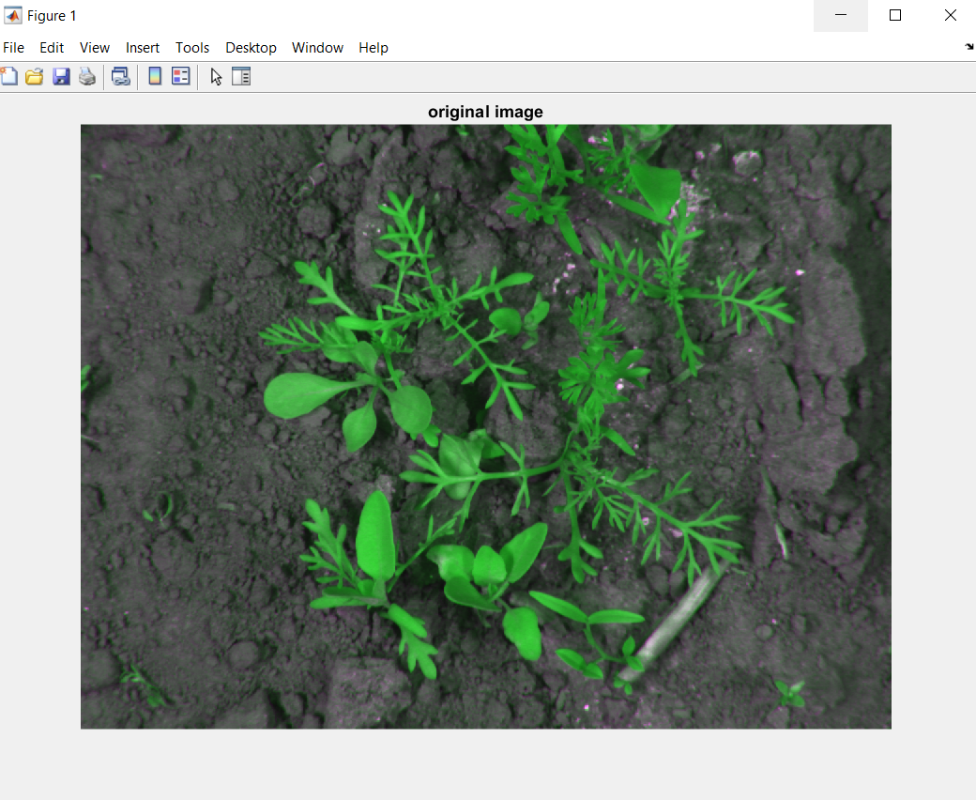

**Fig. 2 Original Image**

Figure 2 depicts the original image under interest.

In the next step, the RGB to grayscale conversion is done to facilitate the computation process from 3 channels to single channel analysis.

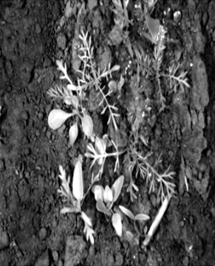

**Fig.3 Illumination Enhancement**

Figure 3 depicts the illumination enhancement performed on the grayscale image. A subsequent processing of the image can be done using the 2-dimensional discrete wavelet transform (DWT). The wavelet decomposition has been done using the Haarlet family at level 4. The decomposition and subsequent synthesis of the image from the co-efficients has been depicted in figure 4.

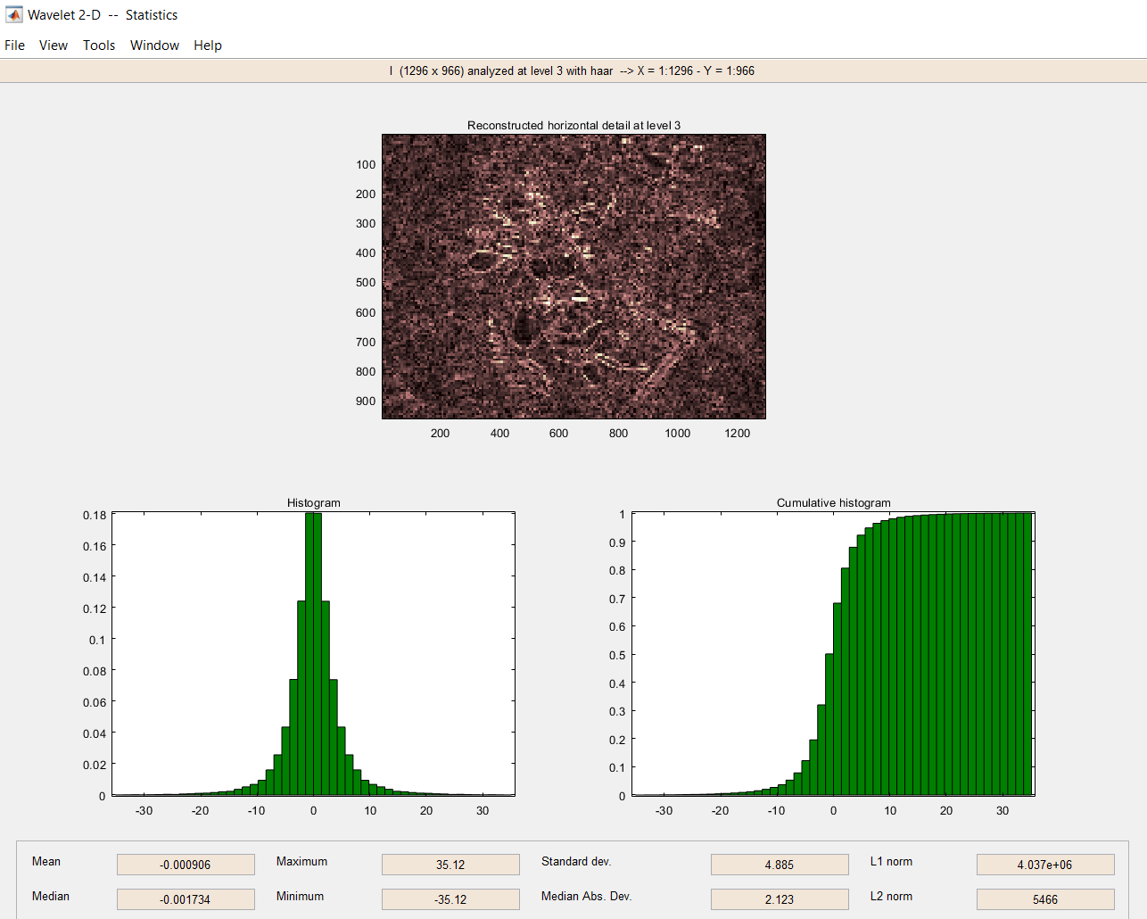

**Fig.4 Wavelet Decomposition and Histogram Analysis**

Figure 4 depicts the histogram analysis of the details using co-efficient values at

**Table.1. Histogram Analysis**

|  |  |  |  |
| --- | --- | --- | --- |
| **Parameter** | **Original** | **Approximated at Level 4** | **Detailed at Level 4** |
| **Minimum** | 234.5 | 184.9 | 35.12 |
| **Maximum** | 14.17 | 18.34 | -35.12 |
| **Mean** | 74.86 | 74.86 | -0.000906 |
| **Standard Deviation** | 73.7 | 73.66 | -0.001734 |
| **Mean Absolute Deviation** | 22.64 | 20.47 | 4.85 |
| **L1 Norm** | 12.28 | 9.37 x 107 | 2.123 |
| **L2 Norm** | 9.37 x 107 | 8.68 x 104 | 4.03 x 106 |

It can be observed from table 1 that the histogram of the details are drastically different in terms of the statistical parameters such as mean, maximum, minimum, standard deviation and mean absolute deviation as compared to the original image. On the contrary, the histogram of the approximations (synthesized image) shows close similarity to the original image, which indicates that the approximations contain the maximum information content while the detailed co-efficient values contain additional details which often contain noise and disturbance effects as exogenous inputs to the image. Thus an iterative filtering using the DWT is effective in noise removal. As an illustration, the 12 features for a non-infested and infested image are computed are tabulated in table 2. The same process is applied to the complete dataset.

**Table 2. Feature Values**

|  |  |  |
| --- | --- | --- |
| **Feature** | **Non-infested** | **Infested** |
| **Contrast** | 0.344886363636364 | 0.348295454545455 |
| **Correlation** | 0.0348645446583504 | 0.0132823676850939 |
| **Energy** | 0.648327091942149 | 0.676514075413223 |
| **Homogeneity** | 0.896439393939394 | 0.905397727272727 |
| **Mean** | 0.00534961346174364 | 0.00404130200934658 |
| **Standard Deviation** | 0.106494858974864 | 0.106552559248169 |
| **Entropy** | 3.77534313502299 | 3.76249894182648 |
| **rms** | 0.106600358177805 | 0.106600358177805 |
| **Variance** | 0.0112786991593108 | 0.0112905013310115 |
| **Inverse Difference** | 0.908139616971321 | 0.881912908569653 |
| **Kurtosis** | 4.94085468988672 | 5.05381147561750 |
| **Skewness** | 0.256943895681977 | 0.896207776217934 |

Table 2 depicts the typical feature values of an infested and a non-infested image. It can be seen that the feature values bear similarity in magnitude which makes it necessary to use a classifier which can effectively classify data sets with fuzzy or blurred boundaries.

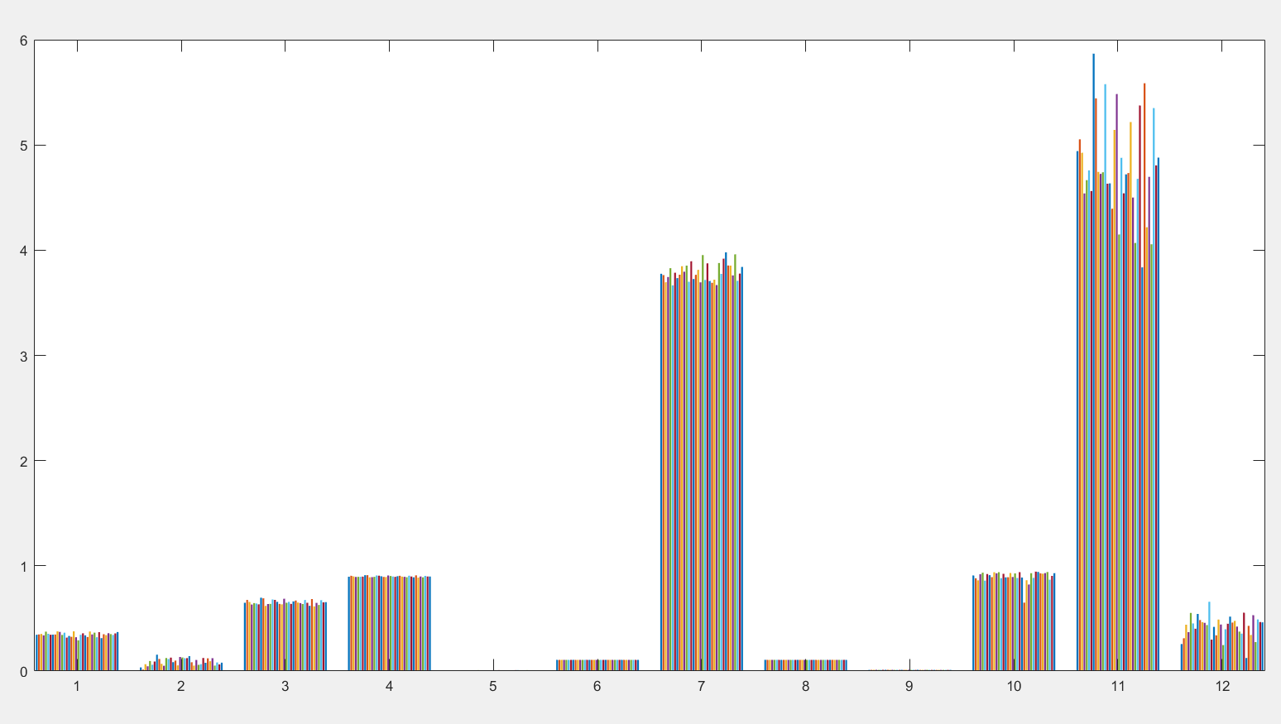

**Fig. 5 Bar graph for image features**

A bar graph for the twelve features for the sample size has been depicted in figure 5. Figure 5 signifies that a particular feature for the dataset attain a similar value implying the consistency in the feature extraction part.

The classification of the proposed work has been done based on the Deep BayesNet with the sigmoid activation function. The back propagation training rule has been used for weight update. The classification accuracy can be visualized using the confusion matrix.

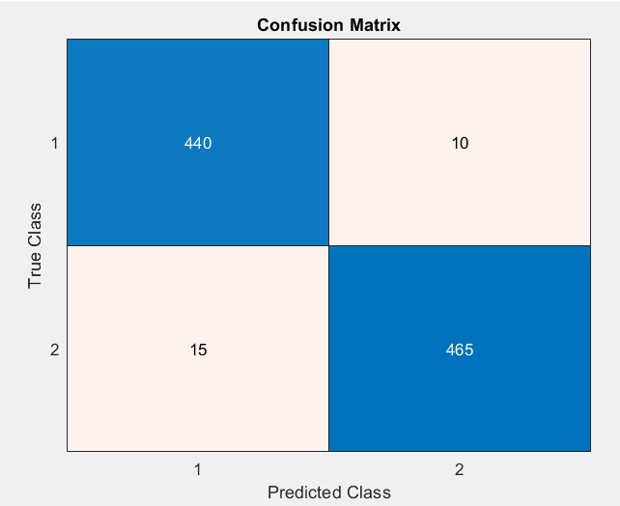

**Fig. 6 Confusion Matrix**

The accuracy of the proposed system is computed as:

$$Ac=\frac{440+465}{440+465+15+10}=97.31\%$$

Thus for the used dataset, the proposed system attains an accuracy of 96% which outperforms baseline techniques in terms of classification accuracy. A summary of results is provided in table 3 for ready reference.

**Table. 3 Summary of Results**

|  |  |  |
| --- | --- | --- |
| **S.No.** | **Parameter** | **Value** |
| 1 | Dataset Set | GitHub: https://github.com/cwfid/dataset |
| 2 | Image Type | jpg |
| 3 | Pre-Processing | DWT |
| 4 | Segmentation Method | Max gradient |
| 5 | Features | 12: stochastic |
| 6 | Classifier | Deep BayesNet |
| 7 | Custom CNN (500 X 500) | 94.7 |
| 8 | Custom CNN (250 X 250) | 90.6 |
| 9 | Custom CNN (125 X 125) | 89.7 |
| 10 | ResNet 18 | 94.8 |
| 11 | ResNet 50 | 95.7 |
| 12 | DenseNet 128 | 90.1 |
| 13 | VGG Net | 91 |
| 14 | Faster RCNN | 67 |
| 15 | YOLO | 95 |
| 16 | **Accuracy (proposed work)** | **97.31%** |

It can be observed that the proposed technique comprising of image pre-processing, segmentation followed by classification through the Deep Bayes Net can outperforms baseline techniques in terms of classification accuracy.

# CONCLUSION

This paper introduces the need for precision agriculture along with its applications in the domain of automated classification of crop and weeds. The working of automated classifiers along with their attributed and dependence on feature extraction has been explained in detail. Different stages of the image processing and segmentation have been enlisted. The significance of different image features and extraction techniques have been clearly mentioned with their utility and physical significance. Various machine learning based classifiers and their pros and cons have been highlighted. The mathematical formulations for the feature extraction and classification gave been furnished. A comparative analysis of the work and results obtained has been cited in this paper. Results presented in this paper clearly indicate that the proposed method is capable of classifying crop-weeds with high accuracy and beats baseline techniques in terms of classification accuracy.

The future scope of the proposed model can be employing the Maximum Overlap Discrete Wavelet Transform (MODWT) which results in lesser information loss compared to the DWT, but the filtration capability must be tested.

Hybrid machine learning/Deep learning models can be tested.

# Acknowledgments

# The authors would acknowledge the support of the members of the department of computer science, CT University for their valuable suggestions and insights which have helped in making the paper more impactful

# References

1. T Luo, J Zhao, Y Gu, S Zhang, X Qiao, W Tian, "Classification of weed seeds based on visual images and deep learning," Information Processing in Agriculture, Elsevier 2023, vol.10, no.1, pp.40-51.
2. ASMM Hasan, D Diepeveen, H Laga, MGK Jones, "Image patch-based deep learning approach for crop and weed recognition," Ecological Informatics, Elsevier 2023, vol. 78,. 102361.
3. BK Hu, Z Wang, G Coleman, A Bender, T Yao, S Zeng, "Deep learning techniques for in-crop weed recognition in large-scale grain production systems: a review," Precision Agriculture, Springer Nature 2024, , vol. 25, pp. 1–29.
4. FH Juwono, WK Wong, S Verma, N Shekhawat, “Machine learning for weed–plant discrimination in agriculture 5.0: An in-depth review”, "Artificial Intelligence in Agriculture, Elsevier, 2023, vol. 10, pp. 13-25.
5. H. L. Lee, C. L. Chang and C. C. Chang, "Precision Agriculture and Its Applications in Taiwan," in IEEE Technology and Engineering Education (ITEE), 2016, pp. 200-205
6. D. Li, Z. Zhou and S. Li, "A Review of UAV Applications in Precision Agriculture," in Journal of Sensors, vol. 2017, pp. 1-13, 2017
7. J. R. Rosell-Polo, D. Sanz-Robinson and J. J. Vallés-Ros, "A Review of Methods and Applications of the Geometric Characterization of Tree Crops in Agriculture," in Sensors, vol. 15, no. 6, pp. 13035-13061, 2015.
8. A. Nayyar, J. Irvin and C. A. Grift, "A Review of UAV-Based Precision Agriculture and Its Contributions to Sustainability in Crop Production," in Sustainability, vol. 11, no. 17, pp. 4706-4722, 2019.
9. S. Arabi and S. G. McClure, "Integration of Unmanned Aerial Vehicles (UAVs) in Agriculture: A Review," in Computers and Electronics in Agriculture, vol. 144, pp. 49-61, 2017.
10. S. Bareth, M. Bolten and H. Gnyp, "Combined Spectral and Spatial Modeling of Crop Height Using Unmanned Aerial Vehicles," in Remote Sensing, vol. 7, no. 4, pp. 4213-4238, 2015.
11. D. Wang, Z. Gao, X. Wei and Z. Liu, "Crop-Weed Classification for Precision Agriculture Using a Deep Convolutional Neural Network," in IEEE Access, vol. 7, pp. 146471-146479, 2019
12. C. C. Ogbodo and B. J. Adeoye, "Crop-weed discrimination using machine learning techniques," in IEEE International Conference on Electro/Information Technology (EIT), 2018, pp. 0919-0923
13. A. Singh, A. Dhaka and V. K. Banga, "Crop-Weed Classification using Machine Learning Techniques: A Review," in IEEE International Conference on Computing, Communication and Automation (ICCCA), 2016, pp. 614-618
14. M. U. Anwar, H. Saeed and M. Riaz, "Crop-Weed Discrimination using Machine Learning Techniques: A Comparative Study," in IEEE International Conference on Robotics and Automation Sciences (ICRAS), 2018, pp. 253-257
15. A. Raza, M. Rehman and F. Yasmin, "Crop and Weed Classification using Machine Learning Techniques," in IEEE International Conference on Emerging Technologies (ICET), 2018, pp. 1-6
16. A. Zhang, X.Wei X. “A review on weed detection using ground-based machine vision and image processing techniques. Computers and Electronics in Agriculture”, Elsevier 2019, 158, pp: 226-240
17. AM Anter, AE Hassenian, D Oliva, “An improved fast fuzzy c-means using crow search optimization algorithm for crop identification in agricultural”, Expert Systems with Applications, Elsevier 2019, vol.118, pp.340-354.
18. A.Bakhshipour, A.Jafari A, S.Nassiri. D.Zare, “Weed segmentation using texture features extracted from wavelet sub-images”, Biosystems Engineering, Elsevier 2017, vol.157, pp.1-12.
19. J Torres-Sospedra, P Nebot, “Two-stage procedure based on smoothed ensembles of neural networks applied to weed detection in orange groves”, Biosystems Engineering, Elsevier 2014, vol.123, pp.40-55.
20. I Dasgupta, J Saha, P Venkatasubbu, “AI crop predictor and weed detector using wireless technologies: a smart application for farmers”, Arabian Journal for Science and Engineering, Springer 2020, vol.45, pp.11115–11127.
21. U. Shruthi, V. Nagaveni and B. K. Raghavendra, "A Review on Machine Learning Classification Techniques for Plant Disease Detection," 2019 5th International Conference on Advanced Computing & Communication Systems (ICACCS), 2019, pp. 281-284.
22. Y Chen, Z Wu, B Zhao, C Fan, S Shi, “Weed and corn seedling detection in field based on multi feature fusion and support vector machine” Sensors, MDP1 2021, vol.21, no.12, pp.1-18.
23. X. Jin, J. Che and Y. Chen, "Weed Identification Using Deep Learning and Image Processing in Vegetable Plantation," in IEEE Access 2021, vol. 9, pp. 10940-10950.
24. S Abouzahir, M Sadik, E Sabir, “Bag-of-visual-words-augmented Histogram of Oriented Gradients for efficient weed detection”, Biosystems Engineering, Elsevier 2021, vol.202, pp. 179-194.
25. V. N. Thanh Le, G. Truong and K. Alameh, "Detecting weeds from crops under complex field environments based on Faster RCNN," 2020 IEEE Eighth International Conference on Communications and Electronics (ICCE), 2021, pp. 350-355.
26. V. N. Thanh Le, G. Truong and K. Alameh, "Detecting weeds from crops under complex field environments based on Faster RCNN," 2020 IEEE Eighth International Conference on Communications and Electronics (ICCE), 2021, pp. 350-355.
27. M. Alam, M. S. Alam, M. Roman, M. Tufail, M. U. Khan and M. T. Khan, "Real-Time Machine-Learning Based Crop/Weed Detection and Classification for Variable-Rate Spraying in Precision Agriculture," 2020 7th International Conference on Electrical and Electronics Engineering (ICEEE), 2020, pp. 273-280.
28. S Sabzi, Y Abbaspour-Gilandeh, “Using video processing to classify potato plant and three types of weed using hybrid of artificial neural network and partincle swarm algorithm”, Measurement, Elsevier 218, vol.126, pp.Pages 22-36.
29. Tin-Yau Kwok and Dit-Yan Yeung, "Constructive algorithms for structure learning in feedforward neural networks for regression problems," in IEEE Transactions on Neural Networks, vol. 8, no. 3, pp. 630-645.
30. F.Ahmed, Al-Mamun, A.Bari, E.Hossain, “Classification of crops and weeds from digital images. A support vector machine approach Journal of Crop Production”, Elsevier 2013, vol.40, pp: 98-104.
31. S. S. Athani and C. Tejeshwar, "Support Vector Machine-Based Classification Scheme of Maize Crop," 2017 IEEE 7th International Advance Computing Conference (IACC), 2017, pp. 84-88.