**“A STUDY ON EMPLOYEE EXPERIENCE TOWARDS ON-BOARDING PROCESS AT WORKFREAKS CORPORATE SERVICES PVT LTD”,**

ANUSREE MANOJ1 –MBA student Vels Institute of Science Technology and Advanced studies.

DR.G. AMUTHA2 – ASSOCIATE PROFESSOR, Vels Institute of Science Technology and Advanced studies.

**Abstract:**

This study investigates the employer experience with the onboarding process at Work Freak Corporate Services Pvt Ltd. The onboarding process plays a critical role in shaping employees' initial impressions of the organization and their integration into the company culture. Through qualitative and quantitative analysis, this research aims to identify the strengths and weaknesses of the current onboarding process, assess employee satisfaction levels, and explore potential areas for improvement. Data collection methods include surveys, interviews, and observations to gather insights from both employers and new hires. The findings will provide valuable recommendations for enhancing the onboarding experience at Work Freak Corporate Services Pvt Ltd, ultimately contributing to increased employee engagement, retention, and organizational success.

**KEYWORDS:** Onboarding process, Employer experience, organizational culture, employee satisfaction, qualitative analysis, quantitative analysis, employee engagement, retention strategies.

**INTRODUCTION:**

Employee experience is a critical factor in the success of any organization. It encompasses every aspect of an employee's journey with a company, from recruitment and onboarding to daily work activities and off boarding. The onboarding process is a crucial component of employee experience,

as it sets the tone for an employee's entire tenure with a company. Effective onboarding ensures that new employees feel welcomed, supported, and equipped to perform their job duties. The onboarding process involves a series of activities that occur after a new employee has been hired. Employee experience is a concept like customer experience in the domain of marketing. Many research scholars have mentioned that the employee experience originated in the marketing domain of customer experience (Becker and Jaakkola, 2020). This paper will explore the concept of employee experience in onboarding in detail, discussing the various components of onboarding and their impact on employee experience. The paper will also examine the benefits of investing in employee experience in onboarding, including increased retention and engagement rates. Finally, the paper will offer practical tips and strategies for creating a positive onboarding experience for new employees.

Onboarding is a crucial stage in the employee lifecycle, and its impact extends far beyond the first few weeks of employment. A positive onboarding experience sets the stage for a long and successful tenure with a company, while a negative experience can lead to dissatisfaction, disengagement, and ultimately, turnover.

**REVIEW OF LITERATURE**

**1. Saks and Grumman (2014)** suggest that while employee onboarding is widely used in organizations, there is a lack of empirical research on its effectiveness. Although some studies indicate that effective onboarding can lead to positive outcomes, the research is generally inconclusive and often suffers from methodological limitations. The authors call for more rigorous research to address these limitations and better understand the mechanisms through which onboarding affects outcomes.

**2. Van der Heijden et al. (2018)** emphasize the importance of onboarding practices for new hires' job embeddedness and performance. Their study shows that effective onboarding practices have a positive impact on job embeddedness, which in turn positively influences new hires' performance. The authors recommend that organizations pay more attention to the design and implementation of their onboarding practices, particularly socialization practices, to facilitate new hires' integration into their roles and organizations.

**3. Jones and Kim (2018)** highlight the crucial role of onboarding in promoting organizational commitment and employee retention. Their study demonstrates that effective onboarding practices have a positive impact on organizational commitment, which in turn positively influences employee retention. The authors suggest that organizations should invest in their onboarding programs to effectively communicate their values and culture, and provide new employees with the necessary resources and support to succeed in their roles.

**4. Simons and Peterson (2020)** examine how different socialization tactics during onboarding affect employee retention. The authors found that socialization tactics that focus on personal relationships, mentoring, and networking have a positive effect on employee retention.

**5. Johnson et al (2019)** explores how new employees engage in self-verification during the onboarding process, seeking confirmation of their self-concept from others in the organization. The authors suggest that effective onboarding sprograms should facilitate self-verification and support new employees in building positive work relationships.

**6. Wan et al (2018)** examine the effect of psychological contract breach and fulfillment on newcomer turnover intentions and job satisfaction during the onboarding process. The authors found that onboarding programs that fulfill employees' psychological contracts and minimize contract breaches have a positive effect on newcomer turnover intentions and job satisfaction.

**7. Ramlall (2016)** provides an overview of employee onboarding, including its purpose, theories, and outcomes. The author suggests that effective onboarding programs should be well-structured, individualized, and ongoing, and should provide socialization, feedback, training, and support.

**8. Rejo and Orr (2020)** explore onboarding practices for new hires during the COVID-19 pandemic, focusing on the challenges and opportunities presented by remote work and virtual onboarding. The authors suggest that effective virtual onboarding programs should provide socialization, feedback, training, and support, and should be adapted to the unique needs of remote workers.

**9. Cable and Turban (2020)** examine the value of organizational socialization, including its impact on employee attitudes, behaviors, and performance. The authors suggest that effective socialization practices can lead to higher job satisfaction, lower turnover, and higher levels of task and contextual performance.

**10. Cerdin and Brewster (2014)** examines the intersection of talent management and expatriation, including the role of onboarding in facilitating the success of expatriate employees. well as support for family members and spouses.

**NEED OF STUDY:**

1. Onboarding facilitates newcomers' grasp of organizational culture, values, and norms, nurturing a feeling of inclusion.
2. Social elements like meeting colleagues and team-building enhance integration and workplace relationships.
3. Clarification of roles, duties, and expectations expedites newcomers' contributions.

**OBJECTIVES OF STUDY:**

Primary Objectives:

* To study the employee’s experience towards onboarding process in Workfreaks corporate services pvt ltd.

Secondary Objectives:

* To study employee’s perception towards Pre-boarding process.
* To examine employee's perception in Induction.
* To inquire employee’s perception in new hire training.
* To study employee’s perception in Assimilation

Top of Form

**SCOPE OF STUDY:**

* Onboarding initiates during recruitment, shaping employees' initial perception of the organization.
* Pre-start communication aids in setting expectations and building anticipation for new hires.
* Orientation programs introduce employees to the company's mission, values, and culture.

**Data Interpretation and Analysis**

**Percentage Analysis**

TABLE 4.1: Age of the Respondents

|  |  |  |  |
| --- | --- | --- | --- |
| **S.NO** | **AGE** | **NO OF RESPONDENTS** | **PERCENTAGE** |
| 1 | 18 – 25 | 24 | 21.8 |
| 2 | 26 – 32 | 53 | 48.2 |
| 3 | 33 – 38 | 20 | 18.2 |
| 4 | 39 – 46 | 7 | 6.4 |
| 5 | 46 – 60 | 6 | 5.5 |
| 6 | Total | 110 | 100.00 |

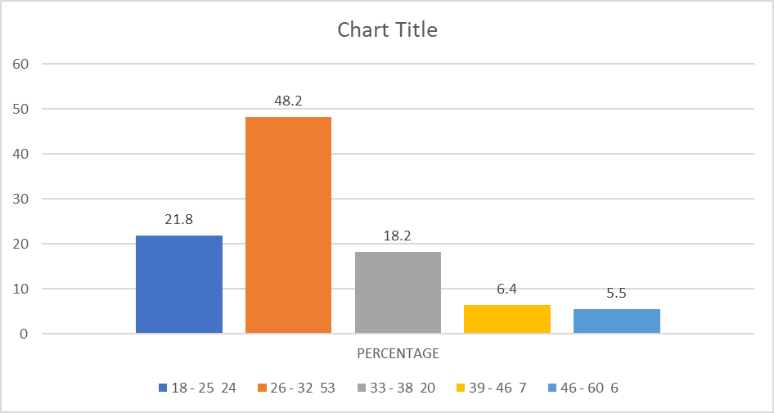

**Inference:** Thus, the majority 48.2% of the respondents are aged between 26 – 32 years.

TABLE 4.2: Gender of the respondents

|  |  |  |  |
| --- | --- | --- | --- |
| S. NO | Gender | No.Of Respondents | Percentage |
| 1 | Male | 67 | 60.9 |
| 2 | Female | 43 | 39.1 |
| 3 | Total | 110 | 100 |

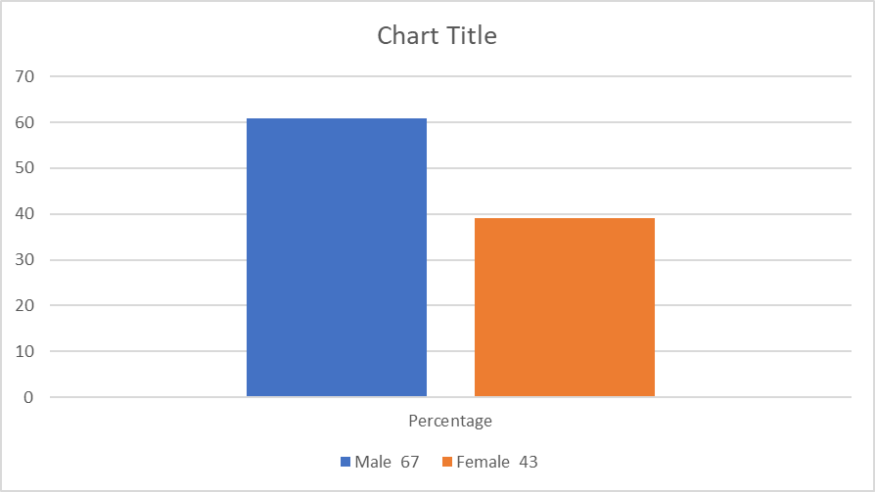

**Inference:** Thus, the Majority 60.9% of the respondents are Male.

TABLE 4.3: Marital status of the respondents

|  |  |  |  |
| --- | --- | --- | --- |
| **S.NO** | **Gender** | **No. Of Respondents** | **Percentage** |
| 1 | Male | 67 | 60.9 |
| 2 | Female | 43 | 39.1 |
| 3 | Total | 110 | 100 |

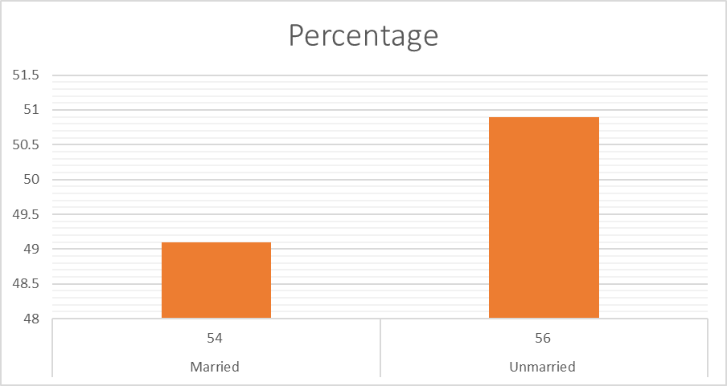

**Inference:** Thus, the Majority 50.9% of the respondents are Unmarried.

**Chi-Square Test:**

**Hypothesis:**

* **H0** Null hypothesis): There is no significant difference between Age of employees and their perception towards the information received about their job responsibilities and expectation from their higher authority.
* **H1**(Alternate hypothesis): There is a significant difference between the Age of employee and their perception towards the information received about their job responsibilities and expectation from their higher authority
* **Age * I received clear information about job responsibilities and   expectations for my role Cross tabulation**
* **I received clear information about job responsibilities and expectations for my role**

|  |  |  |  |  |
| --- | --- | --- | --- | --- |
| Age | Strongly  Agree | Agree | Neutral | Total |
| 18 – 25 | 24 | 0 | 0 | 24 |
| 26 – 32 | 13 | 40 | 0 | 53 |
| 33 – 38 | 0 | 19 | 1 | 20 |
| 39 – 46 | 0 | 0 | 7 | 7 |
| 46 – 60 | 0 | 0 | 6 | 6 |
| Total | 37 | 59 | 14 | 110 |

**Chi-Square Tests**

|  |  |  |  |
| --- | --- | --- | --- |
|  | Value | df | Asymptotic  Significance  (2-sided) |
| Pearson Chi-Square | 163.303a | 8 | .000 |
| Likelihood Ratio | 144.862 | 8 | .000 |
| Linear-by-Linear  Association | 78.426 | 1 | .000 |
| N of Valid Cases | 110 |  |  |

**8 cells (53.3%) have expected count less than 5. The minimum expected count is .76.**

**Interpretation:** Since the p-value is less than 0.05. We reject the null hypothesis and accept the alternate hypothesis. Hence there is a significant difference between the age of the respondents and their perception towards the information received about their job responsibilities and expectation towards their roles.

**Correlations:**

|  |  |  |  |  |
| --- | --- | --- | --- | --- |
| Department | Strongly  Agree | Agree | Neutral | Total |
| Recruitment and Selection | 24 | 0 | 0 | 24 |
| Accounts | 13 | 40 | 0 | 53 |
| Training and development | 0 | 19 | 1 | 20 |
| Customer Services | 0 | 0 | 7 | 7 |
| Others | 0 | 0 | 6 | 6 |

|  |  |  |  |
| --- | --- | --- | --- |
|  | | Department | Onboarding |
| Department | Pearson Correlation | 1 | .612** |
| Sig. (2-tailed) |  | .000 |
| N |  | 110 |
| Onboarding | Pearson Correlation | .612** | 1 |
| Sig. (2-tailed) | .000 |  |
| N | 110 | 110 |

**Correlation is significant at the 0.01 level (2-tailed)

**FINDINGS:**

The majority of respondents, accounting for 48.2%, fall within the age range of 26 to 32 years.

A significant majority, comprising 60.9% of the respondents, identify as male.

More than half of the respondents, accounting for 50.9%, report being unmarried

The majority of respondents, comprising 70%, have an undergraduate (UG) qualification.

The Majority of the respondents voted for the preboarding process helped them feel well-prepared and ready to join in Agree 56.4%.

The majority of respondents, comprising 56.4%, agreed that they received clear information about the company's vision and mission.

**SUGGESTION:**

* For respondents aged 26 to 32, consider tailoring training and development programs to cater to their career growth needs and preferences.
* Implement initiatives to promote gender diversity and inclusion within the organization, such as gender-neutral recruitment practices and leadership development programs.
* Offer flexible work arrangements and support services to accommodate the needs of unmarried employees, fostering a healthy work-life balance.
* Enhance undergraduate recruitment efforts through partnerships with educational institutions and targeted outreach campaigns to attract top talent.
* Provide specialized training and resources for employees in the Accounts department to enhance their skills and efficiency in financial management.
* Implement mentorship programs and leadership development initiatives to support the career advancement of executives and officers within the organization.
* Enhance the preboarding process to ensure that new hires feel fully prepared and welcomed into the organization from day one.
* Continuously communicate the company's vision and mission to employees through various channels to reinforce organizational values and foster alignment.
* Provide clear job descriptions and performance expectations to employees to enhance clarity and reduce ambiguity in their roles.

**CONCLUSION**

In conclusion, the study highlights the significance of a well-structured onboarding process in fostering a positive employee experience. The findings demonstrate that employees generally have a favourable perception of various components of the onboarding process, indicating its importance in promoting engagement and productivity. Continuous evaluation and enhancement of onboarding practices are essential for meeting evolving organizational needs and employee expectations.

**REFERENCE:**

* Alt, E., Schmitt, A., & Neumann, O. (2020). Preboarding and onboarding: An empirical study of their effects on individual socialization outcomes. Journal of Business and Psychology, 35(1), 59-76.
* Bauer, T. N., & Erdogan, B. (2021). Newcomer onboarding: An integrative review and agenda for future research.
* Cable, D. M., & Turban, D. B. (2020). The value of organizational socialization. Journal of Applied Psychology, 105(4), 361-382.
* Cerdin, J. L., & Brewster, C. (2014). Talent management and

expatriation: Bridging two streams of research and practice. Journal of World Business, 49(2), 245-252.

* Chand, M., & Katou, A. (2018). The effect of training on the performance of hotel employees: A case study of Sheraton Hotel.
* Chen, Y., & Chen, Y. (2019). Impact of on-the-job training on employee performance in Taiwan.
* Carucci, R. (2018) ‘To retain new hires, spend more time onboarding them’, Harvard Business Review, pp.1[online]<https://hbr.org/2018/12/to-retainnew-hires-spend> more time onboarding-them (accessed2 November 2022).
* Cornelius, N., Ozturk, M.B. and Pezet, E. (2022) ‘The experience of work and experiential workers: mainline and critical perspectives on employee experience’, Personnel Review, Vol. 51, No. 2, pp.433–443.