

**AN ASSESSMENT OF THE RISK MANAGEMENT ON NON-VESSEL OPERATING COMMON CARRIER AT PHOENIX LOGISTICS, CHENNAI.**

**AN PROJECT REPORT SUBMITTED TO**

**VELS INSTITUTE OF SCIENCE, TECHNOLOGY AND ADVANCED STUDIES (VISTAS)**

**(Estd. U/s 3 of the UGC Act, 1956)**

***In partial fulfillment of the requirement For the award of the degree of***

***MASTER OF BUSINESS ADMINISTRATION SHIPPING AND LOGISTICS MANAGEMENT***

***Submitted by***

#### PRIYATHARSHAN A

**Reg Number (22302122) Under the guidance of**

**Dr. D. ANITHA KUMARI ASSOCIATE PROFESSOR - MBA**

#### SCHOOL OF MANAGEMENT STUDIES VISTAS

**P.V. VAITHIYALINGAM ROAD, OLD PALLAVARAM CHENNAI-600 117**

**(2022-2024)**



#### SCHOOL OF MANAGEMENT STUDIES BONAFIDE CERTIFICATE

This is to certify that Project report on **AN ASSESSMENT OF THE RISK MANAGEMENT ON NON-VESSEL OPERATING COMMON CARRIER AT PHOENIX LOGISTICS,**

**CHENNAI,** is a Bonafide record of work carried out by **PRIYATHARSHAN A, 22302122.**

**School of Management Studies** under **VISTAS** submitted in partial fulfilment of the requirements for the award of the degree of **Master of Business Administration in Shipping and Logistics Management** for the fourth semester during 2022-2024 under our guidance.

|  |  |
| --- | --- |
| **INTERNAL GUIDE** | **CII GUIDE** |
| **Dr. D. Anitha Kumari** | **Thilak Rajan** |
| **Associate Professor** | **CII Faculty** |
| **Programme Coordinator – MBA SLM** |  |
| **Dr.P.G. Thirumagal HOD -MBA** | **Dr.P.R.Ramakrishnan DEAN- MBA** |
|  | **`** |

**INTERNAL EXAMINER EXTERNAL EXAMINER**

## COURSE COMPLETION LETTER

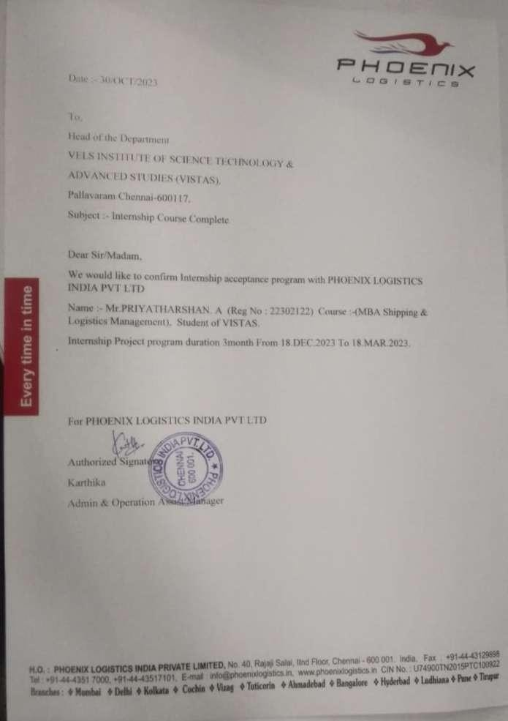

**DECLARATION**

I, **PRIYATHARSHAN A, Reg number (22302122)**, a student of MBA - Shipping and Logistics Management, SCHOOL OF MANAGEMENT STUDIES, VISTAS here by, declare that the PROJECT work titled **AN ASSESSMENT OF THE RISK MANAGEMENT ON NON-VESSEL OPERATING COMMON CARRIER AT PHOENIX LOGISTICS,**

**CHENNAI.** submitted to the VISTAS in partial fulfilment of the requirement for the award of the degree of **Master of Business Administration in Shipping and Logistics Management** is a record of Bonafide research carried out by me under the guidance of **Dr. D. ANITHA KUMARI, Associate Professor and Program Coordinator– MBA-SLM, SCHOOL OF MANAGEMENT STUDIES, VISTAS** and no part of it has been submitted for any other degree or diploma.

**Place: Chennai**

**Date:**

#### PRIYATHARSHAN A

**ACKNOWLEDGEMENT**

I am very much grateful to our Chancellor **Dr. Ishari K Ganesh, Dr. A. Jothi Murugan**, Pro Chancellor – Planning & Development, **Dr. Arthi K Ganesh**, Pro Chancellor – Academics and **Dr. Preethaa Ganesh**, Vice President for giving us an opportunity to study and encouraged us in all our efforts during the program.

I would like to express my deep gratitude to our Vice Chancellor **Dr.S.Sriman Narayanan,** Pro Chancellor **Dr. M. Bhaskaran** our Registrar **Dr. P.Saravanan** and Controller of Examinations **Dr. A. Udayakumar**, for all their endeavor in educating us in this esteemed organization.

I wish to express my gratefulness to **Dr. P.R Ramakrishnan**, Dean, School of Management Studies and Commerce, for the encouragement and guidance during the Internship. I would like to thank **Dr.P.G.Thirumagal,** Associate Professor & Head of the department, and **Dr. D. Anitha Kumari, Associate Professor -Programme Coordinator,** MBA Shipping and Logistics Management, School of Management Studies for nurturing with a conducive environment and for her professional insights and updates to complete my Internship successfully.

I wish to express my humble thanks to my internal guide **Dr. D. Anitha Kumari, Associate Professor – MBA,** School of management studies, VISTAS and External Guide **CII Faculty Name** with Designation for her guidance throughout the Project.

I am indebted to my Company Guide (KARTHIKA)

#### PRIYATHARSHAN A

**CONTENTS**

|  |  |  |
| --- | --- | --- |
| **CHAPTER NO.** | **TITLE** | **PAGE NUMBER** |
| **I** | **INTRODUCTION** | 1 |
| **1.1 INDUSTRY PROFILE** | 9 |
| **1.2 COMPANY PROFILE** | 14 |
| **1.3 STATEMENT OF PROBLEM** | 17 |
| **1.4 NEED FOR THE STUDY** | 17 |
| **1.5 OBJECTIVES OF THE STUDY** | 17 |
| **II** | **REVIEW OF LITERATURE** | 18 |
| **III** | **RESEARCH METHODOLOGY** | 22 |
| **3.1 RESEARCH DESIGN** | 22 |
| **3.2 SAMPLING TECHNIQUE** | 23 |
| **3.3 DATA COLLECTION METHOD** | 23 |
| **3.4 QUESTIONNAIRE DESIGN** | 24 |
| **3.5 HYPOTHESIS FORMULATION** | 24 |
| **3.6 STATISTICAL/ANALYTICAL TOOLS USED** | 25 |
|  | **3.7 LIMITATIONS OF THE STUDY** | 28 |
| **IV** | **4.1 DATA ANALYSIS AND INTERPRETATION** | 29 |
|  | **4.2 STATISTICAL TOOL** | 59 |
| **V** | **FINDINGS OF THE STUDY** | 62 |
| **RECOMMENDATIONS AND SUGGESTIONS** | 63 |
| **CONCLUSION** | 63 |
|  | **BIBLIOGRAPHY** | 64 |
|  | **QUESTIONNAIRE** | 65 |

**LIST OF TABLES**

|  |  |  |
| --- | --- | --- |
| **Table**  **No** | **TITLE** | **PAGE**  **NO** |
| **4.1.1** | Does the NVOCC comply with international Shipping standards | 34 |
| **4.1.2** | If there is potential risks identified in NVOCC Operations | 35 |
| 4.1.3 | Does the cargo security measures implemented to mitigate risks | 36 |
| **4.1.4** | Does the insurance coverage for potential risk in NVOCC activities | 37 |
| **4.1.5** | The NVOCC equipped with emergency response plans for unforeseen events | 38 |
| **4.1.6** | Do you know the vendors and partners assessed for potential risks | 39 |
| **4.1.7** | The cybersecurity measures in place to protect digital assets? do you agree this | 40 |
| **4.1.8** | Does the NVOCC manage financial risks associated with it's operations | 41 |
| **4.1.9** | The NVOCC prepared with contingency plans for unforeseen disruptions | 42 |
| **4.1.10** | Does the NVOCC adhere to relevant regulations in it's operations | 43 |
| **4.1.11** | How effective are the training programs provided to staff regarding risk management | 44 |
| **4.1.12** | Does the physical assets protected against potential risk in NVOCC activities | 45 |
| **4.1.13** | How well is integrity of data maintained to prevent potential risk | 46 |
| **4.1.14** | Does the NVOCC handle communication during crisis situation | 47 |
| **4.1.15** | Does the NVOCC address environmental risk in it's operations | 48 |
| **4.1.16** | Whether the geopolitical risk assessed in NVOCC decision making | 49 |
| **4.1.17** | Whether the geopolitical risk assessed in NVOCC decision making | 50 |
| **4.1.18** | Did you know the audit and review processes in identifying and addressing risks | 51 |
| **4.1.19** | Does the NVOCC incorporate the feedback for continuous improvement in risk management | 52 |
| **4.1.20** | How resilient is the NVOCC to external shocks and unexpected events | 53 |
| **4.1.21** | Do you agree that NVOCC should be subject to stringent penalties for Non-compliance with regulatory requirements | 54 |
| **4.1.22** | Do you believe that NVOCC should have clear protocols in place for handling hazardous materials in compliance with regulatory standards | 55 |
| **4.1.23** | Does ethical guidelines and policies to mitigate the risk of unethical behavior or practices in NVOCC operations | 56 |
| **4.1.24** | Implement stringent quality control measures to ensure the integrity and reliability of goods transported through NVOCC service | 57 |
| **4.1.25** | Do you believe that NVOCCs should engage in continuous improvement initiatives to enhance their compliance with regulations | 58 |

**LIST OF CHARTS**

|  |  |  |
| --- | --- | --- |
| **Table**  **No** | **TITLE** | **PAGE**  **NO** |
| **4.1.1** | Does the NVOCC comply with international Shipping standards | 34 |
| **4.1.2** | If there is potential risks identified in NVOCC Operations | 35 |
| 4.1.3 | Does the cargo security measures implemented to mitigate risks | 36 |
| **4.1.4** | Does the insurance coverage for potential risk in NVOCC activities | 37 |
| **4.1.5** | The NVOCC equipped with emergency response plans for unforeseen events | 38 |
| **4.1.6** | Do you know the vendors and partners assessed for potential risks | 39 |
| **4.1.7** | The cybersecurity measures in place to protect digital assets? do you agree this | 40 |
| **4.1.8** | Does the NVOCC manage financial risks associated with it's operations | 41 |
| **4.1.9** | The NVOCC prepared with contingency plans for unforeseen disruptions | 42 |
| **4.1.10** | Does the NVOCC adhere to relevant regulations in it's operations | 43 |
| **4.1.11** | How effective are the training programs provided to staff regarding risk management | 44 |
| **4.1.12** | Does the physical assets protected against potential risk in NVOCC activities | 45 |
| **4.1.13** | How well is integrity of data maintained to prevent potential risk | 46 |
| **4.1.14** | Does the NVOCC handle communication during crisis situation | 47 |
| **4.1.15** | Does the NVOCC address environmental risk in it's operations | 48 |
| **4.1.16** | Whether the geopolitical risk assessed in NVOCC decision making | 49 |
| **4.1.17** | Whether the geopolitical risk assessed in NVOCC decision making | 50 |
| **4.1.18** | Did you know the audit and review processes in identifying and addressing risks | 51 |
| **4.1.19** | What do you feel about warehousing services in export FCL | 52 |
| **4.1.20** | How resilient is the NVOCC to external shocks and unexpected events | 53 |
| **4.1.21** | Do you agree that NVOCC should be subject to stringent penalties for Non-compliance with regulatory requirements | 54 |
| **4.1.22** | Do you believe that NVOCC should have clear protocols in place for handling hazardous materials in compliance with regulatory standards | 55 |
| **4.1.23** | Does ethical guidelines and policies to mitigate the risk of unethical behavior or practices in NVOCC operations | 56 |
| **4.1.24** | Implement stringent quality control measures to ensure the integrity and reliability of goods transported through NVOCC service | 57 |
| **4.1.25** | Do you believe that NVOCCs should engage in continuous improvement initiatives to enhance their compliance with regulations | 58 |

# CHAPTER I

## INTRODUCTION

NVOCC (NON-VESSEL OPERATING COMMON CARRIER) are regulated by the shipping act of 1984. This bill was introduced by the 98th united states congress for the improvement and development of the international ocean commerce transportation system of the United States. The performance of an NVOCC can be evaluated based on various factors such as service reliability, pricing competitiveness, transit times, cargo tracking capabilities, customer service, and overall efficiency.

NVOCC (NON-VESSEL OPERATING COMMON CARRIER) when it comes to Ocean

transport for export and import of materials, NVOCC plays a vital role. NVOCC is an intermediary that helps small and medium business. NVOCC lease or rent space in containers from large shippers or freight forwarders, and sell it to smaller shippers. While NVOCC do not usually have their own warehouse, but many own their own fleet of containers. They may also offer services such as cargo consolidation, deconsolidation, and using out-sourced services such as container cleaning, and repair.

The performance of an NVOCC can be evaluated based on various factors such as service reliability, pricing competitiveness, transit times, cargo tracking capabilities, customer service, and overall efficiency.

In terms of service reliability, an NVOCC must ensure that the cargo is delivered on time and without damage. This requires proper planning and coordination with the shipping lines and other parties involved in the supply chain. Pricing competitiveness is another important factor, as NVOCCs must offer competitive rates to attract customers in a highly competitive market.

Transit times are also crucial for NVOCCs, as customers often require their cargo to arrive at its destination within a specific timeframe. To ensure timely delivery, NVOCCs need to have a good understanding of the various shipping routes and schedules, as well as the potential risks and delays associated with each route.

**Cargo tracking** capabilities are also important for NVOCCs, as customers expect to be able to track their shipments in real-time. NVOCCs must have a robust system in place to provide customers with accurate and up-to-date information on the status of their cargo.

**Customer service** is another key factor in evaluating the performance of an NVOCC. NVOCCs must provide prompt and efficient customer service to address any issues orconcerns that customers may have.

**Overall efficiency** is also important for NVOCCs, as they need to maximize their resources and minimize costs to remain competitive in the market. This requires effective management of operations, including cargo handling, documentation, and communication with other parties in the supply chain.

### Process of Non-Vessel Operating Common Carrier (NVOCC) Shipping:

Non-Vessel Owning Common Carrier transports who serves as a shipper's one- stop shop, moves the materials from point A to point B. Several modes of transportation, including rail, ocean, and road, are used in NVOCC shipment. In order to maximize the asset, the shipping company will occasionally outsource the warehouse and issue its own House Bill of Lading. The agents ensure that the NVOCC shipping paperwork are correctly created and processed during the shipping procedure.

One of the benefits of NVOCC shipping is that they frequently provide their customers with smooth and customized services. The agency typically maintains strong relationships and lines of communication with the locals, which facilitates the completion of work more quickly and with less disruption. The fees associated with being a non-vessel owning common carrier tend to differ between ports and shipping companies. Another factor that affects the price of NVOCC transportation is the distance.

### Operation chart of Non-Vessel Owning Common Carrier transports

Shipper

NVOCC

LINER

* Container Leasing Charges.
* Slot and Freight Charges.
* Transportation Charges.
* Documentation and CFS operation charges.
* Clearing and forwarding arrangement

## DIFFERENT STAKEHOLDERS INVOLVED IN NON-VESSEL OPERATING COMMON CARRIER

* Shipper
* Main line operator
* Freight forwarder
* Slot operator
* Customs House agent
* CFS & ICD & transporters
* Consignee

## SHIPPER

A shipper is a person or entity who wants to transport goods to another destination who is also known as consignor. He is responsible for organizing and transporting of goods from one point to another.

## MAIN LINE OPERATORS

Main line operators (MLO) are the one who owns and operates vessel they also provide slot to NVOCC’s and others through slot operators. They are responsible for issuing B/L to the shipper.

## FREIGHT FORWARDER

A freight forwarder or forwarding agent is a person or a company, for a fee, organize shipment for the shipper (an individual /party that arranges an item for shipment).by liaising with carriers. In other words, freight forwarders are an organization that arranges to pick up or delivery goods on instruction of a shipper or a consignee from or to a point by various necessary conveyances and common carriers. A forwarder does not move the goods but acts as an agent in the logistics network.

## SLOT OPERATOR

The term "slot operator" refers to a company that leases space on a container ship from the vessel's owner, and then sells that space to other companies who need to transport their cargo. Slot operators act as intermediaries between shippers and the shipping line, providing access to shipping capacity without the need for shippers to charter an entire vessel. Slot operators typically have agreements with several shipping lines, which allows them to offer a range of routes and services to their customers.

## CUSTOMS HOUSE AGENT

A Customs House Agent (CHA) is a licensed individual or a firm authorized by the government to act as an intermediary between importers/exporters and the customs department for the clearance of goods from customs barriers. CHAs are required to have a good understanding of customs laws, regulations, and procedures, as well as knowledge of various trade agreements and policies. They work on behalf of importers and exporters to ensure that goods are cleared efficiently and quickly, while complying with all legal requirements.

## CFS & ICD & TRANSPORTERS

CFS, ICD, and transporters are all part of the logistics chain involved in the movement of goods, particularly for imports and exports.

**CFS (Container Freight Station)** is a facility where cargo is consolidated, de- consolidated, and stored before being transported to its final destination. CFS operators receive containers from shipping lines, handle the customs clearance process, and store them until they are ready for further transportation by road, rail, or sea.

**ICD (Inland Container Depot)** is a dry port located in the interior of a country, which acts as a gateway for goods being transported by rail or road to/from seaports. ICDs are equipped with modern handling facilities, and they serve as a hub for the consolidation and de-consolidation of cargo, customs clearance, and storage.

**Transporters**, on the other hand, are companies that provide transportation services to move goods from one place to another. They are responsible for loading, transporting, and unloading goods, and they play a crucial role in the supply chain by ensuring that goods reach their intended destination on time and in good condition.

## CONSIGNEE

The consignee is the recipient of the goods in a shipping process. The consignee need not be the final buyer, he can also be an agent.

## TYPES OF CONTAINERS DRY STORAGE CONTAINER

Dry cargo container are three different sizes 20 feet ,40 feet and high cube they

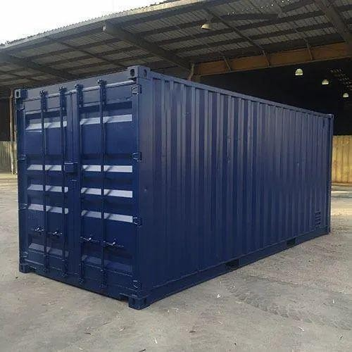are used to transport dry goods. The dimension of dry storage container for 20 feet is 20 *8 * 8.6, for 40 feet is 40 * 8* 8.6. dry containers cannot be used for any chemicals or goods which needs temperature control because dry container doesn’t allow temperature control.

## OPEN TOP CONTAINER

In open top container the top of the container can be removed to make an open top, itis used to load heavy cargoes and over dimensional goods from the top and it is covered with tar paulin. It is expensive than other close top containers, due to their specialized design and additional costs associated with lashing equipment’s. The available sizes in open top container are 20ft and 40 ft are built as per ISO standardsas closed top containers.

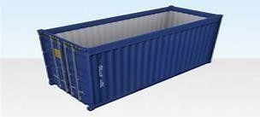

## REFRIGERATOR CONTAINER

Refrigerator container is also known as reefer container. It is capable of controlling temperature ranging from -65°c to 40°c as it is equipped with a refrigerator unit to maintain the temperature of the cargo’s goods like fruits, vegetables, pharmaceuticals are often transported in a reefer container. Reefer containers are more expensive than standard dry containers because it requires additional equipment’s and its maintenance charges will be high as it as refrigeration system

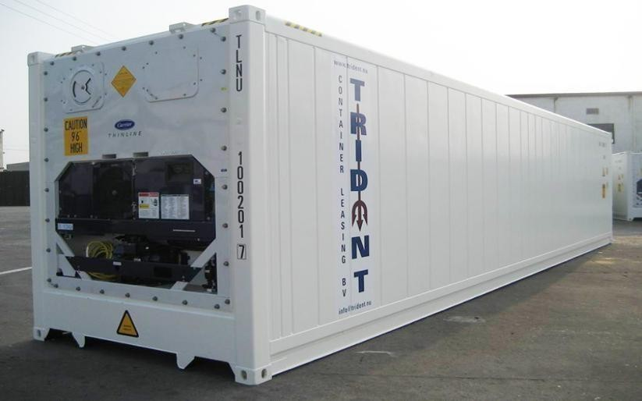

## TANK

These types of container storage units are used mainly for transporting liquid materials; a considerable proportion of the shipping industry uses them. They are mostly made of strong steel or other anti-corrosive materials, which provides them with a long life and the best protection for the materials stored in them.

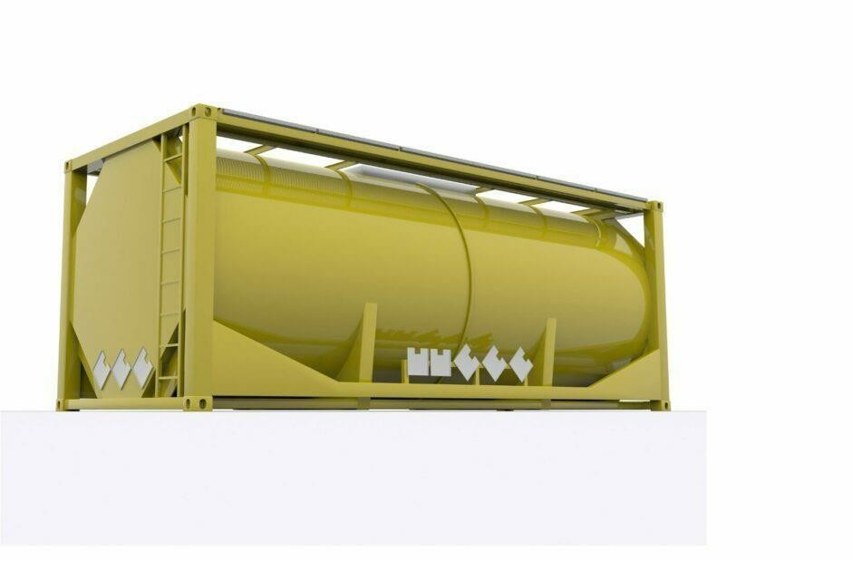

## FLAT TRACK

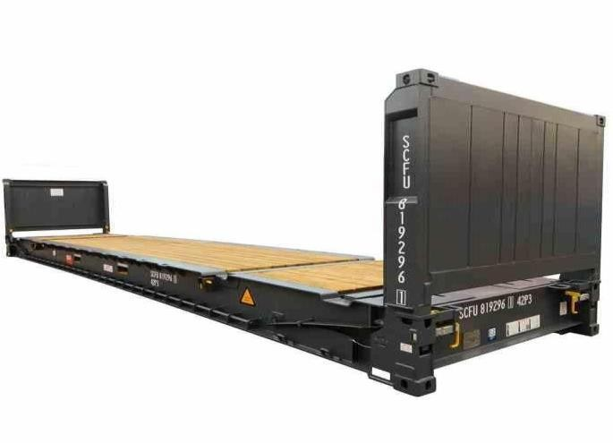A flat rack container has no top and only two sides. This makes room for heavy loads to be set the rack from above or from the side. Most flat rack containers are either 20 or 40 feet long, and they are made from steel for strength and durability. Some flat rack containers are collapsible, and some come with additional walls that can be attached to the frame. A flat rack is a type of shipping container that is open on the sides and top, and has a flat bed or platform for carrying cargo. It is designed for transporting oversized or irregularly shaped cargo, such as machinery, pipes, vehicles, or construction materials that cannot fit into standard containers or require special handling. Flat racks typically come in two sizes, 20- foot and 40-foot, and can be made of steel or aluminum. They have four corner posts, with removable end walls or bolsters that can be used to secure the cargo with chains, straps, or cables. Some flat racks also have collapsible or foldable ends that can be easily removed for loading or unloading. Flat racks are commonly used in the shipping industry for transporting heavy and bulky goods over long distances, either by sea or by land. They are also used in the construction and mining industries for hauling equipment and materials to remote locations.

## INDUSTRY PROFILE

**SHIPPING INDUSTRY**

The shipping industry includes a wide range of activities and services, such as shipping lines, port services, logistics and supply chain management, shipbuilding and repair, and maritime law and insurance. It also encompasses various types of vessels, including container ships, bulk carriers, tankers, and cruise ships, among others. The shipping industry faces various challenges, including environmental concerns such as air and water pollution, climate change, and the impact of shipping on marine eco systems. The industry also faces economic challenges, such as fluctuations in demand for shipping services and increasing competition. To address these challenges, the shipping industry is constantly evolving and adopting new technologies and practices, such as using more fuel-efficient vessels, implementing digital solutions for logistics and supply chain management, and exploring alternative fuels and propulsion systems. Overall, the shipping industry plays a critical role in facilitating global trade and economic growth, while also facing the challenges of sustainability and competitiveness in an ever-changing global landscape. Shipping industry is responsible for over 90% of world trade. The various stake holders of shipping industry are ship owners and operators, ferries, tour boat, ports, stevedores and terminals marine service, customs and it has been further supported with various party such as freight forwarding, customs house agent, slot operators, non-vessel operator common carriers (NVOCC).

## FREIGHT FORWARDING

Organizing the transportation of the cargo to its final destination is the freight forwarder's primary duty. In addition, the freight forwarder is responsible for processing and preparing the necessary paperwork for international freight forwarding. The bills of lading and trade invoices are among the available documentation that the forwarder has to go over. In order to reduce the amount of paper records utilized, the carrier is required by the country of destination where the products will be imported to evaluate the remaining paperwork in electronic format. Establishing communication with the other parties involved in the international freight forwarding process is the responsibility of the freight forwarder.

## CUSTOMS HOUSE AGENT

A customs house agent (CHA) is a person or a firm licensed by the government to act as an intermediary between importers and exporters and the customs department. Their primary responsibility is to facilitate the clearance of goods through customs and ensure that all legal requirements related to import and export of goods are met. CHA's typically work on behalf of their clients, who may be importers or exporters, and their responsibilities include preparing and filing all necessary documentation with customs authorities, calculating and paying duties and taxes, coordinating with shipping companies and freight forwarders, and ensuring that goods are cleared through customs in a timely and efficient manner. In addition to their role in customs clearance, CHA's may also provide other services such as logistics and transportation, warehousing and storage, and insurance services.

## SLOT OPERATOR

A slot operator is a professional who manages and maintains slot machines in a casino or other gaming facility. Their responsibilities typically include ensuring the machines are functioning properly, monitoring the payouts, and making sure the machines are stocked with the necessary supplies such as coins or tickets. They may also be responsible for resolving customer complaints related to the machines and working with other casino staff to ensure a smooth and efficient gaming experience for all customers. Additionally, they may be required to keep detailed records of the machines' performance and revenue. Overall, the slot operator plays an important role in the operation of a casino or gaming facility, as they help ensure that the slot machines are functioning properly and that customers are able to enjoy a fair and enjoyable gaming experience.

## NON-VESSEL OPERATOR COMMON CARRIER

NVOCC stands for Non-Vessel Operating Common Carrier. It refers to a company that provides ocean freight forwarding services without owning any vessels. Instead, NVOCCs typically contract with steamship lines to reserve space on their vessels and then sell that space to shippers. NVOCCs act as intermediaries between shippers and carriers, arranging for the transportation of goods between ports. They handle the documentation, booking, and tracking of shipments, and often provide additional services such as cargo insurance, customs clearance, and warehousing. NVOCCs have become an important part of the global shipping industry, allowing smaller shippers to access the same transportation options as larger ones. They also provide greater flexibility and reliability compared to traditional freight forwarders, who may not have direct access to carrier space. NVOCC details with various types of containers as follows

## GROWTH OF SHIPPING INDUSTRY IN INDIA

In today’s world, shipping industry has grown as a huge industry where it is expected to grow at a compound annual growth rate 12.0%, at 2021 the market size value was USD 11.33 billion and it is forecasted to be USD 15.83 billion by 2028. In India according to the ministry of shipping 95% of India’s trade volume and 70%by value is done through maritime transport. In NOV 2020, the Ministry of Shipping was renamed as the Ministry of Ports Shipping and Waterways. India has 12 majors as such follows

## MAJOR PORTS OF INDIA

|  |  |  |
| --- | --- | --- |
| **Zone** | **State** | **Port** |
| Eastern Coast | Tamil Nadu | Chennai |
| Western Coast | Kerala | Kochi |
| Eastern Coast | Tamil Nadu | Ennore |
| Eastern Coast | West Bengal | Kolkata |
| Western Coast | Gujarat | Kandla |
| Western Coast | Karnataka | Mangalore |
| Western Coast | Goa | Mormugao |
| Western Coast | Maharashtra | Mumbai Port Trust |
| Western Coast | Maharashtra | Jawaharlal Nehru Port Trust (JNPT) |
| Eastern Coast | Odisha | Paradip |
| Eastern Coast | Tamil Nadu | Tuticorin |
| Eastern Coast | Andhra Pradesh | Visakhapatnam |
| Bengal Of Bay | Andaman & Nicobar Islands | Port Blair |

And 200+ notified minor and intermediate ports. Under the National Perspective Plan for Sagarmala, six new mega ports will be developed in the country. The Indian ports and shipping industry play a vital role in sustaining growth in the country’s trade and commerce. India is the sixteenth-largest maritime country in the world with a coastline of 7,516.6 kms. The Indian Government plays an important role in supporting the ports sector. It has allowed Foreign Direct Investment (FDI) of up to 100% under the automatic route for port and harbor construction and maintenance projects. It has also facilitated a 10-year tax holiday to enterprises that develop, maintain, and operate ports, inland waterways and inland ports.

### Shipping industry is associated with the organizations such as

IMO (INTERNATIONAL MARITIME ORGANISATION), FIATA (INTERNATIONAL FEDERATION OF FREIGHT FORWARDERSASSOCIATIONS), IATA (INTERNATIONAL AIR

TRANSPORT ASSOCIATION). To know in detail about the roles and regulations of the association follow the below paragraphs.

## TOP 10 CONTAINER LINES

The below listed is the 10 largest container shipping companies as of 23rd April 2024, according to alpha liner, it is ranked in order of the twenty-foot equivalent unit (TEU) capacity of their fleet.

|  |  |  |  |  |
| --- | --- | --- | --- | --- |
| **RANK** | **COMPANY** | **HEADQUARTE RS** | **SHIPS** | **MARKET**  **SHARE** |
| 1 | Mediterranean shipping company  (MSC) | Italy /Switzerland | 620 | 19.8% |
| 2 | Maersk | Denmark | 732 | 14.5% |
| 3 | CMACGM | France | 581 | 12.5% |
| 4 | COSCO  shipping lines | China | 465 | 10.17% |
| 5 | Hapag-laoyd | Germany | 248 | 7.0% |
| 6 | Ocean network express | Japan | 204 | 5.7% |
| 7 | Evergreen  marine corporation | Taiwan | 201 | 6.8% |
| 8 | HMM co ltd | South korea | 76 | 2.8% |
| 9 | Zim intergrated shipping services | Israel | 93 | 2.4% |
| 10 | Yangming marine transport  Corporation | Taiwan | 138 | 2.4% |

## IMO (INTERNATIONAL MARITIME ORGANISATION)

The United Nations has a dedicated body called the International Maritime Organization (IMO) that is in charge of implementing policies to increase international shipping security and safety as well as to stop ship-related marine pollution. International maritime security and safety are governed by rules established by the IMO. It is in charge of all international maritime laws, including those pertaining to shipbuilding, legal matters, and cargo dimensions. The motto of the International Maritime Organization might be summed up as follows: "Safe, secure, and efficient shipping on clean oceans." In essence, the IMO establishes rules on environmental best practices, safety, and security as well as international maritime legislation. In addition, the IMO coordinates worldwide marine traffic and handles legal concerns related to international shipping, including liability and compensation difficulties. Every two years, the IMO's governing body, the Assembly, convenes to discuss matters pertaining to international shipping and to review the organization's budget. Five committees have been assigned the responsibility of formulating policies and creating, reviewing, and implementing regulations and guidelines in order to distribute the workload and guarantee that every IMO area of concern receives the necessary attention. These committees are the Committee for Technical Cooperation, the Committee for Maritime Safety, the Committee for Marine Environmental Protection, the Committee for Law, and the Committee for Facilitation. Additionally, these committees are overseen by seven subcommittees.

## FIATA (INTERNATIONAL FEDERATION OF FREIGHT FORWARDERS ASSOCIATIONS)

FIATA is a non-governmental organization, representing the freight forwarders of 150countries. It membership is of 109 association members, it represents over 40,000freight forwarding industry and logistics firms worldwide. FIATA is committed to representing the interest of its members by actively engaging with the World Trade Organization, United Nations agencies and other international organizations, transport organizations, global partners and governments to promote and protect the interest of the industry. FIATA is a reference source on international policies and regulations governing the freight forwarding and logistics industry. FIATA works at the international level to represent service providers who operate in trade logistics and supply chain management.

## IATA (INTERNATIONAL AIR TRANSPORT ASSOCIATION)

The International Air Transport Association is referred to as IATA. It is a global trade group for airlines with the main objective of advancing efficient, safe, and reliable air travel. IATA codes, which are three-letter designations assigned to airports and airlines, facilitate the processing of reservations, ticketing, and baggage management.

## COMPANY PROFILE



Phoenix Logistics is an international freight forwarder specializing in the optimization of supply chain, logistics, warehousing and distribution of freight. The company began as a basic service provider for air and sea freight movements in 2007 at Chennai. Phoenix has evolved into an organization with a depth of expertise in providing integrated logistics solutions to suit individual customers' needs. Over the years, Phoenix has expanded its operations to other major cities by opening branches in Mumbai, Delhi, and Tuticorin & Tirupur. Over 100s of clients use Phoenix as their logistics partner to meet their transportation needs. We hire the best in the industry - people with high integrity, creativity, flexibility, and customer service skills. Our employees are experts in many industries. They have the technology and expertise to solve logistics challenges and move products from origin to destination, anywhere in the world, door to door. Our success is founded on the high degree of customer care provided by our skilled team combined with the use of leading-edge information technology.

### Branches OF Phoenix Logistics in India

* Chennai
* Mumbai
* Delhi
* Kolkata
* Vizag
* Cochin
* Tuticorin
* Ahmedabad
* Bangalore
* Hyderabad
* Ludhiana
* Pune
* Tirupur
* Coimbatore

### Vision

* To be the country’s leading logistics provider by innovating and evolving with the changing times

### Mission

* To understand, identify and recommend solutions to help our clients manage their deliveries and stay competitive

## MILESTONES:

2007- April 2007 opened Chennai branch office 2010- Expanded operation in textile torn of Tirupur

2012- Opened branch office in Mumbai, commercial capital of India

2014- Strengthen presence in south India, opened branch office in Tuticorin 2015- Opened branch office in New Delhi to power north India

2017- Opened a branch office in Kochi, Kerala. 2019- Commence operation in Bangalore, IT Capital

2020- Kolkata office to service customers on the east coast, including Nepal and Bhutan. 2020- Visakhapatnam (Vizag) largest port in central india

2020- Opened Vadodara office to Handle Mundra and Hazira port

## SEA FREIGHT:

Be it full container loads, less than container loads or buyer’s consolidation-Their strength and expertise are your gain. In close partnership with leading shipping companies. They can offer you a very wide range of services. Hanging garments or out gauge cargo- They know all about it.

## AIRFREIGHT:

In airfreight they offer innovative solutions for small and large loads. Their dedicated staffs keep long-standing relationship with a variety of reliable airlines, enabling us to fulfil all our requirements. They choose the airline, depending on the service, transit and most importantly rates. They specialize in handling hanging garments. Their operation team will arrange to fabricate GOH containers, based on your specific requirements. Their experience is your benefit!!

## SEA-AIR/SEA SHIPMENTS:

They provide sea-air as well as air-sea services to their customer. This multimodal operation is faster than ocean mode, and is cost effective than air freight.

## PROJECT SHIPMENTS:

They have the technical know-how and infrastructure to handle all types of project cargoes. Their teams of experts are well equipped to assist with “tailor- made solutions” They can handle just about any cargo any size. DDP/DDU/EXW: These days’ customers are interested in door- to-door service, with the help of their worldwide network of partners they offer door to door services under DDP/DDU/EXW terms. They monitor the entire supply chain, from supplier’s door to consignee’s warehouse.

## 4PL:

They assemble the resources, capabilities, and technology within the organization and other organization to design, build and run comprehensive supply chain solutions. Logistics outsourcing has long been hailed as a creative solution for companies that are seeking to restructure focus on optimizing performance in their core businesses.

## THEIR PEOPLE:

They hire people with high creativity, flexibility, and customer service skills. Their employees are experts in many industries. They have the technology and expertise to solve logistics challenges and move products from origin to destination, anywhere in the world, door to door. Their success is founded on the high degree of customer care provided by their skilled team combined with the use of leading-edge information technology.

## WAREHOUSE & STORAGE:

They have own storage space near all major ports and airports. They have dedicated space in all the CFS to handle their cargoes. Their warehouse staff monitors the inward and outward movement of goods. Goods are accepted into the warehouse, only after physical examination of the cargo by the warehouse staffs. Daily reports on the movement of goods are updated to the parties concerned. Phoenix logistics India private limited, can help you develop and implement the tactical or strategic changes for your organization you are ready for them.

## OUR STRENGTHS

* Reliable Worldwide Network.
* One-Stop for Total Logistics Solutions.
* Committed to High Quality Services.
* Highly Trained, Motivated and Result Oriented Staff.
* Excellent Team Work.
* Competitive Rates.
* Positive Approach.
* Transparency

## SERVICES:

We provide diverse service as below:

* Air Freight Service (Import & Export)
* Ocean Freight Service (Import & Export)
* Sea-Air and Air-Sea Services
* 4 PL

## PROBLEM STATEMENT:

Non-Vessel Operating Common Carrier (NVOCC) operations face numerous risks due to non- availability of vessel space, Freight Rate Fluctuations, Capacity Management, and Customer Services. The reliance on stakeholders like carriers, shippers, and freight forwarders introduces additional layers of risk. The dynamic nature of maritime trade exposes NVOCCs to unpredictable events like natural disasters and piracy.

## NEED OF STUDY:

Studying risk management in Non-Vessel Operating Common Carrier (NVOCC) operations is crucial due to several challenges inherent in the industry. NVOCCs play a vital role in the global shipping and logistics network by consolidating cargo from multiple shippers into containers for transportation.

## OBJECTIVE

* + - To Identify Key Risk in associated with the handling of NVOCC
    - To study the rules regulation followed in the NVOCC operation
    - To evaluate the container service quality provided by the NVOC

# 

# CHAPTER II

#### REVIEW OF LITERATURE

**RK Bank, AW Craig, EJ Sheppard - 2005**, since the early 1900s, the United States has had an ocean transportation regulating framework that is akin to the British "conference system." The US Federal Maritime Commission (FMC) became increasingly involved in maritime affairs as a result of the 1916 Shipping Act, the 1984 Shipping Act, and the 1998 Ocean Shipping Reform Act. Ocean shipping regulations are viewed more laxly in European countries. Diverse economic ramifications have resulted from this, including the prohibition against non-vessel operating common carriers (NVOCCs) from entering into contract rates with shipper-customers.

**Q Peng, C Wang -, 2022,** Shipping e-commerce now has new business opportunities thanks to the sharing economy. This article introduces a liner shipping system that includes two Non- Vessel Operating Common Carriers (NVOCCs) and a ship space booking platform. Using multi-party game theory, the best sharing method and space renting mode for the platform are found. Differential rentals are found to work best for NVOCCs with higher prospective demand and to work against those with lower demand. Several NVOCCs are included in the model.

**Z Song,** [**W Tang**](https://scholar.google.com/citations?user=jKzxJC0AAAAJ&hl=en&oi=sra)**,** [**R Zhao**](https://scholar.google.com/citations?user=F0zjflIAAAAJ&hl=en&oi=sra) **- … 2017**, In a maritime cargo service chain, the canvassing tactics of ocean carriers are examined in this research with a particular emphasis on freight forwarders and NVOCCs. It analyzes relationships using a principal-agent model, showing that high capacity promotes effort while low capacity impedes NVOCC information.

**V Pandi – 2017** Since 1950, container shipping has revolutionized the movement of commodities and unitized freight. Price wars, overcapacity, and declining freight rates are some of the obstacles the market must overcome. The purpose of this thesis is to investigate the "Negative Freight" pricing approach used by NVOCC on the Middle East-South Asia trade route and to comprehend the pricing process. According to the survey, even though software interfaces and other technology developments are progressing, businesses still require significant organizational adjustments in order to identify their corporate strategy and adjust prices appropriately.

**Z Zhang – 2021**, Originating in the freight forwarder industry, the NVOCC is an important player in China's shipping sector. However, because of restricted liability, shippers are impacted by maritime fraud. The purpose of this study is to examine the shipping industry in order to enhance the NVOCC management system in China. It compares NVOCC to other nations including the US and Japan, explores its history, significance, and current state in China, and makes recommendations for development.

**N Sarwar – 2013,** The thesis looks into theoretical frameworks for measuring port performance and contrasts the application of time-related KPIs in practice with theoretical approaches. The Port of Melbourne is studied as a case study. The study emphasizes the use of KPIs in measuring the quality of port services, as well as its interoperability and interaction with other KPIs. Due to the study's reliance on a single case study, it is recommended that future research examine case studies in greater detail and compare performance assessment systems across time.

**A Dua, D Sinha - …, 2019** This study examines the literature on quality-perspective multimodal transportation, with a particular emphasis on this emerging topic. It draws attention to the gaps in the literature, makes recommendations for future research, and emphasizes the need for a more thorough understanding of multimodal transportation.

**Borka Tushevska Gavrilovikj Balkan, 2014,** This study compares freight forwarders in the US, UK, and Germany with an emphasis on their legal responsibility to principals and other parties under common and civil law. The concept of representation and the legal ramifications of unsettled status are the main topics of this analysis, which also looks at the benefits and drawbacks of the German, British, American, Continental, and Anglo-Saxon legal systems. The repercussions of globalization on freight forwarders' positions and the financial implications of representation are also covered in this study. The study investigates whether common law systems provide freight forwarders with a more appropriate legal framework or whether the distinctions between these systems are not as important as they are in other areas of the law.

**D Stapleton, AM Nandialath - …, 2016** Ocean carriers' liability is limited under the Carriage of Goods by Sea Act of 1937, although NVOCCs and OTIs are coming under more scrutiny for the dissemination of counterfeit brands. This study proposes an incentive scheme for reducing counterfeit goods utilizing both fixed and variable rewards. Ocean carriers' liability is limited under the Carriage of Goods by Sea Act of 1937, although NVOCCs and OTIs are coming under more scrutiny for the dissemination of counterfeit brands. This study proposes an incentive scheme for reducing counterfeit goods utilizing both fixed and variable rewards.

**Beškovnik - Brodogradnja: …, 2020** The difficulties in controlling spot ship space booking and overbooking on container ships are covered in the article. It is hypothesized that because of Container Lines' (CL) larger ships and low space occupation, freight forwarders feel threatened by CL and are worried about a new spot booking mode and ocean pricing formulation. A survey conducted between non-vessel operating common carriers and freight forwarders offers advice for creating a three-step plan that will enhance ship space optimization and lower business risks. In addition to pointing out weaknesses in operational and strategic approaches for ship cargo space optimization, the study advances effective maritime logistics.

**SW Kim -, 2008** The 'Basic Act of Logistics Policy' was introduced by the Korean government in 2007 with the aim of improving international logistics forwarding enterprises. The goal of the strategy was to increase competitiveness, efficiency, security, and economic growth in logistics companies. The US Federal Maritime Commission instituted new licensing requirements in 1999 for NVOCCs and ocean freight forwarders doing business in the United States. The purpose of this study is to evaluate and contrast the American OTI freight forwarder and NVOCC systems with the Korean freight forwarding system.

**CB Clott - , 2000** NVOCCs, or non-vessel operating common carriers, face both new opportunities and problems in the ocean freight markets as a result of the US Ocean Shipping Reform Act of 1998, as well as changes in the economy and the growth of internet-based transactions.

**G Yoganandan, KE Balaji - …, 2018** Compared to other industries, freight forwarding services must meet the high expectations of customers. A freight forwarder arranges shipments on behalf of importers, exporters, or other organizations for people or businesses. They have agreements with several carriers to transport cargo in a secure, economical, and timely manner. Consumer perceptions of industry service quality are superior.

**A Matopoulos, EM Papadopoulou - …, 2007** Due to shifts in industrial production and manufacturing, the global logistics sector is growing, resulting in mergers, outsourcing, and a greater reliance on information technology. An overview of the development and current developments in logistics service providers is given in this chapter, with particular attention to the function of Internet-based apps and logistics e-marketplaces. These markets still have issues with integrated customs links and translation services, despite offering more services.

**S Koo, KS Hwang, HJ Yeo -, 2009** This article investigates the services offered by the shipping sector using a questionnaire that is distributed to international shippers in South Korea and the United Kingdom. The findings indicate that British shippers have a higher level of satisfaction with varied service supply, with notable variations in performance within the three service roles. The results provide direction for further investigation.

**CC Yang, PB Marlow, CS Lu - …, 2009** The relationship between resource, logistics service capability, and innovation capability in Taiwanese container shipping companies is examined in this study. The findings indicate that while logistics service capability has a favorable impact on business performance, resource has a beneficial impact on these capabilities. Resources and inventiveness, however, have little effect on performance.

**Chen, J., Lin, Y., & Yang, X. (2020),** This paper investigates the impact of network relationships on the competitive advantage of NVOCCs. The authors used a social network analysis to measure the network centrality and network density of NVOCCs and their business partners. The study found that network relationships have significant positive impact on the competitive advantage of NVOCCs in terms of cost efficiency, service quality, and customer satisfaction.

**Bao, Y., & Hua, G. (2021),** This study examines the relationship between service quality and customer loyalty in the context of NVOCC logistics service. The authors used a survey to collect data from shippers and consignees in China. The study found that service quality has a positive impact on customer satisfaction and loyalty, and the dimensions of service quality that are most important to customers are reliability, 29 responsiveness, and empathy. The study provides insights into how NVOCCs can enhance their service quality to improve customer loyalty

**Huang, C. C., & Chen, Y. T. (2020),** This study examines the impact of e-commerce on the competitiveness of NVOCCs in Taiwan. The authors used a structural equation model to analyze the relationships among e-commerce adoption, operational efficiency, service quality, customer satisfaction, and competitive advantage. The results show that e-commerce adoption has a positive impact on the competitiveness of NVOCCs in terms of operational efficiency, service quality, and customer satisfaction.

**Park, J. Y., & Han, J. K. (2017),** This study analyzes the competitive advantage of NVOCCs in the East Asia container shipping industry. The authors used the Porter's Five Forces model to analyze the industry structure and the RBV to identify the unique resources and capabilities of NVOCCs. The study found that service differentiation, operational efficiency, and customer relationship management are key factors that contribute to the competitive advantage of NVOCCs.

**Zhen, Y., Liu, Y., & Liu, Y. (2020),** This paper examines the effects of social capital on the competitive advantage of NVOCCs in China. The authors used a survey to collect data from NVOCCs and their business partners. The study found that social capital has a positive impact on the competitive advantage of NVOCCs in terms of cost efficiency, service quality, and customer satisfaction

# CHAPTER III

#### RESEARCH METHODOLOGY

* 1. **RESEARCH DESIGN**

The reception of a legitimate procedure is a basic and significant advance in directing study (or) any examination. In this investigation the scientist has embraced an engaging examination technique. Engaging exploration contemplates are those investigations which are worried about portraying the attributes of a specific individual or of a gathering.

There are two types of research design:

* + - **Exploratory research design**
    - **Descriptive research design**

### Exploratory research

Exploratory research design is a methodology that helps researchers understand a problem before attempting to quantify mass responses into statistically inferable data. It's often qualitative and primary in nature, but a study with a large sample conducted in an exploratory manner can be quantitative as well. Exploratory research is used when:

* + - The issue you're studying is new
    - The data collection process is challenging
    - There is no preexisting knowledge or paradigm with which to study it

#### DESCRIPTIVE RESEARCH DESIGN

Descriptive research is a reality discovering examination which is gone for portraying the qualities of an individual, circumstance or a gathering (or) depicting the situation as it exists in the present. This theory might be framed with the current data.

Descriptive research design uses a combination of qualitative and quantitative data, with quantitative research being the primary method. The goal of descriptive research is to provide a comprehensive and accurate picture of the population or phenomenon being studied. For example, descriptive studies might be used to answer questions such as:

What percentage of Head Start teachers have a bachelor's degree or higher?

What is the average reading ability of 5-year-olds when they first enter kindergarten? What kinds of math activities are used in early childhood programs?

Descriptive research design has several advantages, including: Diverse data collection methods, High quality data and thorough information, and Forms a basis for decision making.

## SAMPLING TECHNIQUE

The idea of a sample also plays a significant role in the process of identifying rising and considerate new market constructs that need to be investigated by the researcher. There are two types of sampling techniques, probability sampling and non-probability sampling.

Here non-probability sampling was employed. However, the type of non-probability sampling used is “convenience sampling” where the samples are drawn at the convenience of the researcher.

#### CONVENIENCE SAMPLING

The respondents establishing the example are chosen from the universe based on simple entries. It is comprised of the accommodation of the analyst and respondents.

#### SAMPLE AREA

The sample area of the study is CHENNAI

#### SAMPLE SIZE

The sample size for the study undertaken was 40.

## DATA COLLECTION METHOD

**Primary Data**

Primary data refers to information gathered first-hand by the researcher for the specific purpose of the study. It is crude information without understanding and speaks to the individual or authority’s conclusion or position. Essential sources are the most legitimate since the data isn't separated or altered. Information accumulation from people can be made through surveys.

### Secondary Data

The information was collected from the company magazines, various books and also from the internet.

## QUESTIONNAIRE DESIGN

In this questionnaire, I have used the personal details of the employees and internship students, employee's perceptions towards the Risk of NVOCC, identifying the various measures of improvement & practices followed in NVOCC organizations, The first part involves five questions like Gender, Age, Qualification, Experience, and Designation. The second part involves agreement statements on NVOCC.

## HYPOYHESIS FORMULATION

* + - (H0) There is no significant association type between experience and the communication and responsiveness of the NVOCC’s Customer service team.
    - (HO) There is no significant association type between qualification and the NVOCC rates compared to other providers.
    - (H0) There is no significant association type between experience and the communication and responsiveness of the NVOCC’s Customer service team.
    - (H0) There is no significant association type between experience and overall service provided by the NVOCC.
    - (H0) There is no significant accusation type between qualification and rating the accuracy of the NVOCC ‘s documentation and invoicing
    - (H0) There is no significant relationship between overall service provided by the NVOCC and the satisfaction of NVOCC operation in import communication
    - (H0) There is no significant relationship between overall service provided by the NVOCC and the satisfaction of NVOCC operation in exporter communication
    - (H0) There is no significant relationship between usage of service and rating the accuracy of the NVOCC’s documentation and invoicing.
    - (H0) There is no significant the 20 feet container is highly booked container and awareness of NVOCC service in organization

## STATISTICAL/ANALYTICAL TOOLS

**SPSS (Statistical Package for the Social Sciences)**

SPSS (Statistical Package for the Social Sciences) is a software package used for statistical analysis in various fields, including monitoring and evaluation. It was originally developed in the late 1960s by IBM and has since become one of the most widely used statistical software packages, designed to be user-friendly and accessible to users with little or no programming experience. SPSS is commonly used for data management, descriptive statistics, inferential statistics, and data visualization. SPSS offers a wide range of statistical tools and techniques that can be used to analyse data, such as descriptive statistics, inferential statistics, and data visualization. Descriptive statistics are used to summarize and describe key features of a dataset, including calculating measures such as means, medians, and standard deviations, as well as creating histograms, scatterplots, and other visualizations. Inferential statistics are used to draw conclusions from a sample of data about a larger population, including conducting hypothesis tests, such as t-tests or ANOVA, to determine if there is a significant difference between groups.

SPSS is also useful for data management, allowing users to import, clean, and organize large datasets, which is critical for monitoring and evaluation projects that often involve multiple sources of data. SPSS can be used to merge datasets from surveys, focus group discussions, and other sources to create a comprehensive dataset for analysis.

SPSS provides various tools to ensure data quality, including missing value analysis, outlier detection, and data validation. These tools help to identify errors and ensure that data is accurate and reliable.

SPSS is a user-friendly software that is easy to learn and use, which saves time and resources. It provides shortcuts and automation features that enable users to perform complex analyses with minimal effort. It also enables users to store and reuse analysis procedures, which saves time when repeating analyses or comparing results.

In summary, SPSS is a powerful tool for statistical analysis that offers a wide range of features and techniques for data management, descriptive statistics, inferential statistics, and data visualization. It is widely used in various fields, including monitoring and evaluation, and is designed to be user-friendly and accessible to users with little or no programming experience.

#### ANOVA

ANOVA (Analysis of Variance) is a statistical method used to analyse the differences between two or more groups or populations. It is used to determine if there is a significant difference 53 between the means of two or more groups, and if so, which group(s) have a significant difference.

Analysis of Variance (ANOVA) is a statistical tool used to compare variances across the means of different groups. It helps determine if there are significant differences between the means of these groups. ANOVA involves dividing a sample population into multiple groups, where each group receives a specific treatment or condition. By calculating the mean values for each group and comparing them using the F statistic, ANOVA determines if these means are statistically different or similar. The F-ratio in ANOVA compares within-group variance to between-group variance, aiding in accepting or rejecting the null hypothesis. ANOVA terminology includes dependent and independent variables, null and alternative hypotheses, factors, levels, fixed- factor model, and random-factor model. ANOVA is a versatile tool that can analyse the impact of one or multiple factors on a dependent variable, providing insights into complex phenomena.

There are several types of ANOVA, including one-way ANOVA, two-way ANOVA, and repeated measures ANOVA. The choice of which ANOVA to use depends on the research question and design of the study.

Single Factor ANOVA (Analysis of Variance) is a statistical technique used to test whether there are significant differences among the means of three or more groups. It is called "single factor" because it involves only one independent variable or factor that has an effect on the dependent variable.

**ANALYTICAL TOOLS USED:**

Data collection and analysis tools are defined as a series of charts, maps, and diagrams designed to collect, interpret, and present data for a wide range of applications and industries. Various programs and methodologies have been developed in nearly any industry, ranging from manufacturing and quality assurance to research groups and data collection companies. Data analysis tools and techniques are used to explore, clean, process, and analyse data in order to extract valuable insights and knowledge.

## SPSS ANALYSIS TOOLS

* Chi-square Analysis
* Correlation Analysis
* ANOVA

#### CHI-SQUARE ANALYSIS

Chi-square examination sees if at least two properties are related or not. Chi–square test is a non-parameter test that built up the in reliance between factors. It is estimated by contrasting the watched and those of expected frequencies dependent on the theory. Commonly this kind of investigation is alluring. It tends to be utilized to break down the ostensible information.

#### CORRELATION ANALYSIS

Relationship Analysis is a proportion of the relationship between two persistent factors. Connection estimates both the size and heading of connections between two factors. The squared relationship is the proportion of the quality of the affiliation (Tabachnick and Fidell, 1989). Connection examination is the connection between two factors. Connection is indicated by "r". For instance, the connection between pay and use, request and supply. The two factors must be typically related. "r" esteem is dependably in the middle of less one and in addition to one (- 1 and +1). Beneath table describes a point-by-point relationship examination with different factors, for example, "understudy's arrangements", skilful staff is the key factor to draw in worthy understudies into universities", "personnel enablement exercises" "R and D offices"

#### ONE WAY ANOVA

For administrative basic leadership, here and there one needs to complete trial of noteworthiness. The investigation of fluctuation is a viable apparatus for this reason. The target of ANOVA is to test the Homogeneity of the methods for various examples. In measurements, single direction examination of fluctuation is a procedure used to look at methods for at least two examples. This strategy can be utilized just for numerical information. The ANOVA tests the invalid hypothesis that precedents in at any rate two social affairs are drawn from masses with a comparable mean characteristic. To do this, two appraisals are head of the people effect. These appraisals rely upon various assumptions. The ANOVA makes a Statistic, the extent of the vacillation decided among the route to the distinction inside the precedents. If the get- together infers are drawn from masses with a comparative mean characteristic, the distinction between the social event implies should be lower than the variance of the models, following beyond what many would consider possible theory. A higher extent in this manner proposes that the models were drawn from masses with different mean characteristics

## LIMITATIONS OF THE STUDY

* + - Period of study was restricted to three months.
    - Findings of the exploration may change because of age, work experience, designation and so on.
    - Since the logistics and shipping company has less no. of employees it is difficult to collect the required samples.
    - Proper data were not provided from the side of organization as it is confidential**.**

# CHAPTER IV

#### DATA ANALYSIS AND INTERPRETATION

The researcher had obtained feedback from 40 respondents on the enclosed questionnaire format Annexure1-1. Given below the data analysis:

## TABLE

|  |  |  |
| --- | --- | --- |
| PARTICULARS | FREQUENCY | PERCENTAGE |
| FEMALE | 12 | 30% |
| MALE | 28 | 70% |
| **Total** | **40** | **100%** |

#### CHART

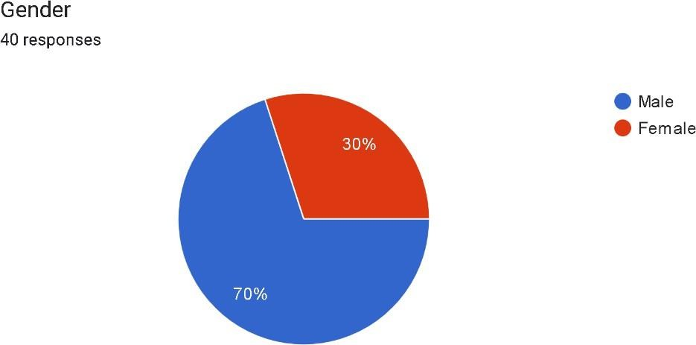

**INTERPRETATION**

From the above table and chart inferred that 70% of respondents are male and 30 are female

## TABLE 2:

|  |  |  |
| --- | --- | --- |
| PARTICULARS | FREQUENCY | PERCENTAGE |
| 21-30 | 24 | 60% |
| 31-40 | 14 | 35% |
| 41-50 | 2 | 5% |
| 50&above |  |  |
| **Total** | 40 | 100% |

**CHART**

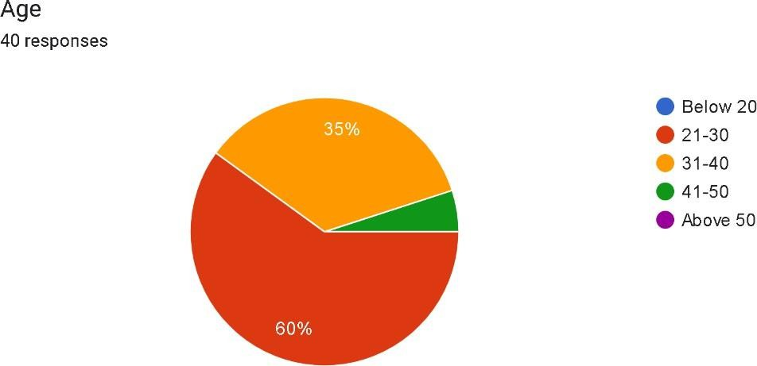

**AGE**

**INTERPRETATION**

From the above table and chart inferred that 60% of the respondent are from the age group between 21- 30 years and 35% of the respondent are from the age group between 31-40 years and 5% of the respondents are from the age between 41-50 years and there are no respondent from the age group of 51- 60 and 60 & above.

#### EDUCATION QUALIFICATION

|  |  |  |
| --- | --- | --- |
| PARTICULAR | FREQUENCY | PERCENTAGE |
| 12TH | 1 | 2.5% |
| DIPLOMA | 3 | 7.5% |
| UNDER GRADUATE | 25 | 62.5% |
| POST GRADUATE | 11 | 27.5% |

**CHART**

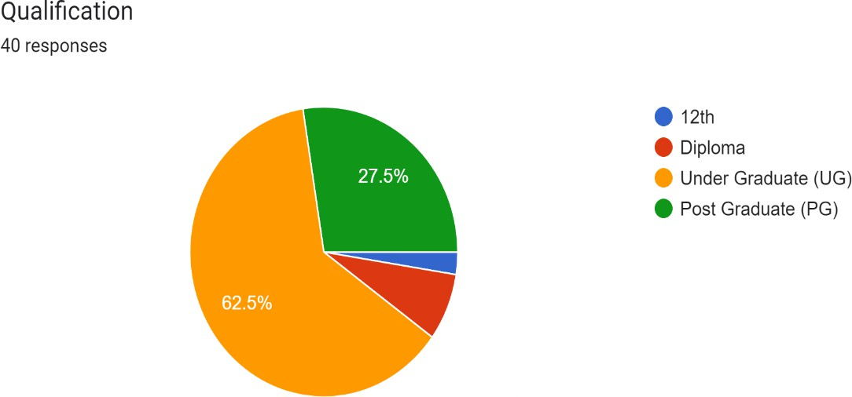

**INTERPRETATION**

Based on the data, educational qualifications vary among individuals surveyed. Only 2.5% hold a 12th grade qualification, suggesting a relatively lower percentage at this educational level. A larger proportion, constituting 7.5%, possess a diploma, indicating a slightly higher attainment compared to 12th grade. The majority, comprising 62.5%, have completed their undergraduate studies, reflecting a significant prevalence of this level of education among respondents. Furthermore, 27.5% of individuals have attained a postgraduate degree, demonstrating a notable portion with advanced educational achievements. This distribution underscores the diverse educational backgrounds of the surveyed population, with a predominant representation at the undergraduate level, followed by postgraduate qualifications and diplomas, while 12th grade qualifications remain less common.

**EXPERIENCE**

|  |  |  |
| --- | --- | --- |
| PARTICULAR | FREQUENCY | PERCENTAGE |
| INTERNSHIP | 5 | 12.5% |
| LESS THAN 1 YEAR | 4 | 10% |
| 1-5 YEAR | 14 | 35% |
| 6-10 YEAR | 9 | 22.5% |
| MORE THAN 10 YEARS | 8 | 20% |

#### CHART

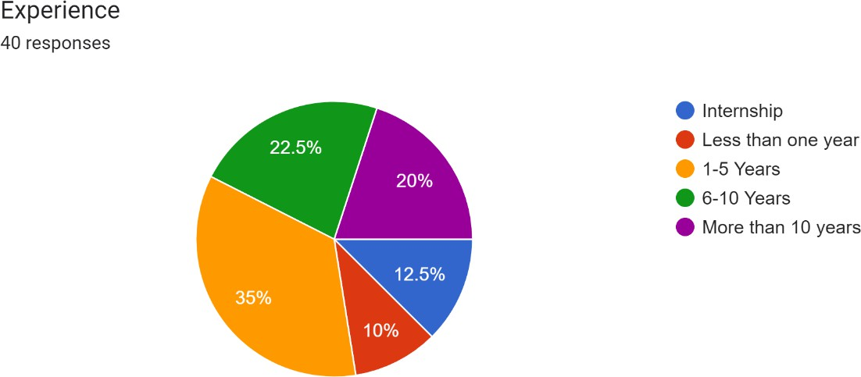

**INTERPRETATION**

The data distribution of individuals' experience levels within a particular context, presumably related to employment or professional backgrounds. Among the surveyed individuals, internships constitute a modest yet notable portion, representing 12.5% of the sample. Entry-level experience, defined as less than one year, accounts for 10% of respondents, indicating a smaller segment but one that still holds significance. Moving up the ladder, the data shows a gradual increase in experience, with 1-5 years constituting the largest cohort at 35%. This suggests a common trajectory of gaining foundational skills and expertise within the initial years of one's career. Subsequently, the distribution maintains a relatively steady pace, with 6-10 years comprising 22.5% of respondents, and those with more than a decade of experience making up 20%. This pattern underscores the continuum of professional development, from early stages through to seasoned expertise, offering insights into the diverse composition of experience levels within the surveyed group.

**DESIGNATION**

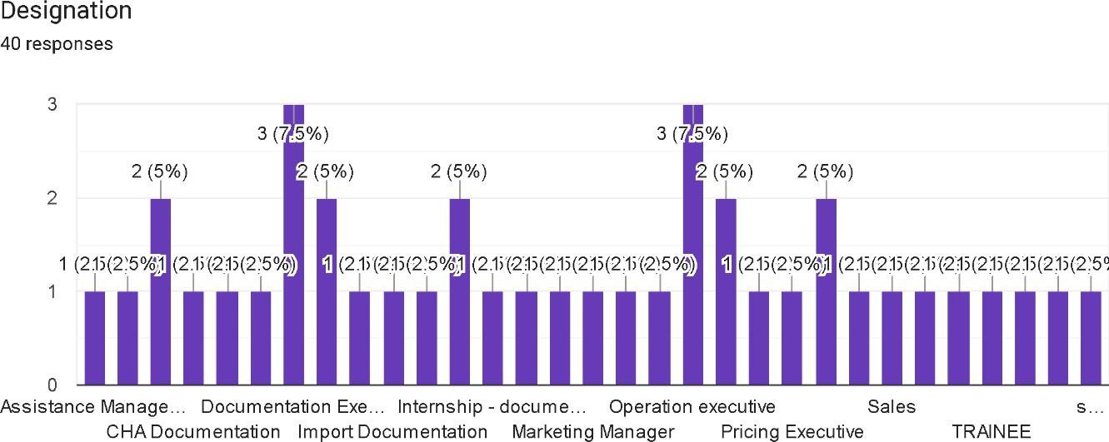

Table No 4.1.1 Does the NVOCC comply with international Shipping standards

|  |  |  |  |
| --- | --- | --- | --- |
| S. No | Statement | Frequency | Percentage |
| 1 | Yes | 36 | 87.5 |
| 2 | No | 1 | 2.5 |
| 3 | Maybe | 3 | 10 |
| 4 | Total | 40 | 100 |

Chart No 4.1.1 Does the NVOCC comply with international Shipping standards

Frequency

40

35

30

25

20

15

10

5

0

Yes

No

Maybe

#### INTERPRETATION

From the above table and chart inferred that the 87.5% of the respondent are saying yes, 2.5% of the respondent are saying no and 10% of the respondent are saying maybe. Hence, that the majority of the respondent are yes with the NVOCC comply with international Shipping standards

Table No 4.1.2 If there is potential risks identified in NVOCC Operations

|  |  |  |  |
| --- | --- | --- | --- |
| **S. No** | **Statement** | **Frequency** | **Percentage** |
| 1 | Yes | 14 | 60 |
| 2 | No | 5 | 12.5 |
| 3 | Maybe | 11 | 27.5 |
| 4 | Total | 40 | 100 |

Chart No 4.1.2 If there is potential risks identified in NVOCC Operations

Frequency

16

14

12

10

8

6

4

2

0

Yes

No

Maybe

|  |  |  |  |  |  |  |
| --- | --- | --- | --- | --- | --- | --- |
|  |  |  | | | | |
|  |  | | | | |
|  | | |  |  |
|  |  | | |  |
|  |  | | |  |
|  |  | | |  |
|  |  |  |
|  |  |  |  |
|  |  |  |  |

#### INTERPRETATION

From the above table and chart inferred that the 60% of the respondent are saying yes, 12.5% of the respondent are saying no and 27.5% of the respondent are saying maybe. Hence, that the majority of the respondent are yes with the potential risks identified in NVOCC Operations

Table No 4.1.3 Does the cargo security measures implemented to mitigate risks?

|  |  |  |  |
| --- | --- | --- | --- |
| **S. No** | **Statement** | **Frequency** | **Percentage** |
| 1 | Yes | 12 | 70 |
| 2 | No | 1 | 2.5 |
| 3 | Maybe | 27 | 27.5 |
| 4 | Total | 40 | 100 |

Chart No 4.1.3 Does the cargo security measures implemented to mitigate risks?

Frequency

30

25

20

15

10

5

0

Yes

No

Maybe

#### INTERPRETATION

From the above table and chart inferred that the 70% of the respondent are saying yes, 2.5% of the respondent are saying no and 27.5% of the respondent are saying maybe. Hence, that the majority of the respondent are yes with the cargo security measures implemented to mitigate risks.

Table No 4.1.4 Does the insurance coverage for potential risk in NVOCC activities

|  |  |  |  |
| --- | --- | --- | --- |
|  | **Statement** |  |  |
| 1 | Strongly agree | 6 | 15 |
| 2 | Agree | 21 | 62.5 |
| 3 | Neutral | 7 | 20 |
| 4 | Disagree | 1 | 2.5 |
| 5 | Strongly Disagree | 0 | 0 |
| 6 | Total | 40 | 100 |

Chart No 4.1.4 Does the insurance coverage for potential risk in NVOCC activities?

Frequency

25

20

15

10

5

0

Strongly agree

Agree

Neutral

Disagree

Strongly Disagree

#### INTERPRETATION

From the above table and chart inferred that 15% of the respondent are strongly agree this statement, 62.5% of the respondent are agree with this statement, 20% of the respondent are neutral with this statement, 2.5% of respondent are disagree with this statement and 0% of the respondent are strongly Disagree with this statement. Hence, we conclude that the majority of the respondents are agree with the above statement.

Table No 4.1.5 The NVOCC equipped with emergency response plans for unforeseen events

|  |  |  |  |
| --- | --- | --- | --- |
| **S. No** | **Statement** | **Frequency** | **Percentage** |
| 1 | Strongly agree | 10 | 27.5 |
| 2 | Agree | 18 | 42.5 |
| 3 | Neutral | 6 | 10 |
| 4 | Disagree | 2 | 10 |
| 5 | Strongly Disagree | 1 | 2.5 |
| 6 | Total | 40 | 100 |

Chart No 4.1.5 The NVOCC equipped with emergency response plans for unforeseen events

Frequency

20

18

16

14

12

10

8

6

4

2

0

Strongly agree

Agree

Neutral

Disagree

Strongly Disagree

#### INTERPRETATION

From the above table and chart inferred that 27.5% of the respondent are strongly agree this statement, 42.5% of the respondent are agree with this statement, 10% of the respondent are neutral with this statement, 10% of respondent are disagree with this statement and 2.5% of the respondent are strongly Disagree with this statement. Hence, we conclude that the majority of the respondents are agree with the above statement

Table No 4.1.6 Do you know the vendors and partners assessed for potential risks

|  |  |  |  |
| --- | --- | --- | --- |
| **S. No** | **Statement** | **Frequency** | **Percentage** |
| 1 | Yes | 28 | 70 |
| 2 | No | 1 | 5 |
| 3 | Maybe | 11 | 25 |
| 4 | Total | 40 | 100 |

Chart No 4.1.6 Do you know the vendors and partners assessed for potential risks

Frequency

30

25

20

15

10

5

0

Yes

No

Maybe

#### INTERPRETATION

From the above table and chart inferred that the 70% of the respondent are saying yes, 5% of the respondent are saying no and 25% of the respondent are saying maybe. Hence, that the majority of the respondent are yes with the the vendors and partners assessed for potential risks

Table 4.1.7The cybersecurity measures in place to protect digital assets? do you agree this

|  |  |  |  |
| --- | --- | --- | --- |
| **S. No** | **Statement** | **Frequency** | **Percentage** |
| 1 | Strongly agree | 12 | 30% |
| 2 | Agree | 15 | 37.50% |
| 3 | Neutral | 10 | 25% |
| 4 | Disagree | 2 | 5% |
| 5 | Strongly disagree | 1 | 2.50% |
| 6 | Total | 40 | 100 |

Chart 4.1.7 The cybersecurity measures in place to protect digital assets? do you agree this

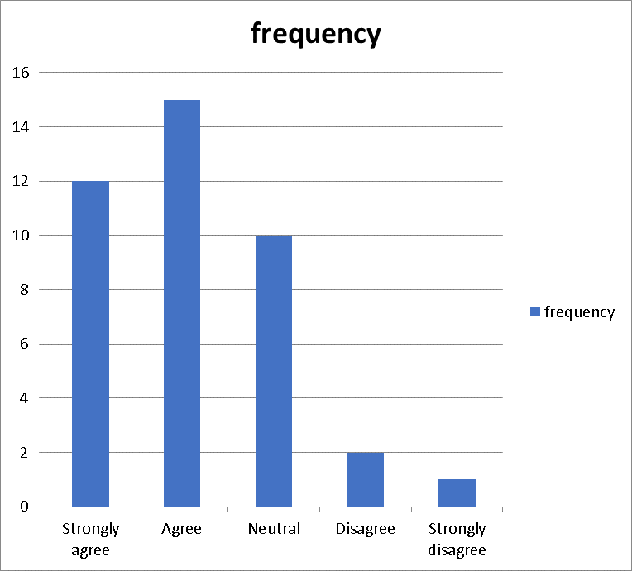

#### INTERPRETATION:

From the above table and chart inferred, comprising 67.5%, either strongly agree or agree that the cybersecurity measures in place adequately protect digital assets. While a quarter remain neutral on the matter, only a small percentage, 7.5%, disagree or strongly disagree. This suggests a general confidence in the effectiveness of existing cybersecurity measures, albeit with some room for improvement as indicated by the minority expressing disagreement.

Table 4.1.8 Does the NVOCC manage financial risks associated with it's operations

|  |  |  |  |
| --- | --- | --- | --- |
| **S. No** | **Statement** | **Frequency** | **Percentage** |
| 1 | Yes | 21 | 53% |
| 2 | No | 5 | 12.50% |
| 3 | Maybe | 14 | 35% |
| 4 | Total | 40 | 100 |

Chart 4.1.8 Does the NVOCC manage financial risks associated with it's operations

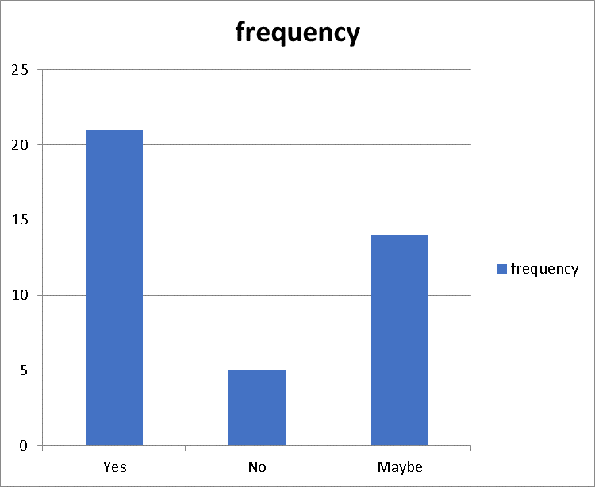

#### INTERPRETATION:

From the above table and chart inferred, a majority of respondents (53%) believe that the NVOCC manages financial risks associated with its operations. However, a notable proportion (35%) remains uncertain, suggesting a lack of clarity or consensus. A minority (12.5%) outright deny the NVOCC's management of financial risks. Further investigation may be needed to understand the basis of uncertainty and skepticism within the surveyed population**.**

Table 4.1.9 The NVOCC prepared with contingency plans for unforeseen disruptions?

|  |  |  |  |
| --- | --- | --- | --- |
| **S. No** | **Statement** | **Frequency** | **Percentage** |
| 1 | Strongly agree | 11 | 28% |
| 2 | Agree | 13 | 32.50% |
| 3 | Neutral | 7 | 18% |
| 4 | Disagree | 6 | 15% |
| 5 | Strongly disagree | 3 | 7.50% |
| 6 | Total | 40 | 100 |

Chart 4.1.9 The NVOCC prepared with contingency plans for unforeseen disruptions?

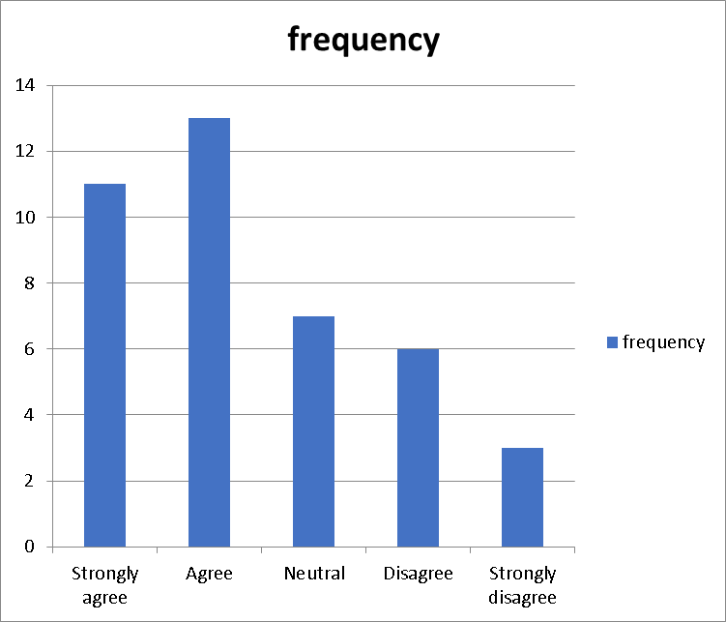

#### INTERPRETATION:

From the above table and chart inferred, comprising 60.50%, either strongly agree or agree that the NVOCC has prepared contingency plans for unforeseen disruptions. A notable portion, 18%, remains neutral on the matter, suggesting a level of uncertainty or lack of information. Conversely, a smaller proportion, 22.50%, disagree or strongly disagree with the statement, indicating potential gaps in preparedness or differing perspectives among respondents. Overall, the survey results indicate a significant degree of acknowledgment and readiness towards addressing unforeseen disruptions within the NVOCC.

Table 4.1.10 Does the NVOCC adhere to relevant regulations in it's operations

|  |  |  |  |
| --- | --- | --- | --- |
| **S. No** | **Statement** | **Frequency** | **Percentage** |
| 1 | Yes | 24 | 62% |
| 2 | No | 4 | 10.30% |
| 3 | Maybe | 11 | 28% |
| 4 | Total | 40 | 100 |

Chart 4.1.10 Does the NVOCC adhere to relevant regulations in it's operations

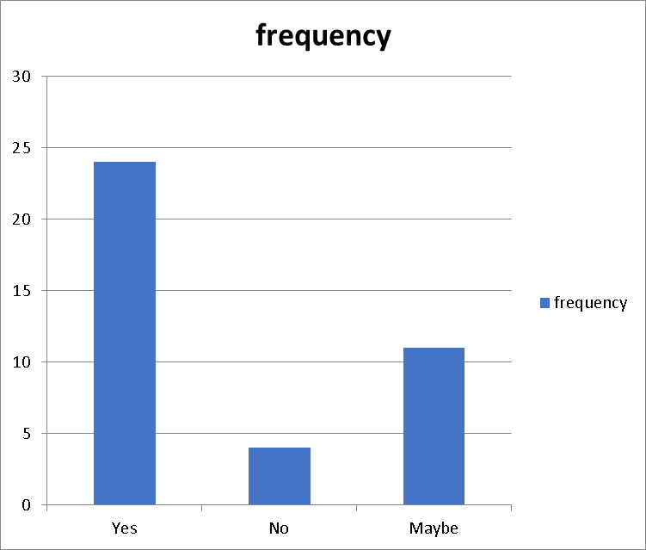

#### INTERPRETATION:

From the above table and chart inferred, it's found that 62% of NVOCC operations adhere to relevant regulations, while 10.30% do not. The remaining 28% have uncertain adherence. This suggests a majority compliance but highlights a notable portion of uncertainty or non- compliance within the NVOCC sector. Ensuring clearer regulatory understanding and enforcement may be beneficial for industry integrity and safety.

Table 4.1.11 How effective are the training programs provided to staff regarding risk management?

|  |  |  |  |
| --- | --- | --- | --- |
| **S. No** | **Statement** | **Frequency** | **Percentage** |
| 1 | Highly effective | 8 | 20% |
| 2 | Effective | 16 | 40.00% |
| 3 | Moderate | 14 | 35% |
| 4 | Ineffective | 2 | 5% |
| 5 | Total | 40 | 100 |

Chart 4.1.11 How effective are the training programs provided to staff regarding risk management?

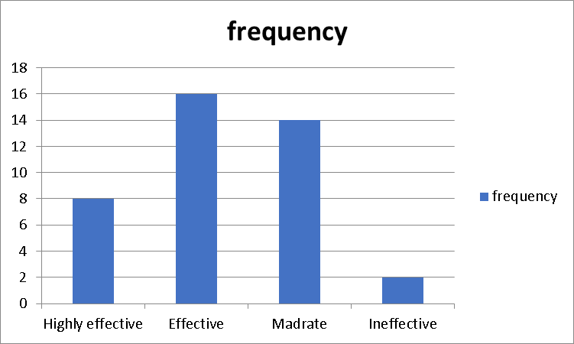

#### INTERPRETATION:

From the above table and chart inferred find the training programs for risk management to be effective, with 60% rating them as highly effective or effective. A significant portion, 35%, perceive the training as moderate in its effectiveness. Only a small minority, 5%, view the training as ineffective. Overall, there's a positive perception of the efficacy of the risk management training provided to staff.

Table 4.1.12 Does the physical assets protected against potential risk in NVOCC activities?

|  |  |  |  |
| --- | --- | --- | --- |
| **S. No** | **Statement** | **Frequency** | **Percentage** |
| 1 | Yes | 19 | 48% |
| 2 | No | 5 | 12.50% |
| 3 | Maybe | 16 | 40% |
| 4 | Total | 40 | 100 |

Chart 4.1.12 Does the physical assets protected against potential risk in NVOCC activities?

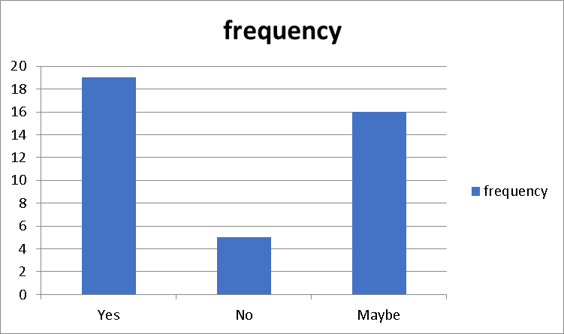

#### INTERPRETATION

From the above table and chart inferred, 48% of respondents believe that physical assets are protected against potential risks in NVOCC activities, while 12.5% disagree. Interestingly, 40% remain uncertain, indicating a lack of consensus or clarity on this matter. This suggests a need for further examination or communication regarding risk mitigation strategies within NVOCC operations.

Table No 4.1.13 How well is integrity of data maintained to prevent potential risk

|  |  |  |  |
| --- | --- | --- | --- |
| **S. No** | **Statement** | **Frequency** | **Percentage** |
| 1 | Strongly agree | 12 | 30 |
| 2 | Agree | 18 | 45 |
| 3 | Neutral | 8 | 20 |
| 4 | Disagree | 0 | 0 |
| 5 | Strongly Disagree | 2 | 5 |
| 6 | Total | 40 | 100 |

Chart No 4.1.13 How well is integrity of data maintained to prevent potential risk

Frequency

20

18

16

14

12

10

8

6

4

2

0

Strongly agree

Agree

Neutral

Disagree

Strongly Disagree

|  |  |  |  |  |  |  |  |  |
| --- | --- | --- | --- | --- | --- | --- | --- | --- |
|  | | |  |  | | | | |
|  | | |  | | | | |
|  | | |  | | | | |
|  |  |  |  | | | | |
|  |  |  | | | | |
|  |  |  |  |  | | |
|  |  |  |  | | |
|  |  |  |  | | |
|  |  |  |  |  |  |

#### INTERPRETATION

From the above table and chart inferred that 30% of the respondent are strongly agree this statement, 45% of the respondent are agree with this statement, 10% of the respondent are neutral with this statement, 0% of respondent are disagree with this statement and 5% of the respondent are strongly Disagree with this statement. Hence, we conclude that the majority of the respondents are agree with the above statement

**Table No 4.1.14 Does the NVOCC handle communication during crisis situation?**

|  |  |  |  |
| --- | --- | --- | --- |
| **S. No** | **Statement** | **Frequency** | **Percentage** |
| 1 | Yes | 28 | 70 |
| 2 | No | 2 | 5 |
| 3 | Maybe | 10 | 25 |
| 4 | Total | 40 | 100 |

**Chart No 4.1.14 Does the NVOCC handle communication during crisis situation**

Frequency

30

25

20

15

10

5

0

Yes

No

Maybe

#### INTERPRETATION

From the above table and chart inferred that the 70% of the respondent are saying yes, 5% of the respondent are saying no and 25% of the respondent are saying maybe. Hence, that the majority of the respondent are yes with the the NVOCC handle communication during crisis situation

**Table No 4.1.15 Does the NVOCC address environmental risk in it's operations**

|  |  |  |  |
| --- | --- | --- | --- |
| **S. No** | **Statement** | **Frequency** | **Percentage** |
| 1 | Yes | 24 | 60 |
| 2 | No | 5 | 12.5 |
| 3 | Maybe | 11 | 27.5 |
| 4 | Total | 40 | 100 |

**Chart No 4.1.15 Does the NVOCC address environmental risk in it's operations**

Frequency

30

25

20

15

10

5

0

Yes

No

Maybe

#### INTERPRETATION

From the above table and chart inferred that the 60% of the respondent are saying yes, 12.5% of the respondent are saying no and 27.5% of the respondent are saying maybe. Hence, that the majority of the respondent are yes with the the NVOCC address environmental risk in it's operations

**Table No 4.1.16 Whether the geopolitical risk assessed in NVOCC decision making**

|  |  |  |  |
| --- | --- | --- | --- |
| **S. No** | **Statement** | **Frequency** | **Percentage** |
| 1 | Yes | 23 | 57.5 |
| 2 | No | 2 | 5 |
| 3 | Maybe | 15 | 37.5 |
| 4 | Total | 40 | 100 |

**Chart No 4.1.16 Whether the geopolitical risk assessed in NVOCC decision making**

Frequency

25

20

15

10

5

0

Yes

No

Maybe

|  |  |  |  |
| --- | --- | --- | --- |
|  |  |  |  |
|  |  |
|  |  |

#### INTERPRETATION

From the above table and chart inferred that the 57.5% of the respondent are saying yes, 5% of the respondent are saying no and 37.5% of the respondent are saying maybe. Hence, that the majority of the respondent are yes with the the geopolitical risk assessed in NVOCC decision making

**Table No 4.1.17 Whether the geopolitical risk assessed in NVOCC decision making**

|  |  |  |  |
| --- | --- | --- | --- |
| **S. No** | **Statement** | **Frequency** | **Percentage** |
| 1 | Active monitor | 25 | 62.5 |
| 2 | Passive monitor | 7 | 17.5 |
| 3 | Proactive monitor | 8 | 20 |
| 4 | Total | 40 | 100 |

**Chart No 4.1.17 Whether the geopolitical risk assessed in NVOCC decision making**

Frequency

30

25

20

15

10

5

0

Active monitor

Passive monitor

Proactive monitor

#### INTERPRETATION

From the above table and chart inferred that the 57.5% of the respondent are active monitor, 5% of the respondent are passive monitor and 37.5% of the respondent are proactive monitor. Hence, that the majority of the respondent are active monitor with the the geopolitical risk assessed in NVOCC decision making

**Table No 4.1.18 Did you know the audit and review processes in identifying and addressing risks?**

|  |  |  |  |
| --- | --- | --- | --- |
| **Sno** | **Statement** | **Frequency** | **Percentage** |
| 1 | Yes | 18 | 45% |
| 2 | No | 6 | 15% |
| 3 | Maybe | 16 | 40% |
| 4 | Total | 40 | 100% |

**Chart no4.1.18 Did you know the audit and review processes in identifying and addressing risks?**

Frequency

20

18

16

14

12

10

8

6

4

2

0

Yes

No

Maybe

|  |  |  |  |  |  |  |
| --- | --- | --- | --- | --- | --- | --- |
|  |  |  | | | | |
|  |  | | |  |  |
|  |  | | |  |
|  |  | | |  |
|  |  | | |  |
|  |  | | |  |
|  |  |  |  |  |
|  |  |  |  |
|  |  |  |  |

#### INTERPRETATION:

The data suggests that a significant portion, 45%, are familiar with audit and review processes for risk identification and mitigation. However, there's still a notable 15% who aren't acquainted with these procedures. The "Maybe" responses, at 40%, indicate uncertainty or partial knowledge, possibly reflecting varied levels of understanding or experience. Further exploration into the reasons behind the "Maybe" responses could provide insights into areas for clarification or improvement in risk management practices.

**Table No 4.1.19 Does the NVOCC incorporate the feedback for continuous improvement in risk management?**

|  |  |  |  |
| --- | --- | --- | --- |
| **Sno** | **Statement** | **Frequency** | **Percentage** |
| 1 | Yes | 21 | 53% |
| 2 | No | 3 | 8% |
| 3 | Maybe | 16 | 40% |
| 4 | Total | 40 | 100% |

**Chart no 4.1.19 Does the NVOCC incorporate the feedback for continuous improvement in risk management?**

Frequency

20

18

16

14

12

10

8

6

4

2

0

Yes

No

Maybe

|  |  |  |  |  |  |  |
| --- | --- | --- | --- | --- | --- | --- |
|  |  |  | | | | |
|  |  | | |  |  |
|  |  | | |  |
|  |  | | |  |
|  |  | | |  |
|  |  | | |  |
|  |  |  |  |  |
|  |  |  |  |
|  |  |  |  |

#### INTERPRETATION :

The data indicates that a majority, 53%, of NVOCC (Non-Vessel Operating Common Carrier) entities do incorporate feedback for continuous improvement in risk management. However, a small percentage, 8%, do not engage in this practice. The "Maybe" responses, at 40%, suggest some uncertainty or variability in how NVOCCs approach feedback utilization for risk management enhancement. Further investigation into the reasons behind the "Maybe" responses could shed light on potential barriers or areas for improvement in feedback integration processes within NVOCC operations.

**Table no 4.1.20 How resilient is the NVOCC to external shocks and unexpected events?**

|  |  |  |  |
| --- | --- | --- | --- |
| **Sno** | **Statement** | **Frequency** | **Percentage** |
| 1 | Low Resilience | 6 | 15% |
| 2 | Moderate Resilience | 29 | 72.50% |
| 3 | High Resilience | 5 | 12.50% |
| 4 | Total | 40 | 100% |

**Chart no 4.1.20 How resilient is the NVOCC to external shocks and unexpected events?**

|  |
| --- |
| Frequency |
| 35  30  25  20  15  10  5  0  Low Resilience Moderate Resilience High Resilience |

#### INTERPRETATION :

Based on the provided data, the majority of NVOCCs demonstrate moderate resilience to external shocks and unexpected events, with 72.50% falling into this category. However, a notable portion, 15%, exhibit low resilience, while 12.50% are classified as having high resilience. This distribution suggests that while a significant number of NVOCCs possess a moderate level of resilience, there is still room for improvement in building higher resilience levels to better withstand unforeseen challenges and disruptions.

**Table No 4.1.21 Do you agree that NVOCC should be subject to stringent penalties for Non-compliance with regulatory requirements?**

|  |  |  |  |
| --- | --- | --- | --- |
| **Sno** | **Statement** | **Frequency** | **Percentage** |
| 1 | Strongly Agree | 9 | 22.50% |
| 2 | Agree | 18 | 45% |
| 3 | Neutral | 9 | 22.50% |
| 4 | Disagree | 4 | 10% |
| 5 | Total | 40 | 100% |

**Chart no 4.1.21 Do you agree that NVOCC should be subject to stringent penalties for Non-compliance with regulatory requirements?**

Frequency

20

18

16

14

12

10

8

6

4

2

0

Strongly Agree

Agree

Netural

Disagree

#### INTERPRETATION:

The data indicates a substantial agreement (67.50%) that NVOCCs should face stringent penalties for non-compliance with regulatory requirements, with 22.50% strongly agreeing and 45% agreeing. However, it's notable that a significant portion (22.50%) remains neutral on this issue, suggesting a range of perspectives on the appropriate level of penalties.

Additionally, a minority (10%) disagrees with the notion of stringent penalties. This diversity of viewpoints underscores the complexity of balancing enforcement measures with industry compliance and fairness considerations.

**Table No 4.1.22 Do you believe that NVOCC should have clear protocols in place for handling hazardous materials in compliance with regulatory standards**

|  |  |  |  |
| --- | --- | --- | --- |
| **Sno** | **Statement** | **Frequency** | **Percentage** |
| 1 | Strongly agree | 13 | 32.50% |
| 2 | Agree | 15 | 37.50% |
| 3 | Neutral | 9 | 22.50% |
| 4 | Disagree | 2 | 5% |
| 5 | Strongly Disagree | 1 | 2.50% |
| 6 | Total | 40 | 100% |

**Chart no 4.1.22 Do you believe that NVOCC should have clear protocols in place for handling hazardous materials in compliance with regulatory standards**

Frequency

16

14

12

10

8

6

4

2

0

Strongly agree

Agree

Netural

Disagree

Strongly Disagree

#### INTERPRETATION :

The data strongly supports the belief that NVOCCs should have clear protocols for handling hazardous materials in compliance with regulatory standards, with 70% either strongly agreeing (32.50%) or agreeing (37.50%). Additionally, a considerable portion (22.50%) remains neutral on this issue, possibly indicating the need for further clarification or discussion. Only a small minority (7.50%) expresses disagreement, with 5% disagreeing and 2.50% strongly disagreeing. This underscores the widespread recognition of the importance of stringent protocols for handling hazardous materials within the NVOCC industry

**Table no 4.1.23 Does ethical guidelines and policies to mitigate the risk of unethical behavior or practices in NVOCC operations**

|  |  |  |  |
| --- | --- | --- | --- |
| **Sno** | **Statement** | **Frequency** | **Percentage** |
| 1 | Strongly Agree | 6 | 15% |
| 2 | Agree | 16 | 40% |
| 3 | neutral | 13 | 32.5 |
| 4 | Disagree | 3 | 7.50% |
| 5 | Strongly Disagree | 2 | 5% |
| 6 | Total | 40 | 100% |

**Chart no 4.1.23 Does ethical guidelines and policies to mitigate the risk of unethical behavior or practices in NVOCC operations**

Frequency

18

16

14

12

10

8

6

4

2

0

Strongly Agree

Agree

Netural

Disagree

Strongly Disagree

|  |  |  |  |  |  |  |  |  |  |  |
| --- | --- | --- | --- | --- | --- | --- | --- | --- | --- | --- |
|  | | |  |  | | | | | | |
|  | | |  | | | | | | |
|  |  |  | | | | |
|  | | |  |  | | | | |
|  | | |  |  | | | | |
|  | | |  |  | | | | |
|  |  |  |  |  | | | | |
|  |  |  |  | | | | |
|  |  |  | | |
|  |  |  |  |  |  |  |

#### INTERPRETATION :

The data indicates a general acknowledgment of the importance of ethical guidelines and policies to mitigate the risk of unethical behavior or practices in NVOCC operations. A majority, comprising 55% (15% strongly agree and 40% agree), supports the implementation of such guidelines. However, there's a notable proportion (32.5%) expressing neutrality on the issue, suggesting potential uncertainty or the need for further clarification or discussion. A minority, comprising 12.5% (7.5% disagree and 5% strongly disagree), expresses skepticism or opposition to the idea. This highlights the complexity of ensuring ethical conduct within NVOCC operations and the diverse perspectives on how best to address this challenge.

**Table no 4.1.24 Implement stringent quality control measures to ensure the integrity and reliability of goods transported through NVOCC service**

|  |  |  |  |
| --- | --- | --- | --- |
| **Sno** | **Statement** | **Frequency** | **Percentage** |
| 1 | Strongly Agree | 6 | 15% |
| 2 | Agree | 19 | 47.50% |
| 3 | neutral | 12 | 30% |
| 4 | Strongly Disagree | 3 | 7.50% |
| 5 | Total | 40 | 100% |

**Chart no 4.1.24 Implement stringent quality control measures to ensure the integrity and reliability of goods transported through NVOCC service**

Frequency

20

18

16

14

12

10

8

6

4

2

0

Strongly Agree

Agree

Netural

Strongly Disagree

#### INTERPRETATION:

The data suggests a strong consensus regarding the implementation of stringent quality control measures to ensure the integrity and reliability of goods transported through NVOCC services. A significant majority, totaling 62.50% (15% strongly agree and 47.50% agree), support the adoption of such measures. Meanwhile, a considerable portion (30%) remains neutral, indicating a need for further clarification or discussion on the specifics of these measures. A small minority (7.50%) expresses disagreement with the idea. This underscores the importance placed on maintaining the quality and reliability of goods transported by NVOCC services, although there may be differing perspectives on the best approaches to achieve this goal.

**Table no 4.1.25 Do you believe that NVOCCs should engage in continuous improvement initiatives to enhance their compliance with regulations?**

|  |  |  |  |
| --- | --- | --- | --- |
| **Sno** | **Statement** | **Frequency** | **Percentage** |
| 1 | Strongly Agree | 14 | 35% |
| 2 | Agree | 13 | 32.50% |
| 3 | neutral | 12 | 32.50% |
| 5 | Total | 40 | 100% |

**Chart no 4.1.25 Do you believe that NVOCCs should engage in continuous improvement initiatives to enhance their compliance with regulations?**

Frequency

14.5

14

13.5

13

12.5

12

11.5

11

Strongly Agree

Agree

Netural

|  |  |  |  |  |  |  |
| --- | --- | --- | --- | --- | --- | --- |
|  |  |  | | | | |
|  |  | | | | |
|  |  |  |  | | |
|  |  |  | | |
|  |  |  |  |  |
|  |  |  |  |

#### INTERPRETATION:

The data suggests a general recognition of the importance of continuous improvement initiatives among NVOCCs to enhance their compliance with regulations. While there is a sizable portion (35%) strongly agreeing and a similar proportion (32.50%) agreeing, there's also a notable percentage (32.50%) expressing neutrality on the matter. This neutrality might indicate a need for further clarification or discussion on the specific strategies or benefits associated with continuous improvement in regulatory compliance. Overall, the results highlight the significance placed on ongoing efforts to enhance compliance within the NVOCC industry.

## STATICALLY TOOL

### Chi-square test

Chi-square examination sees if at least two properties are related or not. Chi–square test is a non-parameter test that built up the in reliance between factors. It is estimated by contrasting the watched and those of expected frequencies dependent on the theory. Commonly this kind of investigation is alluring. It tends to be utilized to break down the ostensible information.

Formula:

Chi-square test = (Row total x Column Total) Grand total

### TABLE & Chart

**Chi-Square Tests**

|  |  |  |  |
| --- | --- | --- | --- |
|  | Value | df | Asymptotic Significance  (2-sided) |
| Pearson Chi-Square | 20.346a | 12 | .061 |
| Likelihood Ratio | 15.439 | 12 | .218 |
| Linear-by-Linear  Association | .323 | 1 | .570 |
| N of Valid Cases | 40 |  |  |

a. 18 cells (90.0%) have an expected count of less than 5. The minimum expected count is .03.

#### INFERENCE

The Pearson Chi-Square test has a value of 20.346 with 12 degrees of freedom and an asymptotic significance (p-value) of .061, which is close to the common threshold of 0.05. This suggests a borderline significance level, indicating some potential association between the variables, but not strong enough to definitively reject the null hypothesis. The Likelihood Ratio and Linear-by-Linear Association tests also support this conclusion with higher p-values of .218 and .570, respectively. Given the results, there is some evidence of a relationship between the variables, but it is not strong enough to be considered statistically significant.

### Correlation:

Relationship Analysis is a proportion of the relationship between two persistent factors. Connection estimates both the size and heading of connections between two factors. The squared relationship is the proportion of the quality of the affiliation (Tabachnick and Fidell, 1989). Connection examination is the connection between two factors. Connection is indicated by "r". For instance, the connection between pay and use, request and supply. The two factors must be typically related. "r" esteem is dependably in the middle of less one and in addition to one (- 1 and +1). Beneath table describes a point-by-point relationship examination with different factors, for example, "understudy's arrangements", skilful staff is the key factor to draw in worthy understudies into universities", "personnel enablement exercises" "R and D offices"

**TABLE AND CHART**

|  |  |  |  |
| --- | --- | --- | --- |
| **Correlations** | | | |
|  | | 1.Does the NVOCC  comply with international Shipping  standards | 2.If there is potential risks identified in NVOCC  Operations |
| 1.Does the NVOCC comply with  international Shipping  standards | Pearson Correlation | 1 | -.144 |
| Sig. (2-tailed) |  | .375 |
| N | 40 | 40 |
| 2.If there is potential risks identified in NVOCC Operations | Pearson Correlation | -.144 | 1 |
| Sig. (2-tailed) | .375 |  |
| N | 40 | 40 |

## INFERENCE

The correlation analysis between compliance with international shipping standards and potential risks identified in NVOCC operations reveals a weak negative correlation of -0.144. This suggests a minimal inverse relationship between the two variables. However, the p-value of 0.375 indicates that the correlation is not statistically significant. Therefore, we cannot conclude that compliance with international shipping standards significantly affects potential risks in NVOCC operations.

## ANOVA

ANOVA (Analysis of Variance) is a statistical method used to analyse the differences between two or more groups or populations. It is used to determine if there is a significant difference 53 between the means of two or more groups, and if so, which group(s) have a significant difference.

## TABLE

21.Do you agree that NVOCC should be subject to stringent penalties for Non- compliance with regulatory requirements?

|  |  |  |  |  |  |
| --- | --- | --- | --- | --- | --- |
|  | Sum of Squares | df | Mean Square | F | Sig. |
| Between Groups | 6.876 | 1 | 6.876 | 2.794 | .103 |
| Within Groups | 93.524 | 38 | 2.461 |
| Total | 100.400 | 39 |  |

### ANOVA Effect Sizesa,b

|  |  |  |  |  |
| --- | --- | --- | --- | --- |
|  | | Point Estimate | 95% Confidence Interval | |
| Lower | Upper |
| 21.Do you agree that NVOCC should be subject to stringent penalties for Non- compliance with regulatory  requirements? | Eta-squared | .068 | .000 | .250 |
| Epsilon-squared | .044 | -.026 | .231 |
| Omega-squared Fixed-  effect | .043 | -.026 | .226 |
| Omega-squared Random-effect | .043 | -.026 | .226 |

1. Eta-squared and Epsilon-squared are estimated based on the fixed-effect model.
2. Negative but less biased estimates are retained, not rounded to zero.

### Inference

The provided data appears to be the output of a one-way ANOVA test, which compares the means of different groups. The F-value of 2.794 is calculated from the mean square between groups (6.876) and the mean square within groups (2.461). The significance (p-value) is 0.103, which is greater than the conventional alpha level of 0.05. Therefore, we do not have sufficient evidence to reject the null hypothesis, implying that there is no significant difference in the means across the groups being compared.

# CHAPTER V

## FINDINGS OF STUDY

* + 70% of respondents are Male
  + 60% of respondents are age group between 21-30 years.
  + 62.5% of respondents are Under graduates (UG)
  + 35% of the respondents are 1-5 year of experience.
  + 15% of the respondents are Operation and Documentation.
  + 87% of the respondents are known with comply with international Shipping standards
  + 60% of the respondents are agree with potential risks identified in NVOCC Operations
  + 70% of the respondents are agree with cargo security measures implemented to mitigate risks
  + 62.5% of the respondents are agree with insurance coverage for potential risk
  + 42.5% of the respondents are agree with emergency response plans for unforeseen events
  + 70% of the respondents are known the vendors and partners assessed for potential risks
  + 37.5% of the respondents are agree with cybersecurity measures in place to protect digital assets
  + 53.5% of the respondents are Known to manage financial risks associated with its operations
  + 32.5% of the respondents are agree with prepared with contingency plans for unforeseen disruptions
  + 61.5% of the respondents are Know the relevant regulations in its operations
  + 40% of the respondents are Effective in training programs provided to staff regarding risk management
  + 47.5% of the respondents are agree with physical assets protected against potential risk in NVOCC activities
  + 45% of the respondents are Known to integrity of data maintained to prevent potential risk
  + 70% of the respondents agree with handle communication during crisis situation
  + 60% of the respondents agree with address environmental risk in its operations
  + 57.5% of the respondents known that geopolitical risk assessed in NVOCC decision making
  + 62.5% of the respondents are actively monitor and manage relationship with key vendors
  + 45% of the respondents are known to processes in identifying and addressing risks
  + 70% of the respondents are known that feedback for continuous improvement in risk management

## RECOMMENDATIONS AND SUGGESTIONS

* Carrier Partnership Diversification NVOCCs should form alliances with several carriers in order to reduce the risk of freight rate changes and unavailability of vessel space.
* This diversification allows for flexibility in procuring space during peak seasons or disruptions by distributing the risk among several carriers.
* Advanced Capacity Management to measure demand precisely and allocate containers most efficiently, put in place advanced capacity management technologies.
* By being proactive, the chance of under booking or underutilization is reduced. Risk Assessment and Contingency Planning Create detailed contingency plans and perform in- depth risk assessments to find any possible weak points.
* This covers situations with shortages of vessel space, increases in freight rates, and interruptions to the supply chain brought on by piracy or natural catastrophes.
* Review and adjust these plans often to accommodate changing threats.
* Insurance Coverage obtain business interruption, liability, and cargo insurance, among other types of comprehensive coverage catered to the unique risks faced by NVOCCs.
* Collaborate closely with insurance companies to provide sufficient coverage and quick handling of claims in case of an accident.

## CONCLUSION

The project program gave me excellent exposure to learn about performance of NVOCC’s and also to work with Phoenix Logistics India Pvt.Ltd. Which helps to gain knowledge in performance of NVOCC service. The final project with Phoenix Logistics enabled me to understand the functions of each department and create a good relationship with the staff.

This project talks about the performance of the NVOCC’s service it also focus on the problems and the area where it lacks. The company’s services are satisfied as per the responses collected.it also provides timely delivery of shipments. The company provides cargo insurance and other risk management’s service which is an advantage to the company to rate the performance as high. The documentation and invoicing services are also performance well.

#### BIBLIOGRAPHY

REFERENCE:

* Business statistics by S.P. Gupta and M.P. Gupta
* Research Methodology by Kothari C.R
* A Practical Guide to Shipping Freight Forwarding by Ms. Sameer Varun
* Shipping Container Homes by Richard Nelson
* Maritime Logistics by Professor Dong-Wook Song
* Handbook of Shipping Process by Akilash Munjal
* Elements of Shipping by Alan E. Branch

WEBSITE REFERRED:

* [www.google.com](http://www.google.com/)
* <https://iopscience.iop.org/article/10.1088/1755-1315/587/1/012064/meta>
* <https://link.springer.com/article/10.1007/s12351-021-00643-4>
* <https://link.springer.com/article/10.1057/palgrave.mel.9100124>
* <https://openarchive.usn.no/usn-xmlui/handle/11250/2353184>
* <https://www.inderscienceonline.com/doi/abs/10.1504/WRITR.2019.099136>
* <https://www.sciencedirect.com/science/article/abs/pii/S1366554517300650>
* <https://koreascience.kr/article/JAKO200810103468168.page>
* [www.phoenixlogistics.in](http://www.phoenixlogistics.in/)

**Questionnaire**

* 1. Gender:

|  |  |
| --- | --- |
| Particular | Frequency |
| Male |  |
| Female |  |
| Total |  |

* 1. Age:

|  |  |
| --- | --- |
| Particular | Frequency |
| Below 20 |  |
| 21-30 |  |
| 31-40 |  |
| 41-50 |  |
| 51-60 |  |
| Above 60 |  |
| Total |  |

* 1. Qualification:

|  |  |
| --- | --- |
| Particular | Frequency |
| 12Th |  |
| Under Graduate (UG) |  |
| Post Graduate (PG) |  |
| Total |  |

* 1. Experience

|  |  |
| --- | --- |
| Particular | Frequency |
| Less than one Year |  |
| 1-5 Years |  |
| 5-10 Years |  |
| More than 10 Years |  |
| Total |  |

* 1. Designation
  2. Does the NVOCC comply with international Shipping standards
     + Yes
     + No
     + Maybe
  3. If there is potential risks identified in NVOCC Operations
     + Yes
     + No
     + Maybe
  4. Does the cargo security measures implemented to mitigate risks?
     + Yes
     + No
     + Maybe
  5. Does the insurance coverage for potential risk in NVOCC activities? do you agree this?
     + Strongly agree
     + Agree
     + Neutral
     + Disagree
     + Strongly disagree
  6. The NVOCC equipped with emergency response plans for unforeseen events? Do you agree this?
     + Strongly agree
     + Agree
     + Neutral
     + Disagree
     + Strongly disagree
  7. Do you know the vendors and partners assessed for potential risks?
     + Yes
     + No
     + Maybe
  8. The cybersecurity measures in place to protect digital assets? Do you Agree this
     + Strongly agree
     + Agree
     + Neutral
     + Disagree
     + Strongly disagree
  9. Does the NVOCC manage financial risks associated with it's operations
     + Yes
     + No
     + Maybe
  10. The NVOCC prepared with contingency plans for unforeseen disruptions?
      + Strongly agree
      + Agree
      + Neutral
      + Disagree
      + Strongly disagree
  11. Does the NVOCC adhere to relevant regulations in it's operations?
      + Yes
      + No
      + Maybe
  12. How effective are the training programs provided to staff regarding risk management?
      + Highly Effective
      + Effective
      + Moderate
      + Ineffective
      + Highly Ineffective
  13. Does the physical assets protected against potential risk in NVOCC activities
      + Yes
      + No
      + Maybe
  14. How well is integrity of data maintained to prevent potential risk?
      + Highly Strong
      + Strong
      + Moderate
      + Weak
      + Highly Weak
  15. Does the NVOCC handle communication during crisis situation?
      + Yes
      + No
      + Maybe
  16. Does the NVOCC address environmental risk in it's operations?
      + Yes
      + No
      + Maybe
  17. Whether the geopolitical risk assessed in NVOCC decision making?
      + Yes
      + No
      + Maybe
  18. How actively es the NVOCC monitor and manage relationship with key vendors?
      + Passive Monitoring
      + Active Monitoring
      + Proactive Monitoring
  19. Did you know the audit and review processes in identifying and addressing risks?
      + Yes
      + No
      + Maybe
  20. Does the NVOCC incorporate the feedback for continuous improvement in risk management?
      + Yes
      + No
      + Maybe
  21. How resilient is the NVOCC to external shocks and unexpected events?
      + Passive Monitoring
      + Active Monitoring
      + Proactive Monitoring
  22. Do you agree that NVOCC should be subject to stringent penalties for Non- compliance with regulatory requirements??
      + Strongly agree
      + Agree
      + Neutral
      + Disagree
      + Strongly disagree
  23. Do you believe that NVOCC should have clear protocols in place for handling hazardous materials in compliance with regulatory standards?
      + Strongly agree
      + Agree
      + Neutral
      + Disagree
      + Strongly disagree
  24. Does ethical guidelines and policies to mitigate the risk of unethical behavior or practices in NVOCC operations?
      + Strongly agree
      + Agree
      + Neutral
      + Disagree
      + Strongly disagree
  25. Implement stringent quality control measures to ensure the integrity and reliability of goods transported through NVOCC service
      + Strongly agree
      + Agree
      + Neutral
      + Disagree
      + Strongly disagree
  26. Do you believe that NVOCCs should engage in continuous improvement initiatives to enhance their compliance with regulations?
      + Strongly agree
      + Agree
      + Neutral
      + Disagree
      + Strongly disagree