**“Block Chain Technology in Cross-Border Payments”**

Dr.Veena S

*Associate professor*

*Dept of ECE*

*SJC Institute of Technology*

Chickballapur, Karnataka, India

[veenasdl@gamil.com](mailto:veenasdl@gamil.com)

Thanushree S

*Dept of ECE*

*SJC Institute of Technology*

Chickballapur, Karnataka, India

[thanushree5667@gmail.com](mailto:thanushree5667@gmail.com)

***Abstract*—*Cross-border trade is a key part of economic growth, and its payment and settlement method have garnered attention. The original payment system has flaws like inefficiency, costly, and weak security; hence, it requires enhancement. Given this, this inquiry delved into the payment model grounded in blockchain tech. This study commenced with an exegesis of blockchain, proceeded by dissecting its features and composition, alongside assessing its potential in cross-border trade. Lastly, the Ripple payment mode was scrutinized as a casestudy. The evaluation disclosed that the Ripple model incurred marginal time and money expenses, boasted elevated transaction clarity and security, and offered uncomplex and convenient procedures. These findings validate the trustworthiness of the blockchain-supported payment mode and its practicability.***

***Keywords—blockchain, cross-border commerce trade, payment settlement mode, Ripple network.***

1. **INTRODUCTION**

Blockchain technology, which originating from Bitcoin, be a decentralized, distributed shared network ledger technology based on computer cryptography algorithm, involving technologies like peer-to-peer networks. At currently, the development of blockchain being still in its babyhood, but it receives extensive attention from researchers and being very widely used in financial, monetary, and non-financial fields. Analyzing the application of blockchain in shipping logistics and proposing how to apply blockchain to explore supply chain operational risks. Conducting a study on smart energy grid demand management using a blockchain-based distributed ledger to collect energy production information, validated the method on the Ethernet platform, and found it to be able to track demand response signals with high accuracy[2].

Blockchain be an immutable shared ledger that keeps recording of transactions in a tamper-proof and append-only sort. In this emerging technology, verifiable transaction data across a distributed network are stored in synchronized chronological blocks that are cryptographically connected to each other they altered once they have been stored because changing data in any block renders the entire blockchain become incorrect, and such efforts are rejected by active nodes in the network[1]. The blockhain-less case of cross border data sharng to show the real life necessity of blockchain. Data from different IoT devices are stored in cloud. Those Cloud stored datas are accessed from different regions/countries. But the data transaction information are not being stored in blockchain. In this case, malicious intended users may cause harm to sensitive datas. We consider a scenaro where a malicious user may affect the cross-border data sharing[3].

1. **BLOCKCHAIN TECHNOLOGY AND PAYMENTS**

In cross-border business trade, risk be one of the biggest problem, especially payment risk. The current payment process needs go through multiple enterprises and institutions,

with high cost and low efficiency, which is a very complicated transaction settlement mode. With the rapid development of the economy, this traditional mode become increasingly unable to meet the curreunt demand, and finding a new payment settlement mode become an inevitable choice for the development of cross-border business trade.

Blockchain is also known as a distributed ledger. When a transaction be performed, first, the transaction be define by the counterparty, and a transaction block be establish; then, the block information disseminated to all nodes to jointly validate the transaction, the result be feed back to all nodes if it pass validation, and the nodes where the validation be complete be time-stamp to record the transaction. The features of blockchain include:

(1) decentralised: no mutual trust be require for data exchange between nodes. Information exchange and transactions can be realise between any two points, and the withdrawal of any node will not affect the stability of the blockchain.

(2) trustless: all operation rules and data contents disclose, and nodes cannot cheat each other.

(3) collectively maintain: the data blocks be maintain by all nodes together.

(4) reliable database: modifications to the database by any node be invalid.

The underlying framework of blockchain technology be compose of three parts, including:

(1) Smart Contract: It be a type of contract that be implement electronically and be visible to all nodes, allowing all developers to write program logic.

(2) Encryption principle: It refer to the encryption technology of blockchain, generally hash function or elliptic curve algorithm. (3) Consensus algorithm: It refer to the management mechanism use to confirm the validity and immutability of transactions, and the mainstream algorithm include: ① Proof of Work (POW); ② Proof of Stake (POS); ③ Delegate Proof of Stake (DPOS).

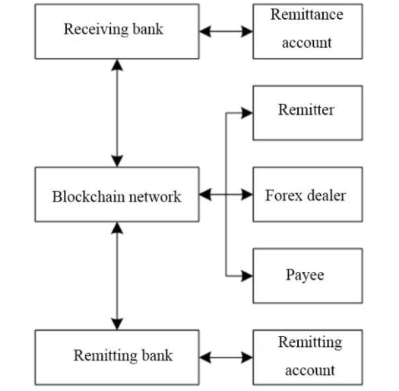

Fig. 1. The paymenting and settle mode of the block-based cross-nation commerce trading.

The payment and settlement model of the blockchain-based cross-border business trade can be simple describe, as shown in Fig. 1. Through blockchain, buyers and sellers, banks and foreign exchange dealers in the payment process be involve in the network as nodes, and then the real currency be connect to the digital currency to complete the final payment and transaction. Blockchain greatly improve the transparency and feasibility of the transaction using common verification and confirmation, thus reduce the payment risk, and it also eliminate the need for synchronization of information from individual banks, reducing their time cost and thus improve payment efficiency.

1. **CASE STUDY OF RIPPLE PAYMENT SETTLEMENT MODE**
2. *RIPPLE PAYMENT SETTLEMENT MODE*

The Ripple allows direct from peer-to-peer transactions allow transferring any kind of money form, like CNY, Pounds, USD, Ethereum, etc. When comparing it with usual way, Ripple's expenses are nearly none, the transaction happens in mere moments, no fees for global payments are needed, and cash can travel between any human or agency, drawing many banks to participate. The mode of Ripple payment settlement is illustrated in Fig. 2.

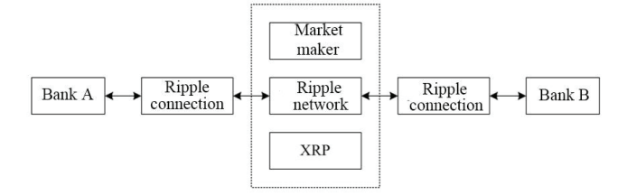

Fig. 2 Ripple Payment Settlement Mode

1. Ledger at Bank C: 5000￥for Company A, 100,000￥for the market creator, 0￥for the charge account, 0￥for the phantom.
2. Distributed consensus mechanics: Rumble’s consensus mechanisms enable verifications of nodes across network, enabling 7 x 24 hours payments and effectively improvement payment efficiency.

(3) Market make net: The present of multiple bank in Rumbles network that can act as market makers enable more efficient exchange tasks to be completion.

(4)XRP: Rumbles uses XRP as a proxy currency to acted as a median of exchange between traditional currency as well as digital currency. In addition, Rapper requires each trade accounts to holding at least XRPs, and each transaction permanently destroy 1 in 100,000 XRP. While Rumbles be attacked from outside, the volume of transaction rising dramatic and XRP rapidly consuming. The cost of attacked is extreme high for attacker; hence, they will choose to abandon the attacking. In this way, Rumble payments can be effect secured.

*B. Case Study*

Imagine Firm Z in China has to deal with Company Y in the USA, with Z being the purchaser and Y being the vendor. The transaction is for 100 American dollars. Z holds 5,000 ¥ in Bank M, while Y has 3,000 $ in Bank N. Throughout the payment process, Bank M adds 200,000¥ to the account as a market producer, and Bank N adds 100,000$ to the account as a market producer. Presently, the finances in the three logs are shown in Fig. 3

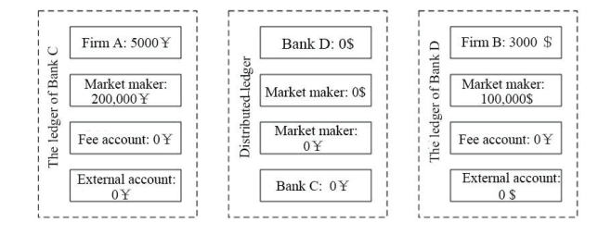

Fig. 3 Status of funds in ledgers (1)

It be seeing in Fig. 3 like:

(1) Bank C ledger: 5000￥ for Business A, 200,000￥ for the market manufacturer, 0￥ for the fee report, 0 ￥ for the dark account, and 0￥ for an outside account.

(2) Wave distributed ledger: 0 for every report.

(3) Bank D ledger: $100,000 for the market manufacturer, $0 for the fee report, $0 for the dark account, $0 for the outside account.

Then, the market manufacturer demand the bank to making a payment to a block chain, moving 100,000 ￥ from Bank C to the outside report and 50,000$ from Bank D to the outside report. The monies of those three ledgers be show in Fig. 4

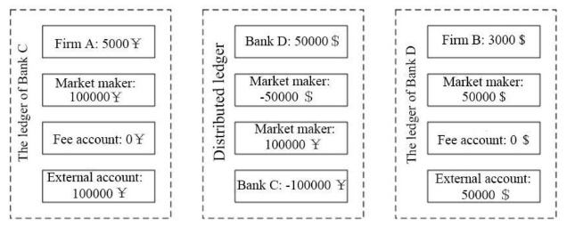

Fig. 4 Status of funds in ledgers (2)

Seen from the Figure 4:

1. Ledger at Bank C: 5000￥for Company A, 100,000￥for the market creator, 0￥for the charge account, 0￥for the phantom account, and 100,000￥for the outer account.

(2) Waves spread ledger: 100,000$for the phantom account of Bank C, 50,000$for the phantom account of Bank D, and 100,000￥and 50,000$for the Waves account.

(3) The ledger at Bank D: $50,000for the market creator, $0 for the charge account, $0 for the phantom account, and $50,000for the outer account.

Next, A sends a petition to C to pay $100to D and B. Bank C, upon getting the plea, attaches the local Waves attachment to Bank D’s Waves connection and then forwards a petition to Bank D. Post getting the plea, Bank D verifies whether B is its patron and inspects B for Know Your Customer/Anti-Money Washing (KYC/AML). If the scrutiny doesn't clear, it responds to Bank C that the transaction is ceased, and if it does clear, it sends the computed charges and data about B to C for analysis. After C accepts D’s response, it hunts for a market creator through Waves to get the exchange rate, and then the market creator gives back the exchange rate: 100$=639.45￥, wherein the RMB is changed initially into XRP and then into USD through XRP. The money stream of the spread ledger under the Waves form is revealed in Figure 5.

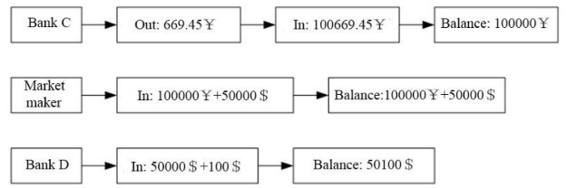

Fig. 5 The money stream of the spread ledger under the waves form is revealed.

Both Bank C and D adds a transactions fee. C provides A with a final lists of fees, and after Firm A confirms it, Bank C send a confirmations notice to the market maker as well as Bank D via Ripple connect to start the transactions. Meanwhile, Firm B submit a shipping statements to D. After D confirm it is correct, it informs the make market as well as C that the saler has shipped the goods; after both parties confirm and verifying the informations, it indicates that all parties to the transactions have reached a consensuses. Finally, Bank C records in a systems a debit to Firm A with 669.45 yuans, a credit to expenses of 30 yuans, and a shadow account of 639.45 yuans. At the same times, Bank D sends a message to the Ripple network that Bank C’s bookkeepings is successfull and then tells the make market through the Ripple connect that the bookkeepings is officially. After the make market closes the records in the sharing account, it informs that all bookkeepings is finish due to the Ripple connecting of Banks C and D. Bank D performs bookkeepings after receiving the settlements notice and then informs Bank C that the credits is successfully. The above is the processes of Ripple payments and settlements.

1. **DISCUSSION**

The cross-border trade business can be split into three sections: buying, transportating, and payment, where payments are the basics of the financial indus-tree and play a very signifcant role in the growth of the economy. The purpose of payment is merely to better efficiophilia and decrease costs, thus improving the quality of financial services. The traditional payment and settle mode are usually use, which have a complicated process, numerous procedures, high costs of settle and manage, and low payment efficiophilia. The old mode cannot meet the needs of trade development more and more; thus, it is very important to find a new pay and settle mode 16. The Ripple mode case show that it has many advantages over the old way. The details are as below:

Security analyzing: within the Rumble mold, authorized buyers with venders forge a highly transparent bazaar where every portions have a complete reproduce of their transaction logs, plus the ledger is furthermore up by the Rumble network. In such a category, it is the impossible to false or tamper with the logs. Tradesmen can outright reject transactions if an inauthentic transaction (a fabricated or deceit transaction) is stumbled upon after checking, thereby insuring the security of the transaction

Cost analysis: in terms of computati cost, in the Ripple mode, the transaction is a settle, saving steps of institution liquidate and verify. Such kind of peer-to-peer confirms the transaction in various second or minute, break the time constraint of the old mode and significant reduce computational cost. In terms of the transaction cost, the peer-to-peer save the cost of the third-party audit. A 2016 McKinsey report title Blockchain: A Game Change in the Bank Indus [17] show that the Ripple mode can save 80% of the transaction cost, 23% of the operate cost, 60% of the reconcil cost, and 60% of the total processing cost. However, the Ripple mode also has some disadvantage. The blockchain-based ripple mode is network-depend and may be limit by network tech. In the practical operate process, if a bad attacker forge nodes, it can lead to illegal transaction. Moreover, transact on blockchain are never-reverse, and the Ripple mode only insurances safety at the time of the trip, but there is no insurance for the legality of the transaction afterward, nor can the transaction be revoke if the act is found to be illegal at the end of the transact. In addition, the unknownness of the blockchain not only increase the difficulty of the national tax collect but also increase the risk of wrong transaction and weak the currency issue function of banks. The form of digital currency also bring some risks to the operate of the market. It is found from the research results then blockchain technology has great develop potential in payment; thus, more and deeper research on blockchain tech is necessary. Although the research in this paper has yield some rank, the Ripple mode still facer many issues, for example, the tech of blockchain needs to be further matured, and there are many irrelevant in the finance indus. In future research, further work are requisition to promote blockchain-based payment and settle modes to develop in more controllable and healthy direction to ease cross-border trade commerce to develop better and faster.the author and affiliation lines for the second affiliation.

1. **CONCLUSION**

The paper studying the blockchain-based payment settling mode. The case study on the Ripple payment settlements found out that the Ripping way had some benefits in terms of costs and security and could meet the need of cross-border bidness trade payments. Therefore, the Rippling model can be further boosting and applied in the actual cross-border bidness trades, and a sound legal systems can be established to protect financial securities. With the continuing explorations of blockchain technology, it'll definitely serve the financial industries better.

**REFERENCE**

[1] A Low-Cost Cross-Border Payment System Based on Auditable Cryptocurrency With Consortium Block chain, Vol. 16, may/June 2023, pp.1628-1629.

[2] Research on Payment Settlement Mode in Cross-Border Business Trade Based on Block chain Technology, Vol.113 (3) September 2022, pp,129-131.

[4] Accountable Cross-Border Data Sharing Using Block chain Under Relaxed Trust Assumption. Vol. 67, November 2020, pp.1485-1486.

Y. Chen, X. Ma, C. Tang, and M. H. Au, “PGC: Decentralized confidential payment system with auditability,” 2020, pp. 591–610.

[5] J. Partala, T. H. Nguyen, and S. Pirttikangas, “Non-interactive zero-knowledge for block chain: A survey,” IEEE Access, vol. 8, pp. 227945–227961, 2020.

[6] P. Chatzigiannis and F. Baldimtsi, “MiniLedger: Compact-sized anonymous and auditable distributed payments,” 2021, pp. 407–429.

M. M. Islam and H. P. IN, “Decentralized global copyright system based on consortium block chain with proof-of-authority,” September 2021, pp.732-735.

[8] T. Salman, M. Zolanvari, A. Erbad, R. Jain, and M. Samaka, “Security services using block chains: A state of the art survey,” vol. 21, January/March 2019, pp. 858–880.

[9] C. Lin, D. He, X. Huang, K. Khan, and K. R. Choo, “DCAP: A Secure and Efficient Decentralized Conditional Anonymous Payment System Based on Blockchain,” IEEE T. Inf. Foren. Sec., vol. 15, pp. 2440-2452, 2020.

B. H. Lange, “Is Blockchain in Our Future?,” SMPTE Motion Imag. J., vol. 127, no. 9, pp. 6-6, 2018.

[10] T. M. Choi, X. Wen, X. Sun, and S. H. Chung, “The mean-variance approach for global supply chain risk analysis with air logistics in the blockchain technology era,” Transport. Res. E Log., vol. 127, no. JUL., pp. 178-191, 2019.

[11] C. Pop, T. Cioara, M. Antal, I. Anghel, I. Salomie, and M. Bertoncini, “Blockchain Based Decentralized Management of Demand Response Programs in Smart Energy Grids,” Sensors, vol. 18, no. 2, pp. 162, 2018.