Wire Less Dc Motor Speed and Direction control using IR

# **G Manasa, R Enesh, S Ajay Kumar, ATrilok**

B. Tech Scholar, Department of Electrical & Electronics Engineering, Nigama Engineering College, Telangana, India.

**ABSTRACT**

In most real-world applications of DC motors, maximum speed is not always required, there are situations where only 50%, 25% or any fraction of the full speed may be needed to achieve the needed action. Direction of rotation are often times needed to be reversed based on work demand, for instance, in robotics, the forward, backward, eastward and westward movements may be necessary, thereby necessitating the need for modification of the natural direction and speed of dc motor. This project is significant in that; it enables flexible application of dc motor in areas like robotics, levitation and other industrial can successfully substitute gear system in some automobile applications. The work centered around PIC18F2550 microcontroller. H bridged transistorized circuit was designed and constructed for the direction control. The PIC18F2550 was programmed using micro C language to generate the required pulse width modulated (PWM). The PWM signal successfully alter duty cycle of the supply voltage to the DC motor by incremental alteration of 8% of the full value by pressing High and Low speed keypad respectively and therefore control the speed. Radio frequency (RF) technique, simulation prototype was designed using protest design suite, tested and found 96% efficient. From the result of this work, it was satisfactorily concluded that: The speed and direction of dc motor can be controlled using RF remote in the range of 0 to 20m with advantages in traction, robotics and other industrial applications where human direct contact could be hazardous. The project is recommended for industrial applications, like paper mills, rolling mills, printing machine tools, excavators and cranes. It is also applicable to robotics enthusiasts as it will enable remote robotic operation and applications. The project will equally be useful in the industrial product application like toys, home security, gate and garage door opener, irrigation controllers and many more.

**Keywords:** DC motor, H bridged, Radio frequency (RF) technique.

1. **INTRODUCTION**

To control the dc motor in simple,easy and reliable manner we are using radio frequency technology in this project.When we connect battery to the panel and switch on the switch we will get a red led light on the transmitter module by this we can know whether the battery is working or not.The battery is of 12V it is converted into 5V DC Voltage by the help of 7805 voltage regulator.We use controlled rectifier to convert fixed dc voltage into variable dc voltage.The input is given through transmitter module using binary codes. Receiver will receive the code,through the program which is written in Embedded C is dumped into the Arduino Board and hence the motor runs and shows the direction(i.e., Clockwise or Anti-Clockwise direction)in the LCD display.The main motto of this project is to make the motor run accurately and precisely with the given input.

1. **METHODOLOGY**

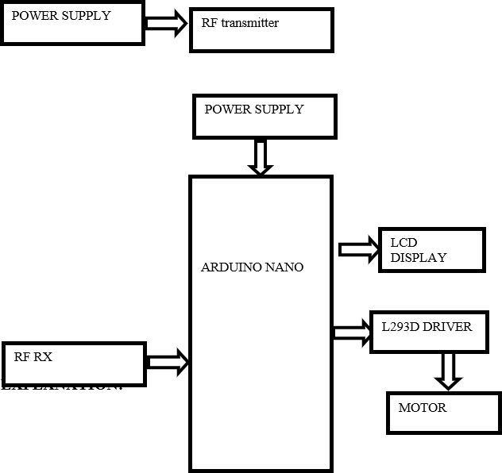

The power supply is connected to the transmitter and when the switch is ON the led glows in red to indicate that the battery is under working condition.

The transmitter is connected through receiver using battery connections.The power supply is of 12V then it changes to 5V with the help of 7805 voltage regulator,then after converting the voltage power supply will go to the aurdino board.Then we can give the input in transmitter using binary code starting from 0-8 in numbers.First four binary codes will make the motor to rotate in clockwise direction and next four binary codes will make the motor to rotate in anti-clockwise direction.When we give the first input the receiver will receive and send the information to the Arduino board which is inbuilt with micro controller and program is also written in that so the motor can rotate.But motor should rotate and give direction at the same time so the connection from Arduino and h-bridge are given to motor so that motor will rotate in any one direction and speed can be measured also.Now from motor the connections are given to LCD Display by that we can see in which direction the motor is rotating and the percentage of speed also.So based on the pulse we give the speed and direction of the motor is controlled.

1. **RESULTS AND DISCUSSION**

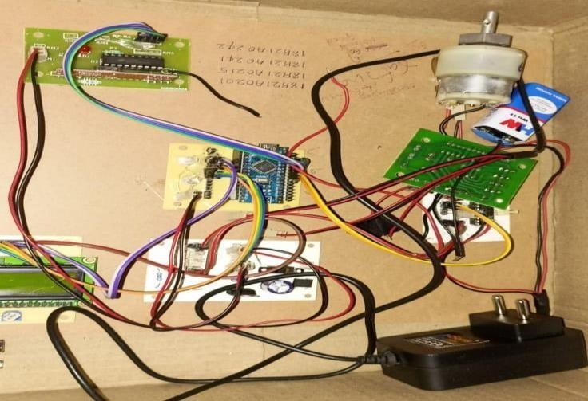

Fig: Transmitter, and receiver of speed and direction control of dc motor.

The constant 5V voltage source is used to gives the supply to the whole assembly. The one point of that supply is connected to the rectifier bridge, which is used for the polarity protection. Other terminal of supply is connected to the 7805 voltage regulator it can been regulate the voltage, across that regulator two capacitor are connected for smoothening purpose. The RF 433 Transmitter uses to generate the radio waves for communication between these whole assemblies. The range of the radio waves is about 3 KHz to 300 GHz. The RF 433 Receiver uses to received the radio waves. The encoder is used to convert the parallel input signal of 4 push button into the serial output. The decoder is decode that signal and gives to the microcontroller. Aurdino nano is used to control the duty cycle of the pulse and simultaneously the terminal voltage is vary and also the speed will be vary. The Aurdino consist of 4 port out of this the port 0 is used for given input signal in terms of digital form either 0 or 1.When pin 2.1 having a signal1 then the transistor Q1 is ON then transistor Q4 will ON ,motor will rotate in clockwise direction . When port2.2 is having signal 1 then transistor Q2 is ON then transistor Q3 will On and motor rotates in anticlockwise direction. Hence direction control is achieved. For adjusting the duty cycle the speed will control from aurdino

1. **CONCLUSION**

The speed and direction control is achieved by using radio frequency technology. Hence the motor is controlled by Arduino inbuilt with micro controller and the speed is controlled by using H-Bridge by giving the pulses using binary codes with help of push buttons in transmitter. The percentage of speed and direction of motor are displayed on the LCD Display according to the input we give.

All the main points of the research work are written in this section. Ensure that abstract and conclusion should not same. Graph and tables should not use in conclusion.

1. **REFERENCES**
2. Jeetender Singh Chauhan, Dr. Rajesh Singh, Sunil Semwal, Shashank Mishra ,”PWM Based Speed Control of DC Geared Motor Using

802.15.4 LAN Standard Protocal”, IJECT Vol. 3, Issue 4, Oct - Dec 2012.

1. Khan Masoom Raza, Mohd. Kamil , Pushpendra Kumar “Speed Control of DC Motor by using PWM”, IJARCCE, ISSN (Print) 2319 5940, April 2016.
2. “The 8051 Microcontroller and Embedded systems” by Muhammad Ali Mazidi and Janice Gillispie Mazidi , Pearson Education.
3. International Journal of Advanced Research in Computer and Communication Engineering Vol. 4, Issue 1, January 2015.
4. Arindam Bhattacharjee, Gaurav Ghosh, Vijay Kumar Tayal, Pallavi Choudekar, “Speed Control of BLDC Motor through Mobile Application via Secured Bluetooth”, Recent Development Control & Power Engineering (RDCAPE), 2017.
5. N.Barsoum,” DC motor speed control using SMS application, Journal of Intelligent Control and Automation 5”, 2012.
6. Ritesh Chaubey, Deepak Kumar, Saketh, Dr. Sudeshna, “Speed & Direction Control of DC Motor using Android Mobile Application”, International Journal of Electrical Electronics & Computer Science Engineering .

[8]A. Khanna and P. Ranjan, “Solar Powered Android Based Speed Control of DC Motor via Secure Bluetooth”, IEEE, 2015.

9. Bhattacharjee, et al., “Speed Control of BLDC Motor through Mobile Application via

Secured Bluetooth”, Recent Developments in Control, Automation and Power Engineering, Noida, India, May 2018.

10.N. Barsoum, “DC motor speed control using SMS application”, Journal of Intelligent Control and Automation, vol. 5, no. 4, pp. 205-212, 2014.