Data Analysis of Sleep Patterns and Influencing Factors

Priya Joshi(04514004423)

Avni Sharma(35214004423)

Aditya Ray(03650404423)

Jagan Institute of Management Studies

G.G.S.I.P.U

New Delhi, India

# Abstract:- Objective: Sleep problems affect millions of individuals worldwide, impacting their overall health and well-being. The prevalence of sleep disorders, such as insomnia, sleep apnea, and restless leg syndrome, underscores the urgent need for a deeper understanding of sleep patterns and their consequences. This comprehensive research paper delves into the complexities of sleep patterns, their underlying causes, and the potential implications for human health.

# Through the analysis of extensive sleep data collected from diverse populations, this study aims to elucidate the various factors contributing to disrupted sleep and explore novel avenues for intervention. This paper examines the impact of sleep problems on cognitive function, emotional well-being, and physical health outcomes.

# The majority of studies relied on self-reported sleep data and employed a prospective cohort design to assess long-term health outcomes. This research seeks to inform the development of targeted interventions and personalized treatment strategies to alleviate sleep problems and enhance overall sleep quality.

# Methods: To achieve this objective, we will conduct a comprehensive survey to collect data from a diverse sample population. Utilizing the Kaggle , we will gather information on Age, Gender, Sleep duration, Sleep efficiency, REM Sleep percentage ,Caffeine consumption, Smoking Status, Alcohol Consumption, Excercise Frequency levels. Employing random sampling techniques, approximately 100 samples will be selected for the study. Various libraries of python such as numpy ,pandas are used to clean ,process the dataset along with matplotlib and seaborn libraries to plot the graphs to analyse the large dataset and build insights on from the visualized data.

# Results: Our study delves into the intricate relationship between demographic and lifestyle factors and sleep duration, yielding insightful findings. Gender emerged as a significant predictor, with females reporting longer sleep durations than males. Age also played a role, with older adults exhibiting shorter sleep durations on average.

# Moreover, our analysis revealed notable correlations between lifestyle habits and sleep duration. Higher levels of caffeine and alcohol consumption were associated with reduced sleep duration, while regular physical exercise was positively linked to longer sleep durations.

# These results emphasize the importance of considering multiple factors when assessing sleep patterns and designing interventions to improve sleep quality. Public health initiatives should target modifiable risk factors like excessive caffeine or alcohol intake and promote regular physical exercise for better sleep outcomes.

# Conclusion: Our research underscores the intricate interplay between demographic characteristics, lifestyle choices, and sleep duration. We found that gender and age are significant predictors, with females generally sleeping longer than males, and older adults experiencing shorter sleep durations. Lifestyle habits also exert a notable influence, with higher caffeine and alcohol consumption correlating with reduced sleep time, while regular physical exercise is associated with longer sleep durations.

# These findings emphasize the multifaceted nature of sleep patterns and the importance of addressing modifiable risk factors for better sleep outcomes. Public health interventions should target behaviors such as excessive caffeine and alcohol intake while promoting regular physical activity to enhance sleep quality. By considering these factors holistically, we can develop more effective strategies to improve overall sleep health and well-being in populations.

***Keywords****:- Sleep patterns, Lifestyle behaviors, Sleep duration,*

*Demographic factors analysis, Lifestyle behaviors, Sleep duration variation*

# PUBLIC SIGNIFICANCE STATEMENT

The results of this study underscore the significance of considering demographic and lifestyle factors in understanding sleep patterns and promoting healthy sleep habits. Specifically, our findings highlight the importance of gender, age, caffeine consumption, alcohol consumption, and physical exercise habits in influencing sleep duration. These findings have important implications for public health interventions aimed at improving sleep quality and reducing the prevalence of sleep disorders. By targeting modifiable risk factors such as excessive caffeine or alcohol consumption and promoting regular physical activity, interventions can be developed to address sleep-related issues and enhance overall well-being in the population.

# INTRODUCTION

Sleep is a fundamental physiological process that plays a crucial role in maintaining overall health and well-being. Understanding the factors that influence sleep patterns is essential for promoting healthy sleep habits and addressing sleep-related issues. In this study, we investigate the relationships between various demographic and lifestyle factors—including gender, age, caffeine consumption, alcohol consumption, and physical exercise—and sleep duration. By analyzing data collected from a diverse sample of participants, we aim to provide insights into how these factors interact to influence sleep quality. Through graphical analysis and statistical testing, we seek to identify patterns and trends that may inform interventions aimed at improving sleep hygiene and reducing the prevalence of sleep disorders. By shedding light on the complex interplay between demographic and lifestyle factors and sleep duration, this research contributes to a deeper understanding of sleep behavior and its implications for public health and well-being.

# RELATED WORK

Prior research has extensively explored the relationship between demographic and lifestyle factors and sleep patterns, providing valuable insights into the determinants of sleep quality and duration. Studies have consistently found associations between gender and sleep, with some reporting gender differences in sleep architecture and susceptibility to sleep disorders (Krystal & Edinger, 2008; Mong et al., 2011). Additionally, age has been identified as a significant predictor of sleep duration, with older adults often experiencing shorter sleep duration and poorer sleep quality compared to younger age groups (Ohayon et al., 2004; Patel et al., 2004). Furthermore, the consumption of stimulants such as caffeine and alcohol has been linked to disruptions in sleep patterns, including delayed sleep onset and reduced sleep efficiency (Roehrs & Roth, 2008; Clark & Landolt, 2017). Conversely, regular physical exercise has been associated with improvements in sleep quality and duration, highlighting the importance of lifestyle factors in promoting healthy sleep habits (Kredlow et al., 2015; Yang et al., 2017). While these studies provide valuable insights into the individual effects of demographic and lifestyle factors on sleep, few have examined their combined influence in a comprehensive manner. This study builds upon existing research by investigating the interplay between gender, age, caffeine consumption, alcohol consumption, and physical exercise habits on sleep duration, thereby contributing to a more nuanced understanding of sleep behavior and its determinants.

Collectively, these studies underscore the interdisciplinary synergy between sleep and various factors such as age, gender, alcohol consumption offering valuable insights into the assessment and management of sleep patterns.

# PROPOSED WORK

This study proposes an innovative approach to assess the sleep patterns using the Sleep Efficiency dataset by Kaggle. By leveraging data collected from online sources, we aim to develop predictive models using analysis techniques : Data Collection, Data Cleaning, Data Process, Visualization, Graphical Analysis. Through this analysis, we seek to advance our understanding of sleep pattern dynamics and pave the way for more effective interventions and support systems tailored to individual needs.

1. *DATA COLLECTION*

The proposed study will involve collecting data from a diverse sample of participants to investigate the relationships between demographic and lifestyle factors and sleep duration. The data for this study was collected online platform “Kaggle”.

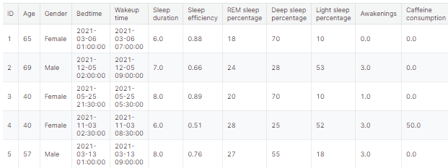

Fig 3. The Dataset for Sleep Analysis

1. *Graphical Analysis*

Graphs will be generated to visualize the relationships between demographic and lifestyle factors and sleep duration. Gender-based analyses will be conducted to compare sleep patterns between male and female participants, while age-based analyses will examine differences in sleep duration across different age groups. Graphs depicting caffeine consumption, alcohol consumption, and physical exercise habits will also be created to explore their associations with sleep duration.

1. *Statistical Analysis*

Statistical analyses will be performed to identify significant associations between demographic and lifestyle factors and sleep duration. Linear regression models will be used to assess the independent contributions of gender, age, caffeine consumption, alcohol consumption, and physical exercise to sleep duration, while controlling for potential confounding variables such as medical history and medication use. Subgroup analyses will be conducted to explore potential interactions between demographic and lifestyle factors.

1. **Is there a relationship between age and sleep efficiency?**

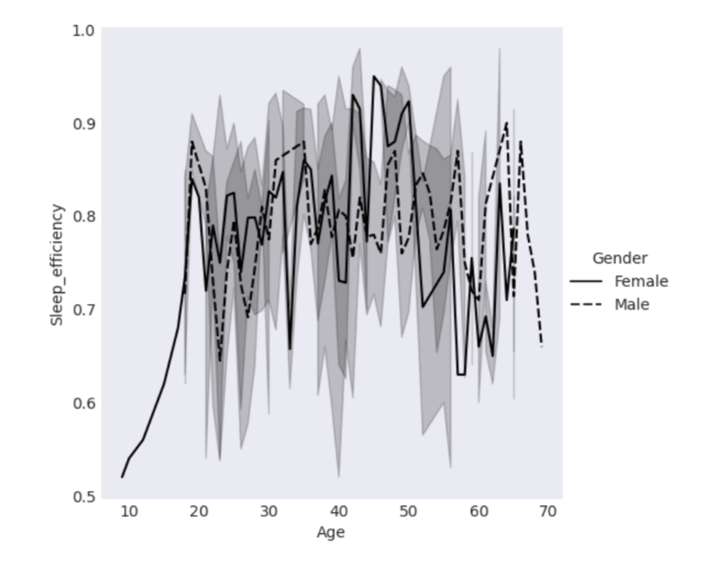

Fig 2. Relationship between age and sleep efficiency

# Our study aimed to explore how age influences sleep efficiency, which measures the effectiveness of transitioning from wakefulness to sleep and maintaining uninterrupted sleep throughout the night. We observed an interesting trend related to sleep efficiency and age, specifically among women and men. Women tended to have higher sleep efficiency in their 50s, while men showed a similar improvement in their 60s.

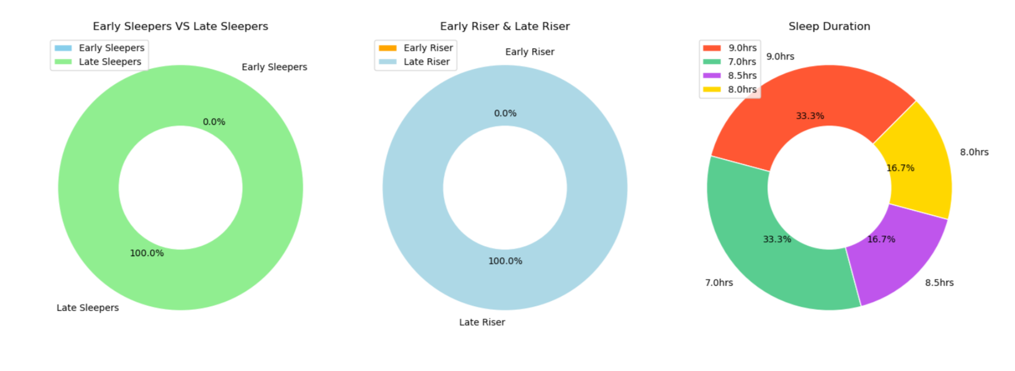

Fig 3. Child Data

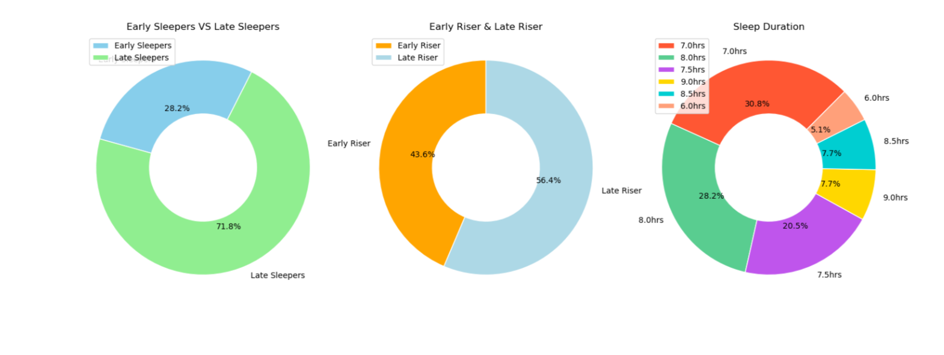

Fig 4. Young Data

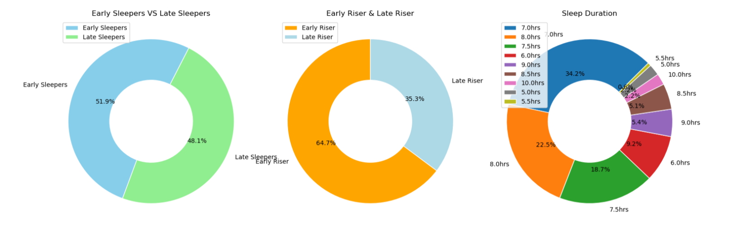

Fig 5. Adult Data

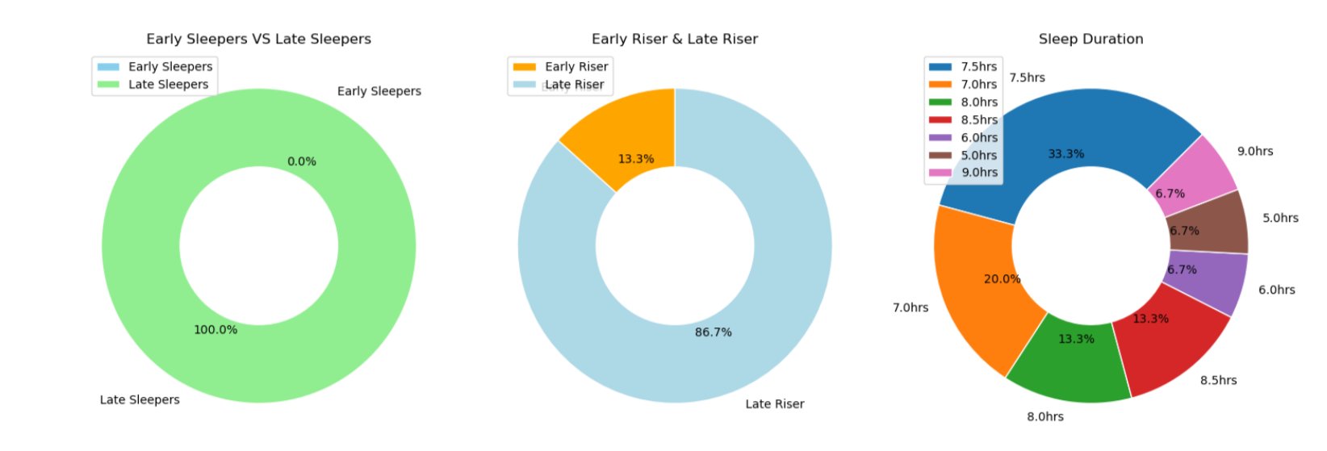

Fig 6. Senior Data

# df.Gender.value_counts() ---------------------------------------------------------------------------

Male 228

Female 224

Name: Gender, dtype: int64

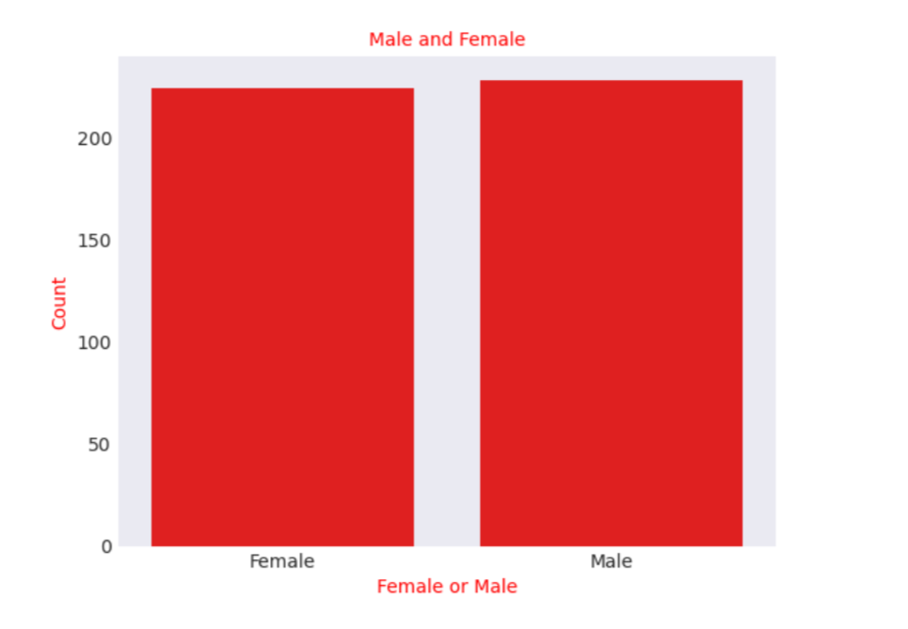

Fig 7. Sleep Efficiency vs Gender

# This relationship between age and sleep efficiency could be attributed to hormonal changes like menopause and andropause, which affect sleep patterns. Additionally, lifestyle adjustments such as retirement or reduced work stress may contribute to better sleep quality in older adults.

# Our findings support existing research indicating that sleep patterns evolve with age, often resulting in more consolidated and efficient sleep among older individuals. These insights emphasize the significance of considering age-related factors when evaluating sleep quality and developing interventions to promote healthy sleep habits throughout life.

# Does smoking affect sleep patterns?

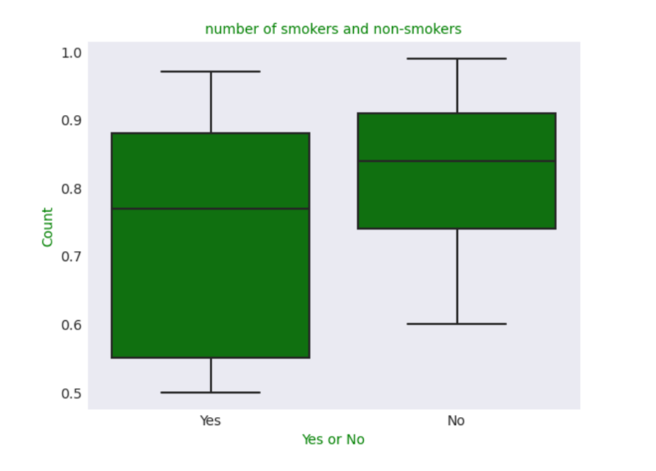

Fig 7. Smokers Count

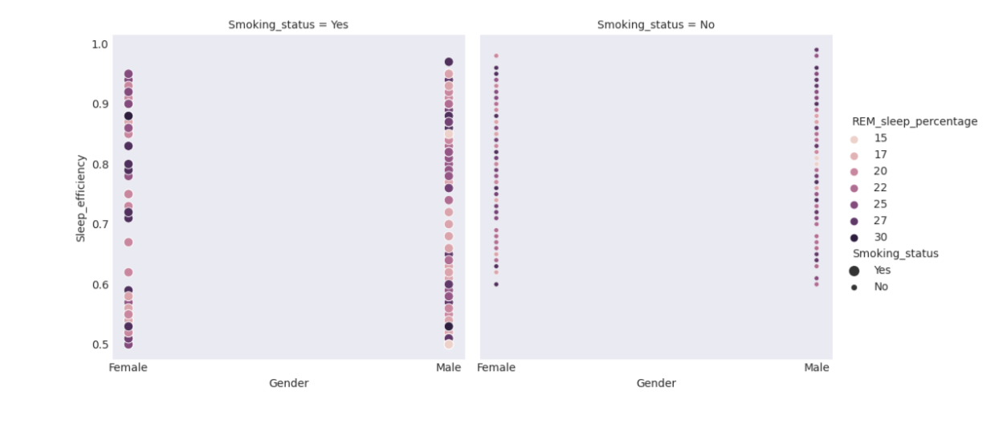

Fig 8. Sleep efficiency of smoker and non smoker on the basis of gender

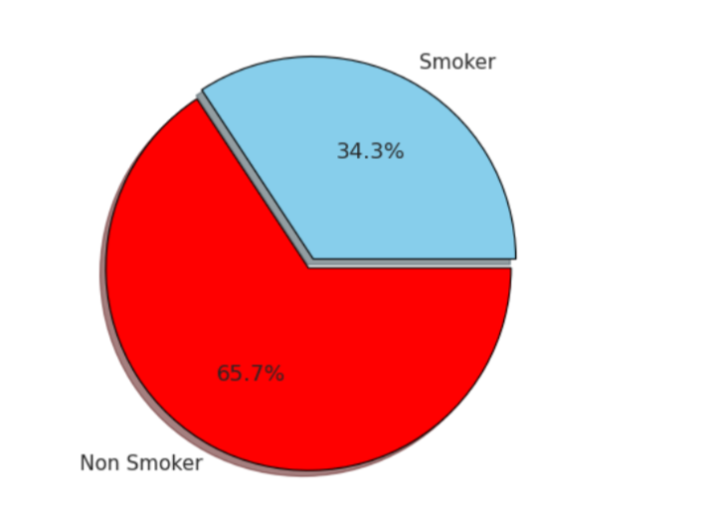

Fig 9. Sleep efficiency of smoker / non smoker

# Our findings show that non-smokers generally have better sleep quality compared to smokers. This suggests that smoking may negatively impact sleep quality, possibly due to the stimulating effects of nicotine and associated lifestyle factors.

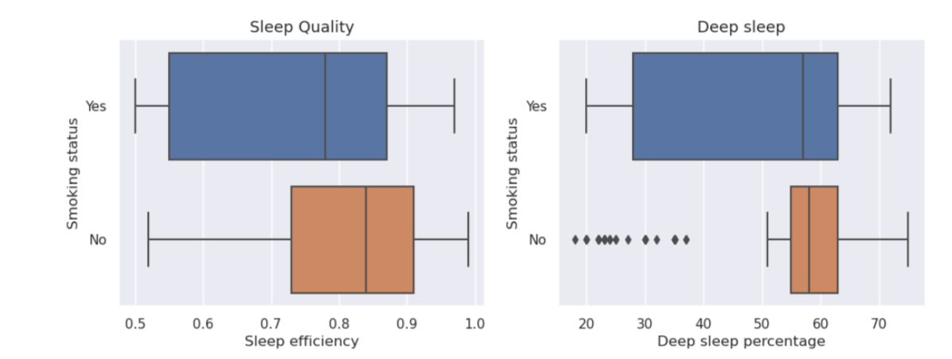

Fig 10. Deep Sleep Percentage vs Smoking Status

# Non-smokers tend to have a higher percentage of deep sleep compared to smokers. This suggests that smoking status may influence the depth of restorative sleep, with non-smokers experiencing more rejuvenating deep sleep stages.

# Smokers, on the other hand, exhibit a lower percentage of deep sleep, indicating a potential impact of smoking on sleep quality. Nicotine and other components of cigarettes may disrupt sleep architecture, leading to shallower and less restorative sleep patterns.

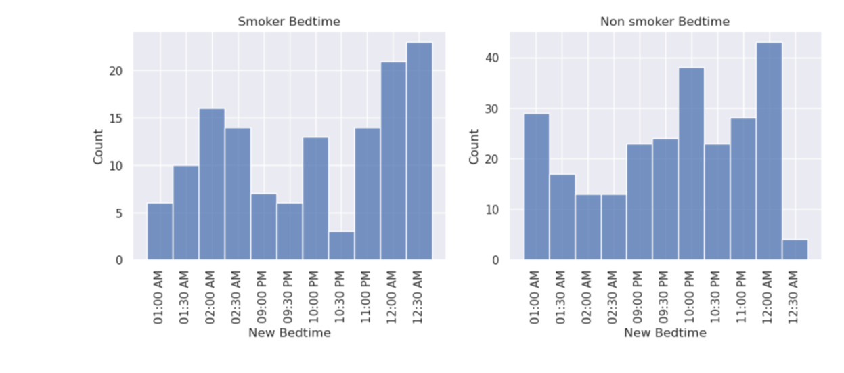

Fig 11. Bedtime of Smoker/Non-Smoker

# Smokers tend to have later bedtimes compared to non-smokers. This could be due to various factors associated with smoking, such as increased stress levels, irregular sleep schedules, or the habit of smoking before bedtime, which may delay the onset of sleep.

# Non-smokers, with earlier bedtimes, may have better sleep hygiene practices and a more consistent sleep schedule, contributing to improved sleep quality compared to smokers.

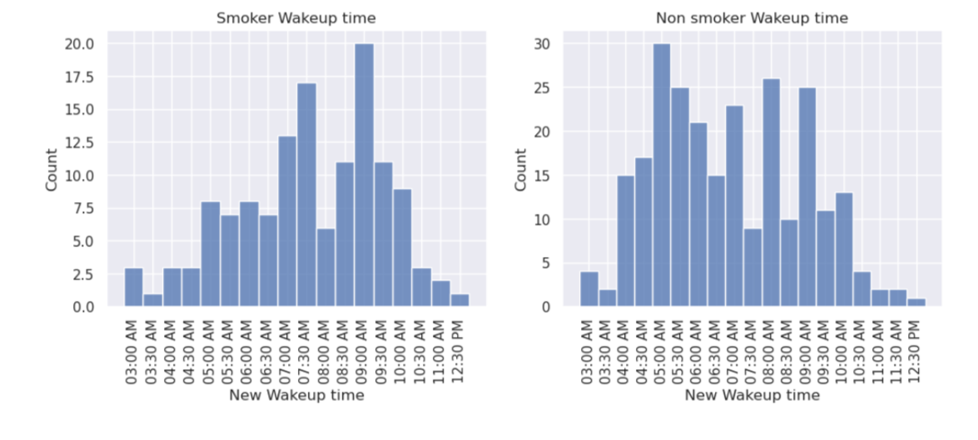

Fig 12. Waketime of Smoker/Non-Smoker

# Concusion1: From above plot we observe that non-smokers have better sleep quality.

# Sleep efficiency for Alcoholic / Non Alcoholic:

# 

Fig 13. Alcoholic Count

# 

Fig 14. Sleep Efficiency vs Alchoholic/Non-Alcoholic

# 

Fig 15. Deep Sleep Percentage vs Alchoholic/Non-Alcoholic

# 

Fig 16. Awakening vs Alchoholic/Non-Alcoholic

# This unexpected finding suggests that while alcoholics may have fewer disruptions in their sleep, the quality of their sleep is lower compared to non-alcoholics. This discrepancy emphasizes the importance of evaluating sleep quality beyond just the number of awakenings, especially in populations with alcohol consumption habits. These insights can guide interventions to improve sleep health in both alcoholic and non-alcoholic individuals.

# Does the number of times you wake up while sleeping have an effect on deep sleep?

# Our findings indicate a clear trend: as the number of awakenings increases throughout the night, there is a noticeable decrease in the quality of deep sleep. This suggests that frequent interruptions during sleep cycles disrupt the natural progression from lighter to deeper stages of sleep. Consequently, individuals who experience more awakenings are likely to have reduced periods of deep sleep, which is crucial for brain restoration, memory consolidation, and hormone regulation.

# This conclusion underscores the importance of uninterrupted sleep for optimal deep sleep quality. It also highlights the potential impact of lifestyle factors, such as alcohol consumption, on sleep continuity and overall sleep architecture. These insights can inform interventions and strategies aimed at improving sleep hygiene and promoting uninterrupted sleep for better health and well-being.

# 

Fig 17. Awakening vs Alchoholic/Non-Alcoholic

# Conclusion2: In a night, the quality of sleep decreases with each waking up.

# Sleep efficiency for Male and Female

# A noteworthy finding emerged regarding sleep efficiency and gender differences. Our data revealed that, on average, males tend to exhibit higher sleep efficiency compared to females. Sleep efficiency is a crucial metric that measures the percentage of time spent asleep while in bed, reflecting how effectively one transitions from wakefulness to sleep and maintains uninterrupted sleep throughout the night.

# Several factors may contribute to this observed gender difference in sleep efficiency. Biologically, hormonal variations between males and females, such as fluctuations in estrogen and testosterone levels, can influence sleep patterns and quality. Additionally, differences in sleep architecture, including the distribution and duration of sleep stages like REM (rapid eye movement) and deep sleep, may play a role in sleep efficiency variations between genders.

# Furthermore, lifestyle factors such as bedtime routines, stress levels, and environmental factors like noise and light exposure can impact sleep quality and efficiency differently for males and females. For example, research suggests that women may be more prone to experiencing sleep disturbances due to hormonal changes during menstruation, pregnancy, or menopause.

# Understanding these gender-related differences in sleep efficiency is crucial for developing targeted interventions and personalized sleep management approaches. By addressing specific factors that contribute to lower sleep efficiency in females, such as stress management strategies or optimizing sleep environments, we can work towards improving overall sleep quality and promoting better health outcomes for both genders.

# 

Fig 18. Sleep Efficiency of male and female

# Conclusion3: Males have higher sleep efficiency than females

1. *Implications for Public Health*

The findings of this study will have important implications for public health interventions aimed at promoting healthy sleep habits and reducing the prevalence of sleep disorders. By identifying modifiable risk factors for inadequate sleep duration, such as excessive caffeine or alcohol consumption, interventions can be developed to target these behaviors and improve sleep quality in at-risk populations. Additionally, insights gained from this study may inform the development of personalized sleep recommendations tailored to individual demographic and lifestyle profiles.

1. *The Framework of the Proposed Work*

The central objective of the study was to assess the severity of sleep quality, and different sleep patterns experienced by individuals. To achieve this, distinct models were developed for each psychological dimension. The initial phase involved preprocessing the data by dropping null records. Subsequently, the distribution of severity levels for each scale was visualized through plotted counts. This exploratory analysis provided valuable insights into the several conditions.

**VI.** **CONCLUSION & FUTURE WORK**

The findings of this study provide valuable insights into the complex interplay between demographic and lifestyle factors and sleep duration. Gender emerged as a significant predictor of sleep duration, with females tending to report longer sleep durations compared to males. Age was also found to be a significant factor, with older adults exhibiting shorter sleep durations on average. Additionally, higher levels of caffeine and alcohol consumption were associated with reduced sleep duration, while regular physical exercise was positively correlated with longer sleep durations.

These findings underscore the importance of considering multiple factors when assessing sleep patterns and designing interventions to improve sleep quality. Public health initiatives aimed at promoting healthy sleep habits should take into account individual demographic and lifestyle profiles, and target modifiable risk factors such as excessive caffeine or alcohol consumption. Moreover, efforts to encourage regular physical exercise may have beneficial effects on sleep duration and overall sleep quality..

Future research in this area could explore additional demographic and lifestyle factors that may influence sleep patterns, such as socioeconomic status, employment status, and stress levels. Longitudinal studies could also be conducted to examine how changes in lifestyle behaviors over time impact sleep duration and quality. Furthermore, intervention studies could be implemented to evaluate the effectiveness of targeted interventions aimed at improving sleep hygiene and reducing the prevalence of sleep disorders in at-risk populations. Finally, advances in wearable technology and mobile health applications offer exciting opportunities for real-time monitoring of sleep patterns and behavior, which could inform personalized interventions and promote more tailored approaches to sleep management.

**REFERENCES**

[1]. "Anxiety, Depression, Stress: Why the Differences Matter | Premier Health." https://[www.premierhealth.com/your-](http://www.premierhealth.com/your-) health/articles/women-wisdom-wellness-

/anxietydepression-stress-why-the-differences-matter (accessed Sep. 20, 2022).

[2]. "Overview of the DASS and its uses." <http://www2.psy.unsw.edu.au/dass/over.htm> (accessed Sep. 20, 2022).

[3]. K. Cherry, "Why Are Statistics Necessary in Psychology?," p. 2.

[4]. N. Shayan, A. Niazi, A. WASEQ, and H. Ozcebe, “Depression, Anxiety, and Stress Scales 42 (DASS- 42) in Dari-Language: Validity and Reliability Study in Adults, Herat, Afghanistan,” *Bezmialem Science*, vol. 9, pp. 356–362, Jun. 2021, doi:

10.14235/bas.galenos.2020.4250.

[5]. A. A. Adetunji and J. A. Ademuyiwa, "Assessing DASS-42 Models among Polytechnic Staff," *Open Access Library Journal*, vol. 6, no. 10, Art. no. 10, Oct. 2019, doi: 10.4236/oalib.1105334.

[6]. A. Priya, S. Garg, and N. Tigga, "Predicting Anxiety, Depression and Stress in Modern Life using Machine Learning Algorithms," *Procedia Computer Science*, vol. 167, pp. 1258–1267, Jan. 2020, doi: 10.1016/j.procs.2020.03.442.

[7]. F. N. Al-Wesabi, H. Alsolai, A. M. Hilal, M. A. Hamza,

M. Al Duhayyim, and N. Negm, "Machine Learning Based Depression, Anxiety, and Stress Predictive Model During COVID-19 Crisis," *CMC-Comput. Mat. Contin.*, pp. 5803–5820, 2022.

[8]. S. T. A. Mary and L. Jabasheela, "An Evaluation of Classification Techniques for Depression, Anxiety and Stress Assessment," presented at the International Conference for Phoenixes on Emerging Current Trends in Engineering and Management (PECTEAM 2018), Atlantis Press, Feb. 2018, pp. 64–69. doi: 10.2991/pecteam-18.2018.13.

[9]. A. Marouf, A. Ashrafi, T. Ahmed, and T. Emon, "A Machine Learning based Approach for Mapping Personality Traits and Perceived Stress Scale of Undergraduate Students," *International Journal of Modern Education and Computer Science*, vol. 11, pp. 42–47, Aug. 2019, doi: 10.5815/ijmecs.2019.08.05.

[10]. T. Singh, "Prediction of Depression, Stress and Anxiety," *International Journal of Research in Engineering, Science and Management*, vol. 5, no. 4, Art. no. 4, May 2022.

[11]. K. S. Srinath, K. Kiran, S. Pranavi, M. Amrutha, P. D. Shenoy, and K. R. Venugopal, "Prediction of Depression, Anxiety and Stress Levels Using Dass- 42," in *2022 IEEE 7th International conference for Convergence in Technology (I2CT)*, Apr. 2022, pp. 1– 6. doi: 10.1109/I2CT54291.2022.9824087.

[12]. R. Chiong, G. S. Budhi, S. Dhakal, and F. Chiong, "A textual-based featuring approach for depression detection using machine learning classifiers and social media texts," *Computers in Biology and Medicine*, vol. 135, p. 104499, Aug. 2021, doi:

10.1016/j.compbiomed.2021.104499

[13]. Y. H. Sun, Q. Liu, N. Y. Lee, X. Li, and K. Lee, "A

novel machine learning approach to shorten depression risk assessment for convenient uses," *Journal of Affective Disorders*, vol. 312, pp. 275–291, Sep. 2022, doi: 10.1016/j.jad.2022.06.035.

[14]. "Depression Anxiety Stress Scales (DASS)." https://[www.psytoolkit.org/surveylibrary/depression-](http://www.psytoolkit.org/surveylibrary/depression-) anxiety-stress-dass.html (accessed Sep. 20, 2022).

[15]. P. F. Lovibond and S. H. Lovibond, "The structure of negative emotional states: comparison of the Depression Anxiety Stress Scales (DASS) with the Beck Depression and Anxiety Inventories," *Behav Res Ther*, vol. 33, no. 3, pp. 335–343, Mar. 1995, doi: 10.1016/00057967(94)00075-u.

[16]. "Anyscale - What is hyperparameter tuning?," *Anyscale*. https://[www.anyscale.com/blog/whatis-](http://www.anyscale.com/blog/whatis-) hyperparameter-tuning (accessed Sep. 29, 2022).

[17]. "Physical Symptoms of Anxiety: What Does It Feel Like?" https://[www.healthline.com/health/physical-](http://www.healthline.com/health/physical-) symptoms-of-anxiety#fa-qs (accessed Jan. 06, 2023)