**“Financial performance of selected companies after GST implementation In india”**

**Shashank dubey And Md Najish shakil * , Ms Smyle**

SCHOOL OF FINANCE & COMMERCE GALGOTIAS UNIVERSITY

**ABSTRACT**

We express our deepest gratitude to all those who contributed to the completion of this research paper on ". FINANCIAL PERFORMANCE OF SELECTED COMPANANIES AFTER IMPLEMENTATION IN INDIA"First and foremost, we extend our sincere thanks to our research supervisor, Smyle , for their invaluable guidance, support, and encouragement throughout this research endeavor. Their expertise and insights have been instrumental in shaping this study. We are also grateful to the faculty and staff of Galgotias University for their assistance and cooperation, which facilitated the smooth conduct of our research. Their support in providing access to resources and facilities is deeply appreciated. Furthermore, we extend our thanks to the participants of this study, whose valuable inputs and feedback have enriched our understanding of the subject matter. Their willingness to share their experiences has been integral to the success of this research. In conclusion, we acknowledge the contributions of all those who have helped us in various capacities, directly or indirectly, in completing this research paper. Thank you all.

**INTRODUCTION**

There is mixed anticipation and different responses on GST from manufacturers, service providers, and different market intermediaries. There is lack of such studies, specifically in the context of India, that provide any empirical support on either positive or negative impact of GST. Thus, the present study sought to empirically analyze the performance of companies after one year of GST implementation. Probability sampling was used to get the relevant sample. A total of 192 BSE listed companies were taken for analysis. Financial parameters (total assets, profit, and market capitalization for FY2017 and FY 2018) and demographic variables (size and experience of companies) were used to analyze the impact of GST roll out. The results indicated that among all three financial parameters, only total assets were significantly different from the pre GST time (FY2017). Further analysis highlighted that age and size of the company also affected the equation and were found significant in influencing the performance of companies after GST implementation. Detailed analysis and results were subsequently discussed in this paper. The study brought forth new insights on effect of new indirect tax regime on financial performance of the companies in order to fill the research gap. The results of the study will be useful for policy makers, strategists, and managers to cope up with the challenges posed by GST

**RESEARCH METHODOLOGY**

**Result Analysis**

41 young respondents provided the primary data, which was gathered. Structured questionnaires are used in conjunction with Google forms, an online survey tool, to collect data using a nonprobability sample strategy. To learn more about the study topic, build a theoretical framework, and formulate research hypotheses, data was also gathered from a variety of secondary sources, including books, magazines, journal articles, websites, reports, working papers, etc..

**Data Collection**

After pinpointing a research problem and crafting the research design, the next step is data collection. When selecting a data gathering strategy for the study, the researcher should contemplate two types of data: primary and secondary.

**Primary Data**

In this study, the survey approach is utilized to gather primary data as it aims to identify areas for development based on the skills needed for the recruitment team. Primary data is information gathered directly from individuals with the intention of aiding the study.

**Primary sources of data include:**

* Personal interviews
* Questionnaire technique
* Questionnaire: Survey among officials and employees of MONARCH
* Personal Interviews with company representatives regarding recruitment and selection practices in the organization

**Secondary Data**

In addition to primary data collection methods, secondary data are also utilized to gather information about the names, positions, and profiles of employers within the organization. Secondary data refers to information obtained by individuals other than the current researcher and can be either internal or external to the company. These data can be accessed online or through previously recorded or published materials.

**Secondary sources of data include:**

* Company brochures
* Internet
* Websites
* Organizational Reports & Records
* Business magazines
* Journals

**DATA ANALYSIS AND INTERPRETATION**

**Interpretation based on responses**

**GENDER:**

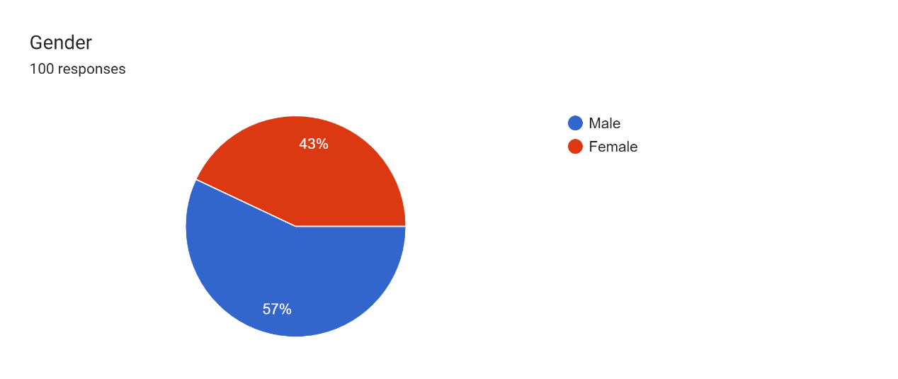

**INTERPRETATION**

100 responses have been collected from the students out of which 43% are females and 57% are males. Hence, more males have responded to the questionnaire.

**AGE**

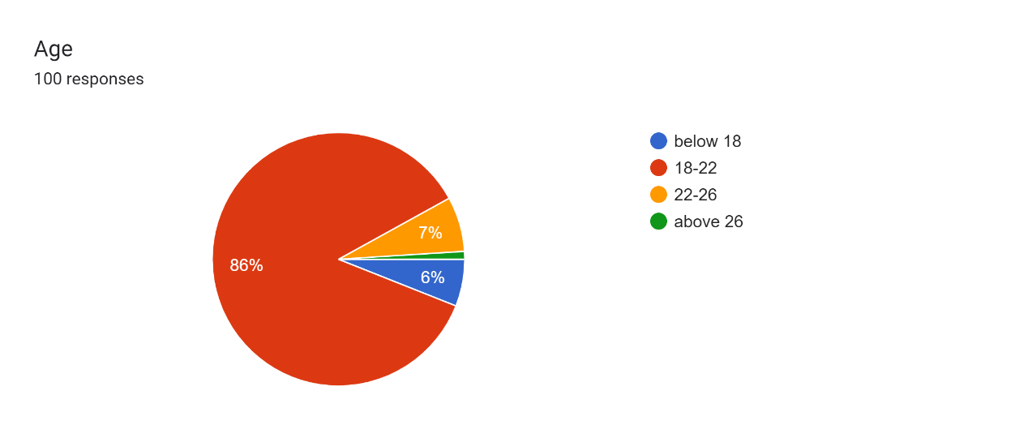**INTERPRETATION:**

100 responses have been collected from the students out of which 86% are of 18-22 ages, 7% are of 22-26 ages, 6% are below 18 ages and 1% are of above 26 ages.

**Introducing Intervals and Live Online Developmental Criticism for Enhanced Learnig**

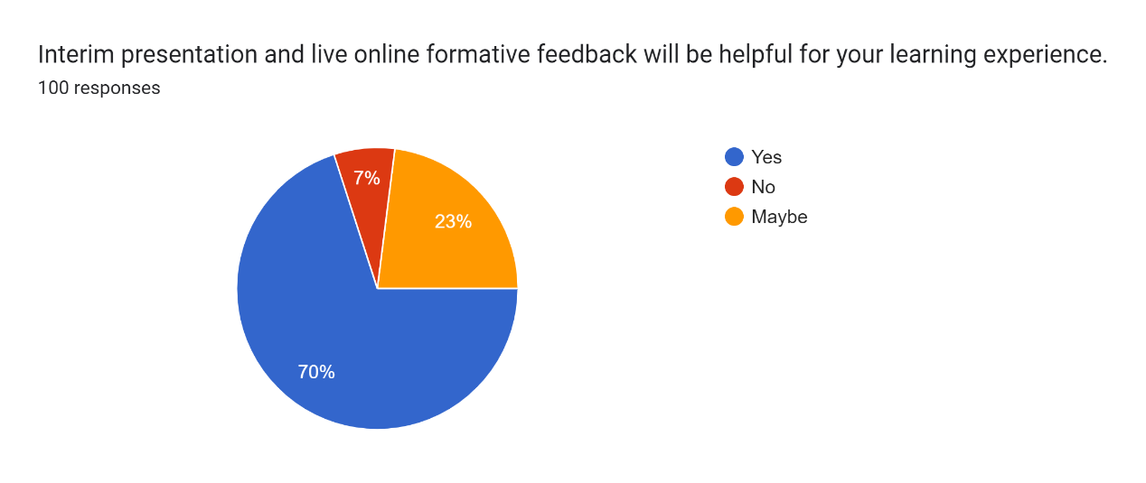

**INTERPRETATION:**

From 100 responses collected from the students, according to 70% respondent satisfied with the statement that interim presentation and online formative feedback will be helpful for your learning experience.

**Students participating in live online sessions should be encouraged to keep their cameras on throughout the duration of the session.**

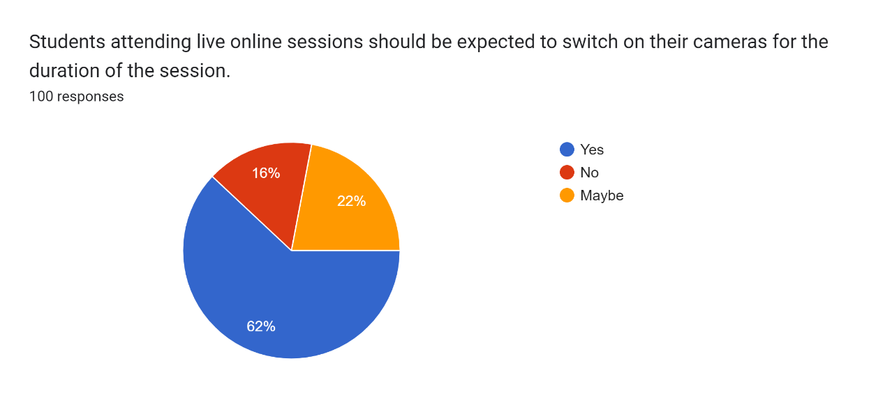

**INTERPRETATION:**

From 100 responses collected from the students, out of which 62% is satisfied with this statement, 22% maybe satisfied with this statement and 16% is not satisfied with this statement. Hence, we can conclude that in online session students must switch on their cameras.

**The computer and technology at your disposal are sufficient for engaging in online learning.**

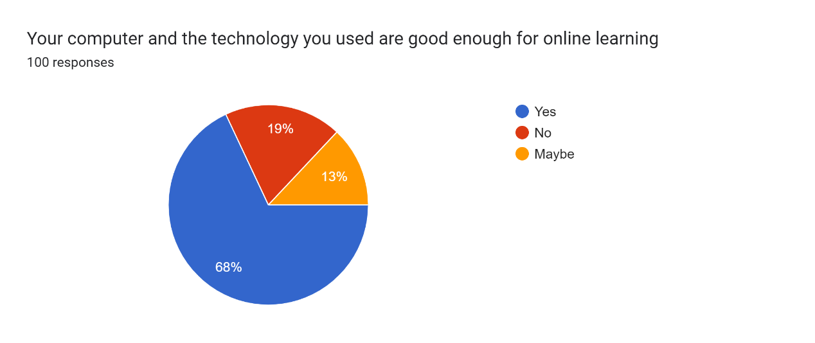

**INTERPRETATION:**

Based on data from 100 student responses, 68% expressed satisfaction with the statement, 19% indicated dissatisfaction, and 13% were unsure. Therefore, it can be inferred that the computer and technology meet the requirements for online learning.

# Your living space or home environment has been suitable for online learning.

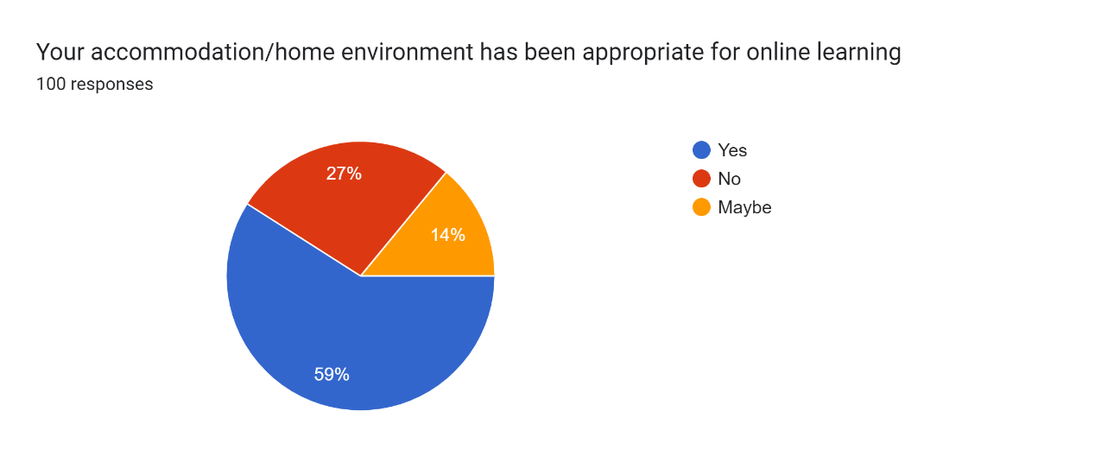

**INTERPRETATION:**

Out of 100 student responses, 59% expressed satisfaction with the statement, 27% indicated dissatisfaction, and 14% were unsure. Therefore, it can be concluded that the home environment has been suitable for online learning.

**What level of satisfaction did you experience regarding the quality of online learning**

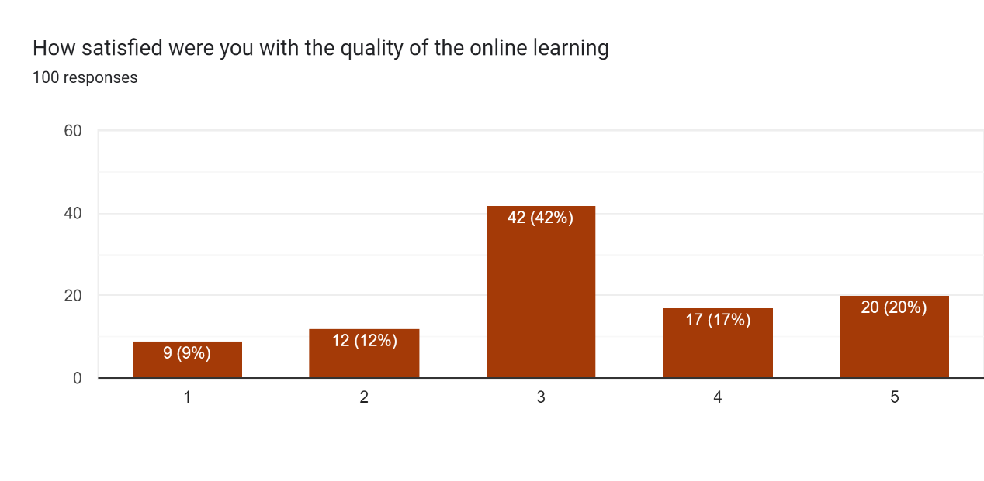

**INTERPRETATION:**

Out of 100 responses gathered from students, 42% of respondents indicated they were neither particularly satisfied nor dissatisfied with the statement, while 20% expressed being highly satisfied with the quality of online learning.

**Participating in live online lectures is deemed more beneficial compared to viewing pre-recorded lectures.**

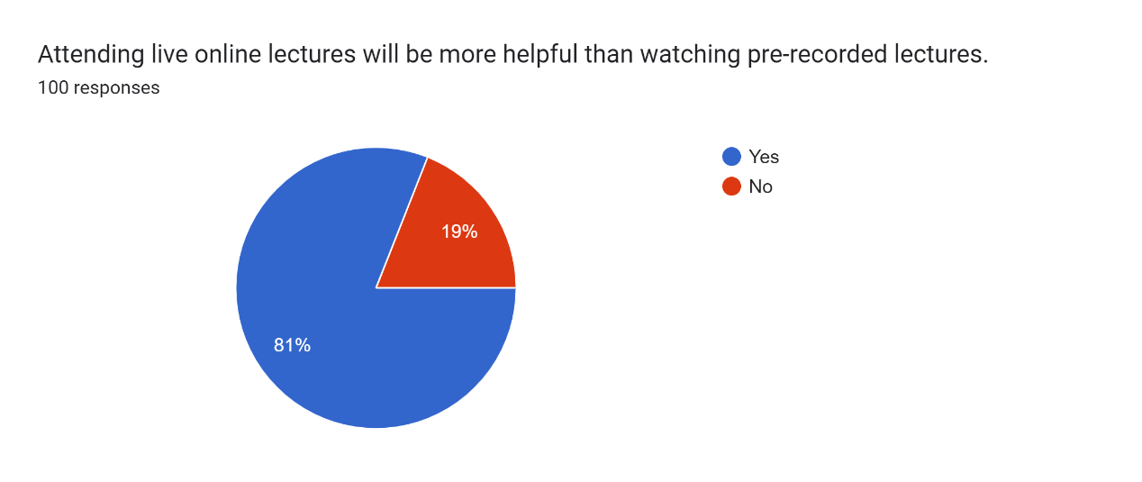

**INTERPRETATION**

Out of 100 student responses, 81% expressed satisfaction with the statement that attending live online lectures would be more beneficial than watching pre-recorded lectures.

# Do you believe that concerns related to GST affect your capacity to learn and study effectively?

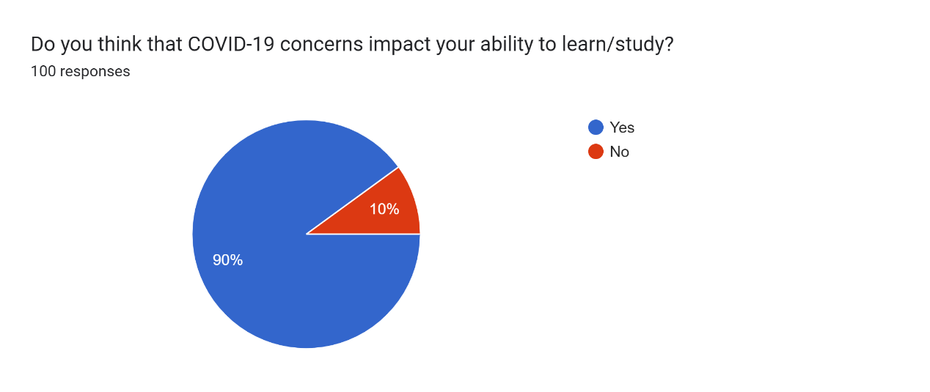

**INTERPRETATION**

From 100 responses collected from the students out of which 90% are satisfied with a statement that covid19 impact our ability to learn/study

**Do you perceive your peers as being actively involved during virtual classroom sessions?**

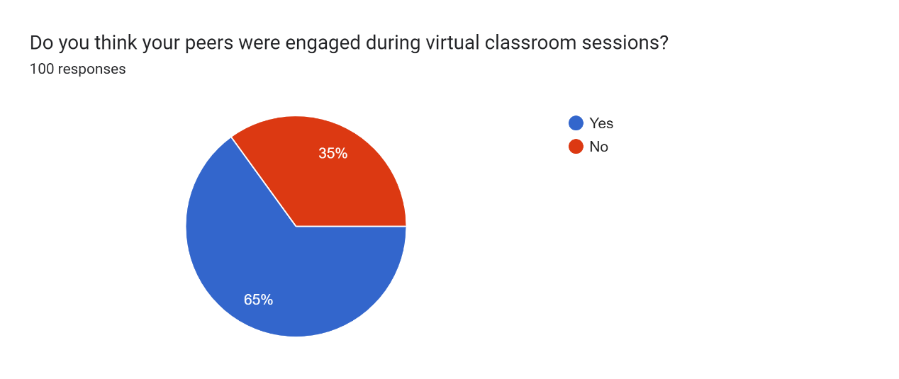

**INTERPRETATION**

From 100 responses collected from the students out of which 65% respondent think that our peers were engaged during virtual classroom sessions and 35% respondent are not satisfied with this statement.

**Do you believe that online learning will continue to be prevalent even after the conclusion of the GST pandemic?**

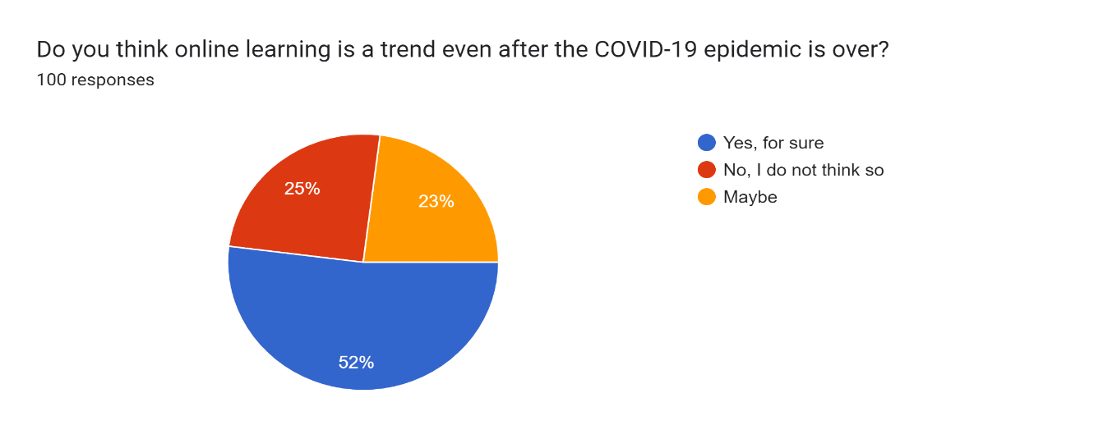

**NTERPRETATION:**

From 100 responses collected from the students out of which are satisfied with the statement that online learning is a trend even after the GST epidemic is over

**Suggestions and Conclusion**

**Conclusion**

The onset of the GST pandemic has prompted a notable transition towards online education as a substitute for conventional classroom-based learning. This shift has introduced several advantages, including enhanced flexibility, accessibility, and convenience. Nevertheless, it comes with its drawbacks, such as reduced social interaction, technical challenges, restricted resource access, limited feedback, and a lack of individualization. To ensure optimal learning outcomes, it is crucial to tackle these limitations and devise strategies to elevate the standard of online education

**Suggestions:**

To enhance the quality of online education, the following recommendations are proposed:

1. Foster Social Interaction: Online education providers should explore avenues to boost social engagement among students, such as virtual discussions, collaborative projects, and peer-to-peer interaction.
2. Ensure Technical Support: Institutions must guarantee that students have access to reliable technology and offer technical support to address any potential issues promptly.
3. Expand Resource Accessibility: Efforts should be made to broaden students' access to pertinent learning materials, including e-books, online libraries, and other educational resources.
4. Enhance Feedback Channels: Institutions should establish efficient feedback mechanisms to ensure students receive timely evaluations on their assignments and assessments.
5. Personalize Learning: Utilizing technology, institutions should tailor learning experiences to accommodate individual learning styles, preferences, and capabilities.
6. Promote Collaborative Learning: Institutions should promote collaborative learning environments by facilitating group projects and assignments that encourage teamwork and shared learning experiences.
7. Facilitate Communication: Effective communication channels should be established between students and instructors, enabling students to seek clarification, ask questions, and receive feedback on their learning progress.

**References**

* [*https://www.sciencedirect.com/science/article/pii/S2452306220302106*](https://www.sciencedirect.com/science/article/pii/S2452306220302106)
* [*https://link.springer.com/article/10.1007/s12528-020-09257-4*](https://link.springer.com/article/10.1007/s12528-020-09257-4)
* [*https://www.tandfonline.com/doi/full/10.1080/08923647.2020.1810030*](https://www.tandfonline.com/doi/full/10.1080/08923647.2020.1810030)
* [*https://www.sciencedirect.com/science/article/pii/S0742051X20303112*](https://www.sciencedirect.com/science/article/pii/S0742051X20303112)
* [*https://www.insidehighered.com/digital-learning/views/2020/06/03/future-online-education-post-covid-world-opinion*](https://www.insidehighered.com/digital-learning/views/2020/06/03/future-online-education-post-covid-world-opinion)
* *<https://www.researchgate.net/publication/349201760_Online_Education_in_the_Post-GST_Era_A_Student_Perspective>*
* [*https://www.uopeople.edu/blog/pros-and-cons-of-online-learning-from-a-students-perspective/*](https://www.uopeople.edu/blog/pros-and-cons-of-online-learning-from-a-students-perspective/)
* [*https://www.frontiersin.org/articles/10.3389/feduc.2021.662296/full*](https://www.frontiersin.org/articles/10.3389/feduc.2021.662296/full)
* [*https://www.ccsenet.org/journal/index.php/jel/article/view/0/45185*](https://www.ccsenet.org/journal/index.php/jel/article/view/0/45185)
* [*https://online-journals.org/index.php/i-jet/article/view/12899/7026*](https://online-journals.org/index.php/i-jet/article/view/12899/7026)
* [*https://www.forbes.com/sites/forbestechcouncil/2020/07/01/the-future-of-online-education-post-GST/?sh=35be44f57304*](https://www.forbes.com/sites/forbestechcouncil/2020/07/01/the-future-of-online-education-post-covid-19/?sh=35be44f57304)
* [*https://unesdoc.unesco.org/ark:/48223/pf0000374316*](https://unesdoc.unesco.org/ark:/48223/pf0000374316)
* [*https://edtechmagazine.com/higher/article/2021/03/impact-GST-education*](https://edtechmagazine.com/higher/article/2021/03/impact-covid-19-education)
* [*https://openknowledge.worldbank.org/handle/10986/35023*](https://openknowledge.worldbank.org/handle/10986/35023)