Proposed Advanced Fault Detection and Localisation System in Transmission Lines using IoT

**Prof. Poonam Chaudhari*1, Manjiri Tote*2, Gaurav Burde*3, Shruti Shende*4, Tejas Ghaiwat*5 , Nayan Dakhole*6 , Utkarsh Shendre*7**

*1Project Guide, Department Of Electronics Engineering, Yeshwantrao Chavan College Of Engineering, Nagpur, Maharashtra, India.

*2,3,4,5,6,7, Department Of Electronics Engineering, Yeshwantrao Chavan College Of Engineering, Nagpur, Maharashtra, India.

**Abstract**

**Now a days, transmission line protection is a key problem in power transmission lines because (85-87) percentage of power system disturbances are occurring in transmission lines. Identification of fault source is tedious task; fast fault detection can help to protect the equipment before any significant damage of the equipment. The exact fault location can help service man to remove persistent of the faults and locate the areas where the faults occur regularly, thus reducing the occurrence of fault and minimize the time of power outages. The paper is intended to detect the location of fault in transmission line using an Arduino board and the same is transmitted to control Centre using Arduino nano device. In this proposed thesis, we sense the current by placing the conducting wire inside the loop of the current transformer and is given to the protective circuit to avoid the high current. This is given to the Arduino Nano(microcontroller). The fire sensor (An IR Receiver) is given to the Arduino to detect the presence of any fire. In case there is a short circuit, the current in the series resistors modifies accordingly to the resistance that modifies with the distance and the load which is connected through a relay to the Arduino is turned OFF when the resistance is below threshold value. In addition, this thesis can also be empowered by using capacitor in the AC circuit to measures the impedance that could also locate the open circuit cable. An LCD display will indicate the status of the transmission lines and buzzer will sound when fault is detected. The SMS alerts will be going to be sent to the corresponding number through GSM Modem.**

**Keywords: Arduino Cloud, Microcontroller, LCD, ESP32S, GPS Module, GSM Module**

# **Introduction**

In overall electrical power system, more than 80% faults occur in transmission line. In this paper the design and implementation of fault detection, classification and protection technique of transmission line are present. When an electrical network, machines and equipments are in operating condition, they suffered by a different types of faults. Whenever the faults occur, the characteristic values of the transmission line may get change from real existing values to another values, until the networks such as lightning, wind, storm, tree falling on line, apparatus failure etc. In our proposed system, the phase voltages and phase current sense by CT & PT and these sensing values are continuously send to the microcontroller. When fault occurred, the insulating path and conducting path get affected which causes the short circuit and open circuit of conductor. During ideal operating condition, the power system equipment operated at normal voltage and current rating. But in faulty condition, the voltage and current values are swing from their reference value. Normally our power system is protected by switch-gear and protection equipments like relays, circuit breaker, fuses to reduce the losses of service due to the electrical failure after the occurrence of faults. Fault: In an electrical power system, a fault or fault current is any abnormal electric current that flows through the line. In three phase system, fault may occur between one or more phases and ground or it may involve only phases.

There are two main types of faults: A. Symmetric fault: This fault is also called as balanced fault. It affects all the three phases of transmission line equally. Approximately 5% faults are symmetric, in total transmission line faults.

B. Asymmetric fault: This type of faults are unbalanced faults. All the three phases of transmission line does not get affected by asymmetric fault.

It is again divided into three types as follows: 1. Line-to-line fault: This fault occurs when there is a short circuit between two lines originated when those two lines comes into physical contact with each other. Roughly 5% are asymmetric L-L fault. 2. Line-to-ground fault: This type of fault occur when there is a short circuit between one line and ground. This happen due to physical contact between line and ground conductor because of storm damages and lightning etc. This is the most frequent fault occur in transmission line faults. 3. Fire detection fault: Whenever the trasmission line and Transformer get sparx or fired then this fault occur. The percentage occurrence of this fault is 15-20%.

# **Background**

There are some Techniques used to find a fault Positive Sequence Voltage Magnitude (PSVM) to detect faults and Positive Sequence Current Angle Differences (PSCADs) to identify their location. Nature and Causes of Faults Nature of a fault is simply defined as any abnormal condition, which causes a reduction in the basic insulation strength between phase conductors, or between phase conductors and earth or any earthed screens surrounding the conductors. In practice, a reduction is not regarded as a fault until is it is detectable, that is until it results either in an excess current or in a reduction of the impedance between conductors, or between conductors and earth, to a value below that of the lowest load impedance normal to the circuit. Thus a higher degree of pollution on an insulator string, although it reduces the insulation strength of the affected phase, does not become a fault until it causes a flashover across the string, which in turn produces excess current or other detectable abnormality, for example abnormal current in an arc-suppression coil.

# **Proposed Work**

An IOT-based transmission line fault detector module is help to find a fault in main ac line they used basic terms to successfully complete that task. Basic Architecture, Hardware component and Software component.

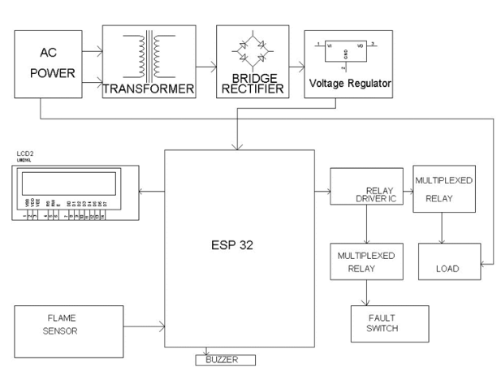**Block Diagram**

**Figure 1:** Block Diagram.

This block diagram illustrates the typical data flow and process structure for an IoT-based transmission line fault detector system, helping to visualize the relationships between different components and how they work together to detect and address faults. In block diagram shows in Fig.1 multiple blocks to indicte all Features of that system. Overall, this project aims to ensure a quick response to faults in power transmission lines by using Arduino-based monitoring and GSM-based communication, enabling efficient maintenance and minimizing downtime.

• Sensor Data Acquisition: The system uses sensors to measure various parameters along the transmission line. Commonly monitored parameters include voltage, current, temperature, and sometimes other environmental factors.

• Data Processing and Analysis: The sensor data is collected by a microcontroller (such as Arduino) that is programmed with fault detection algorithms. The microcontroller continuously reads the sensor values and processes the data to identify any anomalies.

• Fault Detection Algorithms: The fault detection algorithms compare the real-time sensor data with predefined thresholds or patterns of normal behavior. For example, if the current exceeds a certain limit or if there is a sudden voltage drop, it might indicate a fault.

• Fault Identification: If the algorithms detect abnormal conditions that match the criteria for a fault, the system flags the presence of a fault on the transmission line.

**Hardware Description:**

The fundamental components of this system are an Arduino UNO Controlled Board, a GSM Modem, an LCD Module, and a Fault Sensing Circuit.

* 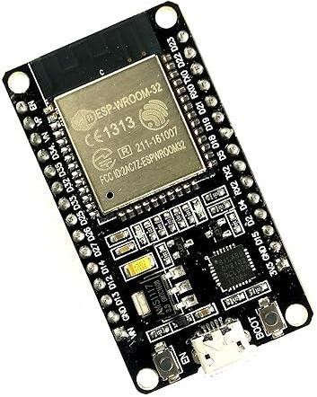ESP32S Wireless Bluetooth Wi-Fi Module: ESP32 is a single 2.4 GHz Wi-Fi and Bluetooth combo chip designed with TSMC ultra-low-power 40 nm technology. It is designed to achieve the best power and RF performance, robustness, versatility, and reliability in a wide variety of applications and different power profiles. ESP32 is a highly-integrated solution for Wi-Fi + Bluetooth applications in the IoT industry with around 20 external components. ESP32 integrates the antenna switch, RF balun, power amplifier, low noise receive amplifier, filters, and power management modules. As such, the entire solution occupies minimal Printed Circuit Board (PCB) area.

**Figure 2:** ESP32S Wireless Bluetooth Wi-Fi Module.

* GSM Modem: GSM is abbreviated as Global System for Mobile Communications. It is a set of protocols produced by the European Telecommunications Standards Institute (ETSI) for second-generation (2G) digital cellular networks used by mobile phones. A Modem is a device that modulates and demodulates signals to suit communication needs. It encodes digital information by modulating an analog carrier signal and demodulates the transmitted information by demodulating the same carrier signal. GSM modem is a device that modulates and demodulates GSM signals, including 2G signals in this case . SIMCOM SIM800 is the modem we're utilizing. It's called a Tri-band GSM/GPRS Modem because it can identify and operate on three different frequencies EGSM 900 MHz, DCS 1800 MHz, and PCS1900 MHz EGSM 900MHz and DCS 1800MHz are the default operational frequencies. The Sim800 GSM module used here has both a TTL and an RS232 interface. The TTL interface allows us to communicate directly with a microcontroller, but the RS232 interface uses a MAX232 IC to communicate with a computer. A buzzer, antenna, and SIM slot are also included.

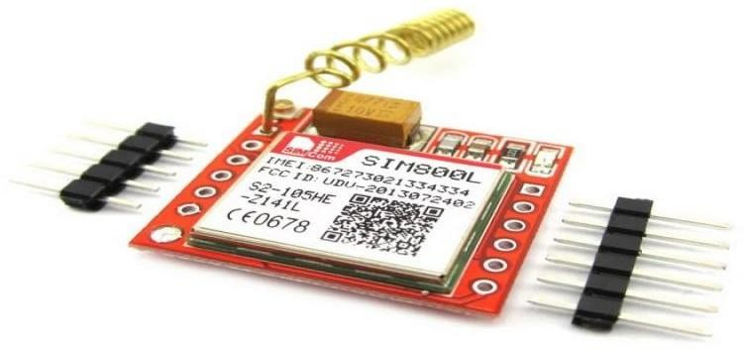

**Figure 3:** GSM Modem

* 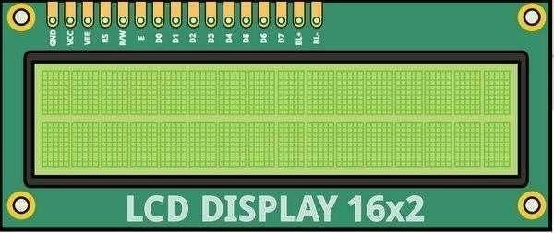LCD Module: A liquid-crystal display (LCD) is a flat-panel display that makes use of liquid crystals' light-modulating abilities. The LCD screen consumes less energy and can be discarded more safely than a CRT. Because of its low electrical power consumption, it can be used more efficiently in battery-powered electronic equipment than CRTs. A 16x2 LCD is a very basic module that can be found in a variety of devices and circuits. Seven-segment and other multi-segment LEDs are preferred over these modules. The reasons for this are as follows: LCDs are inexpensive; they are simple to program; they have no restrictions on displaying special and even custom characters (unlike seven segments), animations, and so on . A 16x2 LCD contains 16 characters per line on each of its two lines. Each character is displayed in a 5x7 pixel matrix on this LCD. The two registers on this LCD are Command and Data. The LCD command instructions are stored in this command register. A command tells the LCD to perform a specific task, such as initializing it, clearing its screen, setting the cursor position, controlling the display, and so on. The data to be displayed on the LCD is stored in this data register.

**Figure 4:** LCD Display

* Flame Sensor: A flame detector is a sensor that detects the presence of a flame or fire and responds accordingly. Sounding an alarm, deactivating a fuel line like a propane or natural gas line, and activating a fire suppression system are all possible responses to a detected flame, depending on the installation . When used in applications like industrial furnaces, their job is to ensure that the furnace is properly lit; they don't do anything other than sending intimation to the operator or control system in these cases. Because of the mechanisms, 93 International Journal for Modern Trends in Science and Technology it uses to detect the flame, a flame detector can often respond faster and more accurately than a smoke or heat detector.

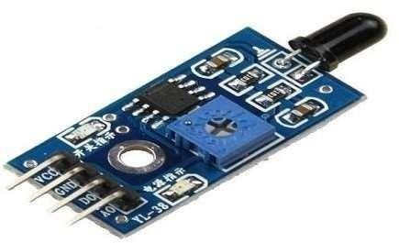

**Figure 5:** Flame Sensor

* Software Requirement: Arduino IDE Compiler: The Arduino integrated development environment (IDE) is a Programming language cross platform application that runs on Windows, Mac OS X, and Linux. It's used to write and upload programs to Arduino compatible boards, as well as other vendor development boards with the help of third-party cores . The Arduino IDE supports the languages C and C++ and organizes code using special rules. Wiring from the Wiring project is a software library included with the Arduino IDE that provides many common input and output procedures. A typical Arduino C/C++ sketch consists of two functions that are compiled and linked into an executable cyclic executive programmed with the help of a programmed stub main ():

• setup (): a function that can initialize settings and runs once at the start of a program.

• loop (): a function that is called until the board turns off. The Arduino IDE uses the programmed argued to convert the executable code into a text file in hexadecimal coding that is loaded into the Arduino board after compiling and linking with the GNU toolchain, which is also included with the IDE application.

# **Result & Analysis**

* The transmission line fault detection mechanism will start working as soon as it detects any fault along the transmission lines. This fault can be an open circuit fault such as a line-to-ground or a breakage in the transmission line, or this fault can be a short circuit fault such as line-to-line fault.
* Another type of fault is the fire detection fault, which when an fire erupts near the transmission line, the flame sensor detects this fault and then sends the warning in the form of an SMS to the nearest base station, with the exact location of fire near the transmission line.
* The sensors along the transmission lines will be able to detect the exact type of fault such as in a three phase system, which are, line1-to-ground, line2- to-ground, line- to-line fault, or a fire fault. And it will then send this data to the ESP32 microcontroller which will process the fault and then determine exactly what is the type of fault and then it will forward this information to the GSM module, this GSM module will then send the SMS to the registered phone number.This is an IoT based project so we will also be able to view the fault using the internet. On the app we will be able to see the exact type of fault and its exact location.

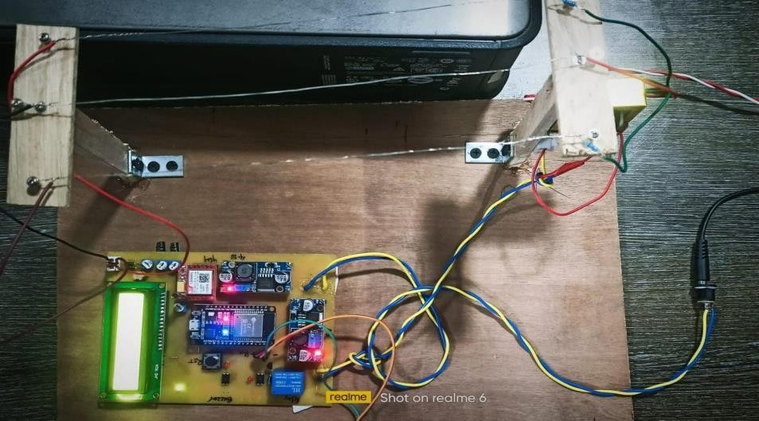

**Figure 6:** Working Model

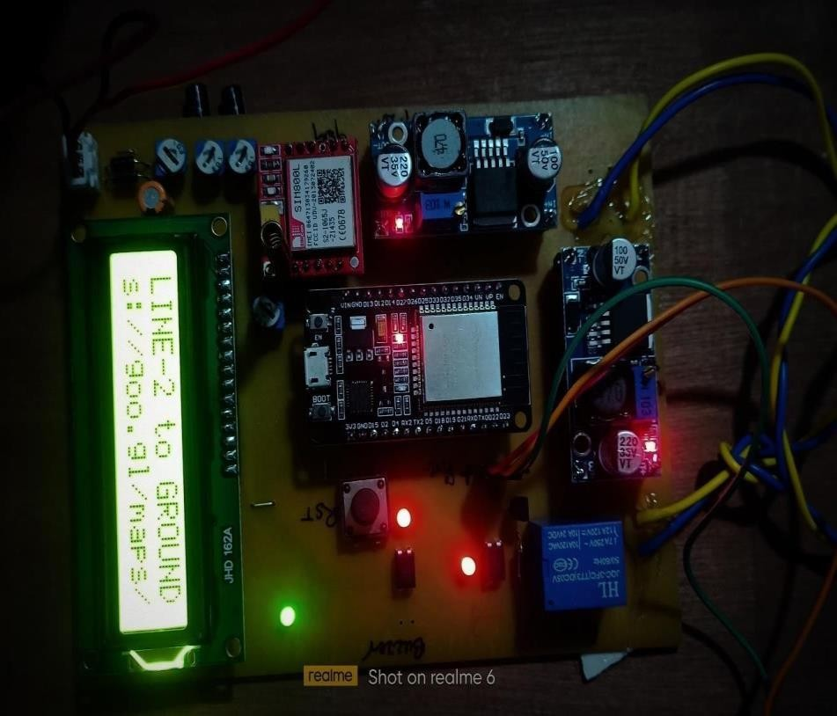

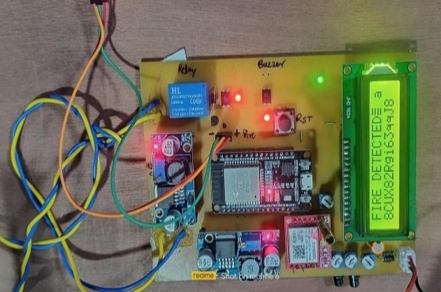

**Figure 7**: Image Showing Fire Fault Detected **Figure 8:** Image Showing the Line to Ground Fault Detected

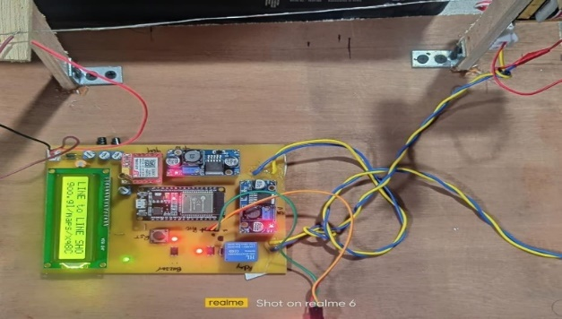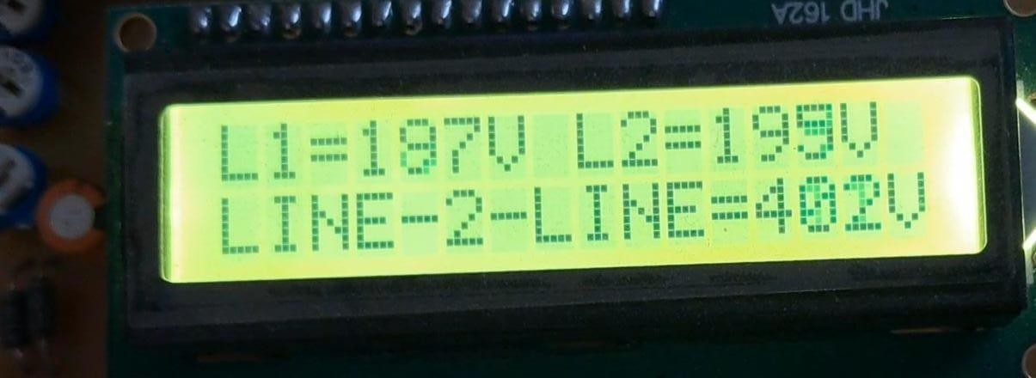

**Figure 9:** Image Showing the Line to Line Fault **Figure 10:** The above image shows the live tracking of Detected voltage in transmission lines.

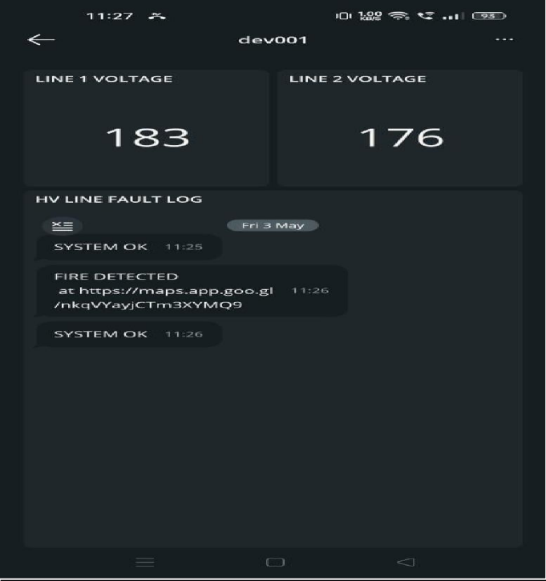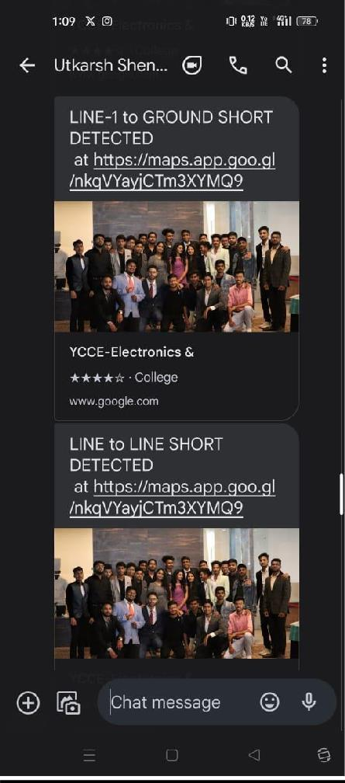

**Figure 11:** Image showing type of fault detected **Figure 12:** Image showing the live tracking of voltages and location of the Fault in the transmission lines and status of the system

# **Conclusion**

In conclusion, transmission line fault detection systems represent a crucial component of modern electrical infrastructure, offering significant societal benefits. By ensuring the reliability and safety of power supply, these systems mitigate disruptions to essential services and prevent accidents, thereby safeguarding communities. Moreover, they contribute to improved energy accessibility, supporting economic development and social welfare. Environmental protection is another key aspect, as fault detection systems help minimize the environmental impact of faults and promote sustainability. Additionally, they play a vital role in disaster preparedness and response, aiding in rapid restoration of power supply during emergencies. Through technological innovation and knowledge sharing, these systems drive advancements in the energy sector, fostering progress and resilience. Overall, transmission line fault detection systems are essential for enhancing the overall well-being and prosperity of societies, ensuring equitable access to electricity and promoting sustainable development.

# **References**

1. N. Dhanalakshmi and Dinesh Reddy Sunkari, "DESIGN OF IOT BASED TRANSMISSION LINE FAULT MONITORING SYSTEM", Journal of Electrical Engineering and Technology (IJEET)*,* vol. 12, no. 6, pp. 336-345, 2021.
2. N. Murugan, J. S. Senthil Kumar, T. Thandapani, S. Jaganathan and N. Ameer, "Underground Cable Fault Detection Using Internet of Things (IoT)", Journal of Computational and Theoretical Nanoscience*,* vol. 17, no. 8, pp. 3684-3688, 2020.
3. Lakshmi Goswami and Piyush Agrawal, "IOT based Diagnosing of Fault Detection in Power Line Transmission through GOOGLE Firebase database", 2020 4th International Conference on Trends in Electronics and Informatics (ICOEI) (48184)*,* pp. 415-420, 2020.
4. R Navaneetha Krishna, Babugouda R J, Vannesh B M, Md. Shamim, Khan, “Transmission Line Fault Monitoring System”, JETIR, Vol.6 issue 5, May 2021, ISSN 2349-5162.
5. Hussain, Aziza Ibrahim, and Ahmed ZakariaSayed, "Optimal User Association of LTE/WiFi/Wi-Gig Bands in 5G Cellular Networks." International Journal on Semantic Web and Information Systems (IJSWIS) 17, no. 2 (2021): 22-40.
6. L. Goswami, M. K. Kaushik, R. Sikka, V. Anand, K. Prasad Sharma, and M. Singh Solanki, “IOT Based Fault Detection of Underground Cables through Node MCU Module,” 2020 International Conference on Computer Science, Engineering and Applications, ICCSEA 2020, 2020.
7. M. Kocakulak and I. Butun, "An overview of Wireless Sensor Networks towards internet of things," 2020 IEEE 7th Annual Computing and Communication Workshop and Conference (CCWC), Las Vegas, NV, USA, 2020, pp.1-6.
8. Jindal, Vandana. "History and architecture of Wireless sensor networks for ubiquitous computing." International Journal of Advanced Research in Computer Engineering & Technology (IJARCET) 7.2 (2019): 214-217
9. S.Suresh, R.Nagarajan, L.Sakthivel, V.Logesh, C.Mohandass, G.Tamilselvan, Department of Electrical and Electronics Engineering, Gnanamani College of Technology, Namakkal, India “Transmission Line Fault Monitoring and Identification System by Using Internet of Things”, International Journal of Advanced Engineering Research and Science (IJAERS), [Vol-4, Issue-4, Apr- 2018], ISSN: 2349-6495(P) | 2456-1908
10. M. Singh, B. K. Panigrahi, and R. P. Maheshwari, “Transmission line fault detection and classification,” 2018 International Conference on Emerging Trends in Electrical and Computer Technology, ICETECT 2011, pp. 15–22, 2018.
11. A. Cozza and L. Pichon, “Echo Response of Faults in Transmission Lines: Models and Limitations to Fault Detection,” IEEE Transactions on Microwave Theory and Techniques, vol. 64, no. 12, pp. 4155–4164, 2018.
12. P.A. Gulbhile, J.R. Rana, B.T. Deshmukh, “Review for overhead line fault detection using GSM technology”, International Journal of Advanced Research in Electrical, Electronics and Instrumentation Engineering,Volume5, Issue12, December 2018 ISSN 2278-8875.
13. K. Saravanababu, P. Balakrishnan and K. Sathiyasekar, "Transmission line faults detection, classification, and location using Discrete Wavelet Transform," 2019 International Conference on Power, Energy and Control (ICPEC), Sri Rangalatchum Dindigul, 2019, pp. 233-238
14. Doshi, D. A., et al. "Real time fault failure detection in power distribution line using power line communication." International Journal of Engineering Science 4834 (2016).