**AUTOMATED HEALTH MONITORING AND FOOD SUPPLY SYSTEM FOR POULTRY FARMING**

**Santhosh T*1 , Sanjana B V *2, Tejashwini N*3, Varsha G V*4, Varsha V Belagavi*5**

*1Professor, Department of Information Science and Engineering, Bapuji Institute of Engineering and Technology, Davangere, Karnataka, India.

*2,3,4,5 Student, Department of Information Science and Engineering, Bapuji Institute of Engineering and Technology, Davangere, Karnataka, India.

# ABSTRACT

# 

One of the most significant and rapidly expanding economic sectors of India's agriculture industry at the moment is poultry. Modern farming management standards and efficient manufacturing techniques have led to a steady rise in chicken output worldwide. Automation is essential in today's environment, and the idea of the Internet of Things (IOT) is growing rapidly. There are efforts underway to transform manual processes into automated ones. Numerous obstacles plagued traditional poultry farming techniques. The primary obstacles include labor-intensive procedures, a plentiful food supply, the impact on the environment, managing diseases, etc. To address these problems, intelligent poultry farming was developed. In this study, we present a the little, four-wheeled robot. Our innovative method gives user complete control over their poultry farming operation by making it simple to control the robot's movements, supervise food feed distribution using an IOT sensor to monitor a number of characteristics, including the temperature and humidity level of the poultry. Farmers can use this information to spot problems early and take the appropriate action. and also With the use of an intuitive mobile-friendly on the web interface, user can precisely control the robot's movement and manage feed distribution. This technology-based approach for the economical, asset-saving, quality-focused, and efficient management of poultry framing is highlighted in this work.

# INTRODUCTION

Among the agriculture industry's most dynamic and quickly growing industries in India, the poultry industry has seen tremendous expansion in recent years. Modern farming management standards and the use of effective manufacturing techniques contribute for this rise. Automation and the emerging idea of the Internet of Things (IoT), which is transforming traditional poultry farming methods, are key components of this transformation.

Conventional poultry farming practices have long faced a number of difficulties, such as labor-intensive procedures, guaranteeing a steady supply of food, negative effects on the environment, managing disease, and more. The paradigm of intelligent poultry farming emerged as a means of overcoming these challenges. This creative method turns manual procedures into automated ones by combining automation with the emerging idea of the Internet of Things (IoT). The advent of the little, four-wheeled robot is at the forefront of this evolution.

Our report offers an innovative approach that gives users total control over their poultry farming business. user can now regulate motions and oversee food distribution with unprecedented ease thanks to the small robot. With its Internet of Things (IoT) sensors, the robot keeps an eye on vital parameters like temperature and humidity in the farming environment, allowing user to identify problems early and take appropriate action.

# LITERATURE SURVEY

1. Archana M P1, Uma S K2

**“Monitoring and controlling of poultry farm using IOT”**

International Conference on Computer & Communication Engineering, May 2016. The goal of this is to provide abundant and high-quality meals by collecting, organizing, and controlling the data related to the chicken farm. This method was developed to solve several problems associated with chicken farms, such as the need for multiple human workers to oversee the farm, excessive maintenance expenses, and inaccurate data gathered all at once. The recommended technique plays a major role in doing this project in the allocated time. For the management of chicken framing, a technology-based strategy that is economical, asset-saving, quality-focused, and efficient is recommended.

1. Geetanjali A. Choukidar, Prof. N.A. Dawande

“Smart poultry farm automation and monitoring system”

IEEE, June 2017. This work illustrates how sensors are used to control temperature, water level, gas, smoke, and food distribution. They are all connected to the Raspberry Pi, which is capable of controlling every sensor and monitoring every bit of data. All of the information about the poultry farm and the state of the environment is kept on a webpage, and it is sent via GPRS.

1. Raghudathesh G P1, Deepak D J2

“IOT based intelligent poultry management system using Linux embedded system”

IEEE, Aug 2017. The primary focus of the study is the automation of chicken farms through the use of mobile communication systems and wireless sensor networks. The autonomous monitoring and control of environmental variables like temperature, humidity, and ammonia gas is another topic covered in this study.

# PROBLEM STATEMENT

Traditional poultry farming methods confront a variety of difficulties that call for all-encompassing solutions in order to move the sector toward increased sustainability and efficiency. Manual feeding and monitoring are two labor-intensive processes that put a load on resources and prevent scaling. Furthermore, maintaining a steady and efficient supply of food for poultry while reducing waste is still a logistical and financial difficulty. Growing environmental issues including pollution and resource depletion highlight the need for more environmentally friendly farming methods.

# EXISTING SYSTEM

In poultry farming nowadays, a lot of work is done by hand to complete tasks like feeding and environmental monitoring. Feed is manually distributed by farmers, which might result in inconsistencies and inefficiencies in feeding procedures. The majority of temperature and humidity monitoring in the poultry environment is done by hand, which could cause delays in problem detection. Due to their limited automation and remote monitoring capabilities, farmers frequently struggle to maximize output and quickly solve issues. All things considered, the current method is deficient in the accuracy, efficacy, and real-time data insights required for current management of chicken farms.

# PROPOSED SYSTEM

The proposed approach integrates mobile, IoT, and robotic technologies to bring an innovative approach to managing chicken farms. A small, four-wheeled robot with Internet of Things (IoT) sensors is used to monitor temperature and humidity levels in the poultry environment and to properly distribute feed. Farmers are then able to precisely adjust feed distribution and remotely operate the robot's movement thanks to the transmission of this data to an intuitive mobile web interface. The suggested system seeks to improve efficiency, productivity, and sustainability in the poultry farming business by optimizing feed consumption, streamlining operations, and enhancing environmental management through the use of automation and real-time monitoring.

# SYSTEM ARCHITECTURE

**Arduino uno**

**Power supply**

**DTH 11**

**Dispenser**

**ESP8266 microcontroller**

**Web page**

**MOBILE**

**SERVER**

**INTERNET**

The user interacts with a web page, likely on a mobile device.

The web page communicates with a server on the internet, possibly to place an order or trigger a mechanism.

The server communicates with the ESP8266 microcontroller. The ESP8266 is a Wi-Fi Microcontroller, which means it can connect to the internet via Wi-Fi.

The ESP8266 microcontroller communicates with the Arduino Uno microcontroller. Arduino Uno is a popular open-source microcontroller board based on the ATmega328P chip.

The Arduino Uno microcontroller controls the DTH11 sensor and dispenser. The DTH11 sensor might be used to sense a condition, such as temperature or humidity. The dispenser dispenses a liquid or other substance.

Overall, this system appears to be designed to dispense a substance based on a user’s input on a web page. The exact function would depend on the specific programming of the microcontrollers and the web page.

# FLOWCHART

**access web page via local server**

**If dispenser ON/OFF**

**User clicks on dispenser button**

**Robot feed the food**

**Robot stops feeding**

**User checks temperature**

**View in webpage**

Flowchart outlines a basic process for how a web-controlled robot might function. The user interacts with a webpage to either view a camera feed or send commands to the robot. The robot processes these commands and sends the requested information back to the user.

# IMPLEMENTATION

Implementing automated food supply and health monitoring systems in poultry farming using IoT involves several steps:

**Identify Requirements**: Define the specific needs and goals of the system, such as monitoring feed levels, water supply, temperature, humidity, and health parameters of the poultry.

**Select Sensors**: Choose appropriate sensors for monitoring parameters like temperature, humidity, feed levels, water supply, and health indicators such as heart rate, respiratory rate, and activity levels of the poultry.

**IoT Platform Selection**: Select an IoT platform or framework that supports the required functionalities and can integrate with the chosen sensors.

**Hardware Setup**: Install sensors in the poultry house or barn according to the layout and requirements. Ensure they are properly calibrated and connected to the IoT platform.

**Data Transmission**: Set up a reliable communication network (e.g., Wi-Fi, LoRaWAN, or cellular) to transmit data from sensors to the IoT platform securely and in real-time.

**Data Processing and Analysis**: Develop algorithms or use machine learning models to process and analyze the data collected from sensors. This can include anomaly detection, predictive maintenance, and health condition monitoring.

**Integration with Control Systems**: Integrate the IoT system with control systems for automated feed dispensing, water supply management, ventilation control, and other necessary functions based on the analyzed data.

**Alerts and Notifications:** Implement an alerting system to notify farmers or operators about any abnormalities or critical conditions detected by the IoT system via SMS, email, or mobile app notifications.

**User Interface Development:** Develop a user-friendly interface for farmers or operators to visualize the data, control the system, and receive alerts and notifications. This can be a web-based dashboard or a mobile application.

**Testing and Deployment**: Thoroughly test the system in a controlled environment before deploying it in the actual poultry farm. Fine-tune algorithms and system configurations based on feedback and performance evaluation.

**Training and Maintenance**: Train farm personnel on how to use the system effectively and provide ongoing maintenance and support to ensure its smooth operation.

**Continuous Improvement**: Regularly update the system based on feedback, technological advancements, and changing requirements to enhance its performance and functionality over time.

# RESULTS

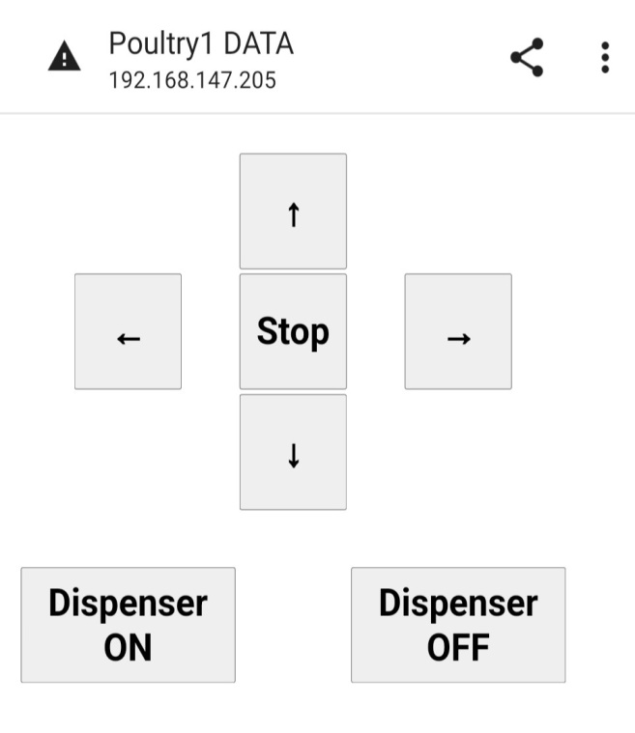

**FIG: WEB PAGE OF POULTRY CONTROLLER**

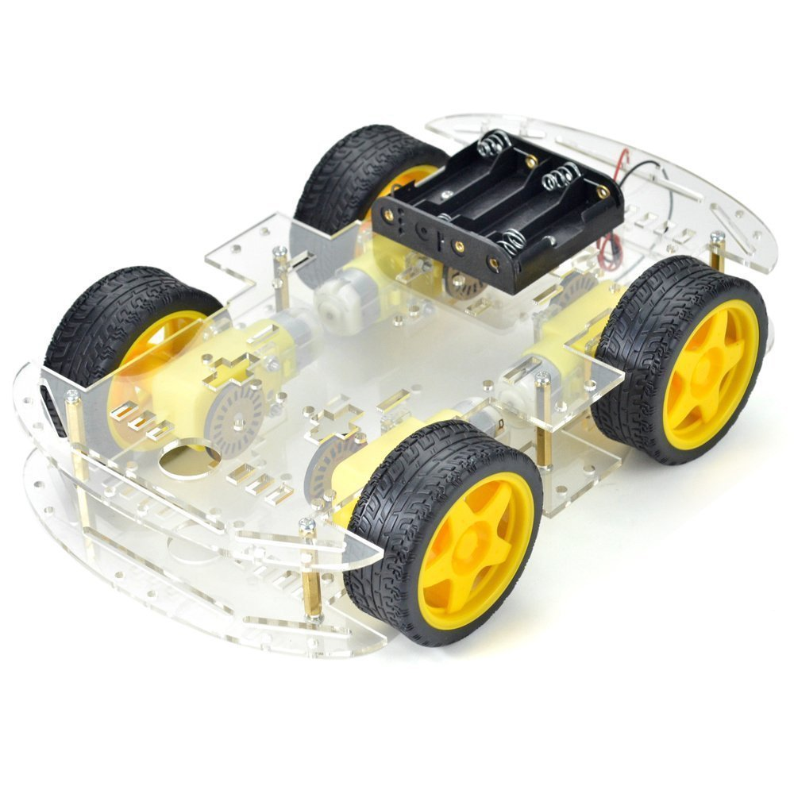

**Fig: CHASSIS 4 WHEELED DRIVE**

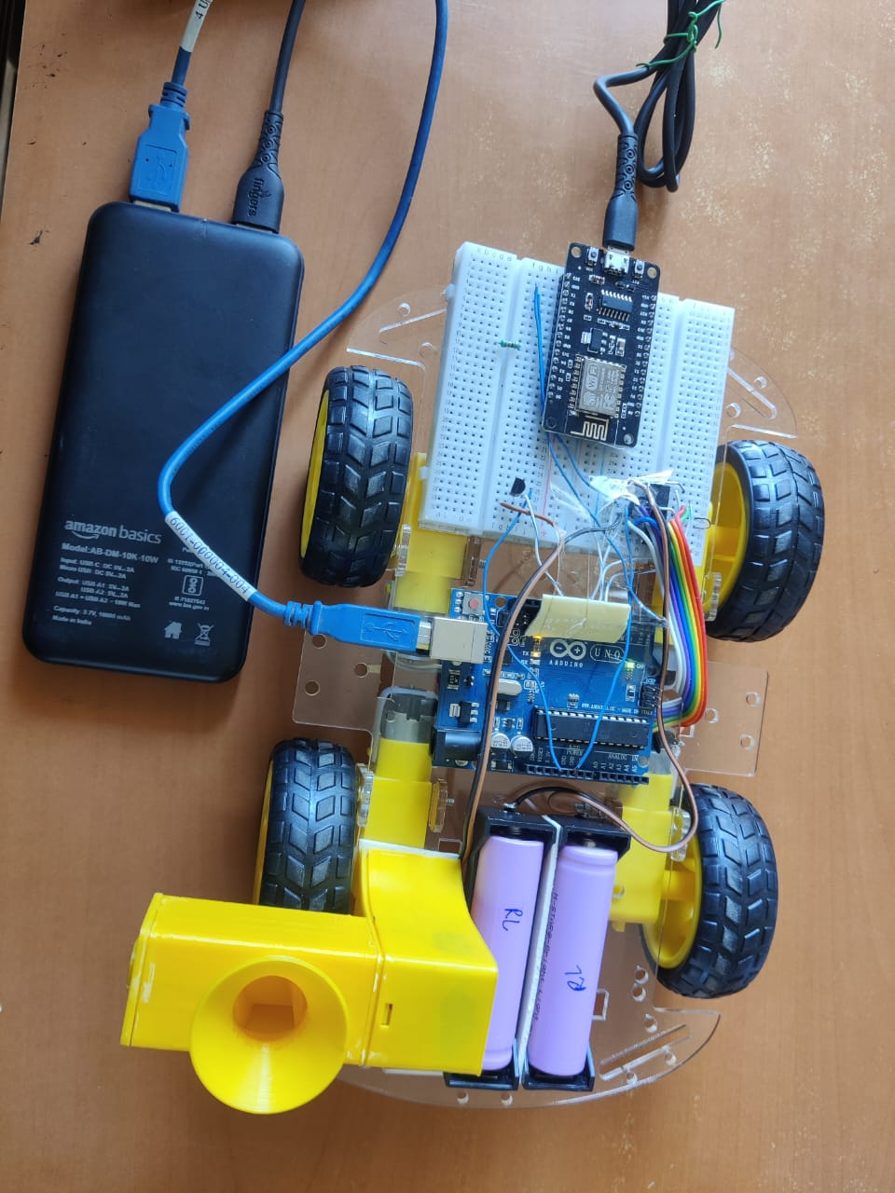

**Fig: CHASSIS CONNECTED WITH ARDUINO BOARD AND ESP CONTROLLER**

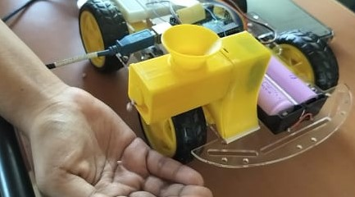

**Fig: WORKING OF FOOD DISPENSOR**

# CONCLUSION

As result, combining contemporary technology like web-based interfaces, IoT, and robotics offers an achievable approach to improve the efficiency of poultry farming operations. user may monitor environmental conditions and manage feed distribution more conveniently, precisely, and efficiently by utilizing these innovations. With the help of a mobile-friendly online interface, user can remotely control the robot's movements and oversee feed distribution, enabling them to make well-informed decisions and promptly implement solutions for optimal management of poultry farming. Furthermore, preventive actions that ensure the well-being of the poultry flocks are made easier by real-time temperature and humidity monitoring. All things considered, the industry might undergo a significant transformation with the implementation of such creative ideas, leading to higher production, profitability, and sustainability in the poultry farming sector.

# REFERENCES

* [**https://www.slideshare.net/slideshow/irjet-iot-based-smart-poultry-farm/153506202**](https://www.slideshare.net/slideshow/irjet-iot-based-smart-poultry-farm/153506202)
* [**https://www.scribd.com/document/376813959/IOT-Based-Smart-Poultry-Farm**](https://www.scribd.com/document/376813959/IOT-Based-Smart-Poultry-Farm)
* [**https://www.srpublication.com/modern-innovations-in-poultry-farming/**](https://www.srpublication.com/modern-innovations-in-poultry-farming/)
* [**https://www.poultryhub.org/all-about-poultry/husbandry-management/robotics-in-the-poultry-industry**](https://www.poultryhub.org/all-about-poultry/husbandry-management/robotics-in-the-poultry-industry)