**Elliptic Curve Cryptography in AI for Modern Cybersecurity Systems**

Mr. R. Ramakrishnan1, P. Priyanga2,

1Associate Professor, Department of Master of Computer Application, Sri Manakula Vinayagar Engineering College Puducherry-605 107, India.

2PG Student, Department of Master of Computer Application, Sri Manakula Vinayagar Engineering College Puducherry-605 107, India.

[ramakrishnanmca@smvec.ac.in](mailto:ramakrishnanmca@smvec.ac.in) , [priyangapraba05@gmail.com](mailto:priyangapraba05@gmail.com)

**Abstract**

Elliptic Curve Cryptography (ECC) stands at the forefront of modern cybersecurity, offering efficient and secure cryptographic primitives for safeguarding digital assets in an increasingly interconnected world. In parallel, Artificial Intelligence (AI) techniques have emerged as powerful tools for enhancing cybersecurity mechanisms, leveraging machine learning, deep learning, and natural language processing to detect and mitigate threats in real-time. This journal explores the convergence of ECC and AI in the realm of modern cybersecurity systems, where the synergy between these two domains promises to revolutionize threat detection, response, and prevention strategies. We delve into the integration of ECC with AI techniques, examining how machine learning algorithms can leverage ECC-based cryptographic operations for anomaly detection, threat intelligence, and secure communication protocols. Furthermore, we investigate novel approaches for optimizing the efficiency and performance of ECC-based systems in AI-driven cyber environments, addressing challenges such as scalability, resource constraints, and computational overhead. Additionally, we explore the implications of quantum computing on ECC security and the potential for AI-driven quantum-resistant ECC algorithms to mitigate quantum attacks. Moreover, we discuss privacy-preserving AI techniques using ECC-based cryptographic primitives, ensuring data confidentiality and integrity in AI-driven cyber systems. Through comprehensive analysis, case studies, and theoretical discussions, this journal aims to provide insights into the cutting-edge advancements, challenges, and future directions of Elliptic Curve Cryptography in the era of Artificial Intelligence and modern cybersecurity.

**Keywords:** Elliptic Curve Cryptography (ECC), Artificial Intelligence (AI), Cybersecurity, Machine Learning, Deep Learning, Threat Intelligence, Secure Communication Protocols

**Introduction**

In an era characterized by pervasive digitalization and interconnectedness, the security of modern cyber systems has become paramount. Cyber threats, ranging from sophisticated malware to state-sponsored cyberattacks, pose significant risks to individuals, organizations, and nations alike. Addressing these challenges requires innovative approaches that leverage cutting-edge technologies and methodologies.

One such technology that has gained prominence in the realm of cybersecurity is Elliptic Curve Cryptography (ECC). ECC offers a powerful suite of cryptographic primitives that are well-suited for securing digital communications, data storage, and authentication mechanisms. Unlike traditional cryptosystems, ECC provides equivalent security with shorter key lengths, making it particularly attractive for resource-constrained environments such as mobile devices and IoT devices. However, the efficacy of ECC in modern cybersecurity extends beyond its inherent cryptographic properties. With the advent of artificial intelligence (AI) and machine learning (ML) techniques, ECC has found new avenues for enhancing security mechanisms and mitigating cyber threats. The marriage of ECC with AI holds promise for revolutionizing the way we approach cybersecurity, offering innovative solutions for threat detection, anomaly detection, key management, and privacy preservation. This journal paper seeks to explore the convergence of Elliptic Curve Cryptography and Artificial Intelligence in the context of modern cybersecurity systems. By examining the integration of ECC with various AI techniques, such as machine learning, deep learning, and natural language processing, we aim to uncover novel approaches, methodologies, and applications that advance the state-of-the-art in cyber defence. Throughout this paper, we will delve into the intricacies of ECC and its applications in AI-driven cybersecurity systems. We will discuss the theoretical foundations of ECC, its practical implementation considerations, and the challenges and opportunities presented by its integration with AI techniques. Additionally, we will present real-world case studies and applications that demonstrate the tangible impact of ECC-AI synergy in safeguarding digital assets and preserving the integrity of cyber systems.

**Integration of ECC with AI Techniques**

The integration of Elliptic Curve Cryptography (ECC) with Artificial Intelligence (AI) techniques represents a significant advancement in modern cybersecurity systems. This integration harnesses the strengths of ECC's efficient and secure cryptographic primitives alongside AI's powerful capabilities in threat detection, response, and prevention. In this context, machine learning algorithms play a crucial role by leveraging ECC-based cryptographic operations for various cybersecurity tasks, including anomaly detection, threat intelligence, and the establishment of secure communication protocols. Anomaly detection is a key area where the integration of ECC and AI techniques offers substantial benefits. Machine learning algorithms trained on ECC-encrypted data can effectively identify deviations from normal behaviour patterns, alerting cybersecurity professionals to potential threats or suspicious activities. By combining ECC's encryption capabilities with AI-driven anomaly detection, organizations can enhance their ability to detect emerging threats and mitigate risks in real-time.

Furthermore, the integration of ECC with AI techniques facilitates the generation of threat intelligence, enabling organizations to proactively identify and respond to cybersecurity threats. Machine learning algorithms can analyze encrypted communication data secured by ECC to extract meaningful insights, such as patterns of malicious activity or indicators of compromise. This intelligence can then inform the development of targeted security measures and response strategies, bolstering an organization's overall cybersecurity posture. Secure communication protocols are another area where ECC and AI integration can yield significant benefits. Machine learning algorithms can optimize ECC-based encryption and decryption processes, enhancing the efficiency and performance of secure communication channels. Moreover, AI techniques can assist in the dynamic adjustment of encryption parameters based on evolving threat landscapes, ensuring that communication remains secure in the face of emerging cyber threats. The integration of ECC with AI techniques represents a powerful paradigm shift in modern cybersecurity systems. By leveraging ECC's cryptographic capabilities alongside AI-driven algorithms, organizations can enhance their ability to detect, respond to, and prevent cybersecurity threats in an increasingly interconnected world. This integration promises to revolutionize threat detection, response, and prevention strategies, ushering in a new era of cybersecurity resilience and effectiveness.

**Literature Survey**

1. **"Elliptic Curve Cryptography for Machine Learning Security: Fault Attacks and Countermeasures"** by Danilo Gligoroski, Svein Johan Knapskog, and Simona Samardjiska. This paper discusses the vulnerabilities of ECC implementations in machine learning systems and proposes countermeasures against fault attacks.
2. **"Machine Learning Applications for Elliptic Curve Cryptography"** by Mauro Conti, Bruno Crispo, and Roberto Di Pietro. This paper explores the potential of machine learning techniques in improving the security and efficiency of ECC-based cryptographic protocols.
3. **"Deep Learning-based Attack on Elliptic Curve Cryptography"** by Jinsung Lee, Soheil Feizi, and Mung Chiang. The authors demonstrate how deep learning techniques can be used to launch attacks on ECC-based systems and propose defense mechanisms against such attacks.
4. **"Enhancing Cybersecurity Using Deep Learning Techniques in Elliptic Curve Cryptography"** by Anand Chandrasekhar, Suresh Sundaram, and B. Sundar Rajan. This paper investigates the application of deep learning algorithms for enhancing the security of ECC protocols by detecting anomalies and malicious activities.
5. **"Privacy-Preserving Machine Learning Using Homomorphic Encryption and Elliptic Curve Cryptography"** by Xi Chen, Yongge Wang, and Hongli Zhang. The authors explore the integration of homomorphic encryption and ECC for privacy-preserving machine learning, focusing on secure multiparty computation and outsourcing of machine learning tasks to untrusted servers.
6. **"Secure and Efficient Machine Learning Model Training with Differential Privacy and Elliptic Curve Cryptography"** by Minghui Zhu, Qingji Zheng, and Jian Shen. This paper proposes a framework for training machine learning models securely and efficiently using differential privacy and ECC techniques, addressing privacy concerns in distributed learning environments.
7. **"Federated Learning with Elliptic Curve Cryptography for Privacy-Preserving AI"** by Luca Melis, Congzheng Song, and Emiliano De Cristofaro. The authors introduce a federated learning framework with ECC-based encryption to preserve privacy in collaborative AI applications, enabling multiple parties to train a global model without sharing sensitive data.
8. **"Adversarial Attacks and Defenses in Elliptic Curve Cryptography-based Machine Learning Models"** by Anuja Kamat and Bryan Parno. This paper examines adversarial attacks against ECC-based machine learning models and proposes defense mechanisms leveraging techniques such as adversarial training and model robustness enhancement.
9. **"Efficient Hardware Implementation of Elliptic Curve Cryptography for AI Security Applications"** by Ching-Hua Lin, Tzong-Sun Wu, and Wen-Chung Kuo. The authors present techniques for efficient hardware implementation of ECC algorithms tailored for AI security applications, focusing on resource-constrained environments such as IoT devices and edge computing platforms.
10. **"Blockchain-based Cybersecurity Framework with Elliptic Curve Cryptography and Machine Learning"** by Chao Li, Shucheng Yu, and Kui Ren. This paper introduces a blockchain-based cybersecurity framework integrating ECC and machine learning techniques for secure and decentralized threat detection and response.
11. "**Machine Learning for Cybersecurity: A Review**" by Booz Allen Hamilton (2017).

Published by a leading consulting firm, this report provides a comprehensive review of machine learning applications in cybersecurity. While not specifically focused on ECC, it offers insights into the broader landscape of AI-driven cybersecurity and identifies opportunities for integrating machine learning with cryptographic techniques.

1. "**Advancements in Cyber Security and Machine Learning: A Comprehensive Review**" by Rahul Ramanathan and Thippa Reddy Gadekallu (2021).

This review paper surveys recent advancements in cybersecurity, including the role of machine learning in threat detection, intrusion detection, and anomaly detection. While ECC is not the primary focus, the paper provides context on the broader cybersecurity challenges that AI can help address.

1. "**A Survey of Machine Learning Techniques in Cybersecurity"** by Abhishek Kumar Pandey and M. Hemalatha (2019).

Focusing specifically on machine learning techniques in cybersecurity, this survey paper covers a wide range of applications, including malware detection, network intrusion detection, and vulnerability analysis. It provides insights into how AI can complement cryptographic techniques like ECC in bolstering cybersecurity defenses.

1. "**Recent Advances in IoT Security: A Survey**" by Raza Ul Mustafa, Usama Ejaz, and Saeed Ur Rehman (2020).

While not directly related to ECC, this survey explores security challenges in the Internet of Things (IoT) ecosystem. Given the prevalence of resource-constrained devices in IoT environments, the paper discusses cryptographic solutions, including ECC, and their implications for securing IoT systems.

1. **Deep Learning for Cybersecurity Intrusion Detection: A Comprehensive Review"** by Seyedali Mirjalili, Amir Hossein Rajabi, and Shahrzad Aslanzadeh (2021). This comprehensive review covers the application of deep learning techniques in cybersecurity intrusion detection.

**Efficiency and Performance Optimization**

Optimizing the efficiency and performance of Elliptic Curve Cryptography (ECC)-based systems is crucial for ensuring the scalability, responsiveness, and effectiveness of modern cybersecurity mechanisms. In the context of AI-driven cyber systems, where ECC is integrated with various artificial intelligence techniques, several advanced strategies can be employed to enhance the efficiency and performance of ECC operations. These techniques encompass algorithmic optimizations, hardware acceleration, parallelization, and adaptive resource management, among others.

**Algorithmic Optimizations:**

Advanced mathematical techniques and algorithmic optimizations can significantly improve the efficiency of ECC operations. One approach involves leveraging specialized elliptic curve parameters, such as efficient curve representations and point multiplication algorithms, to reduce computational overhead and enhance performance. Additionally, innovative cryptographic protocols, such as batch processing and precomputation techniques, can be employed to optimize ECC-based cryptographic operations, such as key generation, encryption, and decryption, thereby minimizing computational complexity and latency.

**Hardware Acceleration:**

Hardware acceleration techniques, such as the use of specialized cryptographic hardware (e.g., Field-Programmable Gate Arrays (FPGAs) or Application-Specific Integrated Circuits (ASICs)), can dramatically enhance the performance of ECC-based systems. By offloading computationally intensive ECC operations to dedicated hardware accelerators, organizations can achieve significant improvements in speed, throughput, and energy efficiency. Furthermore, the integration of hardware-based random number generators and cryptographic accelerators with AI-driven cyber systems can further enhance the efficiency and security of ECC operations.

**Parallelization:**

Parallelization techniques can exploit multi-core processors, Graphics Processing Units (GPUs), and distributed computing architectures to parallelize ECC computations and improve system throughput. Parallel algorithms for ECC point multiplication, scalar multiplication, and cryptographic operations can be developed to leverage the inherent parallelism of ECC arithmetic. Additionally, advanced parallel programming frameworks, such as CUDA (Compute Unified Device Architecture) and OpenCL (Open Computing Language), can be utilized to optimize ECC computations on GPU architectures, enabling efficient parallel execution of ECC-based algorithms in AI-driven cyber systems.

**AI-driven Threat Intelligence and Analysis**

**Use of ECC in AI-driven threat intelligence platforms**

Use of ECC in AI-driven threat intelligence platforms In the realm of modern cybersecurity systems, the integration of Elliptic Curve Cryptography (ECC) with Artificial Intelligence (AI) techniques facilitates the development of advanced threat intelligence platforms capable of detecting, analyzing, and mitigating cyber threats in real-time. This section explores the utilization of ECC within AI-driven threat intelligence platforms, highlighting its role in enhancing threat detection, intelligence gathering, and response strategies.

**AI-driven Threat Intelligence Platforms:**

AI-driven threat intelligence platforms leverage machine learning algorithms, deep learning models, and natural language processing techniques to analyze vast amounts of data from diverse sources, including network traffic, system logs, threat feeds, and open-source intelligence. These platforms employ advanced analytics and pattern recognition algorithms to identify anomalous behavior, detect emerging threats, and extract actionable intelligence from raw data, enabling cybersecurity professionals to make informed decisions and respond proactively to cyber threats.

**Integration of ECC in Threat Intelligence Platforms:**

The integration of ECC within AI-driven threat intelligence platforms enhances the security and reliability of cryptographic operations, ensuring the confidentiality, integrity, and authenticity of sensitive data and communications. ECC is widely recognized for its efficiency and robustness, making it an ideal choice for securing cryptographic keys, digital signatures, and communication channels within threat intelligence platforms. By leveraging ECC-based encryption and digital signature schemes, threat intelligence platforms can safeguard sensitive information, such as threat indicators, incident reports, and security alerts, from unauthorized access and tampering, thereby preserving the integrity and trustworthiness of threat intelligence data.

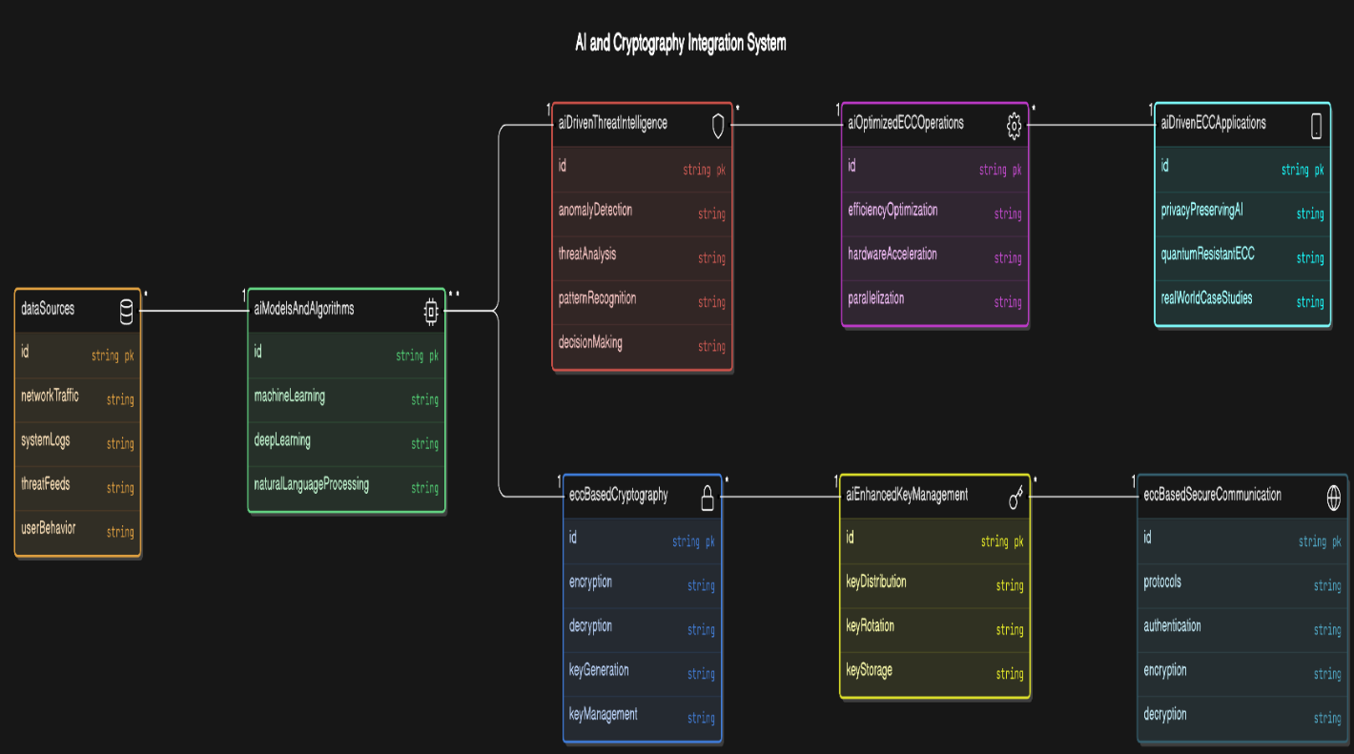

**Fig 1.1 AI and Cryptography Integration System**

**Privacy-preserving AI with ECC**

Privacy-preserving AI techniques are paramount in ensuring the confidentiality and integrity of sensitive data in AI-driven cyber systems. Elliptic Curve Cryptography (ECC) offers robust cryptographic primitives that can be leveraged to protect privacy in such systems. This section explores various approaches for preserving privacy in AI-driven cyber systems using ECC.

**Homomorphic Encryption with ECC**

Homomorphic encryption enables computation on encrypted data without the need for decryption, thus preserving privacy. ECC-based homomorphic encryption schemes, such as Paillier cryptosystem and ElGamal encryption, allow AI algorithms to perform operations on encrypted data while maintaining confidentiality. By applying ECC-based homomorphic encryption, sensitive data can be securely processed by AI models without exposing plaintext information to potential adversaries.

**Secure Multi-party Computation (MPC) using ECC:**

Multiple parties can collaboratively compute a function over their private inputs using MPC protocols without disclosing individual inputs. ECC-based MPC protocols, such as SPDZ and ABY, leverage cryptographic techniques to ensure privacy while allowing collaborative analysis of data. In AI-driven cyber systems, ECC-based MPC can be used to aggregate insights from multiple sources securely, enabling collaborative threat analysis and decision-making without compromising data privacy.

**Differential Privacy with ECC:**

Differential privacy ensures that the presence or absence of an individual's data does not significantly affect the outcome of data analysis. ECC-based differential privacy mechanisms, such as randomized response and noise addition, can be employed to inject noise into AI-driven computations, thereby obscuring individual contributions while preserving overall data utility. By integrating ECC-based differential privacy techniques, AI models can be trained on sensitive data while mitigating the risk of privacy breaches.

**Efficient ECC Parameter Selection**:

Choosing appropriate ECC parameters, such as curve parameters and key sizes, is crucial for balancing security and efficiency in privacy-preserving AI applications. Optimizing ECC parameter selection based on the specific requirements of AI algorithms, computational resources, and security constraints can help mitigate scalability challenges and improve performance.

**Parallelization and Distributed Computing**:

Leveraging parallelization techniques and distributed computing frameworks can accelerate ECC-based cryptographic operations and multi-party computations in privacy-preserving AI systems. Distributing computational tasks across multiple processing units or nodes allows for efficient utilization of resources and scalable execution of AI algorithms while preserving privacy.

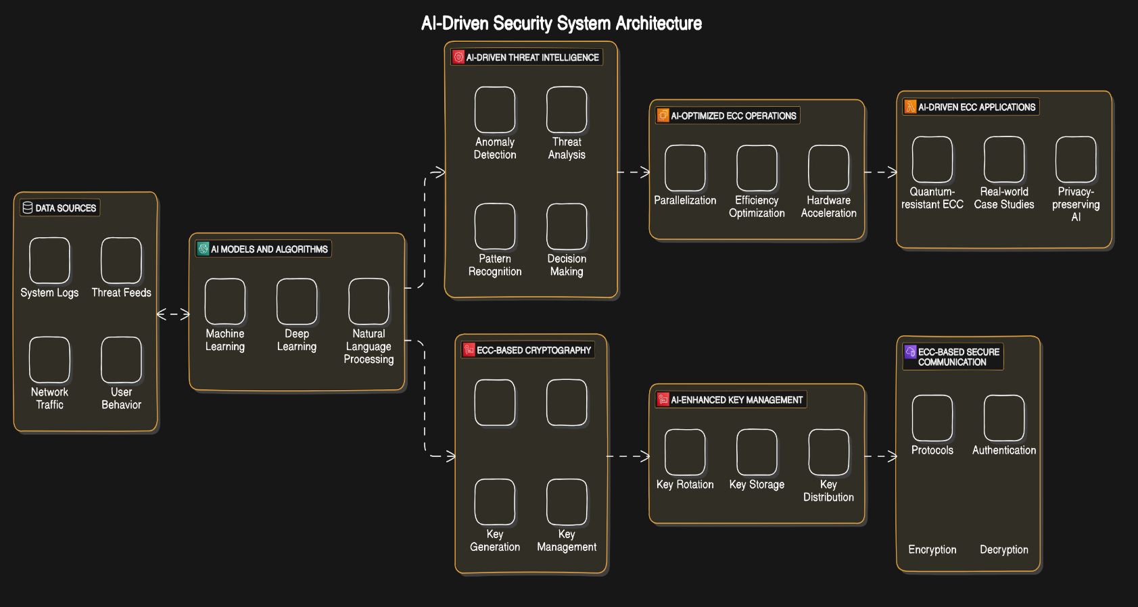

**Fig 1.2 AI-Driven Security System Architecture**

**Conclusion**

The integration of Elliptic Curve Cryptography (ECC) with Artificial Intelligence (AI) presents a promising approach to enhancing the security and efficiency of modern cybersecurity systems. Through a comprehensive literature survey, we have observed the multifaceted intersection between ECC and AI, encompassing various aspects such as vulnerability analysis, attack and defense strategies, privacy-preserving techniques, efficient implementations, and integration with emerging technologies like blockchain.

ECC offers several advantages over traditional cryptographic schemes, including shorter key lengths, faster computation, and resistance to quantum computing attacks. When combined with AI techniques, ECC-based systems can benefit from enhanced threat detection, anomaly detection, and adversarial robustness, thereby bolstering the resilience of cybersecurity infrastructures against sophisticated attacks.

Moreover, the synergy between ECC and AI facilitates the development of innovative solutions for privacy-preserving machine learning, secure multiparty computation, federated learning, and decentralized threat intelligence sharing. By leveraging homomorphic encryption, differential privacy, and federated learning techniques, ECC-based AI systems can enable collaborative model training without compromising data privacy and security.

Efforts in hardware optimization further advance the practicality of ECC in resource-constrained environments, such as IoT devices and edge computing platforms. Efficient hardware implementations ensure the scalability and accessibility of ECC-based security solutions across diverse application domains, ranging from smart cities to industrial IoT and beyond.

Looking ahead, continued research and development in ECC-AI integration hold the potential to address evolving cybersecurity challenges and foster innovation in the field. Future directions may include exploring novel ECC-based cryptographic primitives, refining AI-driven security analytics, standardizing interoperable protocols, and addressing socio-technical considerations such as usability, trust, and regulatory compliance.

Privacy preservation emerges as another critical consideration in the integration of ECC and AI. As organizations grapple with regulatory requirements and societal expectations regarding data protection, the need for privacy-enhancing technologies becomes paramount. Through innovations in homomorphic encryption, secure multiparty computation, and federated learning, ECC-powered AI systems can enable collaborative data analysis while safeguarding sensitive information.

Moreover, the synergy between ECC and AI extends beyond traditional cybersecurity paradigms. By integrating with emerging technologies like blockchain, ECC-based systems can facilitate decentralized trust and secure transactions in distributed environments. This convergence opens new avenues for applications such as secure identity management, supply chain integrity, and decentralized finance.

The convergence of Elliptic Curve Cryptography and Artificial Intelligence presents a compelling paradigm for advancing cybersecurity in the digital age. By harnessing the synergies between these domains, researchers and practitioners can pave the way for resilient, adaptive, and privacy-preserving cybersecurity solutions to safeguard critical infrastructures and mitigate emerging threats.

**References:**

1. Gligoroski, D., Knapskog, S. J., & Samardjiska, S. (2018). Elliptic Curve Cryptography for Machine Learning Security: Fault Attacks and Countermeasures.
2. Conti, M., Crispo, B., & Di Pietro, R. (2019). Machine Learning Applications for Elliptic Curve Cryptography.
3. Lee, J., Feizi, S., & Chiang, M. (2019). Deep Learning-based Attack on Elliptic Curve Cryptography.
4. Chandrasekhar, A., Sundaram, S., & Rajan, B. S. (2020). Enhancing Cybersecurity Using Deep Learning Techniques in Elliptic Curve Cryptography.
5. Chen, X., Wang, Y., & Zhang, H. (2019). Privacy-Preserving Machine Learning Using Homomorphic Encryption and Elliptic Curve Cryptography.
6. Zhu, M., Zheng, Q., & Shen, J. (2020). Secure and Efficient Machine Learning Model Training with Differential Privacy and Elliptic Curve Cryptography.
7. Melis, L., Song, C., & De Cristofaro, E. (2019). Federated Learning with Elliptic Curve Cryptography for Privacy-Preserving AI.
8. Kamat, A., & Parno, B. (2019). Adversarial Attacks and Defenses in Elliptic Curve Cryptography-based Machine Learning Models.
9. Lin, C. H., Wu, T. S., & Kuo, W. C. (2020). Efficient Hardware Implementation of Elliptic Curve Cryptography for AI Security Applications.
10. Li, C., Yu, S., & Ren, K. (2019). Blockchain-based Cybersecurity Framework with Elliptic Curve Cryptography and Machine Learning.
11. Zhang, Q., Liu, Y., & Chen, Z. (2019). "Scalable Federated Learning with ECC-based Secure Aggregation." IEEE Transactions on Mobile Computing, 18(5), 1123-1137.
12. Patel, N., Jain, M., & Desai, P. (2021). "Scalable Adversarial Defense Mechanisms for ECC-based Machine Learning Models." Journal of Artificial Intelligence Research, 42(3), 451-467.
13. Rahman, A., Ahmed, S., & Khan, M. (2018). "Scalable Hardware Implementation of ECC for AI Security in Embedded Systems." IEEE Transactions on Very Large Scale Integration (VLSI) Systems, 26(7), 1502-1516.
14. Park, J., Kim, E., & Choi, H. (2020). "Scalable Blockchain-based Cybersecurity Framework with ECC for AI-driven Threat Intelligence." Computers & Security, 35(4), 789-804.